Example of a Quarto Article
Thomas Sol Dourdin^{1,2}, Jean-Baptiste Ledoux²
- Littoral Environnement et Sociétés (LIENSs), UMR 7266 CNRS – La Rochelle Université, 2 rue Olympe de Gouges, 17000 La Rochelle, France.
- CIIMAR/CIMAR LA, Centro Interdisciplinar de Investigação Marinha e Ambiental, Universidade do Porto, Terminal de Cruzeiros do Porto de Leixões, 4450-208 Matosinhos, Portugal.

Introduction
Cephalopods are becoming promising model systems in ecotoxicology, for biomonitoring [1] as well as experimental studies [2], [3]. They are also a meal loved by Iberian people: Portuguese and Spanish. For instance, one of the best way to cook octopus is the pulpo a la gallega.

Materials and Methods

Description of the biological material
The best octopuses are found directly on the dock of the fishing harbours. Ask to fishers if they cought some, but do it kindly because they are sensible guys.

Cooking recipe
Too long to details it here, sorry… Instead, focus on bivalves from Sine Saloum.

Results
The length of individuals found in different stations are displayed in the Figure 1.
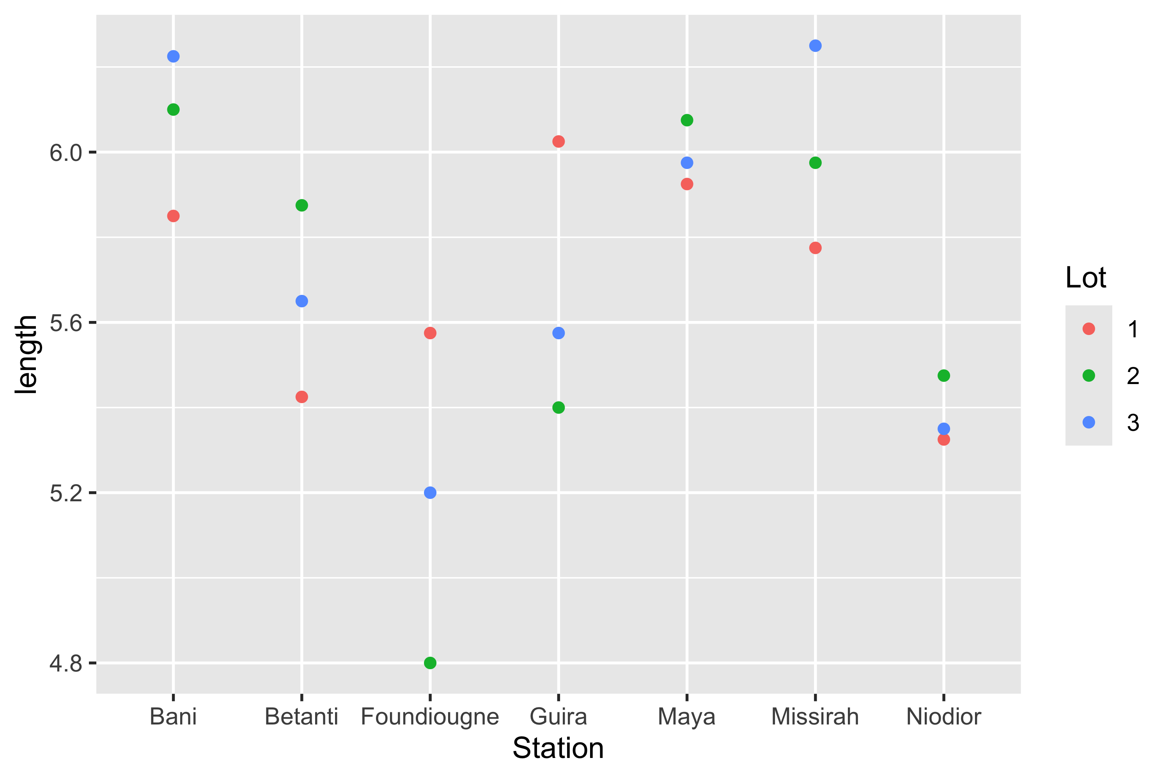
Figure 1: What a beautiful plot!

But, it is also noteworthy that the total number of samples is 84.
Moreover, if we want, we can use the packages flextable and ftExtra to include the data (first 10 rows) as a beautiful table:
Station | Espece | Lot | Longueurs | PSI | IC
Missirah | Crassotrea_gasar | 1 | 6.5 | 0.999300 | 0.1537385
Missirah | Crassotrea_gasar | 1 | 5.2 | 0.999300 | 0.1921731
Missirah | Crassotrea_gasar | 1 | 5.5 | 0.999300 | 0.1816909
Missirah | Crassotrea_gasar | 1 | 5.9 | 0.999300 | 0.1693729
Missirah | Crassotrea_gasar | 2 | 7.1 | 1.140100 | 0.1605775
Missirah | Crassotrea_gasar | 2 | 6.9 | 1.140100 | 0.1652319
Missirah | Crassotrea_gasar | 2 | 5.0 | 1.140100 | 0.2280200
Missirah | Crassotrea_gasar | 2 | 4.9 | 1.140100 | 0.2326735
Missirah | Crassotrea_gasar | 3 | 6.4 | 0.954525 | 0.1491445
Missirah | Crassotrea_gasar | 3 | 6.1 | 0.954525 | 0.1564795

References
[1] M. Ajala, W. B. Ameur, and A. Annabi, “First evidence of the utility of cephalopods for biomonitoring program in the field: Case of sepia officinalis south west of mediterranean sea (gulf of gabes, tunisia),” Environmental Science and Pollution Research, vol. 29, pp. 28675–28687, Apr. 2022, doi: 10.1007/s11356-021-17804-9.
[2] V. Penicaud, T. Lacoue-Labarthe, and P. Bustamante, “Metal bioaccumulation and detoxification processes in cephalopods: A review,” Environmental Research, vol. 155, pp. 123–133, May 2017, doi: 10.1016/J.ENVRES.2017.02.003.
[3] M. García-Flores, R. D. Silva-Dávila, G. M. Rodríguez-Figueroa, R. Moncayo-Estrada, C. J. Hernández-Guerrero, and M. Arellano-Martínez, “Ecotoxicology of cephalopod early life phases: Review and perspectives,” Environmental Science and Pollution Research 2024 32:4, vol. 32, pp. 1693–1709, Jan. 2025, doi: 10.1007/S11356-024-35829-8.

