编译命令如下，因为用的vscode，之前编译用的链接库懒得删了

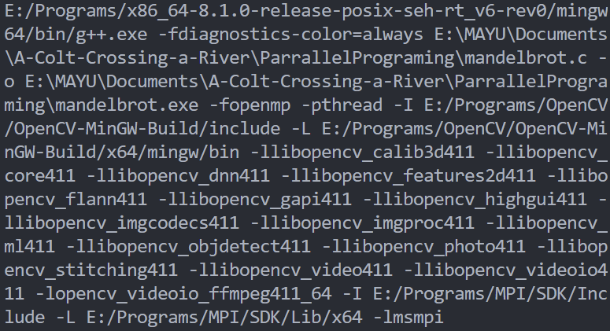

运行和结果

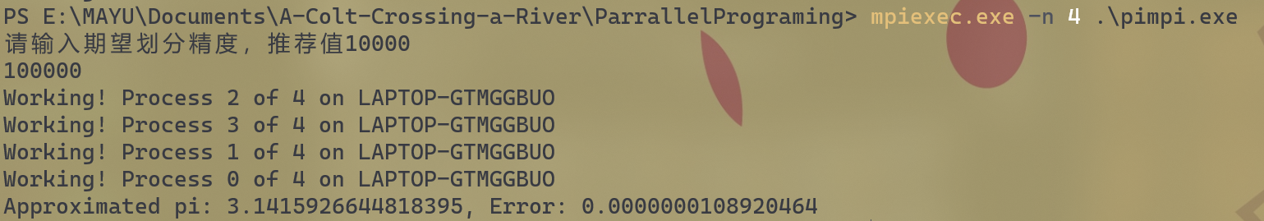

代码

#include <stdio.h>

#include <iostream>

#include <mpi.h>

#include <math.h>

#ifndef **M_PI**

#define **M_PI** (3.14159265358979323846)

#endif

int **main**(int *argc*, char \**argv*[]) {

    int rank, size;

**MPI_Init**(&*argc*, &*argv*);

**MPI_Comm_rank**(**MPI_COMM_WORLD**, &rank);

**MPI_Comm_size**(**MPI_COMM_WORLD**, &size);

    int n;

    double mypi = 0.0;

    if (rank == 0) {

        std::cout**<<**"请输入期望划分精度，推荐值10000"**<<**std::**endl**;

        std::cin**>>**n;

    }

**MPI_Bcast**(&n, 1, **MPI_INT**, 0, **MPI_COMM_WORLD**);

    double w = 1.0 / (double)n;

    double sum = 0.0;

    for (int i = rank + 1; i <= n; i += size) {

        double x = w * ((double)i - 0.5);

        sum += **sqrt**(1.0 - x * x);

    }

    double pi;

    int my_rank, numprocs;

**MPI_Comm_size**(**MPI_COMM_WORLD**,&numprocs);

**MPI_Comm_rank**(**MPI_COMM_WORLD**,&my_rank);

    int  namelen;

    char processor_name[**MPI_MAX_PROCESSOR_NAME**];

**MPI_Get_processor_name**(processor_name,&namelen);

**printf**("Working! Process %d of %d on %s\n",my_rank,numprocs,processor_name);

**MPI_Reduce**(&sum, &pi, 1, **MPI_DOUBLE**, **MPI_SUM**, 0, **MPI_COMM_WORLD**);

    if (rank == 0) {

        pi *= 4.0 * w;

**printf**("Approximated pi: %.16f, Error: %.16f\n", pi, **fabs**(pi - **M_PI**));

    }

**MPI_Finalize**();

    return 0;

}