运行结果：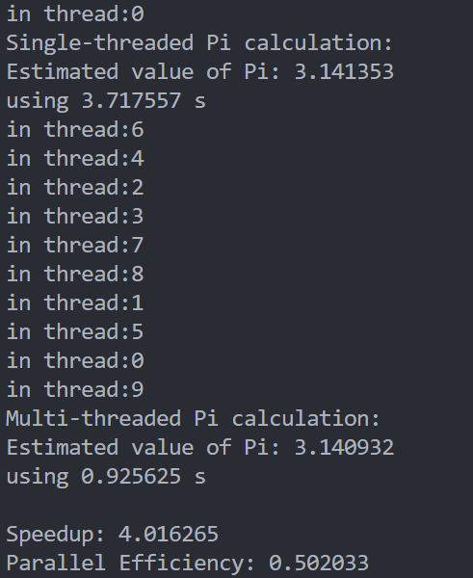

源代码：
#include <stdio.h>
#include <stdlib.h>
#include <pthread.h>
#include <time.h>

#define NUM_POINTS 100000000
#define MILLION 1000000

int points_inside_circle = 0;
pthread_mutex_t lock;
int NUM_THREADS = 1;

void *compute_pi(void *arg)
{
int thread_id = *((int *)arg);
int points_in_thread = NUM_POINTS / NUM_THREADS;
int points_inside_thread = 0;

for (int i = 0; i < points_in_thread; i++)
{
double x = (double)rand() / RAND_MAX;
double y = (double)rand() / RAND_MAX;

if (x * x + y * y <= 1.0)
{
points_inside_thread++;
}
}
pthread_mutex_lock(&lock);
printf("in thread:%d \n", thread_id);
points_inside_circle += points_inside_thread;
pthread_mutex_unlock(&lock);

return NULL;
}

int main()
{
double timedif[2];
for (int j = 0; j < 2; j++)
{
if (j == 1)
{
NUM_THREADS = 10;
}
points_inside_circle = 0;

pthread_t threads[NUM_THREADS];
pthread_mutex_init(&lock, NULL);
// 计时开始
struct timespec tpstart;
struct timespec tpend;
clock_gettime(CLOCK_MONOTONIC, &tpstart);

int thread_ids[NUM_THREADS];
for (int i = 0; i < NUM_THREADS; i++)
{
thread_ids[i] = i;
pthread_create(&threads[i], NULL, compute_pi, &thread_ids[i]);
}

for (int i = 0; i < NUM_THREADS; i++)
{
pthread_join(threads[i], NULL);
}

pthread_mutex_destroy(&lock);
clock_gettime(CLOCK_MONOTONIC, &tpend);
timedif[j] = (tpend.tv_sec - tpstart.tv_sec) + (double)(tpend.tv_nsec - tpstart.tv_nsec) / 1e9;

double pi_estimate = 4.0 * (double)points_inside_circle / NUM_POINTS;
if (j == 1)
{
printf("Multi-threaded Pi calculation:\n");
}
else
{
printf("Single-threaded Pi calculation:\n");
}
printf("Estimated value of Pi: %lf\n", pi_estimate);
printf("using %lf s\n", timedif[j]);
}

double S8 = timedif[0] / timedif[1];
double E8 = S8 / 8;
printf("\nSpeedup: %lf\nParallel Efficiency: %lf\n", S8, E8);
return 0;
}

