Business data analysis

Prepared by: Teresina Toney

June 5, 2019

**Table of Contents**

# **Executive Summary**

# **Introduction**

## Purpose

## Background

## Scope

# **Discussion**

## Methods of Analysis

## Factors affecting the Campaign Projects

## Advantages to Successful Projects

## Disadvantages to Failed Projects

## The Significance of Categories

# **Conclusion and Recommendations**

# **EXECUTIVE SUMMARY**

Kickstart is the largest and most popular crowdfunding platform. Traditional measures usually consist of getting a loan from a bank. The project owners are called creators.

The creator can post the “project” (a tech product, book, film, etc.) to the platform, set a monetary goal, and raise money from the general public (“backers”) to fund it.

# **INTRODUCTION**

The company’s appeal to the aspiring entrepreneur is the ability to bypass traditional fundraising models resorting to collecting cash directly from the general public, and bringing their products to market.

**Kickstarter Campaign Project Steps:**

1. Start a campaign,
2. Set minimum funding goal,
3. And choose a deadline.

The most important aspect to know about launching a Kickstarter project is that if the project falls short of meeting its minimum funding goal, **the project will not receive any funds.**

# **DISCUSSION Excel Data Set Limits: 250 MB**

The projects analyzed in this assignment falls into one of 9 categories (Film & Video, Food, Games, journalism, Music, Music, Photography, Publishing, Technology, and Theater) and 41 subcategories. Only **46% of campaigns reached their funding goal;** therefore, it is extremely important for creators to know the factors that might impact the outcome of their project before the launch.

I started with a **pre-scraped dataset of 41,113 projects and 13 features.** Each project had a status of either canceled, failed, live or successful.

The data set analyzed started from 2009–2017, with total pledged amount just **over $461 million**. About **42% Projects failed** to meet their minimum goal.

I focused my analyzing on the statistics of successful and failed projects because I was interested in discovering any trends and/or strong indicators that will differentiate successful and failed projects.

**(Image 1)** presents the statistics of the projects in my data set. Overall, the dataset contained more **successful projects (46%) in comparison to the failed projects (42%).** More information is need to explore if number of backers catapulted an increase to a successfully funded project. Another note, what is the probability that more updates on the projects increased funding success.

Further analysis was conducted on whether certain project categories performed better than the rest. To answer this, I analyzed the project success rate according to each category. Upon review of **(Images 2 & 3), Music and Photography seems to achieve 77%** respectively, which is greater than the average success rate of all project (44%). Journalism and Food performed the poorest with success rates of 0% and 17% respectively.

**(Image 4)** A feature I also found interesting and would have liked to explore further was the “country location”. I would have added an image of a world map and created location points of the projects on the map.

This analysis determined that “Category” is the most important feature.

# **CONCLUSION & RECOMMENDATIONS**

In conclusion, the most successful projects know their Kickstarter audience. From the opening stage of the project, the creator must provide all links, media content and other content along with the “funded goal” that is relevant to making a business decision.

I believe if a successful project/creator provides the accurate and timely updates to the bankers, condenses and simplifies their copy and have visually appealing media content.

**Visuals**

**(Image 1)**

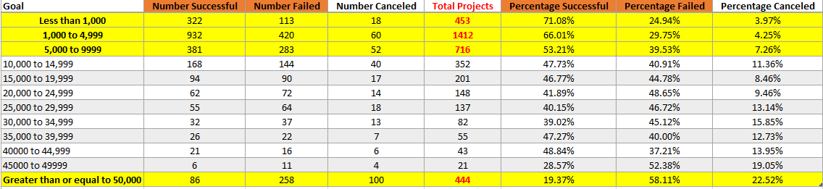

**(Image 2)**

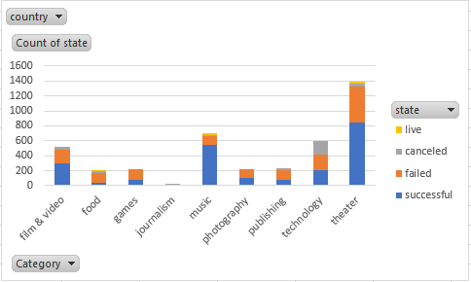

**(Image 3)**

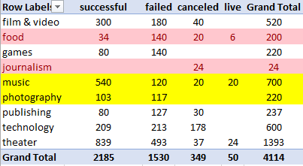

**(Image 4)**

