**KROY**

User manual

**All about Kroy**

In the year 2042, York has been invaded by extraterrestrials (ETs) from planet Kroy. Your task is to destroy all the ET fortresses which are in key locations in York such as York Minster and Clifford tower. Watch out for the ET patrols.

**Fire trucks**

In Kroy, you will be controlling fire trucks that spray water at ET fortresses to destroy them. Fire trucks can be swapped out at any point during the game, each fire truck is different in its own unique way.

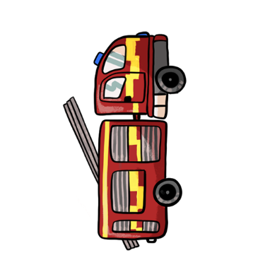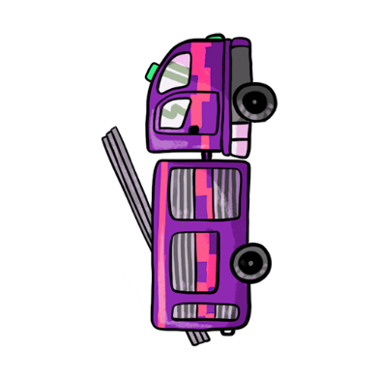



You will be tasked with destroying the alien fortresses set up in key York locations. 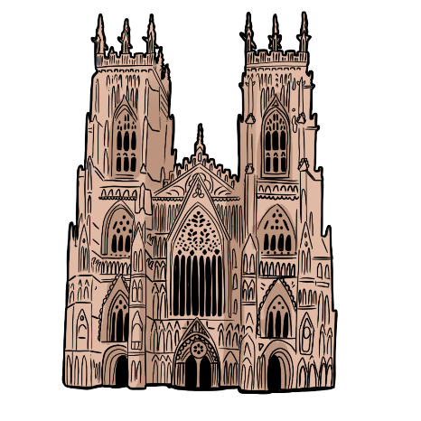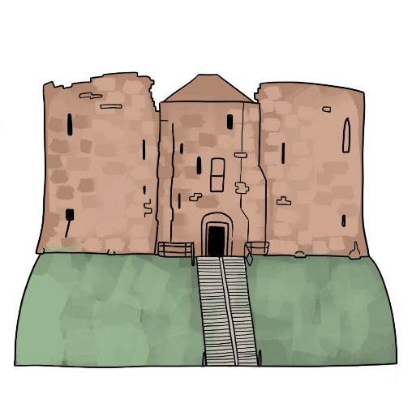



**Main menu**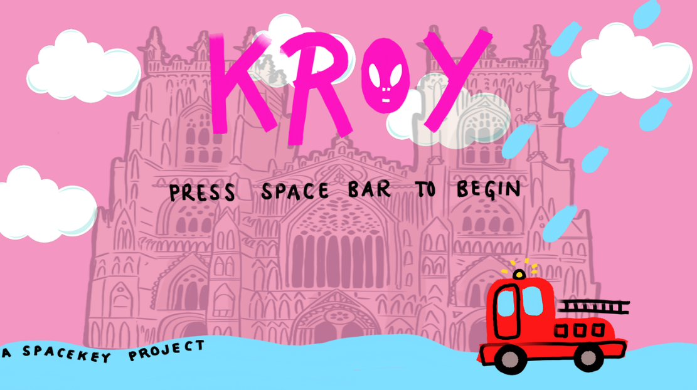

When you start the game, you will be presented with this menu. Press the space bar to begin the game.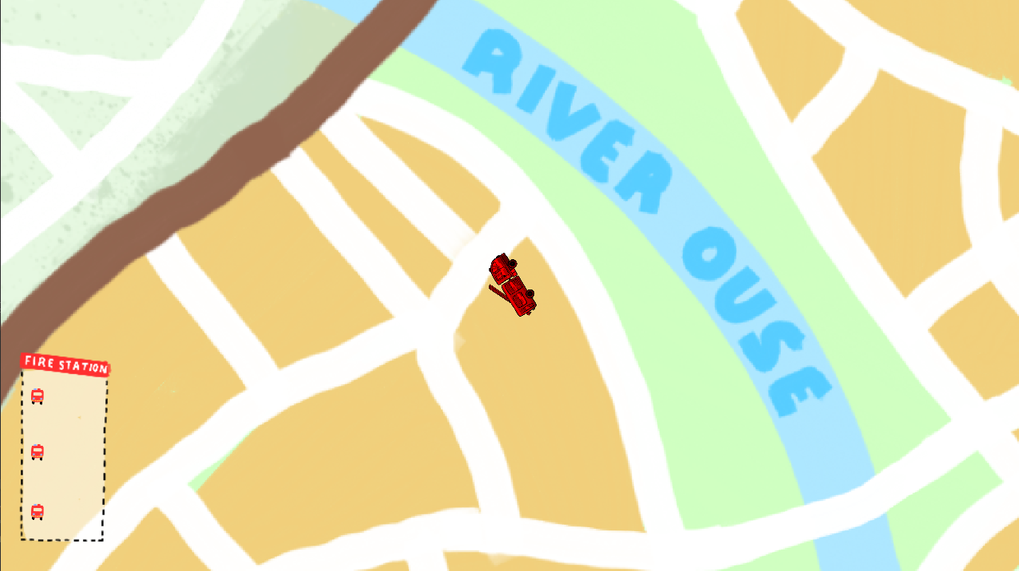











**Movement**

To control a fire truck, use the arrow keys:

* The **UP** arrow key will make the fire truck go forwards
* The **DOWN** arrow will make the fire truck go backwards
* The **RIGHT** and **LEFT** arrow keys will make the fire truck turn in their respective directions.

**Attacking**

To attack a fortress, you need to aim the truck you’re controlling at the fortress, then press the **SPACE BAR** to fire water at it. Make sure you avoid the fortress attacks (it won't be easy!).

**Fire station**

