SBA Report
2022-2025

By Tse Chun To 6E24
Index Page

- Chapter 0 About the System
- Chatper 1 Data storage
- Chapter 2 Login of Users
- Chapter 2 View Goods
- Chapter 3 Filtering
- Chapter 4 Manipulation of Goods Data
- Chapter 5 Shopping cart
- Chapter 6 Check-out and collection of goods
- Chapter 7 Data visualization
- Chapter 8 Testing
- Chapter 9 Debugging
- Chapter 10 Improvement
- Chapter 11 investigation and Improvement

Chapter 0

About the System

- Introduction:

Online shopping is the latest trend in which provides a variety of goods with high convenience. The biggest advantage of online shopping comparing to the traditional shopping in the supermarket is that online shopping allows users to purchase goods online which reduce the time cost and beyond the time, geographical barrier as users can check the goods of different shops around the world at any time they want. Notwithstanding, the great variety of goods provided by traditional shops is an unique advantage and the key to remaining competitive towards the trend. If the two advantages combined forming an online shopping platform providing a great variety of goods will be a step in the right direction.

0.1 Problem identification:

1. Time and geographical limitations:
People have to spend a lot of time going to the shop and looking for the desired
goods. Moreover, the time needed to go to the shop increases positively related
to the distance to the shop. Of equal importance is that queuing in physical
shops take a lot of time , which may even takes longer than looking for goods in
peak hours. A lot of unnecessary time is spent on travelling.

2. Unable to purchase the goods
For the elderly, going to the market or shop to buy the desired goods and carry
the heavy goods back to their home will be a problem for them due to their
limitation in stamina and strength. There may also be a potential problem where
elderly may get hurt while carrying out the goods.

For the busy white-collar workers, they lack time to go to the market or shop to
choose their desired goods due to their packed schedule.

3. The reducing of competitive for traditional market or shop
Given the convenience of online shopping platforms, traditional shops may
provide some rare goods but not as much as the online shopping platform does
on the general daily necessities.

4. Unable to satisfy customers’ desire, concern
As the online shopping platform has an array of limitations, for instance
difficulties in transporting food that is easily spoiled or raw meat, long delivery
time and the concerns of fake goods, online shopping platform faces a series of
potential problems.

0.2 Aims and objectives:
A good online shopping platform should combine the advantages of both
traditional physical shops and the online shopping platform, in which the
customers can enjoy the great variety of goods in online shopping platforms and
allow them to use their familiar way of shopping i.e. buying from the physical
shops. Also, the sales of the online shopping platform can be promoted through
collaboration with different famous chain brand shops or small individual shops.
To solve the difficulties of the users that are unable or without time to go shopping , the platform should be an alternative for them to purchase their goods .

0.3 Target users and their needs:
1. Elderly
They may not be physically able to purchase goods through physical shops
and carry the heavy goods back home. They need a delivery service where
they can shop without going to the physical shop and of the utmost
importance is that they don’t have to carry heavy goods back home by
themselves.
2. Busy people
Busy people, for example white-collar workers, often get off their work late
or even at midnight. They lack time to buy goods or even daily necessities.
They need a delivery service which delivers their desired goods to their home
or a planned pickup of their desired goods in physical shops, reducing the
time of looking for desired goods and queuing to check out.

3. Local shop owner
Local shop owners lack a platform to promote their goods or sell their goods.
By using the online shopping platform, they can put their goods online and
sell their goods through online shopping platform in which the great brand
built allowing more attraction to the customers and reach to more potential
customers.

4. Online shopping platform owner
Online shopping platform owner can promote the online shopping platform by the brandname of the franchises (local shop) shop and can increase their occupational percentage in the highly-competitive online sales market in a short period of time.
The owner can also easily sell mtheir products to the people with demand hence their sales revenue can be increased

  - Functions of the system

- Customer
- customer can shop and purchase through an array of goods through online
shopping platforms
- customer can choose to pick-up their purchased goods at the stores owned
by the platform or the franchises (seller) shop
- they can also choose delivery to send their goods to their address

2. Seller
- seller can add goods of their brand to the supermarket (addressing the
problem of insufficient goods variety and promote the sales, fame of the
market)
- seller can also adjust (i.e. managing the stock, price of the goods) their goods
- seller can delete THEIR OWN goods (limited that they can’t delete other
goods – by Permission)

3. Admin
- admin can adjust, add, delete the goods in the shopping markets
- admin can regulate the online shopping platform and adjust accordingly
- admin can check the statistics and analysis the future trending of the
different goods

  - Design Consideration

- Hardware Usage
A large storage device should be used to store the data of the goods and the users’ information and transaction records.

 | Desktop Computer | Direct-attached Storage (DAS) | Network Attached  Storage (NAS)
Cost | Low | Medium | High
Access mode | Direct | Direct | Centralized
Processing Speed | Low | Highest | High
Accessibility | Low | Medium | High

A Network Attached Storage (NAS) is usedbecause of its centralized access mode is well-suited for the online shopping system with multiple access given to different users ( More permission access for the admin , less access for seller )
And it has high processing speed to allow large amount of data to be processed and show to the user with short response time needed

- Backup Device Usage
A backup device should be used to restore the data after a potential data loss to prevent the breakdown of the transaction and the online shopping platform

 | External Hard drive ( SSD ) | Network Attached  Storage (NAS) | Cloud Storage
Setup Cost | Low | High | Highest
Backup/recovery speed | Highest | High | Low
Backup Frequency | Low | High | Highest

A Cloud Storage is used because of its high backup frequncy to minimize the loss of data after a data loss and it allows multiple access of backups at anywhere anytime which provide convenience and allow fast restore of backup.
The storage size of cloud storage can be adjusted in fast according to the demand due to its high Scalability.

- User Interface
A user interface(UI) is used for the users to manage or buy goods in the online shopping platform .

 | Command Line Interface | Menu-driven Interface | Graphical User interface (GUI)
Accessibility | Low | Medium | Highest
Develop Difficulty | Low | Medium | Highest
Need to Learn | Yes | No | No

As a GUI is difficult to develop , in consideration of the accessibility , A Menu-driven interface will be used.

Chatper 1
Data storage

  - Modular Approach

###### Module import ######
import csv
import re
import time
import datetime
import random
import uuid
Different modules like CSV is used to faciliate the read and write of the files used to store the data for goods , customers and shops while the modules like TIME and DATETIME are used to simulate realtime response and real-life interaction ( like calculation the age to check if user is available to buy alcohol according to the real-life date)
  - Data storage in program

###### Global variable ######
permission_stat = 0 # 1:customer 2:Shopper 3:Admin
p_name = "" # the name of the user
p_bday = "" # the birthday of the user
flag_bit = True
goods_data = "D:\SBA\SBA\goods_info.csv"
pickup_data = "D:\SBA\SBA\pickup_data.csv"
purchase_records = "D:\SBA\SBA\purchase_records.csv"

###### admin information ######
admin_name = ["admin"]
admin_pw = ["123"]

###### seller information ######
seller_name = ["Garden"]
seller_pw = ["Garden123"]

###### customer information ######
customer_name = ["Tommy"]
customer_pw = ["5212023"]
customer_bday = [datetime.datetime(2023,5,21)]
shopping_cart = [["NAME","ID","PRICE","Quantity","Total cost"]]

###### goods information ######
age_required = ["066"]
The data of the customer , seller and admin are stored inside the program itself as they are not frequently changed but frequently used data for every user hence to facilitate the login of users the information is stored inside the program instead of a independent file . Birthday is a unique data for the customer as age ( calculated by real-life time to avoid frequent change of age ) is needed for purchasion of alcohol .

  - Data storage in independent files

    - Data for the goods

NAME,ID,COMPANY,PRICE,STOCK
Chocolate_Finger_Biscuits(240g),001,Garden,10,0
Chocolate_Cake,002,Maxin,129.9,79
Cola(1000mL),003,Coca_Cola,12,102
White_Lotus_Seed_Paste_Mooncake,999,Wing_Wah,99,7
Water(200mL),006,Vita,9.9,10
Protein_Powder(1000g),007,MyProtein,595,55
Ion_Water(500mL),059,Pocari,159,8
Fried_Noodles,018,Indomie,22,5
Sparkling_Wine(500mL),066,Choco_Rosso,80.75,18
Pop_Pan_Biscuit,099,Garden,35,100
Family_Assorted_Biscuits(1340g),128,Garden,128,65
Mini_Cream_Wafers,329,Garden,32.9,56

The data of goods is stored in csv file, which can be read in the module CSV , imported in the 1.0 .
It stores the NAME,ID,COMPANY,PRICE,STOCK of the goods available in this online platform for the customers to purchase. Only ADMIN and the SELLER of those goods can adjust the data of thegoods

    - Data for the pickup locations

NAME,ADDRESS,PHONE,START,CLOSE
Welcome,34G_Cambridge Road_Kowloon,26003555,0800,0000
Market Place,G/F_99 Caine Road_Hong Kong,54236520,0830,2300
Parknshop,23F_Martin Road_New Territory,36897584,0600,2000
Meaty,23_Sheung Wan Market_Hong Kong,25846500,0500,1900

The data of pickup locations is stored in the csv file. NAME, ADDRESS, PHONE, START, CLOSE are stored in the file (START is the opening time of the shop, while CLOSE is the closing time for the shop) which are the data of the shops allowed for the customers to pick up what they purchased after the order online.

    - Data for the records of purchases

TID,NAME,ID,PRICE,QUANTITY,TOTAL,CUSTOMER,COMANY,TIME
c7830e7b,Chocolate_Finger_Biscuits(240g),001,10,1,10.0,Victor,Garden,2024-09-13 23:07
363787f9,Chocolate_Finger_Biscuits(240g),001,10,1,10.0,Tommy,Garden,2024-09-13 23:08
363787f9,Water(200mL),006,9.9,1,9.9,Tommy,Vita,2024-09-13 23:08
ac8607cb,Mini_Cream_Wafers,329,32.9,10,329.0,Tommy,Garden,2024-09-13 23:15
ac8607cb,Water(200mL),006,9.9,8,79.2,Tommy,Vita,2024-09-13 23:15
cc6ca169,Family_Assorted_Biscuits(1340g),128,128,5,640.0,Victor,Garden,2024-09-13 23:31

The purchase records of customers stores
TID,NAME,ID,PRICE,QUANTITY,TOTAL,CUSTOMER,COMANY,TIME
Those are the data of the customers’ purchases, the TOTAL is the total sum of the transaction , calculated by PRICE times QUANTITY . The TID is the unique transaction ID to identify different transactions. ADMIN can view the statistical data of those transactions and adjust the stock or price of the goods

Chapter 2
Login of Users

2.0 Login system

def login() : # Main log in
global permission_stat
global shopping_cart
for i in range(50) : print("=" , end="")
role = str(input("\n You are : A - Admin / S - Seller / C - Customer / NEW - New account registration( Please fill in short form ) : "))
if role == "A" : # Admin log in
while admin_login() == False :
pass
permission_stat = 3
elif role == "S" : # Seller log in
while seller_login() == False :
pass
permission_stat = 2
elif role == "C" : # Customer log in
while customer_login() == False :
pass
permission_stat = 1
elif role == "NEW" : # Creating new account
while new_user() == False :
pass
login()
else : # Invalid input
print("Please fill in valid short form (A/S/C/NEW) ! ")
login()
shopping_cart = [["NAME","ID","PRICE","Quantity","Total cost"]] # reset the shopping cart

The users can choose if they are existing users (admin, customer, seller) or register as a new user by inputting the representing short form (A/C/S/NEW)
While their login function is not correct, they must retry until a valid input is inputted
Different identities have different login functions
The function of creating new users is used for NEW users

2.1 Admin Login

def admin_login() :
global p_name
login_name = str(input("Hi Admin , Your username is : "))
if login_name in admin_name :
location = find(admin_name,login_name)
login_pw = str(input("Hi Admin , Your password is : "))
if admin_name[location] == login_name and admin_pw[location] == login_pw : # check if the account matches with the password
print("")
print("Welcome Admin {} !".format(login_name))
p_name = login_name
return True
else :
print("Your password is NOT correct , please try again")
else :
print("Username does NOT exist , please try again")
return False

The login name is inputted by the user. If the input of the users is in the list of admin login name, A password is needed for the user to input to log in If both are correct, the login is successfully for the admin. If the password is not correct or the username does not exist, the user must re-enter the username and the password again

def find(matrix,target) : # To find the index of an item in a list
for pos , item in enumerate(matrix) :
if item == target :
return pos
return False

A find function is used to find the index of the input of username in the list of admin names. Matrix (parameter) will be the admin list, as we are searching for the name of the admin, and target (parameter) will be the input of user, which we want to find in the name list of admins.

OUTPUT of admin login :

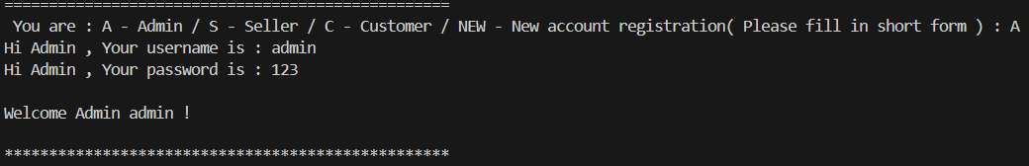

2.2 Seller Login

def seller_login() :
global p_name
login_name = str(input("Hi Seller , Your username is : "))
if login_name in seller_name :
location = find(seller_name,login_name)
login_pw = str(input("Hi Seller , Your password is : "))
if seller_name[location] == login_name and seller_pw[location] == login_pw : # check if the account matches with the password
print("")
print("Welcome Seller {} !".format(login_name))
p_name = login_name
return True
else :
print("Your password is NOT correct , please try again")
else :
print("Username does NOT exist , please try again")
return False

The login name is inputted by the user. If the input of the users is in the list of seller login name, password is needed for the user to input to log in. If both are correct, the login is successfully for the seller.
If the password is not correct or the username does not exist, the user has to re-enter the username and the password again

OUTPUT of seller login:
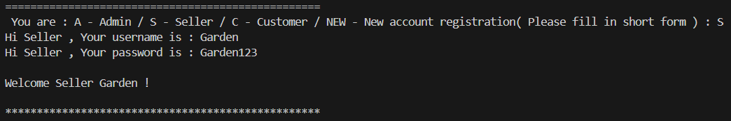

1.3 Customer login

def customer_login() :
global p_bday
global p_name
login_name = str(input("Hi Customer , Your username is : "))
if login_name in customer_name :
location = find(customer_name,login_name)
login_pw = str(input("Hi Customer , Your password is : "))
if customer_name[location] == login_name and customer_pw[location] == login_pw : # check if the account matches with the password
print("")
print("Welcome Customer {} !".format(login_name))
p_name = login_name
p_bday = customer_bday[location]
return True
else :
print("Your password is NOT correct , please try again")
else :
print("Username does NOT exist , please try again")
return False

The login name is inputted by the user. If the input of the users is in the list of customer login names, password is needed for the user to input to log in. If both are correct, the login is successful for the customer
If the password is not correct or the username does not exist, the user has to re-enter the username and the password again

OUTPUT of customer login:
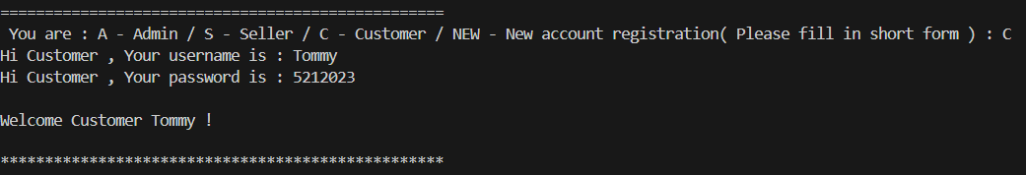

  - New user login

1.4.1 - registration
Two different identities / roles, seller and customer, can be registered (admin cannot be registered as it involves permission of viewing sensitive information)
If the input name is unique (not in the seller or customer name list respectively), the password needs to be created by the users , which certain rules have to be followed . For the customer, a birthday must be input for a potential discount and the most important thing is to confirm the customer can legally purchase alcohol, as the customer under 18 years of age cannot buy alcohol.

###### New user and PW verification ######
def new_user() :
new_role = str(input("Register : S-Seller / C-Customer : "))
if new_role == "S" : # Create new seller
new_name = str(input("Your name is : "))
if new_name not in seller_name : # check if the new name does not repeat
seller_name.append(new_name)
else :
print("Your name has been used , try again !")
return False
new_pw = str(input("Your password is : "))
while pw_check(new_pw) is False : # data validation
new_pw = str(input("Your password is : "))
seller_pw.append(new_pw)
return True
elif new_role == "C" :
new_name = str(input("Your name is : "))
if new_name not in customer_name :
customer_name.append(new_name)
else :
print("Your name has been used , try again !")
return False
new_pw = str(input("Your password is : "))
while pw_check(new_pw) is False :
new_pw = str(input("Your password is : "))
customer_pw.append(new_pw)
print("Please fill in your birthday for more discount and goods available") # only 18+ can buy alcohol
bday = date_input()
while bday >= datetime.datetime.now() :
print("The birthday must before today")
bday = date_input()
customer_bday.append(bday)
return True
else :
print("Please fill in S / C !")
new_user()

The date of the customer should be input by the function date input
Module datetime is used in this function for the use of type “datetime”
If the input of the user is not an integer, the customer must re-enter an integer input (Error handling). This function is also used in date input for other use like delivery date entry ( will be mentioned in following sections ).

def date_input() :
try :
x,y,z= input("Enter the date (YYYY/MM/DD) :").split("/")
new_date = datetime.datetime(int(x),int(y),int(z))
return new_date
except ValueError: # error handling
print("RANGE of Date must between 1/1/1 to 9999/12/31 and The inputs must be INTEGER")
#return False
return(date_input())

*Output of this function will be showed in the output of new user registration .

1.4.2 Password entry

Validation: The password should follow the following rules:
- Not shorter than 8 characters
- Not longer than 20 characters
- At least have 1 capital letter
- At least have 1 number
- No space in the password

If any rules are against, the re-entry of the password by the user is needed until the input is valid.
Verification: The user must input the password twice to confirm the password, to prevent mis-input by the user. The user has to retry the password until the password be the same as the previous password .
def pw_check(pw) :
if len(pw) <8:
print("Your password must be at least 8 characters long !")
return False
if len(pw) >20 :
print("Your password must not exceed 20 characters ! ")
return False
if any(char.isupper() for char in pw) :
pass
else :
print("There should be at least one capital letter")
return False
if any(char.isdigit() for char in pw) :
pass
else :
print("There should be at least one number")
return False
if pw.count(' ') > 0 :
print("No spaces are allowed")
return False
pw_double_check = str(input("Please input the password again :")) # data verification by entering the data twice
while pw_double_check != pw :
print("The second password is NOT the same with the first one")
pw_double_check = str(input("Please input the password again : "))
return True

OUTPUT of new user registration and password entry:

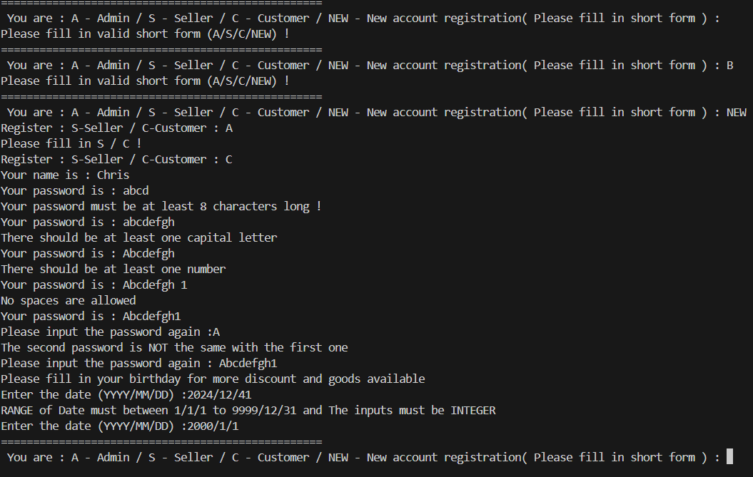

Chapter 2
View Goods

2.0 Main loop:

###### Main Loop ######
if __name__ == "__main__" :
login()
while flag_bit :
menu()
menu_control(permission_stat)

This is the main loop of the whole program, where users must log in
The menu displays the available command for the user under his permission, while menu control allows users to use commands to show or change the data (further explanation are presented in this report) and the flag bit indicates the start/end of the whole program.

2.1 Main Menu :

###### Main Menu ######
def menu() : # showing the commands available for different roles
time.sleep(1.5)
print("")
for i in range(50) : print("*" , end="")
print("\nWelcome to the Control Menu , {} \nEnjoy your time in our supermarket ! \n"
#"Here are the Commands for our online market : \n"
"\n------GENERAL------\n"
"V - View the available goods in our market \n"
"SN - Sort the goods by Name \n"
"SP - Sort the goods by Price \n"
"SID - Sort the goods by the ID\n"
"S - Search for specific goods by name\n"
"SWID - Search for specific goods with the goods ID\n"
"F - Filter the goods with unwanted brand".format(p_name))
if permission_stat == 3 or permission_stat == 2 :
# seller can add , modify , delete their OWN goods while admin can do without limitation
print("\n------GOODS MANAGEMENT------\n"
"A - Add goods of YOUR brand \n"
"M - Modify the status of goods by YOUR brand \n"
"D - Delete the goods by YOUR brand")
if permission_stat == 3 : # admin can view the backstage data of purchases
print("\n------DATA VISUALIZATION------\n"
"T - Show the Total Sales of all the goods\n"
"TQ - Show the Top quantity sold Good\n"
"TS - Show the Top Sales Good\n"
"TC - Show the Company with the most cases sold\n")
elif permission_stat == 1 : # customer can use shopping cart to buy goods
print("\n------SHOPPING CART------\n"
"VC - View your shopping Cart \n"
"AC - Add goods to your shopping Cart \n"
"EC - Edit your shopping Cart\n"
"DC - Delete the good in your shopping cart\n"
"CO - Check Out of your shopping cart")
print("\n------ACCOUNT------\n"
"LO - Log out of this account\n"
"QUIT - Quit this application\n")

The goods can be viewed in different ways , which users can show different data of goods in different ways by different commends . permission_stat is used to store the permission of different users ( 1 – Customer , 2 – Seller , 3 – Admin ) ,
Customer can view their shopping cart and check out but the other two identities cannot
Seller can edit their own goods data while customer cannot.
Admin can edit all the goods data without limitation and view the statistical data while the other two cannot.
Only the user with permission to use the command can see the command.
By typing the commend short form respectively, different commands can be executed to view different data. Only the commands shown can be executed as the commands without permission to execute will NOT be shown .

OUTPUT of Menu:

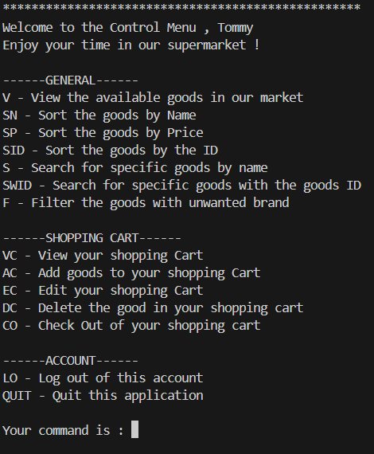

*Situation: The menu for the customer

2.2 Data visualization

2.2.0 View

def menu_control(access) :
global permission_stat
global flag_bit
global p_name
control = str(input("Your command is : "))

if control in ["V","SN","SP","SID","S","SWID","F"] :
sorting_show(control)

The command is typed in the menu hence the different ways of showing the data can be used. Command “V” is used to show the raw form of the data of goods

###### Viewing data in format ######
def view(data) : # output the formatted table-form of data of goods
for i in range(91) : print("-" , end="")
print("")
for row in data :
print('| {:>40} | {:>3} | {:>12} | {:>10} | {:>10} | '.format(row[0],row[1],row[2],row[3],row[4]))
for i in range(91) : print("-" , end="")
for i in range(2) : print("")

The 2D array of the goods data can be presented formatted by the view function
The data (parameter), a 2D array , should be input and a formatted table will be outputted .
The view function will be frequently used in the display of 2D array like goods data, shopping cart.

The output of VIEW:

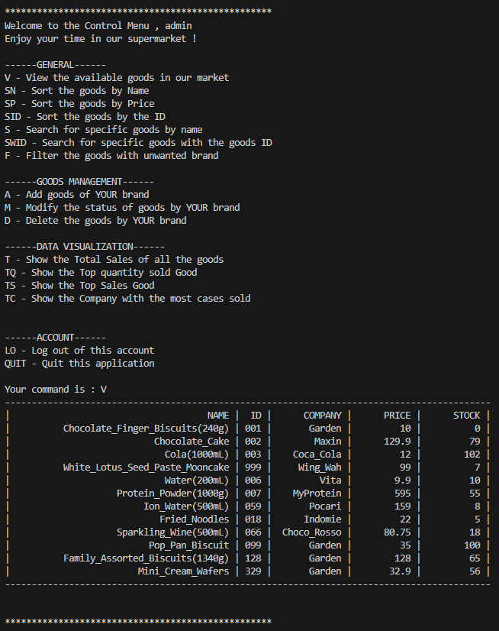

2.2.1 Sort by Name

###### Sorting with 2d array ######
def selection_sort(raw_list,index,start) : #find the smallest item and switch
for i in range(start,len(raw_list)-1) :
pos = i
for j in range(i+1,len(raw_list)) :
if raw_list[j][index] < raw_list[pos][index] :
pos = j
raw_list[i],raw_list[pos] = raw_list[pos],raw_list[i]

The data of goods is input to the selection sort function as the raw_list (parameter), and the index marks the NAME column in the file of goods_data , in this case is 1. The start parameter is 1, stating the first row of the file of goods_data should not be sorted, which is the row of heading
The Selection sort algorithm finds the smallest element and swaps it with the first element, getting the smallest element at its correct position. Then the smallest among remaining elements is to move it to its correct position by swapping. This process will be repeated until all the elements in this list in sorted.

OUTPUT of SN:

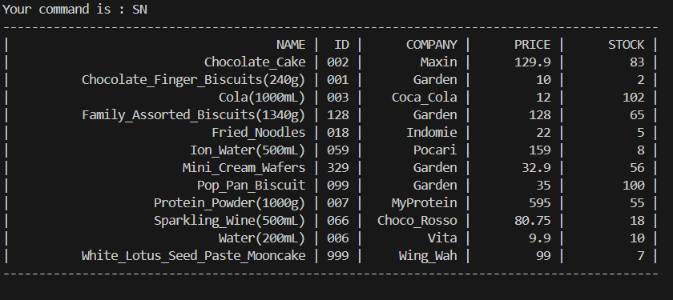

2.2.2 Sort by Price

def bubble_sort(raw_list,index,start) : #switch the nearby items
for i in range(start,len(raw_list)) :
current_pos = i
while current_pos >= start and float(raw_list[current_pos][index]) < float(raw_list[current_pos-1][index]) :
raw_list[current_pos] , raw_list[current_pos-1] = raw_list[current_pos-1] , raw_list[current_pos]
current_pos -=1

The data of goods is input to the bubble sort function as the raw_list parameter, and the index marks the PRICE column in the file of goods_data , in this case is 3. The start parameter is 2, stating the first row of the file of goods_data should not be sorted , which is the row of heading
The bubble sort works by comparing the item with the next item, if the next item is smaller than the item, they swap their position. Hence the largest item will sort to the last position. The process repeats until all the items are sorted

OUTPUT of SP:

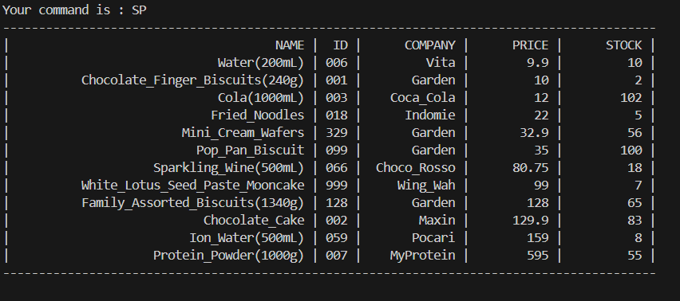

2.1.3 Sort by SID

def insertion_sort(raw_list,index,start) : #pull the item back until find a correct place
for i in range(start,len(raw_list)) :
store2d = raw_list[i]
store = raw_list[i][index]
next = i-1
while next >= 0 and raw_list[next][index] > store :
raw_list[next+1] = raw_list[next]
next -=1
raw_list[next+1] = store2d

The data of goods is input to the insertion sort function as the raw_list parameter, and the index marks the SID column in the file of goods_data, in this case is 1. The start parameter is 2, stating the first row of the file of goods_data should not be sorted, which is the row of heading
The insertion sort works by comparing the second element with the first element and checking if the second element is smaller than the first element, if so, swap them. Repeat the process for the second element and the third element, and so on. The sorting will be done.

OUTPUT of SID:

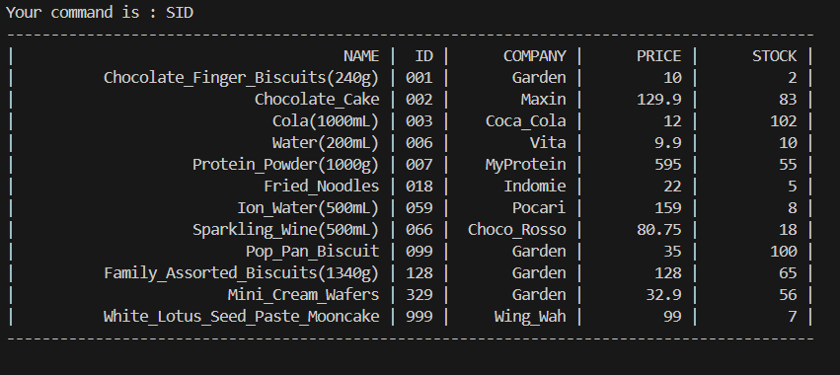

2.1.4 Searching

def searching(raw_list,index,item) :
new_list = []
new_list.append(raw_list[0])
for row in raw_list :
if item in row[index] and row != raw_list[0]: # if the searching keyword is in the searching item
new_list.append(row) # add the result to the new list
return new_list

The function “S” and “SID” using the search function
It works by first creating an empty list. Looping through the raw_list (parameter), a 2D array, and finding the item in the specific position is the same with the desired item(parameter), if so, add the whole item into the new_list and return to show. In the case of S and SID, the index will be 0 and 1, stand for the NAME and the ID in this case respectively.

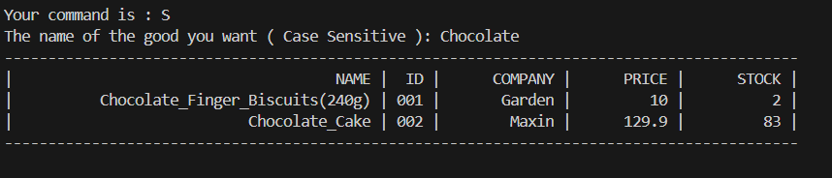
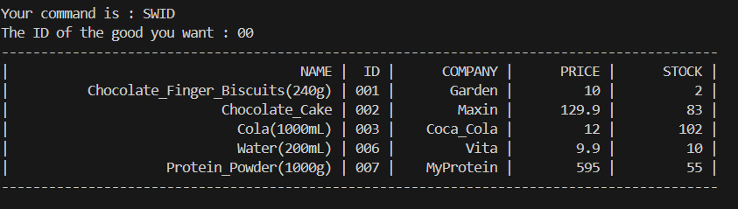


Chapter 3
Filtering

elif way == "F" :
new_list = goods
print("Lets find out your desired good !")
# price checking
print("Price :")
direction1 = str(input("ABOVE or BELOW than or No need(A/B/N):"))
if direction1 not in ["A","B","N"] : # check if the input is valid for price checking
print("ERROR : Fill in A or B or N only ")
return False
if direction1 == "N" :
pass
else :
try :
num = float(input("The price desired :"))
new_list = compare(new_list,(filtering(goods,3,num,direction1))) # filter out the items not in the desired price range
except ValueError :
print("ERROR : Number and decimals only") # verification
return False
# stock checking
print("Stock :")
direction2 = str(input("ABOVE or BELOW than or No need(A/B/N):")) # check if the input is valid for stock checking
if direction2 not in ["A","B","N"] : # check if the input is valid
print("ERROR : Fill in A or B or N only ")
return False
if direction2 == "N" :
pass
else :
try :
num = float(input("The stock desired is :"))
new_list = compare(new_list,(filtering(goods,4,num,direction2)))
except ValueError :
print("ERROR : Number and decimals only")
return False
avoid = str(input("The company you want to display is (N - No need):")) # find the desired company if needed
if avoid == "N" :
view(new_list)
return None
new_list = compare(new_list,filtering(goods,2,avoid))
view(new_list) # view the new list if no company is required
return None
view(goods)

def compare(raw_list1,raw_list2) : #find the repeated items in the first list
new_list = []
for pos1,item1 in enumerate(raw_list1) :
for pos2,item2 in enumerate(raw_list2) :
if item1[1] == item2[1] : # check if the item in the first list is in the second list
new_list.append(item1)
return new_list

def filtering(raw_list,index,item,d="A") : # default is finding the value above the given item
new_list = []
new_list.append(raw_list[0])
if index in [3,4] :
for row in raw_list :
if row != raw_list[0] :
if d == "A" and item <= float(row[index]) and row != raw_list[0]: # finding the result and add it to the list
new_list.append(row)
elif d == "B" and item >= float(row[index]) and row != raw_list[0]:
new_list.append(row)
else :
for row in raw_list :
if item == row[index] and row != raw_list[0]: # if the company is in the searching item
new_list.append(row)
return new_list

The filtering will have 3 criteria : Filter of Price, Stock, Company
Each of them can choose filter or not to filter it. i.e. it is a independent process , you can choose either 1 or 2 or all 3 criteria to filter.
Error handling is used in this case when the user does not input a float or an integer (for example string), Error message will pop, and the user must redo the whole filtering process. The filtering function is used to find the desired output of each filtering criteria (i.e. will do three times at most) and the compare function is used to compare the result to the main list and only left the items that satisfy the filtering

Illustration of the filtering process

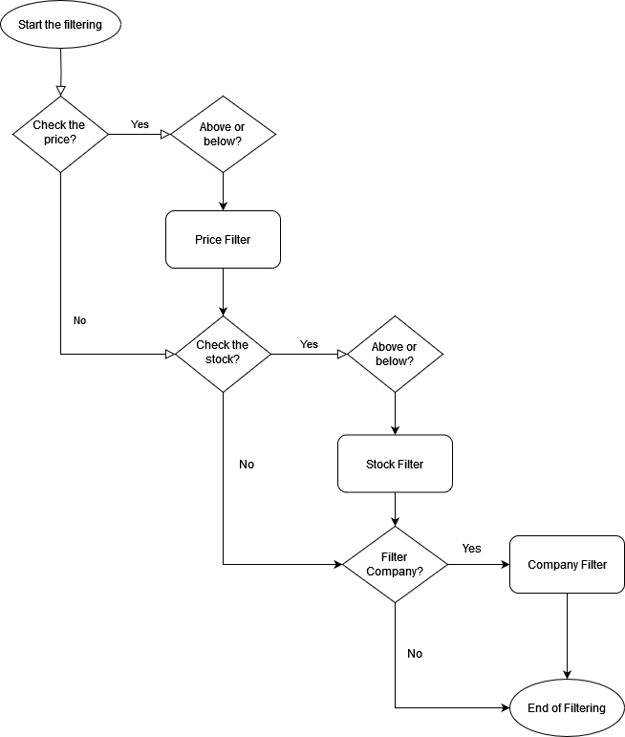

OUTPUT of filtering:

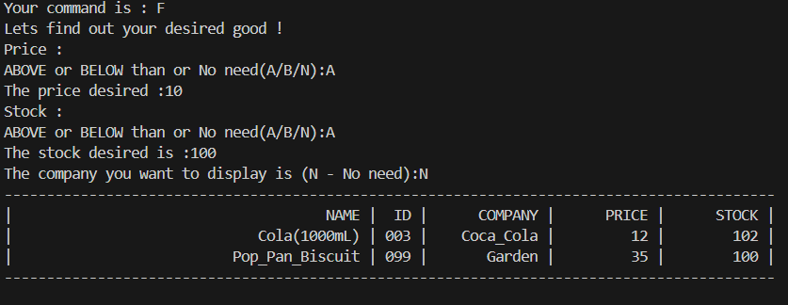

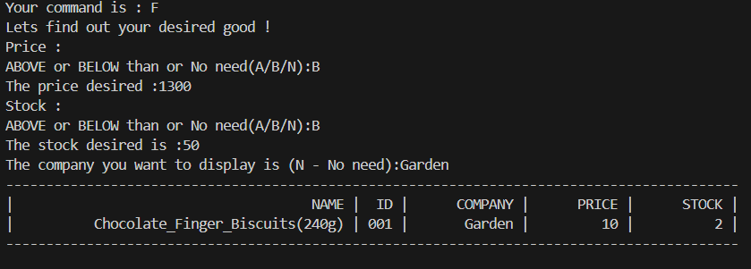

Chapter 4
Manipulation of Goods Data

4.1 Add goods
Only seller and admin can add the goods to the goods data, but not customer, by permission check function. The seller can only add goods with their company’s name while the admin can add goods with any company name without limitation.

NAME, ID, PRICE, STOCK of the goods are needed to fill in to add a good to the file of goods data (COMPANY is needed only by admin) If the inputs are less than 4, meaning the missing of at least 1 item, will have quit to the main menu and re-enter the whole inputs of 4(Error handling). Verifications are also required as the ID must be unique. Also, the number of stock and price should not be less than 0. A age check will be needed for the alcoholic goods, which ID of that goods will be added to the list of age checking.

def menu_control(access) :
global permission_stat
global flag_bit
global p_name
control = str(input("Your command is : "))

if control in ["V","SN","SP","SID","S","SWID","F"] :
sorting_show(control)

elif control == "A" :
if permission_check(permission_stat,2) : # if the user is seller
while add_goods(permission_stat,p_name) == False : # use the log in name as the company name to add goods
pass
elif permission_check(permission_stat,3) :
add_name = str(input("The name of company of the adding good :")) # admin can choose the name of company by itself
while add_goods(permission_stat,add_name) == False : # use the log in name as the company name to add goods
pass
else :
print("Access Denied : Admin and Seller ONLY")

###### Change in Goods ######
def add_goods(p,c) : # write the new data to the csv file with the company name filled
try :
n,id,p,s = str(input("Please input the NAME , ID , PRICE , STOCK of the goods\n" # input new data
"*Separate by SPACE* e.g.Banana 001 10 1 :")).split(" ")
except ValueError : # error handling
print("ERROR : Please fill in all 4 inputs with space separated")
print("//////////////////////////")
return False
with open(goods_data,"r+", newline='', encoding='utf-8') as goods_info :
goods = list(csv.reader(goods_info))
for x in range(1,len(goods)) :
if id == goods[x][1] :
print("ERROR : The ID of the good should be UNIQUE ") # search if any repeat of ID
print("//////////////////////////")
return False
if float(p) <=0 or float(s) <=0 :
print("The price or stock must NOT less than 0")
return False
while age_limit(id) == False :
pass
add([n,id,c,p,s])
print("Command ADD has successfully executed")
return True

def age_limit(id) : # check if the products requires 18 yrs old or above to purchase
age_limit = str(input("Does your product has AGE LIMITATION\n"
"(Under the law of Hong Kong, intoxicating liquor must not be sold or supplied to a minor in the course of business.) (Y/N) :"))
if age_limit == "Y" or age_limit == "N" :
if age_limit == "Y" :
age_required.append(id) # add in the list of goods id which requires age verification while purchasing
return True
else :
print("Please fill in either Y/N ")
return False

OUTPUT of add_goods:

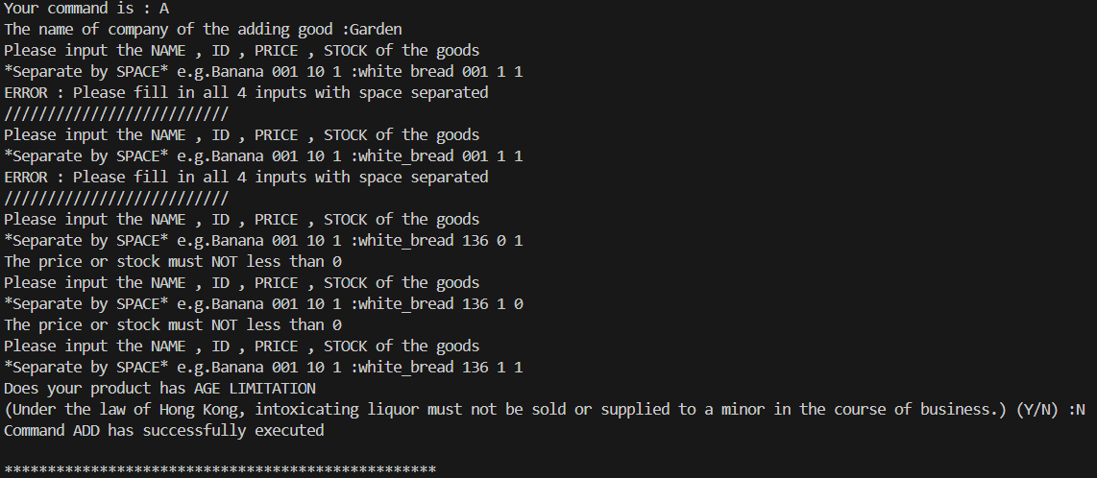
Before adding goods in file of goods information:

NAME,ID,COMPANY,PRICE,STOCK
Chocolate_Finger_Biscuits(240g),001,Garden,10,0
Chocolate_Cake,002,Maxin,129.9,79
Cola(1000mL),003,Coca_Cola,12,102
White_Lotus_Seed_Paste_Mooncake,999,Wing_Wah,99,7
Water(200mL),006,Vita,9.9,10
Protein_Powder(1000g),007,MyProtein,595,55
Ion_Water(500mL),059,Pocari,159,8
Fried_Noodles,018,Indomie,22,5
Sparkling_Wine(500mL),066,Choco_Rosso,80.75,18
Pop_Pan_Biscuit,099,Garden,35,100
Family_Assorted_Biscuits(1340g),128,Garden,128,65
Mini_Cream_Wafers,329,Garden,32.9,56

After adding goods in file of goods information:

NAME,ID,COMPANY,PRICE,STOCK
Chocolate_Finger_Biscuits(240g),001,Garden,10,0
Chocolate_Cake,002,Maxin,129.9,79
Cola(1000mL),003,Coca_Cola,12,102
White_Lotus_Seed_Paste_Mooncake,999,Wing_Wah,99,7
Water(200mL),006,Vita,9.9,10
Protein_Powder(1000g),007,MyProtein,595,55
Ion_Water(500mL),059,Pocari,159,8
Fried_Noodles,018,Indomie,22,5
Sparkling_Wine(500mL),066,Choco_Rosso,80.75,18
Pop_Pan_Biscuit,099,Garden,35,100
Family_Assorted_Biscuits(1340g),128,Garden,128,65
Mini_Cream_Wafers,329,Garden,32.9,56
white_bread,136,Garden,1,1

A new record has been added in the goods information and the table of viewing the goods will be updated and will be shown by the view function

4.2 Modify goods

elif control == "M" :
if permission_check(permission_stat,2) or permission_check(permission_stat,3): # only admin and seller can modify goods
change = str(input("The change of the good is (NAME/COMPANY/PRICE/STOCK) :"))
if change == "COMPANY" and permission_check(permission_stat,2) :
print("Seller can NOT change the company of goods")
return False
input_dicts = {"NAME":0,"COMPANY":2,"PRICE":3,"STOCK":4}
if change in input_dicts :
id = str(input("The ID of the good is :"))
new_value = str(input("The new value of the good is :"))
modify(p_name,id,input_dicts[change],new_value)
print("Command MODIFY has successfully executed")
# The ID should NOT be change by anyone , even for admin
#elif change == 1 :
# print("The ID of the good is NOT allowed to Change")
else :
print("INVALID input , please try again")
else :
print("Access Denied : Admin and Seller ONLY")
*This is a part in the menu function for modification of goods

def modify(company,id,new_pos,new_variable) : # changing the data of goods by overwriting the original data of the goods
finding = False
with open(goods_data, newline='', encoding='utf-8') as f:
r = csv.reader(f) #read the original data
lines = list(r) #change the raw data into lists for better indexation
for pos,row in enumerate(lines) :
if pos != 0 and (row[2] == company or permission_check(permission_stat,3)) and row[1] == id :
# if the ID belongs to the company that logged in # Admin can edit without limitation
new_pos_dict = {4:0,3:1}
try :
if (new_pos == 4 or new_pos == 3) :
if float(new_variable) >= new_pos_dict[new_pos] : # the price must be larger than 1 and stock must be larger than 0
pass
else :
print("ERROR : the Price must be larger than 1 and Stock must be larger than 0")
return False
except ValueError :
print("ERROR : Your input must be a integer or decimals")
return False
lines[pos][new_pos] = new_variable # Change the data
finding = True # end the finding process
return True
if not finding :
print("ERROR : The ID does NOT BELONG to YOUR Company or the ID does NOT EXIST")
return False
writeData(lines)

def writeData(lines) :
with open(goods_data,"w", newline='', encoding='utf-8') as goods_info :
writer = csv.writer(goods_info) # overwrite the data into the file by replacing old data and writing new data
writer.writerows(lines)

The modify function is only available to seller and admin, which sellers can only change the goods that belong to their company while admin has no limitation. After the opening of the goods_data file and store data into the lines(variable), if the ID input can be found in the goods_data , the PRICE , NAME ,COMPANY the STOCK can be changed ( ID is not allowed to change in order to keep the consistency of data) , the input for PRICE and STOCK must be larger than 1. The data of that good in lines is changed, and then writeData function rewrite the whole goods_data file with the data stored in lines for modification of the data.

OUTPUT of modify:

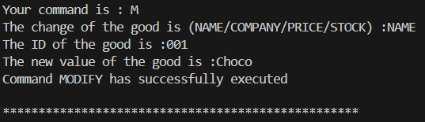
Before the modification :
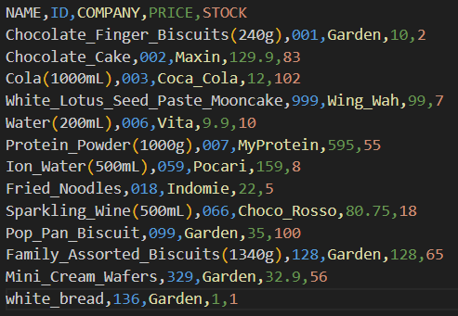

After the modification:

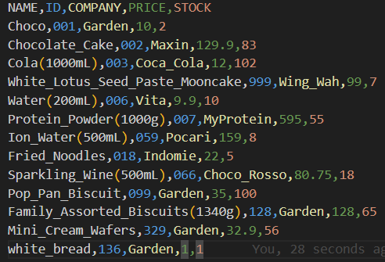

4.3 Delete of goods :

elif control == "D" :
if permission_check(permission_stat,2) or permission_check(permission_stat,3): # only admin and seller can delete goods
delete_id = str(input("The ID of the good you want to delete is :"))
delete(p_name,delete_id)
else :
print("Access Denied : Admin and Seller ONLY")
*This is a part in the menu function for delete of goods

def delete(company,id) :
finding = False
with open(goods_data,"r", newline='', encoding='utf-8') as f:
r = csv.reader(f) #read the original data
lines = list(r) #change the raw data into lists for better indexation
for pos,row in enumerate(lines) :
if pos != 0 and (row[2] == company or permission_check(permission_stat,3)) and row[1] == id :
# seller can only delete their OWN goods while admin can delete ALL goods
lines.remove(row)
finding = True
if not finding :
print("The ID does NOT BELONG to YOUR Company or the ID does NOT EXIST")
return False
writeData(lines)
print("Command DELETE has successfully executed")

The delete function is only available to seller and admin, which sellers can only delete the goods that belong to their company while admin has no limitation. After the opening of the goods_data file and store data into the lines(variable), if the ID input can be found in the goods_data , the good of that ID is delete in the data of lines. AS the data of that good in lines is changed, writeData function rewrite the whole goods_data file with the data stored in lines for deleting of the data.

Output of delete :
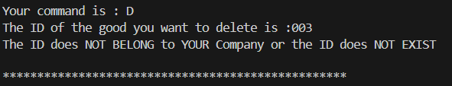
* Situation: The company cannot delete the goods belonging to other companies

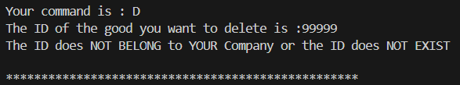
* Situation: The goods cannot be deleted if the good does not exist

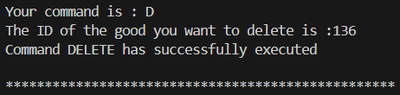
*Successful delete

Before delete :


After delete :
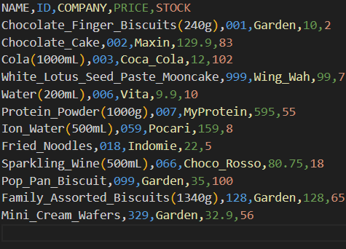

The line of data has been deleted in the file storing goods data and will not be shown by the view function anymore .

Chapter 5
Shopping cart

Shopping cart can only be used by the customer , but not seller or admin .
Shopping cart shows the NAME,ID,PRICE,Quantity,Total cost of the goods , the total cost is calculated by the price multiplied by the quantity, customer can go check out after adding item into the shopping cart

5.1 – Add cart

elif control == "AC" :
if permission_check(permission_stat,1) : # only customer can use the shopping cart function
try :
c_id = input("The ID of the goods :")
c_q = int(input("The quantity of the goods :"))
except ValueError :
print("Your input must be a integer") # error handling
return False
add_cart(c_id,c_q)
else :
print("Access Denied : Customer ONLY")
return False

*This is a part in the menu function for add cart

Customer needs to input the ID and the desired quantity. Error handling for invalid input here.

###### Change in Shopping Cart ######
def add_cart(id,quantity) :
global shopping_cart
finding = False
for item in shopping_cart :
if item[1] == id :
print("ERROR : Good already exists in the shopping cart\n"
"Please use the Edit Cart function to edit")
return False
with open(goods_data,"r+", newline='', encoding='utf-8') as goods_info :
goods = list(csv.reader(goods_info))
for x in range(1,len(goods)) :
if id == goods[x][1] :
if id in age_required :
if age_check(p_bday) : # check if the goods has age restriction
pass
else :
return False
if int(goods[x][4]) >= quantity > 0: # check if the stock is sufficient for purchase
shopping_cart.append([goods[x][0],goods[x][1],goods[x][3],quantity,(float(goods[x][3])*float(quantity))])
finding = True
print("Command ADD CART has successfully executed")
return True
else :
print("ERROR : Insufficient goods for purchase or Invalid amount of purchase")
return False
if finding == False :
print("ERROR : ID do NOT exists")
return False

def age_check(date) :
today = datetime.datetime.today()
age = today-date
if age.days >= 6570 : # Check if the user is above 18 yrs old
return True
print("Your age is under 18 \n"
"Under the law of Hong Kong, intoxicating liquor must not be sold or supplied to a minor in the course of business.\n"
"We can NOT sell this goods to you")
return False

Shopping cart is a 2D array which stores the heading at first. Customer has to input a ID and a quantity to purchase. The add_cart function can only be used for the goods that are not in the shopping cart yet, if the customer wants to add quantity of the goods that are already in the shopping cart, modify_cart function should be used. After opening of the goods_data file, the data of the desired good with given ID will be found (if it exists) and the age_check function checks the customer is above 18 years old if the good has age limitation, an ERROR message will be given if the customer does not satisfy that. If the stock of that good is more than the quantity needed ( Error handling )

OUTPUT of add_cart:

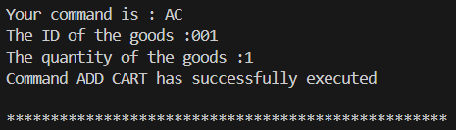

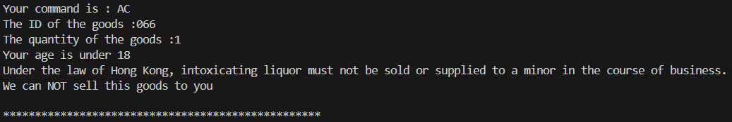
* Situation: Customer under the age of 18 cannot buy alcoholic goods

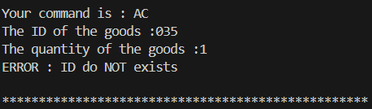
* Situation: The ID does not exist in the goods_data

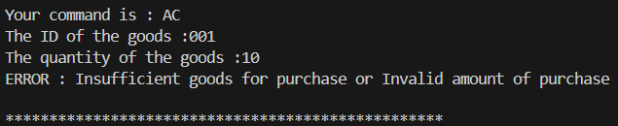
*Situation: The stock of the good “001” is not enough for the customer to purchase

5.2 View cart

elif control == "VC" :
if permission_check(permission_stat,1) : # only customer can use the shopping cart function
view(shopping_cart)
else :
print("Access Denied : Customer ONLY")
return False
*This is a part in the menu function for view cart

The shopping cart is viewed by the function view which is shown at the previous part of this report
Only customers can access the shopping cart but not the admin and seller

OUTPUT of view cart:

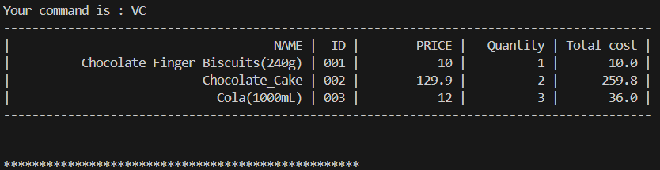
* Situation: The goods 001,002,003 are added to the shopping cart with quantity 1,2,3 respectively
And the shopping cart is viewed.

5.3 Delete cart

elif control == "DC" :
if permission_check(permission_stat,1) :
c_id = input("The ID of the goods :")
for pos in range(len(shopping_cart)) :
if shopping_cart[pos][1] == c_id :
shopping_cart.pop(pos)
print("Command DC has successfully executed")
return True
print("ERROR : ID not found in the shopping cart")
return False
else :
print("Access Denied : Customer ONLY")
return False
*This is a part in the menu function for delete cart

Only customers can access the shopping cart but not the admin and seller.
The ID of the good which is desired to be removed from the shopping cart must be input.
If that ID is found in the shopping cart, the good is removed from the shopping cart by pop()
If that ID is NOT found in the shopping cart, an Error message will be shown

OUTPUT of Delete cart :

Before delete :


*Situation: The goods 001,002,003 are added to the shopping cart with quantity 1,2,3 respectively
And the shopping cart is viewed.

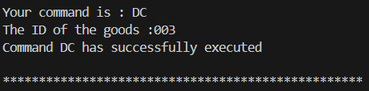
*The delete cart commend

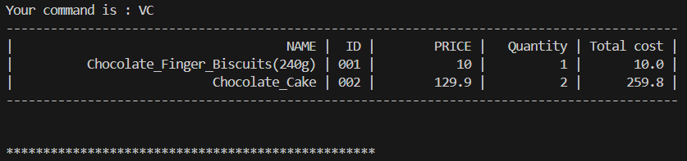
*Situation: The viewing of shopping cart after the delete cart commend is executed

Chapter 6
Check-out and collection of goods

Customer can check out after their satisficing shopping and plenty of goods are added to the shopping cart . The check out can choose two different methods, delivery or pickup, for collection of purchased goods.

6.0 Check out

elif control == "CO" :
global flag_bit
total = check_out()
if not total :
return False
print("The total amount will be ${} ".format(total))
CO_choice = str(input("Delivery and Pickup are available (D/P) :"))
if CO_choice == "P" :
view_pickup()
while not pickup_check() : # to confirm the location and time
pass
flag_bit = False
elif CO_choice == "D" :
address = str(input("Your address is :"))
delivery(address)
else :
print("Unknown input , please retry")
return False

###### Check out , pick up , payment ######
def check_out() :
total = 0
for pos,row in enumerate(shopping_cart) :
if pos != 0 :
total += float(shopping_cart[pos][4]) # find the sum of all the goods
if total == 0 :
print("ERROR : There should be at least 1 good to check out for") # there must be something for check out
return False
return float("{:.2f}".format(total))

The flag_bit indicated the end of the whole program when it changes to False.
The sum of all the goods is calculated in the check_out function (excluding the heading in the shopping list to avoid error) by adding all the amount of the total_cost of every goods in the shopping cart. Customers are not allowed to check out if there is nothing in the shopping cart.

OUTPUT of CO :

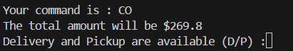

6.1 Delivery

def delivery(address) :
global flag_bit
delivery_date = date_input()
if delivery_date < datetime.datetime.now() : # the delivery date is before now
print("The date of delivery must not before the date of the ordering date")
return False
if delivery_date < datetime.datetime.now()+ datetime.timedelta(days=7) : # the delivery date is shorter than 7 days from now
print("The date of delivery must be 7 days after the ordering date\n")
return False
if delivery_date > datetime.datetime.now()+ datetime.timedelta(days=30) : # the delivery date is longer than 30 days from now
print("The delivery date should be within 30 days from the date of ordering")
return False
print("The delivery service available from 0900-1200 (AM) and 1400-1800(PM) ")
delivery_time = str(input("The time for delivery is (AM/PM) :"))
if delivery_time not in ["AM","PM"] :
print("Please fill in AM/PM")
return False
transaction()
print(f"The address for this delivery is {address} \n"
f"Your delivery will be arrived on {delivery_date.strftime('%Y-%m-%d')} at {delivery_time}")
flag_bit = False

In the delivery function, the customer has to first input their location. The date_input function (presented at the previous part of the report) is called for the user to input a date for the delivery. Datetime module is used to calculate the available range for the delivery (in between 7 days after the checkout and 30 days after the checkout , based on the real time of the checkout has been done) And verify the customer's input of date is in the range or not, if not, then an error message will be showed. If the input of date is valid, the customer can choose the time of delivery (AM or PM) . If the input of time of delivery is valid , the payment function will be called.

def payment(t_id) :
animation = ["■□□□□□□□□□","■■□□□□□□□□", "■■■□□□□□□□", "■■■■□□□□□□", "■■■■■□□□□□", "■■■■■■□□□□", "■■■■■■■□□□", "■■■■■■■■□□", "■■■■■■■■■□", "■■■■■■■■■■"]
# The simulation of payment
payment = str(input("Please enter ur credit card number :"))
v_code = str(input("Please enter ur safety code :"))
v_date = str(input("Please enter ur expire date :"))
for x in animation :
print(x)
time.sleep(random.randint(0,2)) # simulation real payment
print("Payment in process ... ")
time.sleep(3)
print("Payment succeed\n"
f"Your CODE for this purchase is {t_id} \n"
"Welcome for your next purchase !")

def transaction() :
t_id = str(uuid.uuid4())[:8] # an unique purchase code
for i in shopping_cart:
if i != shopping_cart[0] :
add_record(t_id,i[1],i[3],i[4])
payment(t_id)

Several information of the credit of the customer are needed to be input. An animation of the payment will be displayed for a demonstration of the payment process. Finally, a transaction ID will be created by the transaction function , in which uuid module is used for generating a 8- characters purchase code for the customer to act as a receipt ( it will be used in pickup , which will be explained in the later part) and the confirmation message of the delivery will be displayed to the customer for reference.

OUTPUT of the Delivery:

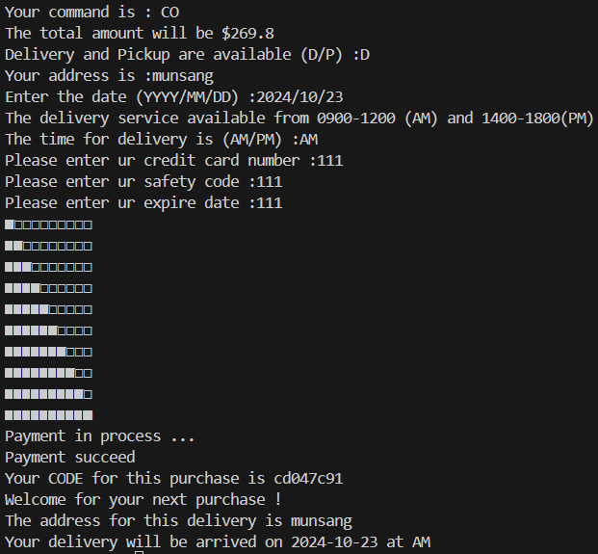

6.2 Pickup

def pickup_check() : # check the pickup location and time are available
with open(pickup_data,"r") as data :
times = list(csv.reader(data))
name = str(input("The name of the pickup store :"))
pickup_date = date_input()
if pickup_date < datetime.datetime.now() : # avoid the pickup date is before or in today
print("The date allocated must be the at least 1 day after the date of ordering")
return False
if pickup_date > datetime.datetime.now()+ datetime.timedelta(days=30) : # avoid the pickup date is after 30 days from now on
print("The pickup date should be within 30 days from the date of ordering")
return False
try :
h,min= input("Please input the time for the pickup\n"
"with hours and minutes in form (13:30):").split(":") # input the desire time
except ValueError :
print("Please fill in the data with format")
return False
for x in range(1,len(times)) :
if times[x][0] == name :
start = datetime.time(int(times[x][3][:2]), int(times[x][3][2:]), 0) # extracting the hour
end = datetime.time(int(times[x][4][:2]),int(times[x][4][2:]),0) # extracting the minute
need_time =datetime.time(int(h),int(min),0)
if start <= end or (start <= need_time or need_time <= end): # return if possible for pickup
transaction() # pay the money through online method
print(f"The pickup will be allocated at {need_time.strftime('%H:%M')} on {pickup_date.date()}\n"
"Please pickup your goods with code given on the booked time at the pickup store\n")
return True
else:
print("The store is NOT at service at that time , please try another time within the service hours")
return False
print("Store NOT found , please check the name of the available stores") # if the loop does not return , the store name is not found in the data
return False

def view_pickup() :
with open(pickup_data,"r", encoding='utf') as pickup_L : # read the location for pickup
p_L = list(csv.reader(pickup_L))
for i in range(84) : print("-" , end="")
print("")
for row in p_L :
print('| {:>20} | {:>30} | {:>8} | {:>5} | {:>5} | '.format(row[0],row[1],row[2],row[3],row[4]))
for i in range(84) : print("-" , end="")
for i in range(2) : print("")

The pickup locations / shops available for the customer to collect their goods will be shown by the view_pickup function, which opens the pickup_data file and present the 2D array in a formatted way. The pickup date will be input by the customer by the date_input function. The date should in the range of the day after the checking out and the 30 days after the day of checking out. The customer has to choose the location that they want to pickup at. The time of the pickup needs to be input and it should be within the opening hours of the shop, which will be shown by the view_pickup function. Transaction will be called afterwards to complete a time of purchase

OUTPUT of Pickup:

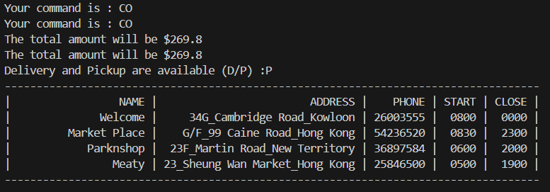
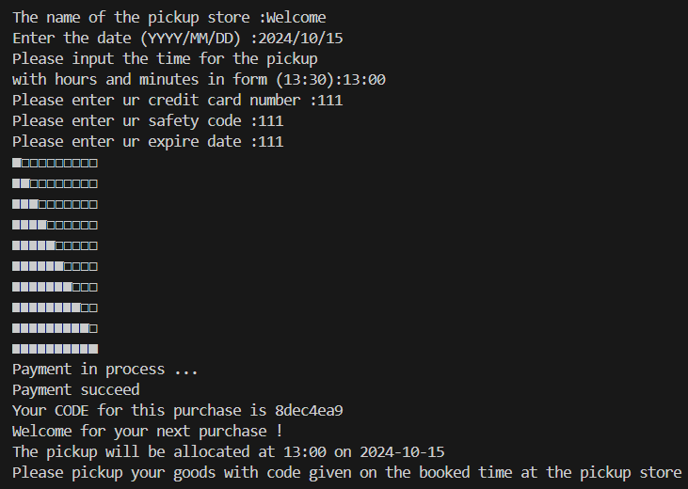

Chapter 7
Data visualization

7.0 Purchase records\

###### Data visualization ######
def add_record(TID,ID,Q,T) : # add a record in the purchase record for each good
with open(purchase_records,"a", newline='',encoding='utf-8') as p_records , open(goods_data,"r+", newline='',encoding='utf-8') as goods_info :
goods = list(csv.reader(goods_info))
for good in goods :
if good[1] == ID and good != goods[0]:
join_list = [TID,good[0],ID,good[3],Q,T,p_name,good[2],str(datetime.datetime.now().strftime("%Y-%m-%d %H:%M"))] # join the goods_info with the goods in shopping cart
writer = csv.writer(p_records)
writer.writerow(join_list)
modify(good[2],good[1],4,int(good[4])-int(Q)) # minus the quantity of the purchased goods in the goods_info

The function add_record will add the transaction record of each good and its information of each good in the shopping cart. The total sum and the quantity will be calculated and written in the file of purchase records. Also, the quantity available of the purchased goods will be reduced by the quantity sold, which will be changed in the file of goods data.

TID,NAME,ID,PRICE,QUANTITY,TOTAL,CUSTOMER,COMANY,TIME
c7830e7b,Chocolate_Finger_Biscuits(240g),001,10,1,10.0,Victor,Garden,2024-09-13 23:07
363787f9,Chocolate_Finger_Biscuits(240g),001,10,1,10.0,Tommy,Garden,2024-09-13 23:08
363787f9,Water(200mL),006,9.9,1,9.9,Tommy,Vita,2024-09-13 23:08
ac8607cb,Mini_Cream_Wafers,329,32.9,10,329.0,Tommy,Garden,2024-09-13 23:15
ac8607cb,Water(200mL),006,9.9,8,79.2,Tommy,Vita,2024-09-13 23:15

Each good in the shopping cart will be appended to the file of purchase record. The TID is a unique ID for each transaction. However, a TID may appear more than once when there are multiple goods in the shopping cart. TOTAL will be calculated based on the Price times Quantity of each goods, but not the total for each transaction.

7.1 Total sales

def total_sales() :
with open(purchase_records,"r", newline='',encoding='utf-8') as p_records :
records = list(csv.reader(p_records))
total_s = 0
for x in records :
if x != records[0] :
total_s += float(x[5])
return total_s

elif control == "T" :
if permission_check(permission_stat,3) :
print("The total sales of all the goods is {}".format(total_sales()))
else :
print("Access Denied : Admin ONLY")

*This is a part in menu() for showing total sales
The total sales will be calculated, summing up all the TOTAL of each transaction in the file of purchase records. Only admin can view the statistical data but not customer and seller .

OUTPUT of total sales:

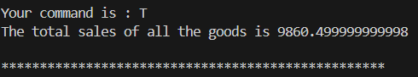

7.2 Total Quantity , Total Sales and Total case
elif control in ["TQ","TS","TC"]:
if permission_check(permission_stat,3) :
sales(control)
else :
print("Access Denied : Admin ONLY")
*This is a part in menu() for showing Total Quantity , Total Sales and Total case
def sales(t) :
with open(purchase_records,"r", newline='',encoding='utf-8') as p_records :
records = list(csv.reader(p_records))
sales_dict = {}
quantity_dict = {}
company_dict = {}
for row in records :
if row != records[0] :
sales_dict[row[1]] = 0
quantity_dict[row[1]] = 0
company_dict[row[7]] = 0
for row in records :
if row != records[0] :
sales_dict[row[1]] += float(row[5]) # sum up all the sales of each item
quantity_dict[row[1]] += int(row[4]) # sum up all the quantity sold of each item
company_dict[row[7]] += 1 # sum up all the transaction for each company
if t == "TS" :
for name , sale in sales_dict.items() :
print("The sales of {} is {:.2f}".format(name,sale)) # showing the sales data
time.sleep(2)
print("The top sales among all the goods is {} with {} dollars".format(max(sales_dict, key=sales_dict.get),sales_dict[max(sales_dict, key=sales_dict.get)]))
time.sleep(2)
if t == "TQ" :
for name , q in quantity_dict.items() :
print("The quantity sold of {} is {}".format(name,q)) # showing the quantity sold data
time.sleep(2)
print("The most sold good among all the goods is {} with {} pieces".format(max(quantity_dict, key=quantity_dict.get),quantity_dict[max(quantity_dict, key=quantity_dict.get)]))
time.sleep(2)
if t == "TC" :
for name , q in company_dict.items() :
print("The cases sold of {} is {}".format(name,q)) # showing the quantity sold data
time.sleep(2)
print("The most sale Company is {} with {} cases".format(max(company_dict, key=company_dict.get),company_dict[max(company_dict, key=company_dict.get)]))
time.sleep(2)

The TS function provides the sales of different goods according to the file of transaction records and sums up all the TOTAL according to the goods as the sales.
Top Sales will be calculated by comparison between all the sales of different goods and find the largest one.

The TC function provides the cases of different companies according to the file of transaction records and sums up all the number of transactions according to the company as the cases.
Most Sale will be calculated by comparison between all the cases of different companies and find the largest one.

The TQ function provides quantities of different goods according to the file of transaction records and sums up all the number of transactions according to the goods as the quantity.
Most Sold Good will be calculated by comparison between all the quantities of different goods and find the largest one.

A dictionary will be created to count the occurrence or required data (like total)of each record to calculate the statistical data

OUTPUT of TQ ,TC ,TS :

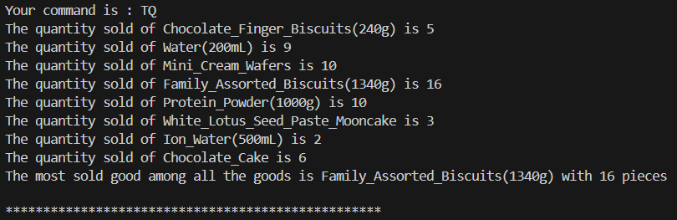
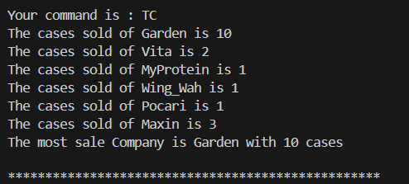

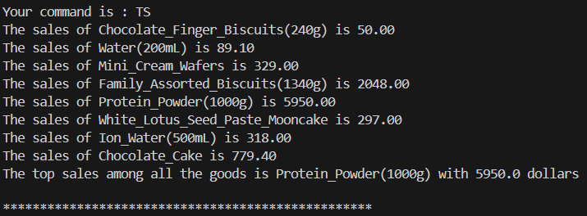

Chapter 8
Testing

Test input 1: The new price of the goods

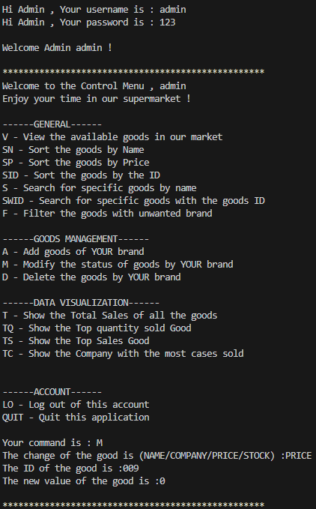

*The Output from the main program

*def modify(company,id,new_pos,new_variable) : # changing the data of goods by overwriting the original data of the goods
finding = False
with open(goods_data, newline='', encoding='utf-8') as f:
r = csv.reader(f) #read the original data
lines = list(r) #change the raw data into lists for better indexation
for pos,row in enumerate(lines) :
if pos != 0 and (row[2] == company or permission_check(permission_stat,3)) and row[1] == id :
# if the ID belongs to the company that logged in # Admin can edit without limitation
if (new_pos == 4 or new_pos == 3) :
if float(new_variable) >= 0 : # the price and stock must be larger than 0
pass
else :
print("ERROR : The price or stock must NOT less than 0")
return False
lines[pos][new_pos] = new_variable # Change the data
finding = True # end the finding process
if not finding :
print("ERROR : The ID does NOT BELONG to YOUR Company or the ID does NOT EXIST")
return False
writeData(lines)
*The code from the main program

NAME,ID,COMPANY,PRICE,STOCK
Chocolate_Finger_Biscuits(240g),001,Garden,10,10
Chocolate_Cake,002,Maxin,129.9,79
Cola(1000mL),003,Coca_Cola,12,102
White_Lotus_Seed_Paste_Mooncake,999,Wing_Wah,99,7
Water(200mL),006,Vita,9.9,10
Protein_Powder(1000g),007,MyProtein,595,55
Ion_Water(500mL),059,Pocari,159,8
Fried_Noodles,018,Indomie,22,5
Sparkling_Wine(500mL),066,Choco_Rosso,80.75,18
Pop_Pan_Biscuit,099,Garden,35,100
Family_Assorted_Biscuits(1340g),128,Garden,128,65
Mini_Cream_Wafers,329,Garden,32.9,56
White_bread,136,Garden,1,1
Papa_Pepper,009,Trash,0,0
*The updated goods data after the change of price

Details of testing:
The PRICE of the goods can be set to 0, which is not a good design as the users may wrongly input the price as 0, which might cause unwanted errors.
There may also be system errors caused by the price as zero under calculations of the statistical data (divided by 0 may happen, causing math errors)
A new dictionary containing the position of PRICE, STOCK (3,4) is created
The PRICE must be larger or equal to 1 while the STOCK must be larger or equal to zero

def modify(company,id,new_pos,new_variable) : # changing the data of goods by overwriting the original data of the goods
finding = False
with open(goods_data, newline='', encoding='utf-8') as f:
r = csv.reader(f) #read the original data
lines = list(r) #change the raw data into lists for better indexation
for pos,row in enumerate(lines) :
if pos != 0 and (row[2] == company or permission_check(permission_stat,3)) and row[1] == id :
# if the ID belongs to the company that logged in # Admin can edit without limitation
new_pos_dict = {4:0,3:1}
try :
if (new_pos == 4 or new_pos == 3) :
if float(new_variable) >= new_pos_dict[new_pos] : # the price must be larger than 1 and stock must be larger than 0
pass
else :
print("ERROR : the Price must be larger than 1 and Stock must be larger than 0")
return False
except ValueError :
print("ERROR : Your input must be a integer or decimals")
return False
lines[pos][new_pos] = new_variable # Change the data
finding = True # end the finding process
return True
if not finding :
print("ERROR : The ID does NOT BELONG to YOUR Company or the ID does NOT EXIST")
return False
writeData(lines)
*New main program after debugging

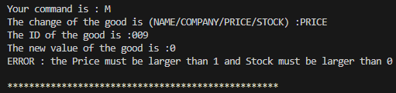
*New output after changing

Input Data (Price) | Expected Results | Actual Results
0 | Invalid (re-enter is required) | Invalid (re-enter is required)
1 | Valid | Valid
-1 | Invalid (re-enter is required) | Invalid (re-enter is required)
100.06 | Valid | Valid
A | Invalid (re-enter is required) | Invalid (re-enter is required)

The Output results of each test data:

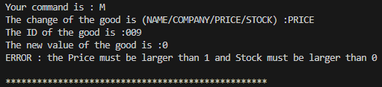
Input Data: 0

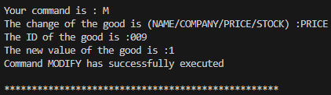
Input Data: 1

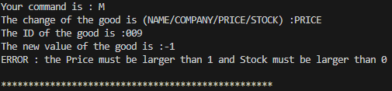
Input Data: -1

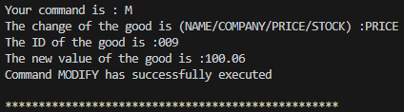
Input Data: 100.06

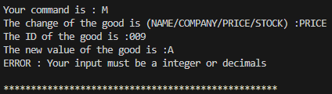
Input Data: A

Test input 2: The password input verification

Validation: The password should follow the following rules:
- Not shorter than 8 characters
- Not longer than 20 characters
- At least have 1 capital letter
- At least have 1 number
- No space in the password
Verification:
- The password input should be the same as the previous one
- The birthday should be in a correct format within the limit`

Input Data (Validation) | Expected Results | Actual Results
abcd | Display error message | Display error message
Abcdefgh123456789123456789 | Display error message | Display error message
abcdefgh | Display error message | Display error message
Abcdefgh | Display error message | Display error message
Abcdefgh 1 | Display error message | Display error message
Abcdefgh1 | Valid | Valid

Input Data (Verification) | Expected Results | Actual Results
A | Display error message | Display error message
Abcdefgh1 | Valid | Valid
2024/12/32 | Display error message | Display error message
2024/12/1 | Valid | Valid

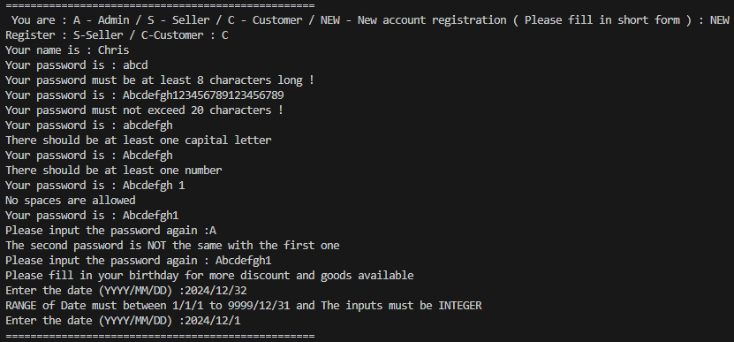

*Output of the program for the password and account registration

The actual results (output ) of the test data of both verification and validation remain the same with the expected results .
The verification and the validation are successfully implemented into the program without error outputs .

Test input 3 : Sorting algorithm

Sorting Method | Sort by | Expected result | Actual result
Selection sort | Name | Table of goods data sorted by Name | Table of goods data sorted by Name
Insertion sort | ID | Table of goods data sorted by ID | Table of goods data sorted by ID
Bubble sort | Price | Table of goods data sorted by Price | Table of goods data sorted by Price

The actual output of the sorting algorithm are the same with the expected results without displaying errors.
The sorting functions are successfully displayed in the program.

Output of the sorting algorithm

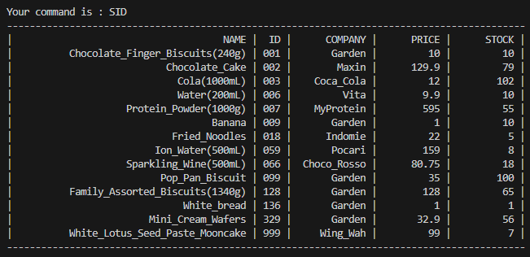

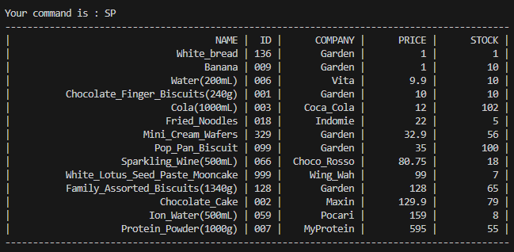

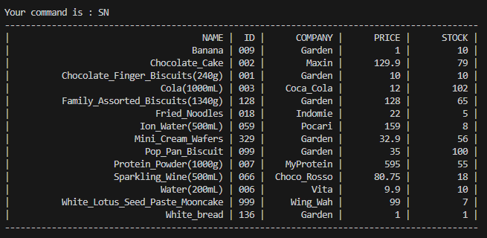

8.2 Unit Test
Commands in the program for all users

Command | Expected Results | Actual Results | Validity
V | Show table of goods data | Show table of goods data | Valid
S | Search goods by name | Search goods by name | Valid
SWID | Search goods by ID | Search goods by ID | Valid
F | Filter the table of goods data | Filter the table of goods data | Valid
A | Add new goods | Error | Invalid
M | Modify the goods | Modify the goods | Valid
D | Delete the goods | Delete the goods | Valid
T | Show total sales | Show total sales | Valid
TQ | Show top Quantity sold | Show top Quantity sold | Valid
TS | Show top sales goods | Show top sales goods | Valid
TC | Show company with the most sold goods | Show company with the most sold goods | Valid
VC | View shopping cart | View shopping cart | Valid
AC | Add goods to cart | Add goods to cart | Valid
EC | Edit cart | Edit cart | Valid
DC | Delete item in cart | Delete item in cart | Valid
CO | Check out | Error | Invalid

Chapter 9
Debugging

Invalid Output of command “A”
Error 1 : ValueError due to String input

def add_goods(p,c) : # write the new data to the csv file with the company name filled
try :
n,id,p,s = str(input("Please input the NAME , ID , PRICE , STOCK of the goods\n" # input new data
"*Separate by SPACE* e.g.Banana 001 10 1 :")).split(" ")
except ValueError : # error handling
print("ERROR : Please fill in all 4 inputs with space separated")
print("//////////////////////////")
return False
with open(goods_data,"r+", newline='', encoding='utf-8') as goods_info :
goods = list(csv.reader(goods_info))
for x in range(1,len(goods)) :
if id == goods[x][1] :
print("ERROR : The ID of the good should be UNIQUE ") # search if any repeat of ID
print("//////////////////////////")
return False
if float(p) <=0 or float(s) <=0 :
print("The price or stock must NOT less than 0")
return False
while age_limit(id) == False :
pass
add([n,id,c,p,s])
print("Command ADD has successfully executed")
return True
*Original main program

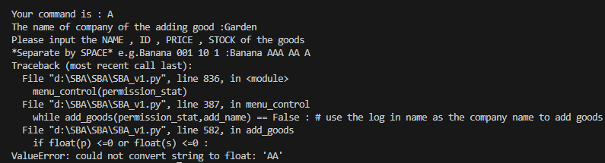
*Output of the code when error occurs

Details of error:
The program was designed to convert the user’s input integers or decimals for the price and stock of the desired goods to add and the float() function converts the users’ input into Float (a data type) for further calculation and data management.
However, if the users enter string (another data type), the float() function could not convert the string user input into the Float .
An Error Handling condition should be added to prevent the ValueError interrupting the running of the whole program. If the user inputs the string , an error message should be displayed and asks user to re-input the value for the good

def add_goods(p,c) : # write the new data to the csv file with the company name filled
try :
n,id,p,s = str(input("Please input the NAME , ID , PRICE , STOCK of the goods\n" # input new data
"*Separate by SPACE* e.g.Banana 001 10 1 :")).split(" ")
except ValueError : # error handling
print("ERROR : Please fill in all 4 inputs with space separated")
print("//////////////////////////")
return False
with open(goods_data,"r+", newline='', encoding='utf-8') as goods_info :
goods = list(csv.reader(goods_info))
for x in range(1,len(goods)) :
if id == goods[x][1] :
print("ERROR : The ID of the good should be UNIQUE ") # search if any repeat of ID
print("//////////////////////////")
return False
try :
if float(p) <=0 or float(s) <=0 :
print("The price or stock must NOT less than 0")
return False
except ValueError:
print("ERROR : Your input for the Price and Stock must be in Integers or Decimals")
print("//////////////////////////")
time.sleep(3)
return False
while age_limit(id) == False :
pass
add([n,id,c,p,s])
print("Command ADD has successfully executed")
return True

*The updated main program

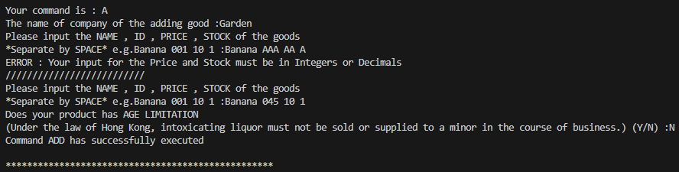
*The updated output

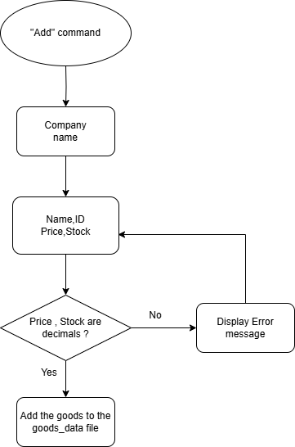

*The new flow of the Add command and its mechanism

Invalid output of command “CO”
Error 2 : Unable to return a new input

def date_input() :
try :
x,y,z= input("Enter the date (YYYY/MM/DD) :").split("/")
new_date = datetime.datetime(int(x),int(y),int(z))
return new_date
except ValueError: # error handling
print("RANGE of Date must between 1/1/1 to 9999/12/31 and The inputs must be INTEGER")
#return False
date_input() #return(date_input())

The code of date_input function

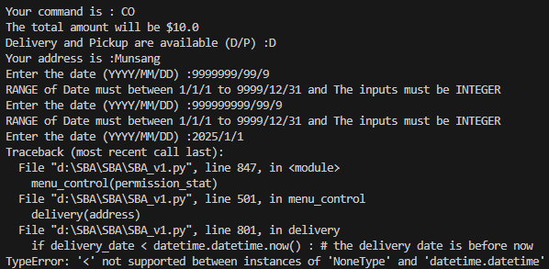
The displayed error message

Details of the error :
The function “data_input” was designed for user to input a date in a specific format ( i.e. separating day, month, year by / ) However , after multiple times of entering an invalid date , even though the user entered a right date , the function will still end up as an error message . This is due to the invalid return of the results.
The recall of the function date_input while having a value error requires user to enter a new date. But if the date entered is wrong again, user has to entered the 3rd date. However, the date entered at the 3rd time is not returning to the previous date_input function hence the return of the previous date_input function is “None”, causing the TypeError as a None type cannot be compared with the datetime type

A flow chart showing the original flow of the date_input function

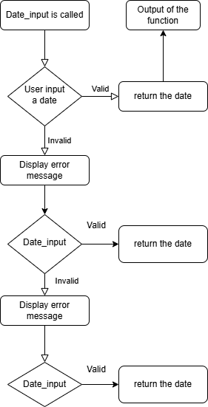

There is no relationship between the result returned by the 2nd and the 3rd date_input function. Hence the 1st and the 2nd date_input function returns None as no input can be returned .

def date_input() :
try :
x,y,z= input("Enter the date (YYYY/MM/DD) :").split("/")
new_date = datetime.datetime(int(x),int(y),int(z))
return new_date
except ValueError: # error handling
print("RANGE of Date must between 1/1/1 to 9999/12/31 and The inputs must be INTEGER")
#return False
return(date_input())
The updated code of date input

The new code adds a “return” before the calling of date_input function after the user failed to enter a right date at the 1st call of the function. The “return” allows the function to pass the result of the 3rd call of the function to the 2nd call of the function , which eventually to be returned to the 1st call of the function . Hence the correct date input by the user in the 3rd call can be returned to the function and to be used as a program .

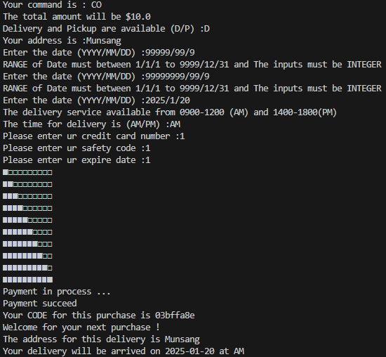
The input is successful .
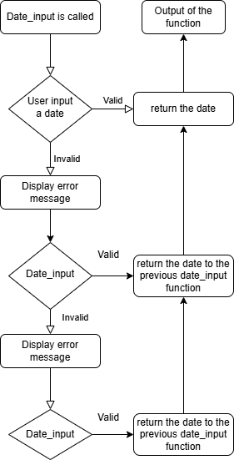

The new flow of the date_input function allows the re-enter of the date to be passed to the previous date_input after entering an invalid date .

Chapter 10
Improvement

Future development Direction

10.1 Membership system

A membership system can be introduced,
and the membership points can be acquired through shopping by the customers. Members can enjoy various benefits from being a member,
for example: 5% off per shopping trip,
enjoy birthday discounts and
use their membership points to exchange coupons.

The membership system can increase the willingness of the members to purchase more of our goods to increase our revenue. Also, the fame of this online system will be boosted to attract more sellers to join our online shopping platform and further expand our business. The birthday discounts keep the sticky of the customers i.e. the customers will choose our platform rather than other platforms and increase our competitiveness.

The simple outline of the membership system:
-Create a file to store the data of the customers
-A column will store their membership points
-Define a function which automatically add points to the customers after they shopped
-Adding commands related to membership points which allow users to exchange for different goods by their points

10.2 Seasonal event

Some seasonal events can be introduced according to the date .
For example,
Black Friday Sales , Christmas Sales , Lunar New Year Sales , Easter Sales and Valentine’s Day Sales

A series of sales can be allocated to boost the sales of goods. Also, more customers will be attracted to join our platform and so do the sellers. The Seasonal discounts keep the sticky of the customers.

The simple outline of the seasonal event system:
-Define a function which automatically check the date and introduced scheduled discounts like 10% off or discounted goods
-Seller can schedule discounts on their own goods by using new function
-Admin can schedule discounts for the whole system by new function ( 5% off on the whole bill )

10.3 Advertisement

Through advertising, the platform can generate a tremendous amount of income which allows us to promote our system
i.e. buying more servers to improve our access speed by users
which can further improve the business of our platform and boost our fame in global markets. More sponsors will join our platform to allow an expand of our platform to unlock a further , bigger markets like other countries or Mainland China.

The simple outline of the advertising system:
-Adding a new role called “Sponsor” which can invest advertisement in the platform
-Define a new function which will display advertisement after every command

Chapter 11
investigation and Improvement
11.1 Efficiency investigation
###### Sorting with 2d array ######
def selection_sort(raw_list,index,start) : #find the smallest item and switch
for i in range(start,len(raw_list)-1) :
pos = i
for j in range(i+1,len(raw_list)) :
if raw_list[j][index] < raw_list[pos][index] :
pos = j
raw_list[i],raw_list[pos] = raw_list[pos],raw_list[i]

def bubble_sort(raw_list,index,start) : #switch the nearby items
for i in range(start,len(raw_list)) :
current_pos = i
while current_pos >= start and float(raw_list[current_pos][index]) < float(raw_list[current_pos-1][index]) :
raw_list[current_pos] , raw_list[current_pos-1] = raw_list[current_pos-1] , raw_list[current_pos]
current_pos -=1

def insertion_sort(raw_list,index,start) : #pull the item back until find a correct place
for i in range(start,len(raw_list)) :
store2d = raw_list[i]
store = raw_list[i][index]
next = i-1
while next >= 0 and raw_list[next][index] > store :
raw_list[next+1] = raw_list[next]
next -=1
raw_list[next+1] = store2d

goods_data = "D:\SBA\SBA\goods_info.csv"
def test(way) :
with open(goods_data,"r", newline='', encoding='utf-8-sig') as goods_info :
goods = list(csv.reader(goods_info))
if way == "SID" :
insertion_sort(goods,1,2)
elif way == "SP" :
bubble_sort(goods,3,2)
elif way == "SN" :
selection_sort(goods,0,1)
import time
from datetime import datetime
way_list = ["SID","SP","SN"]
for way in way_list :
start_time = datetime.now()
test(way)
print("--- %s seconds ---" % (datetime.now() - start_time))

From this testing program, the efficiency of the 3 different sorting method ( selection sort , bubble sort , insertion sort ) will be investigated by the runtime of different methods . In details, each sorting method will sort the goods data from the goods_data file and investigate the time required for each sorting method to finish the sorting.
The runtime will be outputted by the program by reducing the end time from the start time of the sorting .

Sorting Method | Runtime (in seconds) | Time Complexity (max.) | Time Complexity  (min.)
Selection sort | 0:00:00.001006 | O(n^2) | O(n^2)
Insertion sort | 0:00:00.000995 | O(n^2) | O(n)
Bubble sort | 0:00:00.000999 | O(n^2) | O(n)

From the perspective of efficiency in terms of running time, insertion sort is the most efficient one as it spends the least time completing the sorting.

However, selection sort provides an advantage of which performs at most(n−1)
swaps. Selection sort may become more efficiency when the total number of goods increases and the number of swaps increases dramatically for the other two sorting methods , selection sort can perform the most stable performance out of the three methods .

Moreover , bubble sort has high simplicity which lower the maintainence cost of different sorting methods . Bubble sort can be used for an alternatives when errors occur with the other two relatively more complex sorting methods , bubble sort comes in clutch with its high readability to provide a simple , stable alternative choice for the programmer .

In consideration of efficiency , long-term development and back-up alternatives , All three sorting methods are used in the program.

Sorting Method | Advantage | Disadvantage
Selection sort | Efficient when large number of data | Require more number of swaps in small amount of data
Insertion sort | Require the least time to finish sorting | Less stable when handling large amount of data
Bubble sort | Easy to maintain due to high simplicity | Relatively lower efficiency

11.2 Algorithm and program improvement

###### admin information ######
admin_name = ["admin"]
admin_pw = ["123"]

###### seller information ######
seller_name = ["Garden"]
seller_pw = ["Garden123"]

###### customer information ######
customer_name = ["Tommy"]
customer_pw = ["5212023"]
customer_bday = [datetime.datetime(2023,5,21)]
shopping_cart = [["NAME","ID","PRICE","Quantity","Total cost"]]

###### goods information ######
age_required = ["066"]
*Code from main program

Problem 1 : data lost after termination of program

a) The users information is not stored in a separate file or files in consideratin of privacy and security .
However , the change of users information or adding new users may not be able to be stored after the execution and termination of the whole program.

b) Age requirement for the goods should be a colomn for the data of the goods in the goods_data file for storing the requirement after the termination of the program without security concerns .

Solution :
a) 3 seperate files for admin , seller and customer should be used to store the data of them storage thus the data of them can be refered and used for login in future and retain the data privacy and security.

b) The age requirement should be set as a column of the goods as ‘0’/’1’ which stands for required or not to faciliate the efficiency of checking whether the goods is age-required or not and allow the data be kept after program termination .

Problem 2 : Rebundancy of the codes

def admin_login() :
global p_name
login_name = str(input("Hi Admin , Your username is : "))
if login_name in admin_name :
location = find(admin_name,login_name)
login_pw = str(input("Hi Admin , Your password is : "))
if admin_name[location] == login_name and admin_pw[location] == login_pw : # check if the account matches with the password
print("")
print("Welcome Admin {} !".format(login_name))
p_name = login_name
return True
else :
print("Your password is NOT correct , please try again")
else :
print("Username does NOT exist , please try again")
return False

def seller_login() :
global p_name
login_name = str(input("Hi Seller , Your username is : "))
if login_name in seller_name :
location = find(seller_name,login_name)
login_pw = str(input("Hi Seller , Your password is : "))
if seller_name[location] == login_name and seller_pw[location] == login_pw : # check if the account matches with the password
print("")
print("Welcome Seller {} !".format(login_name))
p_name = login_name
return True
else :
print("Your password is NOT correct , please try again")
else :
print("Username does NOT exist , please try again")
return False

def customer_login() :
global p_bday
global p_name
login_name = str(input("Hi Customer , Your username is : "))
if login_name in customer_name :
location = find(customer_name,login_name)
login_pw = str(input("Hi Customer , Your password is : "))
if customer_name[location] == login_name and customer_pw[location] == login_pw : # check if the account matches with the password
print("")
print("Welcome Customer {} !".format(login_name))
p_name = login_name
p_bday = customer_bday[location]
return True
else :
print("Your password is NOT correct , please try again")
else :
print("Username does NOT exist , please try again")
return False
*Code from main program

As shown above , the codes for the login of customer , admin and seller are more or less the same or have high similarity . The initial design for different login method of different uses have a high variety and difference

( Customers are required to enter the birthday to login toverify the age requirement to ensure the identity of the user , Admin is required to enter the One-time passcode from their phones for security concerns as Admin are required to manage sensitive data )
However , this design is abandoned due to its high complexity and unnecesserity .

Solution :
a)The above functions for identity verification are added into the code for high level of data security and integrity
b)The three functions of logins will be combined into one simple login program for simplification of the code and to allow easier maintainence given the high simplicity.
The runtime for the program can be reduced and less resource are required to store the code hence enhance the efficiency of the codes .

11.3 Evaluation on Aim designed

To elderly and busy white-collar workers , the Delivery services provided by the platform allows them to purchase different goods online to prepare their daily necessarites without stepping out of their house . Providing an array of convinence , they do not have to spend time going to different supermarkets to choose and take the heavy goods back to their house but instead , they can wait at their home without spending any extra effort as the delivery service allow users to choose the time for delivery which provide flexibility for users , preventing the problem of busy users unable to pick-up the goods .

To local and online shop owner ( seller ) , they can enjoy the benefits of fame and sales brought by the tremendous amount of customers attracted by the online shopping platform , for instance the Filter service and the various View command provides an easy and convenient shopping experience for the users which can attract customers to use . Their sales and fame can be boosted under such circumstance which is a
Win-Win situation for both Online shopping platform owner ( us) and the local and online shopping owner as we get the fame and the brandname effect while they enjoy a boost in salary and total sales .

