Plot

## Đọc dữ liệu

library(tidyverse)   
library(dplyr)  
library(ggplot2)  
library(GGally)  
library(caret)  
library(skimr)  
  
library(scales)  
library(hrbrthemes)  
library(viridis)

data <- read.csv("Sleep_health_and_lifestyle_dataset.csv")  
  
data <- data[, c(2:13)]

## Tiền xử lý dữ liệu

* Blood Pressure

data$Blood.Pressure <- sub("/", " ", data$Blood.Pressure)   
data <- separate(data, Blood.Pressure, into = c("Systolic", "Diastolic"), sep = " ")   
data$Systolic <- as.numeric(data$Systolic)   
data$Diastolic <- as.numeric(data$Diastolic)

* BMI Caterogy

data$BMI.Category<- gsub("Normal Weight", "Normal", data$BMI.Category)   
data$BMI.Category<- gsub("Obese", "Obesity", data$BMI.Category)

* Outcome

data$Sleep.Disorder[data$Sleep.Disorder == "Sleep Apnea"] = "Sleep.Apnea"   
data <- data %>% transform(Sleep.Disorder = as.factor(Sleep.Disorder))

* factor

data$Gender <- as.factor(data$Gender)   
data$Occupation <- as.factor(data$Occupation)   
data$BMI.Category <- as.factor(data$BMI.Category)

## Trực quan hóa dữ liệu

### Gender

data %>% count(Gender) %>% mutate(labels = round(100 * n/ sum(n), 1)) %>%  
 ggplot(aes(x = "", y = labels, fill = Gender, group = Gender))+  
 geom_bar(stat = "identity")+  
 coord_polar(theta = "y", start=0) +  
 geom_text(aes(label = labels), position = position_stack(vjust = 0.5), color = "white") +  
 theme_void()

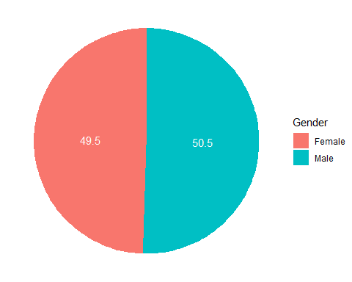

data %>% count(Gender, Sleep.Disorder) %>% group_by(Gender) %>%  
 ggplot(aes(x = Gender, y = n, fill = Sleep.Disorder)) +  
 geom_bar(stat = "identity", position = 'dodge', alpha = 0.75) +  
 ggtitle("Gender") +  
 geom_text(aes(label = n), position = position_dodge(0.9), color = "white", vjust = 1, hjust = 1) +  
 labs(y = 'count') +  
 theme_minimal()

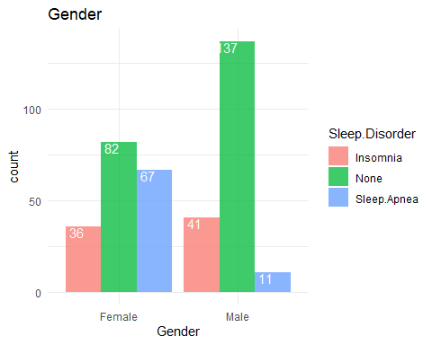

data %>% select(Gender, Sleep.Disorder) %>%   
 count(Gender, Sleep.Disorder) %>% arrange(Gender) %>%  
 mutate(values = round(100*n/sum(n), 2)) %>% mutate(labels = paste(Gender, '_', Sleep.Disorder)) %>%  
 ggplot(aes(x = "", y = values, fill = labels, group = labels)) +  
 geom_col(width=1, color="white") +  
 coord_polar(theta = "y", start=0) +  
 ggtitle("Gender") +  
 theme_void() +  
 geom_text(aes(label = paste0(values, "%")), position = position_stack(vjust = 0.5), color = "white") +  
 theme(  
 panel.spacing = unit(0.1, "lines"),  
 axis.ticks.x=element_blank()  
 )

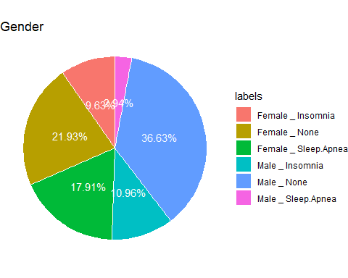

### Age

data %>% ggplot(aes(x = Age)) +  
 geom_histogram(binwidth = 2, color = "lightblue", fill = "blue", alpha = 0.75) +  
 # geom_density(aes(y= 2 * after_stat(count)),color = "blue", alpha = 0.15) +  
 ggtitle("Age") +  
 ylab("count")+  
 theme_minimal()

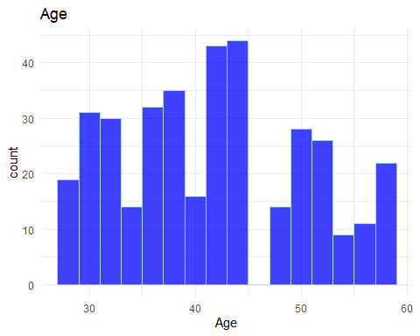

data %>% ggplot(aes(x = Age, fill = Sleep.Disorder, color = Sleep.Disorder,)) +  
 geom_density(aes(y= after_stat(count)), alpha = 0.15) +  
 ggtitle("Age") +  
 theme_minimal()

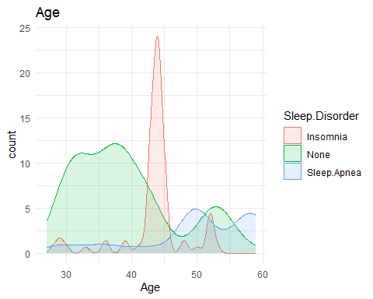

### **Occupation**

data %>% count(Occupation) %>% arrange(n) %>% mutate(name = fct_reorder(Occupation, desc(n))) %>%  
 ggplot(aes(x = name, y = n)) +  
 geom_bar(stat = "identity",fill="#1FBF92", alpha=0.5) +  
 coord_flip() +  
 ggtitle("Occupation") +  
 geom_text(aes(label = n), nudge_y = -0.5, color = "#169CCC") +  
 theme_bw()

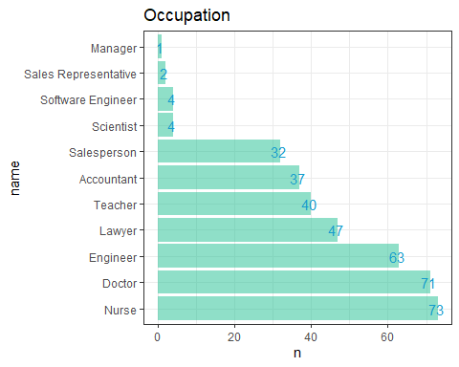

### **Sleep Duration**

ggplot(data = data, aes(x = Sleep.Duration)) +  
 geom_histogram(color = "#6DA7F2", fill = "#6DA7F2", alpha = 0.5, binwidth = 0.2) +  
 ggtitle("Sleep Duration") +  
 theme_minimal()

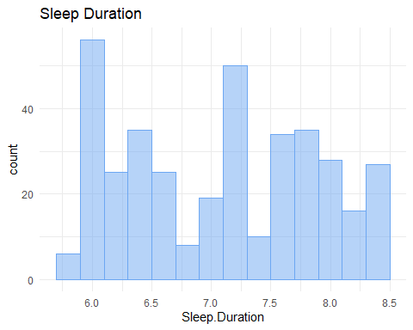

data %>% ggplot(aes(x = Sleep.Duration, fill = Sleep.Disorder, color = Sleep.Disorder)) +  
 geom_density(aes(y= after_stat(count)), alpha = 0.1) +  
 ggtitle("Sleep duration distribution") +  
 theme_minimal()

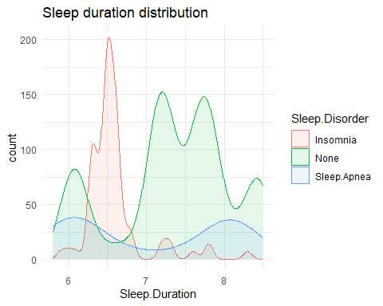

### **Quality of sleep**

data %>% ggplot(aes(x = Quality.of.Sleep)) +  
 geom_density(aes(y= after_stat(count)), color = "#6DA7F2", fill = "#6DA7F2", alpha = 0.5) +  
 ggtitle("Quality of sleep") +  
 theme_minimal()

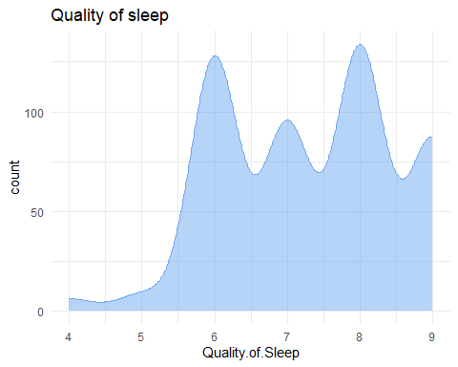

data %>% ggplot(aes(x = Quality.of.Sleep, color = Sleep.Disorder, fill = Sleep.Disorder)) +  
 geom_density(aes(y= after_stat(count)), alpha = 0.1) +  
 ggtitle("Quality of sleep distribution") +  
 theme_minimal()

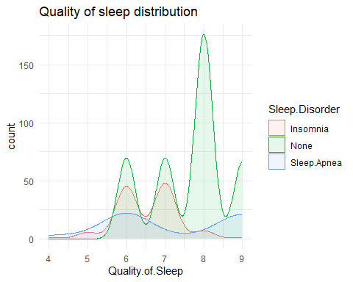

### Physical Activity level Distribution

data %>% ggplot(aes(x = Physical.Activity.Level)) +  
 geom_density(aes(y = after_stat(count)),color = "#6DA7F2", fill = "#6DA7F2", alpha = 0.5, binwidth = 5) +  
 ggtitle("Physical Activity Level distribution") +  
 theme_minimal()

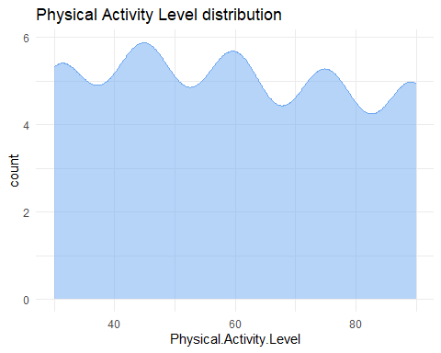

data %>% ggplot(aes(x = Physical.Activity.Level, color = Sleep.Disorder, fill = Sleep.Disorder)) +  
 geom_density(aes(y= after_stat(count)), alpha = 0.1) +  
 ggtitle("Physical Activity Level distribution") +  
 theme_minimal()

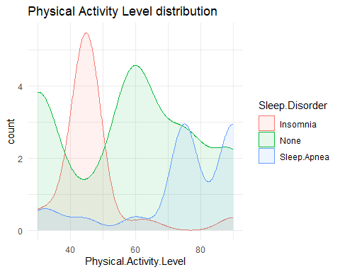

### Stress level

data %>% ggplot(aes(x = Stress.Level)) +  
 geom_histogram(fill = "#6DA7F2", color="#6DA7F2", alpha = 0.5, binwidth = 1) +  
 ggtitle("Stress Level") +  
 theme_minimal()

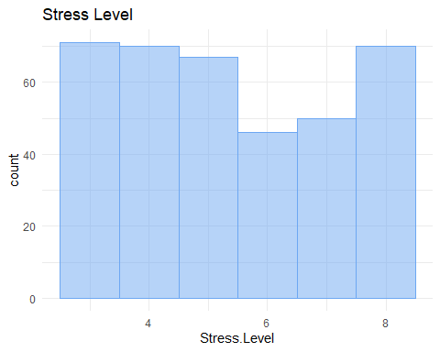

data %>% ggplot(aes(x = Stress.Level, color = Sleep.Disorder, fill = Sleep.Disorder)) +  
 geom_density(aes(y= after_stat(count)), alpha = 0.1) +  
 ggtitle("Stress Level distribution") +  
 theme_minimal()

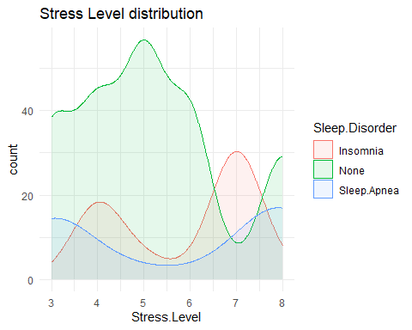

### BMI

data %>% count(BMI.Category, Sleep.Disorder) %>% group_by(BMI.Category) %>%  
 ggplot(aes(x = BMI.Category, y = n, fill = Sleep.Disorder)) +  
 geom_bar(stat = "identity", position = 'dodge', alpha = 0.75) +  
 ggtitle("BMI") +  
 geom_text(aes(label = n), position = position_dodge(0.9), color = "white", vjust = 1, hjust = 1) +  
 labs(y = 'count') +  
 theme_minimal()

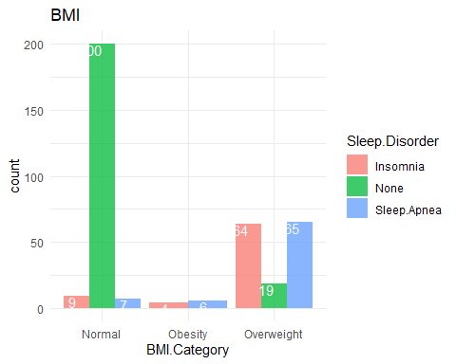

### Systolic

ggplot(data, aes(x=data$Systolic)) +   
 geom_density(aes(y = after_stat(count)),color="lightblue", fill = "blue", alpha = 0.5)+  
 labs(x = "Systolic", y = "Count") +  
 theme_minimal()

## Warning: Use of `data$Systolic` is discouraged.  
## ℹ Use `Systolic` instead.

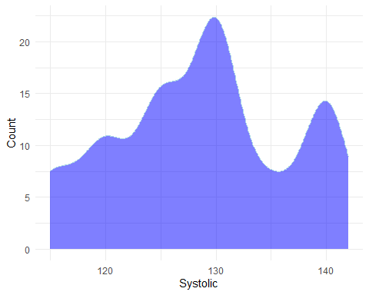

data %>% ggplot(aes(x = Systolic, color = Sleep.Disorder, fill = Sleep.Disorder)) +  
 geom_density(aes(y= after_stat(count)), alpha = 0.1) +  
 ggtitle("Systolic distribution") +  
 theme_minimal()

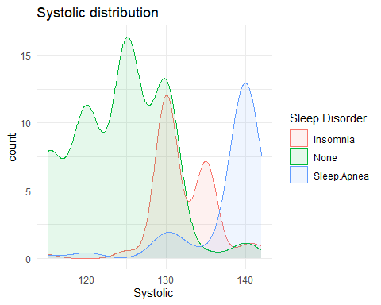

### Diatolic

ggplot(data, aes(x=data$Diastolic)) +   
 geom_density(aes(y = after_stat(count)),color="lightblue", fill = "blue", alpha = 0.5)+  
 labs(x = "Diastolic", y = "Count") +  
 theme_minimal()

## Warning: Use of `data$Diastolic` is discouraged.  
## ℹ Use `Diastolic` instead.

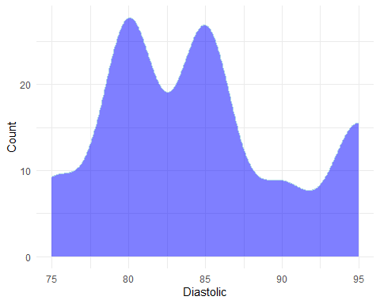

data %>% ggplot(aes(x = Diastolic, color = Sleep.Disorder, fill = Sleep.Disorder)) +  
 geom_density(aes(y= after_stat(count)), alpha = 0.1) +  
 ggtitle("Diastolic distribution") +  
 theme_minimal()

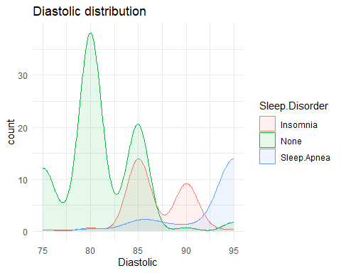

### Heart rate

data %>% ggplot(aes(x = Heart.Rate, color = Sleep.Disorder, fill = Sleep.Disorder)) +  
 geom_density(aes(y= after_stat(count)), alpha = 0.1) +  
 ggtitle("Heart Rate distribution") +  
 theme_minimal()

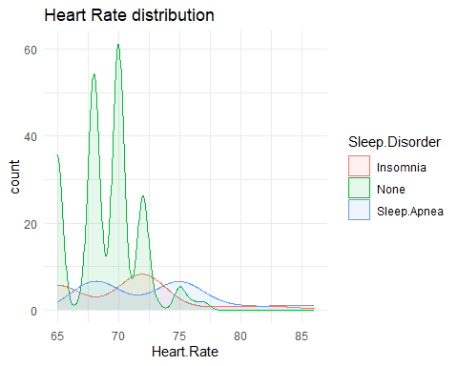

### Daily Steps

ggplot(data, aes(x=data$Daily.Steps)) +   
 geom_density(aes(y = after_stat(count)),color="lightblue", fill = "blue", alpha = 0.5)+  
 labs(x = "Daily Steps", y = "Count") +  
 theme_minimal()

## Warning: Use of `data$Daily.Steps` is discouraged.  
## ℹ Use `Daily.Steps` instead.

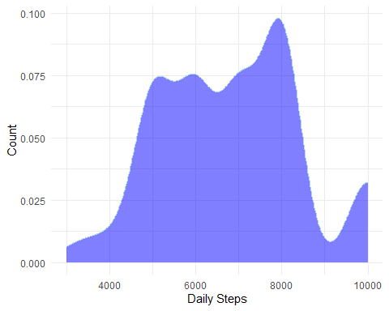

data %>% ggplot(aes(x = Daily.Steps, color = Sleep.Disorder, fill = Sleep.Disorder)) +  
 geom_density(aes(y= after_stat(count)), alpha = 0.1) +  
 ggtitle("Daily Steps distribution") +  
 theme_minimal()

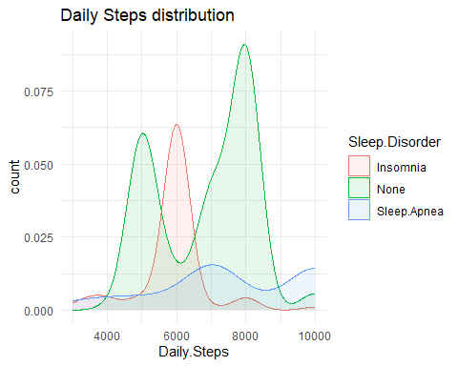

### Sleep Disorder

data %>% select(Sleep.Disorder) %>%   
 count(Sleep.Disorder) %>% arrange(n) %>%   
 mutate(labels = scales::percent(n/sum(n))) %>%  
 ggplot(aes(x = "", y = labels, fill = Sleep.Disorder)) +  
 geom_bar(stat="identity", width=1, color="white") +  
 coord_polar("y", start=0) +  
 ggtitle("Sleep Disorder") +  
 theme_void() +  
 geom_text(aes(label = labels), position = position_stack(vjust = 0.5), color = "white")

