

**TTCOIN CRYPTOCURRENCY**

**Contents**

**What is TTcoin?**

* Information
* Structure

**Who are we?**

* **Founders**
* **Team**

**What are TTcoin Goals?**

* Goals

**What is TTcoin Network?**

* **Information**
* **Distribution Plan**

**What is TTcoin Plus?**

* **Information**

**What is TTcoin Classic?**

* **Information**

**What is TTcoin?**

1. **Information**

**With its Official Name TTCOIN, unlike most tokens, wants to make a first by branding, and by trying to use this brand name in every field, it wants Cryptocurrency to benefit users in different ways. TTcoin, which has unlimited usage areas, can be used or distributed for a different reason in every area.**

**By the TTcoin team, TTcoin is mostly important for increasing brand value and branding.**

**With a supply of 6 billion, TTcoin is more than enough for most people to buy.**

1. **Structure**

**TTcoin was created as a TRC20 token on the Tron network with the least cost for users and the TTcoin team.**

**Name : TTCOIN**

**Symbol : TC**

**Max. Reserve : 6,000,000,000**

**Sensitivity : 4**

**Blockchain : TRC20**

**Creation Date : 24.03.2021**

**Mining Start Date : 16.06.2021**

**Who are we?**

1. **Founders**

TTcoin was created on March 24 by two Turkish brothers (**Tunahan Taner, Tayfun Taner**).

**The two brothers, who were successful in most areas before, made researches and then presented TTcoin to the market, which they wanted to establish for two years, but in order to create it under the right plan and to distribute it to the users.**

**The name TTcoin comes from the initials .**

1. **Team**

**TTcoin founders appointed representatives to represent TTcoin all over the world. Mostly, it has made representative appointments in the countries according to the download density in the miner application.**

**This allows TTcoin to be transmitted to users in a more understandable way through representatives.**

**The TTcoin team has allocated 1 billion TTcoin as a share. This reserved portion will be distributed to most agents, agreed exchanges, and within the team.**

**The TTcoin team is preparing a large allowance for TTcoin to be listed on higher exchanges.**

**What are TTcoin Goals?**

1. **Goals**

**The biggest goal of the TTcoin Team is to break new ground in the crypto world.**

**That's why the TTcoin Team**

**Their aim is to be listed on all exchanges in the world, then the football club TTcoin wants to establish and create TTcoin products bearing the name TTcoin.**

**These goals may seem strange, but our goal is to sign projects that will add color to this world.**



**What is TTcoin Network?**

1. **Information**

**It is an Android application created to distribute an amount of TTcoin to users before TTcoin enters the stock markets.**

**It is distributed to users within the framework of the distribution plan.**

**Payments are sent to Tronlink , Trust Wallet .etc Wallets.**

**App Url :** [**https://play.google.com/store/apps/details?id=com.ttcoin.tc**](https://play.google.com/store/apps/details?id=com.ttcoin.tc)

1. **Distribution Plan**

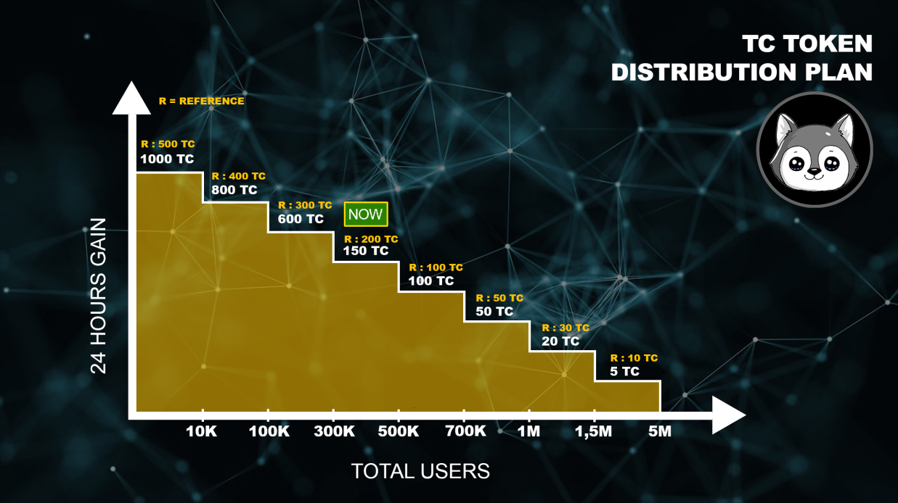

**What is TTcoin Plus?**

1. **Information**

**TTcoin plus, which will not be distributed, can only be purchased with Pre-sale. It will be created to be given as a special prize to users in TTcoin Applications and to be distributed to users as a prize in special competitions. TTcoin Plus, with a total supply of 6 million, will be listed on justswap and then on certain exchanges on October 10.**

**Name : TTcoin Plus**

**Symbol : TP**

**Max. Reserve: 6,000,000**

**Decimal: 8**

**Blockchain: TRC-20**

**Creation Date: 10.10.2021**

**LOGO**



**What is TTcoin Classic?**

1. **Information**

**TTcoin classic, which will be produced as an alternative by the TTcoin team, will start distribution on December 1, 2021. After the 6-month distribution period, mining will be stopped.**

**It will distribute a fixed number daily and the minimum withdrawal amount will be 1000 TTcoin Classic.**

**TTcoin Classic, which will offer a new mining interface, will pre-sale 1 month before it starts distribution.**

**Name : TTcoin Classic**

**Symbol: TTCC**

**Max. Reserve : 600,000,000**

**Precision: 6**

**Blockchain: TRC-20**

**Creation Date : ?.11.2021**

**Mining Start Date: 01.01.2022**

**LOGO**



IMPORTANT LINKS

<https://tronscan.org/#/token20/TCMwzYUUCxLkTNpXjkYSBgXgqXwt7KJ82y>

<https://tronscan.org/#/contract/TCMwzYUUCxLkTNpXjkYSBgXgqXwt7KJ82y/code>

Telegram : <https://bit.ly/3wqhKYG>

Telegram Group : <https://bit.ly/3gnDobI>

YouTube : <https://bit.ly/3xykKDn>

Twitter : <https://bit.ly/3efPTTQ>

Instagram : <https://bit.ly/3glyGLB>

Facebook : <https://bit.ly/3jU1wV9>

Facebook Group : <https://bit.ly/3xoM7jl>

Google Play : <https://bit.ly/36i6Nxz>

Web Site : <https://bit.ly/3hJswnn>

