**NDEJJE UNIVERSITY**

**Kampala Campus**

**Course Unit: Software Engineering Project**

**Lecturer: Bazzeketa Datsun**

|  |  |  |
| --- | --- | --- |
| **NO** | **NAME** | **REG. NO** |
| **1.** | **NAMAGANDA T.E REBBECCA** | **16/2/370/W/618** |
| **2.** | **NAMULI MARGARET** | **16/2/370/W/520** |

**STRATCOM ONLINE STUDENT INFORMATION MANAGEMENT SYSTEM**

# 1.0Introduction

An information management system, or IMS, is any computer system used to collect and store information, with tools for analysing that information so that you can monitor operations and make informed business decisions. Software that tracks sales data, produces weekly reports and expands on past sales to provide you with sales forecasts would be one example of a management information system.

# 1.1 Why Use An Online Information Management System?

Iinformation Management systems improve your decision-making, because they provide information that is accurate, timely, relevant and complete. ... Companies that use management information systems ensure that all Operations are worked on from the same set of data and make decisions based on identical information.

# 1.2 Why develop Stratcom Online Information Management System

**Background about Stratcom**

Stractcom is an IT-based company that offers quite a number of services including internship Training but they have a problem with managing the information that comes with the Internship training for example Students who have paid, the modules offered, the institutions from which the students come from to mention hence the need to develop an Online Information Management System.

# 1.3 Users of the Stratcom Online Information Management System

An Admin who in this case is the CEO at Stratcom Computer Solutions Limited

The assistant who is always at the premises and who the internship students usually interface with.

# 2.0 System Design and Data Modeling:

This was achieved by using Entity-Relationship Diagrams to show the data requirements and model. This yield the structure of relations in the relational schema (database).

**Figure 1: Entity Relationship Diagram of the Stratcom Online Information Management System**

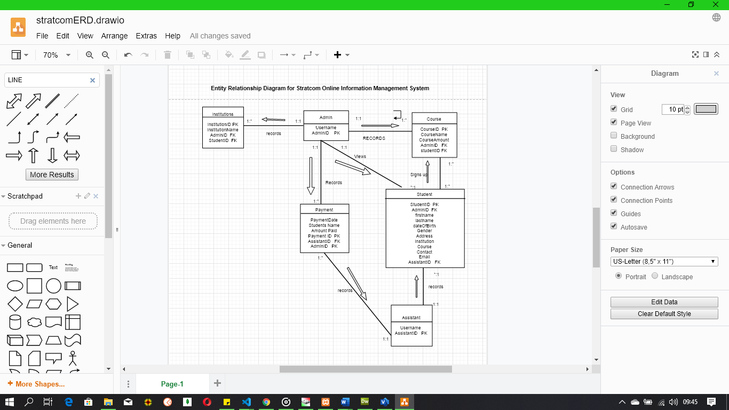

**Figure 2: Level 0 Context Diagram of the Stratcom Online Information Management System**

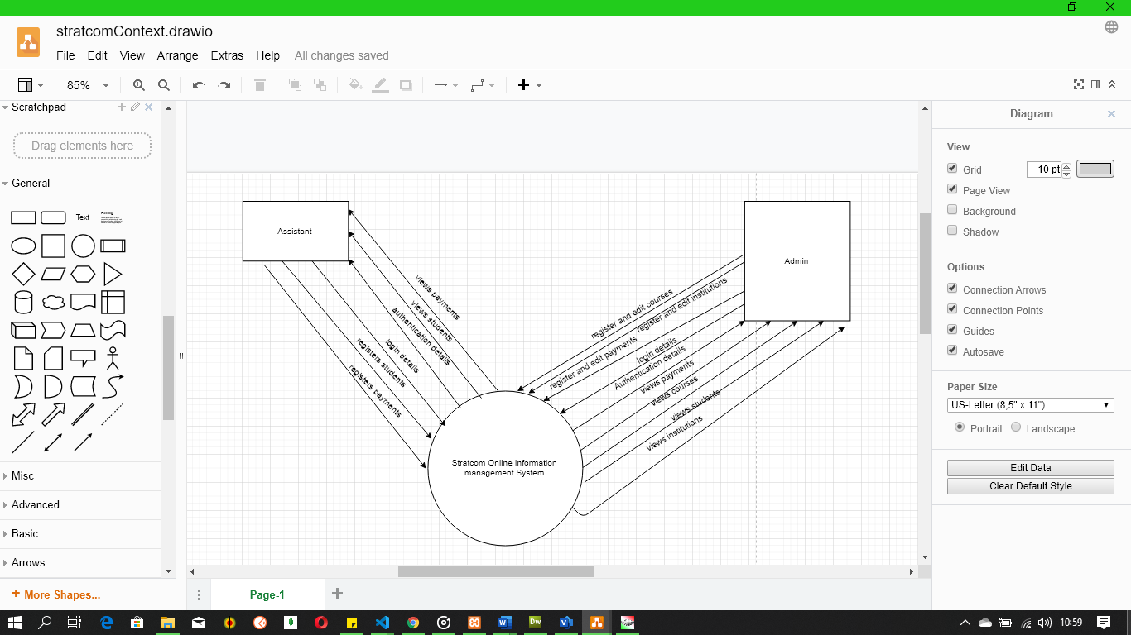

**Figure 3: Level 1 Context Diagram of the Stratcom Online Information Management System**

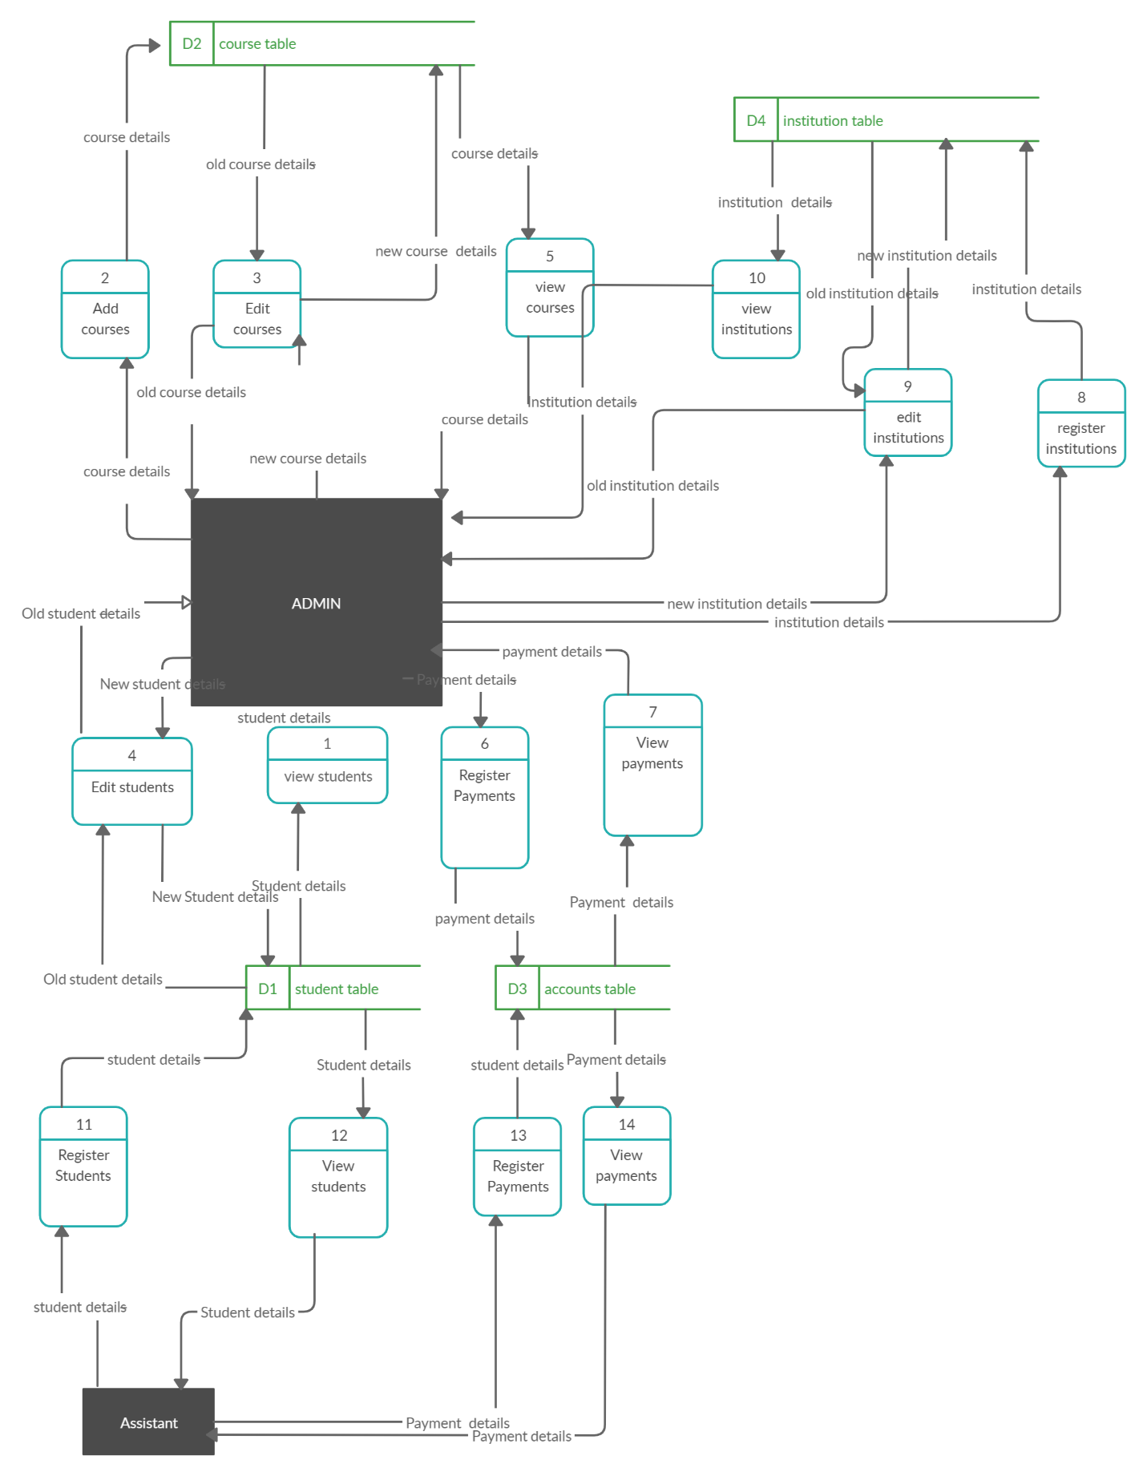

# 2.1 Implementation Tools

These are the tools that we used in turning the system design into running software, these included

# HTML

This was used to implement the user interface (data entry page, data view page, and menus) html is universally used and understood by web application and this had the ability to shorten the development time because of its simplicity.

# MYSQL

The MySQL sever was used to implement the data bases design (tables, relationship and output reports). We preferred it because it is an open source databases server and it is widely supported by online service providers.

# PHP

We used this tool to code data processing scripts (implementing the function design) it is preferred because it is designed to work specifically with MySQL, the data base server to be used in this system.

# Data Dictionary

A data dictionary provides an explanation of the system processes, data flows, data stores and the external entities that are included in the system.

**Table 1 Shows a data dictionary that describes all processes involved in the data flow diagram.**

|  |  |
| --- | --- |
| **PROCESS** | **DESCRIPTION** |
| Login | Capture information about the users of the system (including the administrator, and user) and stores it in the user and admin details in the database. |
| View Students | Allows a User to view a list of the registered students and allows him/her to edit or delete a student of his/her own interest according to his/her access level. |
| View Course | Allows a User to view a list of the registered courses and allows him/her to edit or delete a course of his/her own interest according to his/her access level. |
| View Payments | Allows a User to view a list of the payments made by students. |
| Register Student | Allows the users of the information management system to capture all the required information about a student |
| Register course | Provides a form like interface which captures a given course |
| Register payments | Provides a form like interface which captures a given payment. |
| View/Update students’ details | Allows you to make changes about the student’s information. |