Scam Signatures: Discovering Fraud Families in Online Job Postings
Project 1, Milestone 2: Draft White Paper
Author: Timothy Hollis
Bellevue University
DSC680 – Applied Data Science
Professor Xu Ashton
Date: September 17, 2026

Business Problem and Research Questions
Job scams are a growing source of consumer harm. The Federal Trade Commission reported more than $220 million in job scam losses in the first half of 2024 alone (Federal Trade Commission, 2024). Existing detection tools, including a classifier and a fine-tuned language model I built on this dataset in earlier courses, answer only one question: is this posting fraudulent? A verdict without an explanation is hard for a job seeker to act on and hard for a trust and safety team to audit. This project asks instead whether fraudulent postings organize into a small, explainable set of families based on their language alone.
Three research questions follow. First, when postings are grouped by textual similarity with the fraud label withheld, do fraudulent postings concentrate in a small number of clusters or scatter among legitimate ones? Second, how many distinct signatures exist, and what distinguishes each one? Third, do postings written in 2025 and 2026 fall into those signatures or form new groups?
My hypotheses were that fraud would concentrate, that a minority of clusters would hold a majority of it, and that signatures would be defined as much by what a posting omits as by what it says. The third question is deferred to the final milestone; this paper reports on the first two.

Background and History
A job posting is a document a stranger is invited to trust, and applying requires handing over exactly the information an identity thief wants. Unlike phishing email, a fraudulent posting is published openly on a platform with a commercial interest in volume, so detection has to happen at scale rather than through individual reporting.
The Employment Scam Aegean Dataset (EMSCAD) was assembled to support research on this problem (Vidros et al., 2017). It contains real postings collected through a recruiting platform between 2012 and 2014, annotated by that platform’s own specialists. Most published work treats it as supervised classification, which produces accurate verdicts and no explanations. Reframing it as unsupervised discovery asks a different question: not whether a model can separate fraud from legitimate postings, but whether fraud has recognizable internal structure a human reviewer could learn to see.

Data Explanation
The dataset contains 17,880 postings, of which 866 (4.84%) are annotated fraudulent. Each posting carries five free text fields, six categorical fields, three binary flags, and a salary range. I worked from the public Kaggle mirror (Bansal, 2020), which preserves the original 17,880 rows and 18 columns.
Preparation ran in five reproducible steps. I joined the five text fields into one document per posting and stripped residual HTML. The dataset replaces URLs, emails, and phone numbers with placeholder tokens; I counted those as a structural feature before normalizing them to plain words, since a direct contact instruction is informative while a random hash is noise. I recorded field presence flags before any missing values were filled, because a missing company profile is a signal rather than a defect. I then removed one posting with no description, one document under five words, and 2,006 exact duplicates, leaving 15,872 postings at a 4.48% fraud rate.
Deduplication removed a real signal, since fraudulent postings were duplicated at 22.3% against 15.0% for legitimate ones. Density-based clustering is unusually vulnerable to duplicates, because twenty identical copies create a dense region that is one posting counted twenty times rather than a pattern. I therefore recorded each posting’s copy count as a feature before collapsing duplicates.
Key fields are summarized below.
Field | Type | Description
title, company_profile, description, requirements, benefits | Text | The five source text fields, joined into one document for modeling
telecommuting, has_company_logo, has_questions | Binary | Platform flags for remote work, employer logo, and screening questions
employment_type, required_experience, required_education, industry, function, location | Categorical | Used to describe clusters, not to form them
fraudulent | Binary | Target label, withheld during clustering and revealed only for evaluation
document, doc_length | Derived | Cleaned combined text and its word count
n_copies | Derived | Number of times the identical document appeared before deduplication
n_contact_tokens | Derived | Count of URL, email, and phone placeholders in the source text
has_company_profile, has_requirements, has_benefits, has_salary | Derived | Field presence flags captured before any imputation
cluster, cluster_tfidf, archetype | Derived | Cluster assignments under each representation, and the archetype label

Methods
The pipeline represents each posting as a vector, reduces the dimensionality, clusters, and interprets. For representation I used sentence embeddings from all-MiniLM-L6-v2 (Reimers & Gurevych, 2019), chosen on the assumption that scam postings paraphrase a shared pitch and that semantic similarity would outperform exact word matching. The model has a 256 token limit, which truncated 83.9% of documents unevenly: because fields are concatenated in a fixed order, the description was never seen for 12.2% of postings, requirements for 67.8%, and benefits for 81.3%. Since compensation claims live in benefits, this was a defect rather than a limitation, so I split each document into 180 word chunks, embedded each, and averaged them.
I applied UMAP (McInnes et al., 2018) twice: five components with a minimum distance of zero as the clustering space, and two components for visualization. Compressing to two dimensions discards structure that density-based clustering depends on, so one reduction serving both purposes would have cost real information.
I used HDBSCAN (McInnes et al., 2017) as the primary clustering method because it determines the number of clusters from the data and can assign ambiguous points to noise rather than forcing them into a group. The minimum cluster size of 25 was selected on internal evidence before the labels were revealed. A sweep showed silhouette scores holding steady through 40 and then falling, with the largest cluster jumping from 335 to 750 members over the same interval, indicating that distinct groups merge past that point. I chose 25 over 40 on an asymmetry of errors: a family of thirty postings is discarded as noise at 40 and never appears in the results, whereas a family split across two clusters at 25 announces itself on reading.
Two baselines tested those choices independently: K-means on the same reduced space tested the algorithm, and TF-IDF with truncated SVD substituted for the sentence encoder tested the representation, everything else held constant. All methods were scored on one yardstick, the share of fraud captured by clusters running at three times base rate divided by the share of corpus they occupy. That measure is fair to methods that leave points unassigned and to methods that do not, and it matches the practical question a reviewer faces.
Validation ran in both directions: internally through silhouette scores and stability across three seeds, and externally by revealing the withheld label only after the clustering was fixed. I deliberately did not report adjusted Rand index against the label, because comparing a 173 way partition to a two way one penalizes exactly the splitting the method was asked to perform and would produce a near zero score that misrepresents the result.

Analysis

Stability
Across UMAP seeds of 42, 7, and 2026 the pipeline produced 173, 172, and 190 clusters at 31.4%, 29.1%, and 31.0% noise. Pairwise agreement on the roughly 9,800 postings clustered in every run gave adjusted Rand indices of 0.898 to 0.937 and normalized mutual information above 0.97 (Hubert & Arabie, 1985). The structure is in the data rather than in any single initialization, though about one thousand boundary postings move between clustered and noise depending on the seed.
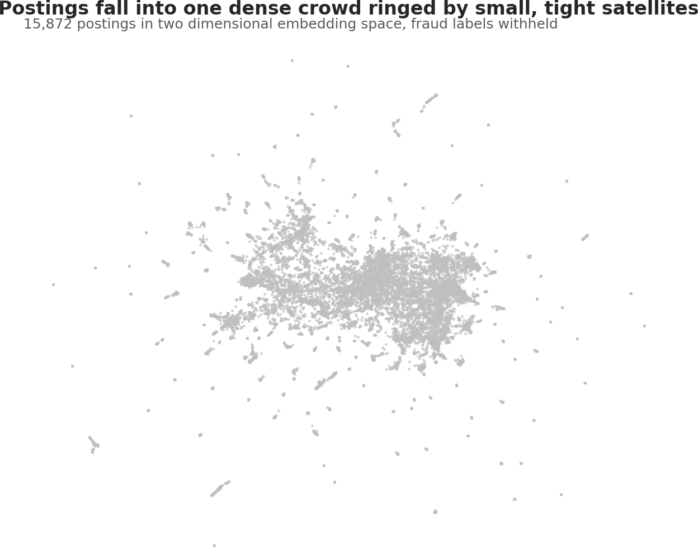
Figure 1. Postings in two dimensional embedding space, labels withheld. A dense central mass of ordinary postings is surrounded by dozens of small, well separated satellite groups.

Research question one: concentration
Fifteen clusters ran at three times base rate or higher, holding 302 of 711 fraudulent postings (42.5% of all fraud) within 910 postings, or 5.7% of the corpus. The two densest ran at 96.8% and 90.0% fraudulent.
The more informative number is the noise group. Postings HDBSCAN declined to classify carried 4.01% fraud, below the 4.48% corpus rate. Had fraud been mostly improvised, the unclustered middle would have carried it at or above base rate. It carried less, which is direct evidence that fraud preferentially occupies dense, template shaped regions.
The qualification is that 57% of fraudulent postings were not in a high lift cluster. The answer to research question one is therefore both: a substantial minority of fraud is organized into recognizable families, and the rest is either genuinely one off or camouflaged inside ordinary groups.
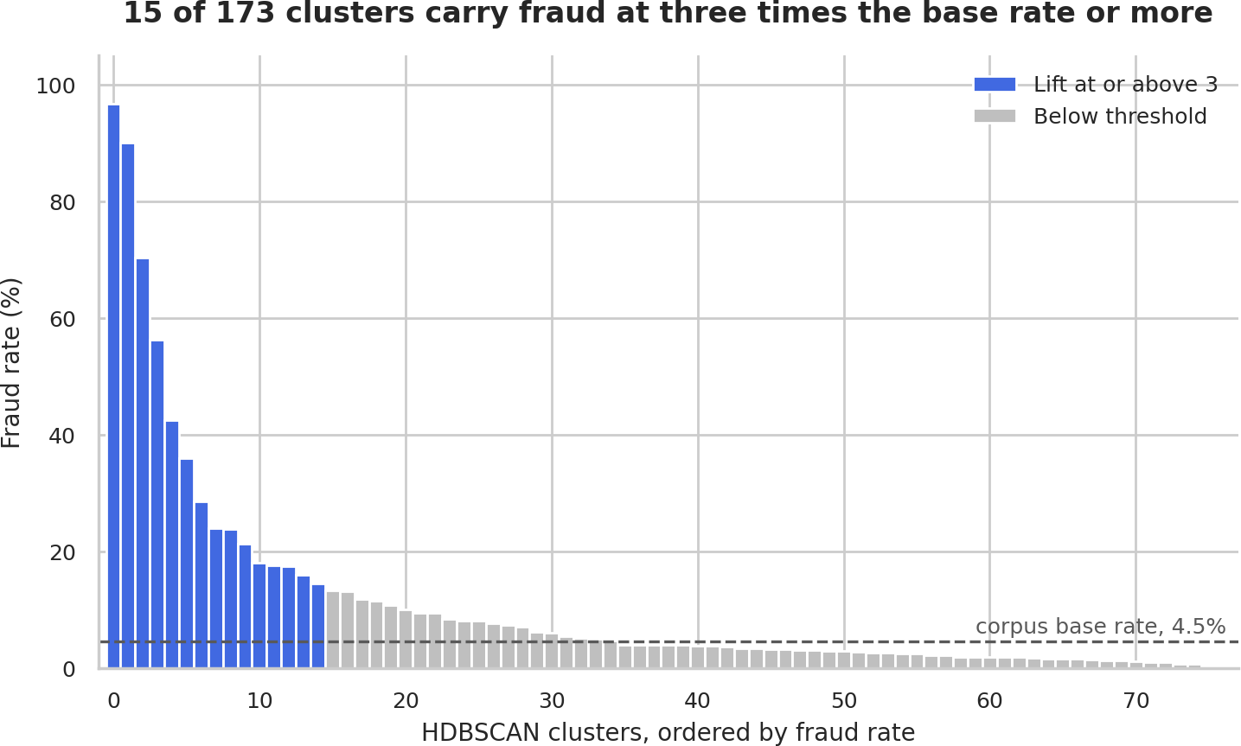
Figure 2. Fraud rate by cluster against the corpus base rate, showing the small number of clusters carrying high lift.

Comparison of methods
The baseline comparison reversed my starting assumption.
Method | Fraud captured | Corpus occupied | Unassigned | Concentration
HDBSCAN on embeddings | 42.5% | 5.7% | 31.4% | 7.4
K-means (k = 173) on embeddings | 55.8% | 8.2% | 0.0% | 6.8
HDBSCAN on TF-IDF | 61.0% | 6.6% | 27.3% | 9.3
K-means (k = 173) on TF-IDF | 67.7% | 9.7% | 0.0% | 7.0

TF-IDF outperformed sentence embeddings on both recall and precision, reversing my proposal’s premise that semantic similarity would matter because scam postings paraphrase a shared pitch. These families do not paraphrase; they copy and paste. Lexical overlap is therefore the stronger signal, and an uncased 384 dimensional representation actively discards the brand names, dollar figures, and misspellings that identify a template.
The K-means runs also showed that the silhouette based selection of k my proposal specified does not select in this data. Silhouette rose monotonically from 0.324 at k = 10 to 0.502 at k = 173 with no elbow, because the data is one large mass plus many small satellites, so every additional centroid finds another satellite. With K-means, nothing tells you how many clusters to request.
The two representations proved complementary rather than redundant. Of 711 fraudulent postings, 226 were captured by both, 76 by embeddings only, 208 by TF-IDF only, and 201 by neither. Their union captured 510 postings, 71.7% of all fraud, within 9.8% of the corpus. They answer different questions: lexical similarity finds families organized by the claimed identity of the poster, semantic similarity finds families organized by the nature of the offer.
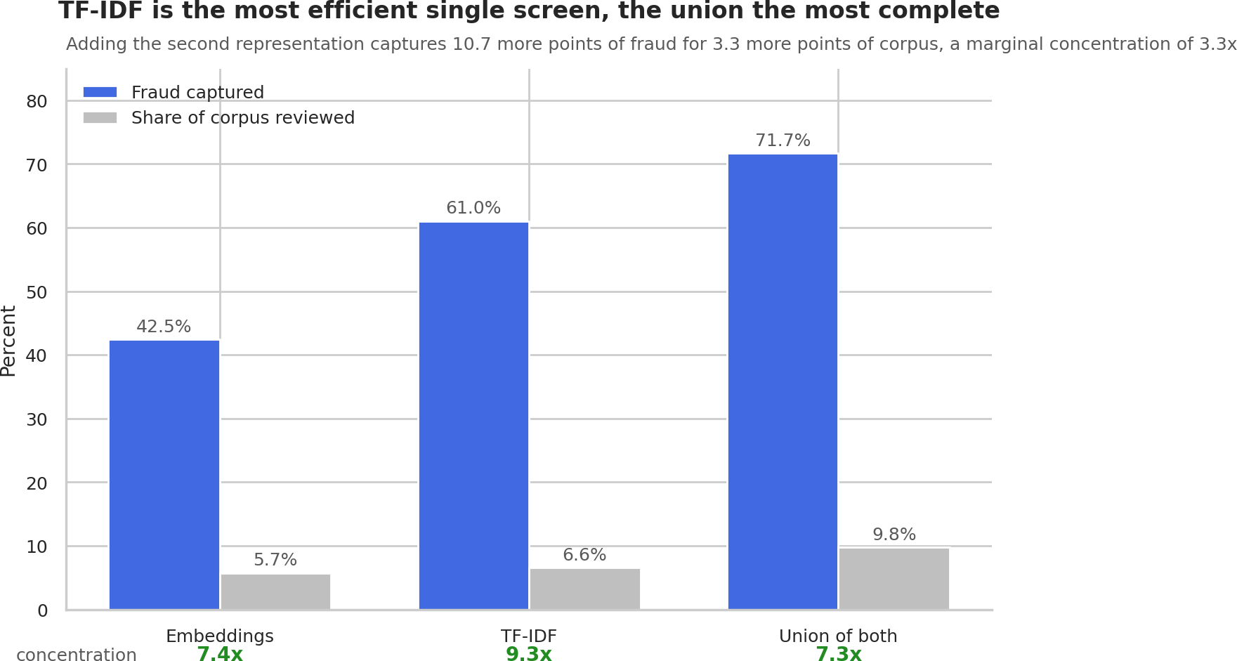
Figure 3. Fraud captured by each representation and by their union, against the share of the corpus reviewed.

Research question two: the archetypes
Reading the fraud dense clusters under both representations produced four recognizable archetypes, together accounting for 504 postings, 3.2% of the corpus, containing 47.5% of all fraud.
Archetype | Postings | Fraud rate | Company profile | Logo | Screening questions | Median words
The Bait Ad | 71 | 92.9% | 0.0% | 4.2% | 5.6% | 81
The Ghost Agency | 99 | 100.0% | 100.0% | 100.0% | 89.9% | 571
The Borrowed Brand | 51 | 100.0% | 58.8% | 58.8% | 0.0% | 514
The Common Form | 283 | 43.1% | 36.8% | 40.6% | 40.3% | 208
Corpus baseline | 15,872 | 4.5% | 80.7% | 80.0% | 49.1% | 366

The Bait Ad targets the job seeker directly and is recognizable entirely by absence. Not one carries a company profile, screening questions appear on 5.6% against 49.1% for the corpus, and at a median of 81 words they run a fifth the length of a typical posting while flagging telecommuting at fifteen times base rate. The offer is remote work, no experience, immediate start, with guaranteed wages spanning an implausible range. This is the one archetype a simple structural filter catches reliably.
The Ghost Agency is the most consequential finding here. A single operator advertised 60 distinct professional roles across 22 locations under at least two brand names, every posting opening with the same signature paragraph: 99 postings, all fraudulent, 13.9% of all fraud in the dataset. No two documents are identical, because the job specific body varies enough to defeat duplicate detection while the opening paragraph is reused verbatim, and shared misspellings confirm single authorship. Structurally these postings are flawless, carrying a company profile and logo on 100% of listings and screening questions on 89.9%, better presented than the average legitimate posting. Every absence based heuristic fails on them completely.
The Borrowed Brand copies a real multinational’s corporate description verbatim, including a duplicated section header, and attaches it to invented roles across 32 job titles. All 51 postings are fraudulent. The stolen text supplies credibility, so profile and logo appear near corpus norms. One tell survives: screening questions appear on exactly 0.0%, because nobody adds an application step to a vacancy that does not exist.
The Common Form is the highest volume archetype and the least conclusive: stock job descriptions from free template libraries, generic administrative listings, and short informal advertisements, spanning 200 job titles at a 43.1% fraud rate. Scammers and low effort legitimate employers reach for the same forms because they are free and look adequate, and every cluster within this archetype contains real employers. It indicates how much scrutiny a posting warrants, never a verdict.
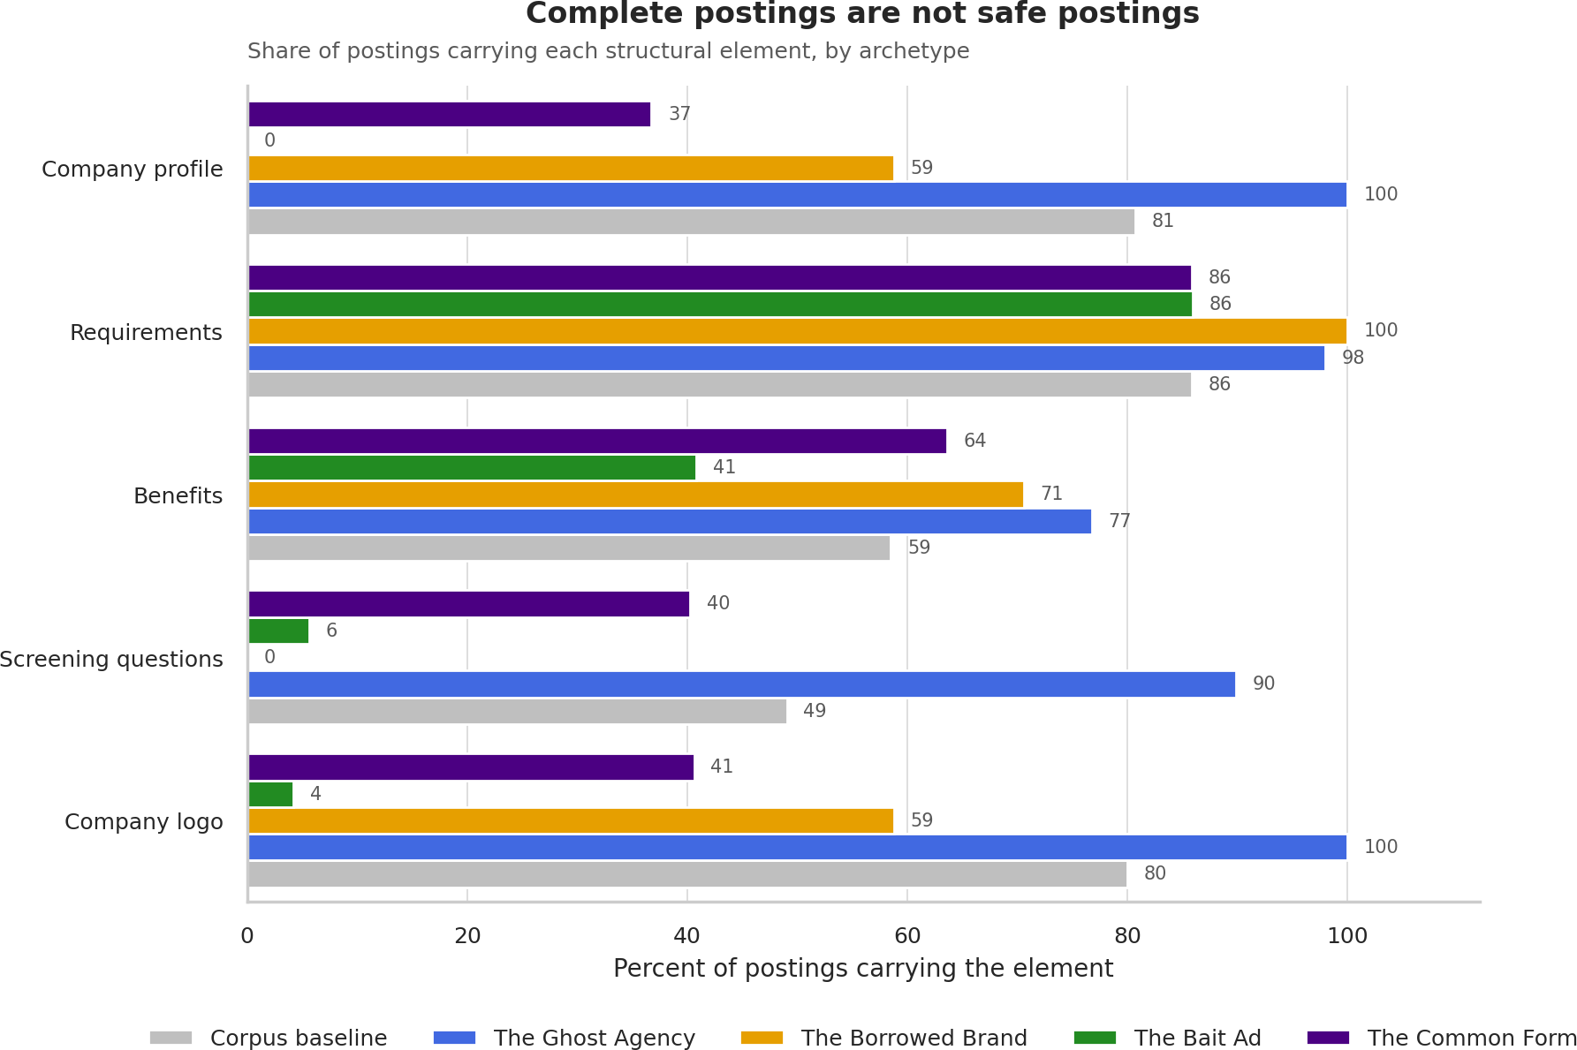
Figure 4. Structural fingerprint of each archetype against the corpus baseline, showing that completeness does not indicate legitimacy.
Together the archetypes reverse an intuition underlying most heuristic fraud detection. The crudest fraud is easiest to catch and the most professional is hardest, and the structural completeness that reads as legitimacy is precisely what the largest operator in this dataset invested in.
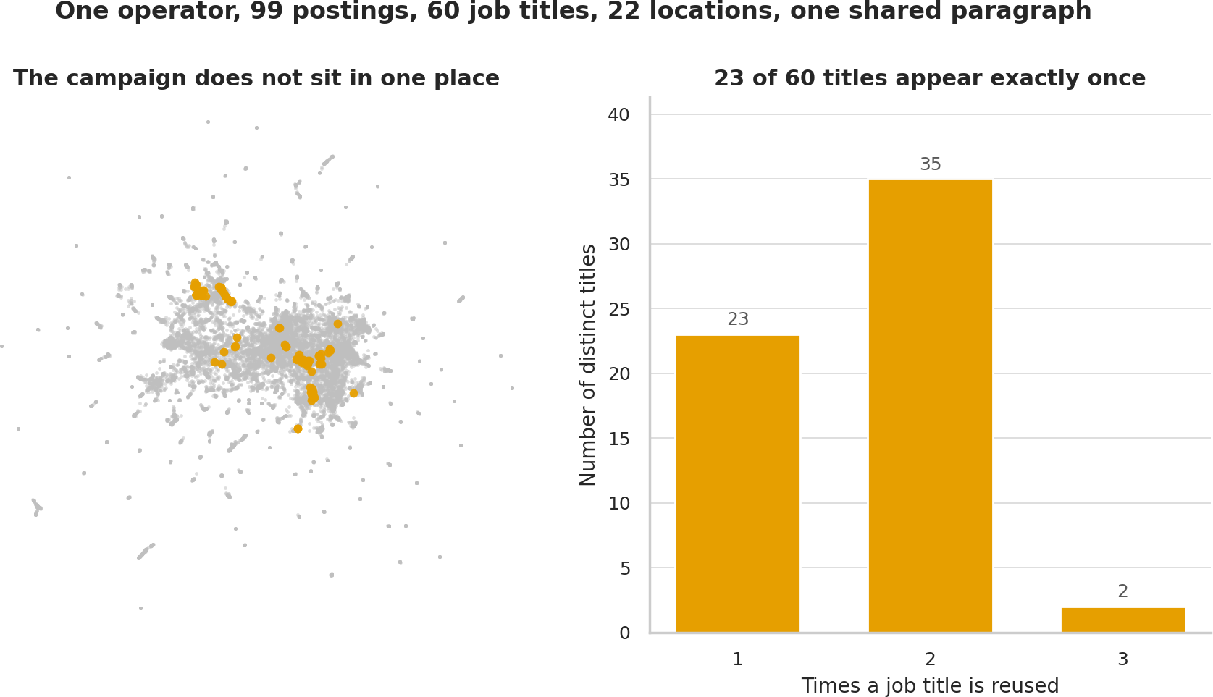
Figure 5. The Ghost Agency campaign: 99 postings, 60 job titles, 22 locations, all sharing one signature paragraph.

Conclusion
Fraudulent job postings both concentrate and scatter. Roughly seventy percent of fraud can be surfaced by grouping postings on language alone, within under ten percent of the corpus, and the remaining thirty percent is not reachable by clustering at all. Fraud organizes along two independent axes, the offer being made and the identity being claimed, and a method capturing one will miss much of the other.
For a trust and safety team the practical result is that reviewing roughly one posting in ten, selected by these methods, surfaces seven of every ten scams. For a job seeker the result is a vocabulary: four recognizable shapes a fraudulent posting takes, three of which can be described without any statistical training.

Assumptions
I assumed the platform’s fraud annotations approximate ground truth closely enough to serve as an evaluation reference, that patterns present in 2012 to 2014 postings retain some relevance to current fraud, that the five text fields carry the signal of interest, and that cosine distance on normalized embeddings and Euclidean distance on the reduced space are appropriate similarity measures for this data.

Limitations
The most serious limitation concerns the labels. Within one recruiter’s postings I found byte identical company descriptions where the dataset labels one posting fraudulent and two others legitimate. If the label distinguishes documents that are textually indistinguishable, it encodes information outside the text, most plausibly complaints received or account action taken after publication. No text based method can recover that, and it places a ceiling on what any result here, mine or anyone’s, can claim.
Approximately 28% of fraudulent postings fall outside every cluster either method identified. A single operator accounts for 13.9% of all fraud, so the concentration result partly measures one actor being prolific rather than many distinct families existing. The embedding model is uncased and therefore blind to capitalization and punctuation irregularities a human reader treats as strong signals. Mean pooling weights long fields more heavily than short ones. Finally, the dataset is more than a decade old, and modern scam categories such as the paid coaching call are absent entirely.

Challenges
Three challenges shaped the work. Truncation was discovered only after the first embedding run, when a diagnostic showed the benefits field was never seen for 81.3% of postings; rebuilding with chunking cost a pipeline stage but corrected a defect that would have invalidated the results. The comparison baselines reversed my central methodological assumption, requiring the methods argument to be rewritten around the finding rather than the plan. And the minimum cluster size produced a family split across two clusters, which I recovered by testing shared phrases, confirming one operator at 100% precision across four template phrases.

Future Uses and Additional Applications
The immediate extension is research question three, testing whether 2025 and 2026 postings fall into these archetypes or form new ones. Typography features such as capitalization consistency and misspelling rates would capture signal the embedding model structurally cannot see, and embedding each field separately would prevent long marketing text from outweighing short compensation claims. The method is domain general and would apply to rental listings, marketplace advertisements, or any venue where a fraudulent offer must imitate a legitimate one.

Recommendations
First, run both representations rather than choosing between them. They find different fraud, and the union captures 71.7% of scams within 9.8% of the corpus, which neither achieves alone.
Second, use clustering to discover campaigns and then extract their distinctive phrases as exact match rules. In this dataset four template phrases identified 99 postings at 100% precision, including three that the clustering itself missed. Discovery is expensive and matching is nearly free, so the sequence matters.
Third, treat the archetype as a scrutiny level rather than a verdict. Three of the four are strong fraud indicators; the fourth contains real employers and must never be used to act against a poster automatically.
Fourth, do not treat structural completeness as evidence of legitimacy. The largest fraud operator in this dataset scored higher on company profile, logo, and screening questions than the average genuine employer. Employer verification, not posting quality, is the only defense against the Borrowed Brand and the Ghost Agency.

Implementation Plan
The archetype signal is designed to deploy into the existing Verify This Job application, which already combines a fine tuned language model with an independent rule based safety net. Adding a third signal requires only the fitted TF-IDF vectorizer and a matrix of cluster centroids: a new posting is vectorized, compared to the centroids by cosine similarity, and assigned to its nearest archetype, whose reference fraud rate is reported alongside the existing verdict. The structural features require no model at all.
This avoids shipping the embedding model, the UMAP reducer, or the clustering model, none of which are needed once the archetypes are fixed. It also addresses a real gap: the Borrowed Brand and Ghost Agency archetypes are invisible to both the fine tuned model and the rule based net, because those postings are structurally perfect. Archetype matching is the only one of the three signals that can flag them.
For a job board rather than a consumer tool, the same components would run as a nightly batch, with high lift archetype matches routed to human review and confirmed campaigns converted into phrase rules applied at submission time.

Ethical Assessment
Seven concerns apply to this project. Each is identified, assessed for likelihood and impact, and paired with the mitigation applied.
Concern | Likelihood | Impact | Mitigation applied
Harm to legitimate employers whose postings fall inside fraud dense groups | High | Moderate to high | Report fraud rates per cluster rather than labeling clusters as fraudulent; present archetypes as scrutiny levels, not verdicts; no employer named in any published output
Label validity, given annotations assigned by platform staff more than a decade ago | High | Moderate | Treat labels as a reference point rather than truth; report the case of identical text carrying opposite labels; state the resulting ceiling explicitly
Privacy of individuals and organizations named in the postings | Moderate | Moderate | All organization and individual names masked in every displayed output through a redaction layer applied before printing
Potential for misuse, since describing what makes a posting recognizable also describes how to avoid recognition | Low | Moderate | Signatures described at the level of themes and structural patterns; no publishable word list or template text reproduced
Fairness across industries and regions, if scam heavy sectors become proxies for suspicion | Moderate | Moderate | Industry and location composition reported alongside fraud rates; archetypes defined by behavior rather than sector
Researcher bias in interpretation, since I chose which clusters to read and how to name them | Moderate | Moderate | Representative members selected by membership confidence or random sample with a fixed seed rather than by hand; naming grounded in printed evidence
Data sourcing and terms of use | Low | Low | Public research dataset used under its stated license; no scraping; every transformation documented in the notebook

Changes made to the data. I removed 2,008 rows: one posting with no description, one document under five words, and 2,006 exact duplicates. I derived nine features and normalized anonymization placeholders to plain words. Nothing was imputed and no outliers removed. Every filtering decision is stated with its count in the notebook; the five word minimum was set only after measuring that very short postings are fraud enriched, so it removed degenerate rows without discarding signal. Nothing was filtered silently.
Legal standing, presentation risk, and sourcing. The dataset is published for research use, contains no personal information beyond what employers chose to publish, and no protected attributes are used as features. A production deployment acting against real employers would raise fair notice questions a research analysis does not, which is why the recommendations stop at routing for human review. Two transformations carry risk: deduplication removed a genuine fraud signal, mitigated by recording copy counts first, and mean pooling underweights short fields. Presenting fraud rates by cluster invites a reader to treat membership as a verdict, which the Common Form archetype makes unsafe, so that caution is repeated in the Conclusion and the Recommendations. The identity masking applied here reduces amplification of names in published results but cannot make a public research dataset private, and the redaction list itself remains visible in the notebook source.

Code and Reproducibility
The complete analysis is contained in a single notebook, HollisT_Proj1MS2_DSC680.ipynb, which runs top to bottom and reproduces every figure and table in this paper. The notebook and the five figures are available at https://github.com/TTHollis/DataSciencePortfolio/tree/main/projects/ScamSignatures. Embeddings are cached to avoid recomputation, and all random seeds are fixed. The source dataset is not redistributed; the notebook locates it or prompts for it.

References
Bansal, S. (2020). Real or fake: Fake job posting prediction [Data set]. Kaggle. https://www.kaggle.com/datasets/shivamb/real-or-fake-fake-jobposting-prediction
Federal Trade Commission. (2024, December 12). New FTC data show skyrocketing consumer reports about game-like online job scams [Press release]. https://www.ftc.gov/news-events/news/press-releases/2024/12/new-ftc-data-show-skyrocketing-consumer-reports-about-game-online-job-scams
Grootendorst, M. (2022). BERTopic: Neural topic modeling with a class-based TF-IDF procedure. arXiv. https://doi.org/10.48550/arXiv.2203.05794
Hubert, L., & Arabie, P. (1985). Comparing partitions. Journal of Classification, 2(1), 193-218. https://doi.org/10.1007/BF01908075
McInnes, L., Healy, J., & Astels, S. (2017). hdbscan: Hierarchical density based clustering. Journal of Open Source Software, 2(11), 205. https://doi.org/10.21105/joss.00205
McInnes, L., Healy, J., & Melville, J. (2018). UMAP: Uniform manifold approximation and projection for dimension reduction. arXiv. https://doi.org/10.48550/arXiv.1802.03426
Reimers, N., & Gurevych, I. (2019). Sentence-BERT: Sentence embeddings using Siamese BERT-networks. In Proceedings of the 2019 Conference on Empirical Methods in Natural Language Processing (pp. 3982-3992). Association for Computational Linguistics. https://doi.org/10.18653/v1/D19-1410
Rousseeuw, P. J. (1987). Silhouettes: A graphical aid to the interpretation and validation of cluster analysis. Journal of Computational and Applied Mathematics, 20, 53-65. https://doi.org/10.1016/0377-0427(87)90125-7
Vidros, S., Kolias, C., Kambourakis, G., & Akoglu, L. (2017). Automatic detection of online recruitment frauds: Characteristics, methods, and a public dataset. Future Internet, 9(1), 6. https://doi.org/10.3390/fi9010006

Appendix A: Supporting Documentation

A1. Archetype to cluster mapping
Archetypes were assigned in precedence order so that a posting appearing under both representations receives a single label. The Ghost Agency was assigned first because its membership is phrase verified at 100% precision, followed by the Borrowed Brand, the Bait Ad, and the Common Form.
Archetype | Source representation | Cluster identifiers | Assignment basis
The Ghost Agency | TF-IDF | 37, 41, plus three outside | Exact match on four template phrases
The Borrowed Brand | TF-IDF | 2 | Cluster membership
The Bait Ad | Embeddings | 66, 35 | Cluster membership
The Common Form | Both | 170, 171, 138, 139, 67 | Cluster membership

A2. Template phrase evidence for the Ghost Agency
Four phrases drawn from the two clusters were matched across the full corpus. Every posting containing any of them is annotated fraudulent, and the matches span both clusters, confirming a single operator behind two brand identities.
Phrase (abbreviated) | Postings | Fraud rate | Clusters spanned
"leveraging your career" | 78 | 100% | 37, 41, and three others
"redesigned the recruiting wheel" | 35 | 100% | 37
"have partnered up in an effort to streamline" | 43 | 100% | 37, 41, and three others
"Represented candidates" | 56 | 100% | 37, 41
Union of all four | 99 | 100% | 37, 41, and three others

A3. HDBSCAN parameter sweep
The minimum cluster size was chosen from this sweep before the labels were revealed. Silhouette scores are computed on the reduced space and are optimistic by construction, since dimensionality reduction increases separation; they are used here only to compare settings against one another.
Minimum cluster size | Clusters | Noise | Silhouette | Largest cluster
10 | 411 | 28.3% | 0.701 | 269
15 | 280 | 28.4% | 0.683 | 327
25 (selected) | 173 | 31.4% | 0.651 | 327
40 | 108 | 37.5% | 0.629 | 335
60 | 64 | 36.1% | 0.530 | 750
100 | 36 | 43.8% | 0.539 | 769

Ten Questions an Audience Would Ask
1. This dataset was used in two of your previous courses. What is genuinely new here, and how do you avoid simply re-reporting earlier results?
2. How do you know your clusters are capturing fraud patterns rather than industries? Several of your high lift clusters look like occupational categories.
3. The data is from 2012 to 2014. Why should a trust and safety team today act on patterns found in decade old postings?
4. A single operator accounts for 13.9% of all fraud in your dataset. Does that mean your concentration finding is really a finding about one scammer?
5. The literature generally favors sentence embeddings over TF-IDF for text clustering. Why did the opposite hold here, and would it hold on a different corpus?
6. What happens to a legitimate employer whose posting lands in a cluster that is 90% fraudulent? What recourse would they have?
7. In production there are no labels. How would you know whether the archetypes were still working, or whether the clusters had drifted?
8. You chose a minimum cluster size of 25. How sensitive are your conclusions to that choice, and what would change at 15 or 40?
9. If this method were published and adopted, how quickly could a scam operator adapt to evade it, and what would that adaptation cost them?
10. What would it cost, in compute and in human review time, to run this over a live job board processing thousands of postings a day?

