Predicting Fraudulent Job Postings Using Machine Learning and NLP
DSC630 — Predictive Analytics | Milestone 2: Project Proposal
Tim Hollis | Bellevue University | March 24, 2026

Introduction
The rise of online job platforms has fundamentally changed how people search for employment, but it has also created a growing opportunity for bad actors to exploit job seekers through fraudulent postings. These postings range from phishing attempts designed to harvest personal information to advance-fee scams that extract money from applicants under the pretense of securing a position. The consequences for victims can be severe, including financial loss, identity theft, and significant emotional harm during an already vulnerable period of their lives.
This project proposes a binary classification system that uses machine learning and natural language processing to identify fraudulent job postings before they reach job seekers. By analyzing both structured metadata and unstructured text content within job listings, the goal is to build a model capable of flagging suspicious postings with high precision and recall. Beyond the technical problem, this work carries meaningful ethical weight: an effective detection system has the potential to protect vulnerable populations and improve trust in online hiring platforms.

Problem Statement
The core problem is a binary classification task: given a job posting, can a machine learning model reliably distinguish between a legitimate listing and a fraudulent one? This is complicated by several factors. Fraudulent postings are intentionally designed to appear legitimate, often mimicking the tone and structure of real listings. The dataset is also heavily imbalanced, with fraudulent postings representing a small minority of all entries, which means naive models will tend to classify everything as legitimate and still achieve high accuracy while failing to detect nearly all fraud cases.
Addressing this problem requires a combination of structured feature engineering and text-based NLP techniques that can surface the subtle linguistic patterns that differentiate fraudulent postings from legitimate ones. The stakes of mis-classification are asymmetric: a false negative, meaning missing a fraudulent posting, is significantly more harmful than a false positive, meaning flagging a legitimate one. This asymmetry has direct implications for how the model should be evaluated and optimized.

Dataset
The primary dataset for this project is the Employment Scam Aegean Dataset (EMSCAD), available on Kaggle as the Real or Fake Job Posting Prediction dataset (Shivamb, 2020). The dataset contains 17,880 job postings, of which 16,244 are genuine and 1,636 are fraudulent, representing an approximate 91/9 class split. Each posting includes 18 features covering a mix of structured metadata and free-text fields.
Key structured features include:
- Location, employment type, required experience, and required education
- Boolean flags indicating whether the posting has a company logo or screening questions
- Salary range and industry classification
Key text features include:
- Job title, company profile, job description, requirements, and benefits
- These fields contain the richest signals for NLP-based fraud detection
Notably, several columns such as department and salary range contain a significant number of missing values, which will be addressed during pre-processing. The class imbalance is a known challenge with this dataset and will be handled through techniques such as SMOTE or class weighting during model training.

Planned Models and Rationale
This project will use a progression of models, starting with a simple interpret-able baseline and building toward more complex ensemble methods.

Logistic Regression (Baseline)
Logistic regression will serve as the baseline model. It is interpret-able, computationally efficient, and well suited for binary classification tasks. A baseline is essential for establishing a performance floor against which more complex models can be meaningfully compared. TF-IDF vectorization will be applied to the text fields before feeding them into the logistic regression model.

Random Forest (Primary Model)
Random Forest is the planned primary model. It handles mixed data types well, is robust to missing values, and naturally accommodates class imbalance through class weighting. Existing research on this dataset has found Random Forest to be among the strongest performers, with some studies reporting F1 scores above 98% (Vidros et al., 2017). Its feature importance output will also provide useful insight into which signals are most predictive of fraud.

TF-IDF for NLP Feature Extraction
Term Frequency-Inverse Document Frequency vectorization will be used to convert the free-text fields into numeric features for model input. TF-IDF is well established for this type of classification task and should effectively surface the word patterns that distinguish fraudulent postings, such as vague language, unrealistic compensation claims, and requests for personal information.

Evaluation Plan
Given the class imbalance in this dataset, accuracy alone is a misleading metric. A model that classifies every posting as legitimate would achieve roughly 91% accuracy while failing to detect a single fraudulent listing. The following metrics will be used instead:
- F1 Score: The harmonic mean of precision and recall, balancing the cost of false positives and false negatives. This is the primary evaluation metric.
- AUC-ROC: Measures the model ability to discriminate between classes across all classification thresholds.
- Confusion Matrix: Will be used to visualize false negative and false positive rates directly, given the asymmetric cost of misclassification in this domain.
A standard 80/20 train-test split will be used, with cross-validation applied during model training to reduce the risk of overfitting.

Learning Goals
This project is an opportunity to develop practical skills across several areas that are central to applied data science. The primary learning goals are:
- Gain hands-on experience with NLP preprocessing pipelines including tokenization, stopword removal, and TF-IDF vectorization applied to real-world text data
- Understand how to handle severely imbalanced datasets in a classification context and evaluate the tradeoffs between different resampling and weighting strategies
- Compare a simple baseline model against an ensemble method and articulate where and why performance differences emerge
- Explore what linguistic and structural patterns most reliably characterize fraudulent job postings, and whether those patterns align with domain intuition

Risks and Ethical Implications
Several risks and ethical considerations below are relevant to this project:

Class imbalance and recall
  - The most immediate technical risk is that the class imbalance leads to a model with poor recall on the minority class. Missing a fraudulent posting is a more harmful outcome than falsely flagging a legitimate one, so the model will need to be tuned with that asymmetry in mind. Oversampling techniques such as SMOTE will be explored as a mitigation strategy.

Bias and fairness
  - There is a risk that the model learns to associate certain industries, locations, or job types with fraud in ways that reflect the composition of the training data rather than genuine fraud signals. This could result in legitimate postings from certain sectors being disproportionately flagged. Feature importance analysis will be used to inspect whether any such patterns emerge.

Generalizability
  - The EMSCAD dataset was collected from a specific platform over a defined time period. Fraud tactics evolve rapidly, and a model trained on this data may not generalize well to newer or more sophisticated fraudulent postings. Any conclusions drawn from this project should be framed as exploratory rather than prescriptive for real-world deployment.

Contingency Plan
If the EMSCAD dataset proves insufficient or unworkable for any reason, an alternative dataset is available. The Fake Job Postings dataset by Srisai Suhas Sanisetty is also available on Kaggle and covers a similar problem space with a comparable structure. Both datasets are well documented and widely used in academic and student projects, which provides a strong fallback option.
If the NLP-based approach proves too computationally demanding within the available tooling, the scope can be narrowed to structured features only, using the metadata columns rather than free-text fields. This would reduce model complexity while still producing a meaningful classification result, though likely at the cost of some predictive power. The project could then frame this tradeoff as a finding rather than a limitation.

Conclusion
This project proposes a practical and socially meaningful application of machine learning and NLP to the problem of fraudulent job postings. Using the EMSCAD dataset, the plan is to build and compare a logistic regression baseline against a Random Forest classifier, using TF-IDF vectorization to incorporate text-based signals. Evaluation will be driven by F1 score and AUC-ROC given the class imbalance, and the project will maintain a careful distinction between what the data directly shows and what is reasonably inferred. The work has real-world relevance and aligns well with the core themes of predictive analytics as a discipline.

References
Alghamdi, B., & Alharby, F. (2019). An intelligent model for online recruitment fraud detection. Journal of Information Security, 10(3), 155-176. https://doi.org/10.4236/jis.2019.103009
Shivamb. (2020). Real or fake? Fake job posting prediction [Data set]. Kaggle. https://www.kaggle.com/datasets/shivamb/real-or-fake-fake-jobposting-prediction
Vidros, S., Kolias, C., Kambourakis, G., & Akoglu, L. (2017). Automatic detection of online recruitment fraud: Characteristics, methods, and a public dataset. Future Internet, 9(1), 6. https://doi.org/10.3390/fi9010006

Predicting Fraudulent Job Postings Using Machine Learning and NLP
DSC630 — Predictive Analytics | Milestone 3: Preliminary Analysis
Tim Hollis | Bellevue University | April 22, 2026

Updated Class Balance
Initial review of the EMSCAD dataset reveals a more severe class imbalance than originally anticipated in Milestone 2. The dataset contains 17,014 legitimate postings (95.2%) and 866 fraudulent postings (4.8%), representing an approximate 95/5 split rather than the 91/9 split cited in the original proposal. This correction is meaningful: a naive model that classifies every posting as legitimate would now achieve 95.2% accuracy while detecting zero fraud cases. This reinforces the original decision to prioritize the F1 score and AUC-ROC over accuracy as the primary evaluation metrics, and makes the case for SMOTE or class weighting even stronger than previously stated.

Can I Answer the Questions I Want to Answer?
Yes — the data supports the core research question. The dataset contains sufficient volume (17,880 records), a meaningful fraud signal (866 confirmed fraudulent postings), rich text fields for NLP analysis (description, requirements, company_profile), and structured metadata features that already show measurable variation in fraud rates. The binary target variable fraudulent is clean with no missing values, which removes one significant preprocessing burden.
The most important qualification is that the heavy missingness in several columns will limit how broadly those features can be used. Salary range is missing in 84.0% of rows, department in 64.6%, required education in 45.3%, and benefits in 40.3%. These columns cannot serve as primary features without imputation or exclusion, and the imputation choices will need to be carefully justified in Milestone 4. Despite this, the text-based columns and structural boolean flags remain largely intact and are expected to carry the majority of the predictive signal.

What Visualizations Are Most Useful?
Four visualizations were produced during initial EDA and each addresses a distinct dimension of the fraud detection problem (in PDF version of notebook file as well).
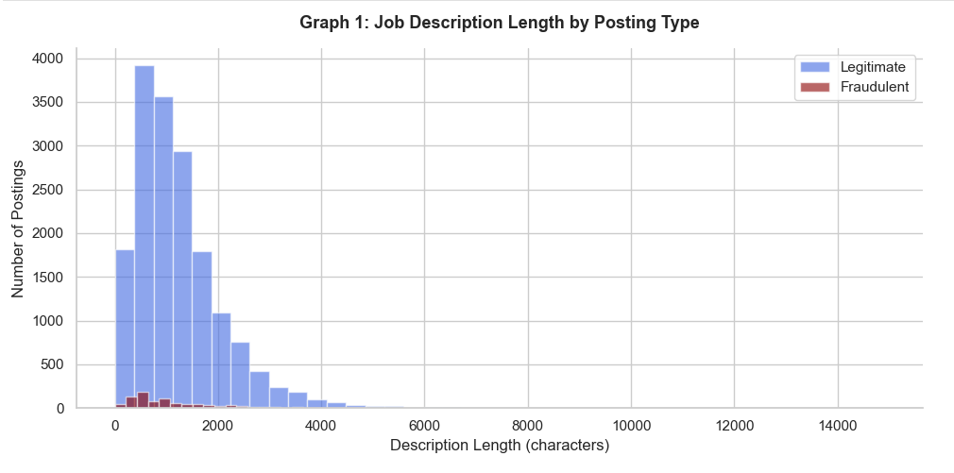
The first visualization reveals that legitimate postings have a mean description length of 1,221 characters compared to 1,155 characters for fraudulent postings. While the difference in means is modest, the distribution shape tells a more meaningful story legitimate postings spread across a much wider range of lengths with many highly detailed listings, while fraudulent postings cluster more tightly at shorter lengths. This suggests fraudulent actors invest less effort in crafting realistic content and motivates description length as an engineered numeric feature in Milestone 4.
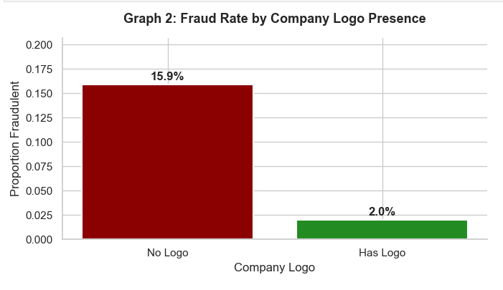

The second visualization produces one of the strongest single-feature signals in the dataset. Postings without a company logo show a fraud rate of 15.9% compared to just 2.0% for postings that include one, nearly an eight-fold difference. This boolean feature is completely observed with no missing values and will be a strong candidate for both the logistic regression baseline and the Random Forest model.
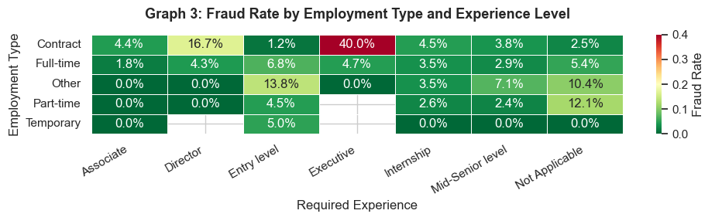
The third visualization reveals interaction effects between two categorical variables that neither captures alone. The most striking cell is Contract/Executive at 40.0% — meaning 4 in 10 contract postings targeting executive-level candidates are fraudulent, nearly eight times the overall dataset rate of 4.8%. The concentration of fraud in specific cells rather than being evenly distributed confirms that the interaction between these two features carries meaningful predictive signal beyond either variable individually.

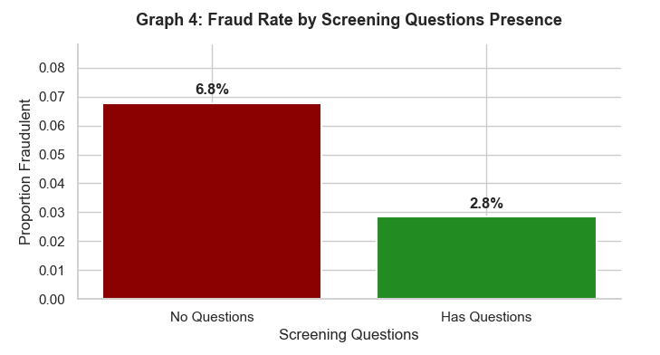

The fourth visualization shows that postings without screening questions have a fraud rate of 6.8% compared to 2.8% for postings that include them. Like the company logo feature, has_questions is fully observed with no missing values. The absence of screening questions suggests a posting designed to collect personal information rather than genuinely evaluate candidates, making it a reliable structural fraud signal.

Do I Need to Adjust the Data or Driving Questions?
The core driving question remains valid and does not need to change: Can a machine learning model reliably distinguish fraudulent job postings from legitimate ones using structured metadata and text-based features? The data clearly supports this question. However, two adjustments are warranted based on EDA findings:
- The class imbalance figure in the proposal should be updated from 91/9 to 95/5 throughout. This is a factual correction and affects the framing of the modeling challenge.
- Salary_range and department should be deprioritized as primary features given their extreme missingness. If retained at all, they will require a missing-as-a-category approach rather than imputation, treating the absence of salary information itself as a potential fraud signal — which is a reasonable domain hypothesis worth testing.

Do I Need to Adjust My Model or Evaluation Choices?
No major adjustments are needed. The logistic regression baseline and Random Forest primary model remain well suited to this problem. The evaluation framework of F1 score, AUC-ROC, and confusion matrix is appropriate and is reinforced by the EDA findings.
One refinement worth noting: given the 95/5 imbalance, precision-recall curves may be more informative than ROC curves in this specific context. ROC curves can be overly optimistic when the negative class dominates this severely. Adding a precision-recall curve to the evaluation plan will provide a more honest picture of model performance at the operating threshold where fraud detection actually matters (Davis & Goadrich, 2006).

Are My Original Expectations Still Reasonable?
Largely yes, with one important update. The expectation that text-based NLP features would carry strong predictive signal is supported by the structure of the data — the description, requirements, and company_profile fields are rich and largely complete. The expectation that structural features like has_company_logo and has_questions would be useful is strongly confirmed by Graph 4, which shows fraud rates of 15.9% and 6.8%, respectively, for postings missing these features.
The one area where expectations need recalibration is the severity of the class imbalance. At 4.8% fraud prevalence rather than 9%, SMOTE or aggressive class weighting will be essential rather than optional. A model that achieves high F1 on the minority class under this level of imbalance will represent a genuinely strong result.
Overall, the data supports the project as originally conceived, and the EDA findings provide a clearer roadmap for the data preparation and modeling work ahead.

References
Alghamdi, B., & Alharby, F. (2019). An intelligent model for online recruitment fraud detection. Journal of Information Security, 10(3), 155– 176. https://doi.org/10.4236/jis.2019.103009
Davis, J., & Goadrich, M. (2006). The relationship between precision-recall and ROC curves. Proceedings of the 23rd International Conference on Machine Learning, 233– 240. https://doi.org/10.1145/1143844.1143874
Shivamb. (2020). Real or fake? Fake job posting prediction [Data set]. Kaggle. https://www.kaggle.com/datasets/shivamb/real-or-fake-fake-jobposting- prediction
Vidros, S., Kolias, C., Kambourakis, G., & Akoglu, L. (2017). Automatic detection of online recruitment fraud: Characteristics, methods, and a public dataset. Future Internet, 9(1), 6. https://doi.org/10.3390/fi9010006

