Predicting Billboard Hot 100 Chart Success
Using NLP-Derived Lyrical Features

Author: Tim Hollis
Bellevue University
DSC550 - Data Mining
Professor Andrew Hua
Date: May 19, 2026

Table of Contents
Introduction 3
Problem Statement 3
Why the Problem Matters 3
Stakeholder Pitch 3
Data Source 3
Organized Summary of Milestones 1-3 4
Milestone 1: Exploratory Data Analysis 4
Milestone 2: Data Preparation 5
Milestone 3: Model Building and Evaluation 6
Final Updates Added Since Milestone 3 7
Conclusion 9
What the Analysis Tells Us 9
Deployment Readiness 9
Recommendations 9
Challenges and Opportunities 9
References 10

Introduction

Problem Statement

The music industry is a multi-billion-dollar ecosystem in which record labels, independent artists, and streaming platforms must decide which songs to sign, promote, and feature. Many of these decisions are made under uncertainty and with limited quantitative support.
This project addresses one central business question: Can the lyrical characteristics of a song predict whether it will achieve top-10 status on the Billboard Hot 100? Reaching the top 10 is a meaningful threshold because it reflects elite commercial performance across streaming, airplay, and digital sales.

Why the Problem Matters

Most chart-prediction work focuses on audio features such as tempo, danceability, or energy. This project instead uses natural language processing (NLP) to measure lyrical length, sentiment, and repetitiveness directly from song lyrics. That framing mirrors how artists, songwriters, and A&R teams often discuss commercial appeal: not only how a song sounds, but also how direct, memorable, and emotionally accessible the lyrics are.
The practical value is a low-cost screening tool. A model that flags lyrical characteristics associated with chart success could support A&R review, help independent artists understand commercial patterns, and help streaming platforms identify songs worth additional promotion. The model should not replace human judgment; it should make early review more focused and evidence-driven.

Stakeholder Pitch

To gain stakeholder buy-in, I would pitch this as an early-stage decision-support tool. Labels and platforms invest heavily in tracks before they know whether a song has mainstream potential. This proof-of-concept shows that even three simple lyrical features can separate top-10 songs from the rest with measurable discriminative power. The immediate business use is not automatic release approval, but a pre-screening layer that helps teams prioritize songs for deeper review before committing expensive marketing resources.

Data Source

The data comes from the Billboard Hot-100 [2000-2023] dataset on Kaggle (Biswas, 2023). It includes 3,397 year-end chart records with full lyrics, chart metadata, and Spotify-related audio fields. The project uses the lyrics column as the primary source for NLP feature engineering and creates a binary target, top_10, from the Billboard ranking column.

Column | Role | Final Use
ranking | Original chart rank | Used only to create top_10; dropped to prevent leakage
lyrics | Full song lyrics | Source for all NLP features
lyric_length | Engineered predictor | Total word count
lyric_sentiment | Engineered predictor | VADER compound sentiment score
repetitiveness | Engineered predictor | Repeated meaningful words divided by total meaningful words
top_10 | Target | 1 if ranking is 1-10, otherwise 0

Organized Summary of Milestones 1-3

Milestone 1: Exploratory Data Analysis

Milestone 1 created the binary target variable top_10. Songs ranked 1-10 were labeled as chart successes, while all other songs were labeled 0. The class distribution is structurally imbalanced because only 10 positions on the year-end chart can qualify as top-10 outcomes. The final target rate is approximately 10%, so later modeling uses class weighting and metrics beyond accuracy.
The EDA was revised to emphasize visuals with stronger predictive value. Instead of relying on a graph where the top-10 rate was largely built into the target structure, the final analysis focuses on lyric-length quartiles and lyric sentiment by chart status. These visuals connect more directly to the model goal because they describe features available before model training.
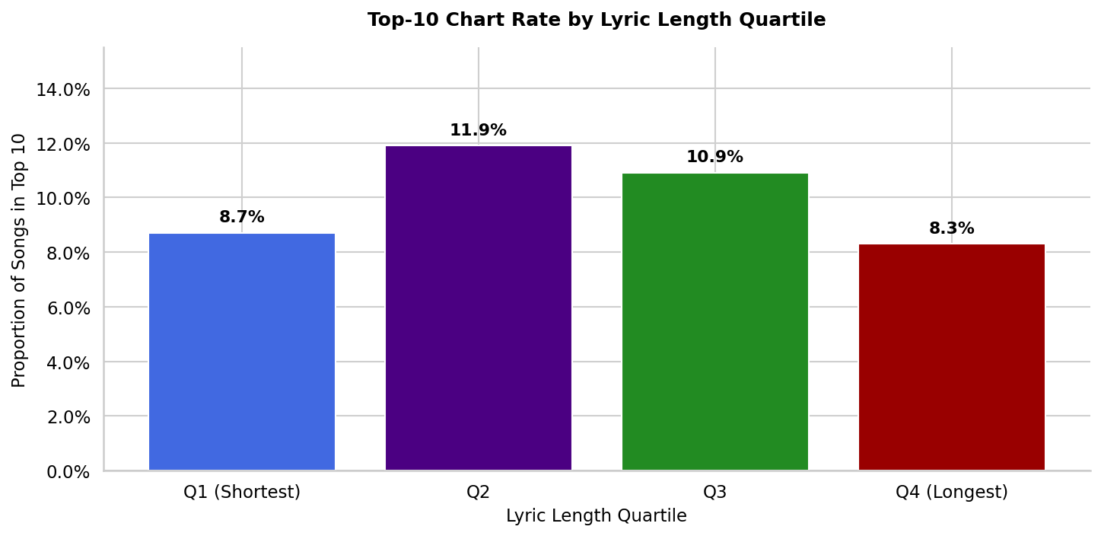
Figure 1. Top-10 rate by lyric-length quartile.
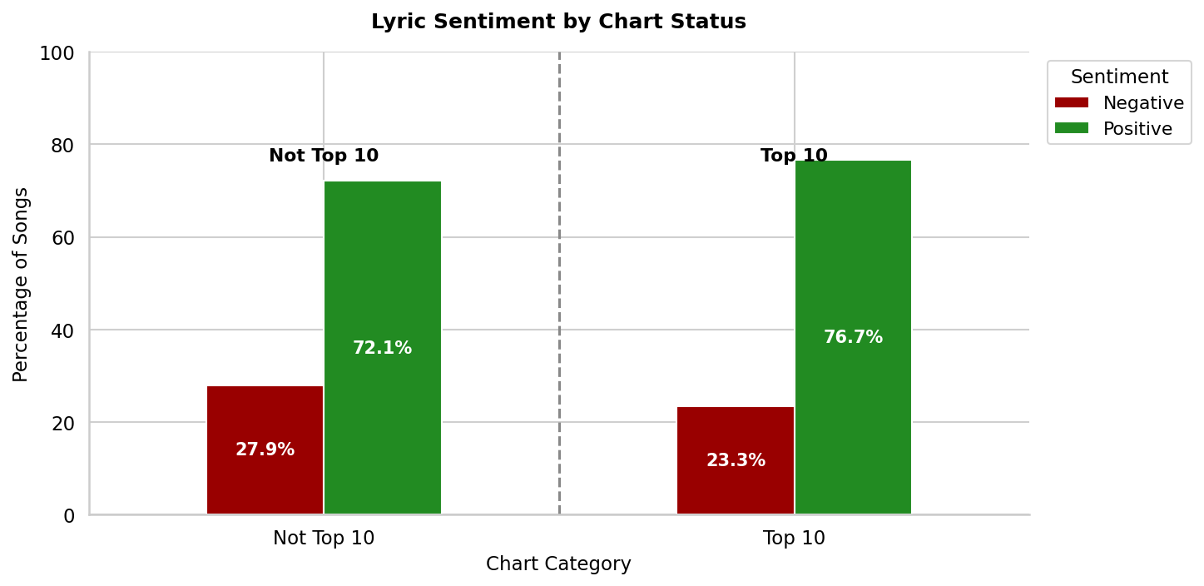
Figure 2. Lyrical sentiment distribution by chart status.
The EDA showed that lyric length has an inverted U-shaped relationship with chart success: middle-length songs performed better than the shortest and longest groups. Sentiment analysis also showed that top-10 songs skewed more positive than non-top-10 songs. These findings justified carrying lyric_length and lyric_sentiment into the modeling phase.

Milestone 2: Data Preparation

Milestone 2 cleaned the dataset and engineered the final NLP feature set. The ranking column was removed after creating top_10 to avoid target leakage. Song title and artist name were dropped because they are high-cardinality identifiers that are unlikely to generalize. Spotify metadata strings were also removed because they do not represent reusable predictive signals.
The largest preparation issue was missingness. The Spotify audio features had 85.69% missing values, concentrated in rows without a Spotify API match. Imputing six of every seven values would have created artificial signal, so those fields were dropped. This required a pivot to an NLP-only feature set, which is reasonable for this milestone because the lyrics column has complete coverage and can be transformed consistently for every song.
- lyric_length counts the total number of words in the lyrics.
- lyric_sentiment uses the VADER compound score from -1 to +1.
- repetitiveness measures repeated meaningful words after punctuation stripping and stopword removal.
Per Milestone 2 feedback, the final notebook now clearly labels full-dataset MinMaxScaler output as an exploratory preview only. The model-ready dataset remains unscaled until Milestone 3, where the scaler is fit on the training set only. A compact output showing top_10 and the three prepared predictors was also added.
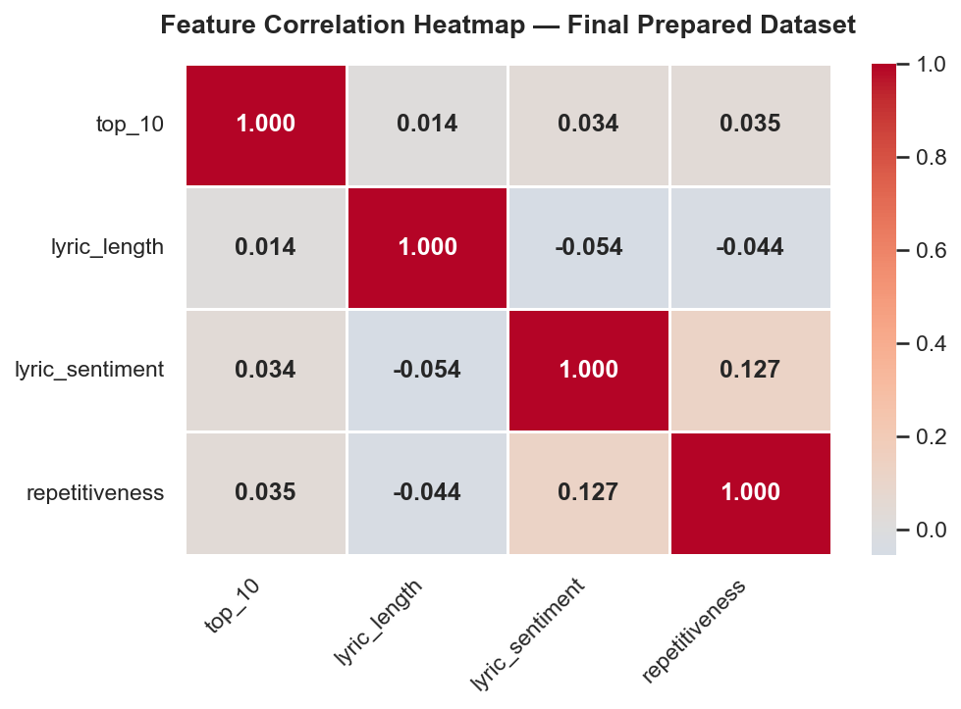
Figure 3. Correlation heatmap for the final model-ready variables.

Milestone 3: Model Building and Evaluation

Milestone 3 trained Logistic Regression and Random Forest classifiers. Logistic Regression served as an interpretable baseline, while Random Forest was selected to capture non-linear interactions among lyric length, sentiment, and repetitiveness. Both models used class_weight='balanced' to address the 90/10 imbalance.
Accuracy was not used as the main performance metric because a model predicting every song as not top 10 would already achieve about 90% accuracy. F1-score for the top-10 class and AUC-ROC were more appropriate because they evaluate minority-class detection and ranking ability.

Model | F1 (Top 10) | AUC-ROC | CV AUC-ROC
Logistic Regression | 0.19 | 0.542 | 0.523 +/- 0.005
Random Forest | 0.59 | 0.778 | 0.733 +/- 0.031
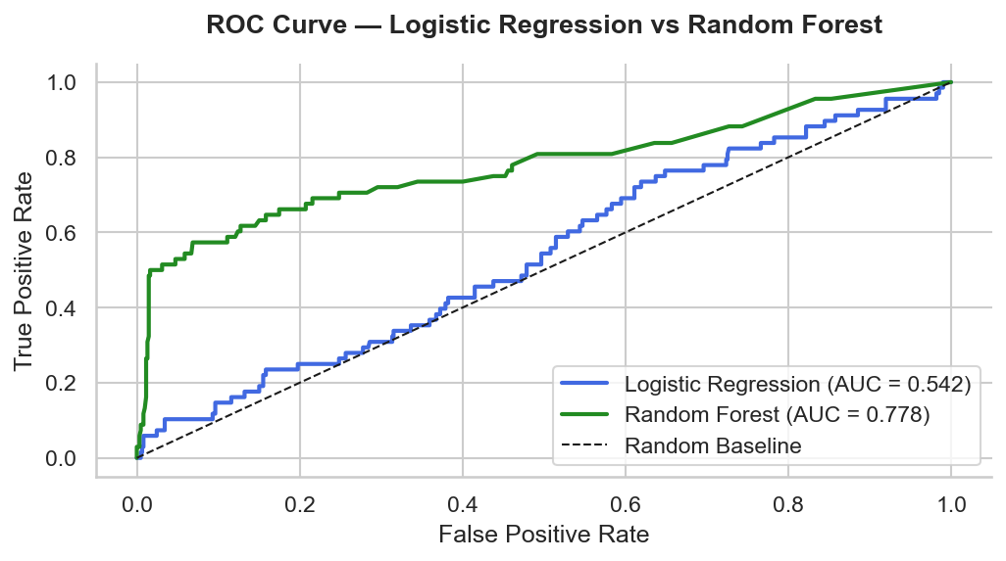
Figure 4. ROC curve comparison for Logistic Regression and Random Forest.
Random Forest outperformed Logistic Regression, achieving a hold-out AUC-ROC of 0.778 and an F1-score of 0.59 for the top-10 class. Five-fold cross-validation was more conservative (mean AUC-ROC 0.733), but still showed Random Forest performing substantially better than Logistic Regression (mean AUC-ROC 0.523). This indicates that the three NLP features contain meaningful predictive signal, while also suggesting that the single hold-out split may be somewhat optimistic.

Final Updates Added Since Milestone 3

The final submission includes new code and analysis beyond Milestone 3. First, nltk.download('stopwords', quiet=True) was added to improve reproducibility in a fresh environment. Second, the notebook now includes a duplicate-lyrics diagnostic to check whether identical lyrics appear across train/test splits. This addresses the concern that duplicate songs or artist-credit duplicates could inflate Random Forest performance.
Third, 5-fold stratified cross-validation was added for both models. This reduces reliance on a single random split and supports the conclusion that Random Forest consistently outperforms Logistic Regression. Fourth, feature-importance and confusion-matrix cells were added to improve interpretability. The confusion matrix is especially important for business use because the dominant risk is false negatives: songs that could become top-10 hits but are missed by the model.
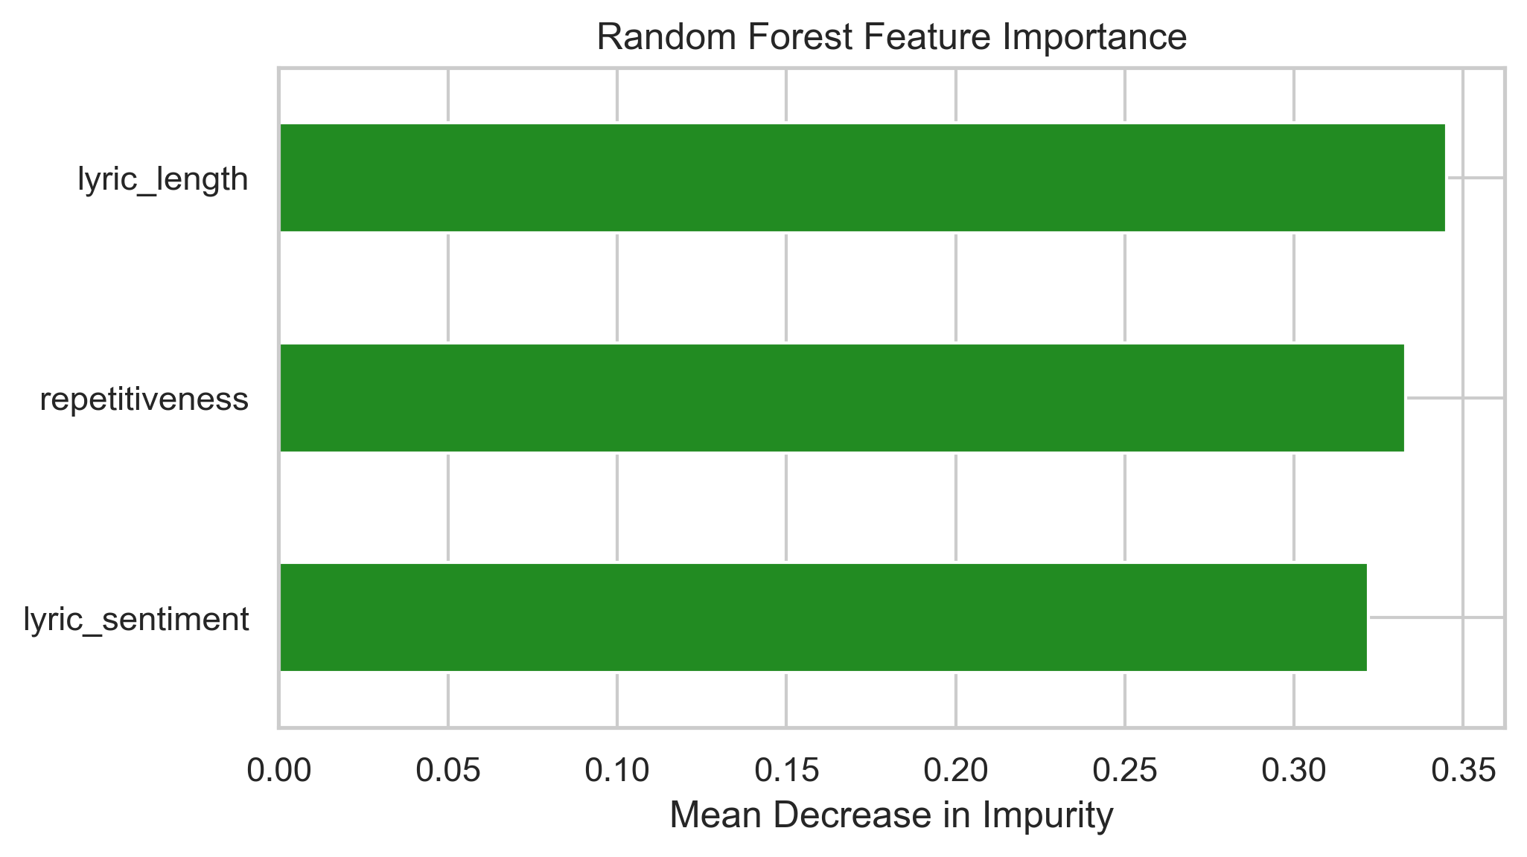
Figure 5. Random Forest feature importance for the final NLP predictors.
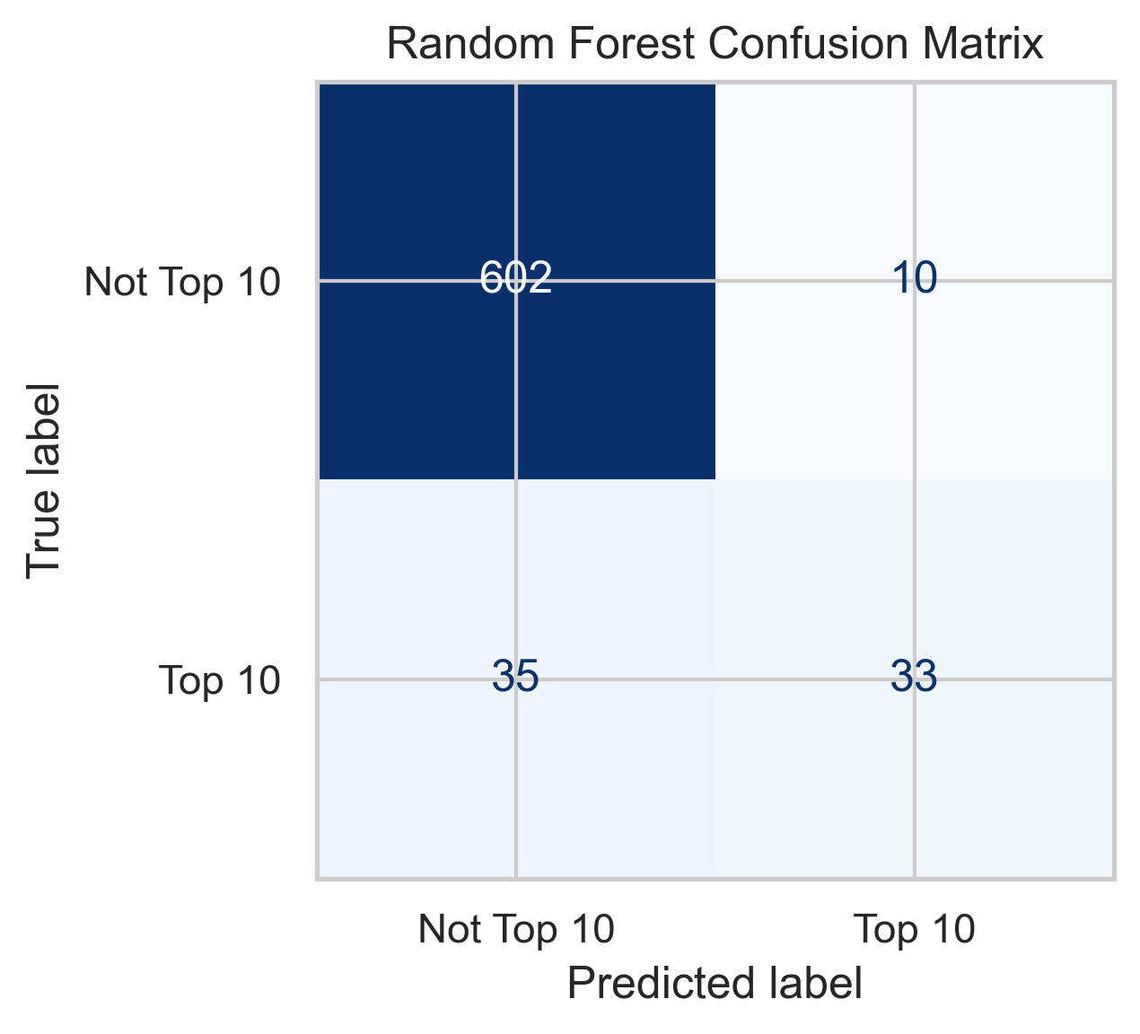
Figure 6. Random Forest confusion matrix on the hold-out test set.

Conclusion

What the Analysis Tells Us

The analysis shows that lyrical characteristics carry measurable, though not complete, predictive signal for Billboard Hot 100 top-10 success. Songs with moderate lyric length, more positive lyrical tone, and more repetitive structure are modestly more likely to reach the top 10. Random Forest captured these relationships better than Logistic Regression, which supports the use of non-linear modeling for this problem.

Deployment Readiness

The model is not ready for deployment. It is a promising proof-of-concept, but the false-negative rate is too high for high-stakes A&R decisions, duplicate lyric records must be handled before final evaluation, and the feature set is intentionally small. A production system would need stronger validation, probability calibration, threshold tuning, and richer lyric features.

Recommendations

- Deduplicate or group identical lyrics before train/test splitting.
- Tune classification thresholds to improve recall for the top-10 class.
- Add TF-IDF, n-gram, topic-modeling, or embedding-based lyric features.
- Recover Spotify audio features through direct API calls and test a hybrid audio + NLP model.
- Use cross-validation for hyperparameter tuning before selecting final Random Forest settings.
- Evaluate probability calibration so business users can interpret model scores as risk-ranked probabilities.

Challenges and Opportunities

The main challenge was missing Spotify feature coverage, which forced a pivot away from audio features. That limitation also creates an opportunity: lyrics are more consistently available than API-derived audio fields, so an NLP-first model may be easier to apply across broader song catalogs. Future work should expand beyond year-end chart data to weekly rankings, add genre and era context, and test richer text representations that capture lyrical themes rather than only summary statistics.

References

Biswas, S. (2023). Billboard Hot-100 [2000-2023] data with features [Data set]. Kaggle. https://www.kaggle.com/datasets/suparnabiswas/billboard-hot-1002000-2023-data-with-features
Han, J., Kamber, M., & Pei, J. (2022). Data mining: Concepts and techniques (4th ed.). Morgan Kaufmann.
Hutto, C. J., & Gilbert, E. E. (2014). VADER: A parsimonious rule-based model for sentiment analysis of social media text. Proceedings of the Eighth International AAAI Conference on Weblogs and Social Media. https://ojs.aaai.org/index.php/ICWSM/article/view/14550

