Predicting Fraudulent Job Postings Using Machine Learning and Natural Language Processing
An Analytical Approach to Identifying Employment Scams
Author:
Timothy Hollis
Bellevue University
DSC630 – Predictive Analytics
Professor Andrew Hua
Date: May 12, 2026

Table of Contents

Introduction 3
Problem Statement and Research Question 3
Dataset Overview 3
Exploratory Data Analysis 4
Data Preparation and Feature Engineering 6
Missing Value Handling 6
Text Preprocessing 7
Structured Feature Construction 7
Class Imbalance Handling 7
Modeling Approach 7
Logistic Regression Baseline 8
Random Forest Primary Model 8
Results 8
Interpretation and Recommendations 11
Risks, Ethics, and Limitations 12
Conclusion 12
References 13

Introduction

Online job platforms have reshaped how people search for employment, but they have also created opportunities for bad actors to exploit job seekers through fraudulent postings. These postings may be phishing attempts, advance-fee scams, or other attempts to collect money and personal information from applicants. The consequences can include financial loss, identity theft, and emotional harm during an already vulnerable period.
This project develops a binary classification approach for detecting fraudulent job postings using structured metadata and natural language processing. The goal is not only to compare predictive models, but also to determine which observable posting characteristics are most useful for identifying fraud and which evaluation metrics best reflect the practical cost of model errors.

Problem Statement and Research Question

The central research question is: Can a machine learning model reliably distinguish fraudulent job postings from legitimate postings using structured job-listing metadata and text-based features?
The problem is complicated by two realities. First, fraudulent postings are intentionally written to look legitimate. Second, the target class is rare, so a model can achieve high overall accuracy while failing to identify the cases that matter most. A false negative, in which a fraudulent posting is missed, is substantially more harmful than a false positive, in which a legitimate posting is flagged for review. For that reason, recall, F1 score, precision-recall behavior, and confusion matrices are more meaningful than accuracy alone.

Dataset Overview

The analysis uses the Employment Scam Aegean Dataset (EMSCAD), available on Kaggle as the Real or Fake Job Posting Prediction dataset (Shivamb, 2020). The dataset contains 17,880 job postings and 18 features covering both structured metadata and free-text content. The binary target variable, fraudulent, has no missing values.
Exploratory review corrected the initial class-balance assumption from approximately 91/9 to a more severe 95.2/4.8 split: 17,014 legitimate postings and 866 fraudulent postings. This means a naive classifier that labels every posting legitimate would achieve 95.2% accuracy while detecting no fraud at all.
Key structured features include:
- Location, employment type, required experience, required education, industry, and function.
- Boolean flags for company logo presence, screening-question presence, and telecommuting.
- Salary range and department, both of which were ultimately excluded because of extreme missingness.
Key text features include the job description, requirements, company profile, and benefits fields, which provide the richest signals for NLP-based fraud detection.

Exploratory Data Analysis

The exploratory analysis confirmed that the dataset supports the project question. The text fields are sufficiently rich for NLP, the fraud label is usable as a clean binary target, and several structural fields show meaningful differences between legitimate and fraudulent postings.

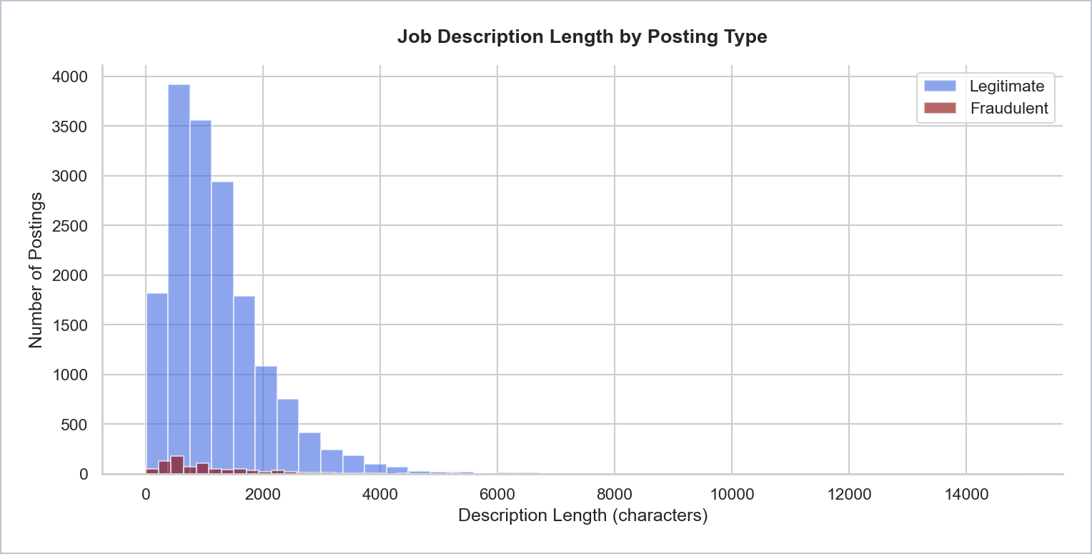
Figure 1. Job description length by posting type. Fraudulent postings cluster more tightly at shorter lengths, suggesting description length is useful as an engineered feature.
Description length shows only a modest mean difference between legitimate and fraudulent postings, but the shape of the distribution is informative. Legitimate postings spread across a wider range and include many highly detailed listings, while fraudulent postings cluster more tightly at shorter lengths.
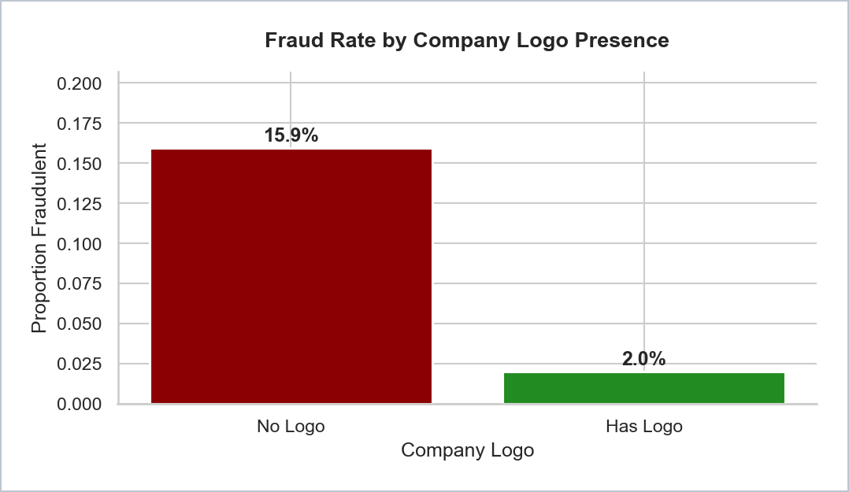
Figure 2. Fraud rate by company-logo presence. Postings without a company logo show a fraud rate of 15.9%, compared with 2.0% when a logo is present.

Company-logo presence is one of the strongest single-feature signals. Because it is fully observed and easy to interpret, it remains a strong candidate feature for both the baseline and primary models.

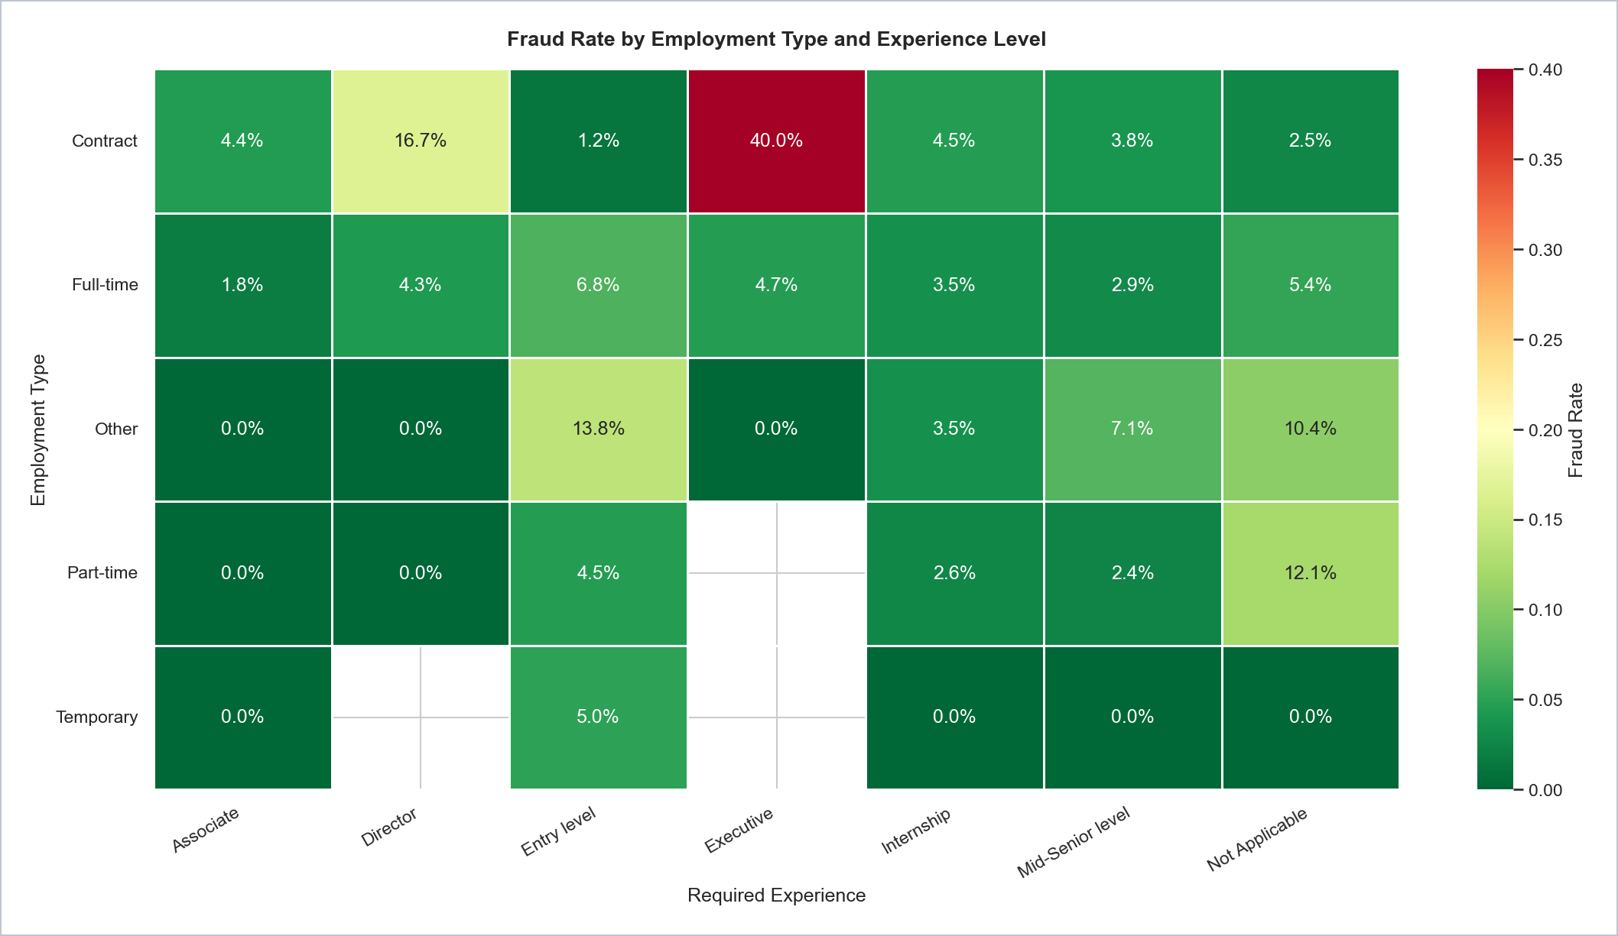
Figure 3. Fraud rate by employment type and experience level. The Contract/Executive cell stands out at 40.0%, showing an important interaction effect.
The employment-type and experience-level heatmap shows that fraud is not evenly distributed across categories. The Contract/Executive combination is especially elevated, demonstrating that feature interactions may carry useful predictive signal beyond individual category effects.

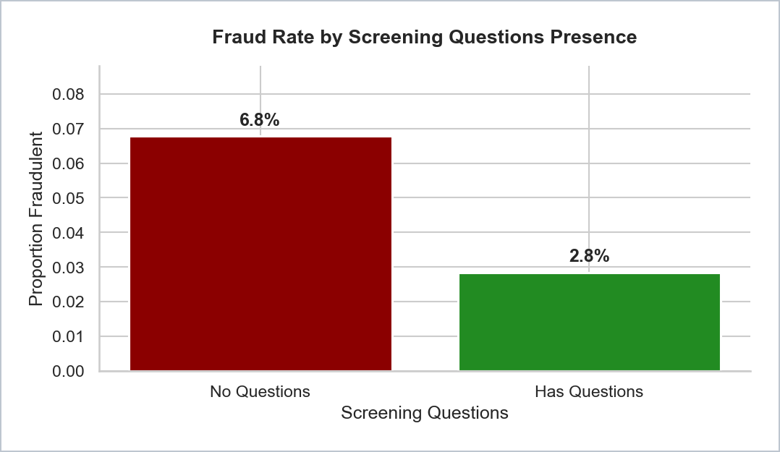
Figure 4. Fraud rate by screening-question presence. Postings without screening questions have a fraud rate of 6.8%, compared with 2.8% when screening questions are present.

Screening-question presence functions as another effort signal. A posting that lacks screening questions may be designed more to collect applicant information than to evaluate candidates.

Data Preparation and Feature Engineering

Missing Value Handling

Data preparation addressed missing values, categorical encoding, text preprocessing, and feature construction in a defined sequence. Transformations were fit on the training set only before being applied to the test set to prevent data leakage.

Salary_range (84.0% missing) and department (64.6% missing) were excluded because their missingness rates made imputation unreliable. Required_education (45.3% missing), required_experience (39.4% missing), employment_type (19.4% missing), industry (27.4% missing), and function (36.1% missing) were filled with the value Unknown and treated as distinct categories. Text fields were filled with empty strings before concatenation so missing text would not introduce null errors.

Text Preprocessing

The description, requirements, company_profile, and benefits fields were concatenated into a combined_text feature. Text was lowercased, stripped of punctuation and special characters using regular expressions, tokenized using whitespace splitting, and filtered using NLTK's English stop-word list. The cleaned text was vectorized with TF-IDF using a maximum vocabulary of 5,000 terms, unigrams and bigrams, and a minimum document frequency of five.

Structured Feature Construction

Three engineered numeric features were added: description length in characters, a binary flag for whether salary information was provided, and a binary flag for whether company profile text was present. Categorical fields were one-hot encoded with handle_unknown='ignore', boolean features were passed through directly, and description length was standardized for logistic regression.

Class Imbalance Handling

SMOTE was applied to the training set only after the train-test split, using the imbalanced-learn library (Chawla et al., 2002). The oversampling target was a 3:1 legitimate-to-fraudulent ratio rather than full balance, preserving some natural class-distribution signal while giving the model enough minority-class exposure to learn fraud patterns.

Modeling Approach

Two models were evaluated: a logistic regression baseline and a Random Forest primary model. Both used the same combined feature matrix: TF-IDF text features, one-hot encoded categorical variables, boolean structural flags, and scaled numeric features. The held-out 20% test set retained the original class distribution.

Logistic Regression Baseline

The logistic regression model used scikit-learn's LogisticRegression with solver='lbfgs', max_iter=1000, and class_weight='balanced'. Sparse feature components were combined using scipy's hstack.

Random Forest Primary Model

The Random Forest model used RandomForestClassifier with n_estimators=300, min_samples_leaf=2, and class_weight='balanced_subsample'. Random Forest was included because it handles mixed feature types well and provides feature-importance estimates that support model interpretation.

Results

Model | Precision | Recall | F1 | AUC-ROC | AUC-PR
Logistic regression | 0.70 | 0.89 | 0.782 | 0.987 | 0.905
Random Forest | 0.97 | 0.64 | 0.774 | 0.992 | 0.924
Table 1. Fraudulent-class test-set performance for the two modeling approaches.

Both models performed well, but they made different tradeoffs. Logistic regression achieved stronger recall on the fraudulent class, while Random Forest achieved much higher precision. Because the domain places greater cost on missed fraud than on flagged legitimate postings, recall carries special weight in model selection.
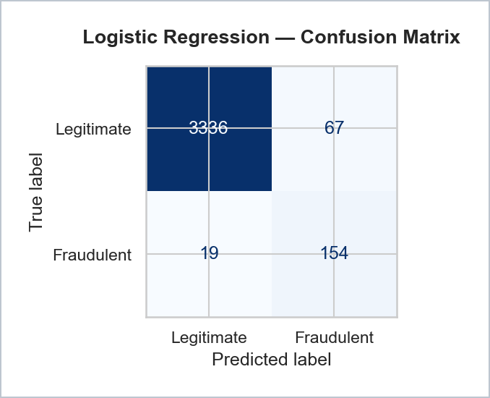
Figure 5. Logistic regression confusion matrix. The model identified 154 of 173 fraudulent postings and missed 19.
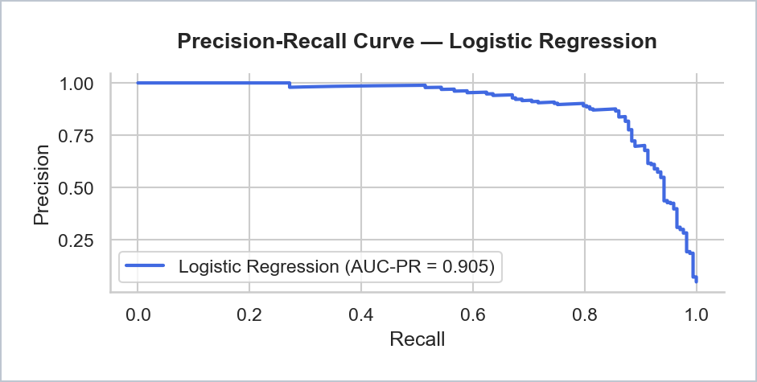
Figure 6. Logistic regression precision-recall curve. The AUC-PR of 0.905 provides a more relevant view than accuracy under severe class imbalance.

The logistic regression model achieved precision of 0.70, recall of 0.89, F1 score of 0.782, AUC-ROC of 0.987, and AUC-PR of 0.905 on the fraudulent class. It produced 154 true positives, 19 false negatives, 67 false positives, and 3,336 true negatives.

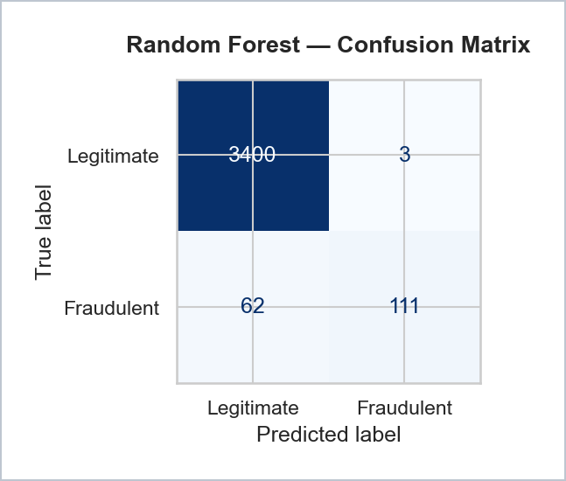
Figure 7. Random Forest confusion matrix. The model produced only three false positives, but missed 62 fraudulent postings.
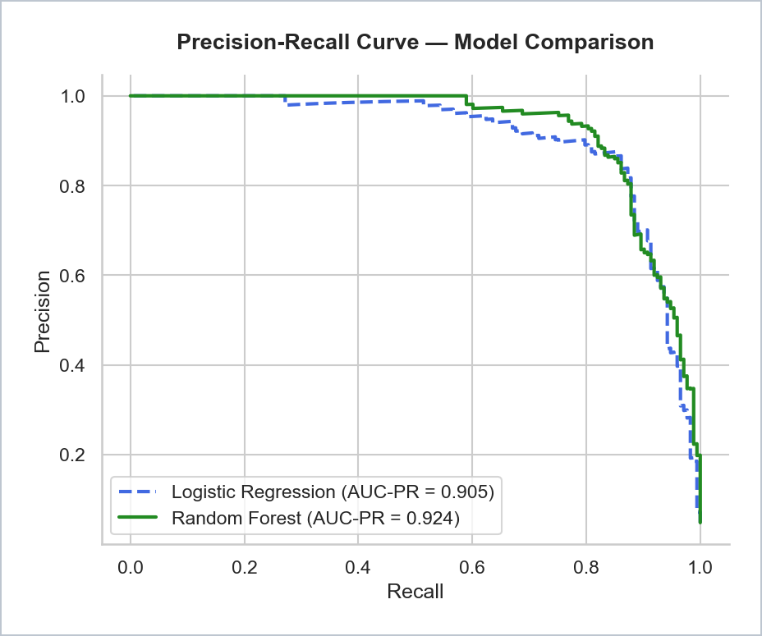

Figure 8. Precision-recall comparison. Random Forest maintains slightly stronger precision across the full recall range, but logistic regression offers better recall at the selected operating point.
The Random Forest model achieved precision of 0.97, recall of 0.64, F1 score of 0.774, AUC-ROC of 0.992, and AUC-PR of 0.924. It produced 111 true positives, 62 false negatives, 3 false positives, and 3,400 true negatives.
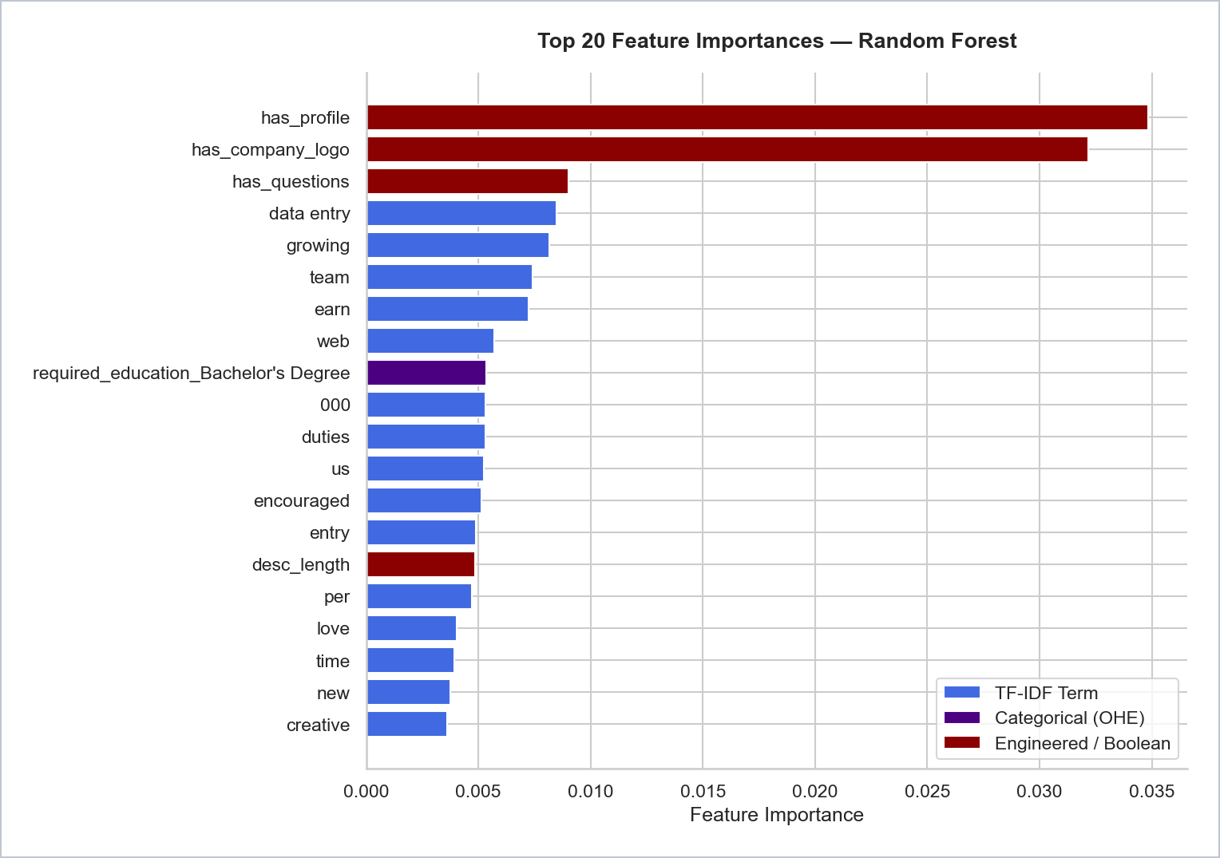
Figure 9. Random Forest feature importance. Company profile presence, company-logo presence, screening questions, and description length are the strongest predictors.
The feature-importance results show that structural effort signals dominate individual word patterns. The strongest predictors were has_profile, has_company_logo, has_questions, and description length. The most important TF-IDF terms included data entry, earn, encouraged, entry, and growing, language consistent with vague opportunity-forward employment scams described in prior research.

Interpretation and Recommendations

The final results support the conclusion that fraudulent job postings are detectable with meaningful reliability using a combination of posting metadata and TF-IDF text features. Logistic regression is the recommended model because it captured 154 of 173 fraudulent postings, compared with 111 captured by Random Forest. In practical terms, the baseline model prevented exposure to 43 additional fraudulent postings on the test set.
The strongest practical insight is that easily observable structural features carry substantial predictive value. A platform could use company-logo presence, company-profile presence, screening-question presence, and description length as a low-cost pre-filter before invoking a fuller model. This would be useful in high-volume environments where every posting cannot receive immediate manual review.

Risks, Ethics, and Limitations

The model should not be deployed as a sole gating mechanism for job postings. The 67 false positives from logistic regression represent legitimate postings that would be incorrectly flagged, potentially disadvantaging employers that simply did not include a logo, profile, or screening questions. In real-world use, model output should be treated as a risk score that routes postings for human review.
Generalizability is also a limitation. EMSCAD was collected from a specific context and time period, while fraud tactics evolve quickly. Performance on newer postings, different platforms, or more sophisticated scams may be lower than the held-out test metrics suggest. Reducing remaining false negatives would require threshold tuning, more labeled fraud examples, additional platform metadata, or more advanced NLP approaches such as transformer-based models.

Conclusion

This project demonstrates that fraudulent job postings can be identified with strong reliability using structured metadata, engineered effort signals, and TF-IDF-based NLP features. Although Random Forest produced the highest AUC metrics and near-perfect precision, logistic regression is the stronger operational choice because it provides substantially better recall in a domain where missed fraud is the most harmful error. The final recommendation is to use logistic regression as a high-recall fraud risk model, route flagged postings to human review, and continue expanding the dataset to improve generalizability over time.

References

Alghamdi, B., & Alharby, F. (2019). An intelligent model for online recruitment fraud detection. Journal of Information Security, 10(3), 155-176. https://doi.org/10.4236/jis.2019.103009
Chawla, N. V., Bowyer, K. W., Hall, L. O., & Kegelmeyer, W. P. (2002). SMOTE: Synthetic minority over-sampling technique. Journal of Artificial Intelligence Research, 16, 321-357. https://doi.org/10.1613/jair.953
Davis, J., & Goadrich, M. (2006). The relationship between precision-recall and ROC curves. Proceedings of the 23rd International Conference on Machine Learning, 233-240. https://doi.org/10.1145/1143844.1143874
Shivamb. (2020). Real or fake? Fake job posting prediction [Data set]. Kaggle. https://www.kaggle.com/datasets/shivamb/real-or-fake-fake-jobposting-prediction
Vidros, S., Kolias, C., Kambourakis, G., & Akoglu, L. (2017). Automatic detection of online recruitment fraud: Characteristics, methods, and a public dataset. Future Internet, 9(1), 6. https://doi.org/10.3390/fi9010006

