Milestone 4: Modeling and Results
Data Preparation
Data preparation for this project addressed missing values, categorical encoding, text preprocessing, and feature engineering in a defined sequence. All transformations were applied to the training set only before being applied to the test set to prevent data leakage.
Missing Value Handling
Each feature with missing data was handled according to its missingness rate and expected role in the model. Salary_range (84.0% missing) and department (64.6% missing) were excluded from the feature set entirely, as the volume of missing data makes imputation unreliable and the risk of introducing noise outweighs any marginal predictive gain. For required_education (45.3% missing), required_experience (39.4% missing), employment_type (19.4% missing), industry (27.4% missing), and function (36.1% missing), missing values were filled with the string "Unknown" and treated as a distinct category during one-hot encoding. This preserves the information that a value was absent, which is itself a plausible fraud signal in several of these fields. The text fields description, requirements, company_profile, and benefits were filled with empty strings before concatenation, so that a posting with no requirements text simply contributes nothing to the combined_text feature rather than introducing a null error.
Text Preprocessing and Feature Construction
The four text fields (description, requirements, company_profile, and benefits) were concatenated into a single combined_text feature after filling missing values with empty strings. This combined field was then preprocessed through a pipeline that converted all text to lowercase, removed punctuation and special characters using regex substitution, tokenized using whitespace splitting, and removed English stop words using NLTK's built-in stop word list. The cleaned text was then vectorized using TF-IDF with a maximum vocabulary of 5,000 terms, using unigrams and bigrams (ngram_range=(1,2)) to capture short phrase patterns that may be characteristic of fraudulent language. Minimum document frequency was set to 5 to filter out rare tokens unlikely to generalize.
In addition to the TF-IDF features, three engineered numeric features were constructed: description length in characters (desc_length), a binary flag for whether any salary information was provided (has_salary), and a binary flag for whether any company profile text was present (has_profile). These simple features are computationally cheap and directly motivated by EDA findings.
Encoding and Scaling
Categorical features (employment_type, required_experience, required_education, industry, function) were one-hot encoded using scikit-learn's OneHotEncoder with handle_unknown="ignore" to handle unseen categories in the test set without error. The boolean features has_company_logo, has_questions, telecommuting, has_salary, and has_profile required no additional transformation. Numeric features (desc_length) were standardized using StandardScaler to ensure comparability with the logistic regression model's coefficient magnitudes. TF-IDF output was not scaled separately, as TF-IDF values are already normalized by design.
Class Imbalance Handling
To address the 95/5 class imbalance, SMOTE (Synthetic Minority Oversampling Technique) was applied to the training set only after the train-test split, using the imbalanced-learn library (Chawla et al., 2002). Applying SMOTE after splitting ensures that synthetic minority samples in the training set do not contaminate the test set, preventing the inflated performance estimates that would result from leakage. The SMOTE ratio was set to produce a 3:1 legitimate-to-fraudulent ratio in the training data, a less aggressive target than full balance, to preserve some of the natural class distribution signal while giving the model sufficient minority class exposure to learn meaningful patterns.
Model Building and Evaluation
Two models were built and evaluated: a logistic regression baseline and a Random Forest primary model. Both models were trained on the preprocessed and SMOTE-resampled training set and evaluated on the held-out 20% test set, which retained the original class distribution.
Logistic Regression Baseline
The logistic regression model was trained using scikit-learn's LogisticRegression with solver="lbfgs", max_iter=1000, and class_weight="balanced" as a secondary imbalance mitigation strategy alongside SMOTE. The combined feature matrix consisted of the TF-IDF output concatenated with one-hot encoded categorical features, boolean flags, and scaled numeric features using scipy's hstack for sparse matrix compatibility.
On the test set, the logistic regression model achieved a precision of 0.70, recall of 0.89, and F1 score of 0.782 on the fraudulent class. The AUC-ROC was 0.987 and the AUC-PR was 0.905. The recall of 0.89 is the standout result: the model correctly identified 154 of 173 fraudulent postings in the test set, missing only 19. The 67 false positives represent legitimate postings incorrectly flagged as fraudulent, a less harmful error given the asymmetric cost structure of this domain. As discussed in the evaluation plan, missing a fraudulent posting exposes a job seeker to potential identity theft or financial fraud, while a false positive results only in a missed application opportunity. The confusion matrix showed 154 true positives, 19 false negatives, 67 false positives, and 3,336 true negatives.
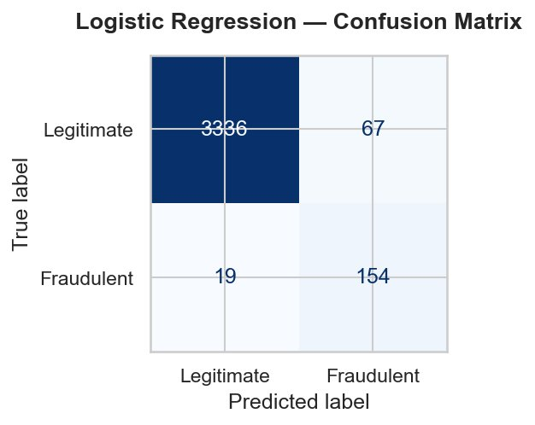
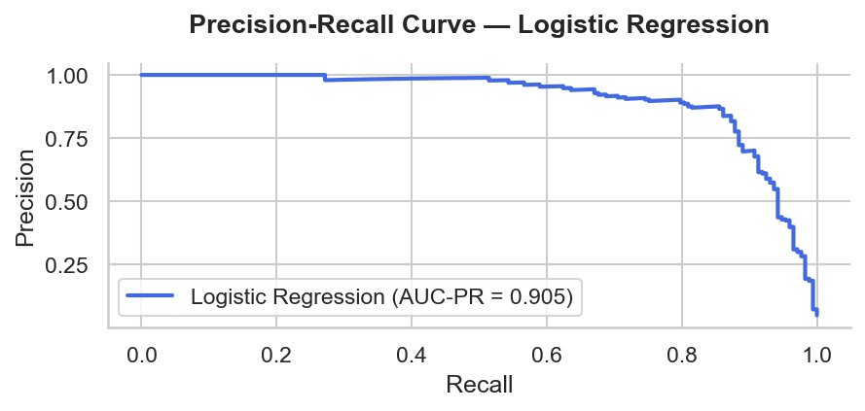
Random Forest Primary Model
The Random Forest model was trained using scikit-learn's RandomForestClassifier with n_estimators=300, min_samples_leaf=2, and class_weight="balanced_subsample". The same combined feature matrix was used as for logistic regression.
On the held-out test set, the Random Forest model achieved a precision of 0.97, recall of 0.64, and F1 score of 0.774 on the fraudulent class. The AUC-ROC was 0.992 and the AUC-PR was 0.924. The confusion matrix showed 111 true positives, 62 false negatives, 3 false positives, and 3,400 true negatives. The Random Forest's near-perfect precision means it almost never flags a legitimate posting as fraudulent, but its recall of 0.64 means it missed 62 of 173 fraudulent postings in the test set, compared to just 19 missed by logistic regression. The precision-recall AUC of 0.924 is higher than logistic regression's 0.905, confirming the Random Forest maintains better precision across the full recall range. However, as discussed in the interpretation section, recall is the more consequential metric in this domain, and on that basis logistic regression is the stronger performer.
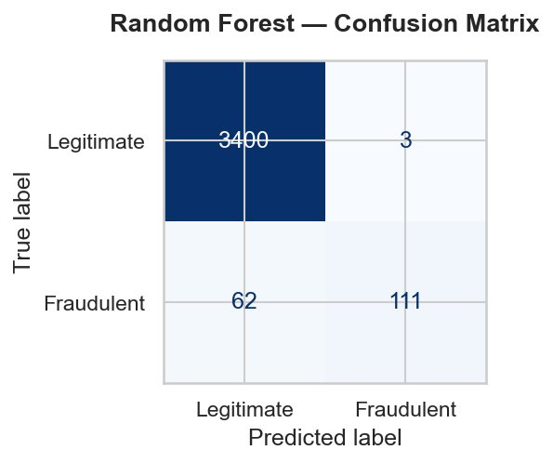
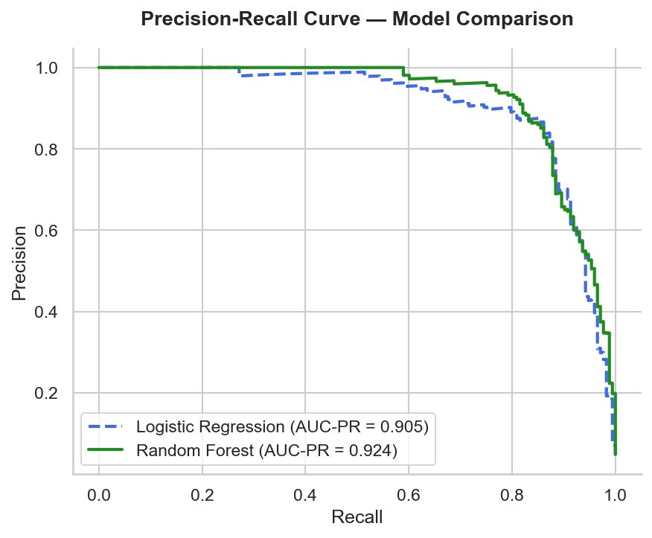
Feature Importance
The Random Forest model's feature importance scores revealed that the top predictors of fraud were has_profile (importance score 0.035), has_company_logo (0.032), has_questions (0.009), and desc_length (0.005). Telecommuting was essentially a non-contributor at 0.0003. Among the TF-IDF features, the top terms in the top 20 included "data entry," "earn," "encouraged," "entry," and "growing" — language consistent with vague, overly enthusiastic postings characteristic of employment scams (Vidros et al., 2017). The dominance of structural boolean features over text terms is a meaningful finding: effort signals are the strongest fraud indicators in the dataset, more important than any individual word pattern.
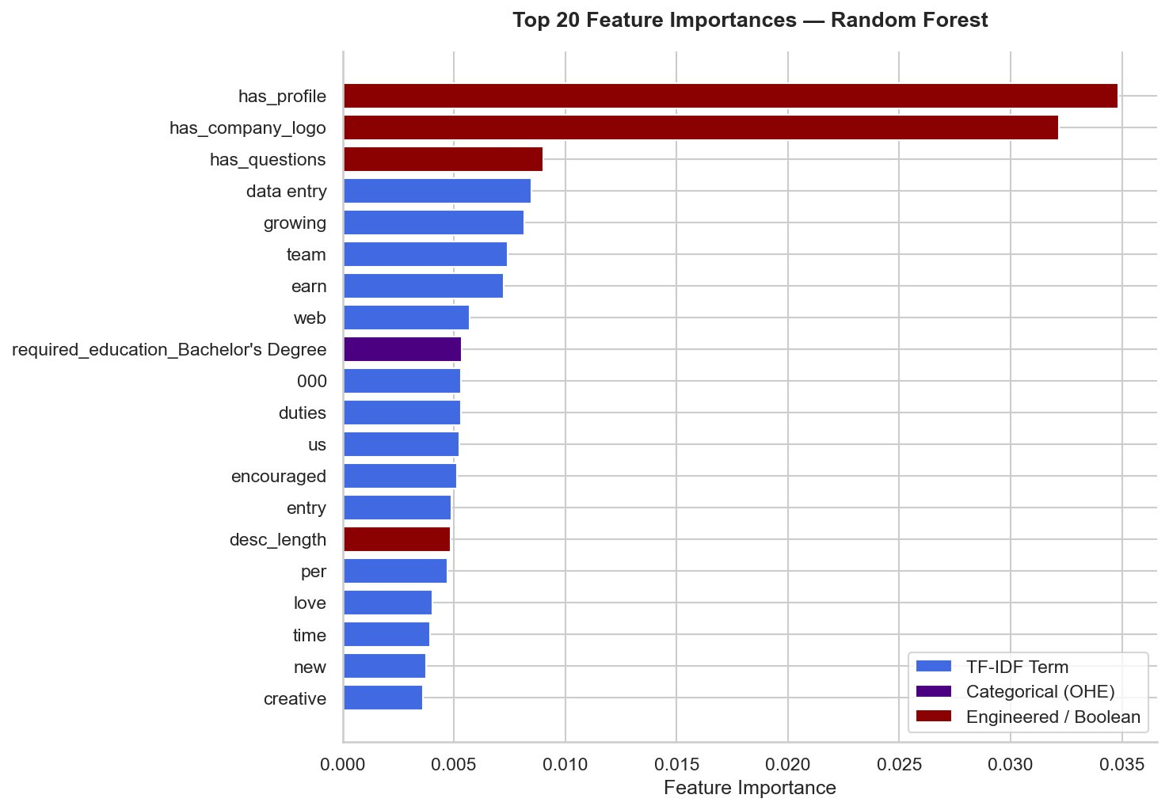
Interpretation of Results
The modeling results support several conclusions about the structure of fraudulent job postings in this dataset. Both models performed well overall, with AUC-ROC scores of 0.987 (logistic regression) and 0.992 (Random Forest), confirming that fraudulent postings are detectable with meaningful reliability using the combination of structural metadata and text features employed here. The two models made a clear tradeoff: Random Forest achieved near-perfect precision (0.97) but lower recall (0.64), while logistic regression achieved stronger recall (0.89) at the cost of more false positives (0.70 precision).
The feature importance results align well with domain intuition. The three strongest predictors — has_profile, has_company_logo, and has_questions — all represent effort signals. Fraudulent posters are less likely to invest the time needed to write a company profile, include a logo, or craft screening questions. The TF-IDF terms that appeared in the top 20 (including "data entry," "earn," "encouraged," and "entry") reflect the vague, opportunity-forward language commonly associated with employment scams in prior research (Alghamdi & Alharby, 2019).
The cost asymmetry in this domain is critical to model selection. A false negative — a missed fraudulent posting labeled as legitimate — exposes a job seeker to potential identity theft or financial fraud, consequences that can be severe and long-lasting. A false positive — a legitimate posting incorrectly flagged — results only in a missed application opportunity, which is recoverable. Given this asymmetry, recall is the north star metric, and logistic regression is the recommended model: it caught 154 of 173 fraudulent postings compared to Random Forest's 111, meaning 43 fewer job seekers were exposed to potential fraud on the test set alone.
One important limitation of the current results is that the model was evaluated on held-out data from the same dataset and time period as the training data. Because fraud tactics evolve over time, performance on genuinely novel fraudulent postings from a different platform or era may be lower than the test set metrics suggest. The remaining 19 false negatives from the logistic regression model represent real-world cases where the model would fail to flag a fraudulent posting. Reducing these further would require either accepting more false positives by lowering the classification threshold, collecting more labeled fraud examples, or incorporating features not currently available in the dataset.
Conclusions and Recommendations
This project demonstrates that fraudulent job postings can be identified with strong reliability using a combination of structural metadata features and TF-IDF-based text analysis. Both models performed well, with logistic regression achieving an F1 score of 0.782 and AUC-ROC of 0.987, and Random Forest achieving an F1 score of 0.774 and AUC-ROC of 0.992. Given the asymmetric cost of misclassification in this domain — where missing a fraudulent posting is significantly more harmful than falsely flagging a legitimate one — logistic regression is the recommended model due to its superior recall of 0.89 compared to Random Forest's 0.64.
The most actionable finding for practitioners is that a small number of easily observable structural features (company logo presence, screening questions, company profile presence, and description length) carry substantial predictive weight on their own. A simple rule-based pre-filter using these features before invoking the full model could flag a large proportion of fraudulent postings at minimal computational cost, which may be valuable in high-volume platform deployment scenarios.
From an ethical standpoint, the model should not be deployed as a sole gating mechanism for job postings without human review for flagged cases. The 67 false positives from the logistic regression model represent legitimate postings that would be incorrectly flagged, potentially disadvantaging employers who simply did not include a logo or screening questions. Any real-world implementation should treat the model output as a risk score to route postings for human review rather than as a binary accept-or-reject decision.
Future work could explore more sophisticated NLP approaches, including transformer-based models such as BERT, which may capture semantic fraud signals that TF-IDF misses. Incorporating temporal features (time of posting, account age) or platform-level metadata could also improve generalizability to real-world deployment settings. Expanding the training data through partnerships with job platforms to include more recent examples of evolving fraud tactics would address the generalizability limitation identified in this analysis.
Additional Reference
Add the following to your existing reference list:
Chawla, N. V., Bowyer, K. W., Hall, L. O., & Kegelmeyer, W. P. (2002). SMOTE: Synthetic minority over-sampling technique. Journal of Artificial Intelligence Research, 16, 321–357. https://doi.org/10.1613/jair.953

