Data Science Community Networking Assignment
DSC630 — Predictive Analytics
Tim Hollis | Bellevue University | 2026

Community Overview

The community selected for this assignment is the Data Science Learning Community, a public Slack workspace dedicated to data science practitioners, students, and enthusiasts at all experience levels. The community can be found at the following link:
https://app.slack.com/client/T6UC1DKJQ/C8J63E0TA
This community was selected because it provides a genuine space for data science learners to share knowledge, ask questions, and engage with peers outside of an academic setting. The channel structure allows for topic-specific discussions across areas such as machine learning, Python, career development, and project feedback, making it well suited for the kind of substantive engagement this assignment requires.

Introduction Post

The first step in engaging with the community was posting a personal introduction in the general channel. The goal was to provide enough context about background and current work to invite meaningful responses while keeping the tone appropriate for a professional public forum.

Screenshot 1: Introduction Post
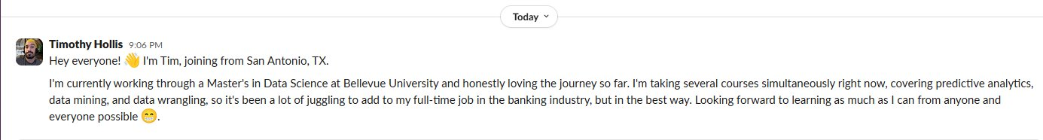

Discussions

The next step was to engage in discussions with both the chat-bot to see what the ability functionality it provides, as well actual people within the community.

Chat-Bot:

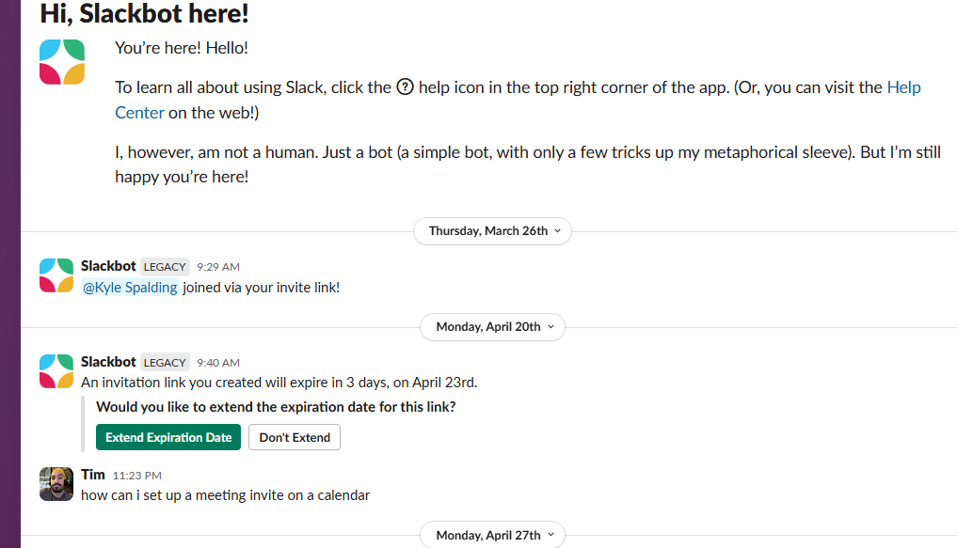

Community Member:
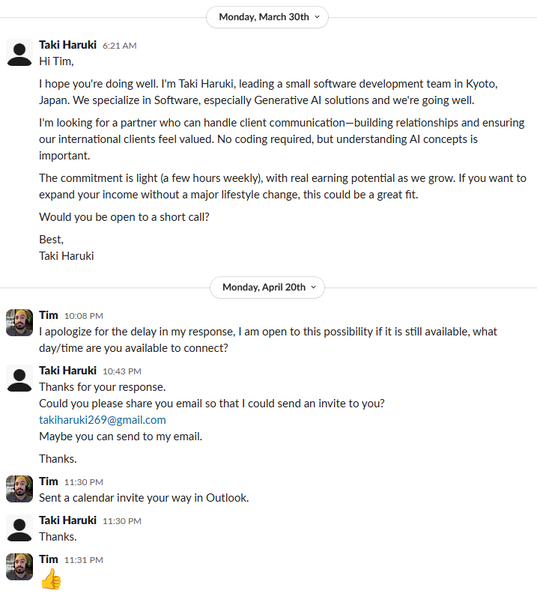

Reflection

Participating in a public data science community offers a different kind of value than structured academic discussion boards. In a course setting, conversations are bounded by the assignment scope and evaluated within a defined rubric. In a community like the Data Science Learning Community, the conversations are driven by genuine curiosity and real problems that practitioners are actively working through, which changes the quality and texture of the engagement entirely.
One of the most immediate benefits of informal communities is the exposure to a wider range of perspectives and experience levels. A question posted in a public Slack channel might receive responses from a self-taught developer, a PhD researcher, and a senior data engineer all at once, each bringing a different lens to the same problem. That kind of cross-pollination is difficult to replicate in a classroom and is one of the primary reasons these communities have become so valuable to practitioners at every stage of their careers.
Consistent, substantive participation over time is what will build real credibility in these spaces. A single introduction or post rarely leads to lasting connections. What matters is showing up repeatedly with thoughtful contributions, whether that means answering a question someone else asked, sharing a resource, or being willing to admit uncertainty and ask for input. That pattern of engagement, done authentically, is how informal communities become genuine professional networks rather than just bulletin boards, and though this assignment may not show the ongoing engagement, the benefit gained from the interactions so far will lead to consistent use of the service (which I also use heavily for the handshake projects I work as well).

Personal Takeaways

This assignment reinforced the value of engaging with the data science community outside of the academic context early in the program rather than waiting until skills feel fully developed. The conversations happening in communities like this one reflect what the field actually looks like in practice, including the ambiguity, the ongoing debates, and the collaborative problem-solving that formal coursework can sometimes smooth over. Engaging now, even as a learner, is more valuable than waiting until there is more to offer. The community channels shown in the screenshots, are heavily focused on R programming which is my personal favorite language, but I look forward to using this as I expand my language exposure for sure!

