Predicting Fraudulent Job Postings Using Machine Learning and Natural Language Processing
An Analytical Approach to Identifying Employment Scams
Author: Timothy Hollis
Bellevue University
DSC630 – Predictive Analytics
Professor Andrew Hua
Date: May 22, 2026

Table of Contents
Introduction 3
Overview of Data Used 4
Dataset Description 4
Class Imbalance 5
Missing Data 6
Exploratory Data Analysis 6
Methods of Analysis 10
Text Preprocessing 10
Feature Engineering 11
Class Imbalance Handling 12
Model Selection 12
Results and Findings 13
LogisticRegression — Default Threshold 13
Logistic Regression — Threshold Tuning 14
Random Forest 15
Model Comparison Summary 17
Feature Importance 18
Conclusion 20
Summary of Findings 20
Deployment Readiness 21
Limitations 21
Future Directions 22
References 23
Appendix A: Python Code 23

Introduction

The rise of online job platforms has fundamentally changed how people search for employment, creating new opportunities for both job seekers and employers while simultaneously opening the door for a growing class of bad actors who exploit those platforms through fraudulent job postings. These fraudulent listings range from phishing attempts designed to harvest personal information to advance-fee scams that extract money from applicants under the pretense of securing a position. The consequences for victims are severe and multidimensional, including financial loss, identity theft, and significant psychological harm during an already vulnerable period of their lives when they are actively seeking work and may be less guarded than usual.
The scale of the problem is significant. Online recruitment fraud has grown alongside the expansion of digital hiring platforms, and existing manual review processes are unable to keep pace with the volume of new postings submitted daily. The Employment Scam Aegean Dataset used in this study reveals that approximately 4.8% of all job postings in the sample are fraudulent — a figure that, applied across platforms hosting millions of listings, represents an enormous potential for harm.
This project proposes and evaluates a binary classification system that uses machine learning and natural language processing to identify fraudulent job postings automatically. By analyzing both structured metadata and the unstructured text content within listings, the goal is to build a model capable of flagging suspicious postings with high recall — prioritizing the detection of actual fraud over the avoidance of false alarms. The asymmetry of misclassification costs is central to this work: a false negative, in which a fraudulent posting is labeled as legitimate and reaches job seekers, carries significantly greater harm than a false positive, in which a legitimate posting is flagged for human review.
The practical value of this system extends across multiple stakeholder groups. Job platforms and employment boards can deploy it as a pre-publication screening layer to reduce the number of fraudulent postings that ever reach applicants. Regulatory agencies and consumer protection organizations can use it to identify patterns in fraud activity across industries, locations, and employment types. Independent job seekers, particularly those in vulnerable employment situations, stand to benefit most directly from any reduction in the volume of fraudulent listings they encounter.
Beyond the immediate application, this work contributes to a growing body of research on automated fraud detection in text-heavy domains. The combination of engineered boolean features, categorical encodings, and TF-IDF derived text signals in a unified classification pipeline offers a replicable framework applicable to similar problems in other online marketplace contexts.

Overview of Data Used

Dataset Description

The primary dataset used in this project is the Employment Scam Aegean Dataset (EMSCAD), made publicly available on Kaggle under the title Real or Fake? Fake Job Posting Prediction (Shivamb, 2020). The dataset was originally compiled and documented by Vidros et al. (2017) as part of research into the characteristics and detection methods of online recruitment fraud. It contains 17,880 job postings sourced from a real-world job platform, of which 17,014 are genuine and 866 are fraudulent, producing a class distribution of approximately 95.2% legitimate to 4.8% fraudulent.
Each record in the dataset includes 18 features spanning a mix of structured metadata and free-text fields. The structured features include job location, employment type, required experience level, required education level, industry classification, and boolean indicators for whether the posting includes a company logo and whether it includes screening questions. The free-text features include the job title, company profile, job description, requirements, and benefits sections — the richest sources of natural language signal for fraud detection.

Class Imbalance

The dataset is substantially imbalanced, with fraudulent postings representing only 4.8% of all records. This imbalance has direct implications for model selection, evaluation strategy, and the interpretation of results. A naive classifier that predicts every posting as legitimate would achieve 95.2% accuracy while failing to identify a single fraudulent listing, making accuracy an unsuitable primary evaluation metric. This project addresses the imbalance through Synthetic Minority Over-Sampling Technique (SMOTE) applied exclusively to the training set, and evaluates model performance using F1-score, AUC-ROC, and AUC-PR metrics that are robust to class imbalance (Chawla et al., 2002).

Missing Data

Several features in the raw dataset contain substantial missing values. The salary_range field is missing for 15,012 of 17,880 records (84.0%), and the department field is missing for 11,547 records (64.6%). Rather than imputing these columns, both were dropped from the modeling pipeline. The salary_range field was first used to engineer a binary has_salary indicator capturing whether salary information was originally present before the column was removed. Categorical fields with moderate missingness were filled with the value Unknown to preserve all records while making the missingness explicit to the model. Text fields with missing values were filled with empty strings before concatenation.

An unexpected finding emerged from the has_salary feature: postings that included a salary range showed a higher fraud rate (7.8%) than postings without one (4.3%). This counterintuitive pattern suggests that fraudulent actors may deliberately include salary information as bait to increase the attractiveness of their listings, making salary presence a meaningful predictive signal rather than an indicator of legitimacy.

Exploratory Data Analysis

Prior to modeling, exploratory analysis was conducted to identify patterns in the data and inform feature engineering decisions. Each visualization below surfaces a distinct signal that informed which features were retained for model training.
The first question examined was whether fraudulent postings differ from legitimate ones in how much they say. Figure 1 shows the distribution of job description lengths across both posting types.

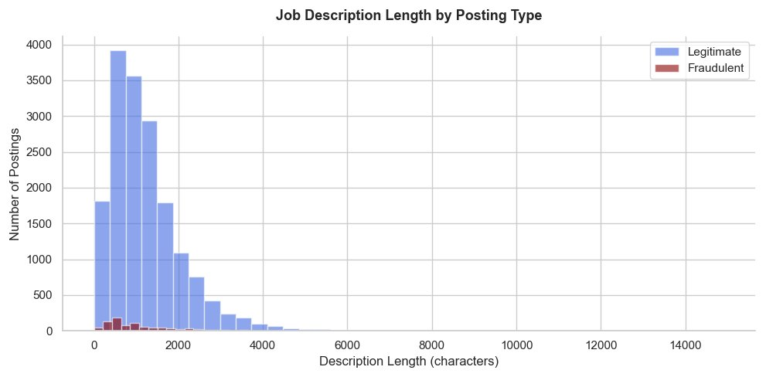
Figure 1. Job description length in characters by posting type. Legitimate postings show a mean length of 1,221 characters compared to 1,155 for fraudulent postings, a difference of 66 characters. While the gap is modest, description length was retained as a numeric feature for modeling.

The overlap between the two distributions is substantial, and the 66-character mean difference alone is not a reliable fraud signal. However, combined with other features it adds marginal discriminative value and was retained for modeling on that basis.

A more striking pattern emerged when examining whether the presence of a company logo differentiates fraudulent from legitimate postings. Figure 2 shows the fraud rate within each logo group.

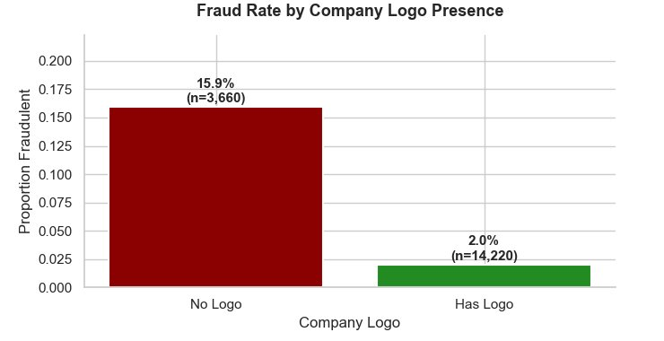
Figure 2. Fraud rate by company logo presence. Sample sizes shown (n) reflect the total number of postings within each logo group, not the total number of fraudulent postings. Of the 3,660 postings lacking a company logo, 15.9% were fraudulent. Of the 14,220 postings that included a logo, only 2.0% were fraudulent — nearly an eight-fold difference and the strongest single-feature signal identified in the dataset.

The magnitude of this difference — nearly eight times the fraud rate among postings without a logo — and the large sample sizes in both groups make this the most reliable single-feature signal in the dataset. It suggests that the structural effort required to associate a verified company identity with a posting acts as a meaningful deterrent to fraud.
To examine whether fraud concentrates within specific combinations of job characteristics rather than distributing evenly, Figure 3 cross-tabulates fraud rates by employment type and required experience level.

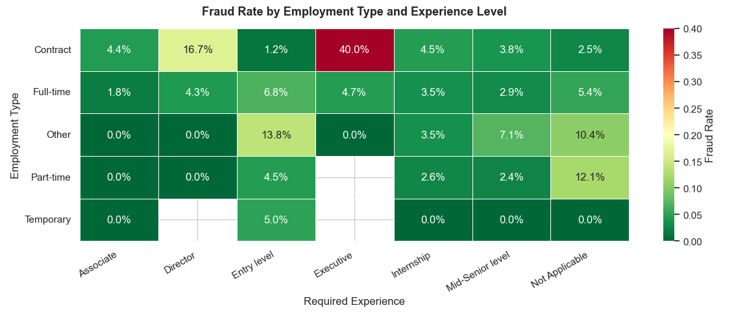
Figure 3. Fraud rate by employment type and required experience level. The Contract/Executive cell shows the highest observed fraud rate at 40.0%, though the small sample size (n = 10) warrants interpretive caution. Fraud concentrates in specific cells rather than distributing evenly, suggesting the interaction between these variables carries predictive signal beyond either feature individually.
The heatmap reveals that fraud is not spread uniformly across employment types or experience levels. Rather, it concentrates in specific intersections, particularly contract postings targeting executive-level candidates. This clustering pattern confirms that the interaction between these two variables contains predictive information that neither feature captures independently, justifying their inclusion in the model as separate encoded inputs.

Finally, the presence of screening questions — a structural feature indicating that the poster invested effort in designing an application process — was examined as a potential fraud signal. Figure 4 shows the fraud rate within each group.

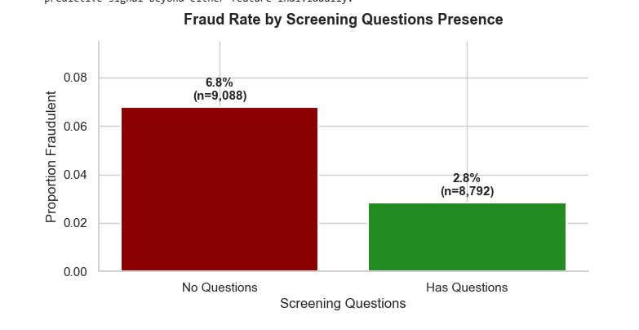
Figure 4. Fraud rate by screening questions presence. Sample sizes shown (n) reflect the total number of postings within each group, not the total number of fraudulent postings. Of the 9,088 postings without screening questions, 6.8% were fraudulent. Of the 8,792 postings that included screening questions, 2.8% were fraudulent — more than double the rate. Both has_questions and has_company_logo are fully observed with no missing values.

Like the company logo finding, this result suggests that structural investment in the posting process correlates with legitimacy. Fraudulent actors appear less likely to create screening questions, perhaps because the additional effort offers no benefit when the goal is to collect personal information rather than evaluate candidates. Both has_questions and has_company_logo were retained as fully observed binary features in all models.

Methods of Analysis

Text Preprocessing

All free-text fields — company profile, job description, requirements, and benefits, as well as the job title — were preprocessed before feature extraction. The cleaning pipeline applied the following steps in order: conversion to lowercase, removal of all non-alphabetic characters using regular expressions, collapse of multiple whitespace characters to a single space, tokenization by whitespace splitting, removal of English stopwords using the NLTK stopwords corpus, and removal of tokens with fewer than three characters. The cleaned text from all five fields was then concatenated into a single combined_text field per record, which served as the input to the TF-IDF vectorizer.
Stopword removal was applied before concatenation to reduce noise in the resulting vocabulary. Tokens shorter than three characters were excluded because single and double character tokens rarely carry semantic content relevant to fraud detection and inflate the feature space unnecessarily. The cleaning function was defined once and applied consistently across all text fields to ensure uniformity.

Feature Engineering

Three categories of features were constructed for model input. The first category consists of TF-IDF derived text features. A TF-IDF vectorizer was fitted on the training set only and used to transform both training and test text into a 5,000-feature matrix using unigrams and bigrams with a minimum document frequency of five and sublinear term frequency scaling. The second category consists of one-hot encoded categorical features derived from employment_type, required_experience, required_education, industry, function, and location, producing 2,948 encoded columns. The third category consists of engineered boolean and numeric features: has_company_logo, has_questions, telecommuting, has_profile, has_salary, and desc_length. The three feature matrices were stacked horizontally into a single sparse matrix of 7,954 columns per record.

Class Imbalance Handling
SMOTE was applied to the training set after feature matrix construction and before model training (Chawla et al., 2002). Applying SMOTE after the train/test split and after feature transformation ensures that synthetic samples are generated from training data only, preventing any information from the test set from influencing the oversampled training distribution. A sampling strategy of 0.33 was used, increasing the minority class from 693 to 4,491 samples and the total training set from 14,304 to 18,102 rows. SMOTE was not applied to the test set, which retained the original 4.8% fraud rate to ensure evaluation reflects real-world class proportions.

Model Selection
Two classification models were trained and compared. Logistic regression served as the interpretable baseline model, configured with the lbfgs solver, a maximum of 1,000 iterations, and balanced class weighting. Random forest served as the primary ensemble model, configured with 300 estimators, a minimum of two samples per leaf, and balanced subsample class weighting. Both models were trained on the SMOTE-augmented training set and evaluated on the held-out test set of 3,576 records.
Evaluation Strategy
Given the class imbalance, accuracy was excluded as a primary metric. Model performance was assessed using F1-score for the fraudulent class, AUC-ROC, AUC-PR, confusion matrices, and precision-recall curves. Because the cost of a false negative — a fraudulent posting reaching job seekers — substantially exceeds the cost of a false positive — a legitimate posting flagged for review — threshold tuning was applied to the logistic regression model to identify the classification threshold that maximizes recall on the fraudulent class while preserving as much precision as possible. Thresholds were swept from 0.10 to 0.90 in increments of 0.01, and the threshold producing the highest precision among all thresholds achieving recall of at least 0.90 was selected.

Results and Findings

LogisticRegression — Default Threshold

At the default classification threshold of 0.50, logistic regression achieved an F1-score of 0.789, AUC-ROC of 0.989, and AUC-PR of 0.916 on the held-out test set. The model correctly identified 157 of 173 fraudulent postings (recall = 0.91) while generating 68 false positives among the 3,403 legitimate postings. These results indicate strong discriminative ability and effective recall on the minority class at the default threshold. Figure 5 shows the full breakdown of correct and incorrect classifications.

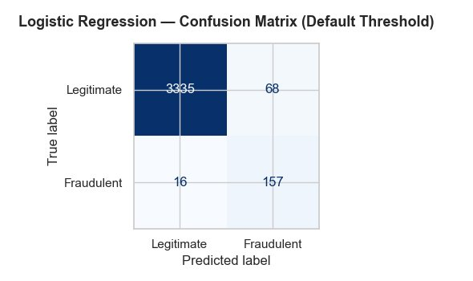
Figure 5. Logistic regression confusion matrix at the default threshold of 0.50. The model correctly identified 157 of 173 fraudulent postings while flagging 68 legitimate postings as potentially fraudulent.
The confusion matrix confirms that the model’s primary limitation at the default threshold is not missed fraud but false alarms: 68 legitimate postings were flagged for review despite being genuine. While this is a manageable false positive rate for most platforms, it motivated the threshold tuning analysis that follows.

Logistic Regression — Threshold Tuning

Threshold tuning identified 0.54 as the optimal operating point, defined as the threshold achieving recall of at least 0.90 on the fraudulent class with the highest attainable precision at that constraint. At the tuned threshold, the model achieved recall of 0.902, precision of 0.739, and an improved F1-score of 0.812. Figure 6 shows how this modest threshold adjustment shifts the classification outcome.

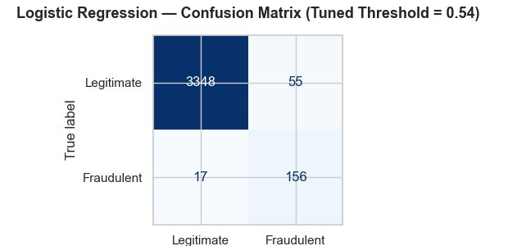
Figure 6. Logistic regression confusion matrix at the tuned threshold of 0.54. False positives decreased from 68 to 55 relative to the default threshold while fraudulent postings caught remained at 156, demonstrating that a modest threshold adjustment produces a meaningfully cleaner screening outcome.
The trade-off is favorable: one fewer fraudulent posting caught in exchange for 13 fewer legitimate postings incorrectly flagged. For a platform routing flagged postings to a human review queue, this translates directly to reduced reviewer workload with negligible impact on fraud detection effectiveness. Figure 7 shows the full precision-recall curve with the selected threshold marked, illustrating the operating point in the context of the model’s complete range of possible thresholds.
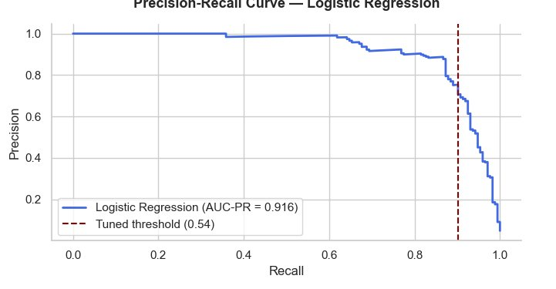
Figure 7. Precision-recall curve for logistic regression (AUC-PR = 0.916) with the tuned threshold of 0.54 marked. The curve maintains near-perfect precision across a wide recall range before declining sharply above 0.90 recall, indicating the model is well calibrated across most operating points.
The precision-recall curve reveals that the model maintains very high precision across most of its recall range, only beginning to trade precision for recall aggressively above the 0.85 recall mark. The selected threshold of 0.54 sits at the edge of this steep decline, capturing the best available precision at the 0.90 recall floor.

Random Forest

The random forest model achieved an F1-score of 0.786, AUC-ROC of 0.993, and AUC-PR of 0.928 — the highest AUC scores of the two models. However, aggregate performance metrics alone do not capture the full picture of how these models behave in practice. Figure 8 reveals a fundamentally different operating profile.

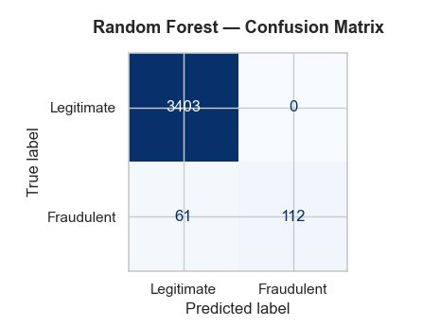
Figure 8. Random forest confusion matrix. The model produced zero false positives but missed 61 fraudulent postings, reflecting a high-precision, lower-recall operating profile that is not well suited to a fraud detection context where missing fraud is the higher-cost error.
The confusion matrix tells a story the AUC scores obscure: the random forest correctly classified every single legitimate posting and generated zero false positives, but it missed 61 of 173 fraudulent postings — more than one in three. In a context where a missed fraudulent posting reaches real job seekers, this miss rate is the operative concern, not the model’s precision or overall AUC. Figure 9 places both models side by side on the precision-recall curve to show where they converge and where they diverge.

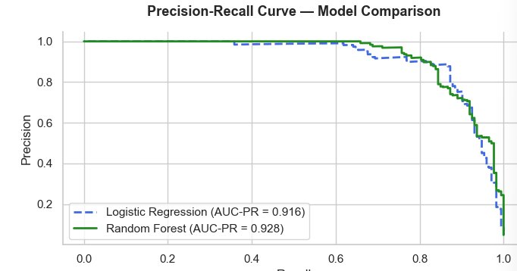
Figure 9. Precision-recall curve comparison between logistic regression (AUC-PR = 0.916) and random forest (AUC-PR = 0.928). The curves are nearly identical across most of the recall range. The practical distinction between the models is better captured in their confusion matrices than in their aggregate AUC scores.
The near-identical precision-recall curves reinforce the point: these two models are similarly capable in aggregate, but they make very different errors. The random forest concentrates its misses on the fraud class while the logistic regression distributes errors more evenly. For this application, the logistic regression’s error profile is the more acceptable one.

Model Comparison Summary
Table 1 consolidates the key performance metrics across all three evaluated configurations, providing a direct basis for the deployment recommendation that follows.

Metric | LR Default | LR Tuned (0.54) | Random Forest
F1 Score | 0.789 | 0.812 | 0.786
AUC-ROC | 0.989 | — | 0.993
AUC-PR | 0.916 | — | 0.928
Fraud Caught (TP) | 157 | 156 | 112
Fraud Missed (FN) | 16 | 17 | 61
Legit Flagged (FP) | 68 | 55 | 0
Table 1. Performance comparison across logistic regression at default threshold, logistic regression at tuned threshold of 0.54, and random forest. All results are on the held-out test set of 3,576 records (173 fraudulent, 3,403 legitimate).
The table makes the trade-offs explicit. Logistic regression at the default threshold catches the most fraud but generates the most false positives. The tuned threshold version achieves the best F1-score and reduces false positives with minimal impact on fraud detection. The random forest achieves the highest AUC scores and zero false positives but at the cost of missing 61 fraudulent postings — nearly four times as many as either logistic regression configuration.

Feature Importance
To understand what the random forest model learned, feature importances were extracted and ranked across all 7,954 features in the model. Figure 10 shows the top 20 features by mean decrease in impurity, color-coded by feature type.

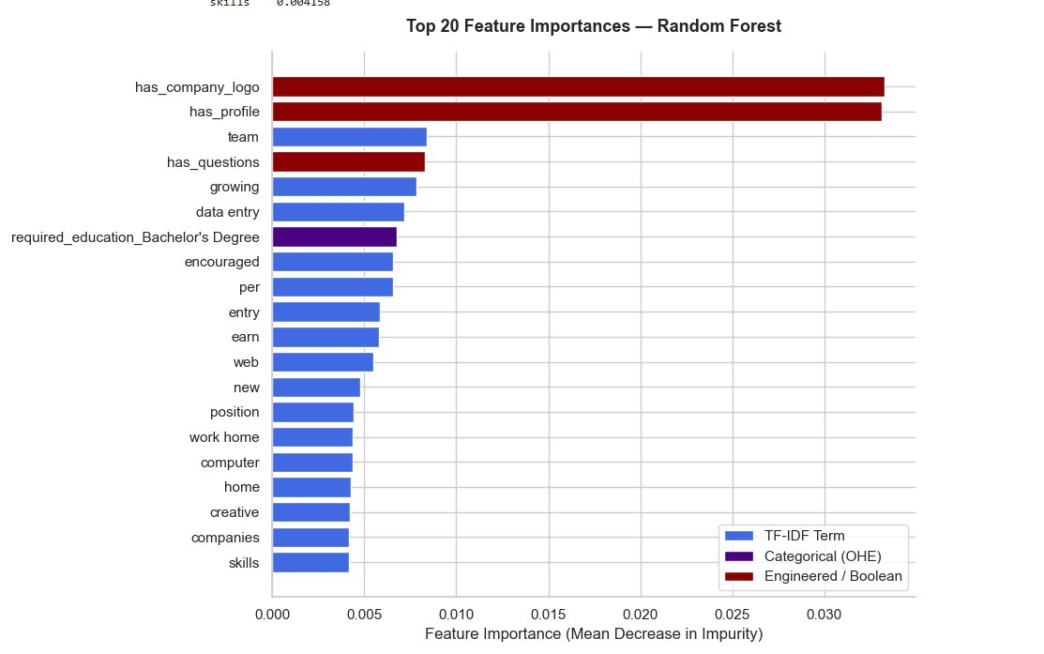
Figure 10. Top 20 feature importances from the random forest model, color-coded by feature type. Engineered and boolean features (dark red) dominate the top positions despite representing a small fraction of total features. TF-IDF terms (blue) contribute the majority of aggregate importance across the full feature set. The single categorical feature in the top 20 (purple) is required_education_Bachelor’s Degree.
The chart makes a striking pattern immediately visible: the two engineered boolean features — has_company_logo and has_profile — dwarf every other signal in the model. Each contributes approximately 3.3% of total feature importance individually, while the next highest features, all TF-IDF terms, peak around 0.8%. Despite engineered and boolean features representing only a small fraction of total feature count, they account for 8.0% of aggregate importance while TF-IDF terms account for 87.3% distributed across 5,000 features. On a per-feature basis, the boolean indicators are roughly 55 times more informative than the average TF-IDF term.
Among the top linguistic signals, terms such as earn, work home, data entry, encouraged, and growing appear consistently in fraudulent postings. These reflect the vague, aspirational language characteristic of fraudulent recruitment: promises of earnings, remote work opportunities, and accessible entry-level positions with minimal specificity about actual job responsibilities. The presence of required_education_Bachelor’s Degree in the top 20 features suggests that fraudulent postings targeting credentialed candidates represent a distinct fraud subtype within the dataset — one that mimics the structure of professional roles to appear more credible.

Conclusion

Summary of Findings

This project demonstrated that fraudulent job postings can be identified with high recall using a combination of engineered boolean features, categorical encodings, and TF-IDF derived text signals in a binary classification framework. Across two models and three evaluation configurations, the tuned logistic regression model emerged as the recommended deployment candidate, achieving 90.2% recall on fraudulent postings with a precision of 73.9% and an F1-score of 0.812 at a classification threshold of 0.54. This configuration correctly identifies 156 of 173 fraudulent postings in the test set while flagging 55 legitimate postings for human review, a false positive rate of approximately 1.6% on the legitimate class.
The most powerful predictors in the dataset are structural rather than linguistic: whether a posting includes a company logo and whether the company has a profile. These two boolean features alone carry more predictive weight than any text-based signal, with each individually contributing approximately 3.3% of total random forest feature importance. This finding has practical implications beyond the model itself: platforms can implement simple structural heuristics as a first-pass filter before applying any machine learning at all.

Deployment Readiness

The tuned logistic regression model is suitable for deployment as a pre-publication screening tool with appropriate human oversight. The recommended workflow is to apply the model at the point of submission, route postings with a fraud probability score at or above 0.54 to a human review queue, and allow postings below that threshold to proceed to publication. This design keeps the model in an assistive rather than autonomous role, which is appropriate given that the 17 fraudulent postings missed by the model at the tuned threshold will require additional detection mechanisms downstream.
Before production deployment, the model should be retrained on deduplicated data with the train/test split applied before any oversampling, to ensure that evaluation metrics reflect true out-of-sample generalization. Threshold calibration should also be revisited at deployment time using platform-specific data, as the optimal threshold may differ depending on posting volume, review team capacity, and the acceptable false positive rate for the specific platform context.

Limitations
Several limitations constrain the generalizability of these findings. The EMSCAD dataset was collected from a single platform over a defined historical period, and fraud tactics evolve rapidly. A model trained on this data may not generalize well to newer fraud patterns, including AI-generated fraudulent content that is increasingly difficult to distinguish from legitimate postings on structural features alone. The dataset is also limited to English-language postings, and the text preprocessing and TF-IDF approach would require significant adaptation for multilingual deployment.
The class imbalance, while addressed through SMOTE and recall-optimized threshold tuning, remains a fundamental challenge. Even at 90.2% recall, the model misses approximately one in ten fraudulent postings in this dataset. In a production environment handling millions of postings, that miss rate translates to a substantial absolute number of fraudulent listings reaching job seekers.

Future Directions

Several extensions would meaningfully improve model performance and applicability. Incorporating pre-trained language model embeddings such as BERT or RoBERTa in place of TF-IDF would allow the model to capture semantic relationships and contextual meaning that bag-of-words approaches cannot represent. Temporal features derived from posting date and duration could surface fraud patterns associated with specific time periods or posting lifecycles. Cross-platform data integration combining postings from multiple job boards with consistent labeling would improve the diversity and generalizability of the training distribution. Finally, active learning approaches that incorporate human reviewer feedback on flagged postings into periodic model retraining would allow the system to adapt to evolving fraud patterns over time.

References
Alghamdi, B., & Alharby, F. (2019). An intelligent model for online recruitment fraud detection. Journal of Information Security, 10(3), 155–176. https://doi.org/10.4236/jis.2019.103009
Chawla, N. V., Bowyer, K. W., Hall, L. O., & Kegelmeyer, W. P. (2002). SMOTE: Synthetic minority over-sampling technique. Journal of Artificial Intelligence Research, 16, 321–357. https://doi.org/10.1613/jair.953
Pedregosa, F., Varoquaux, G., Gramfort, A., Michel, V., Thirion, B., Grisel, O., Blondel, M., Prettenhofer, P., Weiss, R., Dubourg, V., Vanderplas, J., Passos, A., Cournapeau, D., Brucher, M., Perrot, M., & Duchesnay, E. (2011). Scikit-learn: Machine learning in Python. Journal of Machine Learning Research, 12, 2825–2830.
Shivamb. (2020). Real or fake? Fake job posting prediction [Data set]. Kaggle. https://www.kaggle.com/datasets/shivamb/real-or-fake-fake-jobposting-prediction
Vidros, S., Kolias, C., Kambourakis, G., & Akoglu, L. (2017). Automatic detection of online recruitment fraud: Characteristics, methods, and a public dataset. Future Internet, 9(1), 6. https://doi.org/10.3390/fi9010006

Appendix A: Python Code
The following pages contain the complete Python notebook used for all data preparation, feature engineering, modeling, and visualization presented in this paper. Code was executed in JupyterLab using Python 3.11 within an Anaconda environment.

