**TRƯỜNG ĐẠI HỌC THỦ DẦU MỘT**

**KHOA KỸ THUẬT – CÔNG NGHỆ**



**GAME DEVELOPMENT**

**RED FOX**

**GVHD: THS.HỒ ĐẮC HƯNG**

**SVTH: NGUYỄN MINH QUANG**

**TRẦN THANH HƯỞNG**

**NGUYỄN PHƯƠNG NAM**

**LỚP: D17PM02**

**BÌNH DƯƠNG – 11/2020**

**TRƯỜNG ĐẠI HỌC THỦ DẦU MỘT**

**KHOA KỸ THUẬT – CÔNG NGHỆ**



**GAME DEVELOPMENT**

**RED FOX**

**GVHD: THS.HỒ ĐẮC HƯNG**

**SVTH: NGUYỄN MINH QUANG**

**TRẦN THANH HƯỞNG**

**NGUYỄN PHƯƠNG NAM**

**LỚP: D17PM02**

**BÌNH DƯƠNG – 11/2020**

**MỤC LỤC**

CHAPTER 1: THE ONE SHEET 4

**1.** **Game title:** Red Fox 4

**2.** **Intended game systems:** Game PC 4

**3.** **Target age of players:** Over 5 age 4

**4.** **(ESRB) rating:** E10 (Everyone 10+). 4

**5.** **A summary of the game’s story, focusing on gameplay** 4

**6. Game sketch:** 4

**7. Unique selling points** 4

**8.** **Similar competitive products** 5

CHAPTER 2: THE TEN-PAGE 6

**PAGE 1: TITLE PAGE** 6

**PAGE 2: GAME OUTLINE** 7

**PAGE 3: CHARACTER** 8

**PAGE 4: GAMEPLAY** 9

**PAGE 5: GAME WORLD** 10

**PAGE 6: GAME EXPERIENCE** 11

**PAGE 7: GAME MECHANICS** 12

**PAGE 8: ENEMIES** 13

**PAGE 9: MULTIPLAYER AND BONUS MATERIALS** 14

CHAPTER 3: THE GAME DESIGN DOCUMENT 15

**1. Game Story** 15

2. **Game controls** 15

**3. Technological requirements** 17

**4. Logo game** 17

**5.** **Front end of the game** 19

**6.** **Game flowchart** 21

**7.** **Loading screen** 22

**8.** **HUD System** 23

**9. Player skills** 24

**10. Mark** 24

**11. Reward and economy** 24

**12. Game level** 24

**13.** **Collectible/Object sets** 28

**14.** **Graphics, Music and SFX** 28

# CHAPTER 1: THE ONE SHEET

1. **Game title:** Red Fox
2. **Intended game systems:** Game PC
3. **Target age of players:** Over 5 age
4. **(ESRB) rating:** E10 (Everyone 10+).
5. **A summary of the game’s story, focusing on gameplay**

The story is about the fox that once descended from the mountain, the fox discovered that there was a vineyard ahead, and tried all kinds of ways to pick grapes,

When the player chooses to enter a screen, the sub-stages of that screen will open, the player must also follow the sub-stages of that screen in sequence, just like for the main screen.

After the player passes 3 small stages of the first main screen and picks 1 cherries, they will go on to the next level to pick the remaining cherries.

**6. Game sketch:**

The game consists of 4 main levels of gameplay and uses cleverness to defeat and destroy monsters in the way, each level will go from easy to difficult. Each of the 4 levels of the screen will be divided into 3 small screens, meaning that in order to pick a cherries, the player must pass 3 small levels, the player's task is to destroy all the monsters that are blocking the way, pass the Traps in the game (nail holes, deep holes, ...) To pick cherries, will also go from easy to difficult.

**7. Unique selling points**

* *This game brings two Unique selling points:*
* First: Players can play at any time. to help in mental relaxation and comfort.
* Second: Game suitable for all ages. make it easy for everyone to access the game.
* In addition, the nature and plot of the game are not violent and negative, not harmful to children.
  1. **Similar competitive products**
* Sonic Mania
* Snack Pass
* Grow Home
* Mario
* Celeste

# CHAPTER 2: THE TEN-PAGE

**PAGE 1: TITLE PAGE**

1. **Game title:**

Red Fox

**2. Overview**

The red fox is based on the fairy tale of the fox and the green vine, promises to lead players to an exciting world, meet the lovely character system and experience the horizontal screen adventure combat mechanics. fun in the classic style. In the game, players will be playing the role of a fox with the mission of picking grapes.

**3. Game Logo:**

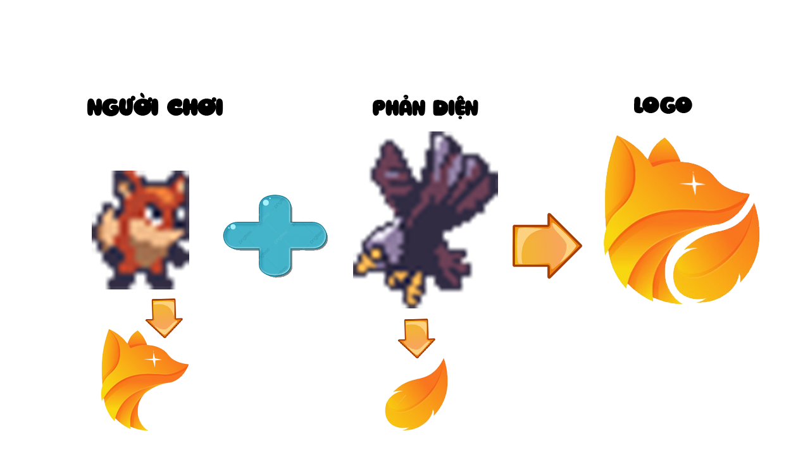

*Picture 1: Game logo*

**PAGE 2: GAME OUTLINE**

**1. Game story summary**

The story is about the fox when he went down the mountain when he discovered that there was a vineyard ahead, and tried all kinds of ways to pick grapes.

1. **Game flow**

Actions that a player can perform are:

* + Move up and down
  + Avoid obstacles such as a moving fire eagle, ...
  + Move left and right

They will be explored in depth in the next part of the game.

**PAGE 3: CHARACTER**

**1. Red Fox**

He is a fox. He tried to pick the grapes

  

*Picture 2: Red Fox*

**2. Monster mushroom**

When you hit this monster. you will die. You will destroy it by jumping on top of it.

  

*Picture 3: Monster*

**3. Landscapes**

The sun, sky, tree,… are the most popular backgrounds in the game.

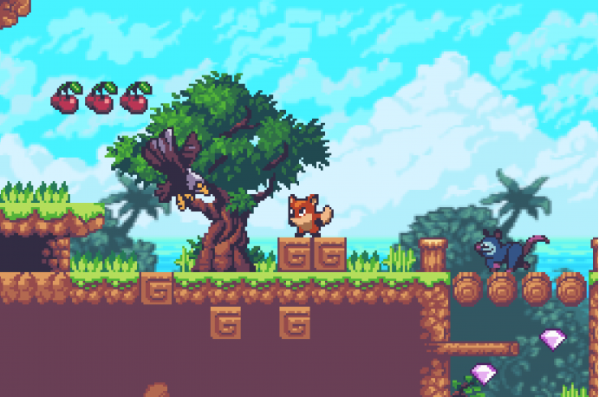

*Picture 4: Landscapes*

1. **Green turtles**

As well as the demon mushroom. If you hit it,

the game will probably end if you run out of lives

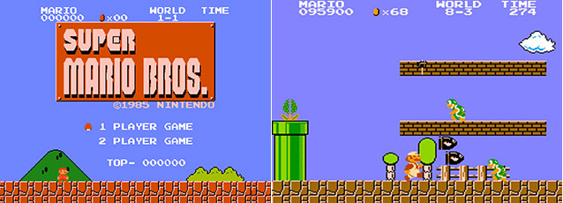

*Picture 5: Bird and obstructions*

7

**PAGE 4: GAMEPLAY**

Players will start from round 1. The Red Fox will only have 1 life. If you then get hit by a moving mushroom. You will die and start over.

You earn a lot of lives, when stabbed by a monster, it will be harder to die than usual. Unless you fall off a cliff. You will die instantly and return to the first round.

You only need to pass 4 levels to pick a bunch of grapes.

**PAGE 5: GAME WORLD**

The player becomes a fox. Through many difficult things to pick grapes. Knowing is difficult, but to achieve the goal. The red fox has gone through many obstacles to pick the grapes.

When you play this game. You will become a real fox. Since you can pick a bunch of grapes, you will grow through each stage. Game for all ages but very interesting and meaningful.

**PAGE 6: GAME EXPERIENCE**

* The game is set in the fresh spring season. Nice weather, green trees. Players will not feel uncomfortable when playing the game by the bright scenery. Very suitable for people who are stressed and feel dark life.
* Players will experience the shape of a very small and lovely fox. Colors of the game help to complement eye-catching colors like blue, orange and blue.
* When playing the game you will find that although the Red Fox is very small in that scene, the Red Fox still tries to achieve its goal despite the bad things waiting.
* When a player starts a game, they will see a loading screen.

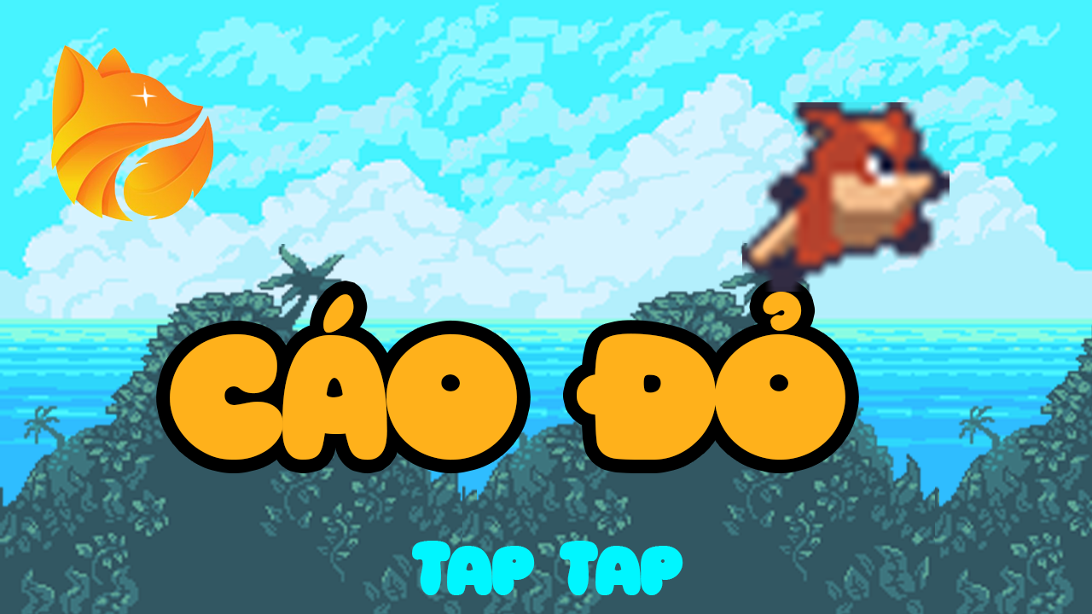

*Picture 6: Loading screen*

* After that, player will be seen the start layout.

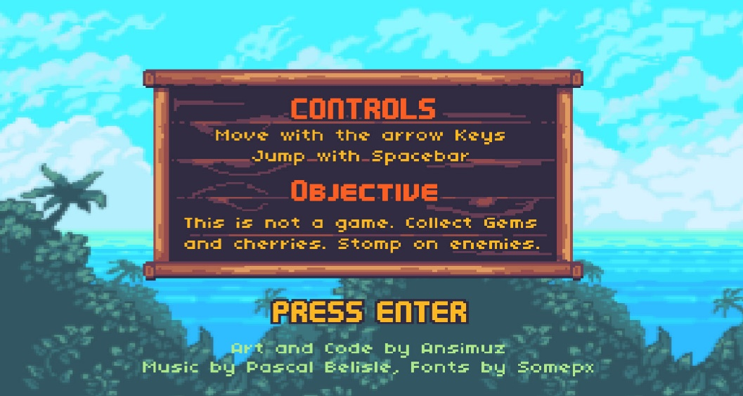

*Picture 7: starting screen*

**PAGE 7: GAME MECHANICS**

The player controls the main protagonist of the Red Fox, and the goal of the game is to run through the forest to pick up a bunch of grapes. Players move from the left side of the screen to the right side of the screen to reach the bunch of grapes at the end of each round.

The world in the game spreads diamonds for the Red Fox to pick up, and. The player is given a certain number of "lives" (and can gain extra lives by picking up green and orange '1-Up' cherries.

Red foxes lose their lives if harmed too many times, falls in a pit, or runs out of time; The game ends when there are no more lives left. The Red Fox's main attack method is to jump on top of the enemy, although depending on the enemy there will be a different reaction after jumping. The game consists of 4 scenes.

The final round of every scene that takes place in the forest one of his monsters will appear. Some scenes feature loops that take place underwater, with different types of opponents. There are also rewards and secret areas in the game. Most secret areas contain diamonds for the Red Fox to pick up.

**PAGE 8: ENEMIES**

* Eagle monster:



* Frog monster:



* Mouse monster:



* All of the above, you have to jump over or jump on top of it and you will be able to get over it.

**PAGE 9: MULTIPLAYER AND BONUS MATERIALS**

When you eat cherry. You will be given an extra life and raised 1 level. The more lives you accumulate, the easier it will be to pick grapes, so try to eat them as they are quite rare.



And when you eat diamonds will accumulate extra points for you. The more points you will top the rankings and be known by many people.



# CHAPTER 3: THE GAME DESIGN DOCUMENT

**1. Game Story**

Based on the fairy tale of the fox and the red cherries, the story tells about the fox that once descended from the mountain, the fox discovered a vineyard ahead, under the green foliage, each bunch of grapes filled with succulent, below Sunlight looks even more appealing. These grapes make people crave. Fox craves so much that saliva spills out on both sides of the mouth. The fox looked ahead and looked back to see that there was no one, many grapes like this, also wanted to eat a few bunches. The fox stood upright, reaching out to pick grapes. But the vine is too tall. My fox, no matter how much he reaches, cannot reach it. The fox quickly thought up a way, tried to jump to see why, but he only managed to reach the grape leaves. The fox could not have the heart to leave the vineyard without any fruit yet, so he circled a few times around the garden, finally discovering a rather short vine. My fox jumped again, couldn't reach the bunch of grapes, tried to jump again, still couldn't pick any grapes. My fox circled around the vine again. Ha ha, finally discovered a bunch of grapes that were even lower than the one earlier. My fox proudly thought that this time he would pick it, but in the end it still could not. No matter what he did, he could not pick grapes, so the fox sadly left, and said the cherries were nothing. In the story, players will transform into the main character of a red fox whose mission is to overcome obstacles and monsters to find 4 red cherries. Red cherries appear at the end of the map of each level. To get the red cherries, the red fox has to overcome obstacles and monsters, after completion, the red cherries will be. Agile and skillful to overcome those challenges, the red fox has encountered many types of monsters, typically a crazy rat, an extremely aggressive and aggressive mouse, in addition, on the way the red fox meets a frog It is a super high jump and dangerous frog that can use its long rod to catch prey. However, the biggest enemy that the player needs to defeat is the Eagle of Fire. is a monster with immense power that has hit and invaded the sky. Fire Eagle used to be a disciple of the Fire Lion, but he pretended to be in control of the sky, so he went on a path and specialized in slaughtering innocent animals where the Fire Eagle lived. Many red cherries appear so wanting to get a red cherry cluster requires the red fox to defeat the Great Ban Fire.

1. **Game controls**



*Picture 9: Map mode*

The game Red Fox is built according to the horizontal game screen, the game has a fairly simple way to use the WASD key combination or the up and down arrow buttons to move in the process of moving, if you encounter obstacles You can double-press the w key or the up arrow button to jump through obstacles. In addition, during the move, encounter obstacles, there are some types of monsters such as ball frogs, crazy mice, fire eagles, so the character will be equipped with skills to fight monsters, the game context is set. Beautiful and strange design, along with many obstacles, dangerous traps that require players to concentrate highly to complete the level.

Controls in the game:

• Use the keys shown to move, double-press the w key or the up arrow to jump

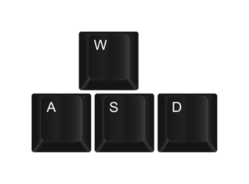

• Fight monsters by jumping on top of monsters, when hit, the monster will die by double pressing w or up arrow to jump

**3. Technological requirements**

• In-game physics works:

• Fire Fox moves in 2D scroll plane, from left to right or from right to left

• An accident will happen when the Fire Fox meets a monster

• Has gravity

• When there is an obstacle in front, the character can jump to get over it

• Design tools:

• Adobe XD

• Photoshop

• Zeplin

• Camera, physics, sound, ... done by programmers.

• Unity

• Fraud control:

• Cheating Life: maximum 4 lives per round, players cannot use more lives if the network reaches its maximum.

• Diamonds: diamonds are calculated for gold based on the finished ring, so it cannot be edited.

• Game scenario: players need to overcome the challenge in the previous screen to continue playing on the star screen.

**4. Logo game**

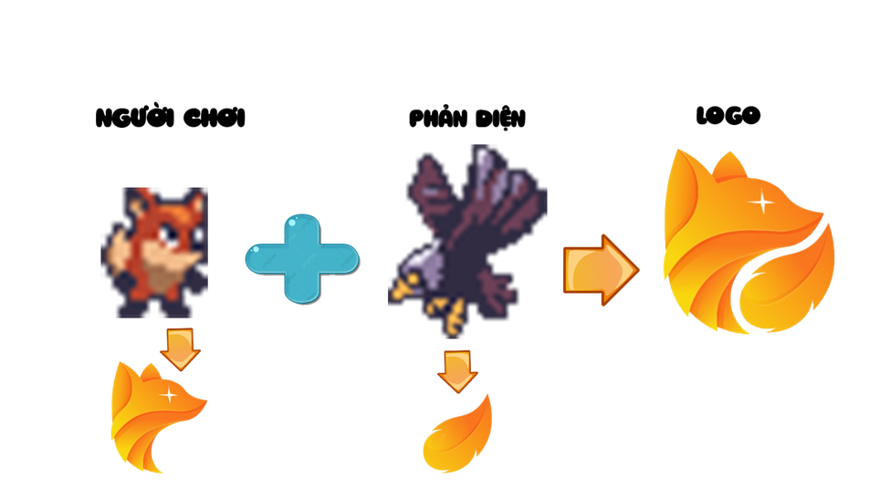

*Picture 10: Game logo*

1. **Front end of the game**

* Main mode:



- Familiar with how to play:

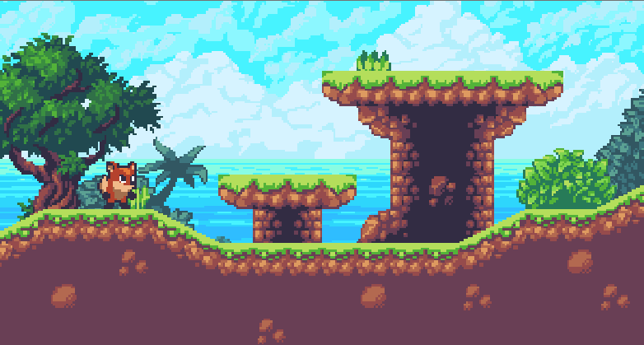

- All mode of map:

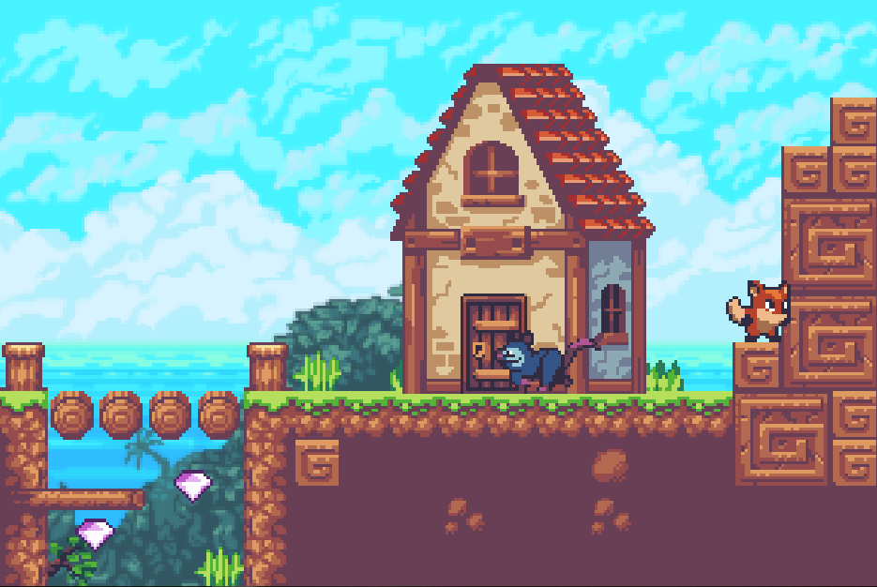

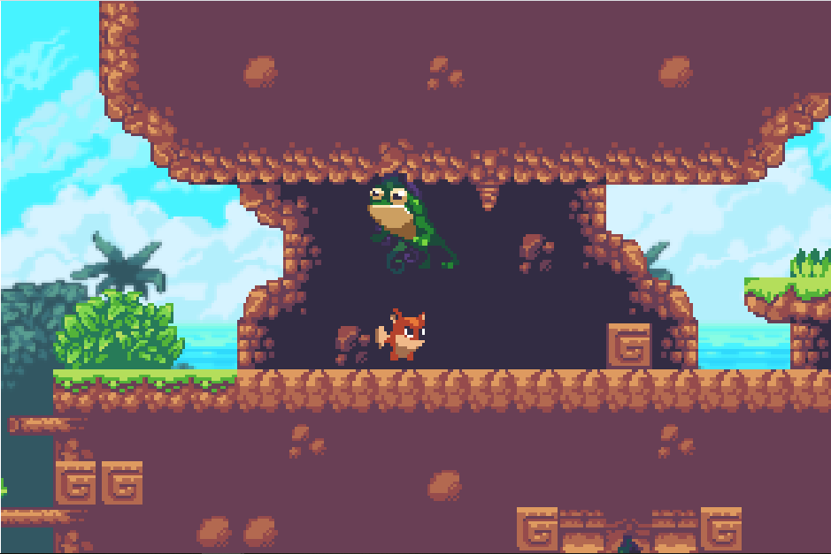

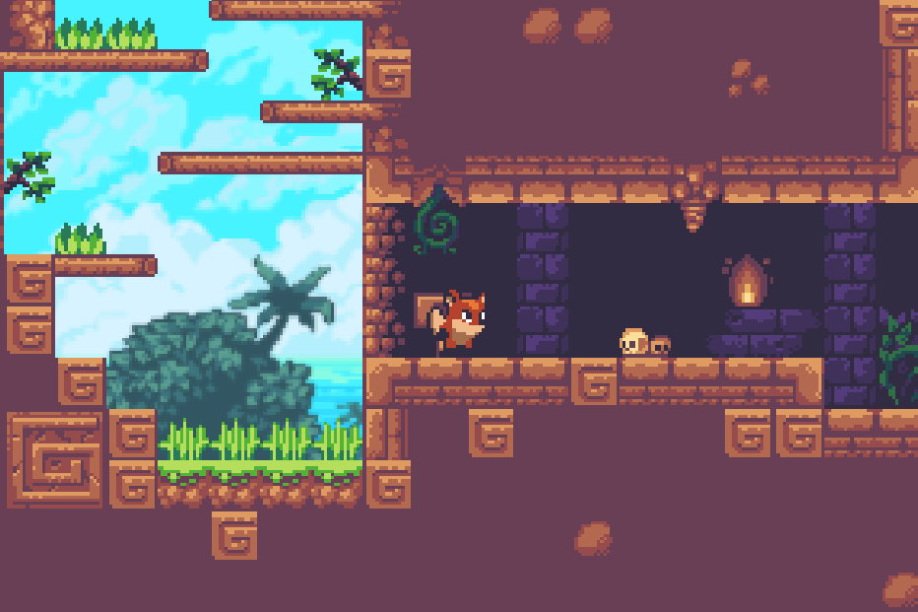

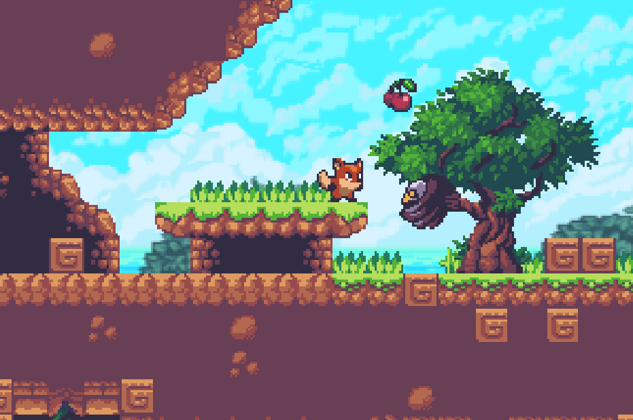

1. **Game flowchart**

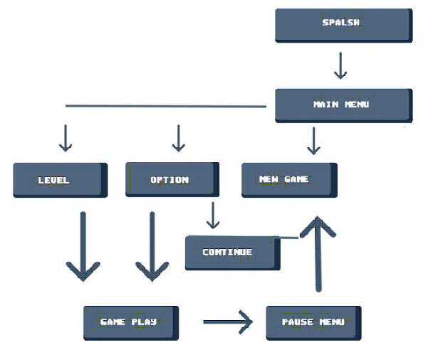

*Picture 15: flowchart*

1. **Loading screen**

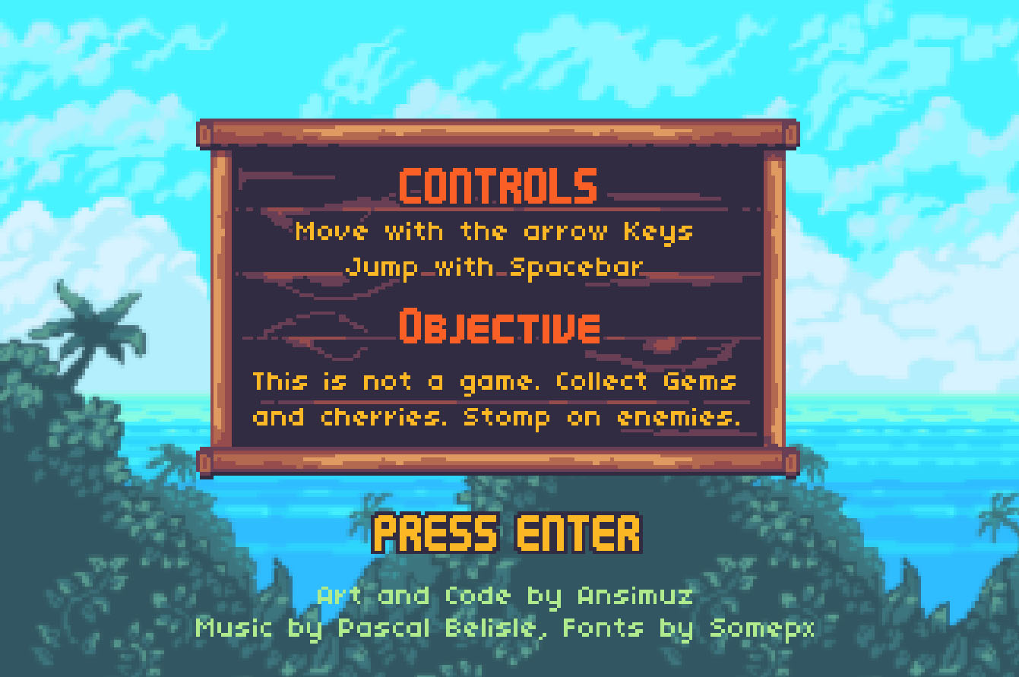

*Picture 16: Loading screen*

**8. HUD System**

Information presented on the screen includes: blood red hearts, four cherries avatar, pause button.

• Red Hearts: At the start of the game, the player will have 4 hearts.



• Avatar 4 cherries: at the beginning of the game, the cherry has 0 fruit, each time you pass 1 screen, there will be 1 plus fruit, when you have enough 4 fruits, the player will win



• pause button: pause button to pause the

**9. Player skills**

* The player can use the Red Fox's jumping skill to destroy monsters and overcome obstacles, by double clicking the up arrow

**10. Mark**

* Diamond: diamonds will appear randomly in the caves in the player's path.
* Unlimited number and duration of diamond items.
* Achievement: At the end of the game, the player still has 4 blood hearts, 3 diamonds will be earned, 2 diamonds out of 3 blood hearts, and 1 diamond below 2 blood hearts. These diamonds will be accumulated through each game screen and used to rate the player's ability. The game will take the accumulated diamonds of each gamer and compare it to rank with other gamers who are friends of the gamer playing.

**11. Reward and economy**

* Each player will earn a certain amount of diamonds from his level of play.
* The game will take the accumulated diamonds of each gamer and compare it to rank with other gamers who are friends of the gamer playing.

**12. Game level**

* In each game screen, the defeat of monsters is the main thing, but besides that the player must also overcome the pitfalls that they have set.

• Act 1: Spooky house

This is the outside of a spooky old house, surrounded by terrible monsters, unexpectedly, at the end of the road out of the house is the place where the red cherries appear, to go all the way, The player must go through 3 levels. In each level, there are not only monsters but also many other traps that they present to make it difficult for the player, the deeper you go, the more traps, the dangerous nail holes, if you let the character fall. The nail hole will kill the character and the player must start again from the beginning of the level. In addition, not only the monsters appear in front of the character, but also the fierce firebirds living around the area of ​​this spooky house hiding the ambush above, they will fall suddenly to attack the player character, if attacked by these ferocious birds, the character will die and the player will lose. However, to kill these animals is also very simple, just jump on top of them and smash they will die, killing 1 human player will be plus 1 diamond, so it requires the player to be very careful, be alert and act quickly.

The player's task is to pass all levels to go to the end of the path and pick a bunch of red cherries.



• Act 2: Swamp King

This is a very beautiful land at first glance but inside is full of traps and monsters guarding, at the end is a place containing red cherries, to go to the end, players have to go through 3 levels. The trap in this level is the large swamps and the shiny frogs that live in this swamp, they will appear intertwined, more and more dangerous.

In each large swamp, there will be a large ball frog living in it, jumping back and forth to prevent the player from passing, while lying in the swamp, while flying up high. So it is very difficult for the player character to cross the other side of the swamp without destroying the ball frog, if not carefully being touched by the ball frog, the player will lose. Also in the swamp there are always precious items such as diamonds and healing potions that will appear randomly. So the player needs to destroy the ferocious ball frog, to go through the swamp to get the items, killing 1 ball frog in this level is as simple as just jumping on top of them and smashing, but because the ball frogs don't lie still. One place, so the player must watch at the right time to avoid being touched by the ball frog. After destroying the ball frog, the player will also get 1 diamond.

The player's task is to pass all levels to go to the end of the swamp to get the red cherry jars.



• Act 3: The cellar of death

This is a dark place full of traps and monsters guarding, at the end is storing the 3rd red cherry jar, to go to the end, the player must go through 3 levels. Traps in this level are red flames and crazy rats, which are also intertwined and also highly fearsome.

In the bunker that the player character goes through, yellow or orange lights will appear. The yellow orange light will slow the player character's movement speed, if hit will lose 30% of the speed, so the player must try to avoid these orange lights.

On the way to pick red cherries, the player character will go through places where there may be crazy mice, when detecting that the mad mouse is approaching, the player must quickly control the character's direction in reverse and run it. Quickly reach safety or destroy them by jumping on top of them and smashing, players must pay attention because the mad mouse has extremely fast movement speed, and is the fastest moving monster in the game, otherwise Run in time, the character will be bitten by the mad mouse, the player will have to lose.

The player's task is to pass all levels to go to the end of the 3rd cherry picker.



• Act 4: King of the sky

This is bright, but full of pitfalls and monsters, at the end contains the fourth cherry, to go to the end, the player has to go through 3 levels. Traps in this level are shadow frogs, mad rats, and orange-yellow lights, and the fire eagle boss, which is constantly appearing intertwined and has a high level of accuracy.

Some sections of the road will have many large ball frogs continuously, if you are not careful to be touched by the ball frogs, or are attacked by a mad mouse and a fire eagle, the player will lose and end the game. The player must skillfully control his character through these roads so as not to be attacked by monsters while moving while picking up items that appear randomly in this passage.

Or players will encounter some organs along the way, namely orange-yellow flames along the way. If you are hit by a character, the player will slow down, the player will most likely lose because of the attack by a mad mouse and a ball frog, so the player must also skillfully control his character to overcome this obstacle. .

The player's task is to pass all levels to go to the end to pick the fourth cherry.



1. **Collectible/Object sets**

* In all levels of the game, players get items that are diamonds.
* Diamonds will randomly appear on the way and fall off when the player has just destroyed 1 enemy. Players jump up or close to pick up diamonds. Or the diamonds will be hidden in caves or somewhere on the player's path. When discovering where diamonds are hidden, the player must reach the chest where diamonds are hidden and pick up diamonds.

1. **Graphics, Music and SFX**

* Funny graphics are the strong point of the game, Sound effects are an important part, indispensable in any game. It greatly contributes to the effect as well as demonstrates the properties of the entire game and in each scene.
* The whole game will have a main music song, but in each game scene, when it is gentle, slow, when drastically hard, the music will change accordingly, when it is easy, when it is intense.
* In each row, when the player picks up an item, there will be a specific noise of that item. Accompany it is the sound effects that make the player really attracted.