**TRƯỜNG ĐẠI HỌC THỦ DẦU MỘT**

**VIỆN KỸ THUẬT – CÔNG NGHỆ**



**ĐỒ ÁN MÔN HỌC  
LẬP TRÌNH GAME TRÊN DI ĐỘNG**

**XÂY DỰNG GAME BẮN MÁY BAY**

**GVHD: TH.S HỒ ĐẮC HƯNG**

**SVTH:**

**TRẦN THANH HƯỞNG MSSV: 1724801030061**

**NGUYỄN MINH QUANG MSSV: 1724801030106**

**NGUYỄN PHƯƠNG NAM MSSV: 1724801030081**

**NGUYỄN QUỐC ANH MSSV: 1724801030191**

**BÌNH DƯƠNG - 04/2021**

**TRƯỜNG ĐẠI HỌC THỦ DẦU MỘT**

**VIỆN KỸ THUẬT – CÔNG NGHỆ**



**ĐỒ ÁN MÔN HỌC  
LẬP TRÌNH GAME TRÊN DI ĐỘNG**

**XÂY DỰNG GAME BẮN MÁY BAY**

**GVHD: TH.S HỒ ĐẮC HƯNG**

**SVTH:**

**TRẦN THANH HƯỞNG MSSV: 1724801030061**

**NGUYỄN MINH QUANG MSSV: 1724801030106**

**NGUYỄN PHƯƠNG NAM MSSV: 1724801030081**

**NGUYỄN QUỐC ANH MSSV: 1724801030191**

**BÌNH DƯƠNG - 04/2021**

**TRƯỜNG ĐẠI HỌC THỦ DẦU MỘT**

**VIỆN KỸ THUẬT – CÔNG NGHỆ**

**NHẬN XÉT VÀ CHẤM ĐIỂM CỦA GIẢNG VIÊN**

Họ và tên giảng viên: **Hồ Đắc Hưng**

Tên đề tài: **XÂY DỰNG GAME BẮN MÁY BAY**

Nội dung nhận xét:

**Điểm:**

Bằng số:

Bằng chữ:

|  |  |
| --- | --- |
|  | **GIẢNG VIÊN CHẤM**  *(Ký, ghi rõ họ tên)* |

**ThS. Hồ Đắc Hưng**

# PREAMBLE

In the age of information technology today, technology products are increasingly subjected to stricter evaluation from users, especially Game products received a lot of reviews from gamers. Or just normal players. The current Game industry can be said to be booming, with the rapid growth rate, many good and interesting games have been born in the past time.

From the development trend and the above shortcomings, this project will aim to experiment with the development of a 2D airplane shooting game. Prepare knowledge and skills for our future career direction (game development), contributing to the development of the home game industry. The first chapters of this document will introduce android.

**TABLE OF CONTENTS**

PREAMBLE iii

TABLE OF CONTENTS iv

LIST OF FIGURES v

OPEN 1

CHAPTER 1. THEORETICAL BASIS 2

1.1. Overview of Android 2

1.1.2. The Linux kernel layer 2

1.2. Library floor 3

1.3. Android runtime part 3

1.4. Application Framework layer 3

1.5. Application Floor 4

CHAPTER 2. DESIGNING THE APPLICATION 6

2.1. Game design 6

2.1.1. Game design ideas 6

2.1.2. Create and configure 2D games 6

2.1.3. Load Back ground 7

2.2. Building 2D airplane shooting game 7

2.2.1. Game introduction 7

2.2.2. The rules of the game 8

2.2.3. Attack 9

2.2.4. Scores 9

2.2.5. How to compile the APK file in android studio 9

RESULTS AND DEVELOPMENT DIRECTIONS 15

REFERENCE DOCUMENT 16

LIST OF FIGURES

**Figure 2.1:** Create a new project 6

**Figure 2.2:** First look interface 7

**Figure 2.3:** Game start interface 8

**Figure 2.4:** Play game interface 8

**Figure 2.5:** Bullet color interface 9

**OPEN**

1. **Reasons for choosing topics**

* The game industry now can say that boom, with a rapid growth rate, a lot of games and attractions have been born over time.
* Found that the importance of the group you decided to find out and implement the topic: ***“The program to program flight games on android”.***

1. **Research purposes**

* The building of a jet - machine game will help to improve, improve memory, develop logical thinking, develop collaborative thinking.

1. **Subject of topic**

* The game is suitable for everyone.

1. **Research scope**

* Learn programming techniques with android studio.

1. **Research Methods**

* Theoretical research
* Practical survey
* Develop the program according to the set goals
* Analyze and design the program system accordingly

1. **Topic layout**

* Nội dung đồ án gồm các thành phần sau:
* MỞ ĐẦU
* Chương 1. Cơ sở lý thuyết
* Chương 2. Thiết kế ứng dụng
* KẾT LUẬN VÀ HƯỚNG PHÁT TRIỂN
* TÀI LIỆU THAM KHẢO

1. THEORETICAL BASIS
   1. Overview of Android

* Android is a Linux-based operating system that runs on touchscreen mobile devices such as smartphones and tablets. Originally developed by Android Corporation, with funding from Google and later acquired by Google itself in 2005. In 2007 android launched with the announcement of the Open Handset Alliance: a union The association is comprised of software, hardware, and telecommunications companies with the goal of promoting standards for mobile devices. October 2008 the first phone running Android went on sale.
* The Android operating system architecture has 4 layers from the bottom up, the Linux kernel layer (version 2.6), the Libraries & Android runtime layer, the Application Framework layer, and the top layer is the Application layer.
  + 1. The Linux kernel layer
* The Android operating system is based on the Linux kernel, specifically the Linux kernel version 2.6, which is shown in this bottom layer. All the things the phone wants to do is done at a low level. This class includes memory management, communication with the hardware (driver model), implementation of security (security), process management (process).
* Although it is based on the Linux kernel, the Linux kernel has been upgraded and modified a lot to suit the characteristics of the handheld devices, such as processor limitations, memory capacity, and size. screen ruler, needs wireless network connection.
* This floor has the main components:
* Display Driver: Controls the display on the screen as well as receiving the user's controls on the screen (moving, touching ...).
* Camera Driver: Control the operation of the camera, receive data stream from the returned camera.
* Bluetooth Driver: Control the Bluetooth receiver and broadcast.
* USB driver: Manage the operation of USB communication ports.
* Keypad driver: Control the keyboard.
* Wifi driver: Responsible for the reception and broadcasting of wifi.
* Audio Driver: Controls the audio transceivers, decodes audio signals into digital signals and vice versa.
* Binder IPC Driver: Responsible for connecting and communicating with wireless networks such as CDMA, GSM, 3G, 4G, E to ensure communication functions are performed.
* M-System Driver: Manage read and write to devices such as SD memory card, flash
* Power Management: Monitor power consumption.
  1. Library floor
* This section has many libraries written in C / C ++ for use by software, such libraries are grouped into several groups such as:
* System C library: A library based on the C standard, used only by the operating system.
* Media Libraries: There are many codecs to support playing and recording all kinds of popular audio, image, and video formats.
* Web Library (LibWebCore): This is a component for viewing content on the web, used to build web browsing software (Android Browse) as well as for other applications to be embedded. It is extremely powerful, supports many powerful technologies such as HTML5, JavaScript, CSS, DOM, AJAX ...
* SQLite Library: A database system that applications can use.
  1. Android runtime part
* This section contains the libraries that a program written in the Java language can operate on. The runtime has 2 parts similar to the model running Java on a regular computer. The first is the core libraries (Core Library), containing classes such as Java IO, Collection, File Access. The second is a Java virtual machine (Dalvik Virtual Machine). Although also written from the Java language, an Android Java application is not run on Sun's JRE, but rather runs on the Dalvik virtual machine developed by Google.
  1. Application Framework layer
* This layer builds the toolkit - high-level elements that programmers can quickly build applications with. It is written in Java, with general usability to save resources.
* This is an open platform, which has 2 advantages:
* With phone companies: It is possible to customize to suit the configuration of the phone they produce as well as to be able to have many models and styles to suit the user's tastes. So, although the same Android platform, Google's phones may be different from Motorola, HTC, T-Mobile, Samsung ...
* For programmers: Allows programmers to use APIs on the upper level without having to understand the underlying structure, giving programmers the freedom to create because they only need to care about the content. which application they work for. A very useful set of built-in APIs such as navigation systems, background services, communication between applications, high-level interface components ...
  1. Application Floor
* This is an application layer that communicates with users, including applications such as:
* Basic applications are installed with the operating system: calling, managing contacts, browsing the web, texting, calendaring, reading email, taking pictures, ...
* Additional applications such as games, dictionaries, and English learning software.
* The programs are characterized by:
* Written in Java with apk extension.
* When each application is run, it has a Virtual Machine version built to serve it.
* Android is a multitasking operating system, which means that there can be multiple programs running at the same time, but for each application there is only one instance that is allowed to run. stop it. That has the effect of limiting the abuse of resources, helping the system work better.
* Applications are assigned user ID numbers to assign permissions when using resources, configuring hardware, and the system.
* Android is an open operating system, unlike many other mobile operating systems, Android allows a 3rd party application to run in the background. Those apps have only one limitation: they are not allowed to use more than 5% of the CPU capacity. That is to avoid monopoly in CPU usage.
* Application has no fixed entry point, no main method to start with.

1. DESIGNING THE APPLICATION
   1. Game design
      1. Game design ideas

* Characteristics of the series that I have built at a time with only one player, the game will have 1 screen, the player will shoot to eliminate the enemy and try to destroy as many ports as possible. high, when a player is hit by a bullet resulting in a collision, the player dies and a restart screen appears informing the player of the highest score he has achieved.
* The screen will move and the enemy troops will appear from there, the more enemy troops later, so the player must skillfully move to avoid enemy bullets to kill the more enemies, the higher the score.
  + 1. Create and configure 2D games
* Create project
* Turn on android studio, go to File / New Project menu

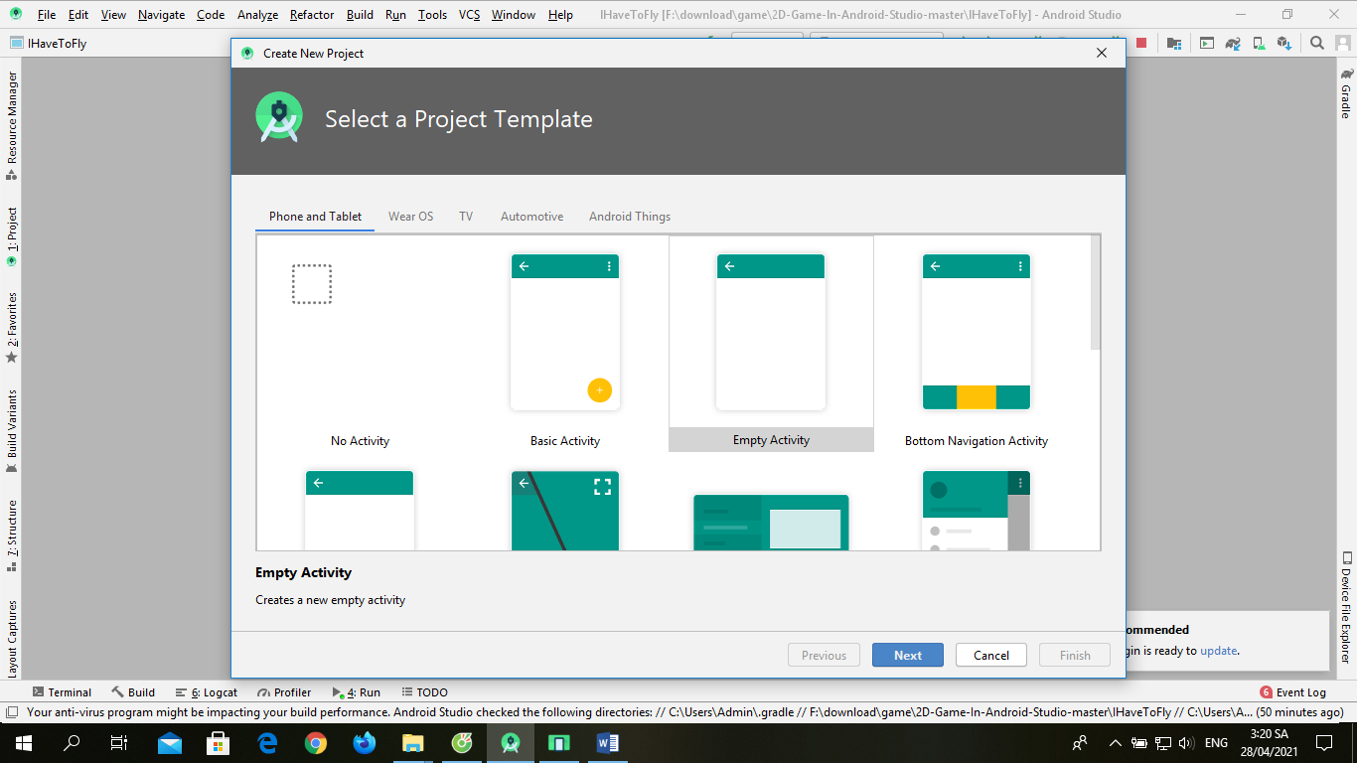

* + - 1. Create a new project
* Select the project type as Empty activity then type in the project name and click finish. The following results:

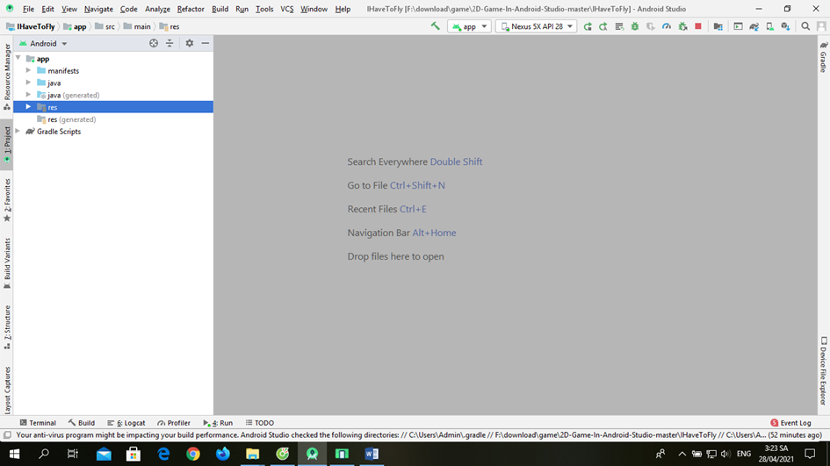

* + - 1. First look interface
    1. Load Back ground
* 2D game is built from many 2D models placed on 2-dimensional space to harmonize with each other to form the scene in the game. Therefore, loading and displaying 2D models in the game is extremely important.
* 2D models are composed of many polygons to create blocks of objects. Today, in a 2D model not only contains one object, it consists of many blocks of objects that are bound together on a skeleton. This prevents the model from having an inward motion and easily changes movement for the model.
* Android studio supports many different 2D model formats such as: PNG, JPG ...
* First, we create layers for objects like the background, Bird, Bullet, Flight
  1. Building 2D airplane shooting game
     1. Game introduction
* Characteristics of the series that I have built at a time with only one player, the game will have 1 screen, the player will shoot to eliminate the enemy and try to shoot as many points, the higher the score, When a player is hit by a collision resulting in a collision, the player will die and a replay screen will appear informing the player with the highest score.
* The screen will move and the enemy troops will appear from there, the more later the enemy army, so the player must skillfully move to avoid the port object and shoot down the enemy to improve score.

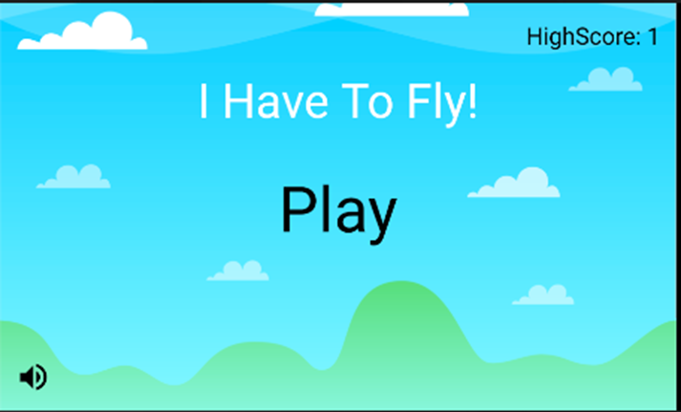

* + - 1. Game start interface
    1. The rules of the game
* Players will move by touching the screen to fly up or down to dodge objects and destroy enemies by touching their shapes on the screen, the longer you play, the more points, players can only move within the camara screen.

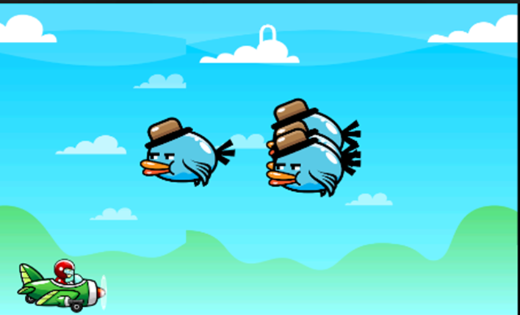

* + - 1. Play game interface
    1. Attack
* Players will shoot bullets to destroy enemies, each enemy shot will be destroyed immediately but the number of enemies will be out continuously, so the player needs to shoot continuously to destroy the enemy. Green planes will have a yellow shot

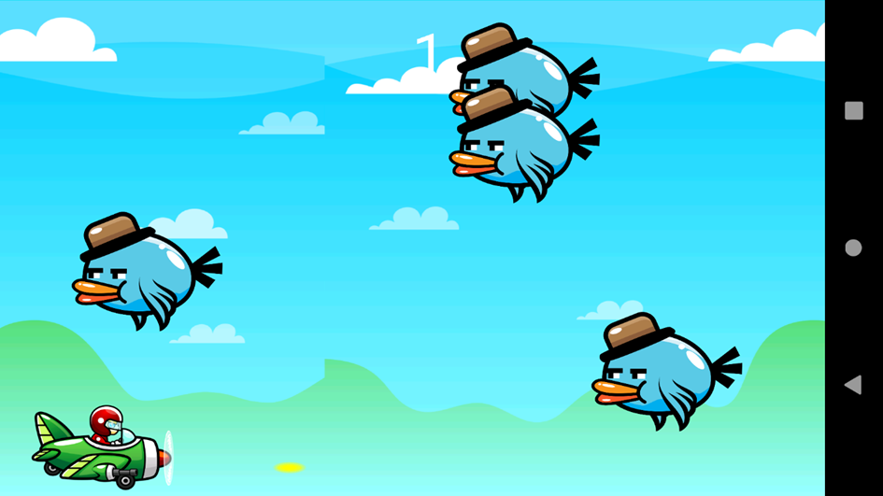

* + - 1. Bullet color interface
    1. Scores
* Player will get points for killing 1 bird will get 1 point, if player collides with birds then game is over.
  + 1. How to compile the APK file in android studio
* To compile, follow these steps:
* Step 1: Create the keystore file
* Go to the Build menu / select Generate Signed APK…

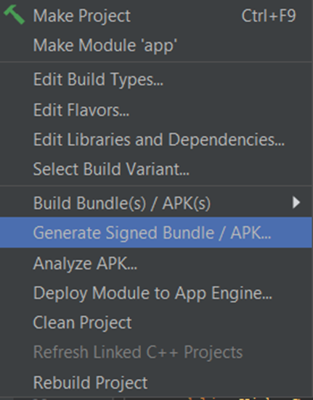

* After selecting Generate Signed APK…

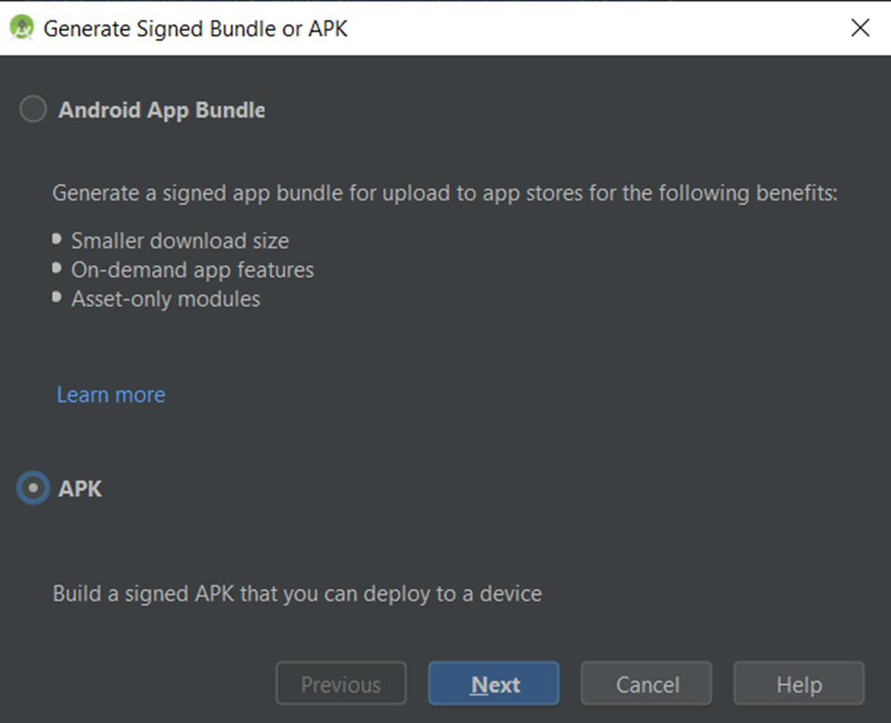

* Click Next to continue:

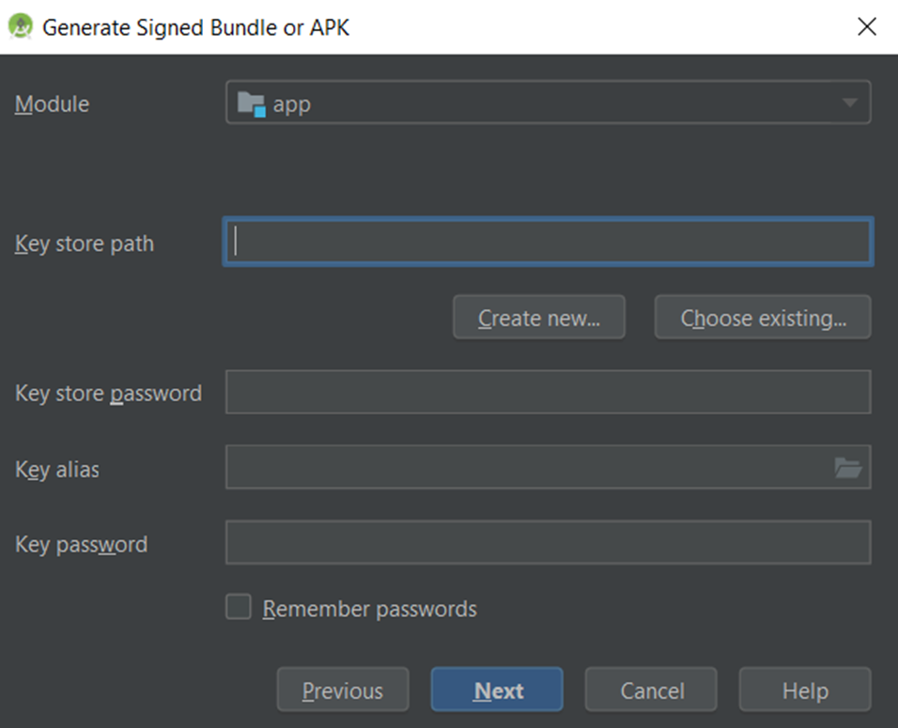

* Item Key store path: As the place to store the key, click on the button "Create New ..."

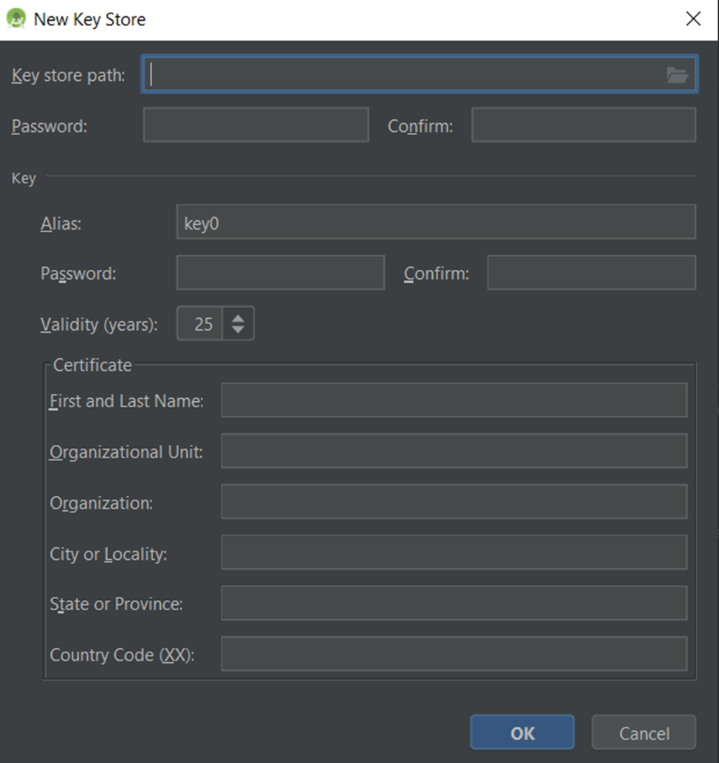

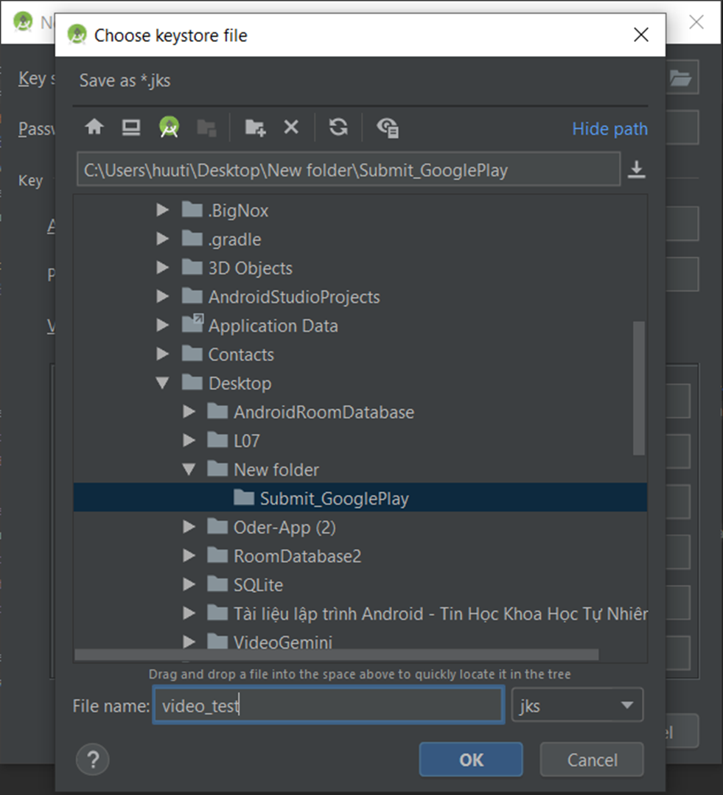

* Step 2: Embed Keystore in apk file
* After naming the file and then click OK:

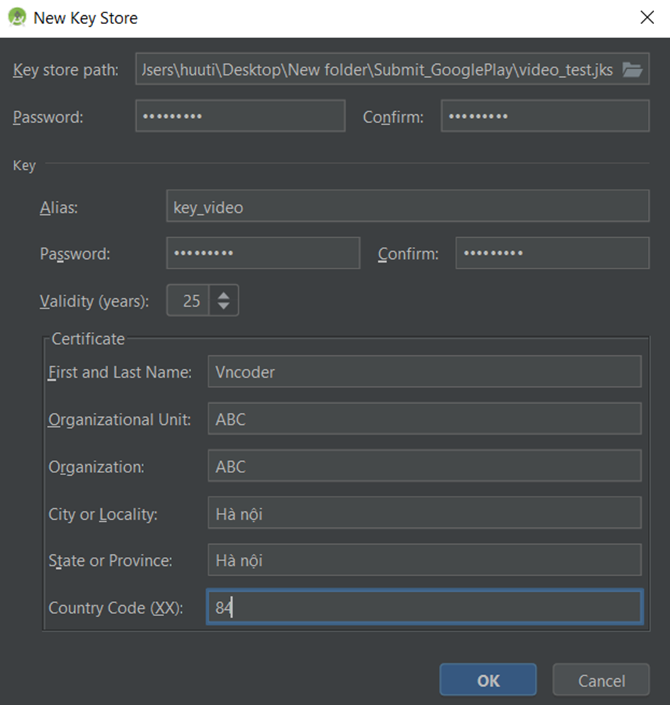

* After clicking OK on the above screen, the information will be displayed again on the screen as follows:

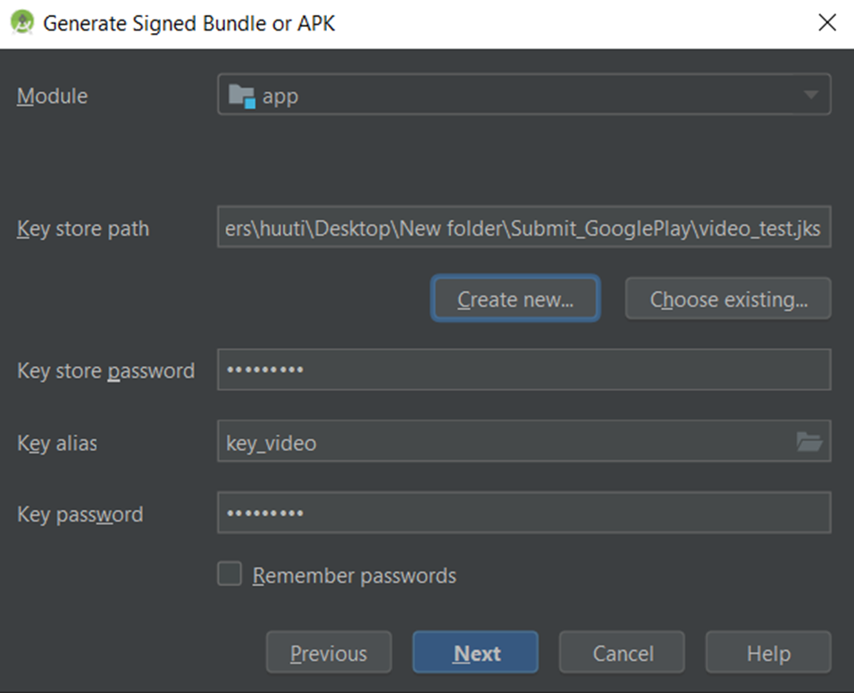

* Step 3: Transfer apk file from debug -> release
* Continue to click Next: Select Release and click Finish, then wait a while to wait for Android studio to create the software publishing file, when the build is complete, it displays "Show in explorer", you click to get the output file. copy:

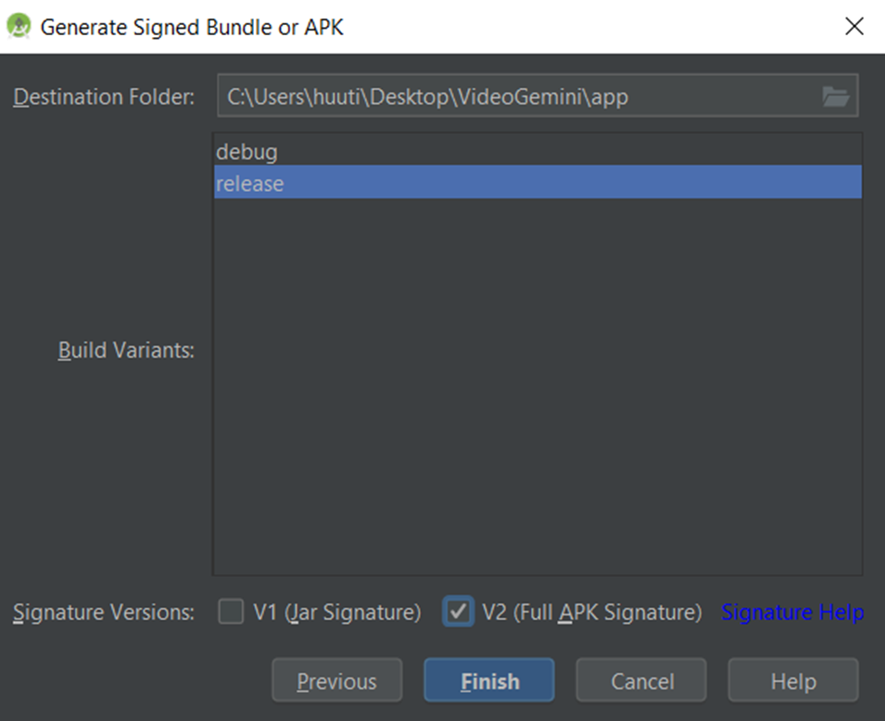



* You see the directory containing the publication file:

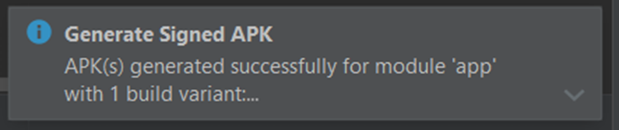

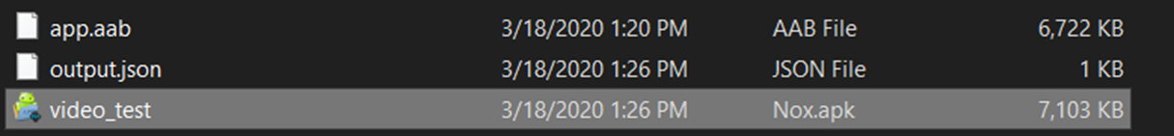

**RESULTS AND DEVELOPMENT DIRECTIONS**

1. **Setting**

* The application is built as a .apk file.
* Copy the .apk file to your Android phone.
* Open the copied .apk file for fiel to install on the phone.

1. **Result**

* Game has a friendly interface, beautiful, easy to use.
* The game has met the basic requirements of the game.

1. **Advantages**

* Understand the structure, how it works, how to develop apps on android studio.
* Improve your programming knowledge and specialized English through materials about android studio in English.
* Build functions such as point, shoot, move .. through java programming language.
* Create sounds for games and some other functions.
* Build characters in the game with software that supports photoshop.

1. **Defect**

* Due to my limited knowledge about android studio and java, the functions in the game are still poor.
* Not yet built a complete game as expected.

1. **Development**

* Optimize processing to make games run faster.
* Increase the number of screens to play more players to choose from.
* Add weapons, ammunition, upgrade aircraft and weapons
* Provide additional tools for players to edit or create their own character images, sound effects, ...

**REFERENCE DOCUMENT**

**Website**

1. <https://www.udacity.com/course/android-basics-user-interface--ud834>
2. <https://www.vogella.com/tutorials/Android/article.html>
3. <https://www.youtube.com/playlist?list=PL6gx4Cwl9DGBsvRxJJOzG4r4k_zLKrnxl>
4. [Google Developers Codelabs](https://codelabs.developers.google.com/?cat=android)
5. [Official Android developers guide](https://developer.android.com/guide)
6. <http://www.xmlnews.org/docs/xml-basics.html>
7. <https://code.tutsplus.com/tutorials/a-beginners-guide-to-http-and-rest--net-16340>
8. <https://www.udacity.com/course/new-android-fundamentals--ud851>
9. <https://www.vogella.com/tutorials/AndroidArchitecture/article.html>
10. <https://www.raywenderlich.com/2071847-reactive-programming-with-rxandroid-in-kotlin-an-introduction>
11. <https://blog.mindorks.com/android-core-looper-handler-and-handlerthread-bd54d69fe91a>