ASTANA IT UNIVERSITY
SOFTWARE ENGINEERING DIPLOMA PROJECT

TT KZ
Design and Development of the TT KZ Web Platform for Digital Integration of the Table Tennis Community in Kazakhstan

Prepared by: Tazhimova Araizhan and Zhanybek Alikhan

Repository: https://github.com/TTKZ12/TTKZ_diploma_work
Supervisor: Zhaksylyk Tomiris

Astana IT University
2026

Contents
1. Project proposal 3
2. Stakeholder evidence and provenance 5
3. Critical literature review 7
4. Existing system comparison 10
5. Technology alternatives and justification 12
6. Initial requirements specification 13
7. Architecture and diagrams 16
8. UX and prototype evidence 17
9. Verification and evaluation plan 25
10. Project management and risks 27
11. Committee feedback forwarded by the supervisor and submission readiness 30
References 32
Appendix A Interview protocols 33
Appendix B Artifact register 34
Appendix C Architecture diagrams 36
Appendix D Stakeholder responses 39
Appendix E Interview provenance register 42
Appendix F Committee feedback and team responses 48
Appendix G TTFRK screenshot evidence 50
Appendix H draw.io diagram insertion guide 54

1. Project proposal

1.1 Background and problem
Table tennis participation brings together players, club operators, coaches, and tournament organizers. Their activities depend on information about venues, availability, suitable partners, and competitions. Multiple disconnected channels can potentially complicate discovery and coordination. These are hypotheses to test in Kazakhstan rather than established facts about all local providers.
TT KZ proposes a unified user-facing environment for finding halls, reserving playing sessions, maintaining player profiles, discovering partners, and browsing tournament announcements. The research problem is whether a consolidated platform addresses demonstrable needs that current channels and services do not sufficiently meet in the Kazakhstani table tennis context.

1.2 Aim and research questions
Aim: To design and develop a web-based TT KZ platform intended to support the digital integration of Kazakhstan’s table tennis community through centralized facility, booking, player-discovery, and tournament-information services.
ID | Research question
RQ1 | What problems do Kazakhstan-based table tennis players and facility representatives experience when finding venues, booking tables, and coordinating activities?
RQ2 | Which relevant functions are offered by federation, community, and booking platforms, and where do gaps remain?
RQ3 | Which technologies and architecture best satisfy TT KZ functional, usability, security, and reliability requirements?
RQ4 | How can TT KZ prevent overlapping confirmed reservations during simultaneous requests?
RQ5 | How can usability, booking correctness, and platform value be tested against an explicit baseline?

1.3 Objectives
- Gather empirical user and operator needs through stakeholder discussions.
- Critically review literature on digital sport, table-tennis communities, facility bookings, concurrency, usability, and player matching.
- Compare existing systems using consistent criteria and verify claimed feature availability.
- Evaluate competing frontend, backend, and database choices against clear project-specific criteria.
- Define functional/non-functional requirements with testable acceptance criteria.
- Design platform context, use cases, component interactions, and persistence boundaries.
- Implement and test the five priority features over subsequent development stages.

1.4 Scope and expected outcomes
In scope (MVP target) | Out of scope for initial pre-defense / possible later expansion
Sports hall discovery; hall details | Online payments; equipment marketplace
Booking of table or playing session | Live-streaming or federation API integration
Player registration and profiles | Complex ratings and AI recommendations
Finding a playing partner | Built-in direct messaging
Tournament list, details, announcements | Official competition results certification / federation replacement

Expected final outcomes: a tested working web application, documented API and database schema, usable interface, automated tests, engineering documentation, and evaluation findings. At this pre-defense stage, outcomes are primarily research and design artifacts, not production implementation.

1.4.1 Operational definition of digital integration
In TT KZ, digital integration means connecting players, authorized venue staff and tournament organizers through shared records and coordinated workflows in one web platform. A venue has identifiable tables and availability intervals; a booking links a player, table and interval; an opt-in profile supports partner discovery; a tournament record links an event to its location and responsible publisher. The integration is within TT KZ and does not imply automatic synchronization with WhatsApp, 2GIS, RTTF or federation systems.
Participants | Connected process and data | Observable outcome
Players and venue staff | Venue discovery → availability → reservation → cancellation; venue_id, table_id, player_id, interval, booking status. | Less effort to identify and request a suitable slot; no overlapping confirmed records.
Players and other players | Opt-in profile search by city, level and availability preferences. | Users can locate a suitable visible profile without exposing private contact data.
Organizers and players | Authorized publishing and updating of tournament title, dates, location, participation conditions and source. | Users find current event information and identify its source and last update.

1.4.2 Initial pilot and inference limits
The initial pilot is limited to Astana. We propose working with one or two cooperating table tennis venues and recruiting five adult users for an exploratory usability evaluation. No venue partnership or recruitment completion is claimed. Historical interview responses are not assumed to come from Astana because participant locations require confirmation. The project title describes the wider Kazakhstan context; the present evidence does not establish nationwide demand or readiness for a national rollout.
Pilot measures are booking effort, reservation integrity and access to venue/tournament information. Section 9 defines the planned baseline and targets. Expansion beyond Astana depends on verified local data, venue participation, successful pilot evaluation and a separate assessment of transferability.

1.5 Participants and responsibilities
Participant | Primary duties
Zhanybek Alikhan | Backend architecture; PostgreSQL schema; FastAPI API; SQLAlchemy/Alembic; booking business rules and conflict prevention; validation, authentication and access control; backend tests; Docker; API documentation.
Tazhimova Araizhan | React/TypeScript frontend; UI/UX; responsive layout; frontend validation and state; API integration; client-side tests.
Both team members | User research; requirement refinement; API contract; integration/testing; GitHub reviews; YouTrack; pre-defense materials and supervisor consultation.
Zhaksylyk Tomiris | Academic supervision; review of scope, research, architecture and evaluation plan; feedback at agreed checkpoints.

2. Stakeholder evidence and provenance

2.1 Sample and evidence status
The revised dataset contains written responses from five stakeholders: three regular table tennis players (P01-P03), one coach and tournament organizer (C01), and one hall administrator (A01). P01-P03 and C01 responded on 24 October 2026; A01 responded on 25 October 2026, after the initial deadline. Four real participant exchanges were therefore available by 24 October. The earlier illustrative A01 answers were not empirical data and are replaced in this revision. The sample is exploratory, not representative.
Data were collected through written, question-guided messaging exchanges: Telegram for P01-P03 and C01, and WhatsApp for A01. Tazhimova Araizhan conducted the exchanges; original responses were in Russian and Zhanybek Alikhan translated them into English. Metadata and agreement to anonymized use are reported by the team; original screenshots remain to be inserted in Appendix E. No audio recording was made. Participant locations and current translation checks remain to be documented.
Code and role | Reported perspective | Provenance status
P01 – player | Plays about once a week; describes uncertainty about slots and delayed replies. | 24 Oct 2026; written Telegram exchange. Current translation/source check pending; agreement to anonymized use reported.
P02 – player | Plays daily; reports good venue access and uses RTTF/TTRanking. | 24 Oct 2026; written Telegram exchange. Current translation/source check pending; agreement to anonymized use reported.
P03 – player | Plays around six times a week; mentions price and suitable time. | 24 Oct 2026; written Telegram exchange. Current translation/source check pending; agreement to anonymized use reported.
A01 – hall administrator | Telephone/WhatsApp requests; administrator checks availability and confirms a table; alternative slots offered when full. | 25 Oct 2026; written WhatsApp exchange. Current translation/source check pending; agreement to anonymized use reported.
C01 – coach or organizer | Fragmented announcements, repeated questions and disconnected tools. | 24 Oct 2026; written Telegram exchange. Current translation/source check pending; agreement to anonymized use reported.

2.2 Thematic findings and negative cases
Venue discovery and reservations. P01 and P03 use 2GIS; P01 also relies on friends and chats. Both describe telephone or message contact for reservations. P01 reports uncertainty about availability and response delays; P03 mentions financial limitations and a suitable time. In contrast, P02 reports no difficulties and good facility availability. The proposed booking workflow addresses an observed convenience issue in part of this small sample, not universal dissatisfaction.
Partner and tournament discovery. All three players use tournaments, friends or community chats to find comparable opponents. Tournament news comes from chats, acquaintances, social media and RTTF. P01 reports not having encountered a single amateur calendar; this does not establish that no such calendar exists.
Venue operations. A01 reports telephone and WhatsApp bookings, usually in advance but also on the day when tables are available. The administrator controls availability for approximately eight rental tables, checks the date, time and number of guests, and assigns a table after confirmation. When demand exceeds available tables, another time or date is offered. This supports explicit availability checks and confirmation states; it does not establish actual double bookings, spreadsheet use or delays caused by multiple staff. Customers ask about availability, specific tables, payment and cancellation or rescheduling. Payment is made on arrival without a booking deposit. No separate substantive answer identified the most time-consuming tasks or online-booking limitations.
Tournament communication. C01 reports posting announcements through WhatsApp, Instagram and Telegram and using Google Forms and spreadsheets for other tasks. Missed updates and repeated questions motivate a maintained event listing. Registration and notifications remain possible later enhancements, not current implementation claims.
Information quality. Participants mention table condition, lighting, space, prices, schedule and amenities. P03 names Unreal Engine 5 as an organization tool; this response is retained but excluded from conclusions about table tennis booking applications because it appears to reflect a different interpretation of the question.

2.3 Evidence to requirements
Evidence | Requirement or design implication | Limitation
P01, P03: map search and direct venue contact | FR-02 and FR-03: venue information and available-slot booking. | No verified time-saving measure yet.
P01: unclear slots; A01: availability checked before confirming competing requests. | FR-04 and NFR-02: atomic non-overlap rule and conflict recovery. | Confirmed double bookings and their frequency were not established. Atomic integrity is an engineering requirement.
P01–P03: social ways of finding opponents | FR-05 and FR-06: private-by-default, opt-in player profiles. | No proof that users will adopt a new platform.
P01–P03 and C01: distributed tournament information | FR-07 and FR-11: maintained listings and authorized updates. | Coverage depends on source and organizer cooperation.
A01: administrator controls availability; customers ask about cancellation and rescheduling. | FR-08: manager maintenance. FR-09: clarify and display cancellation policy. | Specific cancellation rules and management-interface preferences were not confirmed.

2.4 Interpretation
The responses provide preliminary motivation for evaluating integrated discovery, booking and information workflows. They do not establish nationwide demand, willingness to pay, venue adoption or platform effectiveness. Statements above remain stakeholder reports with pending provenance checks. If a source cannot be authenticated, its quotation and requirement support must be downgraded or removed; a new session must be dated as a new interview rather than backdated. Only one administrator was consulted, after the initial deadline. Repeated messages were consolidated and were not counted as additional participants or findings. A01 did not provide separate substantive answers about time-consuming tasks or online-booking limitations.

3. Critical literature review

3.1 Review scope and selection
This purposive review synthesizes 13 scientific publications from 2020–2026. The narrative, synthesis matrix and scientific bibliography contain the same 13 studies. Most studies are recent; Gong et al. (2020) is retained as a foundational matching-method reference. Official technical and product sources are listed separately and are not counted as scientific publications. This is a critical project review, not a systematic review conducted by the team.

3.2 Digital transformation and national context
Dašić (2026) provides a conceptual sports-management framing of digital transformation as an organizational and stakeholder process, rather than adoption of isolated IT tools. Wan et al. (2025), using sector-level Chinese economic time series, report varying links between digital industry development and sports service subsectors. These papers support examining integrated sport services, but neither demonstrates demand for a particular Kazakhstan table tennis booking platform.
Ibrayeva et al. (2025) surveyed adults across Kazakhstan and reported low physical activity for 19.7% of analyzed respondents and no leisure-time activity for 58.1%. This supplies Kazakhstan-specific participation context but is not evidence about table-tennis demand, user willingness to book online, or app effectiveness. The cross-sectional design and self-report measures constrain causal inference.

3.3 Clubs and community interaction
An et al. (2025) investigated amateur table-tennis club management in Guangzhou using questionnaires and stakeholder interviews. Their CPECDS framework identifies consumer needs, competition organization, digital technology, and other operational factors, supporting TT KZ’s decision to involve clubs as well as players in requirements discovery. Its organizational findings cannot be transferred uncritically to Kazakhstan.
Stegmann et al. (2026) experimentally studied platform features and social capital in sports-fan engagement. Exploratory associations for different engagement modes illustrate possible roles for broader connections and group affiliation; overall multivariate findings were not statistically decisive. This is conceptual justification for player and community functionality rather than proof of behavioral change among recreational table-tennis players.

3.4 Reservation workflows and data consistency
German et al. (2024) propose Appoint Deportes, an online sports-facility reservation system grounded in observations, interviews, and process/interface modeling. The research illustrates facility discovery, schedule visibility, and booking flows but offers limited evidence of operational reliability under concurrency. Hermawan and Suharso (2025) test atomic Firebase transactions in a billiard-table reservation case. In ten small concurrent-user scenarios, the authors report double bookings before the control and none after, although the trials cover only 2–11 users and omit wider production performance evaluation.
For TT KZ, it is crucial to distinguish front-end availability presentation from a database-enforced non-overlap invariant. Since the planned database is PostgreSQL, an initial design option is range-aware exclusion constraints combined with transactional API operations and appropriate conflict responses. This approach is supported by PostgreSQL technical documentation, not directly tested by Hermawan and Suharso’s Firebase experiment.

3.5 User-centered interface design
Maringka and Lumingkewas (2024) use Design Thinking and Maze usability testing for a sports-facility rental prototype. Among 51 testers, the reported direct success rate was 78.4%, average task duration 46.1 seconds, and misclick rate 30.2%. Differences between screen scores indicate that user-centered design requires repeated measurement and adjustment rather than relying on visual attractiveness alone.

3.6 Player matching
Gong et al. (2020) propose OptMatch, a computational model of competitive matchmaking informed by historical match interactions and predictive optimization. It is scientifically strong but concerns esports and competitive team formation rather than local offline partner search. TT KZ should initially explore simple opt-in profile filters based on location, level and availability; complex data-driven ranking would require sufficient consented match histories and separate evaluation.

Additional perspectives on service integration and measurement
Anantha Sekoh et al. (2025) describe development of a mobile sports-field booking application using agile development and interviews with 20 managers and users. This supports iterative requirements discovery and scheduling workflows. Reported benefits in that setting are not treated as causal evidence that TT KZ will increase participation or reduce booking effort in Astana.
Saputra and Asmawati (2025) review integrated management information systems in sports facilities, drawing attention to information access, staff adoption, security and privacy. Their small review supports connecting user-facing information and venue operations, but does not validate a nationwide community platform.
Rai et al. (2025) synthesize social-media research in sport using the TCCM framework and identify geographical and theoretical gaps. This helps explain why evidence about fan engagement or communication channels cannot simply be transferred to local offline players. TT KZ will assess specific task outcomes rather than assume community growth.
Iversen et al. (2026) distinguish bookings, actual usage and attendance in sports-facility measurement. Accordingly, TT KZ will not label booked capacity as attendance or claim increased physical activity from reservation records alone. Actual attendance is outside the first pilot unless a venue provides a consented verification process.

3.7 Literature synthesis matrix
Study | Method / evidence | Key transferable insight | Limit / TT KZ interpretation
Dašić (2026) | Conceptual literature review | Integrated sport services and stakeholder networks | Not empirical validation of TT KZ
Stegmann et al. (2026) | Scenario experiment, 226 sports fans | Design can shape types of engagement | Effects exploratory; fans not players
Wan et al. (2025) | VAR/economic time series, China | Digital sport services vary by subsector | Macro outcomes not user needs
German et al. (2024) | Observations, interviews, system design | Facility discovery and reservation flows | No rigorous conflict-prevention test
Hermawan & Suharso (2025) | Ten before/after concurrency scenarios | Atomic booking operations needed | Firebase; only 2–11 concurrent users
Maringka & Lumingkewas (2024) | Design Thinking; 51 prototype testers | Task-oriented usability metrics | Prototype and remaining usability issues
An et al. (2025) | 377 club consumers and interviews | Clubs’ needs, events, digital operations | Guangzhou management focus
Ibrayeva et al. (2025) | Nationwide cross-sectional survey | Kazakhstan participation context | Not table-tennis or digital-service study
Gong et al. (2020) | Models and four datasets | Skill and interaction-aware matching | Advanced esports/team setting
Anantha Sekoh et al. (2025) | Agile development; interviews with 20 facility stakeholders | Iterative booking workflow design | Different sport/facility setting; no local effect established.
Saputra & Asmawati (2025) | Review of seven IMIS studies | Connect information, operations and privacy | Small review; facility scope rather than complete sports community.
Rai et al. (2025) | Systematic synthesis of 203 papers | Evaluate channels and local context | Social-media literature does not establish local platform adoption.
Iversen et al. (2026) | Conceptual and empirical facility measurement | Distinguish booking from usage/attendance | Different facility context; no TT KZ evaluation.

3.8 Research gap and intended contribution
Across the reviewed literature, reservation correctness, sports-community engagement, interface usability, and table-tennis club management are each studied, but the selected studies do not validate a single Kazakhstan-focused integration of hall discovery, bookings, partner search, and tournament information. That observation about THIS REVIEW is not evidence that no such market product exists. The proposed contribution is a locally validated combination of those workflows with explicit booking integrity and measurable usability, to be tested rather than presumed successful.
Count reconciliation: 13 studies are discussed in the narrative, 13 appear in the synthesis matrix, and 13 appear in the scientific reference list. Dašić and Wan are included in all three. External validity remains limited: none of these papers establishes demand for the Astana pilot.

4. Existing system comparison

4.1 Scope and evidence rules
We compare three external benchmarks: ITTF, TTFRK and RTTF against nine consistent criteria. TT KZ is the proposed solution, not a fourth existing system. Public-page observations are distinguished from authenticated feature tests. “Not established” means that the reviewed pages do not provide sufficient evidence; it does not assert that a capability is absent. Open TT is excluded from this revision to keep the comparison focused on benchmarks the team can readily demonstrate.
Criterion | ITTF | TTFRK | RTTF | TT KZ target
Event information | Published event news | Calendar verified | Tournament listings | Must
Ratings or rankings | World rankings verified | Downloadable lists verified | Rating functions visible | Out of MVP
Player information | Ranking lists | National-team information links | Public player links | Opt-in profiles
Venue discovery | Not established | Not established | Club directory visible | Astana venue catalog
Table booking | Not established | Not established | Not established | Must
Partner discovery | Not established | Not established | Not established | Opt-in city/level search
Tournament announcements | Event news | Dated news verified | Announcements visible | Must
Venue schedule editing | Not established | Not established | Not established | Authorized manager
Geographic orientation | International | Kazakhstan federation | Russia and regional communities | Astana pilot

4.2 Dated comparison evidence
Evidence ID | Official public source | Observation on 29 October 2026
SYS-01 | https://ttfrk.kz/ru | Federation identity, dated news, sporting events and national-team links.
SYS-02 | https://ttfrk.kz/ru/calendar | 2026 event entries list dates and locations, including Astana events.
SYS-03 | https://ttfrk.kz/ru/rating | 2026 monthly and age-category ranking-download links. File correctness was not independently tested.
SYS-04 | https://ttfrk.kz/ru/teams | Links to national-team information; not proof of editable community profiles.
SYS-05 | https://www.ittf.com/rankings/ | Official indexed ranking page and weekly lists; direct retrieval was restricted in this check.
SYS-06 | https://rttf.ru/ | Official indexed homepage shows club directory, player links, tournament and rating information; direct retrieval timed out.
TTFRK is therefore verified for public calendar, announcement and ranking publication functions. Public-page inspection does not establish a self-service booking, partner-filter or manager interface. The product gap is a testable local-workflow hypothesis, not a claim that these services do not exist elsewhere. Dated source links and observations are preserved in the companion evidence register; no authenticated usability or booking test of these sites is claimed.

5. Technology alternatives and justification
The team selected React with TypeScript for the frontend, FastAPI for the backend and PostgreSQL for data storage. The comparisons below explain these decisions against the project scope and existing work. The frontend prototype exists; backend and database implementation and validation remain pending. No benchmarking results or supervisor approval of the stack are claimed.
Decision | Options | Working rationale | Decision and validation status
Frontend framework | React + TypeScript; Vue + TypeScript; Angular | React is appropriate for reusable interactive components and team familiarity; Vue is approachable; Angular is more opinionated and larger in scope. | React + TypeScript selected. Frontend prototype implemented; backend integration pending.
Backend framework | FastAPI; Django + DRF; NestJS | FastAPI gives Python typing, validation and OpenAPI tooling. Django offers strong built-in management; NestJS aligns with TypeScript across layers. | FastAPI selected. Runnable backend implementation pending.
Database | PostgreSQL; MySQL; MongoDB | Bookings and users form relational data. PostgreSQL supports ACID transactions, foreign keys and exclusion constraints for overlapping time ranges. | PostgreSQL selected. Schema implementation and concurrency tests pending.

5.1 Persistence, tooling and engineering boundaries
SQLAlchemy is proposed as the Python ORM, Alembic for schema migrations, Docker for repeatable local environments, GitHub for change tracking, and YouTrack for task traceability. The first iteration should prefer a modular single-backend application and one authoritative PostgreSQL database. Microservices, event streaming and advanced AI matchmaking are not initial requirements.
Potential booking invariant: for each physical table, no two active/confirmed bookings may overlap in time. One PostgreSQL option is a GiST exclusion constraint over table identifier equality and a time-range overlap operator, with care over time zones, status transitions, cancellations and migration compatibility. API conflict responses and concurrent test cases must complement database enforcement (PostgreSQL Global Development Group, n.d.).
Decision criteria are functional fit, booking integrity, implementation effort, maintainability and reuse of existing work. The following table records the selected options and trade-offs. The general committee feedback forwarded by the supervisor permits continuation of the topic; detailed review of these technology decisions remains pending.
Decision | Comparative assessment | Selected option
Frontend | React preserves the existing component direction; Vue is a reasonable lightweight alternative but requires adaptation; Angular provides a more prescribed structure with additional setup. | React + TypeScript; reuse the existing layout.
Backend | FastAPI fits the Python backend role and API-first workflow; Django + DRF offers integrated administration; NestJS fits a TypeScript backend but changes the assigned language. | FastAPI; prioritize validation and a documented REST contract.
Database | PostgreSQL supports relational integrity and range exclusion constraints; MySQL supports relational transactions but requires a different overlap-control design; MongoDB requires additional modeling for relational booking rules. | PostgreSQL; validate overlap constraints through integration tests.

6. Initial requirements specification

6.1 Functional requirements
ID | Priority | Requirement | Acceptance criterion (draft)
FR-01 | Must | User registration and login | Unique valid email and password create an account; duplicate email is rejected. Valid credentials authenticate; invalid credentials and unauthenticated protected requests are denied.
FR-02 | Must | Sports hall listing and detail pages | Filter halls by city; selecting a hall displays its location, facilities and available schedule. No matches produce an explicit empty state.
FR-03 | Must | Table booking | For an authenticated user, a future interval with start before end and inside availability creates one persisted booking ID. Invalid intervals are rejected.
FR-04 | Must | Booking conflict prevention | Concurrent requests for the same table and overlapping intervals cannot both confirm. The rejected request receives HTTP 409; adjacent non-overlapping intervals remain valid.
FR-05 | Must | Player profiles | Owner can edit city, level, preferences and visibility. Another user cannot modify the profile; private contact fields are not returned publicly.
FR-06 | Must | Partner discovery | Filter opted-in player profiles by city and skill level; opted-out profiles never appear. Empty results are explained.
FR-07 | Must | Tournament information | Tournament list opens details containing title, date, location and organizer information; missing optional data is labeled.
FR-08 | Must | Facility administrator maintenance | Assigned hall manager can update their own venue, tables and future availability only. Existing confirmed bookings are preserved; unauthorized changes are denied.
FR-09 | Should | Reservation cancellation | Proposed policy: owner can cancel a confirmed booking before its start. Status becomes cancelled and the interval is released; another user cannot cancel it.
FR-10 | Should | Search/filter feedback | Search and booking views expose loading, empty, success and recoverable error states; retry does not create duplicate bookings.
FR-11 | Must | Tournament publishing and source maintenance | Authorized organizer or platform administrator creates or updates event title, dates, location and conditions. Store source and last-update time; reject edits by unrelated users.

6.2 Non-functional requirements
ID | Area | Working acceptance metric / method
NFR-01 | Security (Must) | All protected endpoints enforce authentication and appropriate object-level authorization; test denied cases.
NFR-02 | Integrity (Must) | Zero overlapping active bookings after a documented burst test in a controlled environment.
NFR-03 | Usability (Should) | At least 80% of pilot participants complete hall-to-booking prototype task without assistance (proposed threshold).
NFR-04 | Performance (Should) | Proposed target: p95 <= 1000 ms and unexpected error rate < 1% for read endpoints at 20 concurrent users over 5 minutes; log p50 and p95. See section 9 for conditions.
NFR-05 | Maintainability (Must) | A clean checkout starts using documented commands and example configuration; migrations initialize an empty database; all mandatory acceptance tests pass.
NFR-06 | Privacy (Must) | Collect minimal profile data; provide opt-in visibility and avoid exposing private contact fields.
NFR-07 | Information freshness (Must) | Public venue and tournament details display source/owner and last-update date; stale or unconfirmed schedule data is labeled and cannot be presented as bookable availability.

The criteria above are proposed acceptance targets, not measured results. Validate priorities and the cancellation policy with stakeholders and the supervisor. Map FR/NFR IDs to screens, API operations, YouTrack tasks and tests.

7. Architecture and diagrams
High-level proposed flow: Browser (React/TypeScript) → HTTPS REST API (FastAPI) → service/business logic → SQLAlchemy → PostgreSQL. Alembic controls schema evolution; Docker Compose may support local development. This is a proposed logical structure rather than verified implemented code.
Required artifact | Contents to include | Status
System Context Diagram | Players, guests, venue managers and tournament publishers; TT KZ boundary and shared pilot workflows. | Included in Appendix C.1. Editable source and readable export are available in docs/diagrams/.
Use Case Diagram | Registration, venue search, booking/cancel, profile editing, partner search, tournament viewing and management. | Included in Appendix C.2. Editable source and readable export are available in docs/diagrams/.
Component Diagram (draft) | React UI, FastAPI routes, auth, booking, venue, player, tournaments, database; interface contracts. | Included in Appendix C.3. Editable source and readable export are available in docs/diagrams/. The diagram describes the proposed architecture.

Suggested domain model for later ERD: User, PlayerProfile, Venue, Table, AvailabilityRule, Booking, Tournament and optionally TournamentOrganizer. Relationships, constraints and permissions must be reviewed before implementation; this report does not claim a completed schema.
Editable draw.io sources and readable PNG exports accompany this revision. Appendix C retains readable diagrams; optional replacement slots for draw.io screenshots and repository links are provided in Appendix H. Repository publication remains pending.

7.1 Integration traceability
Workflow | Requirements | Components and shared records | Evaluation
Venue to confirmed booking | FR-02,03,04,08,09; NFR-02 | Venue and booking services; Venue → Table → Booking → User. | Time/steps to book; 0 overlaps; 409 recovery.
Opt-in partner discovery | FR-05,06; NFR-06 | Profile/search service; User and PlayerProfile visibility. | Find suitable profile; private fields never returned.
Tournament information updates | FR-07,11; NFR-07 | Tournament service; Tournament, source, venue/location, publisher and update time. | Locate event details; authorized edits visible; freshness recorded.

8. UX/prototype evidence
The existing screenshots document frontend layouts using demonstration data. No database or API is connected; displayed availability and confirmation states do not establish real reservations. The team reports screenshots for venue, player and tournament views, time selection and confirmation, but no frontend conflict-state screenshot. Section 8.1 includes a separate illustrative conflict mockup; it is not an implemented screen.
Scenario | Screens / evidence | Status
Venue discovery | Home, searchable catalog, map/list, venue details | Venue discovery layout included below; venue detail and availability flow require completion.
Reserve table | Date/time selection, conflict and confirmation states | Time-selection and confirmation screenshots reported by team; conflict is an illustrative mockup only. DB/API integration absent.
Player interaction | Profile, discover players, level/availability filtering | Player discovery layout included; own-profile editing and functional filters require verification.
Tournament discovery | List and tournament detail page | Tournament list layout included; detail flow requires verification.

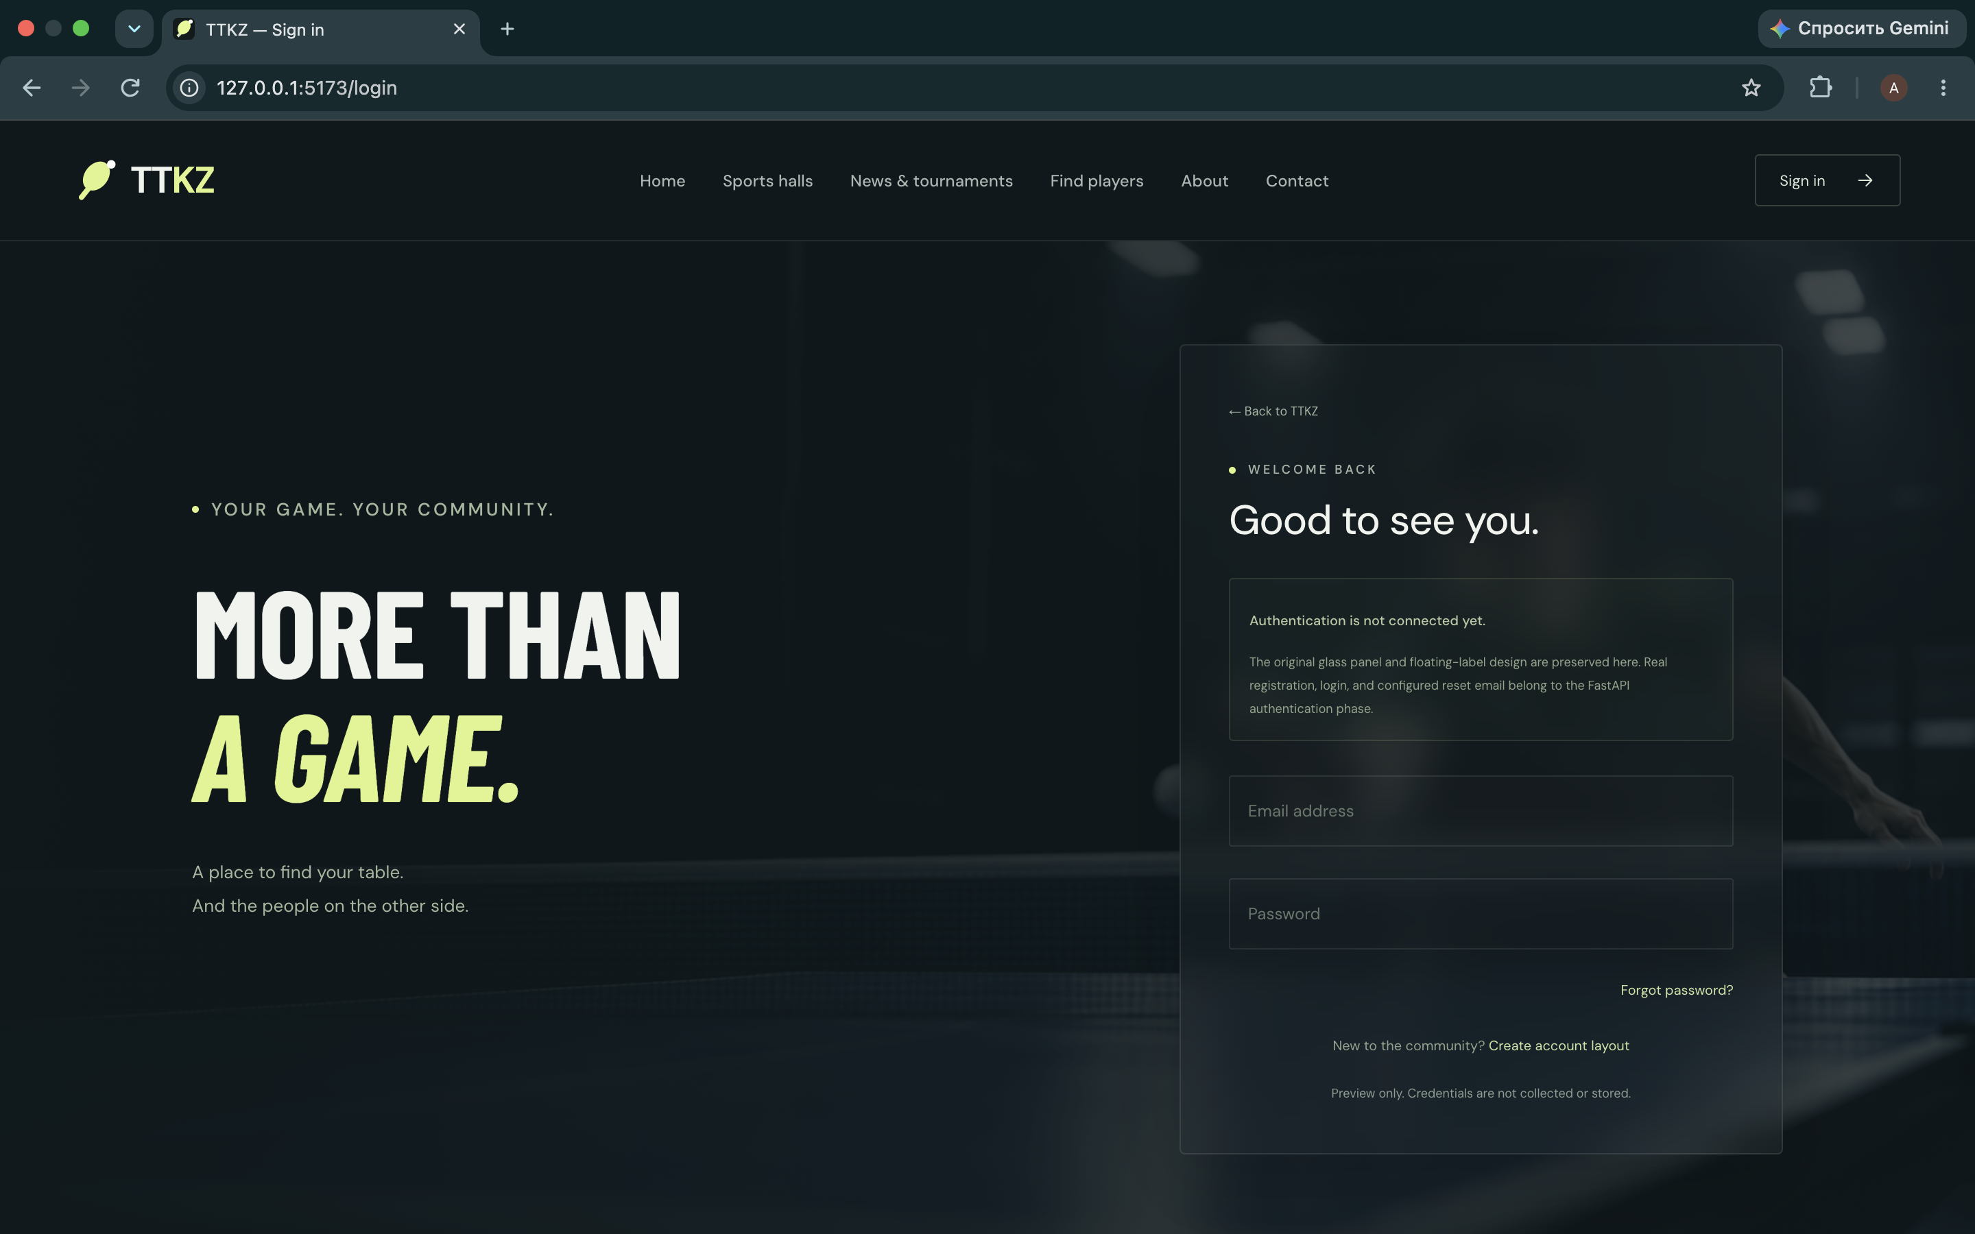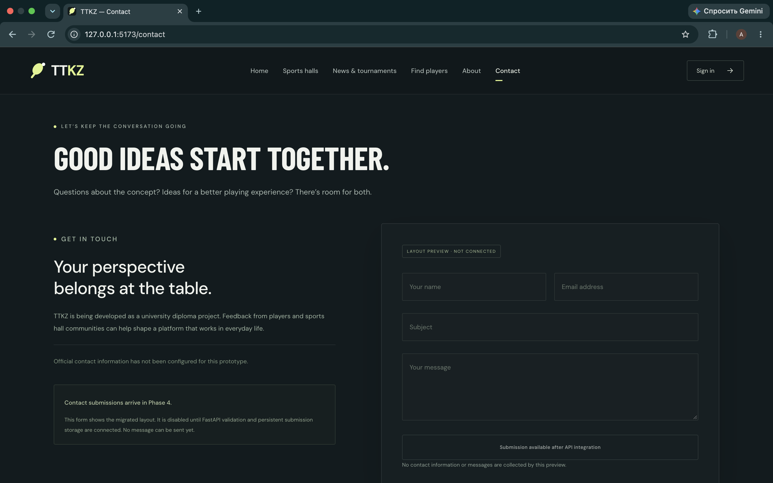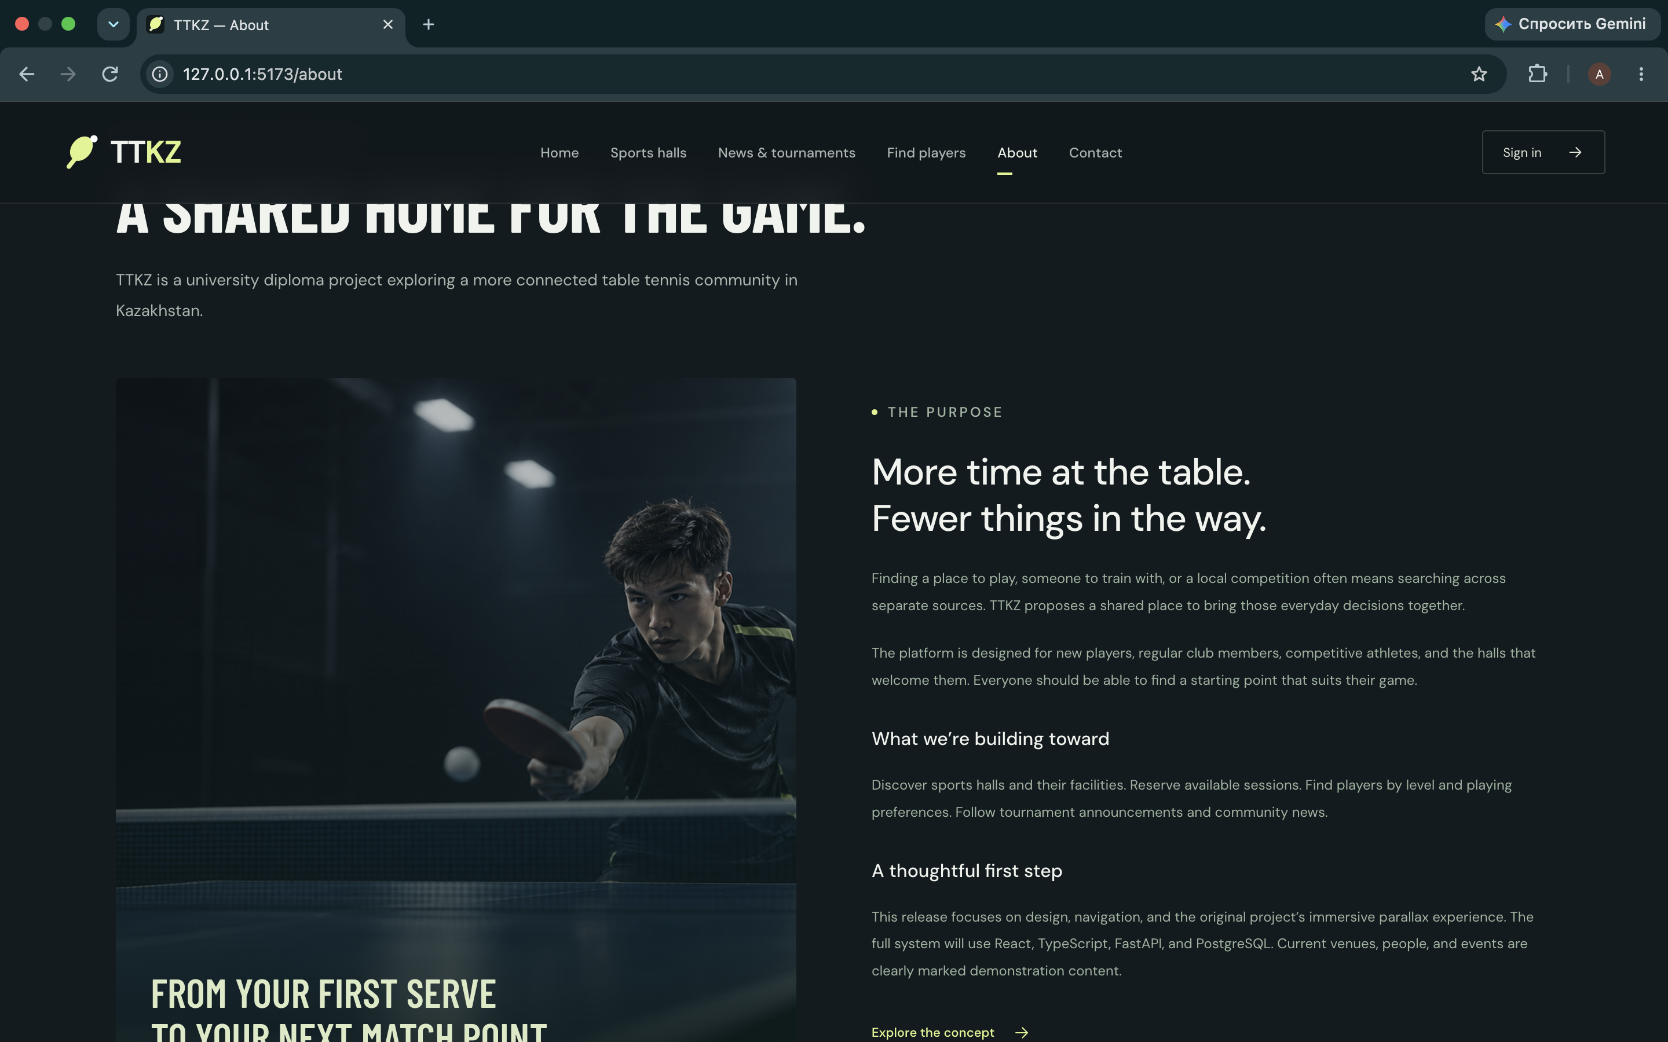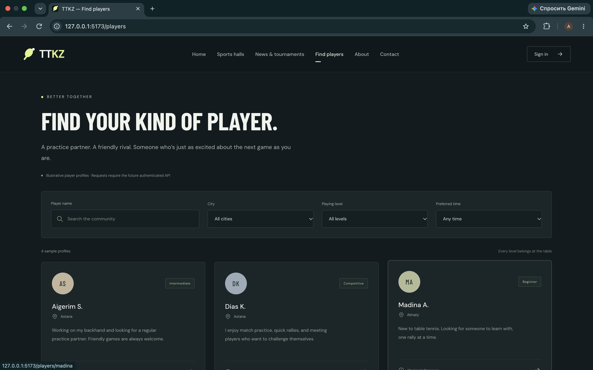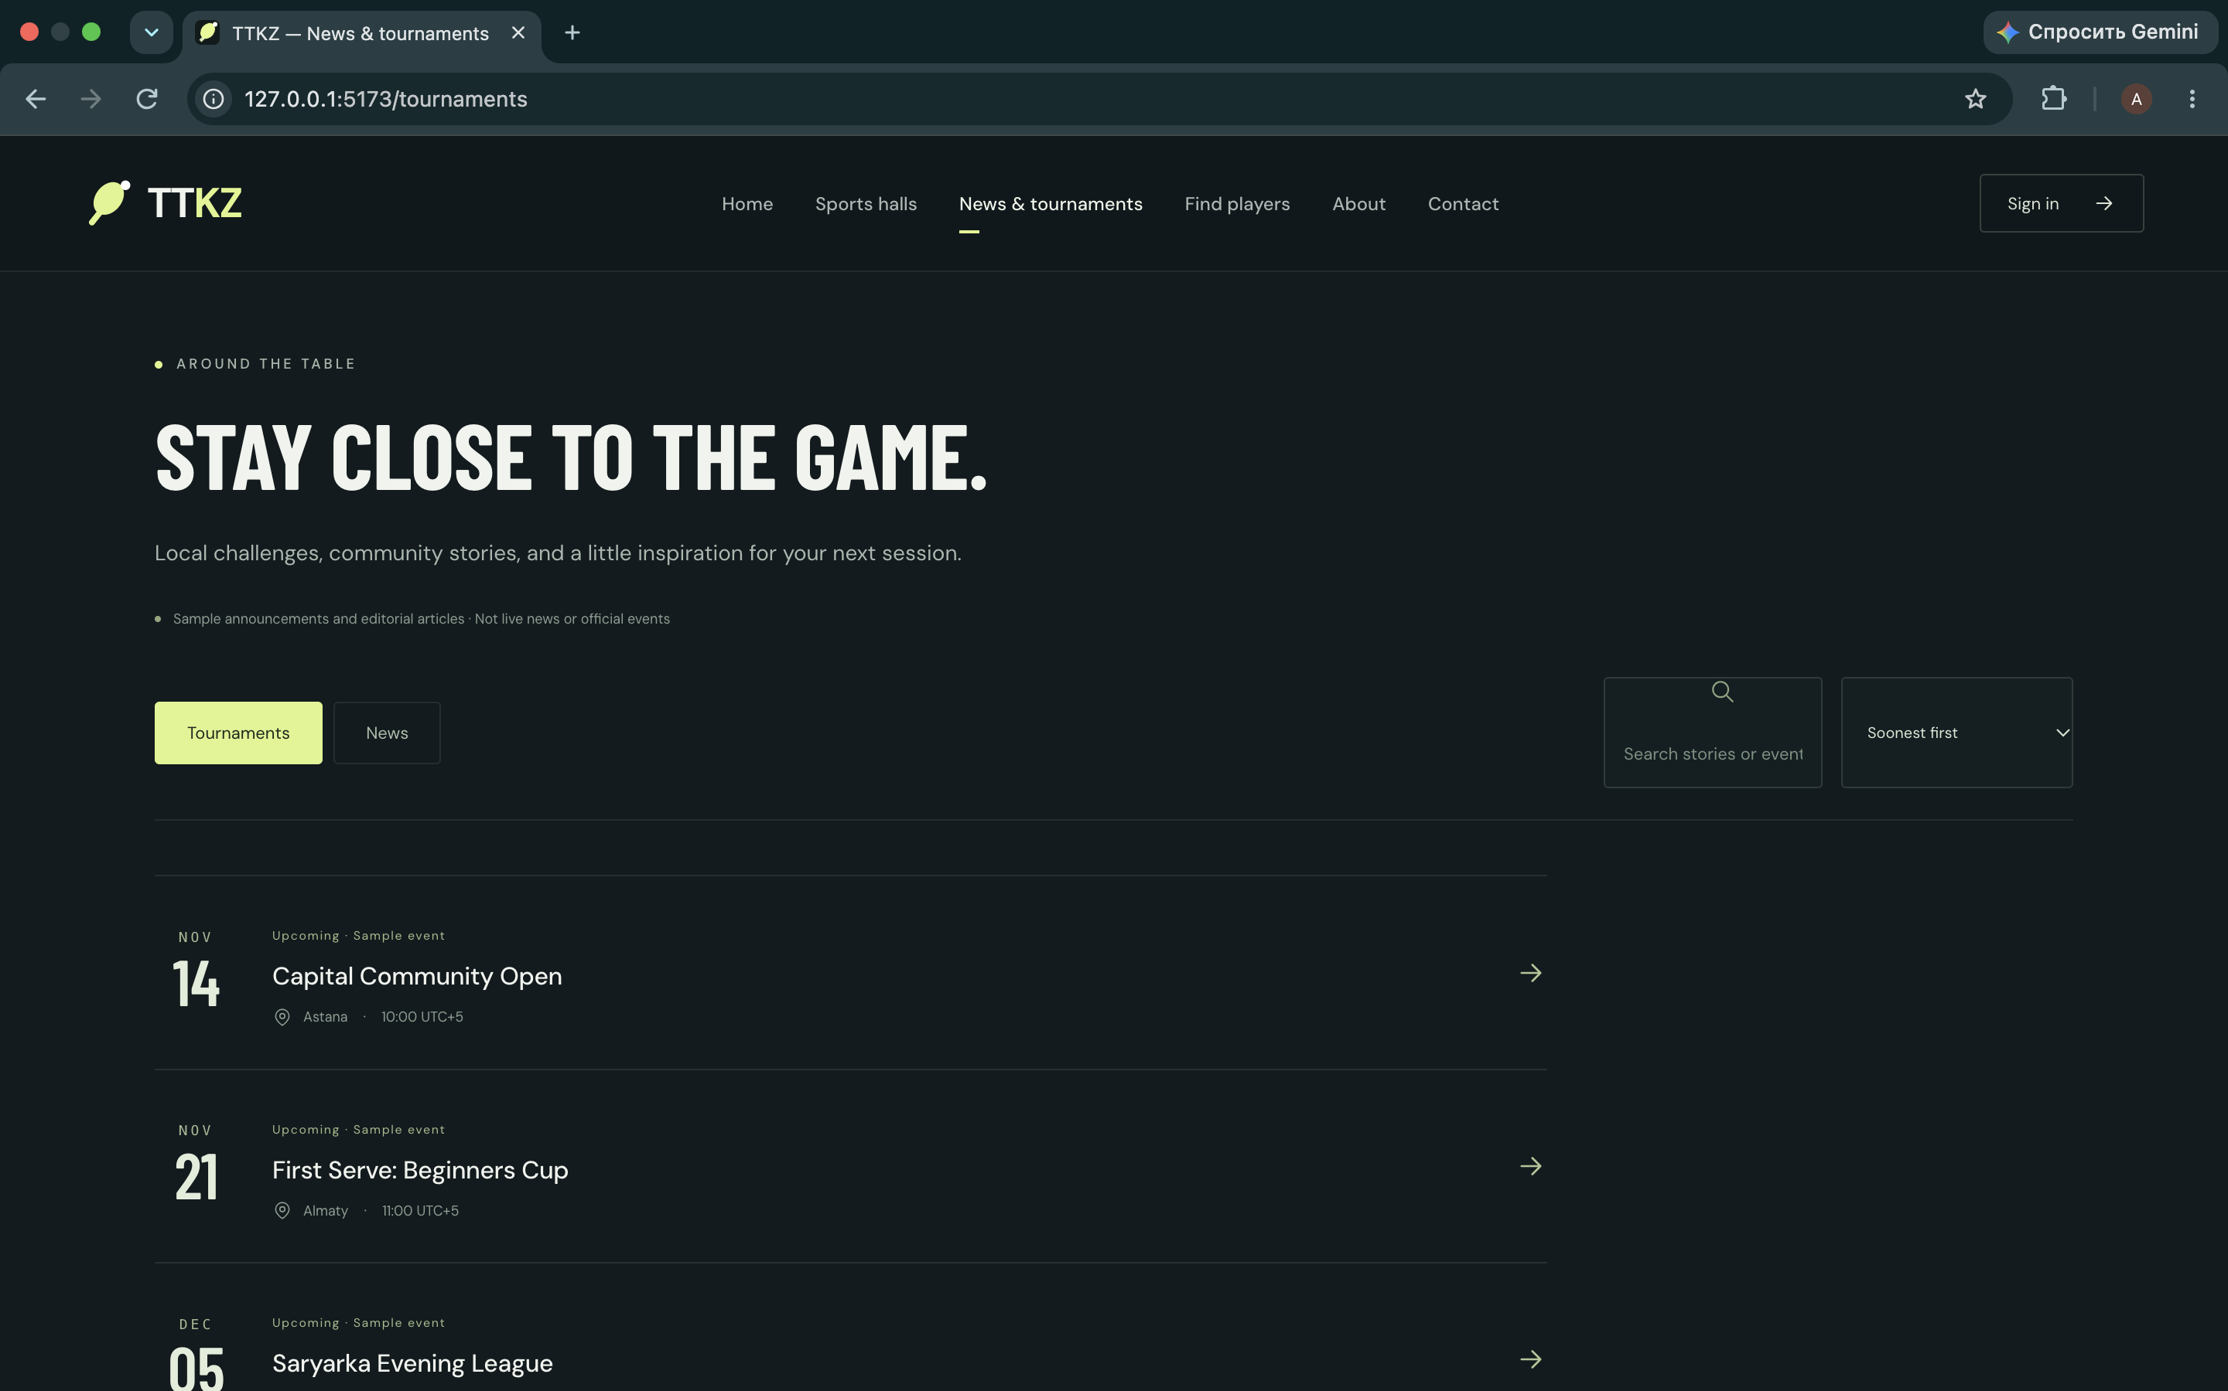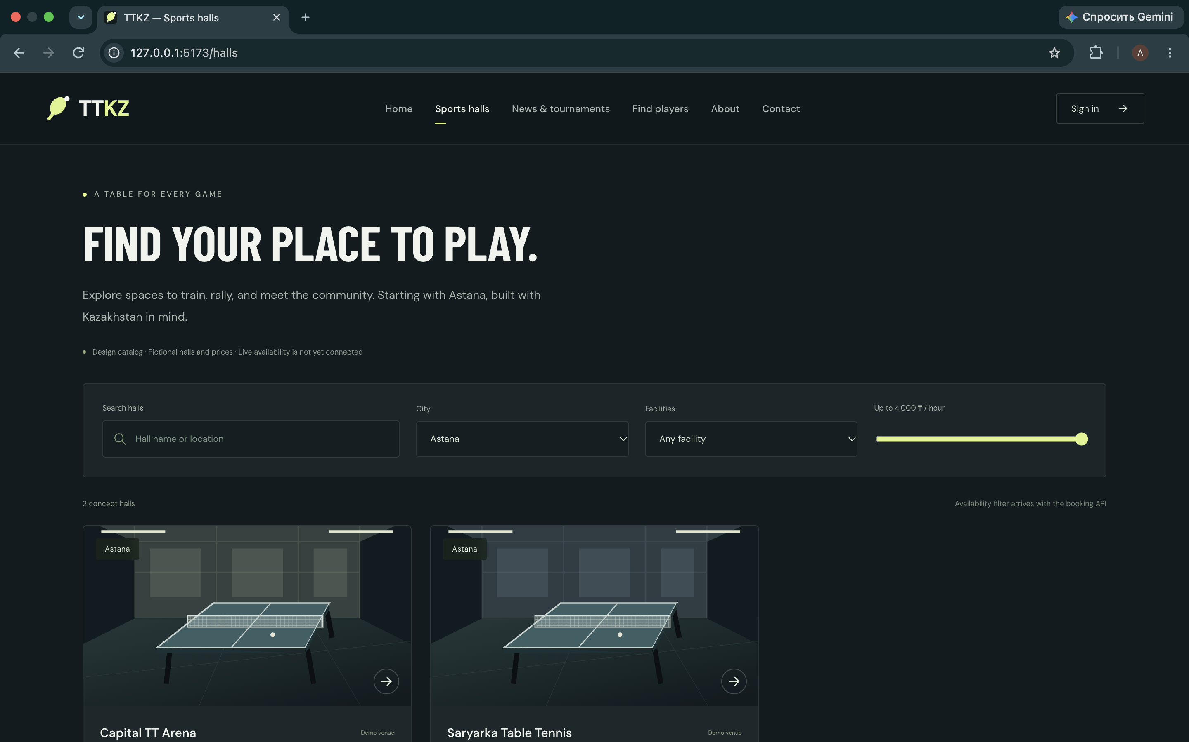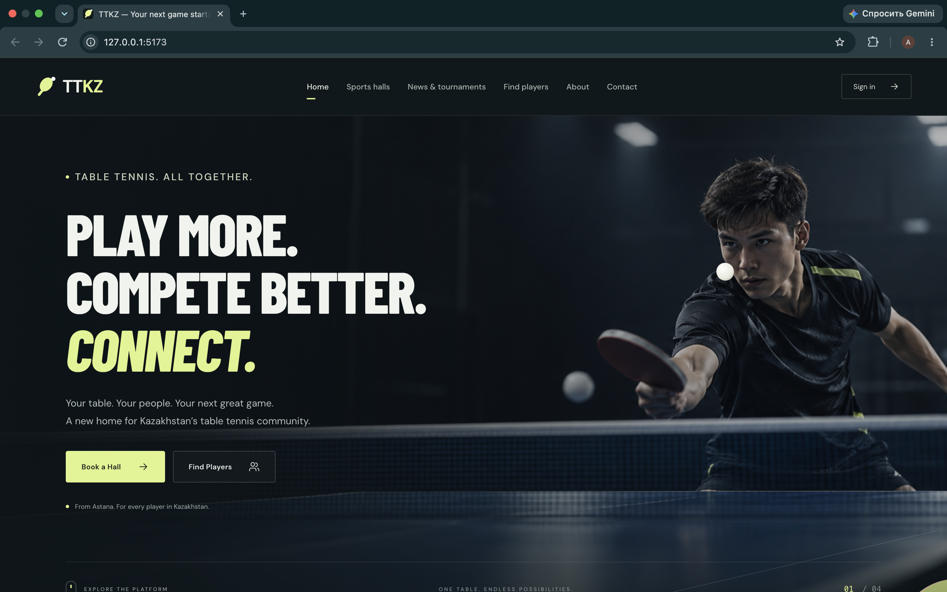

8.1 Booking flow and interaction states
The following illustrative mockups describe time selection, review, confirmation and conflict recovery. Dates, venue details and booking IDs are demonstration data. The conflict image is a design proposal, not a screenshot of the current frontend. No database or API is connected and no actual reservation is evidenced.

Time selection and review before submission
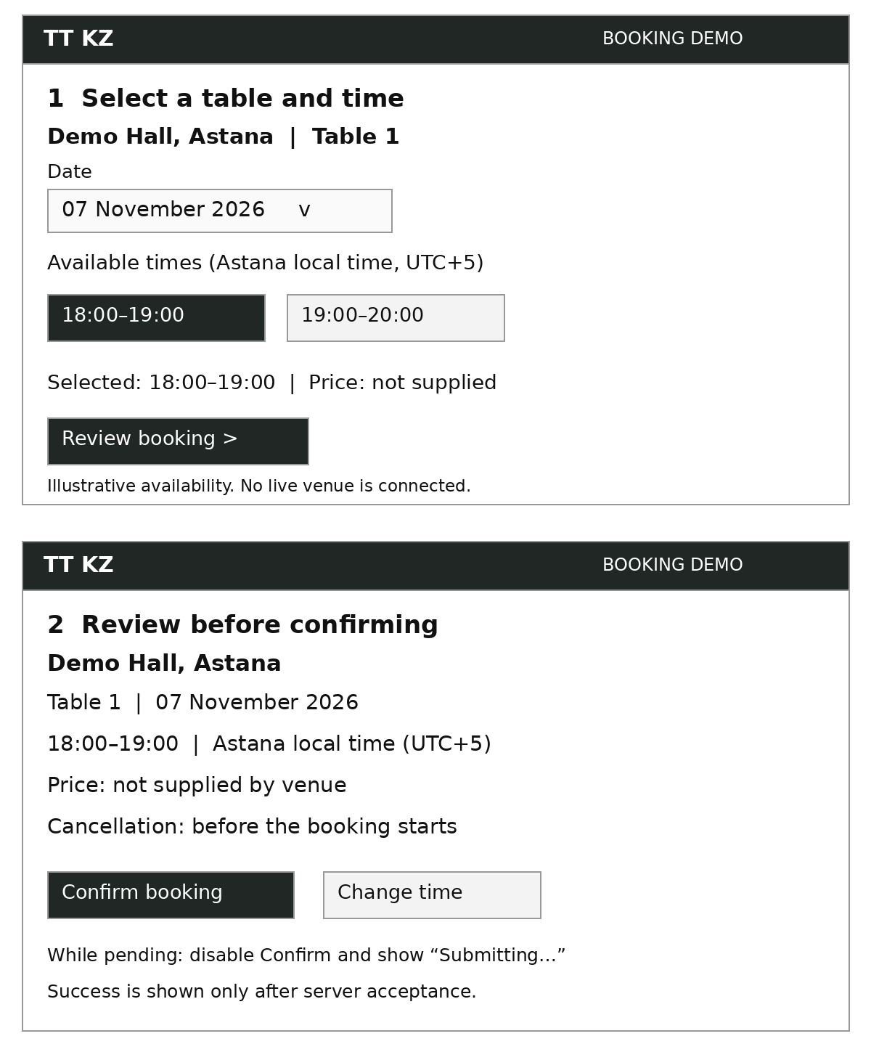

Successful confirmation and conflict recovery
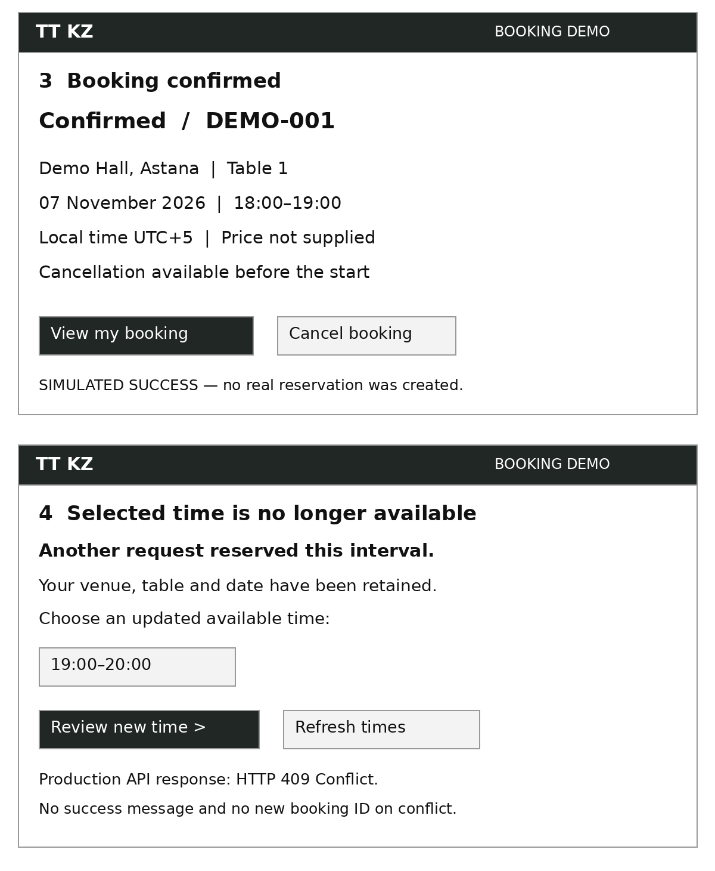

Planned booking behavior: the confirmation action will be disabled while a request is pending. A booking ID will be displayed only after server acceptance. On HTTP 409, the interface will retain the venue and date, refresh available intervals and ask the user to select another time. Network failures will not be displayed as successful bookings. These behaviors are proposed and have not been tested against a connected backend.

Editable mockup sources: docs/prototype/booking-selection-review.svg and docs/prototype/booking-success-conflict.svg.

9. Verification and evaluation plan
Quality objective | Method | Metric / baseline
No conflicting reservations | Issue simultaneous requests to one table/time across a test database | Count overlaps: target 0; compare to intentionally unprotected availability-check flow or manually managed process.
Functional correctness | Automated API tests and manual acceptance checks mapped to FR-01–FR-11 | Pass rate per requirement; failing cases and defect records.
Usability | Short moderated task evaluation with potential users | Success %, task duration, misclicks or errors, qualitative feedback; compare first versus revised prototype.
API behavior | Timed requests in an identical configured environment | p50/p95 latency and error rate; baseline from initial prototype or no-index version.
Access control | Negative tests across player and manager roles | No unauthorized reading/modification of protected records.

Proposed tools: pytest and HTTP testing for FastAPI, PostgreSQL integration test database for transaction tests, browser-based user-task observation for the frontend. Measurements must report machine/configuration, test date, sample size, number of concurrent users, and limitations. No results for the evaluations in this section have been supplied. Historical frontend build/check records in docs/VERIFICATION.md remain separate; they do not demonstrate backend correctness.
All thresholds below are proposed for the next implementation evaluation. They must be reviewed before testing; results are not yet available.
Evaluation | Planned conditions | Pass rule and baseline
Booking integrity | 20 simultaneous clients request the same table and interval; repeat 100 rounds on a reset test database. Include adjacent slots, cancellations and different tables. | Exactly one confirmation per contested interval; zero overlaps. Compare with a deliberately unprotected check-then-insert flow in an isolated test environment only.
Usability | Five potential users perform hall discovery and booking without help on the same desktop setup. Record completion, time and errors; repeat after revisions. | At least 4 of 5 complete the flow; report median task time. Compare first and revised prototype; acknowledge small sample and learning effects.
Performance | 20 concurrent users; 1-minute warm-up followed by 5 minutes; seed 100 venues and 10000 bookings. Document hardware, software, dataset and request mix. | Read endpoint p95 <= 1000 ms; unexpected errors < 1%. Compare initial and revised implementation on the same environment; expected HTTP 409 conflicts are reported separately.
Functional and access control | Map tests to every Must FR/NFR; test unauthenticated, owner, other player and manager roles. | All Must acceptance checks pass; zero unauthorized reads or writes. Preserve failures and rerun evidence.

9.1 Operational outcomes for the Astana pilot
Outcome | Planned baseline and procedure | Proposed target
Booking effort | Five adults complete equivalent booking tasks using a prepared phone/message workflow and the TT KZ prototype. Counterbalance task order; measure elapsed time and user actions using the same venue data. Separate simulated task time from real venue response delays. | At least 20% lower median task time than baseline; at least 4 of 5 users complete without assistance. Report failures and small-sample limits.
Reservation conflicts | 20 concurrent requests for the same table/interval, 100 repeated rounds; include adjacent intervals and cancellations. Compare to unprotected check-then-insert in an isolated test database. | 0 overlapping active bookings; exactly 1 confirmation in each contested round; expected conflicts reported separately.
Access to relevant information | Users locate venue price/conditions and tournament date/location/requirements in equivalent prepared multi-channel information and TT KZ. Measure correctness, time and actions. | At least 4 of 5 users complete correctly; at least 20% lower median lookup time. Report unsuccessful tasks.
Data linkage and freshness | Create a manager availability update and organizer event update; check affected public view and cross-record IDs with seeded data. | All Must traceability cases pass; source and update time visible; unauthorized edits denied.
These are proposed thresholds, not achieved results. No attendance increase or nationwide demand will be inferred. The sample is for formative evaluation, not population estimates. The production booking-integrity test is deferred until the backend exists; current mockups cannot demonstrate database correctness. A01 supports preparing a phone/WhatsApp baseline, but administrator task time and actual conflict frequency were not measured. The planned five usability participants are separate from the five stakeholder interviews; recruitment overlap is not assumed.

10. Project management and risks

10.1 GitHub and YouTrack workflow
Repository: https://github.com/TTKZ12/TTKZ_diploma_work.
YouTrack: https://ttkz.youtrack.cloud/agiles/204-1/current?a=204-0%2Fcurrent
Workstream | Primary owner | Evidence to upload
Backend, DB and booking correctness | Zhanybek Alikhan | DB design, FastAPI contract, migrations, API tests, PRs
Frontend and flows | Tazhimova Araizhan | Layout screenshots, React components, user flows, tests, PRs
User relevance | Tazhimova Araizhan | Interview protocol and anonymized evidence
Literature and systems comparison | Zhanybek Alikhan | Cited report, comparison evidence and revision history
Integration and submission | Tazhimova Araizhan & Zhanybek Alikhan | Component contracts, YouTrack links, reviewed tag

10.1.1 Version and implementation evidence checked on 29 October 2026
The preserved probation tag prob-period-1 points to commit 81dbc95c9ef99a3c53024cb173e4833c60f7791f. The main branch inspected for this revision points to 40331ea7a2c4d4e47f0a00d341e7f21f7dcb18ee. These are different snapshots. The old tag must remain unchanged; revised documents need a new commit and an explicitly identified revision link.
In both the submitted tag and inspected main branch, backend contains only README.md. The current README explicitly describes backend implementation as planned. There is no committed FastAPI application, migration set or backend test suite in those snapshots. TTKZ-2 cannot be evidenced as a completed backend implementation by those files. Historical code elsewhere in Git does not establish completion in the submitted version.
Student or account | Verifiable change | Version limitation
Tazhimova Araizhan – RII77777 | Identity confirmed by Alikhan on 29 Oct 2026. Commit author labels RI and Arai T occur in the inspected history. | Team declaration establishes identity; profile/PR links should be added to README for reviewer verification.
Araizhan frontend change | 3341b40ecd1e16f12d267c5f578a3812878f8d67: player filter reset; merged through PR #4. | Present in inspected main; dated 24 Oct, after preserved submission tag.
Araizhan branch changes | 26a44a5: trim catalog queries; 29a307a: tournament clear-search button. | On frontend-improvements; not in inspected main and not in the probation tag.
Alikhan documentation | e4ac73b: backend planning status; dd1d17b: pre-defense README and supporting records. | Evidence of planning/documentation, not backend implementation.
Evidence links: https://github.com/TTKZ12/TTKZ_diploma_work/pull/4 and commit pages under /commit/ followed by the hashes above. Git author labels alone do not quantify contribution or prove review quality. The relevant diffs are the contribution evidence; emails and private identifiers are not reproduced here.

10.1.2 TTKZ-2 reconciliation and completion rules
The screenshot of TTKZ-2 explicitly requires backend implementation: FastAPI structure, PostgreSQL connection, SQLAlchemy models and Alembic migrations. Reopen it as In Progress if implementation is underway, or To do if it has not started, while these deliverables are absent. Retain the original scope and history, add a correction comment, assign the actual owner and link acceptance evidence. Do not rename an implementation task as planning merely to retain Done. No live status change is claimed here.
Work item | Owner and target | Acceptance evidence before Done
TTKZ-2 backend implementation | Alikhan; replan in YouTrack | Committed runnable FastAPI app, dependency/configuration examples, clean setup instructions, linked PR and relevant passing tests. Reopen while these are absent.
Backend schema and migrations | Alikhan; proposed 6 Nov 2026 | User, venue, table and booking schema; migration from empty DB; overlap constraint and reviewed PR.
Booking API and authorization | Alikhan; proposed 14 Nov 2026 | Create/cancel endpoints; ownership checks; conflict returns 409; concurrent integration tests.
Booking interface integration | Araizhan; proposed 21 Nov 2026 | Time selection, pending, success and conflict states connected to API; error recovery and reviewed PR.
Probation evidence reconciliation | Both; before revised submission | Report, editable diagrams, provenance records, contribution links, review log and YouTrack statuses agree with the identified revision.

10.2 Risk register
Risk | Impact | Mitigation / owner
Lack of facility cooperation | Missing real schedule data | Start with an approved small pilot/demonstration dataset; identify partner early. Joint.
Double booking | Core correctness failure | Enforce database invariant; run concurrent API tests. Zhanybek.
Unclear API contract | Integration delays | Agree endpoint schemas and example payloads before UI wiring. Joint.
Scope expansion | Missed deadlines | Preserve five core features; defer payments, AI and federation integrations. Joint.
Insufficient interview evidence | Weak justification | Verify dates, formats, consent and original records for the five reported responses. Conduct new sessions only where necessary and record their actual dates. Joint.
Incomplete feedback record | Submission risk | Retain the received committee feedback forwarded by the supervisor, confirm its original date and document responses and outstanding actions. Request review of the revised materials. Joint.

10.3 Proposed milestones
The dates below are team planning targets, not university-approved deadlines. The first submission target is 24 October 2026. Later targets must be confirmed with the supervisor.
Target date | Deliverable and owner | Dependency and exit criterion
24 Oct 2026 | Pre-defense evidence package; both students | Initial deadline: four real stakeholder exchanges. A01 obtained 25 Oct; committee feedback forwarded by the supervisor reported 29 Oct. These are later additions, not evidence available by 24 Oct.
6 Nov 2026 | Database schema, migrations and API contract; Alikhan, reviewed by Araizhan | Agreed MVP; migration from empty database, reviewed schema, endpoint definitions and example payloads.
14 Nov 2026 | Booking and authentication API; Alikhan | Schema and contract; ownership and concurrency acceptance tests pass.
21 Nov 2026 | Core interface flows; Araizhan | API contract; venue, booking, player and tournament flows cover success and error states.
28 Nov 2026 | Integrated MVP; both students | Backend and frontend ready; all Must acceptance tests pass.
5 Dec 2026 | Pilot evaluation and revisions; both students | Integrated MVP; usability, load and integrity results documented; defects prioritized.
Task traceability: each meaningful YouTrack task records owner, priority, deadline, expected result and acceptance criteria. Include its ID in the branch and commit or PR description; link the reviewed PR back to the task. Close only after acceptance. Each student uses an identifiable personal account.

11. Committee feedback, supervisor review and submission readiness

11.1 Committee decision and communication

The probation committee allowed the team to continue work on the selected diploma topic and identified issues requiring correction. The supervisor forwarded the committee’s feedback to Tazhimova Araizhan and requested that the comments be addressed.

The team reports receiving the forwarded feedback on 29 October 2026. The screenshots display a weekday rather than a full calendar date. This is the reported receipt date, not an independently verified date of the committee’s review.

The committee’s comments and the team’s responses are recorded below and in Appendix F. Separate dated feedback from the supervisor on the revised materials remains to be obtained.

11.2 Responses to committee comments
Committee comment | Response and location | Status
RII77777 contribution could not be evaluated | Account mapped to Araizhan; specific diffs and main/branch/tag distinctions added in 10.1.1. | Identity clarified; add profile and task/PR links externally.
TTKZ-2 Done does not match committed backend | Implementation status corrected and completion criteria provided in 10.1.2. | Report corrected; live YouTrack correction pending.
Interview dates, formats and originals unverified | Four Telegram exchanges dated 24 Oct and A01 WhatsApp dated 25 Oct recorded; illustrative A01 removed and replaced by actual-response summary. | Content corrected; original screenshots and current translation checks pending.
TTFRK comparison unverified | Official home, calendar, rating and team pages checked on 29 Oct; functions and limits documented in 4. | Public-page verification completed.
Nine papers versus eleven rows; missing references | 13 papers reconciled across narrative, matrix and bibliography, including Dašić and Wan. | Corrected in this revision.
Provide separate dated supervisor feedback with documented team responses. | Forwarded committee feedback is retained in Appendix F.1. Separate supervisor feedback will be recorded in Appendix F.2, together with the team’s actions and evidence. | Pending: separate dated supervisor feedback has not yet been provided.
Define digital integration and geographic pilot | Participants, shared records and workflows specified; initial pilot restricted to Astana in 1.4. | Defined as proposed scope; venue partnerships not claimed.
Define measurable outcomes | Booking effort, conflicts, information access and data linkage mapped to methods and targets in 9.1. | Evaluation plan updated; results deferred.
Add report and editable diagrams to repository | Revised report plus editable draw.io diagrams and mockups prepared in companion package. | Files prepared; remote upload/PR not performed.
Booking prototype lacks time, confirmation and conflict states | Design mockups and expected transitions added in 8.1. | Selection/confirmation evidence reported; conflict remains a design mockup; DB/API not connected.

11.3 Evidence status and remaining actions
- Original conversation screenshots for all five participants are included in Appendix E. Interview dates, channels and source limitations are recorded in the provenance register.
- Screenshots of the committee feedback forwarded by the supervisor are included in Appendix F.1. The team reports receiving the message on 29 October 2026; the screenshots display a weekday rather than a full calendar date.
- Correct TTKZ-2 in YouTrack and connect tasks to the actual PRs, commits and acceptance criteria.
- Commit this revised report, editable diagrams and comparison register through a reviewed PR. Record the new revision URL without moving prob-period-1.
- Keep the backend labeled planned until committed code and checks meet the task acceptance criteria.
- Obtain separate dated feedback from the supervisor on the revised report and project materials. Record each comment, the team’s response and the supporting section or repository link in Appendix F.2.

References
An, M., Kheovichai, K., & Bungmark, W. (2025). The development of the sustainable management model and its implementation on the operation of amateur table tennis clubs in Guangzhou. International Journal of Sociologies and Anthropologies Science Reviews, 5(2), 785–794. https://doi.org/10.60027/ijsasr.2025.5723
Anantha Sekoh, D. O., Haryono, J. F., Silvera, N., Leandros, R., & Wijanarko, B. D. (2025). Development of a mobile-based sports field booking application. Procedia Computer Science, 269, 1220–1228. https://doi.org/10.1016/j.procs.2025.09.063
Dašić, D. (2026). Strategic management of sports organizations in the context of digital transformation: A theoretical framework and implications for sports marketing. Horizonti menadžmenta, 6(1), 89–106. https://hm.edu.rs/index.php/hm/article/view/58
German, J. D., Bautista, S. L. S., Bonagua, P. A. R., Chan, C. V. L., Mallen, J. E. L., & Plantilla, F. C. B. (2024). Appoint Deportes: An online reservation system for sports facilities. In Proceedings of the 2024 7th International Conference on Computers in Management and Business (pp. 206–211). Association for Computing Machinery. https://doi.org/10.1145/3647782.3647814
Gong, L., Feng, X., Ye, D., Li, H., Wu, R., Tao, J., Fan, C., & Cui, P. (2020). OptMatch: Optimized matchmaking via modeling the high-order interactions on the arena. In Proceedings of the 26th ACM SIGKDD International Conference on Knowledge Discovery & Data Mining (pp. 2300–2310). Association for Computing Machinery. https://doi.org/10.1145/3394486.3403279
Hermawan, M. L., & Suharso, W. (2025). Implementation of concurrency control to prevent race condition in a web-based billiard table reservation system. Jurnal Inovtek Polbeng – Seri Informatika, 10(3), 1971–1981.
Ibrayeva, A., Shoranov, M., Muminov, T., Ismoldayev, Y., Tanabayeva, S., & Fakhradiyev, I. (2025). Physical activity levels in Kazakhstan: A cross-sectional nationwide study on demographic, socioeconomic, and regional factors. Medicina, 61(11), Article 1913. https://doi.org/10.3390/medicina61111913
Iversen, E. B., Høyer-Kruse, J., & Forsberg, P. (2026). How do we measure? Perspectives for learning, steering, and accountability when measuring the utilisation of sports facilities. Managing Sport and Leisure, 31(3), 591–604. https://doi.org/10.1080/23750472.2024.2356187
Maringka, R., & Lumingkewas, C. (2024). Designing user interface (UI) and user experience (UX) of a sport space rental application using design thinking method. COGITO Smart Journal, 10(1), 192–203.
Rai, J. S., Kajla, T., Itani, M., & Cho, H. (2025). Social media in sport: A systematic review and research agenda using the theory, context, characteristics, and methodology framework. International Journal of Consumer Studies, 49(5), Article e70102. https://doi.org/10.1111/ijcs.70102
Saputra, D. E. W., & Asmawati, P. (2025). Elevating user experience and service excellence in sports facilities via integrated management information systems: A systematic review. Sports Science and Health, 15(Suppl. V), 111–118. https://doi.org/10.7251/SSH25V111S
Stegmann, P., Ströbel, T., & O’Reilly, N. (2026). Shaping fan engagement behaviour through digital platform features: The role of social capital – An experimental study. International Journal of Sports Marketing and Sponsorship, 27(6), 1–15. https://doi.org/10.1108/IJSMS-04-2025-0164
Wan, Y., Zhang, Y., Zhao, C., & Bu, T. (2025). The new era of sports service industry under digital development: A comprehensive analysis of VAR and cross-elasticity. SAGE Open, 15(2), Article 21582440251336002. https://doi.org/10.1177/21582440251336002
Astana IT University. (2026). First pre-defense requirements for 24 October [Course guidance document supplied by students].
FastAPI. (n.d.). FastAPI documentation. https://fastapi.tiangolo.com/
International Table Tennis Federation. (2026). Rankings. https://www.ittf.com/rankings/
PostgreSQL Global Development Group. (n.d.). Constraints. https://www.postgresql.org/docs/current/ddl-constraints.html
PostgreSQL Global Development Group. (n.d.). Range types. https://www.postgresql.org/docs/current/rangetypes.html
RTTF. (n.d.). Table tennis tournaments, ratings and clubs. https://rttf.ru/ Retrieved October 23, 2026.
React. (n.d.). Learn React. https://react.dev/learn
Table Tennis Federation of the Republic of Kazakhstan. (n.d.-a). Home. https://ttfrk.kz/ru Retrieved October 29, 2026.
Table Tennis Federation of the Republic of Kazakhstan. (n.d.-b). Calendar. https://ttfrk.kz/ru/calendar Retrieved October 29, 2026.
Table Tennis Federation of the Republic of Kazakhstan. (n.d.-c). Rating. https://ttfrk.kz/ru/rating Retrieved October 29, 2026.
Table Tennis Federation of the Republic of Kazakhstan. (n.d.-d). National teams. https://ttfrk.kz/ru/teams Retrieved October 29, 2026.

Appendix A Interview protocols and evidence fields

A.1 Session record
For each participant, retain the actual session date, written channel, role, interviewer, Russian source text, English translation, consent basis and source path. Tazhimova Araizhan conducted the interviews and Zhanybek Alikhan translated the responses. The team reports agreement to anonymized use; no signed consent form or screenshot proof of that agreement is claimed. Record actual dates for checking the current English text against original messages. A01 cannot have been checked on 24 October because the responses were received on 25 October.

A.2 Player questions for P01 to P03
1. How often do you play table tennis?
2. How do you usually find a sports hall or table to play at?
3. Describe how you arranged your most recent playing session or table reservation.
4. What difficulties have you experienced when looking for an available time slot or venue?
5. How do you find opponents with a similar playing level?
6. Where do you find information about amateur table tennis tournaments?
7. What information about a sports hall is important to you before visiting?
8. Do you currently use any websites or applications to organize table tennis games? If so, which ones?

A.3 Hall administrator questions for A01
Opening request: “Could you please answer the following questions?” This is an invitation, not a seventh research question. The six substantive questions follow.
1. How are bookings currently made: by phone, WhatsApp, website, or in person?
2. How is the table availability schedule managed?
3. Have there been cases of overlapping bookings? How were they resolved?
4. What questions do visitors ask most often?
5. Which scheduling tasks take the most time?
6. What limitations or difficulties might arise when using an online booking system?

A.4 Coach and tournament organizer questions for C01
1. How do you currently publish information about tournaments?
2. How do participants find out about tournament dates, locations, conditions, and skill levels?
3. What difficulties do you face when informing participants?
4. What digital tools do you already use?
5. What is missing from existing solutions?

Appendix B. Artifact register
Artifact | Project file location | Status
Pre-defense report (DOCX) | docs/pre-defense/Prob_Period.docx | Editable master. Companion PDF: Prob_Period.pdf, exported from this same DOCX.
Interview evidence | docs/research/interviews/ | Original screenshots for five participants are included in Appendix E. Responses were collected on 24-25 October 2026. The earlier illustrative A01 text has been replaced with actual responses.
Comparison evidence | docs/comparisons/screenshots/ | Official-page screenshots and source links are included in Appendix G. Capture dates are recorded in the figure captions.
Context/use-case/component diagrams | docs/diagrams/ | Three diagrams are included in Appendix C. Editable draw.io sources and readable exports are available in docs/diagrams/. Repository publication: [указать фактический статус или ссылку].
Prototype screenshots / Figma link | docs/prototype/ | Frontend/demo screenshots; conflict mockup only, no conflict screen screenshot. No DB/API connection.
Test plan & results | docs/evaluation/ | Draft plan; results pending
Committee feedback and supervisor review log | docs/supervisor-feedback/ | Forwarded committee feedback and team responses are included in Appendix F.1. Separate dated supervisor feedback and responses remain pending in Appendix F.2.

Appendix C. Architecture Diagrams

The following diagrams present the proposed TT KZ architecture for the initial pilot in Astana. Editable diagram sources are provided in the project repository.

C.1 System Context Diagram
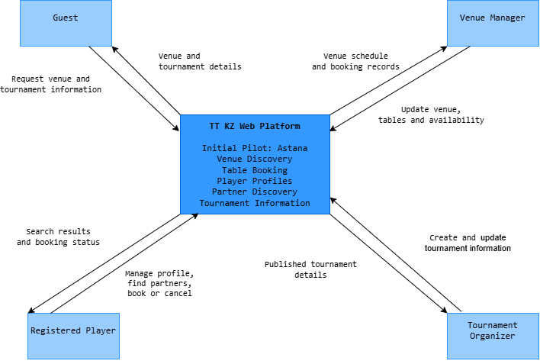
The system boundary connects guests, players, venue managers and tournament publishers. No external federation API or messaging synchronization is assumed.

C.2 UML Use Case Diagram
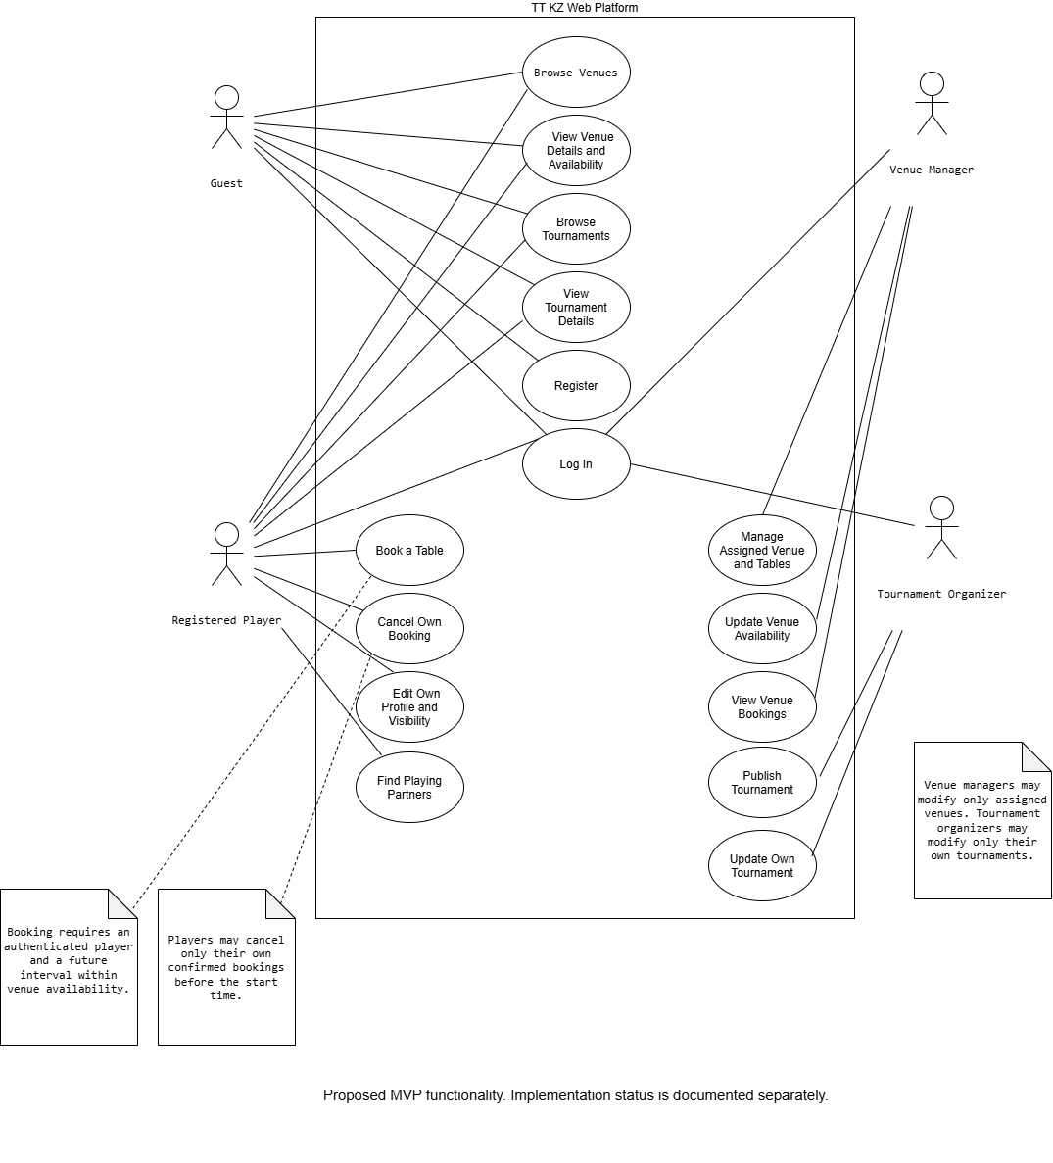
Actors connect to use cases inside the TT KZ boundary. Authentication and available time are booking preconditions. Server-side authorization and atomic non-overlap enforcement are required independently of these interface scenarios.

C.3 Component Diagram
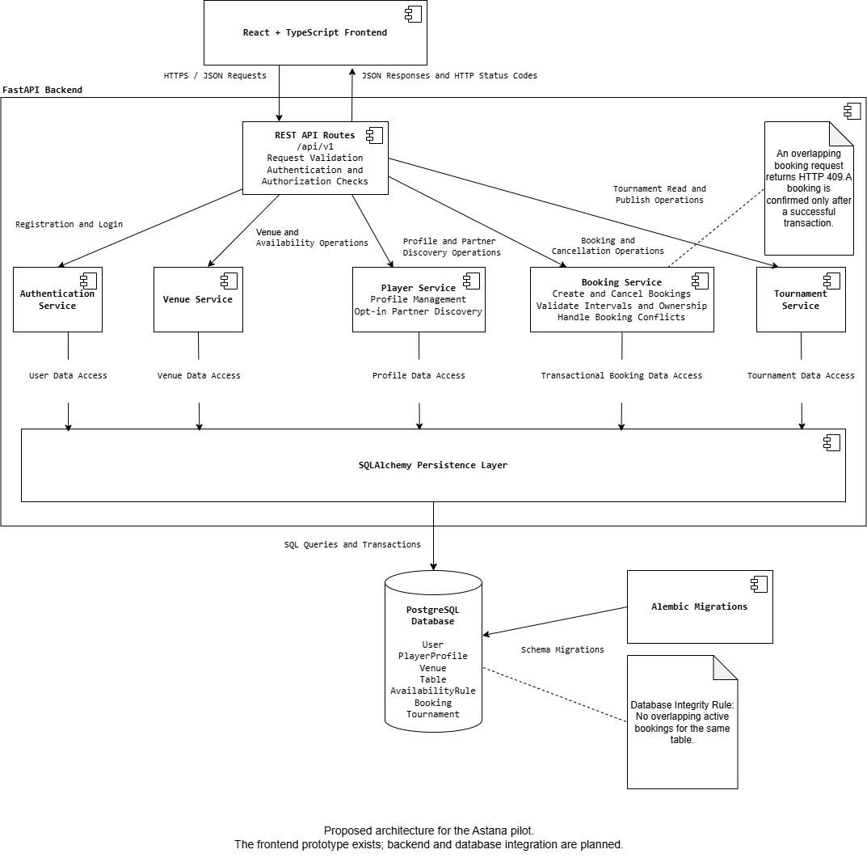
Selected technology stack and planned component interfaces. React communicates with FastAPI REST routes. Routes dispatch to authentication, venue, player, booking and tournament services. The services use the shared SQLAlchemy persistence layer; PostgreSQL stores related records and enforces integrity constraints. These interfaces are proposed architecture, not evidence of implemented backend code. Alembic manages migrations.

C.4 Consistency and verification notes
- Player reservation requires an authenticated user and an available slot; server-side booking must prevent conflicting bookings using PostgreSQL transactions and enforced integrity constraints.
- Guests can browse public hall and tournament information without an account.
- Player matchmaking is initially filter-based (location, skill level, preferences, availability); no AI matchmaking is claimed.
- Tournament publishing and facility administration are proposed manager workflows, subject to actual stakeholder evidence and MVP prioritization.
- No payment gateway, chat, live streaming, federation integration or machine-learning service is assumed in the first release.
Appendix D Stakeholder responses
The revised dataset contains four Telegram exchanges dated 24 October 2026 (P01-P03 and C01) and one WhatsApp exchange dated 25 October 2026 (A01), according to the team. Original responses were in Russian; Zhanybek Alikhan prepared the English translations. Earlier illustrative administrator answers are excluded and replaced in D.5. The other four participants’ response content is retained. Appendix E provides source screenshot slots; verification of the current English text remains to be completed.
1. How often do you play table tennis?
P01: I train approximately once a week, and I mainly play in tournaments.
P02: Every day.
P03: I play table tennis very frequently, approximately six times a week.
2. How do you usually find a sports hall or table to play at?
P01: I usually ask friends who also play table tennis. They recommend places where halls and tables are available. If I need to find a new venue, I ask in group chats, check maps, or use 2GIS.
P02: It is quite easy. The availability of facilities is good.
P03: I usually find a sports hall or table through the 2GIS application by searching for "table tennis."
3. Describe how you arranged your most recent playing session or table reservation.
P01: I message my friends in a group chat, and we agree on a time. If we need a table, I contact the sports hall by message or phone to check availability. There is no single place where I can see the schedule and make a reservation immediately.
P02: We agreed on a time with friends and then found a sports hall where we could play.
P03: I usually arrange a table reservation by phone.
4. What difficulties have you experienced when looking for an available time slot or venue?
P01: It is difficult to know whether a table is available at a particular time without messaging the facility or visiting it. Schedules are often outdated, and sometimes I have to wait for a response. In the evenings, especially after work, tables become occupied quickly, so finding an available time requires manual coordination.
P02: I have not experienced any difficulties. Everything has been fine.
P03: The main difficulties are related to financial limitations and reserving a table at a suitable time.
5. How do you find opponents with a similar playing level?
P01: Mainly through tournaments, where it is easier to understand each player's skill level. Outside tournaments, finding an appropriate opponent is difficult because you cannot always know how well someone plays beforehand. I usually look through friends and other players I know.
P02: Through tournaments. By playing against different participants, I can evaluate their skill levels.
P03: I find opponents of a similar level through dedicated table tennis group chats.
6. Where do you find information about amateur table tennis tournaments?
P01: I usually hear about tournaments from friends and other players, group chats, and occasionally the social media accounts of federations and clubs. I have not come across a single amateur tournament calendar that provides dates, skill levels, and participation requirements.
P02: Through RTTF and group chats.
P03: I usually find information about amateur tournaments through dedicated WhatsApp groups or Instagram accounts.
7. What information about a sports hall is important to you before visiting?
P01: The number and condition of the tables, floor surface, lighting, and available space around each table. I also consider the current schedule, prices, changing rooms and showers, directions to the venue, and parking availability.
P02: Available space, lighting, and table quality.
P03: Information about the tables and the skill levels of potential opponents.
8. Do you currently use any websites or applications to organize table tennis games? If so, which ones?
P01: I do not use any specialized table tennis applications. We organize everything through messaging applications such as WhatsApp and Telegram, group chats with friends, 2GIS, and the Instagram accounts of sports clubs.
P02: RTTF and TTRanking.
P03: Yes, I use Unreal Engine 5 to create graphical games.

D.5 Hall administrator responses
English summary of A01’s written Russian WhatsApp responses, 25 October 2026 ( date). Repeated messages are consolidated without adding findings. This is a paraphrase, not a verbatim quotation. Source screenshot slot: Appendix E, Figure E-A01; use sequential suffixes for multiple images.
1. How are bookings currently made: by phone, WhatsApp, website, or in person?
A01 summary: Bookings are made by telephone or WhatsApp. Customers contact the administrator to check availability and reserve a suitable time. Booking about a day ahead is recommended, but same-day bookings are possible when tables are available.
2. How is the table availability schedule managed?
A01 summary: Approximately eight tables are usually available for rent. The administrator personally checks which tables are available or reserved. Each request specifies the date, time and number of guests. A table is assigned to the customer after confirmation.
3. Have there been cases of overlapping bookings? How were they resolved?
A01 summary: Several customers may request tables for the same time. The administrator checks available tables before confirming. If all tables are occupied, another time or date is offered. Interpretation: this describes competing requests, not an established case of two confirmed bookings for the same table.
4. What questions do visitors ask most often?
A01 summary: Visitors ask about available tables, same-day bookings, the number of available tables, choosing a specific table, deposits, payment methods, cancellation and rescheduling. Payment is made at the visit; no advance booking payment is required.
5. Which scheduling tasks take the most time?
No separate substantive answer was provided. No finding about the most time-consuming scheduling tasks is inferred.
6. What limitations or difficulties might arise when using an online booking system?
No separate substantive answer was provided. No finding about staff training, interface preferences or limitations of online booking is inferred.

D.6 Coach and tournament organizer responses
1. How do you currently publish information about tournaments?
C01: We usually publish tournament information through WhatsApp groups, Instagram, and sometimes Telegram. We share announcements, posters, and registration details. However, the information is spread across different platforms.
2. How do participants find out about tournament dates, locations, conditions, and skill levels?
C01: Participants usually check social media posts or ask questions in group chats. They may also contact the organizer directly to clarify the tournament format, participation requirements, or registration deadline.
3. What difficulties do you face when informing participants?
C01: The main difficulty is reaching all interested players. Some participants may miss announcements, while others receive outdated information. We also have to answer the same questions repeatedly and send updates if the schedule or location changes.
4. What digital tools do you already use?
C01: We mainly use WhatsApp, Instagram, Google Forms, and spreadsheets. These tools help us communicate with participants, collect registrations, and organize tournament information, but they are not connected in one system.
5. What is missing from existing solutions?
C01: It would be useful to have one platform where players can find upcoming tournaments, check the date and location, view participation requirements, and register. Organizers should also be able to update information easily and notify participants about changes. A filter by city and playing level would make it easier for players to find suitable tournaments.

Appendix E Interview provenance register
Updated 2 November 2026. The revised dataset includes two written Telegram exchanges and one written TikTok exchange from 24 October, two written WhatsApp exchanges from 24-25 October. Interviewer: Tazhimova Araizhan; original language: Russian; English translation: Zhanybek Alikhan. According to Araizhan, all participants agreed to anonymized use. Documentary evidence of the agreement and verification of the current English version are not claimed. The original four records were reportedly checked on 24 October; A01 record was reportedly checked on 25 October.
Participant | Actual date and format | Original source and consent | Verification
P01 | 24 October 2026; written Telegram exchange. | Slot E-P01. Agreement to anonymized use reported by Araizhan; documentary evidence unspecified. Screenshot to insert. | Original check reported 24 Oct; current English version check pending.
P02 | 24 October 2026; written Telegram exchange. | Slot E-P02. Agreement to anonymized use reported by Araizhan; documentary evidence unspecified. Screenshot to insert. | Original check reported 24 Oct; current English version check pending.
P03 | 24 October 2026; written TikTok exchange. | Slot E-P03. Agreement to anonymized use reported by Araizhan; documentary evidence unspecified. Screenshot to insert. | Original check reported 24 Oct; current English version check pending.
A01 | 25 October 2026; written WhatsApp exchange. | Slot E-A01. Agreement to anonymized use reported by Araizhan; documentary evidence unspecified. Screenshot to insert. | Original check reported 25 Oct; current English version check pending.
C01 | 24 October 2026; written WhatsApp exchange. | Slot E-C01. Agreement to anonymized use reported by Araizhan; documentary evidence unspecified. Screenshot to insert. | Original check reported 24 Oct; current English version check pending.

E-P01. Original written responses – Regular player
Session: 24 October 2026. Channel: Telegram. Participant code: P01.
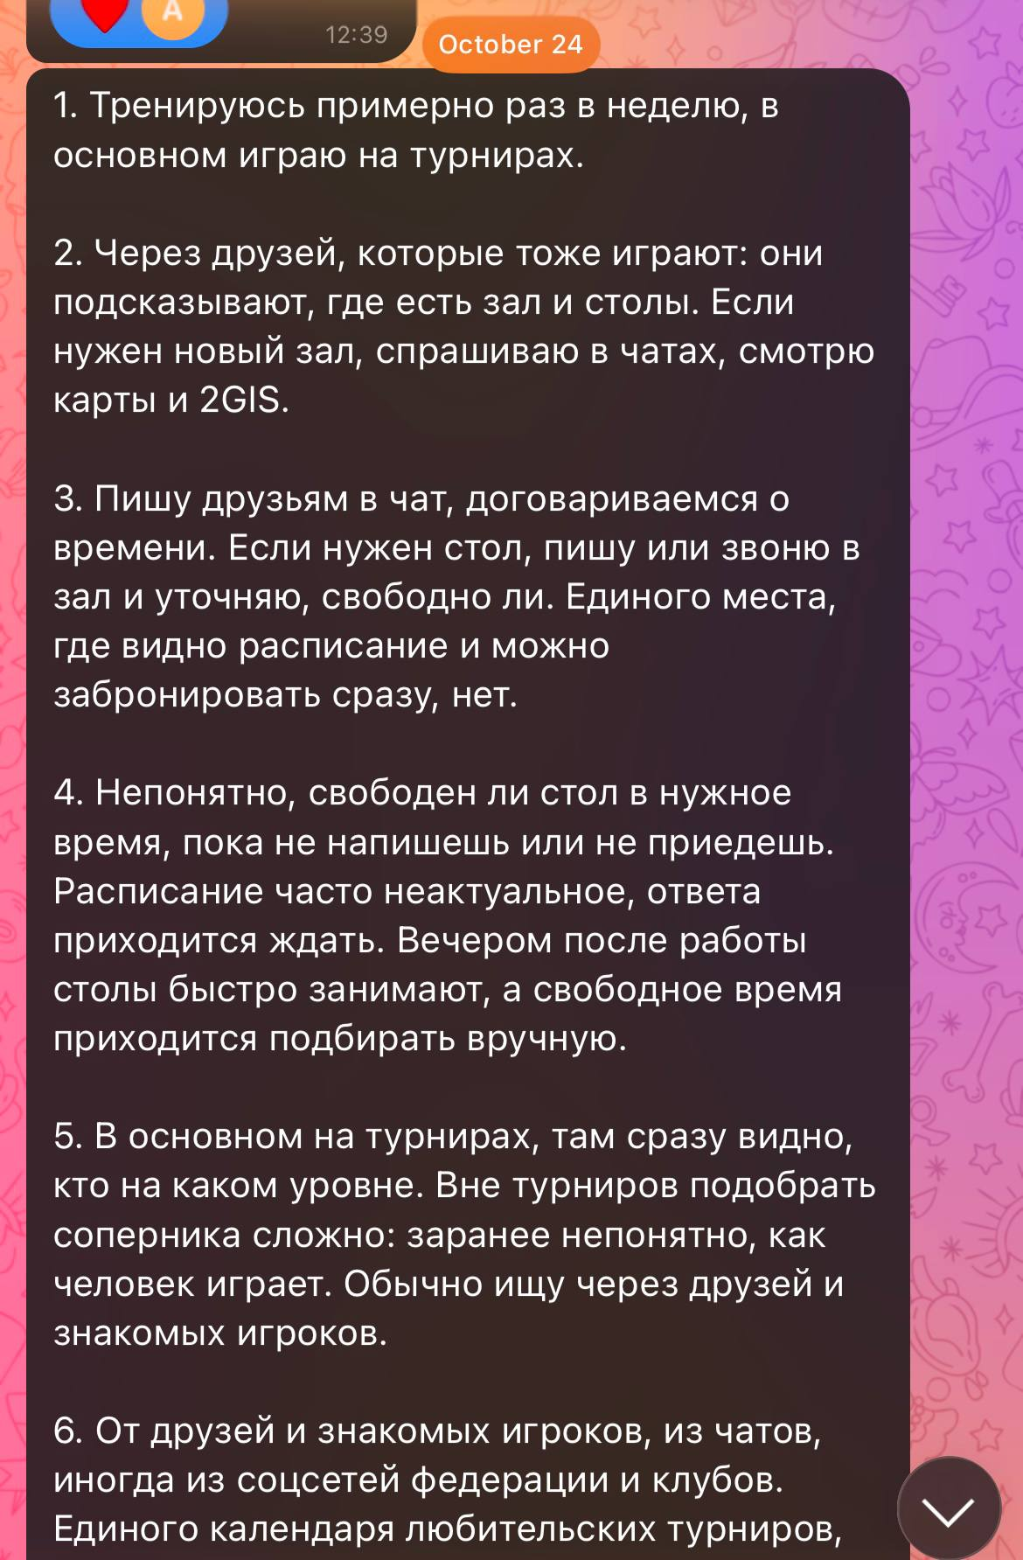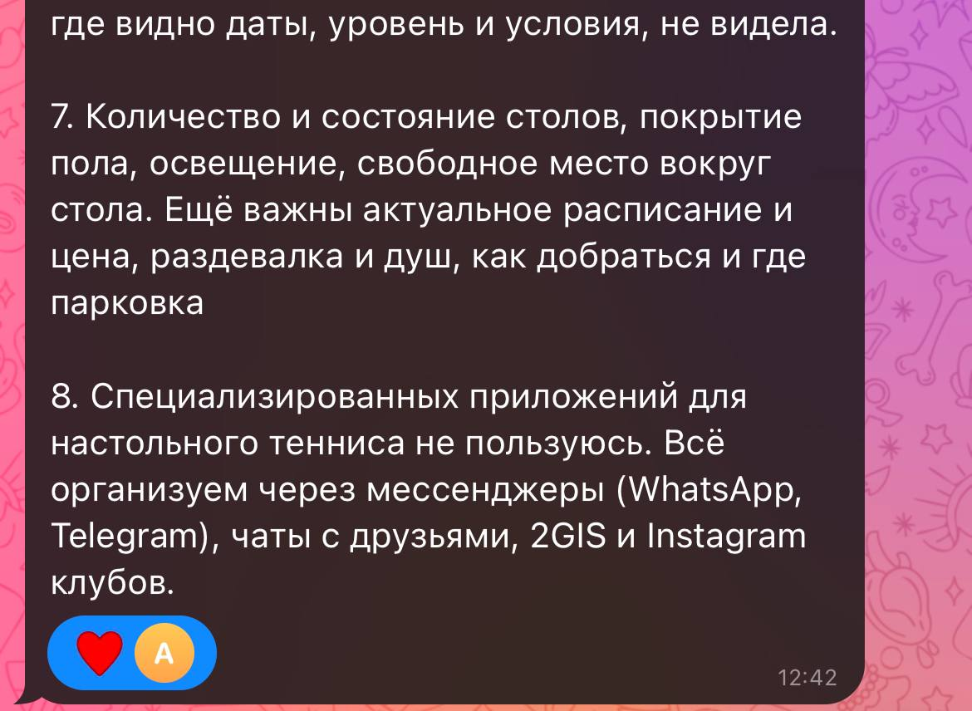
Figure E-P01. Anonymized written Telegram exchange, 24 October 2026. Source: docs/research/interviews/. Interviewer: Tazhimova Araizhan. Language: Russian. English translation: Zhanybek Alikhan. Original-response check reported by Araizhan: 24 October 2026.
E-P02. Original written responses – Regular player
Session: 24 October 2026. Channel: Telegram. Participant code: P02.
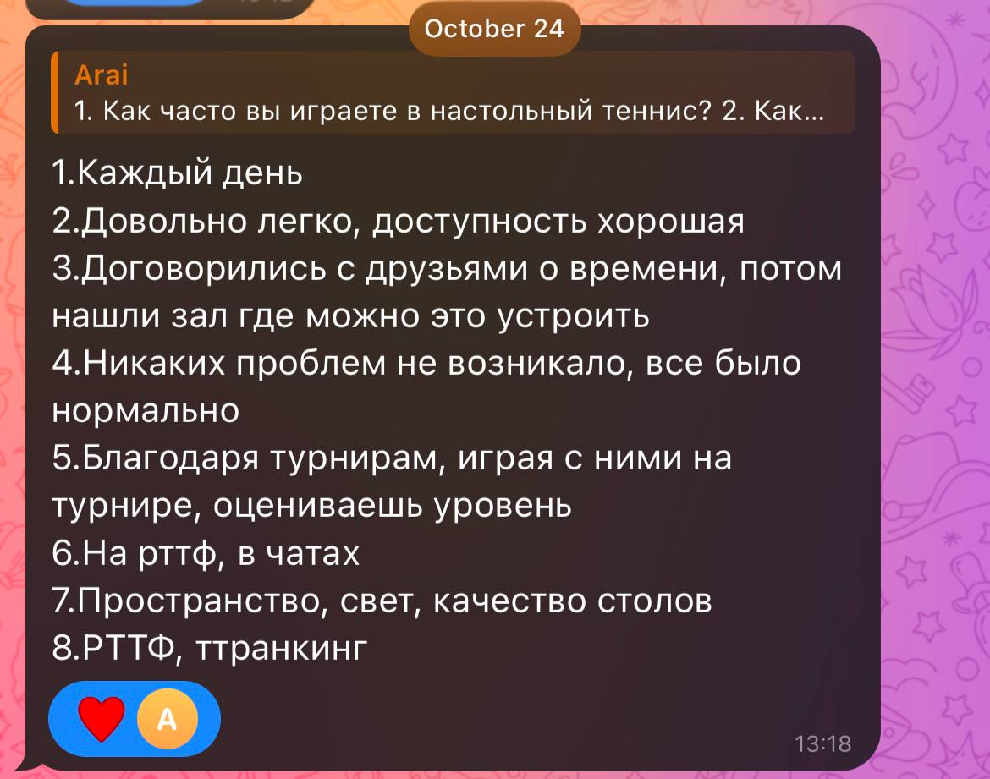
Figure E-P02. Anonymized written Telegram exchange, 24 October 2026. Source: docs/research/interviews/. Interviewer: Tazhimova Araizhan. Language: Russian. English translation: Zhanybek Alikhan. Original-response check reported by Araizhan: 24 October 2026.

E-P03. Original written responses – Regular player
Session: 24 October 2026. Channel: TikTok. Participant code: P03.
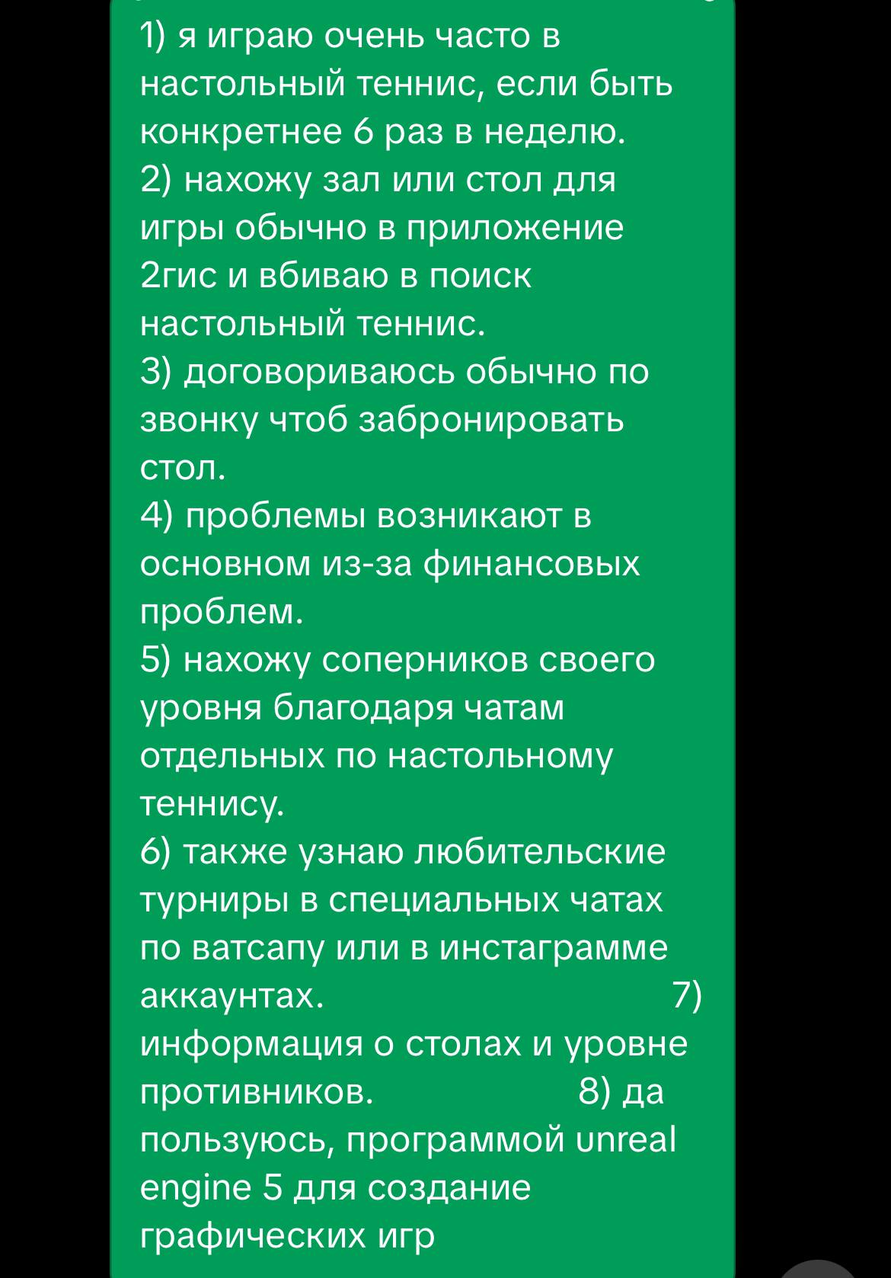

Figure E-P03. Anonymized written TikTok exchange, 24 October 2026. Source: docs/research/interviews/. Interviewer: Tazhimova Araizhan. Language: Russian. English translation: Zhanybek Alikhan. Original-response check reported by Araizhan: 24 October 2026.

E-A01. Original written responses – Hall administrator
Session: 25 October 2026. Channel: WhatsApp. Participant code: A01.
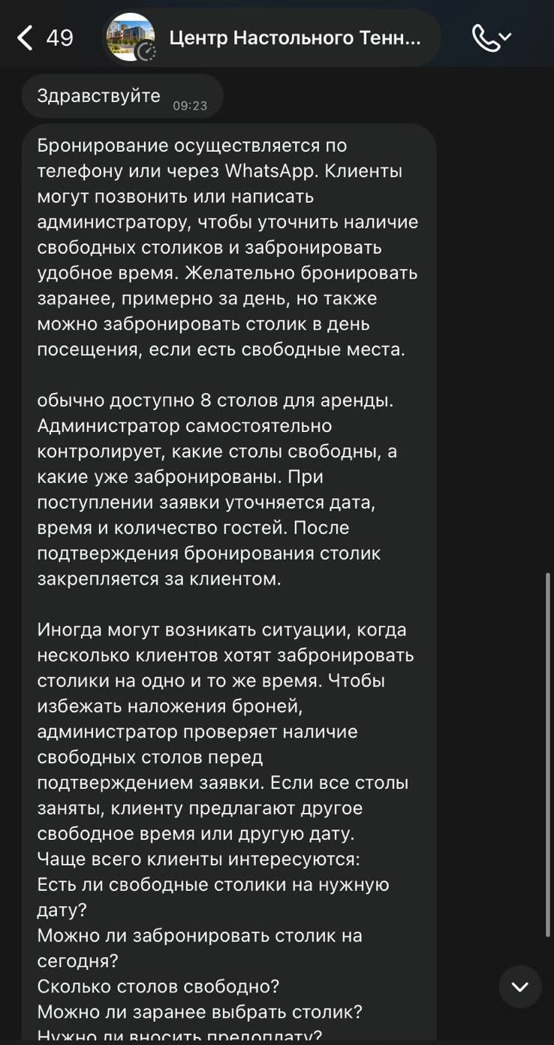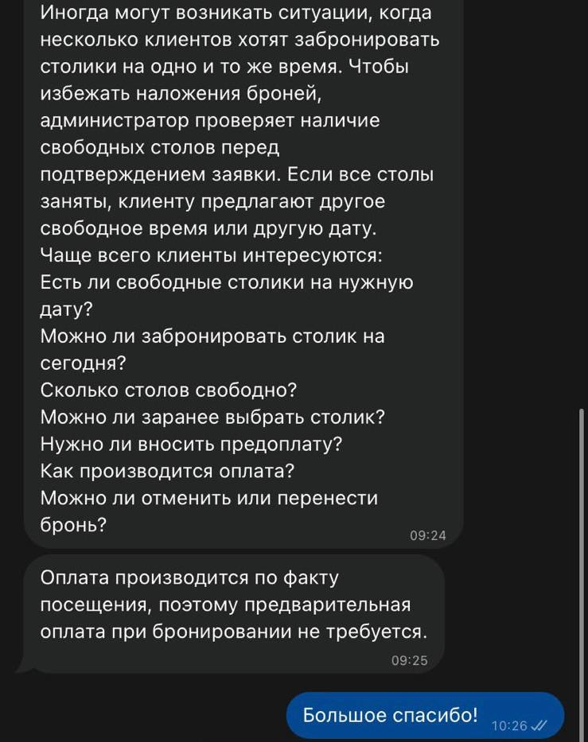
Figure E-A01. Anonymized written WhatsApp exchange, 25 October 2026. Source: docs/research/interviews/. Interviewer: Tazhimova Araizhan. Language: Russian. English translation: Zhanybek Alikhan.

E-C01. Original written responses – Coach and tournament organizer
Session: 24 October 2026. Channel: WhatsApp. Participant code: C01.
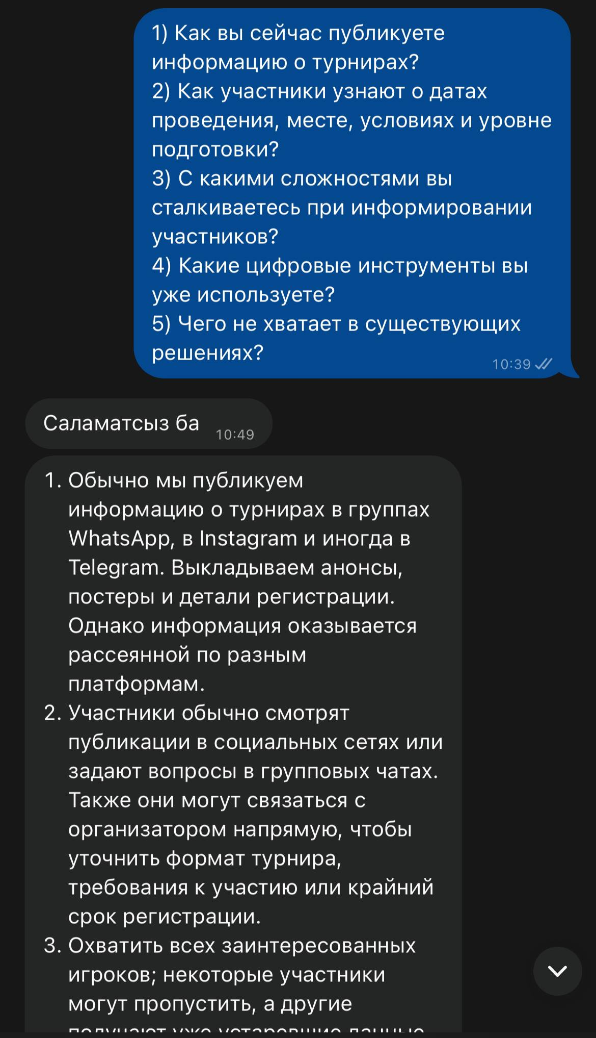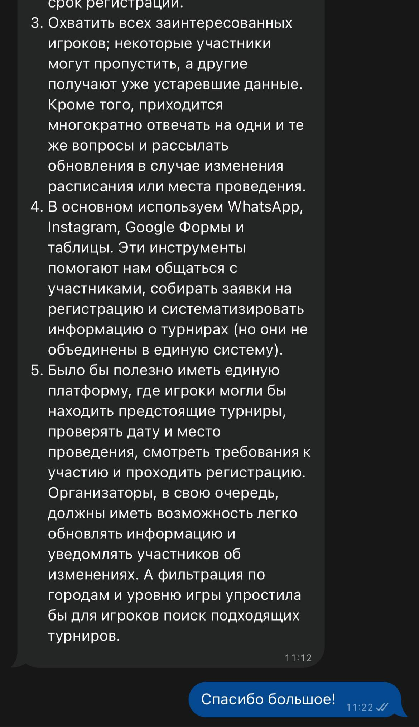
Figure E-C01. Anonymized written WhatsApp exchange, 24 October 2026. Source: docs/research/interviews/. Interviewer: Tazhimova Araizhan. Language: Russian. English translation: Zhanybek Alikhan. Original-response check reported by Araizhan: 24 October 2026.
Evidence for this study consists of written message exchanges and screenshots. No audio or video interview recording was made.
Appendix F Committee feedback and and supervisor review record
The following feedback was issued by the probation committee and forwarded to the team by the supervisor. Tazhimova Araizhan received the message. The team reports receipt on 29 October 2026; the supplied screenshots display the date. The forwarded comments are retained as committee feedback and do not constitute a separate supervisor review.
The submitted report and frontend prototype provide a sufficient preliminary basis for continuing the diploma project. The materials include a defined scope, literature and technology reviews, requirements with acceptance criteria, architectural diagrams, and a measurable evaluation plan. However, several probationary-period requirements remain insufficiently evidenced.
It is not possible to evaluate the contribution of the user with account RII77777.
The state of the repository does not match YouTrack. The task TTKZ-2, regarding the creation of the backend, is marked as Done, yet in the committed version, the backend directory contains only a README file. The outcome of this task needs to be clarified, and the statuses, links to changes, and acceptance criteria must be updated accordingly.
The responses of five participants are provided, but the dates, the format of the sessions, and the original interview recordings have not been verified. The comparison involving TTFRK remains unverified. The review mentions nine research papers, while the matrix lists eleven; Dašić and Wan are cited in the text but are missing from the bibliography.
Obtain the supervisor's feedback and include it in the report.
The topic has practical relevance, as it addresses the coordination needs of table tennis players, venue operators, and tournament organizers. The submitted stakeholder responses provide preliminary support for consolidating venue discovery, booking, partner search, and tournament information. However, the term digital integration requires a clear operational definition. The team should specify which participants, processes, and data the platform will connect, clarify the geographic scope of the initial pilot, and define measurable outcomes, such as reduced booking effort, fewer reservation conflicts, and improved access to relevant information. The current evidence does not establish nationwide demand.
The team must add the report and editable diagram sources to the repository, document interview provenance, resolve literature and reference inconsistencies, complete the comparison evidence, and provide dated committee feedback forwarded by the supervisor with documented responses. The booking prototype should cover time selection, confirmation, and conflict states. A complete application is not required at this stage, but the proposed integration must be reflected consistently in the requirements, architecture, prototype, and evaluation criteria.
Actual acknowledgement from Tazhimova Araizhan (Arai), shown at 12:24; message date not independently established: “Hello! Thank you for the feedback. I will review the comments and make the necessary corrections to the report and project”. The item-by-item response record is in section 11.
Additional supervisor instruction: “Please address the comments of the committee”.
Opening decision: “Hello! After consideration of your probation on diploma, you are allowed to continue your work on the selected topic”.
F.1 Committee feedback forwarded by the supervisor and acknowledgement screenshots
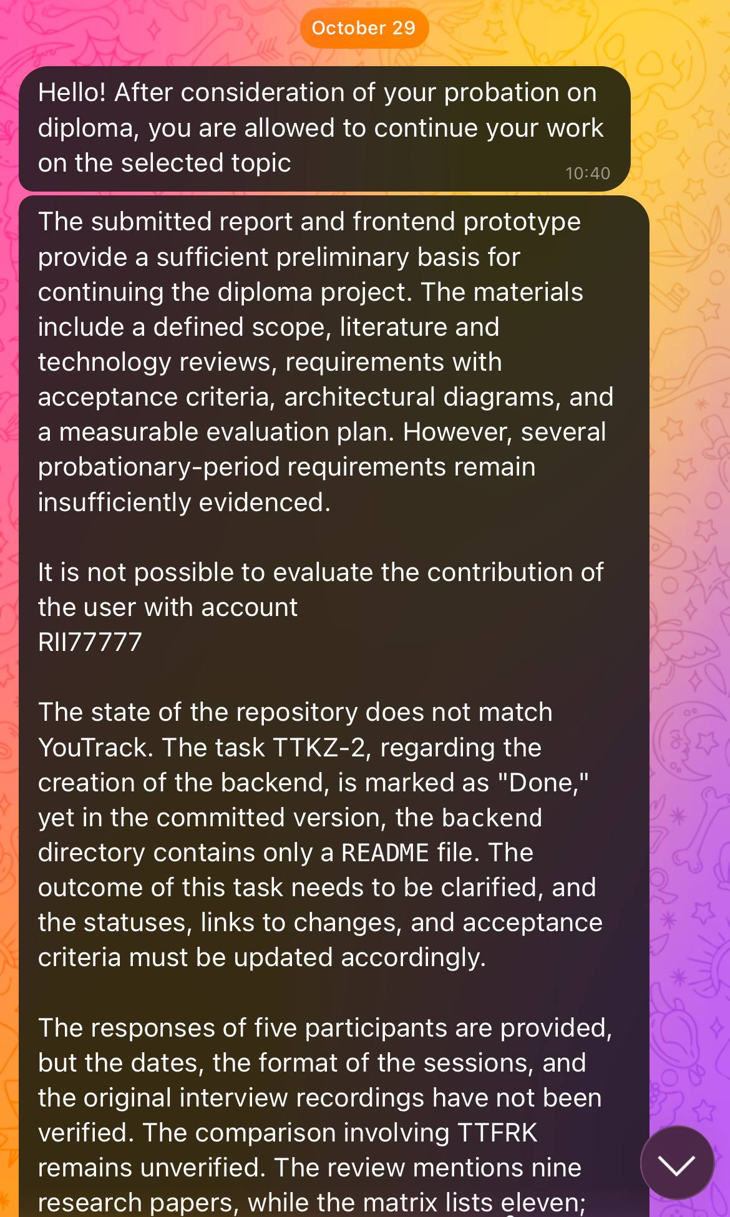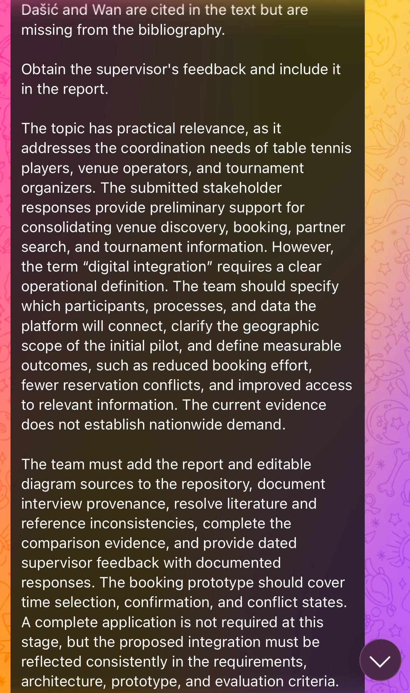
Figure F-01-02. Committee feedback forwarded by the supervisor received by Tazhimova Araizhan.
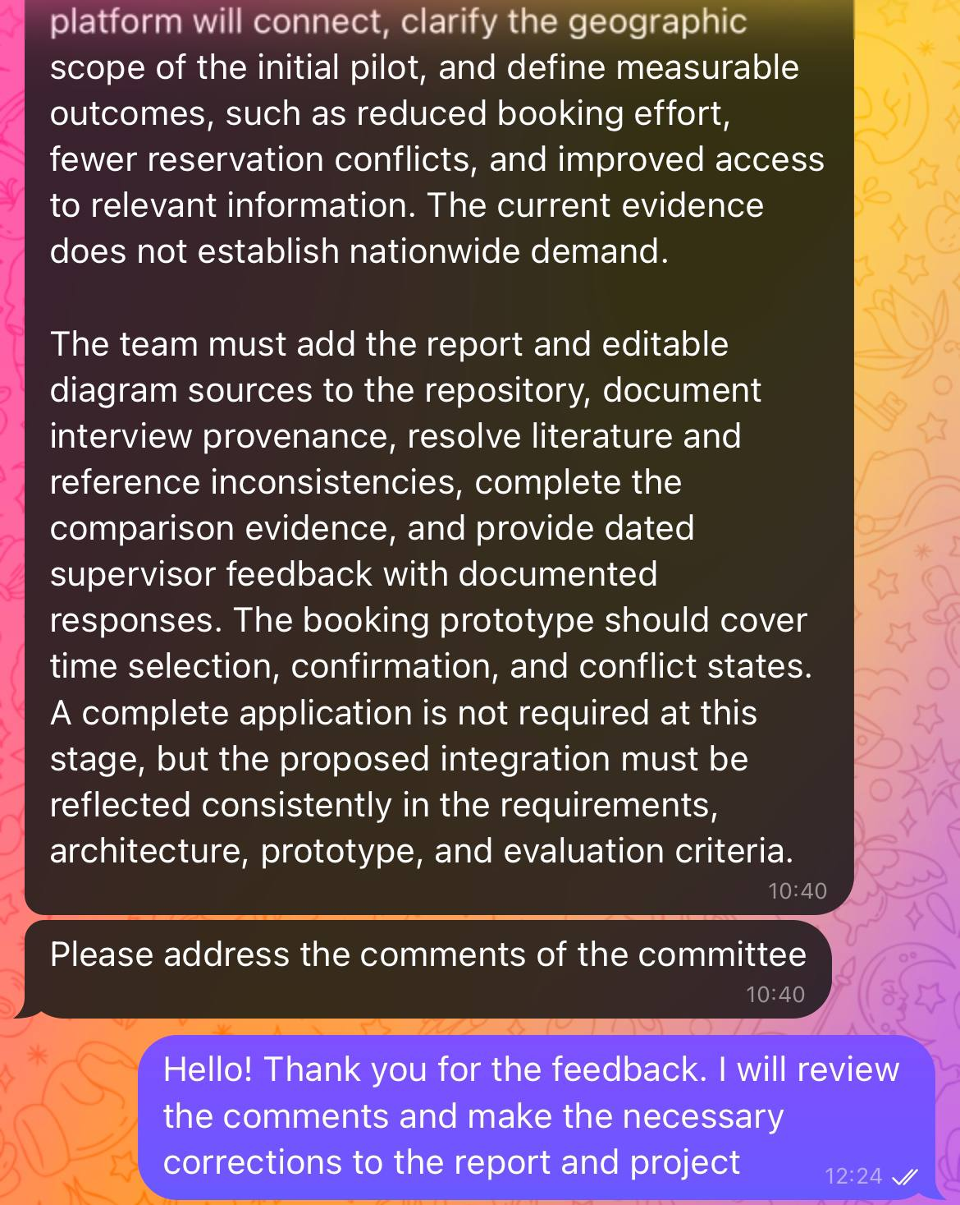
Figure F-03. Continuation of the forwarded committee feedback and related correspondence.
Tazhimova Araizhan acknowledged receipt and stated that the team would review the comments and make the necessary corrections. This acknowledgement is separate from the documented corrective actions in section 11.2.
Date: 29 October 2026.
Files: docs/supervisor-feedback/feedback-2026-10-29-01.png, feedback-2026-10-29-02.png, and feedback-2026-10-29-03.png
F.2 Separate dated supervisor feedback and team responses
Separate dated feedback from the supervisor on the revised materials has not yet been received. This subsection will record the review date, the materials reviewed, the supervisor’s comments and the team’s responses with supporting evidence.

Appendix G TTFRK screenshot evidence
Official public pages rechecked on 29 October 2026. These pages support public-information observations; they do not prove the absence of booking or partner-search functions.

G-01-04. Official home
https://ttfrk.kz/
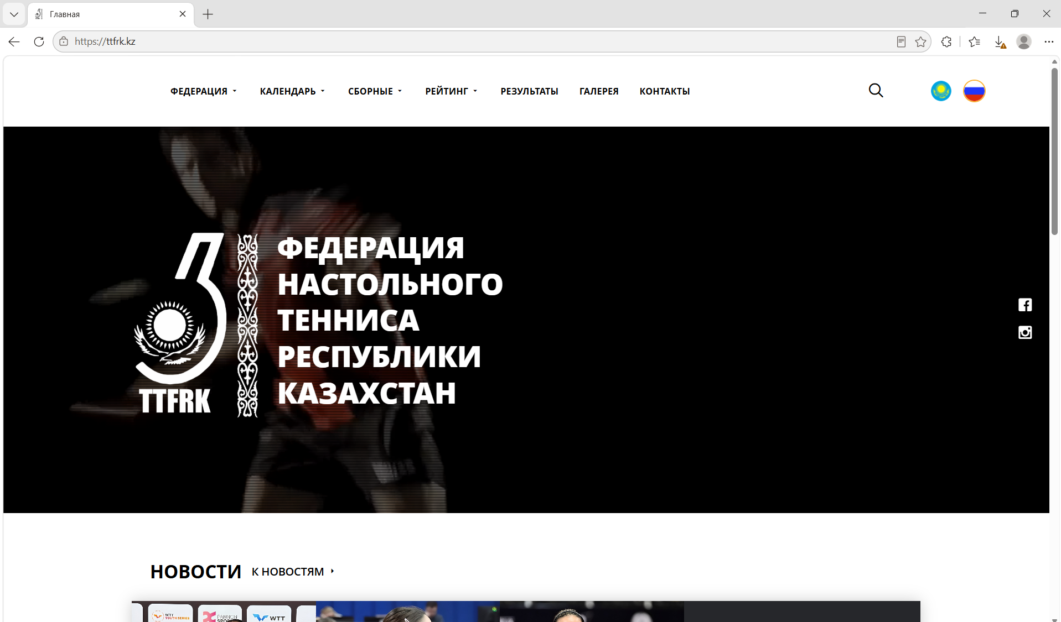
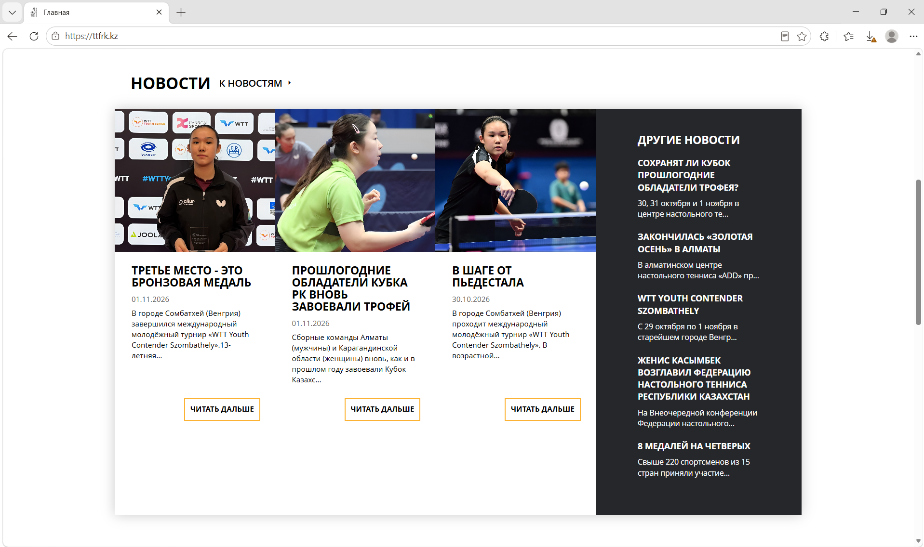
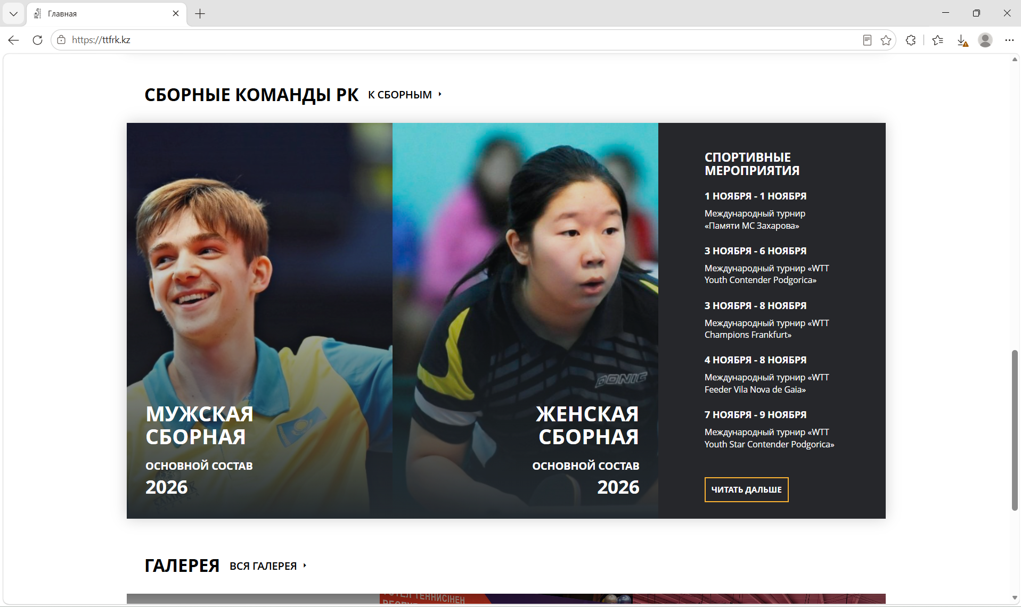
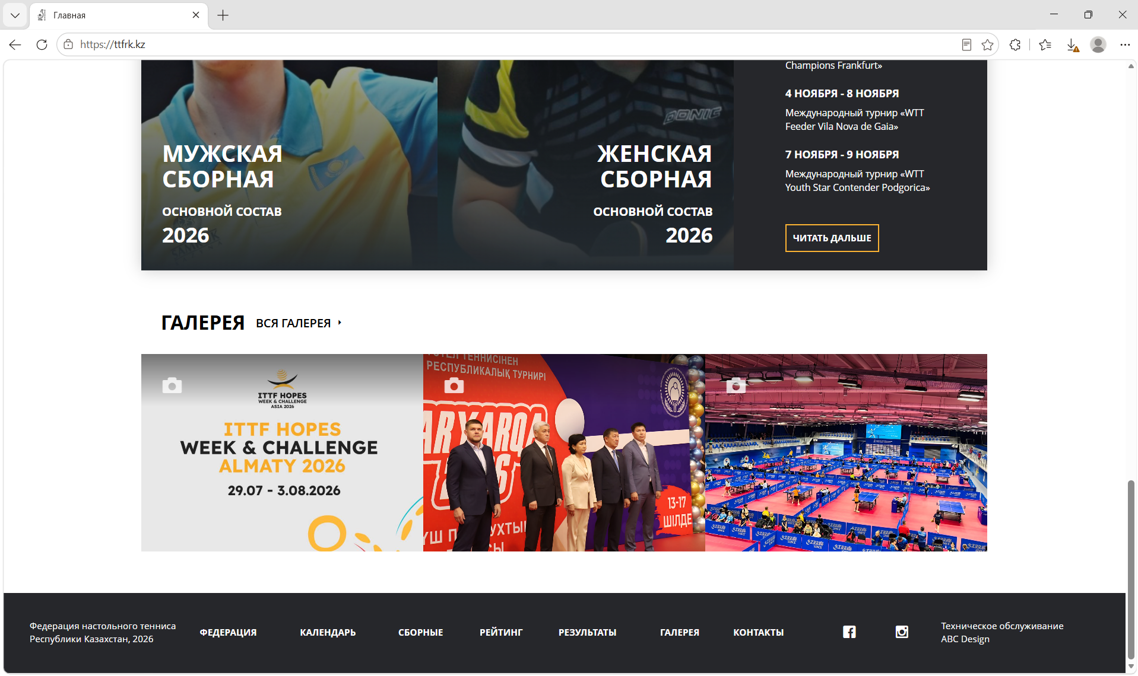
Figure G-01-04. TTFRK official home. Source: https://ttfrk.kz/. Actual capture date: 29.10.2026. Related comparison observations: section 4.
G-05-06. Calendar
https://ttfrk.kz/ru/calendar
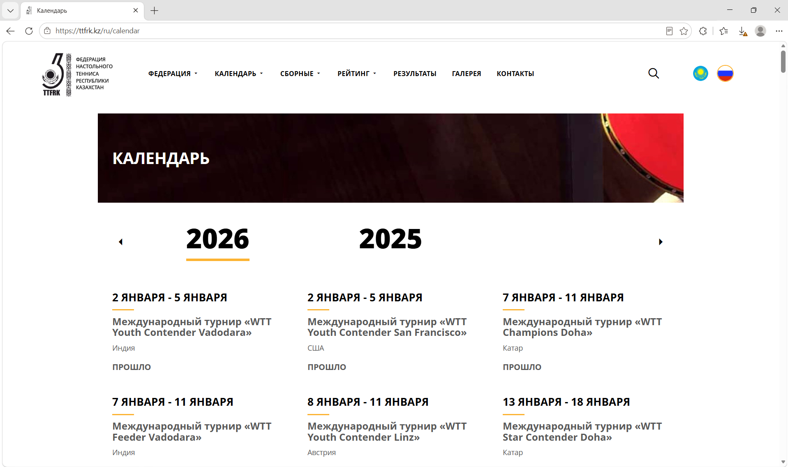
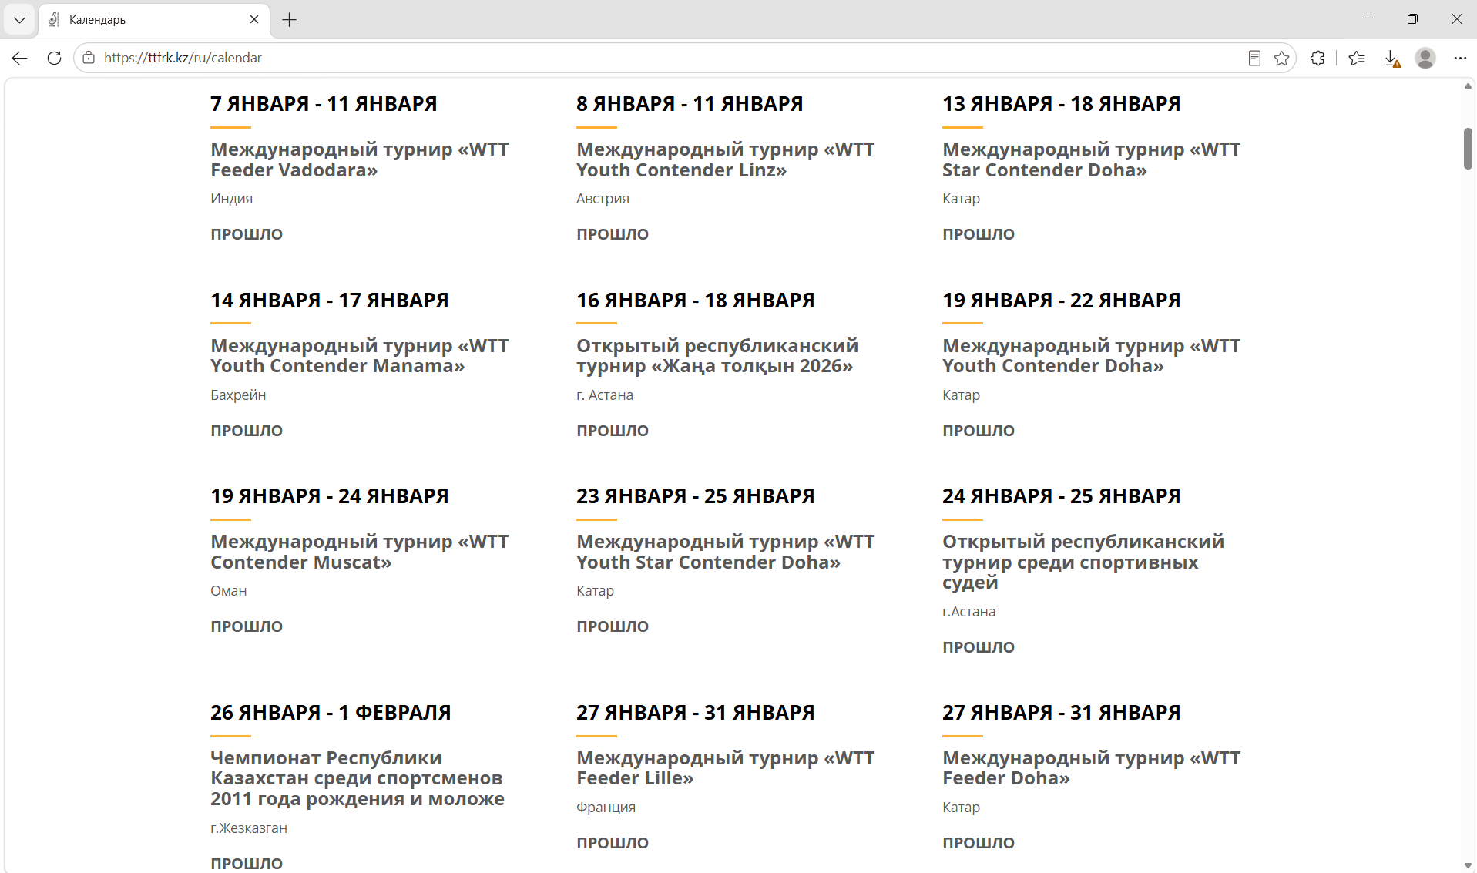
Figure G-05-06. TTFRK calendar. Source: https://ttfrk.kz/ru/calendar. Actual capture date: 29.10.2026. Related comparison observations: section 4.
G-07-08. Rating
https://ttfrk.kz/ru/rating
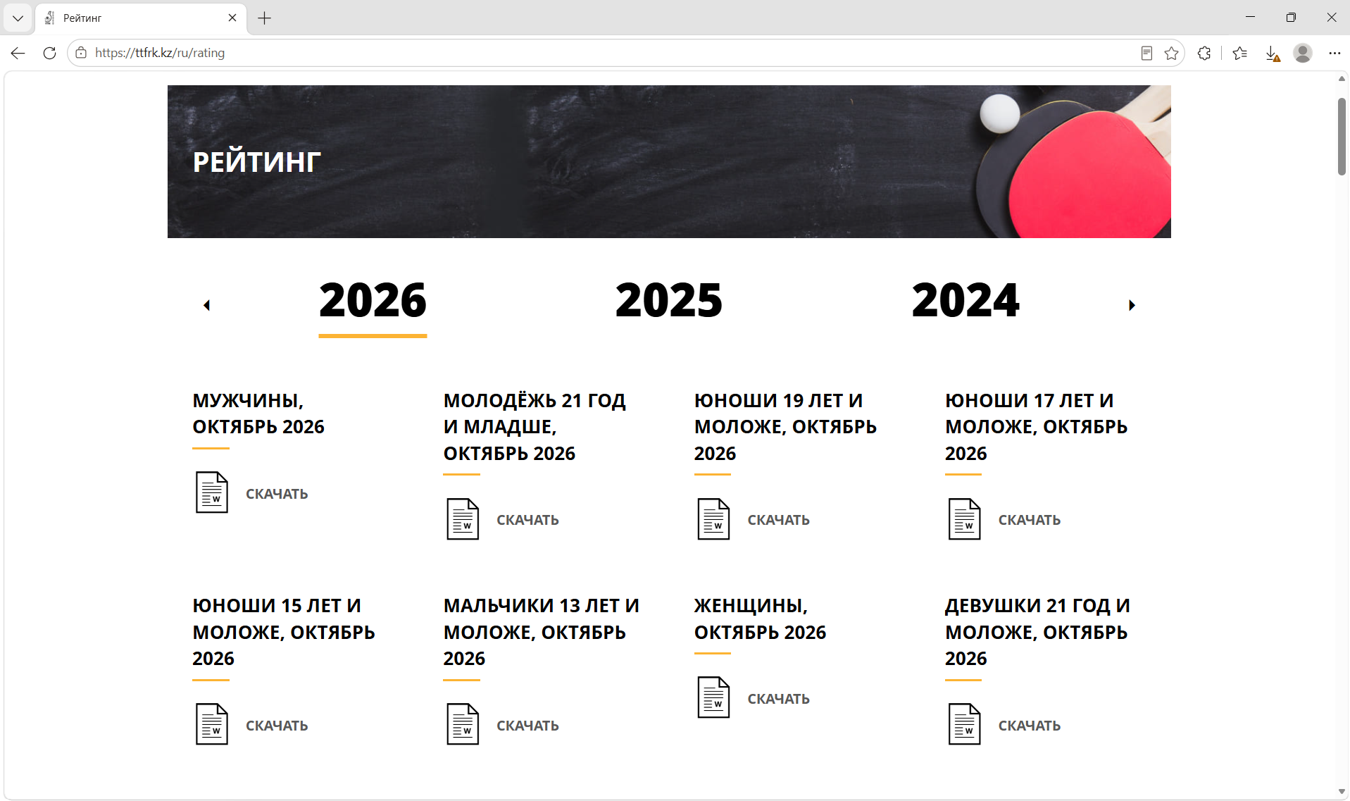
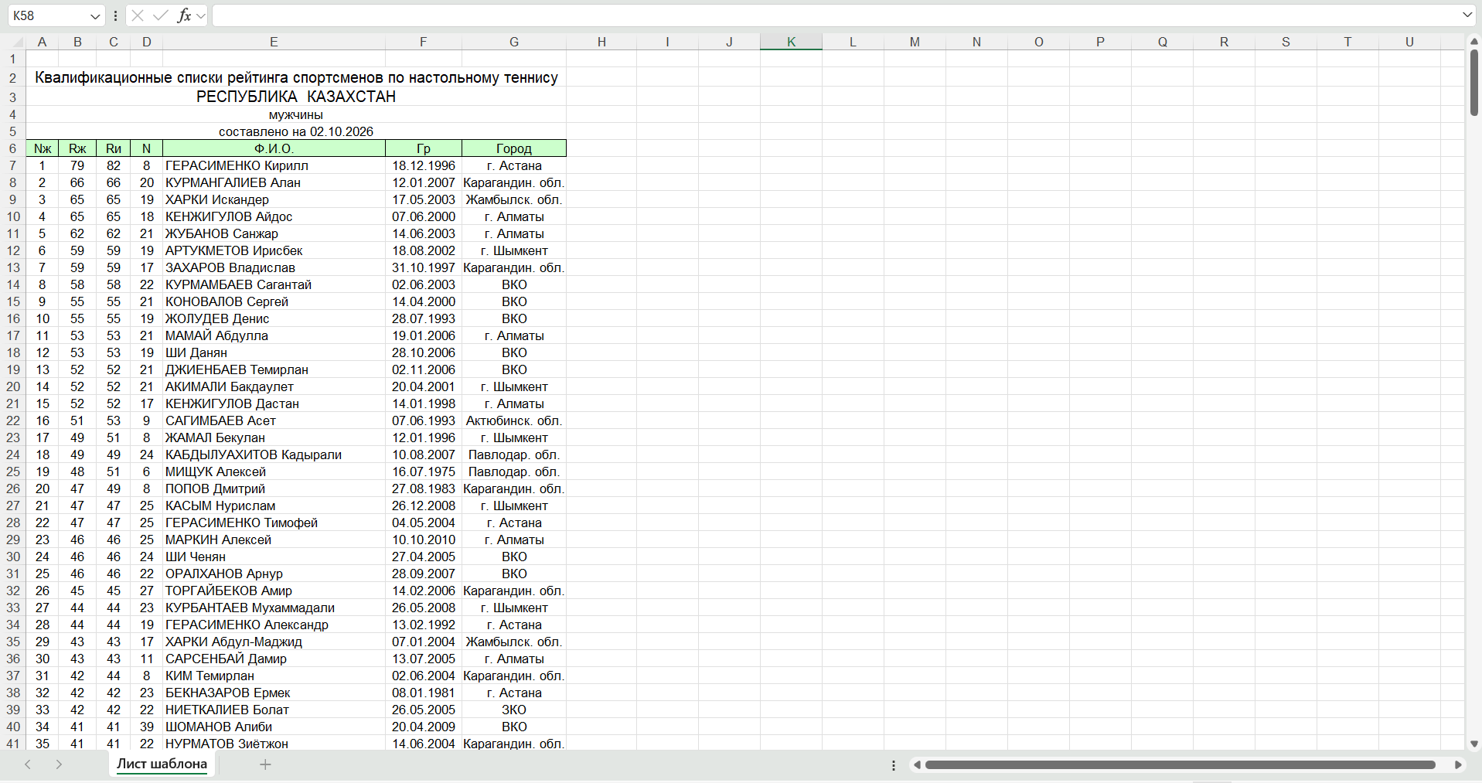
Figure G-07-08. TTFRK rating. Source: https://ttfrk.kz/ru/rating. Actual capture date: 29.10.2026. Related comparison observations: section 4.
G-09-25. National teams
https://ttfrk.kz/ru/teams
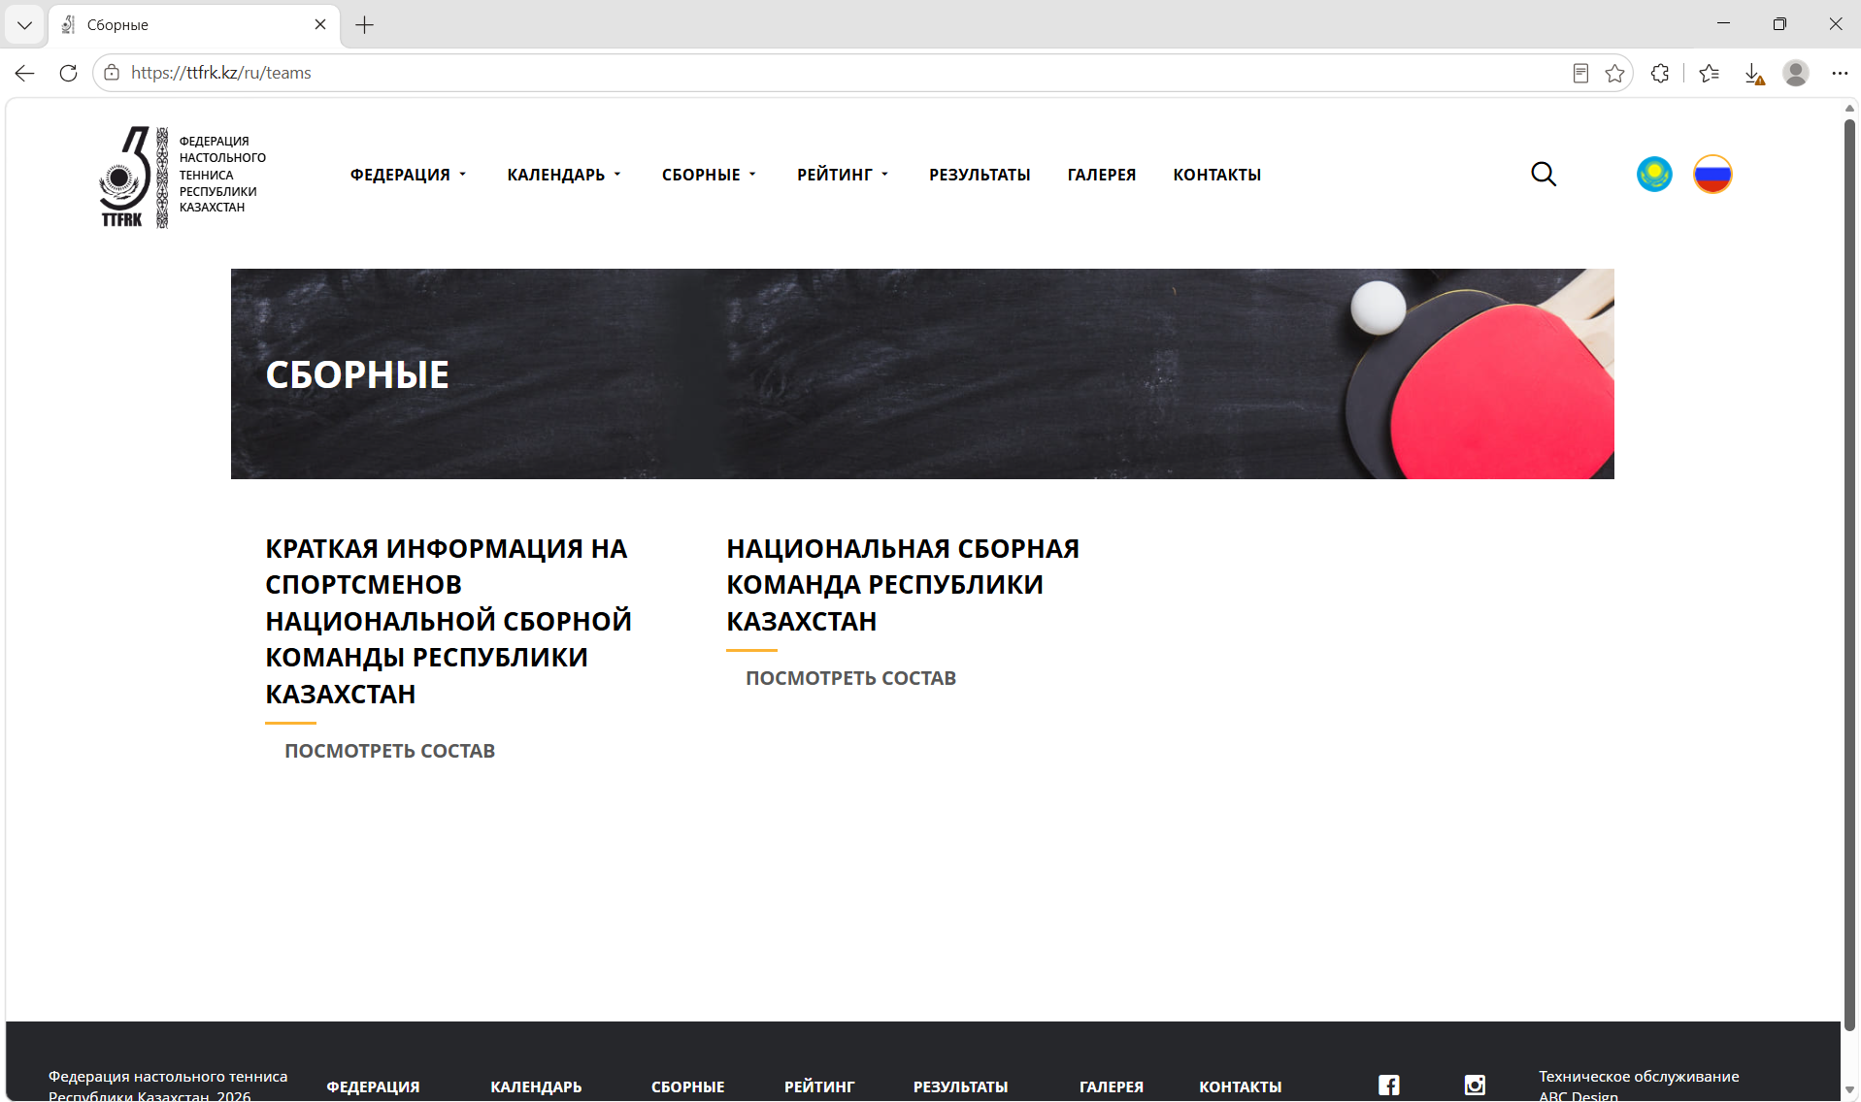
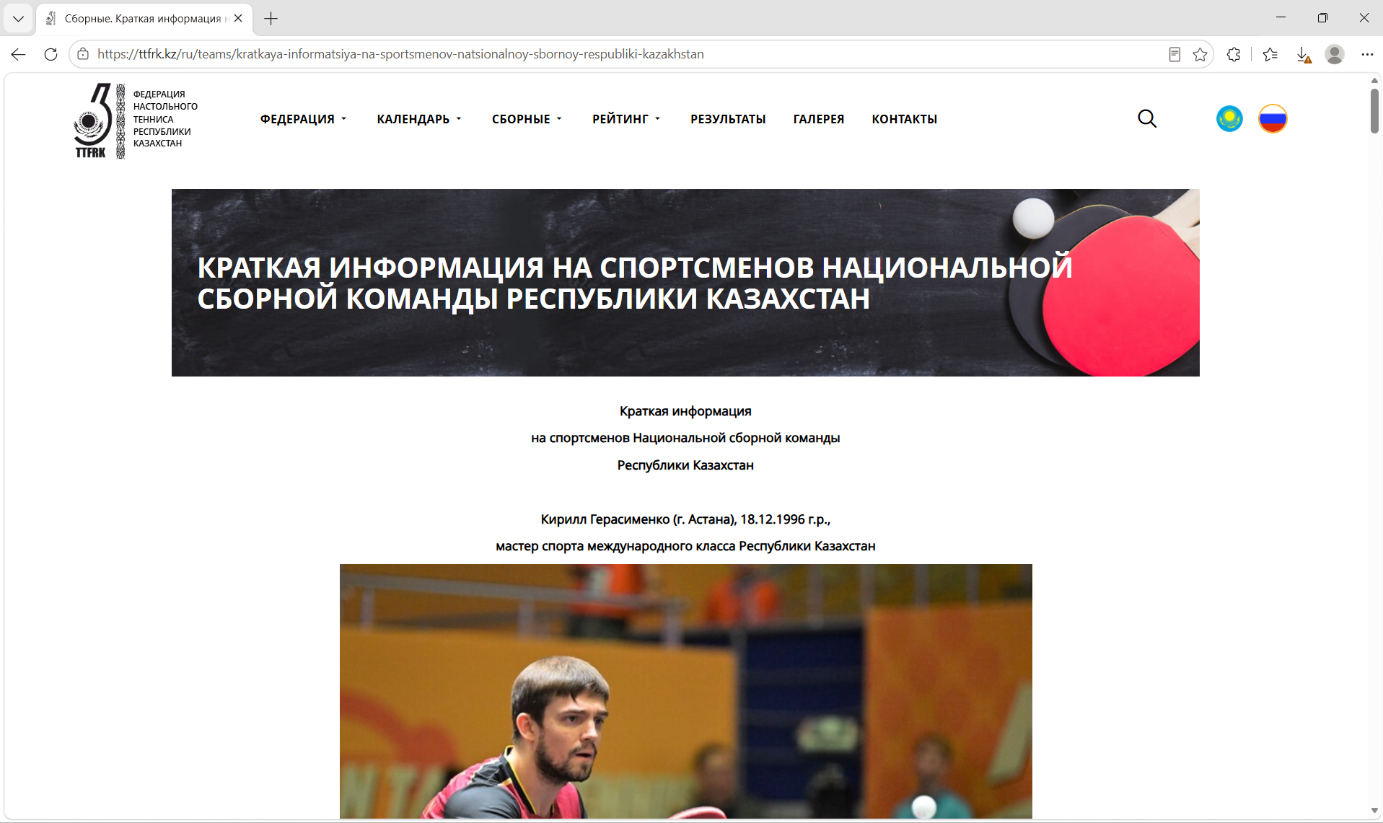
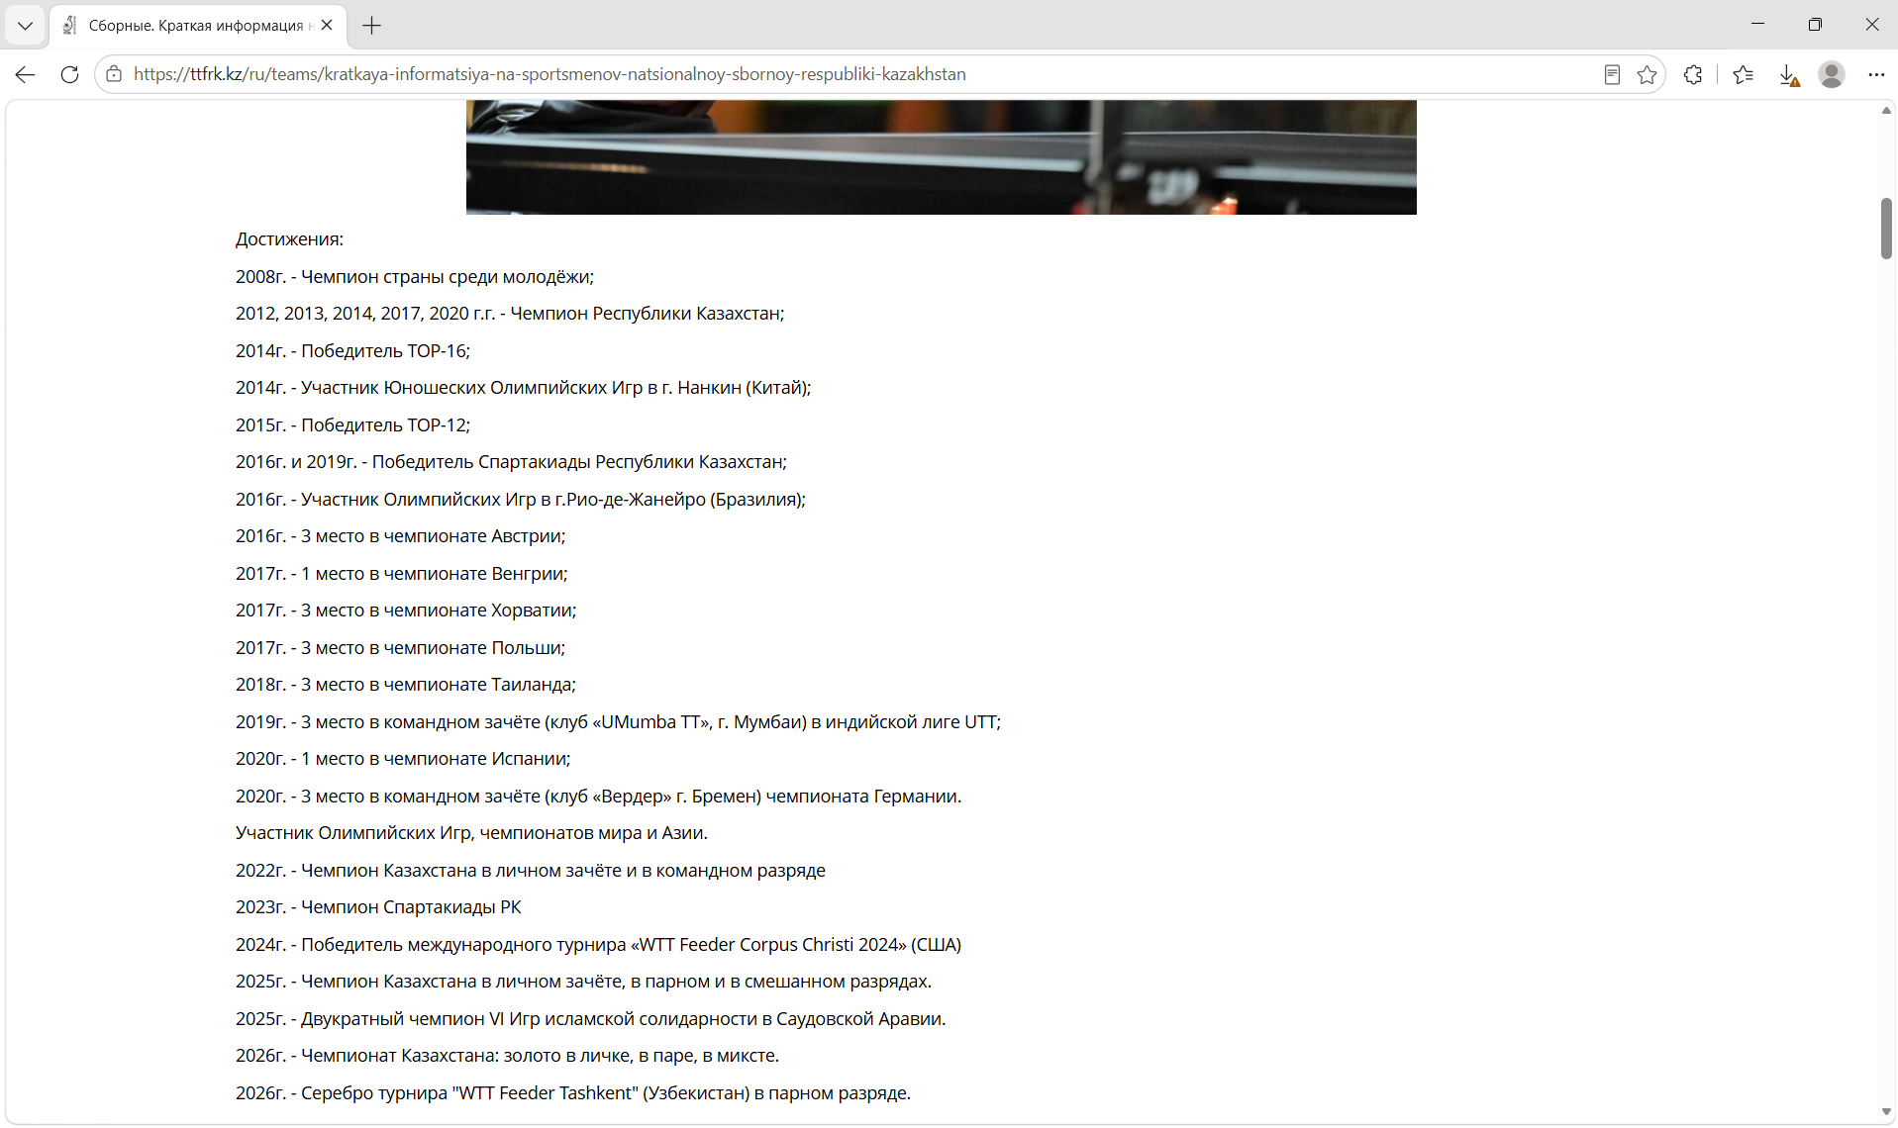
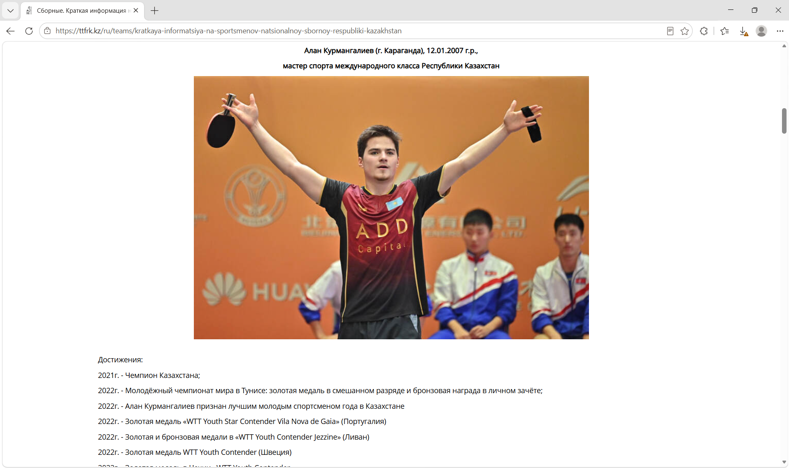
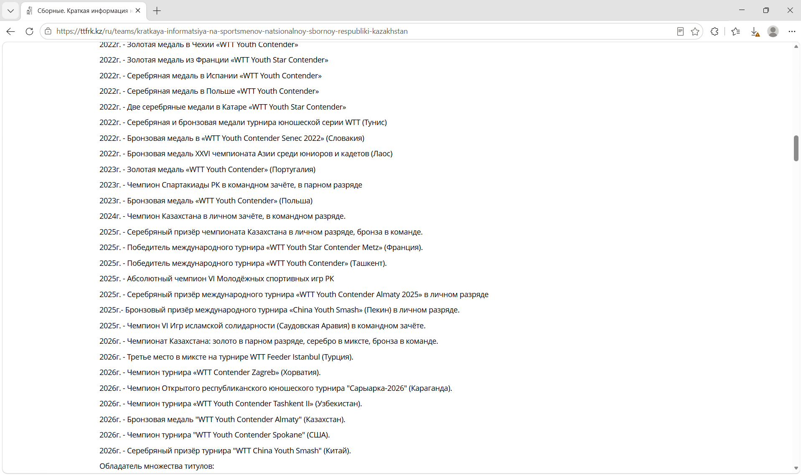
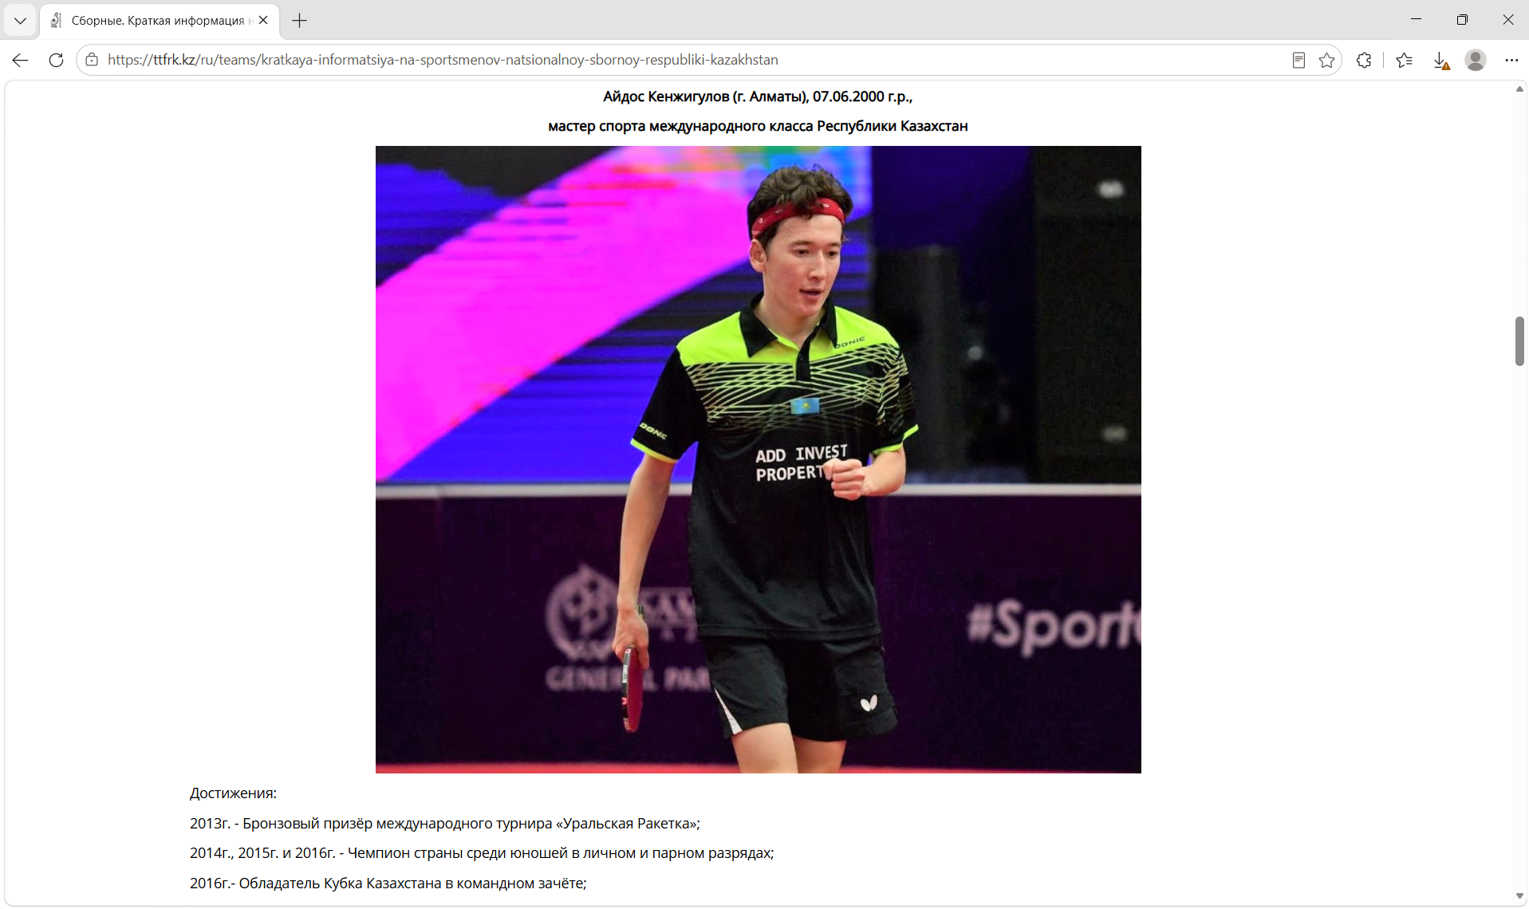
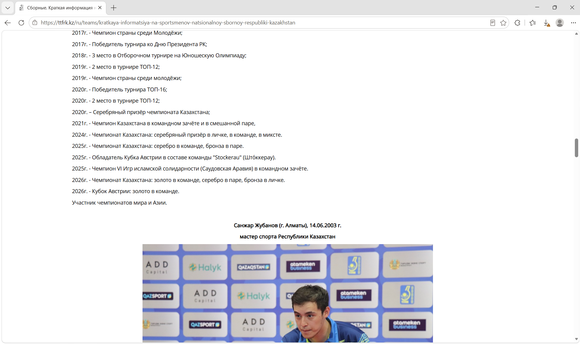
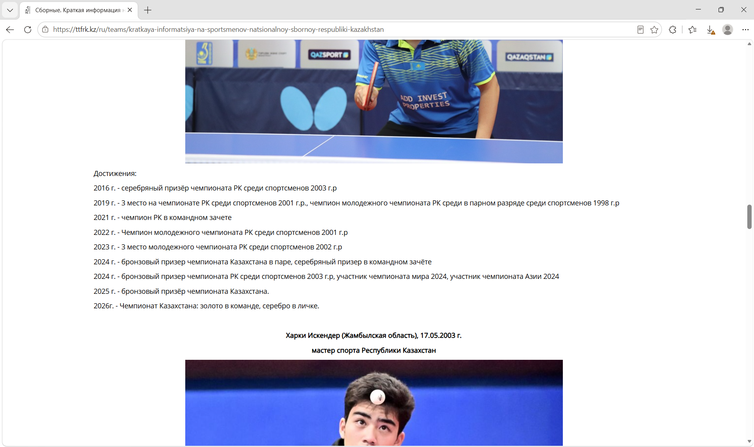
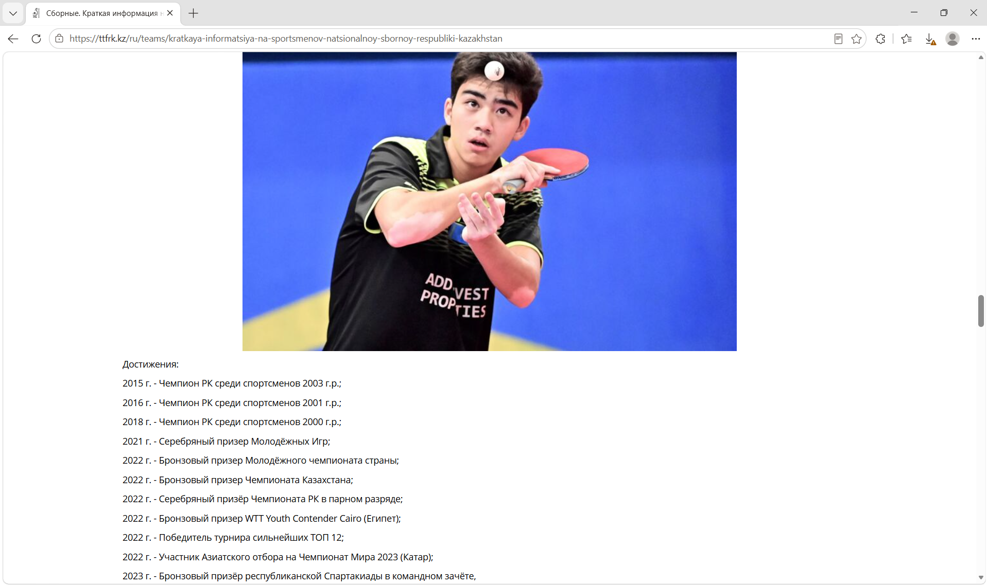
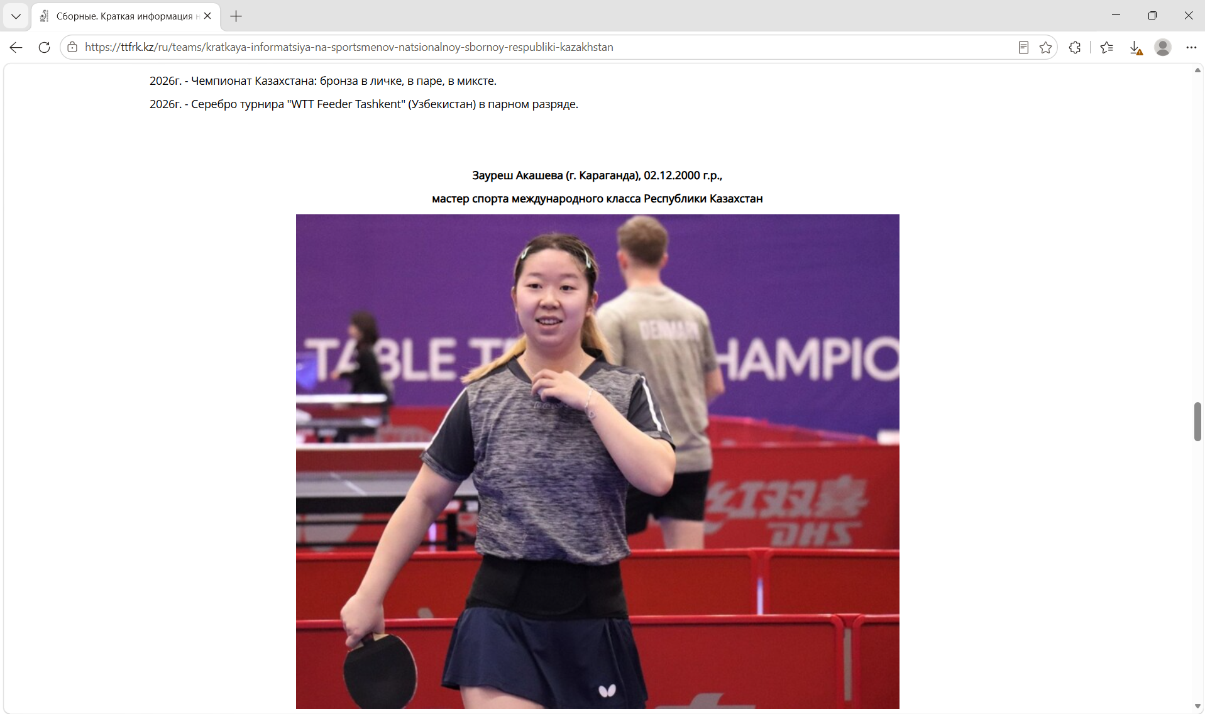
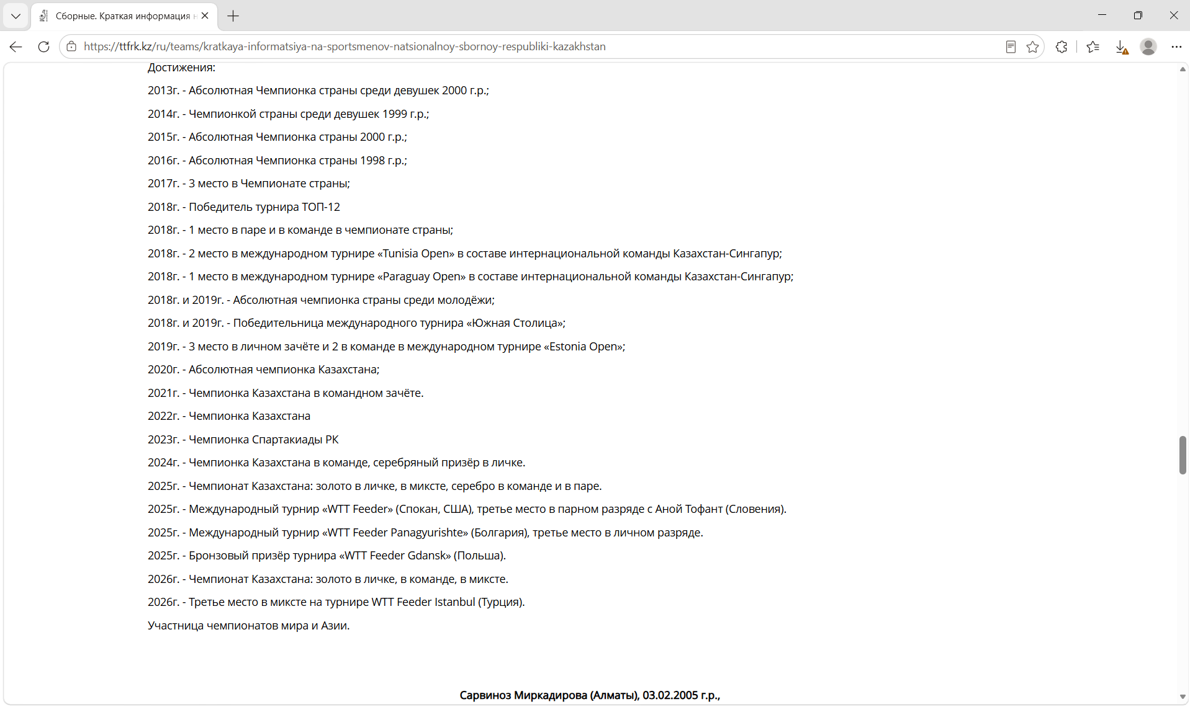
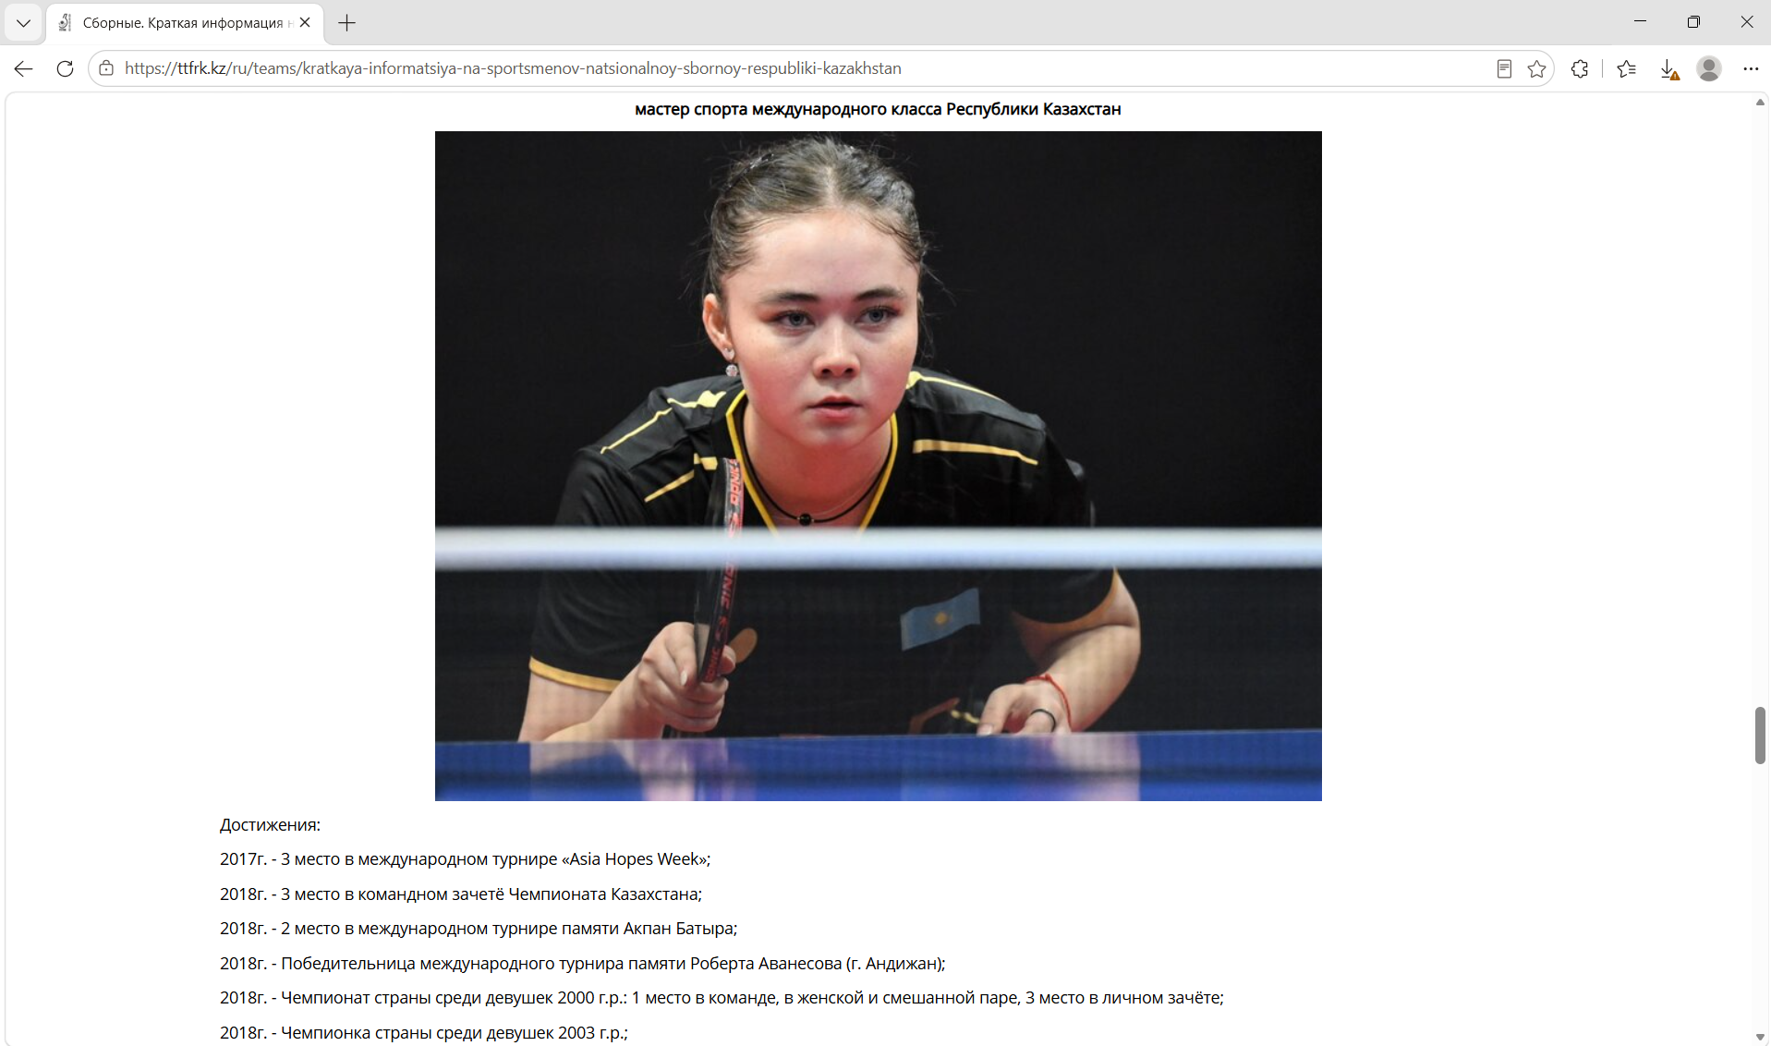
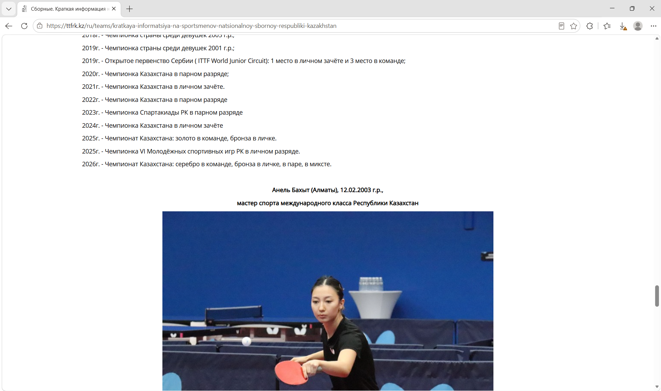
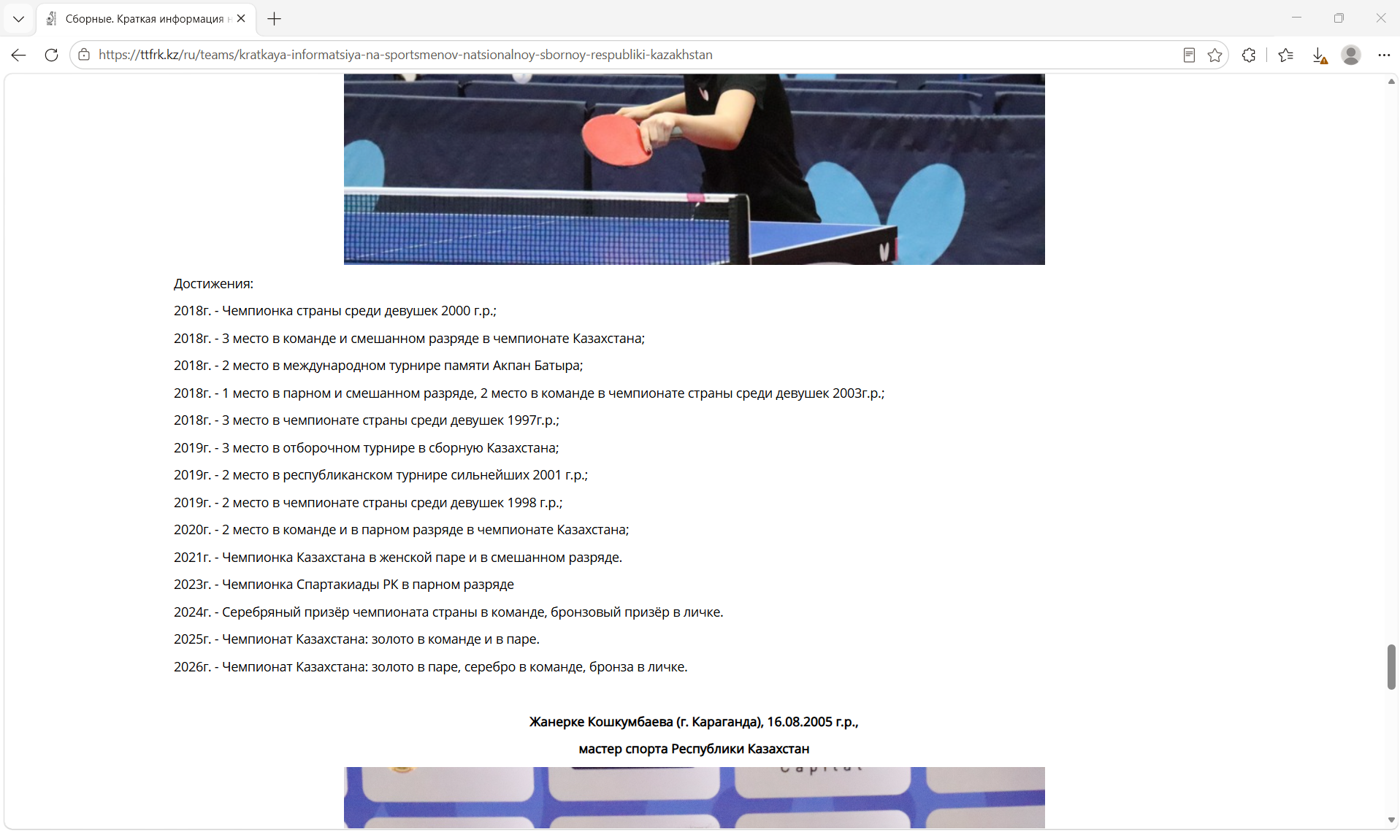
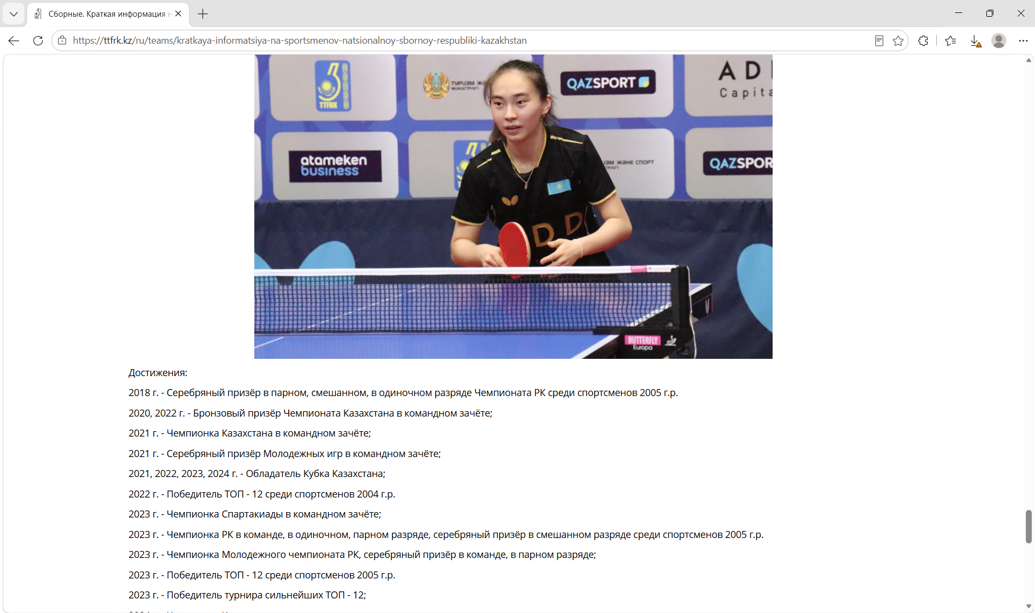
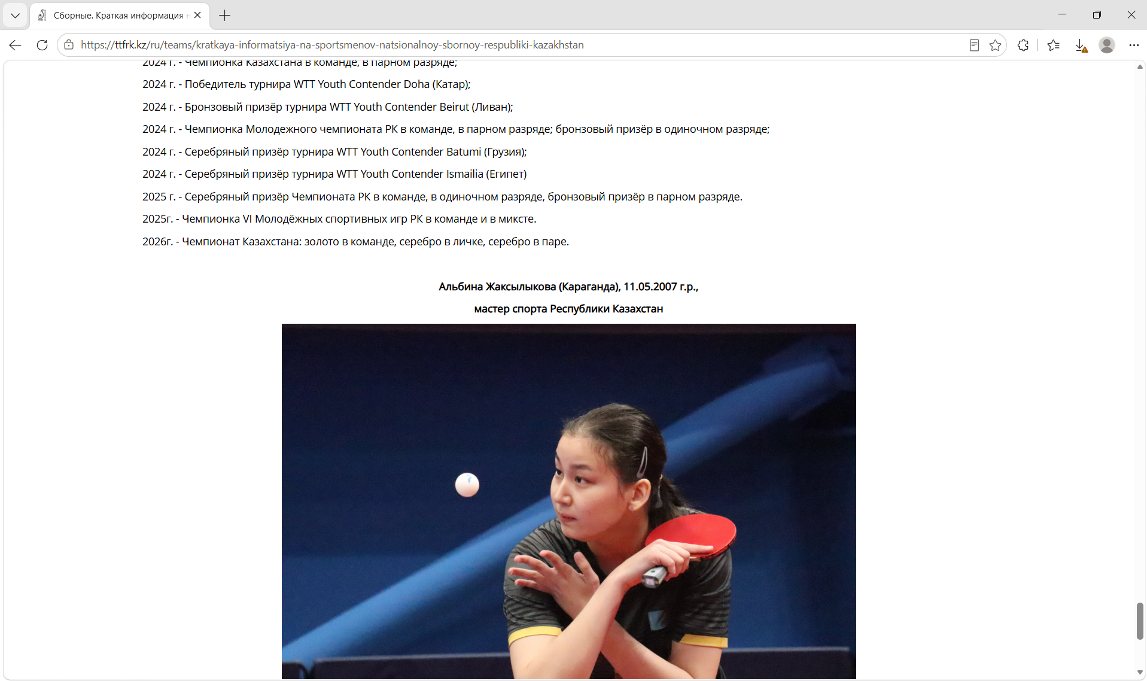
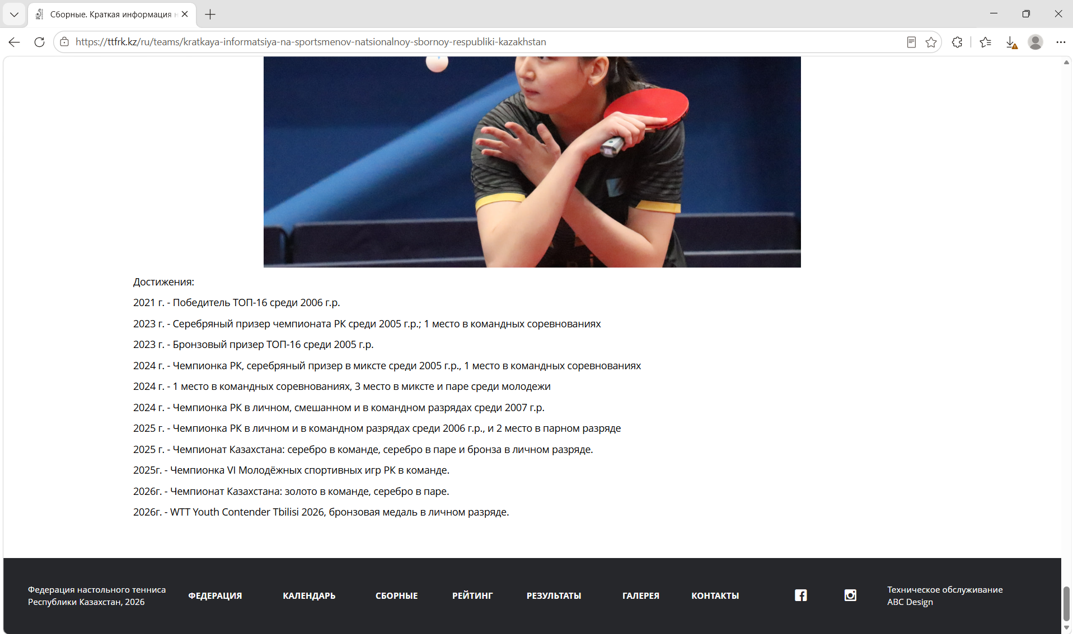
Figure G-09-25. TTFRK national teams. Source: https://ttfrk.kz/ru/teams. Actual capture date: 29.10.2026. Related comparison observations: section 4.
Appendix H Editable diagram sources and exports
The editable sources and PNG exports correspond to the diagrams in Appendix C.
C.1 System Context Diagram
Editable source: docs/diagrams/source/system-context.drawio
PNG export: docs/diagrams/exports/system-context-1.png
C.2 Use Case Diagram
Editable source: docs/diagrams/source/use-case.drawio
PNG export: docs/diagrams/exports/use-case-2.png
C.3 Component Diagram
Editable source: docs/diagrams/source/component.drawio
PNG export: docs/diagrams/exports/component-3.png
These diagrams describe the proposed architecture and do not demonstrate implemented backend functionality.

