POINT HACKS COPILOT
Mobile App — Product Requirements Document
Frequent-Flyer Earning & Planning (not Redemption)
Version 1.0 · Draft for Engineering · 28 May 2026

Document Control
Field | Value
Document title | Point Hacks Copilot — Mobile App PRD
Version | 1.0 (Draft)
Status | Draft — for engineering review
Owner | Tin Luu (Product)
Audience | Engineering, Design, Founders
Last updated | 28 May 2026
Related artefacts | eligibility-engine.ts, seed.ts, Point Hacks Copilot board deck, in-progress mobile reference screenshots

Table of Contents

1. Executive Summary
Point Hacks Copilot is a mobile app for Australian credit-card and frequent-flyer enthusiasts who want to maximise points-earning without burning eligibility for sign-up bonuses. It complements the existing Point Hacks brand by giving members an always-on assistant that tracks the cards they hold, the spend and benefits they still need to use, and the next card they should apply for.
v1 ships with four tabs: (1) Card Matching, (2) Deals & Alerts, (3) Card Optimisation, (4) Next Card Eligibility. Tabs 1 and 2 are placeholder shells in v1 — they integrate existing Point Hacks Copilot technology that will be merged in a later release. This PRD focuses on Tabs 3 and 4 plus the global navigation, a central Floating Action Button (FAB) for core actions, voice input/output, and a Card Alert Centre for push notifications.
v1 is local-first (no backend account required), runs on iOS and Android via React Native/Expo, and reuses the existing eligibility-engine.ts and issuer/card seed data already developed for the Bonus Eligibility reference.
Out of scope for v1: redemption guidance, cashback rewards optimisation, multi-user/family pooling, full Apple Wallet integration, and non-AU markets.

2. Product Vision & Strategy

2.1 Vision
Point Hacks Copilot becomes the trusted earning-and-planning companion for every Australian points-collector — the app that quietly tracks the boring stuff (min-spend deadlines, annual-fee renewals, benefit windows) and surfaces the one next card decision that matters this month.

2.2 Strategic context
- Point Hacks already owns the AU points-and-travel audience via its content brand. A mobile companion deepens that relationship from monthly content visits to weekly utility check-ins.
- The web-based Point Hacks Copilot Chrome extension (board deck, reference screenshots) proves users want surfaced card recommendations and points balances at the point of purchase. The mobile app extends this with always-on tracking and proactive alerts.
- The existing eligibility engine (eligibility-engine.ts) and AU-issuer dataset (seed.ts) are a substantial technical moat. v1 productises that logic into a consumer surface.

2.3 Earning, not redemption
v1 deliberately scopes to earning and planning. Redemption (sweet-spot finder, award availability, transfer partner advice) is an obvious future extension but doubles the data and content complexity. We ship narrow, win user habit, then expand.

3. Goals & Non-Goals (v1)

3.1 In scope
- Track the credit cards the user holds (and has cancelled) with key dates.
- Surface the next sign-up bonus the user is eligible for, ordered by points value and confidence.
- Capture spend updates and benefit redemptions via voice or text.
- Camera-driven card capture using AI vision to populate card details.
- Push notifications for time-sensitive events (min-spend deadline, benefit expiry, annual fee, eligibility unlock).
- Store Qantas Frequent Flyer and Velocity membership numbers and deep-link out to view balance.
- Four-tab bottom navigation with a central FAB for core actions and voice assistant.

3.2 Out of scope (v1)
- Redemption optimisation, award search, transfer-partner advice.
- Cashback / non-points credit cards.
- Multi-user / family pooling of cards and benefits.
- Direct API integration with frequent flyer programs (deep-link only in v1).
- Cloud sync across devices (local-only storage in v1).
- Non-AU issuers and overseas programs (beyond storing membership numbers).
- Apple Wallet / Google Wallet card provisioning.
- In-app application or instant card approval flows.

4. Personas & Jobs-to-be-Done

4.1 The Optimiser
Profile: 30–55, holds 3–6 cards at any time, churns 2–4 cards a year, follows Point Hacks closely, tracks min-spend in a spreadsheet today.
Pain: Loses track of multiple min-spend deadlines. Forgets to use $450 worth of annual benefits. Mis-times Amex 18-month rule and loses a 200k bonus.
Job: Tell me what I need to spend, by when, on which card — and what to apply for next.

4.2 The New Churner
Profile: 25–40, holds 1–2 cards, just discovered points hacking via Point Hacks content.
Pain: Overwhelmed by issuer rules. Doesn't know whether they're eligible for the Amex Platinum 200k offer.
Job: Tell me which cards are safe to apply for, in plain English, and what I'd earn.

4.3 The Forgetter
Profile: Holds 1–3 cards long-term. Not actively churning.
Pain: Pays annual fees on cards whose benefits they never use. Misses retention offers.
Job: Remind me before I'm charged the annual fee, and tell me which benefits I haven't redeemed this year.

5. Competitive Context (brief)
AwardWallet and MaxRewards (US) handle loyalty-account tracking and card optimisation but lean US-issuer and US-program. Card Pointers focuses on transaction-level merchant category bonuses. There is no AU-native mobile app that combines AU issuer eligibility rules, min-spend tracking, and benefit-redemption nudges in one product. The competitive moat is (a) AU issuer-rule depth in the existing eligibility engine and (b) the Point Hacks brand and content engine.

6. Information Architecture & Navigation

6.1 Top-level structure
Persistent bottom tab bar with four tabs, in fixed order:
- Tab 1 — Card Matching (placeholder in v1, existing Copilot tech to merge).
- Tab 2 — Deals & Alerts (placeholder in v1, existing Copilot tech to merge).
- Tab 3 — Card Optimisation (full v1 build).
- Tab 4 — Next Card (full v1 build).

6.2 The FAB
A circular Floating Action Button sits in the centre of the bottom tab bar, visually overlapping the dividing line between Tabs 2 and 3 (i.e., the centre of the tab bar). Tapping the FAB expands a radial / sheet menu with four core actions. The FAB is persistent across all four tabs.

6.3 Navigation rules
- Bottom tabs persist on every primary screen. They hide on full-screen modals (camera, voice session, card-detail expanded view).
- Tab state is preserved when switching tabs (do not reset scroll position or filter selections).
- Deep links from notifications open directly into the relevant card detail or eligibility result, bypassing the tab the user was last on.
- The FAB is always reachable; it expands into a bottom sheet on phones and a popover on tablets.

7. Tab 1 — Card Matching (Placeholder)
Tab 1 in v1 is a placeholder shell containing a heading, a one-line description, and a 'Coming soon' state. The existing Point Hacks Copilot Chrome extension and web-side matching logic will be merged into this tab in a follow-up release.

Acceptance criteria
- Tab renders the placeholder without crashing.
- Placeholder explains the feature in <=2 sentences and links to a 'Notify me when ready' opt-in.
- Tab is keyboard-, screen-reader-, and dynamic-type accessible.

8. Tab 2 — Deals & Alerts (Placeholder)
Tab 2 in v1 is a placeholder shell. Existing Copilot deal-surfacing logic will be merged in a follow-up release.

Acceptance criteria
- Tab renders the placeholder without crashing.
- Placeholder explains the feature in <=2 sentences.
- Tab is keyboard-, screen-reader-, and dynamic-type accessible.

9. Tab 3 — Card Optimisation (Detailed)

9.1 Purpose
Tab 3 is the user's working dashboard for the cards they currently hold. It surfaces the time-sensitive obligations of each card — min-spend, annual fee, benefit expiries — and lets them update spend and benefit usage in seconds.

9.2 Dashboard layout
The Tab 3 home screen is a vertically scrolling stack of card 'cards' (one per held credit card), preceded by a compact summary header.

9.2.1 Summary header
- Total active cards (count).
- Total min-spend remaining across all active sign-up bonuses, in AUD.
- Total points pending (sum of bonus points the user is still working towards across active min-spends).
- 'Action needed' counter (count of cards with an unmet obligation that has a deadline in the next 30 days).

9.2.2 Per-card row (collapsed)
- Card art / issuer mark and product name.
- Status chip: 'On track', 'Action needed', 'At risk' (computed from rules in 9.3).
- One-line headline: the single most important upcoming date or amount (e.g., '$1,240 to go by 12 Sep').
- 3-month-to-bonus CTA icon/blinker: when a held card crosses into a window where the user becomes eligible to apply for a fresh sign-up bonus on a *different* card in 90 days or fewer, show a small pulsing indicator that taps into Tab 4 filtered to that card.

9.2.3 Per-card row (expanded)
- Activation date.
- Card expiry date (printed expiry).
- Annual fee — amount and next charge date.
- Sign-up bonus block: target spend, current spend (editable), spend-by date, projected completion at current pace, points pending.
- Benefits block: list of trackable benefits with redemption status (Used / Unused / Expiring soon) and expiry date.
- Quick actions row: 'Update spend', 'Mark benefit used', 'Cancel card', 'Edit details'.

9.3 Status rules
Status | Trigger
On track | All deadlines >30 days away and projected min-spend completion at current pace covers the deadline.
Action needed | Any deadline 7–30 days away, OR unused benefit expiring 0–30 days, OR projected min-spend completion misses deadline by <=10 days.
At risk | Any deadline <7 days, OR projected min-spend miss >10 days, OR annual fee within 14 days on a card the user has indicated they want to cancel/downgrade.

9.4 3-Month-to-Bonus CTA logic
When Tab 4 produces an eligibility result of status 'waiting' with daysRemaining <=90 for any card not currently held, surface a CTA on Tab 3:
- Placement: a slim banner at the top of Tab 3 *and* a pulsing indicator on any held card that is blocking that eligibility unlock.
- Copy template: 'Eligible for {Card Name} in {N} days — {bonusPoints} pts.'
- Tapping the banner deep-links to Tab 4, scrolled to that card's eligibility detail.
- Dismissable for 7 days; reappears at 60 days and 30 days regardless of dismissal.

9.5 Acceptance criteria
- User can view summary header and at least 6 cards on a single screen scroll on a 6.1" device.
- Tapping a collapsed row expands it within 200ms; expanding does not collapse other rows automatically.
- Editing 'current spend' updates the dashboard within 500ms and recalculates projected completion date deterministically.
- All status chips are computed client-side from the local data store with no network call.
- 3-month CTA logic produces no false positives on cards the user has marked 'don't recommend reapplying'.
- Tab 3 fully renders offline (no spinners) using only on-device data.

10. Tab 4 — Next Card Eligibility (Detailed)

10.1 Purpose
Tab 4 answers one question: 'Which card should I apply for next?' It runs the existing eligibility engine across the AU issuer dataset, taking into account the user's current and cancelled card history, and ranks the result.

10.2 Dashboard layout

10.2.1 'Your best move' hero
- The single highest-ranked eligible card the user can apply for right now.
- Card art, product name, sign-up bonus points, annual fee, and a one-line reason ('Safe to apply now — 150,000 pts').
- Primary CTA: 'View offer' (deep-links out to the issuer or Point Hacks referral).
- Secondary CTA: 'Mark as applied' (writes back into local card history so future eligibility is correctly computed).

10.2.2 Eligible-cards summary
- Total cards eligible right now (count).
- Eligible cards grouped by frequent-flyer program target (Qantas, Velocity, Bank/flexible) — count per group.
- Total points available if the user applied for all currently-eligible cards (sum of bonusPoints).

10.2.3 Upcoming section
- Time-ordered list of cards the user becomes eligible for in future (status 'waiting'), sorted by daysRemaining ascending.
- Each row: card name, eligible date, days remaining, bonus points value.
- Provides a clear forward plan and pairs with the 3-month CTA logic in Tab 3.

10.2.4 Grey-area and Not-eligible lists
- Collapsible sections below 'Eligible' and 'Upcoming'.
- Grey-area items show the issuer's notes from seed.ts (e.g., Amex targeted-offer caveat).
- Not-eligible items show the reason but are de-emphasised visually.

10.3 Per-card eligibility detail
Tapping any card opens a detail view with:
- Card overview: issuer, product, sign-up bonus, annual fee, FF program.
- Eligibility verdict: status (Eligible / Waiting / Grey area / Not eligible), confidence level (High / Medium / Low), and the reason string straight from eligibility-engine.ts.
- For 'waiting' status: countdown to eligibleDate.
- Issuer rules summary: the issuer's eligibilityType, scope, exclusionPeriodMonths, and notes from seed.ts.
- 'Read guide' link: deep-link to the Point Hacks article for that card.
- 'Mark as applied' / 'Mark as held' CTA to update the local card-history pool.

10.4 Eligibility computation
Tab 4 reuses the existing eligibility engine in eligibility-engine.ts wholesale. The engine handles four eligibility types — first_time_only, new_to_bank, once_per_card, time_based — with scope variations (issuer_wide, card_family, same_card). Amex receives special handling for its 18-month issuer-wide waiting period after any cancellation and its separate personal/business pools.
Engineering must port eligibility-engine.ts unchanged where possible. If the engine signature needs adapting for React Native, port the pure-functional core (calculateEligibility, generateRecommendations) and leave behind only the @shared/schema imports.

10.5 Ranking
The generateRecommendations function in eligibility-engine.ts already produces a priority score (status weight + bonusPoints/1000 + confidence weight + urgency bonus for daysRemaining <30). Tab 4 ranks the 'Eligible' list by that score descending. The hero 'Your best move' is rank #1 in that list.

10.6 Acceptance criteria
- Tab 4 renders the hero card, eligible-cards summary, and upcoming list within 1s on a mid-range Android device.
- Eligibility computation runs entirely on-device with no network call.
- Adding a card via the FAB action updates Tab 4 results within 1s.
- Confidence level (High/Medium/Low) is visibly indicated on every result.
- Issuer rule notes from seed.ts are surfaced verbatim in grey-area results — no editorialising in code.
- Sorting and filtering options: by points value, by issuer, by FF program, by eligibility status.

11. FAB & Core Actions (Detailed)

11.1 FAB behaviour
- Tapping the FAB opens a bottom sheet (phones) or popover (tablets) with four action buttons.
- Tapping outside the sheet, swiping down, or tapping the FAB again dismisses it.
- Long-pressing the FAB jumps directly to the most recently used action.
- The FAB icon animates from '+' to '×' when expanded.

11.2 Action 1 — Add New Card

11.2.1 Flow
- User taps FAB → 'Add New Card'.
- App requests camera permission (first run only).
- Camera viewfinder with on-screen card outline overlay. Auto-capture when card is detected and in focus, with manual shutter fallback.
- AI vision processes the captured image to extract: card product name, issuer brand mark, last 4 digits of PAN, printed expiry MM/YY, cardholder name.
- App matches the extracted product to the seeded card catalogue in seed.ts. If matched, pre-fills product/issuer; if unmatched, presents a search-and-select picker.
- App opens a conversational confirmation flow with voice-or-text Q&A: 'Got it — American Express Platinum. When did you activate this card?', 'When is the annual fee next due?', 'Have you received the sign-up bonus yet?', 'Do you hold any other cards I should know about?'.
- After confirmation, card is written to the local data store and immediately reflected in Tab 3 and Tab 4.

11.2.2 Data captured and stored
- Card product (foreign key into the catalogue), issuer.
- Last 4 digits of PAN — stored, displayed masked (e.g., '•••• 1234'). Full PAN is never persisted.
- Expiry month/year (printed expiry).
- Activation date (user-confirmed).
- Annual fee next-due date.
- Sign-up bonus tracking flags: bonus target, spend window end date, bonus-received flag.
- Trackable benefits list (instantiated from card metadata; user can mark off as redeemed).

11.2.3 Privacy and security
- CVV/CVC is never captured or persisted under any circumstances; the OCR pipeline explicitly discards it.
- Full PAN is never persisted — only last 4 digits and a masked representation.
- The captured card image is held in memory for the duration of the OCR run only; it is discarded as soon as extraction completes (no disk write, no upload to a vendor server beyond the OCR call itself).
- If the OCR is performed via a cloud vision API, the request must redact/blur the PAN region before sending, or the vendor must be contractually bound to non-retention.

11.2.4 Acceptance criteria
- Camera flow completes from tap to confirmation in <=15s for a clean, well-lit card.
- Product match accuracy >=90% across the AU card catalogue defined in seed.ts.
- Fallback search-and-pick available within 1 tap of an unmatched OCR result.
- Stored card record never contains a value matching a 13–19-digit number outside the explicit last-4 field.

11.3 Action 2 — Update Card Spend

11.3.1 Flow
- User taps FAB → 'Update Spend'.
- App opens a voice/text dual-input pane.
- User speaks or types: e.g., 'Add 250 to the Amex Plat' or 'I spent four-thirty on my Velocity card today'.
- Speech-to-text returns the transcript; the app parses amount + card reference.
- If parse is unambiguous, app shows a confirmation toast: 'Added $250 to American Express Platinum — $1,250 of $5,000 reached (25%)'.
- If parse is ambiguous (e.g., user has two Velocity-earning cards), app prompts a quick disambiguation: 'Which one — Westpac or Virgin?'.
- On confirmation, the spend is appended to that card's running spend total and min-spend progress is recalculated.

11.3.2 Parsing requirements
- Numeric parsing must handle plain ('250'), dollar ('$250'), spoken ('two fifty', 'four thirty', 'twelve hundred'), and decimal ('1,234.56') forms.
- Card reference parsing must handle product name fragments, issuer names, and user-set nicknames.
- App offers an 'Undo' affordance for 30s after each spend update.

11.3.3 Acceptance criteria
- Voice round-trip (tap-to-confirmation) <=4s for a clear, single-card phrase.
- Parse accuracy >=95% on a curated test set of 100 representative phrases.
- Ambiguous-card disambiguation reaches the right card with at most one extra tap.
- Updates persist locally and reflect on Tab 3 within 500ms.

11.4 Action 3 — Update Card Benefits Redemption

11.4.1 Flow
- User taps FAB → 'Update Benefits'.
- App opens the same voice/text input pane.
- User speaks or types: e.g., 'Used my Amex hotel credit' or 'Burned my $400 travel credit on the Plat'.
- App maps the phrase to a known benefit on a held card.
- On confirmation, the benefit is marked 'Used' for the current benefit period and removed from any 'Expiring soon' state.

11.4.2 Acceptance criteria
- Benefit-matching accuracy >=90% on a curated test set.
- Used benefits visibly shift in Tab 3 within 500ms of confirmation.
- Edge case handled: user marks a benefit used in the *next* period before its current period elapses (treat as planned redemption, surface a tooltip).

11.5 Action 4 — Ask Copilot (voice assistant)

11.5.1 Purpose
A free-form voice (or text) conversational entry point. Users can ask read-only questions about their own data: 'How close am I to my Amex minimum spend?', 'Which benefit am I about to lose?', 'What's the best card I'm eligible for right now?', 'When does my Westpac annual fee hit?'.

11.5.2 Behaviour
- Voice or text input; voice or text output (user preference, configurable).
- Read-only in v1 — the assistant explicitly does not mutate state in v1 (no 'add 200 to my Amex' via this entry; that lives in Action 2).
- Answers are constrained to the user's local data plus the card catalogue. The assistant is not a general chat AI in v1.
- Each session is ephemeral; no chat history persisted in v1.

11.5.3 Acceptance criteria
- Voice round-trip (tap-to-spoken-answer) <=6s for a single-fact question.
- Answers cite the underlying data ('Based on your last spend update on 12 May…').
- Out-of-scope questions return a polite refusal that names what the assistant can answer.

12. Voice Input / Output Requirements

12.1 Modalities
- All FAB actions (except Add New Card, which is camera-first) accept voice or text input interchangeably.
- All confirmations and assistant answers are available as on-screen text and as TTS audio (TTS on by default for the Ask Copilot action; off by default for other actions; user-configurable).
- All voice flows must have a visible cancel / mute affordance.

12.2 Vendor requirements (no vendor commitment in v1)
- Speech-to-text: AU-English support, accuracy >=92% WER on AU-accented benchmark, <=500ms median latency for a 5s utterance, supports streaming partial transcripts.
- Text-to-speech: AU-English voice, natural prosody, <=300ms time-to-first-audio on a 4G connection.
- Optional/preferred: on-device fallback for both STT and TTS for privacy and offline support. If full on-device is not viable in v1, hybrid (on-device wake-word + cloud STT) is acceptable.
- Whisper Flow is a reasonable starting candidate. Final vendor selection is an engineering decision driven by the requirements above.

12.3 Privacy
- Voice recordings are not persisted on device beyond the active session.
- If a cloud STT vendor is used, the contract must prohibit training on user audio and require deletion within 24h.
- A clear in-product disclosure explains what is sent off-device, when, and to whom.

12.4 Accessibility
- Every voice interaction has an equivalent text input.
- Voice prompts are subtitled on-screen in real time.
- VoiceOver/TalkBack focus order is preserved during voice sessions.

13. AI / Vision Requirements

13.1 Card OCR + extraction
- Vision model must extract: card product name (when printed), issuer brand mark, last 4 digits of PAN, printed expiry MM/YY, cardholder name.
- Model must explicitly redact CVV and full PAN from any structured output passed back to the app.
- Required accuracy on the AU card catalogue: >=95% on issuer detection, >=90% on product detection, >=98% on last-4 detection.

13.2 Conversational card setup
- After OCR, a guided Q&A confirms activation date, annual fee date, bonus status, and prompts the user to add any other held cards.
- Q&A must adapt: skip questions for which OCR returned high-confidence answers.
- Q&A runs in <=4 turns for a typical card.

13.3 Vendor stance
PRD does not commit to a specific vision/LLM vendor. Engineering selects between Claude Vision, GPT-4V, Google Gemini, or an on-device equivalent, subject to the accuracy bars above and the privacy requirements in §15.

14. Frequent Flyer Integration

14.1 v1 scope
- Qantas Frequent Flyer.
- Velocity Frequent Flyer.
- Other programs (KrisFlyer, Asia Miles, Avios, etc.) are stored as free-text membership numbers without deep-link behaviour in v1; they are presented as a 'More programs' section.

14.2 What we store
- Membership number (string, AU-format validated where possible).
- Programme display name.
- Last-known points balance (optional, manually entered by the user in v1).

14.3 Deep-link behaviour
- Tapping a stored FF account opens the corresponding program's iOS/Android app via universal/app link if installed, otherwise opens the program's mobile web account page.
- Membership number is pre-filled where the program's app/site supports it (best-effort, no scraping).
- No login credentials are stored.

14.4 Out of scope (v1)
- Direct API/scraping integration to pull live balances.
- Transfer-partner mapping and award search.
- Status credit tracking.

15. Card Alert Centre & Notifications

15.1 Subscription model
The Card Alert Centre is a dedicated settings surface (reachable from the FAB sheet or a gear icon on Tab 3) where users pick which cards they want alerts for and which alert types they want enabled per card.

15.2 Alert types
Alert type | Trigger
Min-spend deadline | Sign-up bonus min-spend not met, <30/14/7/1 days to spend-by date.
Annual fee renewal | Annual fee charge expected in 30/14/3 days.
Benefit expiring | Trackable benefit unredeemed and expiring within 60/30/7 days.
Card expiry | Printed expiry within 60 days.
Eligibility unlock | User becomes eligible for a sign-up bonus on a card they previously held, or a card they marked 'interested'.
3-month-to-bonus | Held card's blocking window ends within 90 days, opening a new sign-up bonus.
Special offer | Issuer-side bonus uplift on a card the user is eligible for (sourced from Point Hacks editorial pipeline post-v1; placeholder in v1).

15.3 Card Alert Centre UI
- Per-card toggles for each alert type.
- Global mute window (e.g., 21:00–07:00 quiet hours).
- Channel preference: push only in v1 (no email/SMS in v1).
- Manual entry inputs: Card Approval Date and Current Points Balance per card.

15.4 Notification delivery
- APNs (iOS) and FCM (Android). v1 does not require a backend account; on-device scheduled local notifications cover all time-driven alerts (min-spend deadline, annual fee, benefit expiry, card expiry, 3-month-to-bonus).
- Eligibility-unlock alerts that depend on issuer-side data freshness (rules and offers) are also scheduled locally based on the local eligibility engine; if the issuer dataset changes, the next app open recomputes and reschedules.
- Future-version note: server-driven push (FCM/APNs from a backend) becomes necessary when (a) issuer offer changes need to be pushed out-of-band, or (b) cloud sync is introduced.

15.5 Acceptance criteria
- All alert types are configurable per card and globally.
- Local notifications fire within ±5 minutes of their scheduled time.
- Tapping a notification deep-links to the specific card/eligibility detail it refers to.
- Notifications respect quiet hours and the OS Do Not Disturb state.
- Notification opt-in prompt is contextual (asked after first card add), not at first launch.

16. Data Model

16.1 Storage strategy
v1 is local-only. All user data persists in an on-device encrypted database. Recommendation: SQLite via Expo SQLite (with SQLCipher) or WatermelonDB; final choice is engineering's. The card catalogue and issuer rules ship bundled and are updated via app updates in v1 (no remote config in v1).

16.2 Entities

Issuer (bundled, read-only)
- id, name, shortName, eligibilityType (first_time_only | new_to_bank | once_per_card | time_based), exclusionPeriodMonths, scope (issuer_wide | card_family | same_card), confidenceLevel (high | medium | low), notes.
- Sourced from seed.ts.

Card (bundled, read-only)
- id, issuerId, name, cardType (personal | business), bonusPoints, annualFee, rewardsProgram (qantas | velocity | flexible), cardFamily, trackableBenefits[].
- Sourced from seed.ts, extended with benefits metadata.

UserCard (local, mutable)
- id, cardId, nickname, last4, expiryMonthYear, applicationDate, activationDate, annualFeeNextDueDate, cancellationDate (nullable), bonusReceived (boolean), bonusTarget (AUD), bonusSpentToDate (AUD), bonusSpendWindowEndDate, notes.

UserBenefitRedemption (local, mutable)
- id, userCardId, benefitId, periodStartDate, periodEndDate, redeemedAt (nullable), redeemedAmount (optional).

UserFFAccount (local, mutable)
- id, programId (qantas | velocity | other), membershipNumber, displayName, lastKnownBalance, lastUpdatedAt.

AlertPreference (local, mutable)
- userCardId, alertType, enabled, leadTimeDays[], quietHoursStart, quietHoursEnd.

ScheduledNotification (local, mutable, derived)
- id, userCardId, alertType, fireAt, deepLinkPayload.

16.3 Migration path
When cloud sync is introduced post-v1, the local schema maps 1:1 to a server schema with the addition of a userId column on every mutable entity. v1 must use UUIDs (not auto-increment ids) so local data is portable to the server without renumbering.

17. Cross-Tab Context Sharing
Tabs 3 and 4 share a single in-memory store backed by the local database. The eligibility engine consumes the full UserCard collection (including cancelled cards) on every render of Tab 4; any mutation in Tab 3 (e.g., marking a card cancelled, adding a card via the FAB) triggers a recomputation of Tab 4 within 1s.
- Tab 3 → Tab 4: cancelling a card in Tab 3 immediately opens new eligibility for that card's family (or issuer) in Tab 4.
- Tab 4 → Tab 3: marking 'I applied for this' in Tab 4 creates a UserCard record that surfaces on Tab 3.
- Tab 3 → Tab 4: the 3-month CTA on Tab 3 (§9.4) reads upcoming-eligibility results computed on Tab 4.
- Tab 4 → Tab 3: when a 'waiting' card crosses into <=90 days, Tab 3 must show the CTA on the next render.

18. Security, Privacy & Compliance

18.1 Card-data handling
- CVV/CVC: never captured, never stored.
- Full PAN: never stored. Last 4 digits stored in a single dedicated field; displayed as '•••• 1234'.
- Card image: held in volatile memory for OCR only; discarded immediately after extraction. Never written to disk and never uploaded to a vendor except via the OCR call, which must be a non-retention vendor (see §13.3).
- Cardholder name: stored if extracted, treated as PII (§18.3).

18.2 Local storage
- All local persistence is encrypted at rest using OS-managed keys (iOS Keychain / Android Keystore wrapping the DB encryption key).
- App is protected by device biometric unlock for re-entry after >60s background (configurable, opt-in, on by default).

18.3 PII
- PII collected: cardholder name (optional, can be skipped), FF membership numbers, voice transcripts (transient).
- No email, phone, address, or income is collected in v1.
- No third-party analytics receive PII (see §20).

18.4 Privacy disclosures
- In-app privacy policy explains: what data is on-device, what (if anything) is sent off-device for OCR/voice, vendor non-retention, and how to delete all data ('Erase all data' action).
- App Store / Play Store privacy nutrition labels must match in-product behaviour exactly.
- Compliance with the Australian Privacy Act 1988 and the Notifiable Data Breaches scheme is the bar for v1.

19. Non-Functional Requirements

19.1 Performance
- Cold start to interactive: <=2s on iPhone 12 / Pixel 6 class hardware.
- Tab switch: <=150ms.
- Eligibility recomputation: <=300ms for a user with up to 50 cards in history.
- OCR end-to-end: <=10s on a 4G connection.

19.2 Offline
- All read flows fully functional offline.
- Spend, benefit, and card-history updates fully functional offline.
- Voice and OCR may be cloud-dependent; the app must surface a graceful 'this needs internet' state.

19.3 Battery & data
- Background work is limited to scheduling local notifications; no background sync in v1.
- Average session data transfer <=200KB excluding voice and OCR sessions.

19.4 Accessibility
- Conformance: WCAG 2.2 AA where applicable to mobile native.
- Full VoiceOver and TalkBack support: every interactive element labelled, focus order logical.
- Dynamic Type / large text: layouts must reflow up to 200% text size without truncation.
- Contrast: minimum 4.5:1 for normal text, 3:1 for large text.
- Voice-first flows must be reachable and completable using only on-screen controls (no voice required).
- Reduce-Motion respected: pulsing CTA indicators degrade to a static badge.

19.5 Internationalisation
- v1 is en-AU only.
- All copy is externalised in a localisation file to enable future translation without code changes.
- Currency is AUD only in v1, but formatting routes through a single helper for forward portability.

19.6 Platforms
- iOS 16+.
- Android 11+.
- Built with React Native via Expo SDK (current LTS at the time of build).

20. Analytics & Telemetry

20.1 Provider
Engineering picks one of PostHog, Amplitude, or Mixpanel. Requirements: AU/EU data residency, anonymous (no PII) event payloads, on-device opt-out toggle in settings.

20.2 Core events
Event | Trigger / properties
app_open | On every cold/warm app start. property: source (icon | notification).
tab_view | On every tab switch. property: tab (matching | deals | optimisation | next).
fab_open | FAB expanded.
card_add_started | User taps Add New Card.
card_add_completed | Card written to local store. property: ocr_used (bool), product_matched (bool).
spend_update | Spend update committed. property: input_mode (voice | text), amount_bucket, card_id_hash.
benefit_redeemed | Benefit marked used. property: card_id_hash, benefit_id.
next_card_view | Tab 4 viewed. property: eligible_count, waiting_count.
best_move_cta_tap | Tap on Tab 4 'Your best move' CTA. property: card_id_hash.
notification_received | Local notification delivered. property: alert_type.
notification_tapped | Local notification opened. property: alert_type, deep_link.
voice_session_started | Ask Copilot opened. property: input_mode.
voice_session_completed | property: turns, duration_ms.
ff_account_linked | User stored an FF membership.
ff_deeplink_tapped | User tapped through to a FF programme. property: program.

20.3 Property hygiene
- No raw card_id sent — always a hash.
- No PAN, name, membership number, or amount sent. Use bucketed amounts ('0-100', '100-500', etc.).
- Identifier is an anonymous install id; never the user's email or device id.

21. Design Principles & Visual Direction

21.1 Tone
Modern, sleek, clean, punchy. The app should feel closer to a premium fintech consumer app (Up Bank, Wise, Revolut) than to a content-publisher app. The Point Hacks brand is the colour anchor; the UI is otherwise its own visual language.

21.2 Colour
- Primary: Point Hacks red (used sparingly for the FAB, primary CTAs, and key accent moments).
- Neutral palette: high-contrast greys (8–9 stops) on a near-white background; dark-mode-first design where feasible.
- Status colours: green (on-track / eligible), amber (action needed / grey area), red (at risk / not eligible). Status colours are accessible at 4.5:1 on both light and dark surfaces.

21.3 Typography
- Single sans-serif family with a generous weight range. Suggested: Inter or the platform default (SF Pro on iOS, Roboto on Android) via React Native's font fallback.
- Numeric data (points balances, dollar amounts) uses tabular figures.
- Headlines lean large and bold; body copy is conservative for readability.

21.4 Density
- Tab 3 cards are dense (5+ data points visible per card in collapsed state) but breathing — generous internal padding.
- Tab 4 hero card commands the top third of the screen; supporting lists are scanner-friendly.

21.5 Motion
- Motion is functional, not decorative: tap feedback, expand/collapse, FAB radial.
- All motion respects the Reduce Motion accessibility setting.

21.6 Reference
The Bonus Eligibility reference screenshots (Appendix) show a working visual direction at the right tier — the v1 mobile design system can evolve from that baseline, not start from zero.

22. Technical Approach

22.1 Stack
- React Native via Expo SDK (latest LTS at build time).
- TypeScript end-to-end.
- Local storage: SQLite (Expo SQLite with SQLCipher) or WatermelonDB.
- Navigation: React Navigation (bottom tabs + stack).
- State: React Query for catalogue + lightweight Zustand/Jotai store for app state, OR a single context-based reducer.
- Camera: Expo Camera.
- Vision (OCR): cloud vision API; vendor TBD per §13.3.
- Voice STT/TTS: cloud or hybrid; vendor TBD per §12.2.
- Push: Expo Notifications (local), wraps APNs / FCM.
- Analytics: PostHog / Amplitude / Mixpanel per §20.

22.2 Reuse from existing tech
- eligibility-engine.ts ports unchanged in its pure-functional core (calculateEligibility, generateRecommendations) — engineering only needs to relocate the @shared/schema types.
- seed.ts data ships bundled as a JSON file; the schema for issuers and cards in the mobile app must match the seed shape so we can update the bundled JSON without code changes.
- The Point Hacks Copilot Chrome extension's recommendation logic is the foundation for Tab 1 (Card Matching) when those tabs are merged in.

22.3 Repo strategy
- Mobile app lives in its own repo, with a /shared workspace package that re-exports eligibility logic and the card catalogue. The Chrome extension and any future web surface can also depend on /shared so the rules stay single-sourced.

23. Release Plan & Milestones
Milestone | Scope | Target
M0 — Project setup | Repo, CI, design tokens, shared package wiring, eligibility engine ported. | Week 0–2
M1 — Tab 4 vertical slice | Tab 4 fully functional against seeded data; add-card-manually flow (no camera). | Week 3–6
M2 — Tab 3 + spend/benefit updates | Tab 3 dashboard, voice/text spend update, voice/text benefit update. | Week 7–10
M3 — FAB + camera/OCR + Ask Copilot | Camera capture flow, AI confirmation Q&A, voice assistant read-only. | Week 11–14
M4 — Notifications + Alert Centre | Local notifications, quiet hours, per-card preferences. | Week 15–17
M5 — Closed beta | TestFlight + Play Internal Testing with 50–100 Point Hacks audience members. | Week 18–20
M6 — Public launch (AU) | App Store + Play Store, AU only, marketed via Point Hacks owned channels. | Week 21–24

The above schedule is indicative for a team of ~3 engineers + 1 designer + 1 PM. Adjust on resourcing.

24. Success Metrics

24.1 Activation (week 1)
- D1 retention: >=55%.
- >=70% of new users add at least one card within 24 hours of install.
- >=40% of new users add 2+ cards in week 1.

24.2 Engagement (week 4)
- WAU/MAU: >=0.45.
- Median spend updates per active user per week: >=3.
- Notification opt-in rate at first contextual prompt: >=65%.
- Voice usage: >=20% of spend/benefit updates use voice input at least once.

24.3 Outcome (month 3)
- % of active users with at least one 'next card' tap-through to an issuer offer: >=30%.
- Self-reported value survey (in-app): >=4.2/5.
- Crash-free sessions: >=99.5%.

25. Risks & Mitigations
Risk | Likelihood | Impact | Mitigation
Issuer T&C changes invalidate eligibility rules | High | High | Bundle issuer rules with the app; ship rule updates via app updates; surface 'rules updated' note on the next launch after an update. Confidence-level field already exists in the engine.
OCR fails on embossed / textured / dark cards | Medium | Medium | Always offer a manual search-and-pick fallback; keep the OCR step skippable; benchmark accuracy on a representative card set pre-launch.
Voice fails in noisy environments | Medium | Low | Always offer text fallback in the same pane; show partial transcripts so the user can correct mid-stream.
Vendor lock-in on OCR/voice | Medium | Medium | Abstract vendor calls behind a single interface; pilot at least two vendors during M3.
FF deep-link breakage when programs update their apps | Low | Low | Use universal/app links via a config-driven URL table that can be updated via app update.
Local-only storage means device loss = data loss | Medium | Medium | v1 supports 'Export my data' to a local file; cloud sync is the planned post-v1 follow-up.
Notification fatigue | Medium | High | Conservative defaults (alert types off by default except the highest-value two); strong per-card and quiet-hours controls; in-product nudge to disable types the user dismisses repeatedly.
Privacy backlash if users believe we send card data to the cloud | Medium | High | Lead the OCR / voice disclosures clearly in the first-run flow; in-product privacy explainer; consider an on-device-only badge for OCR if achievable.
Apple/Google review rejection due to camera-card-capture pattern | Low | High | Make the privacy posture explicit in the App Store listing; emphasise that no payment is processed and CVV is never captured.

26. Open Questions
- Final OCR vendor and on-device feasibility — pilot during M3.
- Final STT/TTS vendor — pilot Whisper Flow and one alternative during M3.
- Whether to ship a Point Hacks editorial 'special offers' feed in v1 or defer to v1.1 (currently deferred).
- Treatment of business cards in v1 — show or hide for users who indicate 'personal only'?
- Whether to allow generic / unknown-card entry in v1 (the Bonus Eligibility reference allows this — recommend yes).
- Final approach to spend-by date computation when the user is unsure of their card's exact bonus-spend window (heuristic from card data vs user-entered).
- Whether 'last 4 digits' is required or optional during card add (recommend optional to lower friction).
- Pricing / freemium gating — v1 is free; post-v1 plans TBD by Product.
- Cloud sync timeline (post-v1) and its impact on the local-only data model.

27. Appendix

27.1 Reference screenshots
The following screenshots are the in-progress Bonus Eligibility reference UI. They are not the final design but establish the v1 visual baseline for Tab 4 and the Add-Card flow.
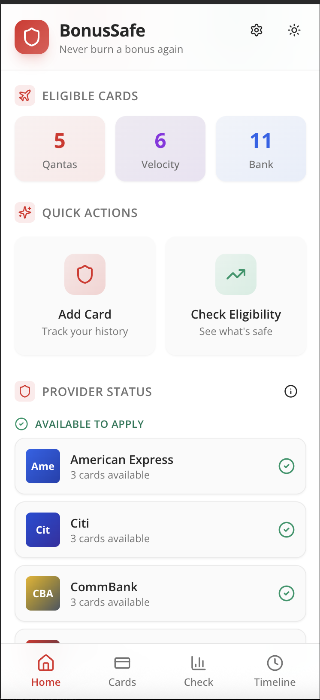
Reference — Home dashboard with eligible-cards summary and Quick Actions
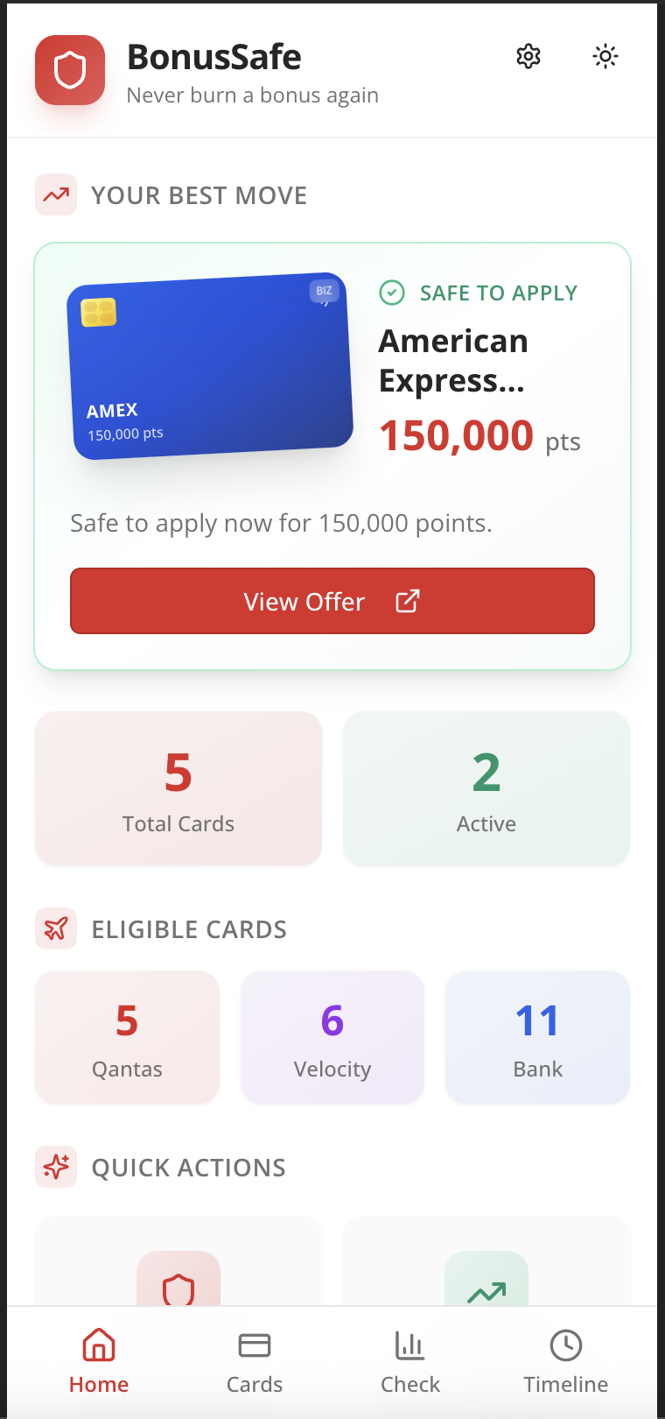
Reference — 'Your Best Move' hero and cards-eligible summary
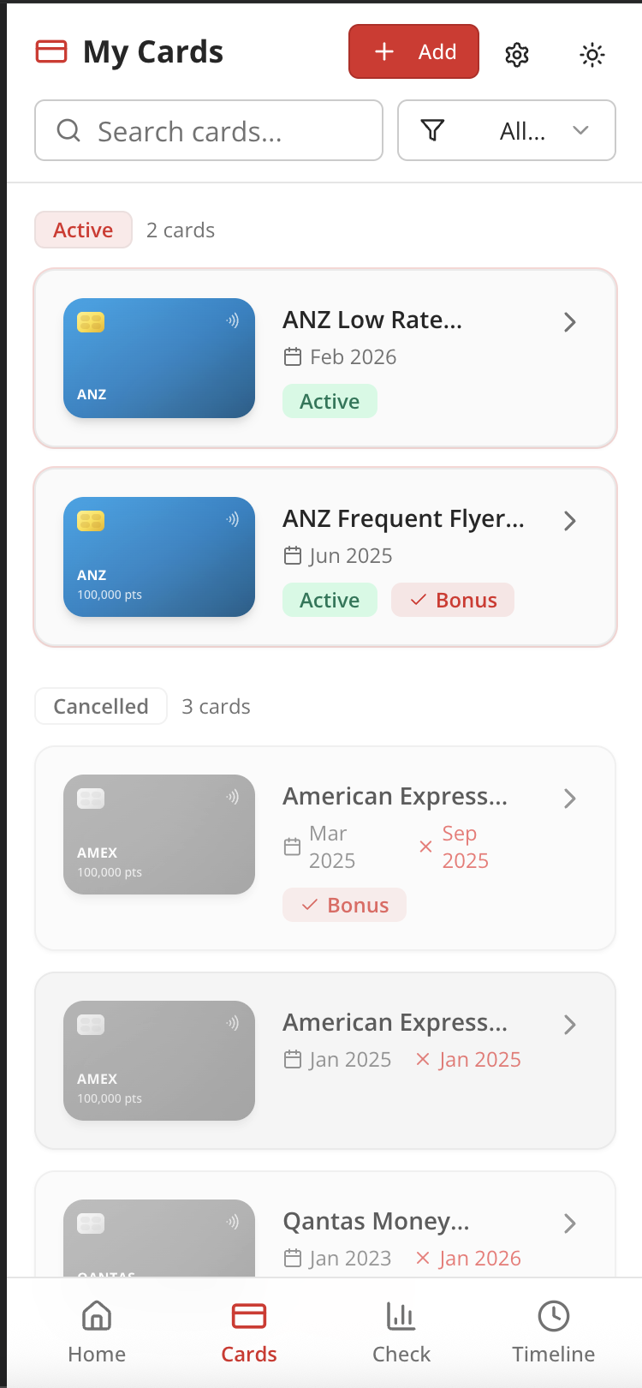
Reference — My Cards list with Active and Cancelled sections
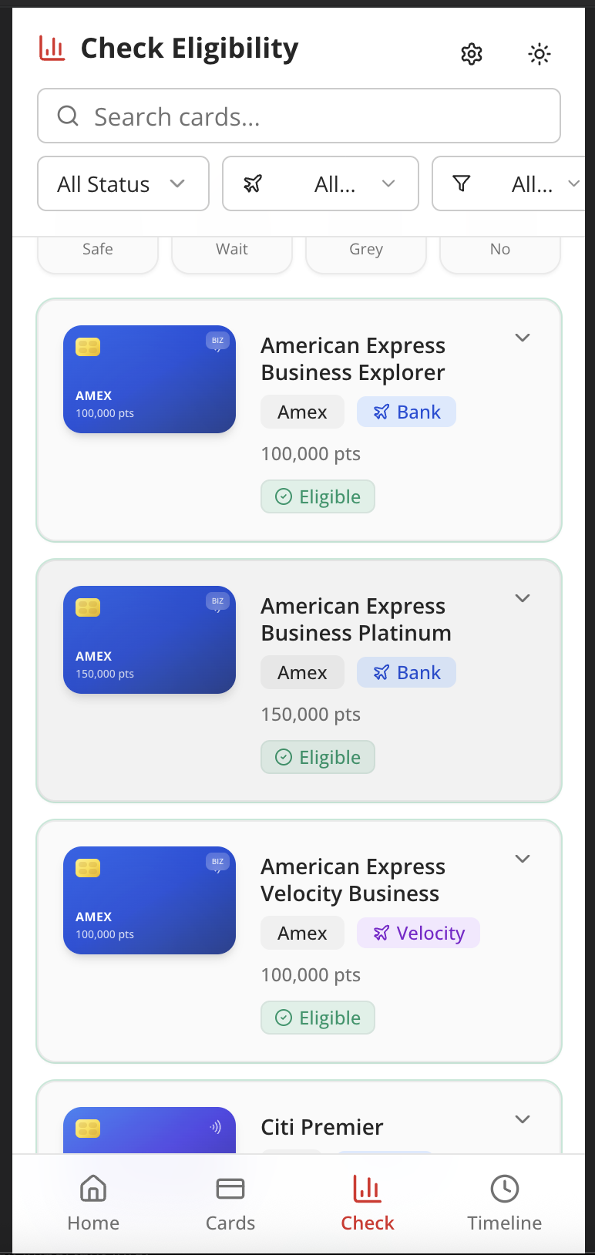
Reference — Check Eligibility list with status filters and Eligible chips
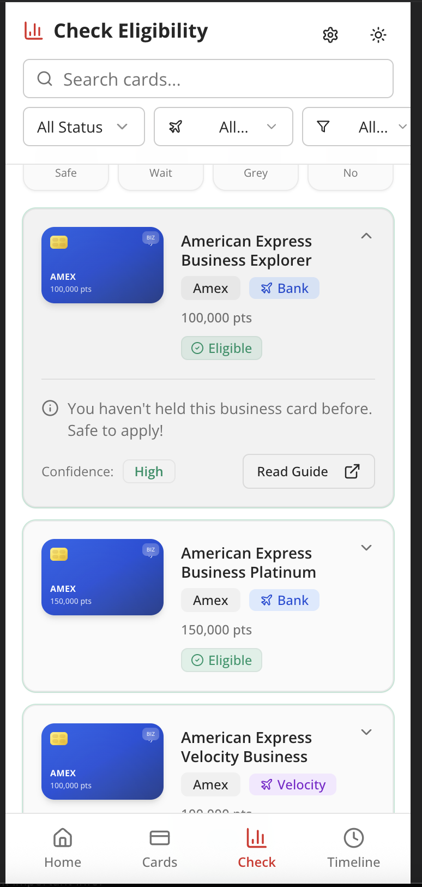
Reference — Per-card eligibility detail with reason and confidence
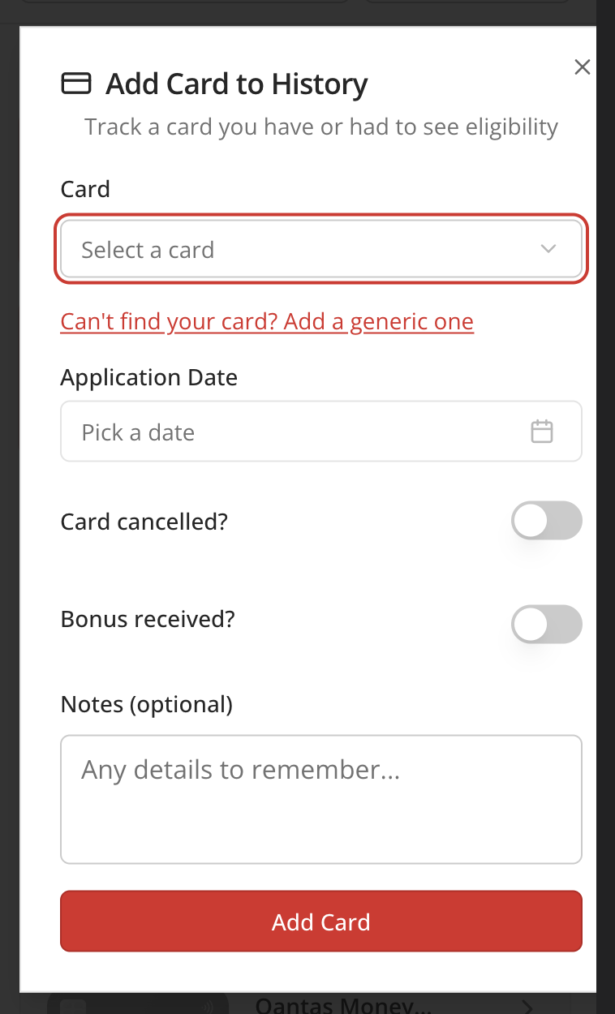
Reference — Add Card to History modal
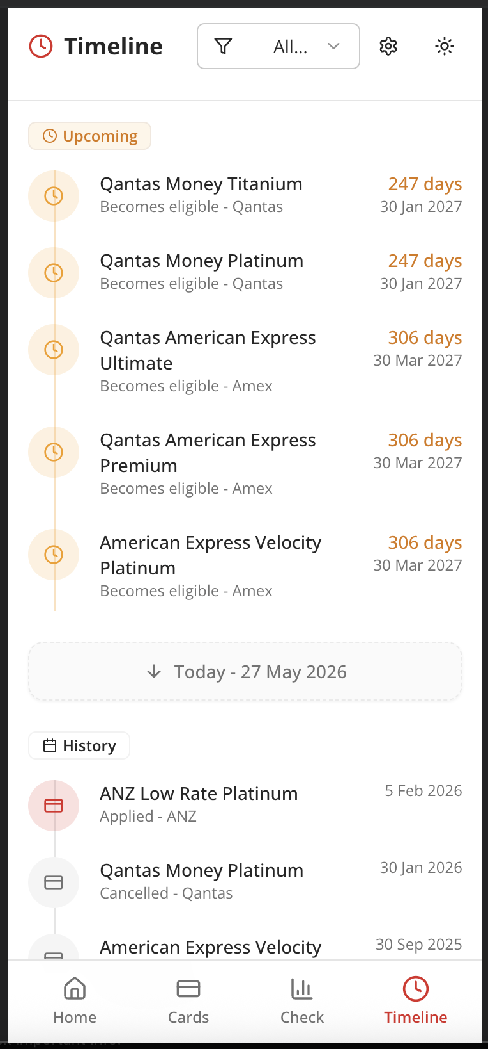
Reference — Timeline view of upcoming eligibility unlocks
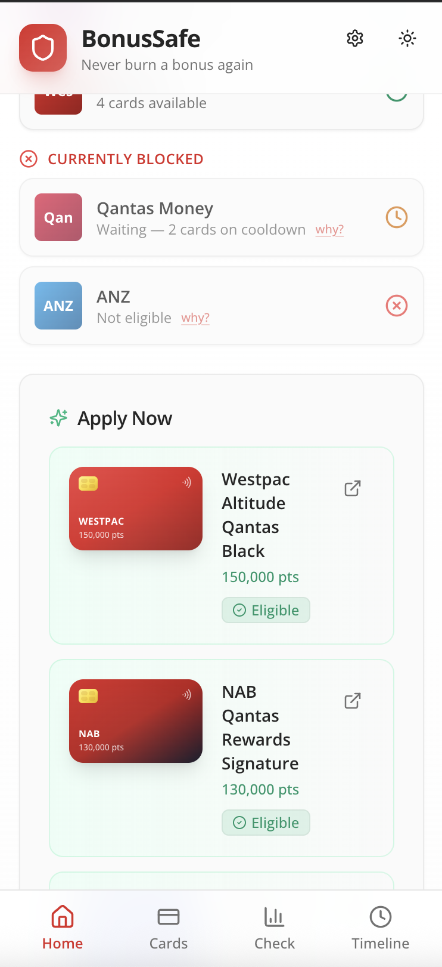
Reference — Currently Blocked + Apply Now sections

27.2 Issuer rule summary (from seed.ts)
Issuer | Eligibility type | Period | Scope | Confidence | Notes
American Express | once_per_card | — | card_family | medium | Lifetime-style rules. Targeted offers may bypass. Business cards separate pool from personal. Amex-specific 18-month issuer-wide cancellation overlay.
ANZ | time_based | 24 months | issuer_wide | high | FF and Rewards programs block each other.
Westpac | time_based | 24 months | card_family | medium | Altitude family treated as one. QF/Rewards/Velocity same family.
NAB | time_based | 18 months | card_family | medium | NAB Rewards vs NAB Qantas are different families.
Qantas Money | time_based | 12 months | card_family | medium | Possible 24-month QFF first-time overlay for some offers.
Citi | new_to_bank | — | issuer_wide | medium | No waiting period if not currently holding.
HSBC | first_time_only | — | issuer_wide | low | Offer-specific. Check current terms.
CommBank | time_based | 12 months | same_card | medium | Soft enforcement historically.
Virgin Money | time_based | 12 months | same_card | medium | Program changes may affect eligibility.

27.3 Eligibility engine semantics
calculateEligibility(card, userCards, allIssuers) returns an EligibilityResult { cardId, card, status, reason, confidenceLevel, eligibleDate?, daysRemaining?, greyAreaNotes? } where status is one of:
- eligible — user can apply and (per current understanding) qualify for the sign-up bonus.
- waiting — user will become eligible at eligibleDate; daysRemaining is included.
- grey_area — likely eligible but the issuer's rules have known soft spots; greyAreaNotes is populated.
- not_eligible — explicit blocker.
generateRecommendations(allCards, userCards, allIssuers) returns a sorted Recommendation[] where priority is a numeric score combining status weight (eligible=100, grey_area=50, waiting=25), bonusPoints/1000, a confidence bonus (high=20, medium=10), and a near-unlock urgency bonus when daysRemaining<30. Tab 4 'Your best move' is rank #1 in this list.

27.4 Glossary
- Min-spend: the minimum total purchases required within a defined window to trigger a card's sign-up bonus.
- Card family: issuer-defined grouping that determines eligibility-rule scope (e.g., Westpac Altitude vs Westpac Rewards).
- FAB: Floating Action Button — the central round button in the bottom navigation.
- FF: frequent flyer.
- FF program: Qantas Frequent Flyer, Velocity, etc.
- Grey area: an eligibility verdict where the issuer's stated rule is unclear or historically inconsistently enforced.

27.5 Document history
Version | Date | Author | Notes
1.0 (Draft) | 28 May 2026 | Tin Luu / Copilot | Initial draft for engineering review.

