Open Azure, type in the search bar and select SQL Server

Select Create

Select Resource group, name the database, choose a location

In Authentication method, select Use SQL authentication

Enter Server admin login and Password, this is the account to log in

Finally select Preview + create

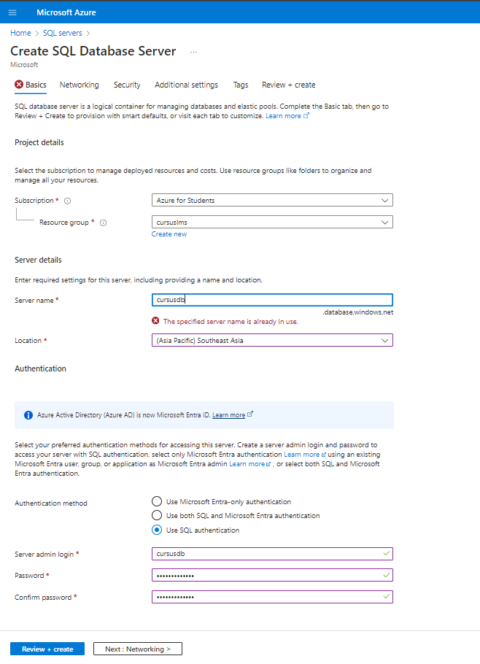

Here is SQL Server after it was created

In SQL Server, just created, select Create database

Name the database , then select Preview + create

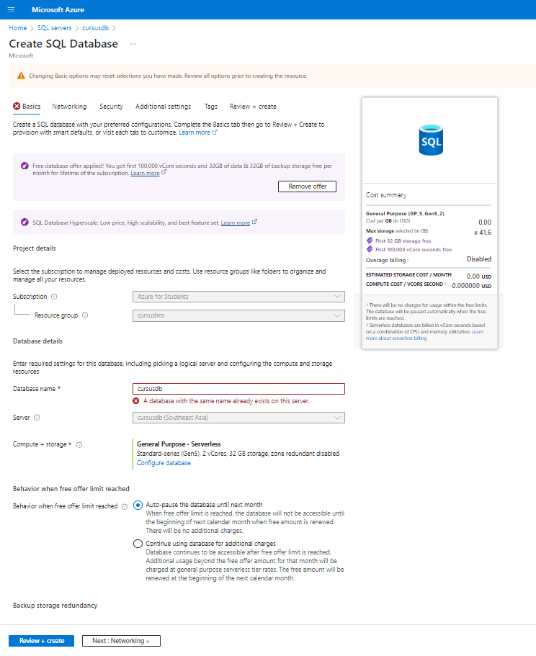

This is the database after it is created

To connect the Backend Project to the Azure Cloud Database, go to the Connection strings section, copy the ADO.NET (SQL authentication) string and paste it into the Connection strings of the Backend API in appsettings

To import data from SQL server running localhost to SQL server running on Azure, first go to SQL Server

Right-click on the database, select Task, then select Export Data Tier Application

Select Browse… and choose where to save the .bacpac file , finally select Next >

Select Finish

Next Disconnect SQL and log in with your Azure database account

If an error message appears with an IP address, go to the Networking section

Select Add your client IPv4 address

Enter the IP address in both the Start IPv4 Address and End IPv4 Address sections

After successful login, right-click on Databases and select Import Data-tier Application

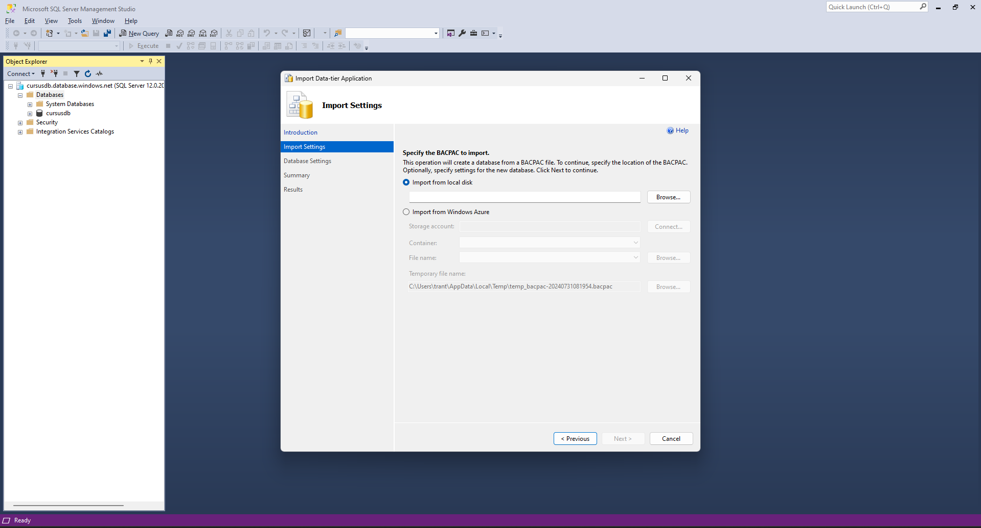

Select the exported .bacpac file and Next

Select Next

Select Finish

So the process of creating a database and importing data on Azure has been completed

End!