**DevOps** is a software development method that combines Development and Operations to improve and automate the software development process. The main goal of DevOps is to shorten software development cycles, increase release speed, and improve software quality. Here are some core elements of DevOps:

1. **Continuous Integration (CI):** The process of integrating code changes from multiple developers into a master branch on a regular basis. Each integration will be tested automatically to detect errors quickly.
2. **Continuous Deployment (Continuous Deployment/Delivery - CD):** Automate the software release process so that new versions can be deployed at any time. Continuous Delivery ensures that software can be deployed at any time through automated tests, while Continuous Deployment automatically deploys any code changes after passing testing.
3. **Monitoring and Logging:** Monitor application and system activity to detect problems and improve performance.
4. **Configuration Management:** Manage and automate the configuration of systems and applications to ensure consistency and minimize risk.
5. **Collaboration and Communication:** Enables development and operations teams to work together effectively to improve the software development process.
6. **Infrastructure as Code (IaC):** Uses encryption to manage and provision infrastructure, making it easier to make changes and replicate configurations.
7. **Automation:** Automate development, testing, and deployment processes to reduce errors and increase performance.

**Benefits of DevOps**

* **Speed up software development:** Automated processes and cross-team collaboration reduce the time from development to software release.
* **Improve software quality:** Automated testing and continuous deployment help detect errors early and ensure high-quality software.
* **Enhance collaboration:** Enable development and operations teams to work together more effectively, reduce conflict, and improve communication.
* **High adaptability:** Easily adjust and change to meet new market or customer needs.

DevOps is not just a set of tools and techniques, but also an organizational culture focused on optimizing the software development process through collaboration and automation.

To use DevOps, you first need to create an account and log in to DevOps Azure

<https://azure.microsoft.com/en-us/products/devops>

After creating an account and logging in successfully, select New project

Enter a name, description and visibility for the project

Project after being created

Next we will create a Repository for DevOps, a mirror from the Git Lab Repository

Select Repos, in the Clone to your computer section, copy the SSH Keys

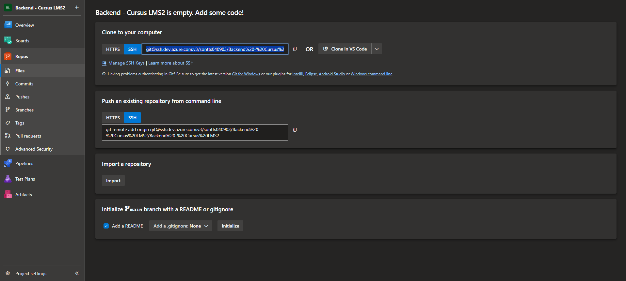

In Git Lab, go to Repository, in the Mirroring repositories section, Expand and select Add new

Paste the SSH key from DevOps and modify it a bit

Add ssh:// to the beginning of the line and change com:v3 to com/v3

In the Authentication section, select SSH public key

Enter Git Lab's username and select Mirror repository

Next copy the newly created SSH public key

Select Manage SSH Keys

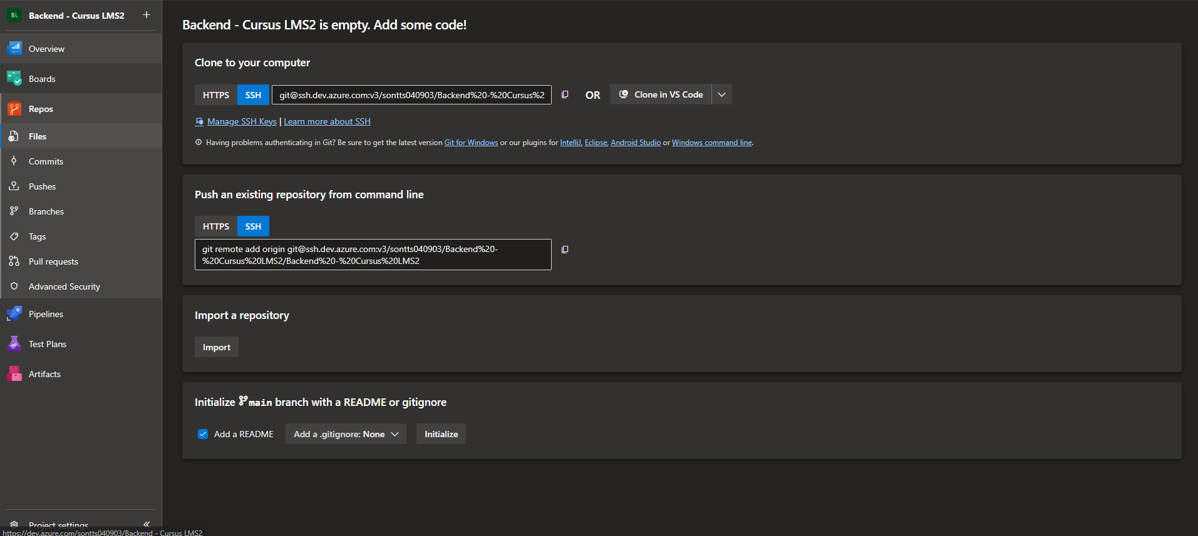

Select New Key

Enter a name for the SSH Key and paste the SSH public key into the public key data and Add

The Mirror repository part from Git Lab to DevOps was successful

To automate Build, Push Image to Azure Registry Container and Deploy to Kubernetes automatically, it is necessary to create a pipline containing the necessary configuration settings

In Repos select Set up build

Select Deploy to Azure Kubernetes Service

tiếp tục

Select Cluster, Kubernetes Namespace, Container Registry, Image Name, Service Port

Validate and configure

A yaml file is created with the selected configurations

Save and run

Save and run

The Deploy process takes place

Build and Deploy happen automatically

The project has been deployed to Kubernetes

Automation using DevOps is successful

End!