Docker is an open source platform that simplifies the process of developing, deploying, and running applications using container technology. Here are some basic concepts about Docker:

**1. Containers**

* **A container** is a lightweight and self-contained environment that contains all the software needed to run the application, including source code, libraries, and other dependencies.
* Containers allow you to run applications consistently across any environment, from personal computers to cloud servers.

**2. Image**

* **Image** is a collection of files and instructions needed to create a container.
* Images are built from a Dockerfile, a text file containing commands to build an image.
* Images are immutable and can be shared through Docker Hub or other registries.

**3. Dockerfile**

* **Dockerfile** is a text file containing commands to build a Docker image.
* It determines how the software is installed and what configurations are required for the application.

**4. Docker Hub**

* **Docker Hub** is a public registry service for storing and sharing Docker images.
* Users can upload or download images from Docker Hub.

**5. Benefits of Docker**

* **Portability** : Run applications consistently across different environments.
* **Scalability** : Easily deploy and manage large numbers of containers.
* **Resource efficiency** : Containers are much lighter than virtual machines, helping to save system resources.
* **Rapid development** : Docker makes it easy for developers to configure development and testing environments.

**6. Compare with virtual machine**

* **Container** : Lighter and shares the operating system kernel with the host system, booting quickly.
* **Virtual Machine** : Each virtual machine runs a full operating system and consumes more resources.

First, install Docker, go to the website: <https://www.docker.com>, download and install

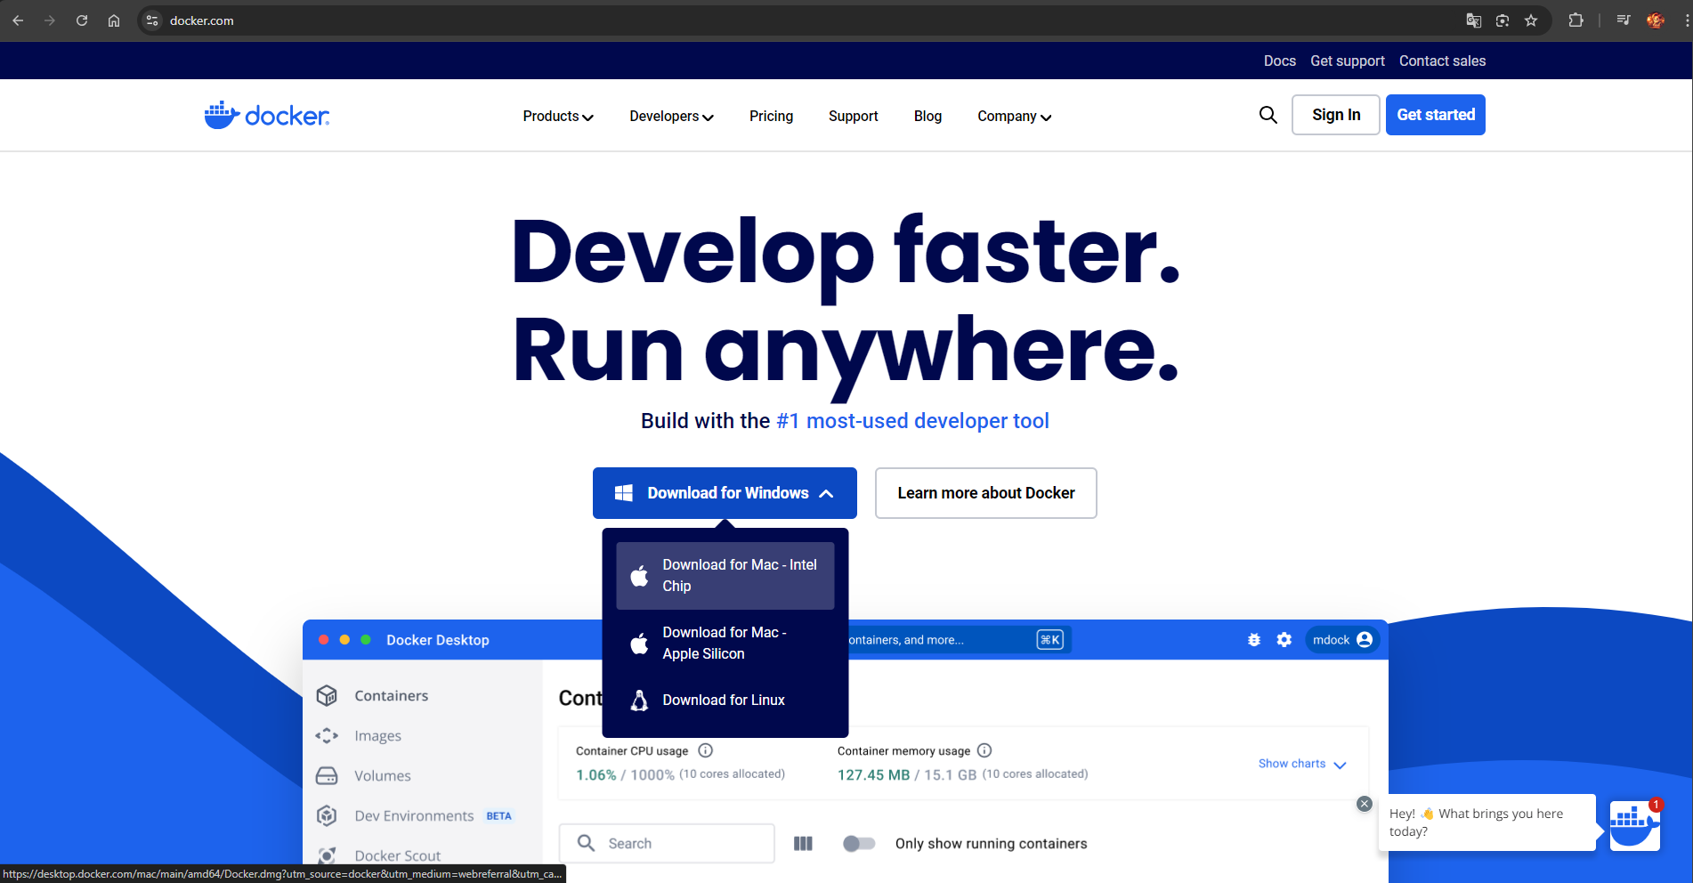

After successful installation

Go to settings and install Kubernetes

Go to Software updates and update to the latest version

To deploy a project in Docker, you first need to create a Dockerfile

Right click on API, select Add, Select Docker Support…

After successfully creating the Dockerfile, we will use Docker to build the image

docker build -t <Your Image Name> .

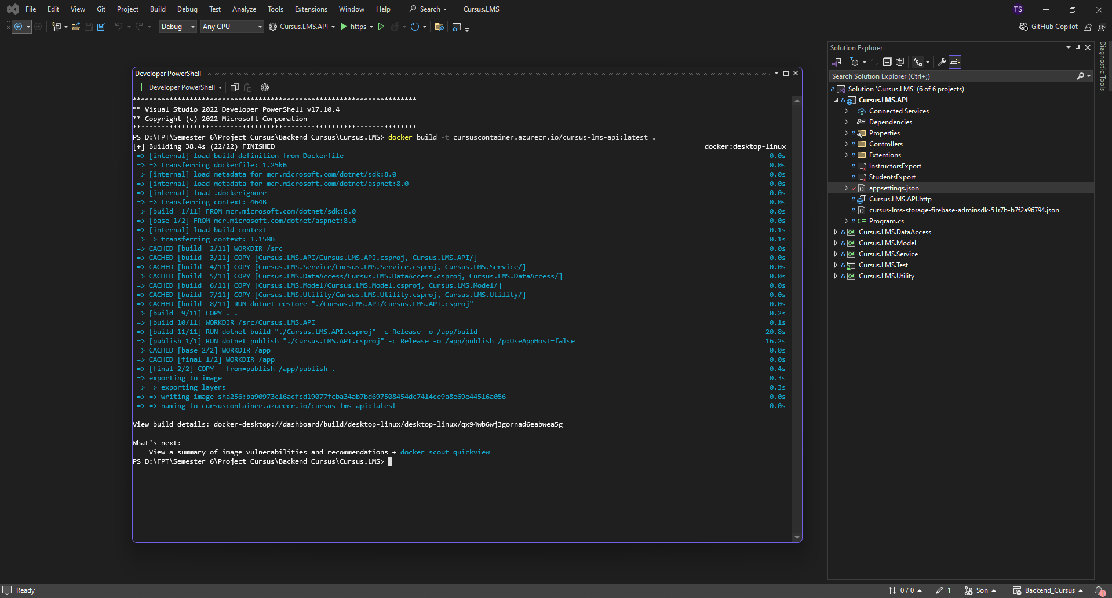

Image has been created in Docker

Run by clicking the run button in the Actions column

Enter Host port and Run

The project is already running in Containers, click on the port to open it in the browser

Data retrieved successfully

The process of creating, building images and running in Docker Containers has been completed

End!