**Helm** is an application package management tool for Kubernetes that helps you easily manage, deploy, and upgrade applications in a Kubernetes cluster. It works like a package manager like apt for Ubuntu or yum for CentOS but specifically for Kubernetes.

Here are some key components and concepts related to Helm:

1. **Chart** :
   * A Helm chart is a package containing all the files needed to deploy an application or service on Kubernetes. A chart can be compared to a formula in another package manager.
   * The chart includes YAML templates, which help you define how your Kubernetes resources will be deployed.
2. **Release** :
   * Each time you deploy a chart on your Kubernetes cluster, Helm creates an entity called release. Release represents a deployed version of a chart with a specific configuration.
3. **Repository** :
   * Helm charts can be stored in online repositories, allowing users to search and install charts from a variety of sources.
4. **Templates** :
   * Helm uses a powerful template system, allowing you to create dynamic, customized YAML manifests based on configuration or user-supplied values.

**Benefits of using Helm**

* **Easy Management** : Helps manage complex Kubernetes applications easily and systematically.
* **Scalability** : Supports deployment and upgrade of applications easily and automatically.
* **Sharing and reuse** : Allows sharing and reuse of charts for different projects or across organizations.

First is to install Helm

Open Power Shell with Administrator rights and run the following commands:

brew install helm - MacOS

choco install kubernetes-helm – Windows

Add Repository Helm to store charts

helm repo add stable https://charts.helm.sh/stable

Update Helm repositories

helm repo update

Create a new chart

helm create <name_chart>

Search Charts

helm search repo <name_chart>

Structure of Chart:

<name_chart>/

├ ── Chart.yaml Contains metadata information about the chart.

├ ── values.yaml Contains default values for templates.

├ ── charts/ Directory containing dependent charts.

├ ── templates/ Contains template files that define Kubernetes resources.

└── .helmignore This file lists files and directories that will be ignored when packing the chart.

In the values.yaml file

Correct the path containing the Container Registry image on Azure

az login

az aks get-credentials --resource-group <resource_group> --name <cluster_name>



Chart Settings

helm install <release_name> ./<chart_name>

To upgrade a release

helm upgrade <release_name> <chart_name>

To delete a release

helm uninstall <release_name>

kubectl get pods

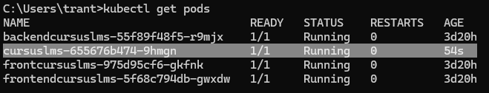

kubectl get svc

kubectl get --namespace default svc -w <Chart Name>



Enter External IP on the browser URL and test the API

The process of deploying the project to Kubernetes using Helm was successful

End!