Real-Time Operating System (RTOS)

1. What is RTOS 2
2. Key concepts of RTOS 2
a. Task 2
b. Task Scheduling 2
c. Task State 3
d. Context Switching 3

- What is RTOS
The OS is a software that can run on Computer or MCU and accomplishes a number of important functions.
First, it is in charge of scheduling background task and user applications. In most of OS dozens of background processes or excuting at the same time. The OS figures out how to give slices of time to each of these processes so that everthing is pure to be happening concurrently.
Second, it manages a number of virual resources like file, library, folder. Allowing appication processes to access when needed.
Third, they can manage a number of device drivers. These drivers allow the system to read and write from an external disk respond to keyboard and mouse input or to draw graphic on your monitor. You properly familiar the General Purpose Operating System (GPOS) like Window, MacOS, Linux, e.t.c. IOS and Andoid also fall into the categories.
Most GPOS are designed with Human actions at the most important feature, so the scheduler design to prioritize such task. That’s may mean some timing deadlines can be missed or pushed back and a little lag, it’s responsiveness. A specially if it is not really noticed by a human, it’s acceptable. Additionally, the scheduler is often non-deterministic which mean we can’t know exactly which task can be excuted when and for how long. If you are making something is required OS and strictly timing deadline like a medical design or engine controller is missing a dealine to say fire a spark plug would be catastrophic.
This is why a real-time operating system can save a day. Most RTOS offer many of the same functions as GPOS but there are desired so the scheduler guarantee meeting timing dealine on the tasks. RTOS may provide some high-level drivers. You usually see thing is intended for MCU like Wifi and Bluetooth stack or simple LCD driver, can also find bare-bond RTOS-s.
Most RTOS provides method for meeting timing deadline that’s not only reason to use RTOS in project. The abillity to run multiple tasks concurrently can be alive saver as well see in the moment if you’ve written program for MCU like Arduino, that’s properly familiar this kind of structure.
When program starts it performs some setup function and then it excutes a task a round robin fast inside a while forever loop. These tasks may read from sensor and perform some caculations base on those reading and display on a gorgeous LED display. These types of simple programmming architecture as known as a Super Loop. A Super Loop can not excute a multiple task concurrently.
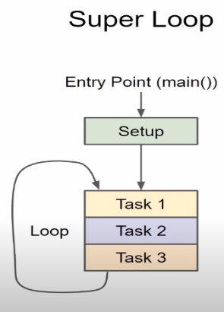
Conclusion, a Real-Time Operating System (RTOS) is a lightweight OS used to ease multitasking and task integration in resource and time constrained designs, which is normally the case in embedded systems. Besides, RTOS also indicates predictability/determinism in execution time rather than raw speed, hence an RTOS can usually be proven to satisfy hard real-time requirements due to its determinism.
- Hard real-time
• Tasks have to be performed on time
• Missing a deadline results in fatal consequences
• Example : Flight Control System
- Soft real-time
• Late completion of jobs is undesirable but not fatal.
• Missed deadlines may lower the quality of service provide our are not catastropnic
• Example: Music Systems

Key concepts of RTOS

Task
- Tasks (could also be called processes/threads) are independent functions running in infinite loops, usually each responsible for one feature.
- Tasks are running independently in their own time (temporal isolation) and memory stack (spatial isolation).
- Spatial isolation between tasks can be guaranteed with the use of a hardware memory protection unit (MPU), which restricts accessible memory region and trigger fault exceptions on access violation.
- Normally, internal peripherals are memory-mapped, so an MPU can be used to restrict access to peripherals as well

Task Scheduling

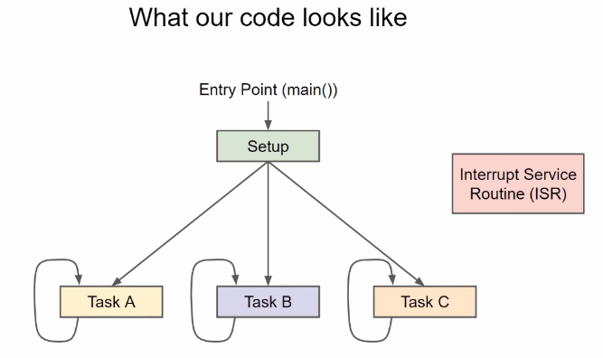

- Time Slicing: Most RTOS use a form of Time Slicing where one of the hardware timer interrupt the processor at regular interval. The OS is required to run every time slice to figure out which task scheduler next. The interval is as known as a tick. The Scheduler looks at the task that need to run and choose the one has the highest priority and only task that needs to run.
- If 2 tasks have the same priority, scheduler excutes each task in term in round robin fashion.
- Pre-emptive Scheduling: CPU time will take away one task to run other which is a higher priority task. This is all done in software. Pre-emptive scheduling allows higher priority tasks to interrupt a lower task in order to fulfill real-time constraints, but it comes in the cost of more overhead in context switching.
- Co-operative Scheduling: task switch will only happen if the current running task yields itself.

- Task State
- When a task is created, automatically it is in Ready state. This task is telling Scheduler is ready to run.
- The scheduler can choose that task only if there is no other higher priority task waiting to run. If a task is not runned because of another equal or higher priority which is chosen, that’s remained at Ready state.
- If a task is chosen by scheduler to run, it works into the Run state and remain in that state while using the processor. If the processor has only one Core, then only one task can run in Running state in the given time.
- The Scheduler can move the task between the Ready state and Running state as needed at each tick.
- While running a task may call API function that move it to the Block state. These API funcitons can be thing like vTaskDelay() or waiting for a Queue or Semaphore. Tasks in the Block state do not run on the processor and can not be selected and run into Running State. The tasks will wait until the unblocking event has occurred like the delay timer expiring or Semaphore being released. The Task will enter to Ready state and and wait to be scheduled for processor time.
- FreeRTOS has a vTaskSuspend() API function, that allows to put a task into suspended state. This API can be called within task itself or from another task. In the Suspended State, the task can not be selected to run like Block State. However, we can call vTaskResume() API to allow the task to go into the Ready State. This is a good way essentially put task to Sleep if you don’t want to rely on a Timer vTaskDelay().
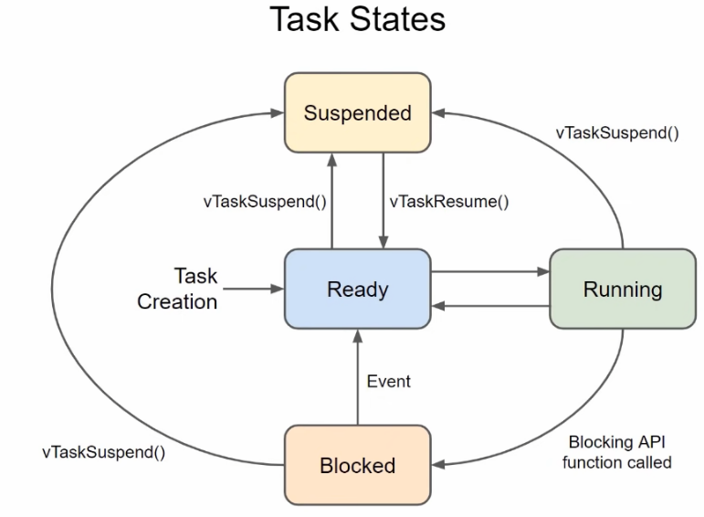

- Context Switching
The scheduler has a job is remembering where is exactly the task left off and all of working variables including values on RAM and CPU registers. All information where the task was in programming instructions and working memory as known as a Context. The process of saving it alls and restores another task context called Context Switching.

