**USER MANUAL WHEAR APP**   
**Step 1**: Download **Expo go** in chplay or appstore   
**Step 2** : Scan qr code with suitable operating system:   
 **Android** **IOS**

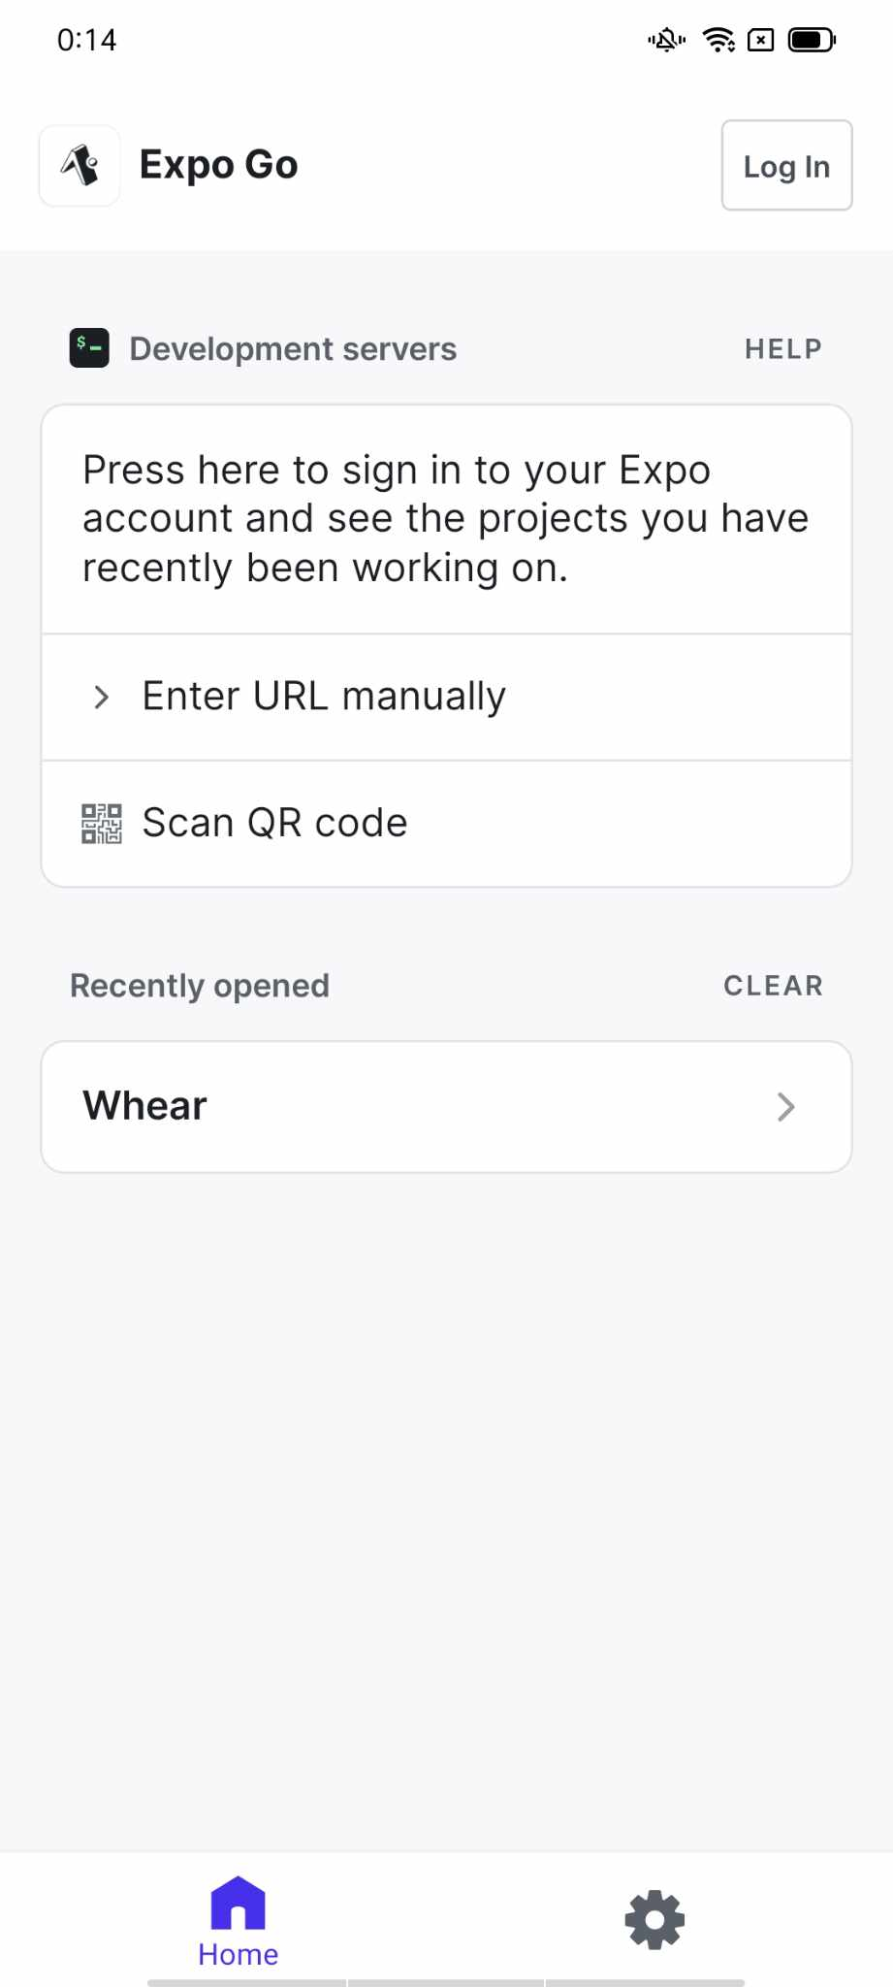

If you want to take the URL manually then click to “**ENTER URL manually**”

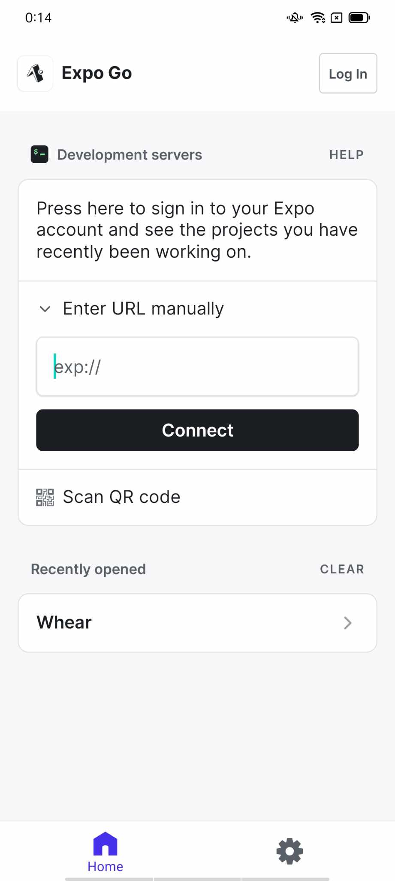**Enter Url in the field**

**WITH Android**: exp://u.expo.dev/update/314f524e-6d74-4e0c-a442-08c1151c28c3

**WITH IOS**: exp://u.expo.dev/update/cef5a500-e042-445f-b192-d4a8ff66ee8c