**Part 1 Intro**

Built in 1636, Skelmorlie Passage was a burial path in Largs, on the west coast of Scotland. Located within the north transept of the medieval parish church in Largs, North Ayrshire, it now stands alone in the old cemetery, the main body of which was demolished in 1812.It contains a burial monument and ceiling decoration of the highest quality. A sign at the west end of Main Street in Largs. The building, mausoleum and crypt were made of three different but local sandstone. It has an elaborately painted barrel-vaulted wood ceiling.

The demolition of the adjoining church to the south in 1812 made the passage particularly vulnerable to rain erosion, as the exterior details were not intended to cope with Scotland's humid climate. The tomb's sandstone allows for intricate sculptural detail, but the stone has weaknesses in mineralogy and porosity that make it susceptible to decay. Records show that the passage walls, tombs and timber ceilings have been deteriorating since 1931, before the monument was placed under state control. Historic Environment Scotland's (HES) current survey programme focuses on stabilising internal environmental conditions, tackling stone decay and monitoring humidity levels. Various previous interventions, including mid-20th century chemical consolidation, have been carried out at the monument. More recently, drainage details have been improved and humidity controls installed to stabilize the interior environment. While the moisture load throughout the passage has been reduced, there is no evidence that the significant moisture affecting the south wall in particular has been alleviated. Below the tomb is a barrel-vaulted red sandstone vault that houses the Montgomery family's 17th-century coffins. As you might expect, it's semi-underground and quite damp. On the walls of the cellar there are large amounts of salt flowers and associated, surface stone decay.

Next we'll focus on the various factors that might be related to the decay observed on the stele. Potential factors include the mineralogy and structure of the sandstone, surface hardening associated with previous consolidation treatments, chemical damage during the chemical removal of paint from the column, salt, moisture entry and condensation episodes.

**Part 2 Problems**

**Moisture**

The cause of the decay of the stones on the tomb was originally expected to be damp. Thus, moisture levels in stone artifacts were assessed by thermal imaging and microwave humidity measurements during multiple visits from 2008 to the present. Due to the fragility of the painted wood ceiling, artificial heating is avoided to enhance thermal imaging. Microwave humidity measurements at depths of 20-30cm on all internal, accessible surfaces revealed intermittent and variable humidity levels, particularly in the gable corners and most notably in the plastered south wall.

**Weathering of salt**

Due to the large amount of salt flowers in the cellar, soluble salt absorbed through the stone products may be related to the decay of the stones.X-ray diffraction (XRD) is used to identify salt weathering visible from crypts and rock walls.

**Analysis of stone**

The pore system of stone is mainly composed of micro/nano pores, which are indistinguishable under the microscope, and the total porosity is less than 1%.The unusually low porosity is likely to make it particularly vulnerable to damage from crystallized salt, as it lacks the ability to accommodate the growth of salt crystals in the pores.Water absorption may occur in clay minerals, which make up about 16% of the stone.XRD analysis reveals that the sandstone contains potentially fragile minerals, and that the resulting acids and subsequent dissolution of carbonate cements may have been involved in the decay process.

**The Solution**

Relative humidity

In March 2015, two dehumidifiers were installed in the passageway.Each is controlled by a Meaco humidifier, which is turned on when the relative humidity (RH) exceeds 65%.The environmental conditions within the stabilization passage are to protect the wood ceiling, avoid condensation events, reduce the water content of the stonework, and stabilize the conditions of the tomb.

In the figure below, the orange line is the average relative humidity, and the blue line is the change in humidity. We can also see from the data that the average relative humidity in the passage is maintained at about 65%, and fluctuates around it.

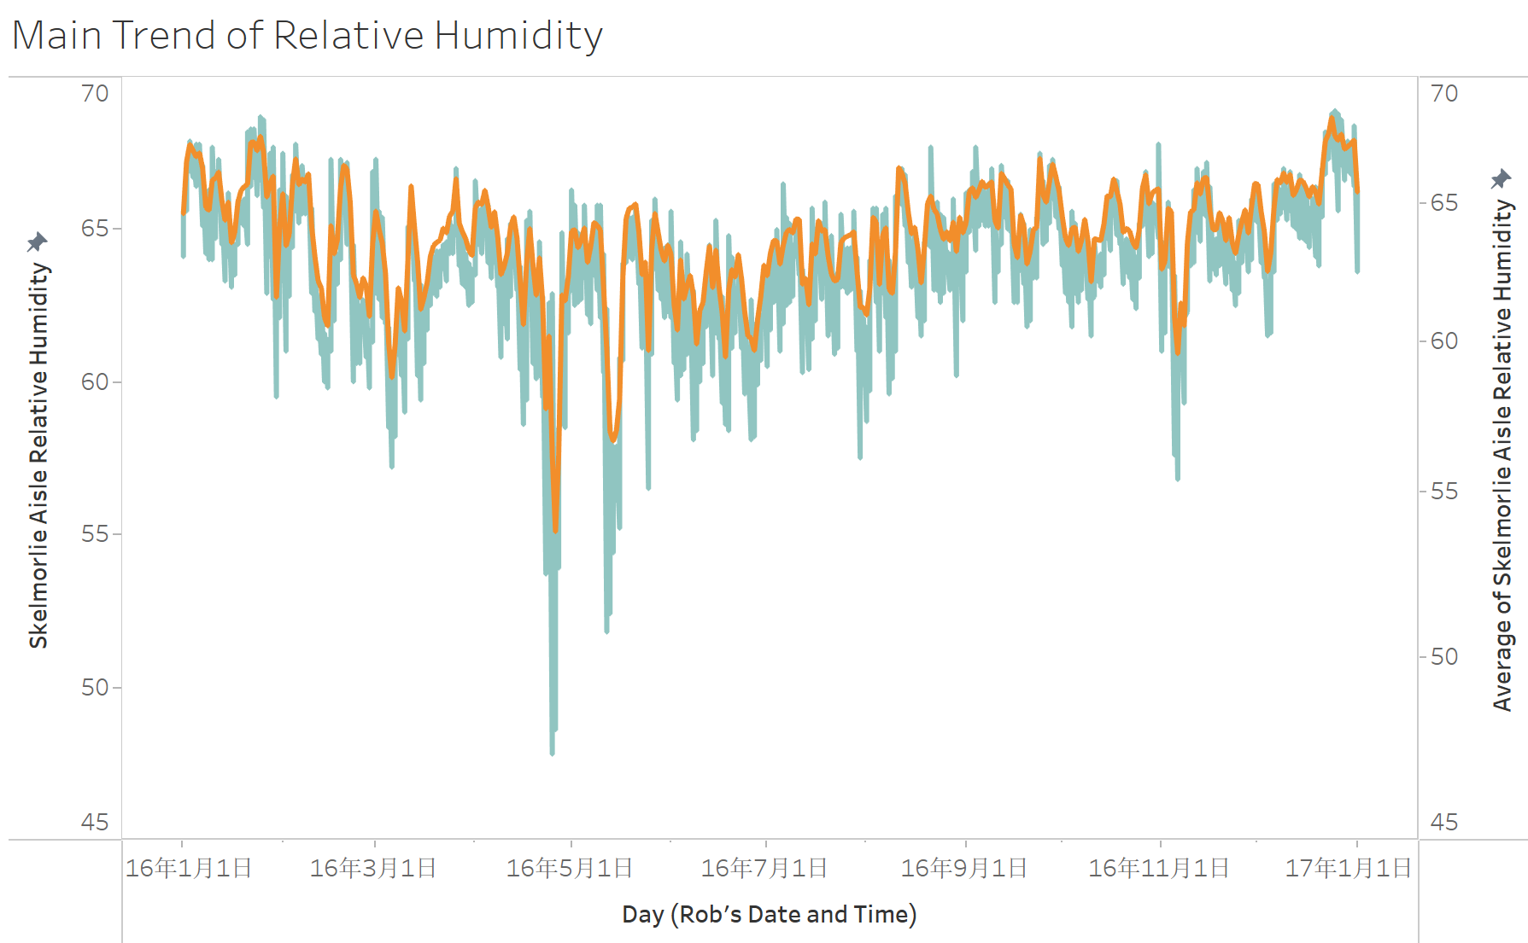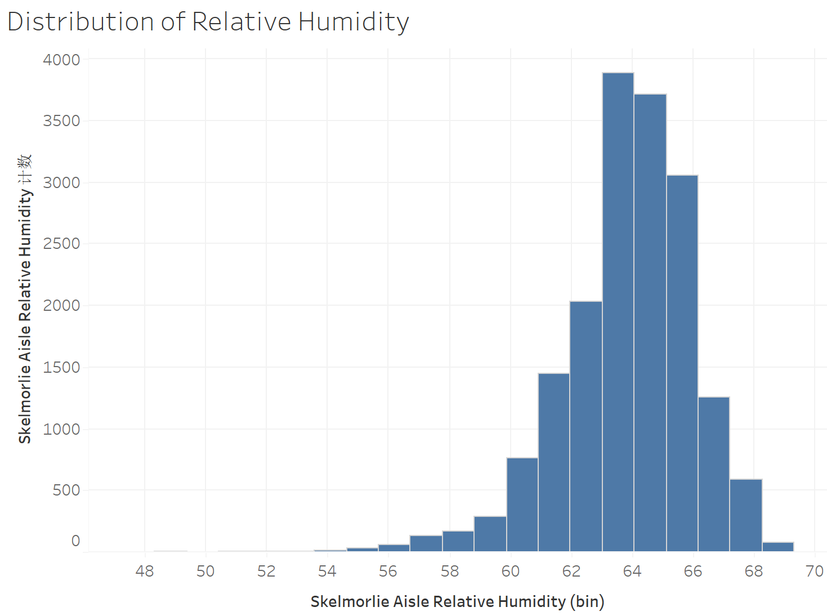

16.1.1 16.3.1 16.5.1 16.7.1 16.9.1 16.11.1 17.1.1

Rob’s Date and Time (Day)

The west coast of Scotland has a relatively humid climate compared to the rest of the UK. Rainfall is highest from October to March, but is relatively high throughout the year. By comparing the picture with the data in the table, it is not difficult to see that the relative humidity in the first quarter and the fourth quarter from October to March was relatively high, at about 63%, while it decreased significantly in the second quarter, only at about 58%.The relative humidity of the channel obviously changed with the seasons and climate.

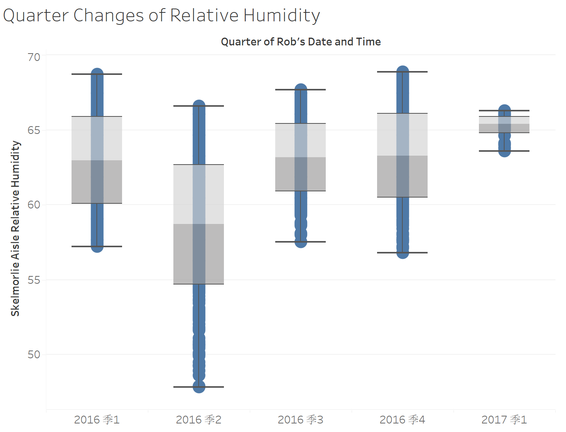

The temperature

At the same time, the temperature in the channel is regulated. Since 2012, background heating has been maintained throughout the year to cope with extreme temperatures. The temperature stays between 10 and 22 degrees for most of the year. The daily temperature fluctuates little and mainly varies with the seasons.

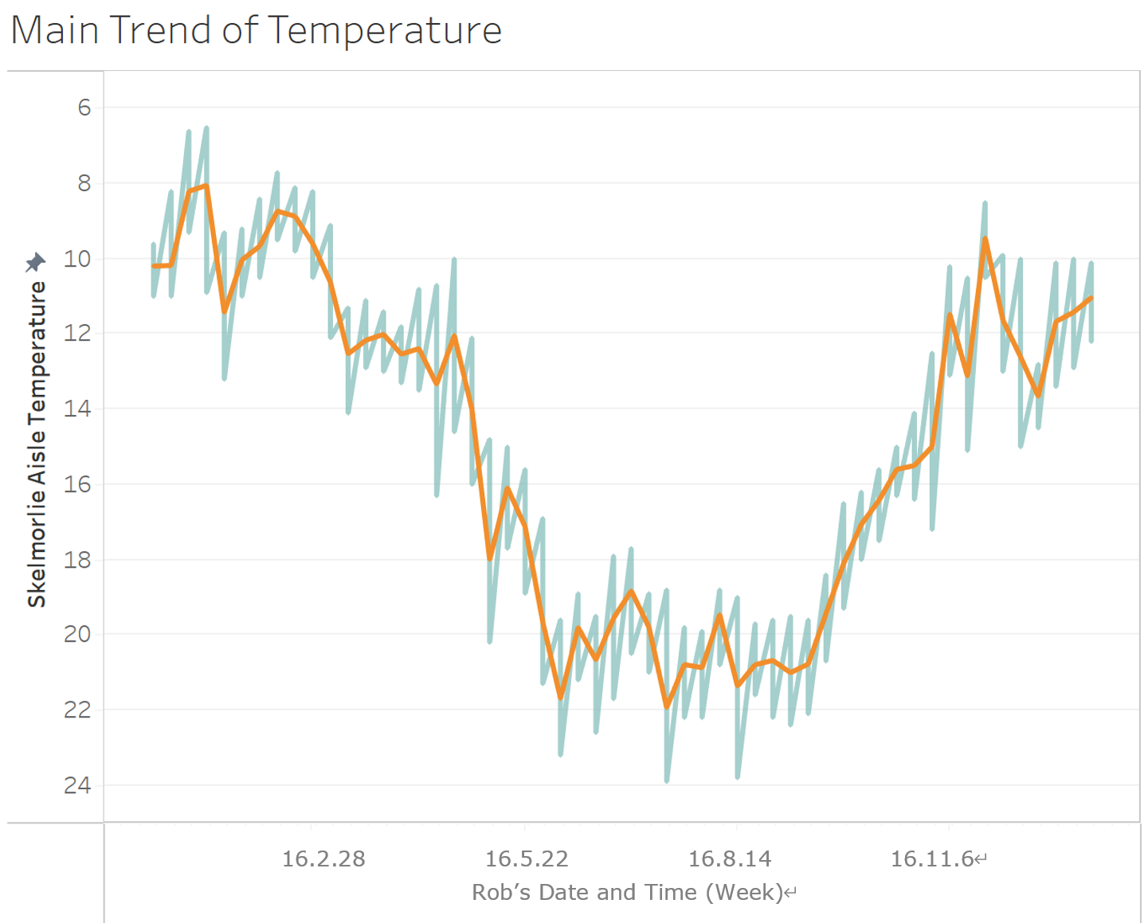

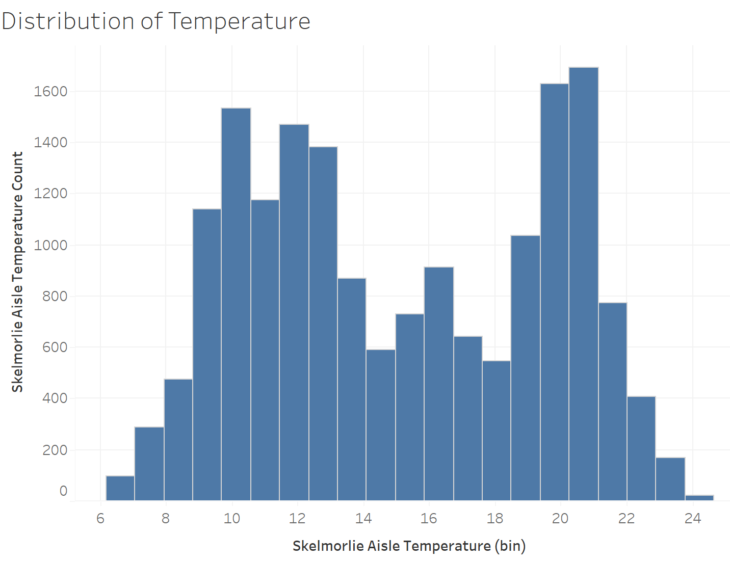

Thermal imaging of the tomb shows considerable temperature variation from top to bottom on its southern side.This is the result of temperature stratification in the channel due to lack of air flow.A temperature gradient of 4 º C throughout the year is common, with higher temperatures in the upper layers.Environmental monitoring (on the roof of the tomb cover) indicates that high humidity (>90%) events were common in the winter months leading up to March 2015.Under these conditions, condensation may occur in the lower part of the tomb.After the installation of the controller has been significantly improved.

Relationship between

From the data, we can see a weak negative correlation between relative humidity and temperature. Most of the data is on the right, showing that relative humidity ranges from 60 to 67 percent most of the time, regardless of temperature.

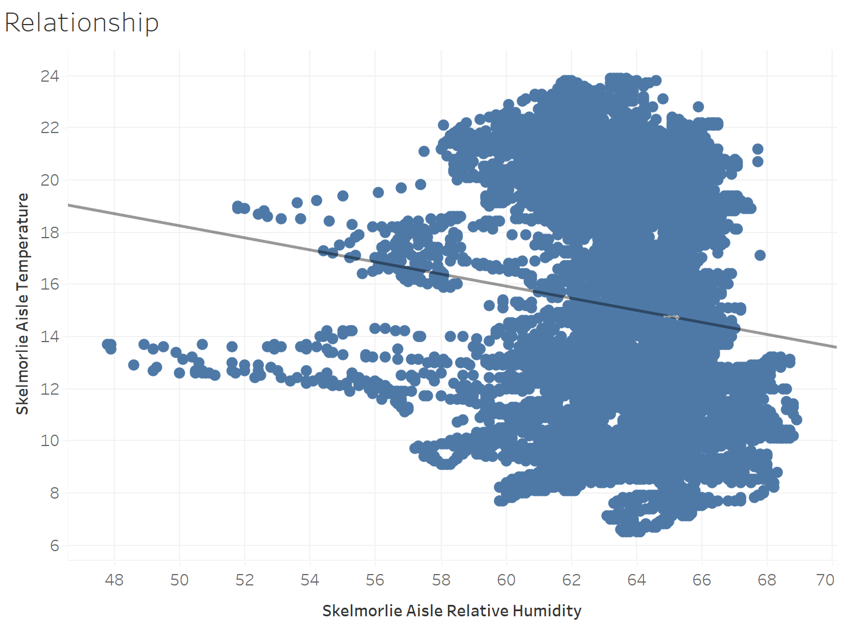

Summary

Environmental controls installed in March 2015 have been shown to reduce humidity in burial chambers and interior walls. However, humidity control has been fighting against a large source of moisture from the south wall, and if its conditions can be improved, the moisture content will be reduced further. Environmental control currently stabilizes the humidity in the passageway at 65% RH. At this level, the stonework throughout the aisles has reduced the moisture content, the daily high humidity range is mitigated, the painted wood ceiling should not be adversely affected, condensation should not occur on the internal surface, and repeated occurrences of crystallization and salt dissolution will be avoided. As follows, through proper control, the standard deviation of relative humidity and temperature in the channel has little fluctuation, ranging from 0 to 2, and is very stable.

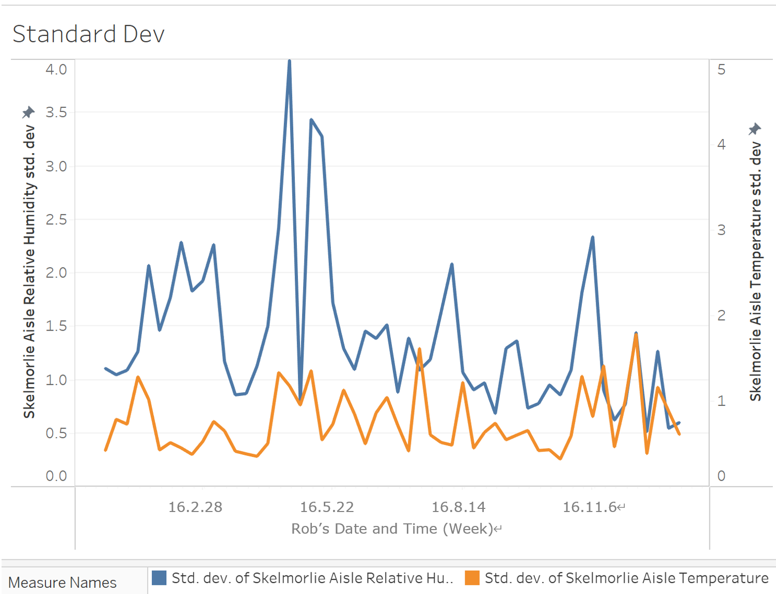

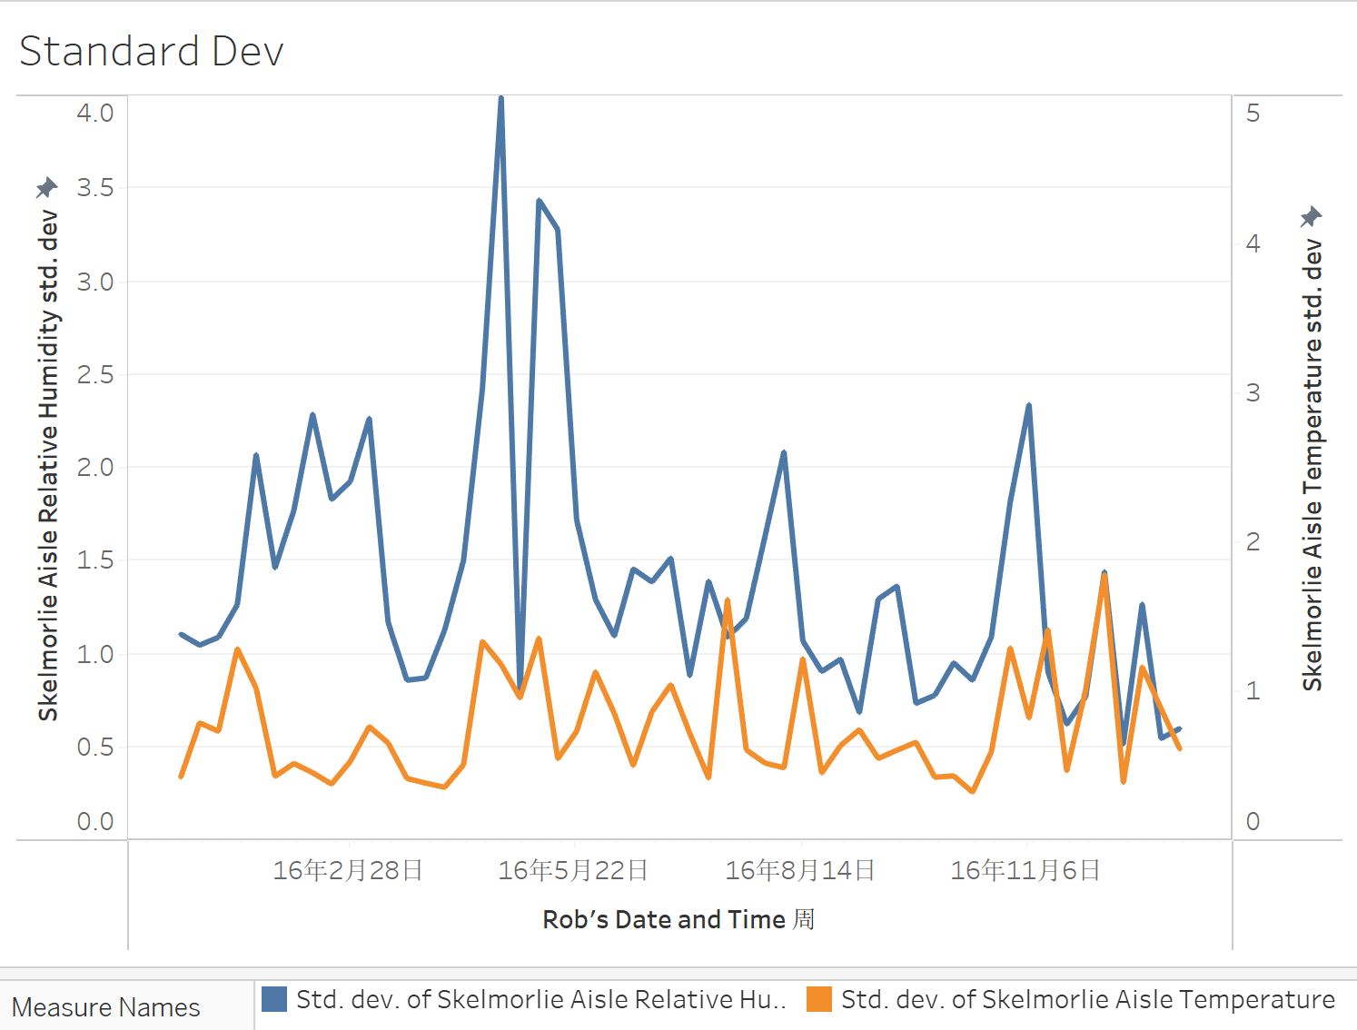

16.2.28 16.5.22 16.8.14 16.11.6

Rob’s Date and Time (Week)