CW2 - Fundamentals of Digital Systems
Name: Timurs Timofejs Ulanovs | Student code: 61931

AI mode: AI-FREE. No AI or generative-AI tool may be used at any stage of this coursework. Topics 3a-3d. Platform: CircuitVerse. Individual, on a personal variant. Due mid-November 2026.
Purpose. To move from truth tables to working hardware: to derive and simplify Boolean expressions, to realise them as gate-level circuits, and to build the first storage elements and a small addressable memory. This is one of the two courseworks in which you must show that you can do this yourself, so no AI assistance of any kind is permitted.
Each student works on a personal variant of the logical function, selected by their sequence number in the group list from Table 1 of the brief (F01-F32). Because every student has a different function, the derivations, circuits and screenshots are individual to each student.
Tasks.
• Exercise 1 - Exploration of basic logic gates. A two-input circuit driving AND, OR, NAND, NOR, XOR and XNOR, evidenced for all four input combinations. Completion is a gate for the rest of the coursework.
• Exercise 2 - Boolean expressions in SOP and POS. Derive the canonical SOP and POS forms of the assigned function, then simplify one of them using Boolean algebra, showing the law applied at each step.
• Exercise 3 - Designing circuits from SOP and POS. Realise both expressions in CircuitVerse and verify them against the original truth table for all input combinations.
• Exercise 4 - Designing a circuit from the simplified expression. Realise the simplified form and confirm that it is functionally equivalent to the canonical versions.
• Exercise 5 - Flip-flops. Build SR, JK, D and T flip-flops both from primitive gates and from CircuitVerse flip-flop blocks, and illustrate the state transitions for all input combinations.
• Exercise 6 - A basic digital memory circuit. Store data from a single 8-bit bus into eight 1-byte parallel registers, with the target register chosen by the user; explain the address decoding and data-routing logic.

Internal weighting.
Component | Weight of CW2
Exercise 1 - basic logic gates | Completion required (0%, but exercises 2-6 are not marked without it)
Exercise 2 - Boolean expressions in SOP and POS | 20%
Exercise 3 - circuit from SOP and POS | 20%
Exercise 4 - circuit from the simplified expression | 20%
Exercise 5 - flip-flops | 20%
Exercise 6 - four-register memory circuit | 80%

Exercises 2-6 is marked on: circuit implementation 40%, documentation 30%, file management 20%, technical understanding as evidenced in the discussion 10%.
Deliverables.
• One consolidated report covering Exercises 1-6, with the declaration of unaided work (Appendix B) completed for every exercise.
• Exported circuit files uploaded in Moodle: S2_EX1_INITIALS.cv, P2_EX3_INITIALS.cv, P2_EX4_INITIALS.cv, P2_EX5_INITIALS.cv, P2_EX6_INITIALS.cv.
• Screenshots evidencing every required input combination, and the truth tables against which each circuit was verified.
Detailed Criteria per Component
Circuit Implementation (40%)
Score | Criteria
Excellent (90-100%) | Circuit functions perfectly for all test cases; optimal design choices; efficient use of components; demonstrates deep understanding of digital logic principles
Good (75-89%) | Circuit functions correctly for most test cases; minor inefficiencies or suboptimal choices; generally sound implementation with minimal errors
Satisfactory (60-74%) | Circuit functions but has some errors or limitations; basic understanding demonstrated; may require debugging or have incomplete functionality
Needs Improvement (40-59%) | Circuit partially functions; significant errors in logic or implementation; shows attempted understanding but with major gaps
Unsatisfactory (0-39%) | Circuit does not function as intended; fundamental errors in design; no evidence of understanding core concepts

Documentation (30%)
Score | Criteria
Excellent (90-100%) | Complete screenshots for all required test cases; clear, detailed explanations of design choices; well-organized presentation; includes truth tables, timing diagrams where appropriate; demonstrates analytical thinking
Good (75-89%) | Most required screenshots provided; good explanations with minor gaps; generally well-organized; shows understanding of concepts
Satisfactory (60-74%) | Basic screenshots provided; adequate explanations but lacking detail; some organization issues; shows basic understanding
Needs Improvement (40-59%) | Incomplete screenshots or documentation; unclear explanations; poor organization; limited evidence of understanding
Unsatisfactory (0-39%) | Missing or inadequate documentation; no clear explanations; cannot follow the design process or reasoning

File Management (20%)
Score | Criteria
Excellent (90-100%) | Files correctly named according to specifications; properly exported and functional; well-organized circuit layout with clear component labels; easy to navigate and understand
Good (75-89%) | Files mostly correctly named; exported properly; generally well-organized with minor labeling issues
Satisfactory (60-74%) | Files named adequately; exported correctly; basic organization but may lack clear labeling
Needs Improvement (40-59%) | File naming errors; export issues; poor circuit organization making it difficult to follow
Unsatisfactory (0-39%) | Incorrect file naming; files not properly exported or corrupted; extremely poor organization

Technical Understanding (10%)
Assessed through the discussion/analysis section of each exercise in the report
Score | Criteria
Excellent (90-100%) | Report demonstrates comprehensive understanding of underlying concepts; clearly explains design rationale and trade-offs; shows insight into digital logic principles; makes connections between theory and implementation; discusses alternative approaches and their implications
Good (75-89%) | Report shows good understanding of concepts; explains most design choices clearly; generally connects theory to practice; some analysis of design decisions
Satisfactory (60-74%) | Report shows basic understanding; explains simple concepts but may struggle with complex relationships; limited discussion of design rationale
Needs Improvement (40-59%) | Report shows limited understanding; difficulty explaining design choices; minimal connection between theory and practice; superficial discussion
Unsatisfactory (0-39%) | Report shows little to no evidence of understanding; cannot explain basic concepts or design rationale; missing or inadequate discussion sections
Exercise 1: Exploration of Basic Logic Gates
Objective: Understand and showcase the operation of all basic logic gates using two inputs.
Tasks:
- Design a circuit in CircuitVerse with two inputs connected to each of the following gates: AND, OR, NAND, NOR, XOR, and XNOR.
- Capture screenshots of the outputs for all four possible input combinations (00, 01, 10, 11) and include them in the report.
- Export your circuit with the filename S2_EX1_YOUR_INITIALS.cv.
- Upload the exported circuit file to Moodle.
- Compile all documentation into a report.

REPORT (you may extend the report as needed beyond this page)
I confirm that the truth tables, derivations, minimisation working, expressions, circuits, code, screenshots and written analysis in this submission are entirely my own work, produced without any AI assistance. | Yes / No
Signature | Timurs Timofejs
Date | 02.11.2026
- Making a circuit:
Here’s a screenshot of the designed circuit in CircuitVerse.
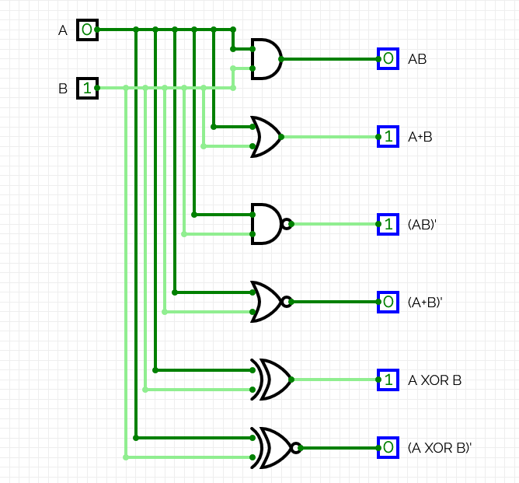
- Checking the outputs
As per the truth table provided, the logic gates give these results.
A | B | AB | A+B | (AB)’ | (A+B)’ | A XOR B | (A XOR B)’
0 | 0 | 0 | 0 | 1 | 1 | 0 | 1
0 | 1 | 0 | 1 | 1 | 0 | 1 | 0
1 | 0 | 0 | 1 | 1 | 0 | 1 | 0
1 | 1 | 1 | 1 | 0 | 0 | 0 | 1

Screenshots that show the outputs based on the input (A,B):
(0,0):
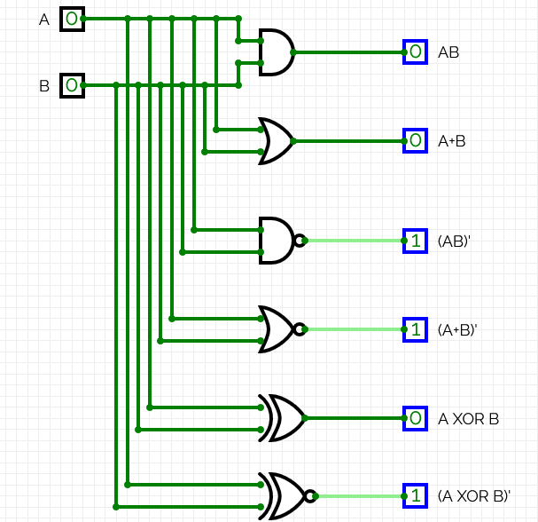

(0,1):
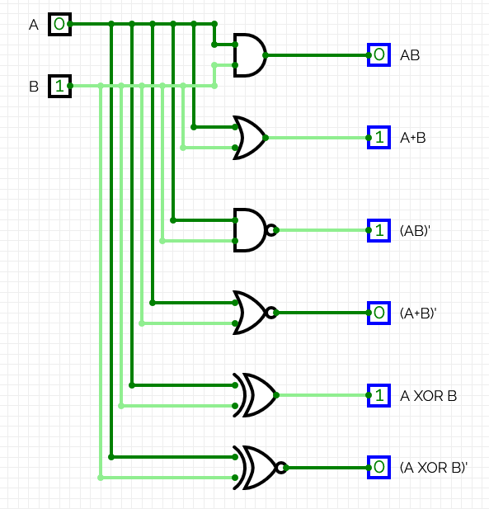

(1,0):
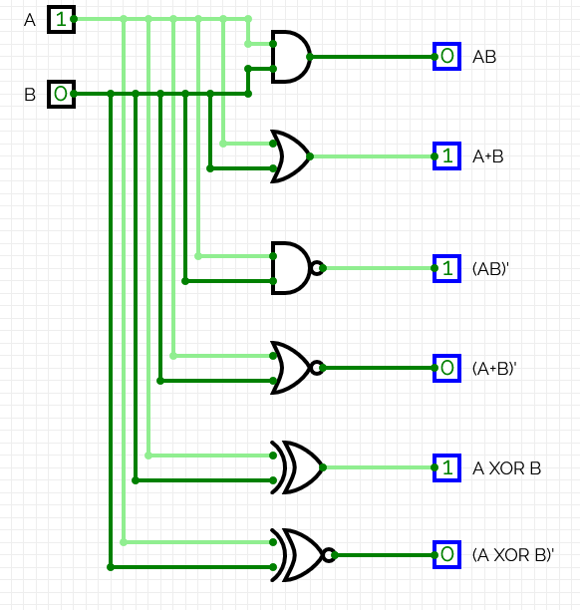

(1,1):
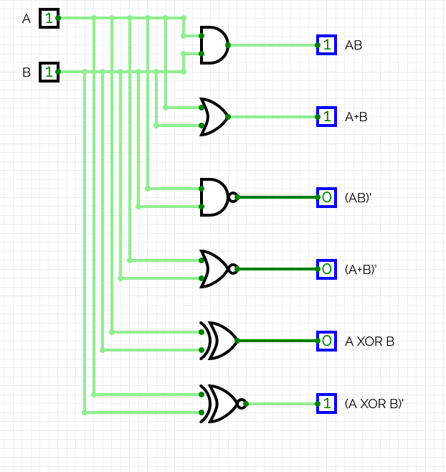

As real circuit outputs are the same as in the truth table, the circuits in CircuitVerse work correctly.

Exercise 2: Boolean Expressions in SOP and POS

Table 1. Logical functions
X₁ | X₂ | X₃ | X₄ | F₀₁ | F₀₂ | F₀₃ | F₀₄ | F₀₅ | F₀₆ | F₀₇ | F₀₈ | F₀₉ | F₁₀ | F₁₁ | F₁₂ | F₁₃ | F₁₄ | F₁₅ | F₁₆
0 | 0 | 0 | 0 | 1 | 0 | 1 | 0 | 1 | 1 | 0 | 1 | 0 | 0 | 0 | 0 | 0 | 0 | 0 | 1
0 | 0 | 0 | 1 | 1 | 0 | 0 | 1 | 0 | 0 | 1 | 1 | 0 | 0 | 1 | 1 | 0 | 1 | 0 | 0
0 | 0 | 1 | 0 | 1 | 1 | 0 | 0 | 1 | 0 | 0 | 0 | 0 | 0 | 0 | 1 | 1 | 0 | 0 | 0
0 | 0 | 1 | 1 | 0 | 0 | 0 | 1 | 1 | 0 | 0 | 0 | 0 | 1 | 0 | 1 | 1 | 1 | 0 | 0
0 | 1 | 0 | 0 | 0 | 0 | 1 | 0 | 0 | 1 | 1 | 0 | 1 | 0 | 0 | 0 | 0 | 1 | 0 | 0
0 | 1 | 0 | 1 | 0 | 0 | 0 | 1 | 0 | 1 | 1 | 1 | 1 | 1 | 1 | 0 | 0 | 1 | 1 | 0
0 | 1 | 1 | 0 | 0 | 0 | 1 | 0 | 0 | 1 | 1 | 0 | 1 | 0 | 0 | 0 | 0 | 0 | 0 | 1
0 | 1 | 1 | 1 | 0 | 0 | 0 | 0 | 0 | 1 | 0 | 0 | 0 | 1 | 0 | 0 | 1 | 1 | 1 | 1
1 | 0 | 0 | 0 | 1 | 0 | 0 | 0 | 1 | 0 | 0 | 0 | 0 | 0 | 1 | 0 | 0 | 0 | 0 | 1
1 | 0 | 0 | 1 | 1 | 0 | 0 | 1 | 0 | 0 | 1 | 1 | 0 | 0 | 1 | 0 | 0 | 0 | 0 | 0
1 | 0 | 1 | 0 | 0 | 1 | 1 | 1 | 1 | 0 | 0 | 0 | 1 | 0 | 0 | 1 | 1 | 0 | 1 | 0
1 | 0 | 1 | 1 | 0 | 1 | 0 | 1 | 0 | 0 | 0 | 0 | 0 | 0 | 0 | 1 | 1 | 0 | 1 | 0
1 | 1 | 0 | 0 | 0 | 0 | 1 | 0 | 0 | 0 | 0 | 0 | 1 | 1 | 0 | 0 | 0 | 0 | 0 | 0
1 | 1 | 0 | 1 | 1 | 1 | 0 | 0 | 0 | 0 | 1 | 1 | 0 | 1 | 1 | 0 | 0 | 0 | 1 | 1
1 | 1 | 1 | 0 | 0 | 1 | 1 | 0 | 1 | 0 | 0 | 0 | 1 | 0 | 0 | 0 | 1 | 0 | 0 | 1
1 | 1 | 1 | 1 | 0 | 1 | 0 | 0 | 0 | 1 | 0 | 1 | 0 | 1 | 1 | 1 | 0 | 1 | 1 | 1

X₁ | X₂ | X₃ | X₄ | F₁₇ | F₁₈ | F₁₉ | F₂₀ | F₂₁ | F₂₂ | F₂₃ | F₂₄ | F₂₅ | F₂₆ | F₂₇ | F₂₈ | F₂₉ | F₃₀ | F₃₁ | F₃₂
0 | 0 | 0 | 0 | 0 | 1 | 0 | 1 | 0 | 1 | 0 | 0 | 0 | 0 | 1 | 0 | 1 | 1 | 1 | 0
0 | 0 | 0 | 1 | 1 | 0 | 1 | 1 | 0 | 0 | 0 | 0 | 1 | 0 | 0 | 1 | 0 | 1 | 0 | 0
0 | 0 | 1 | 0 | 0 | 1 | 0 | 0 | 1 | 0 | 1 | 1 | 0 | 0 | 1 | 0 | 0 | 0 | 1 | 0
0 | 0 | 1 | 1 | 1 | 0 | 1 | 0 | 1 | 0 | 1 | 0 | 1 | 1 | 0 | 0 | 0 | 0 | 1 | 1
0 | 1 | 0 | 0 | 0 | 1 | 0 | 0 | 0 | 0 | 0 | 0 | 0 | 1 | 0 | 0 | 1 | 0 | 0 | 0
0 | 1 | 0 | 1 | 0 | 0 | 0 | 0 | 1 | 1 | 0 | 0 | 0 | 0 | 0 | 0 | 0 | 0 | 1 | 0
0 | 1 | 1 | 0 | 0 | 0 | 0 | 0 | 0 | 0 | 0 | 0 | 1 | 1 | 0 | 0 | 0 | 0 | 0 | 1
0 | 1 | 1 | 1 | 1 | 0 | 1 | 0 | 0 | 1 | 0 | 1 | 0 | 0 | 0 | 0 | 1 | 0 | 1 | 1
1 | 0 | 0 | 0 | 1 | 1 | 0 | 1 | 0 | 1 | 0 | 1 | 0 | 0 | 1 | 1 | 1 | 1 | 1 | 1
1 | 0 | 0 | 1 | 1 | 0 | 0 | 1 | 0 | 0 | 0 | 1 | 1 | 1 | 1 | 1 | 0 | 1 | 0 | 1
1 | 0 | 1 | 0 | 0 | 1 | 0 | 0 | 1 | 1 | 1 | 1 | 0 | 0 | 1 | 1 | 0 | 1 | 1 | 0
1 | 0 | 1 | 1 | 1 | 1 | 0 | 1 | 1 | 0 | 0 | 1 | 1 | 1 | 0 | 1 | 0 | 0 | 0 | 0
1 | 1 | 0 | 0 | 0 | 0 | 1 | 0 | 0 | 0 | 1 | 0 | 0 | 1 | 0 | 0 | 1 | 0 | 0 | 1
1 | 1 | 0 | 1 | 0 | 0 | 1 | 0 | 1 | 1 | 1 | 0 | 0 | 0 | 1 | 1 | 1 | 0 | 0 | 1
1 | 1 | 1 | 0 | 0 | 0 | 1 | 1 | 1 | 0 | 1 | 0 | 1 | 1 | 0 | 0 | 0 | 1 | 0 | 0
1 | 1 | 1 | 1 | 0 | 0 | 1 | 1 | 0 | 1 | 1 | 1 | 1 | 0 | 1 | 0 | 1 | 1 | 0 | 0

Objective: Decompose a given Boolean combination into its Sum-of-Products (SOP) and Product-of-Sums (POS) form.

Tasks:
- Choose your specific variant of the function (as a sequence number in the list of students in the group)
- Obtain the SOP and POS forms of the given Boolean combination.
- Document the derived SOP and POS expressions in the report.
- Using Boolean algebra, simplify the expression choosing either SOP or POS

This should be done by hand, copy and paste here a picture with your solution.
Handwriting MUST BE clear and legible. If it is not readable it will not be marked.

REPORT (you may extend the report as needed beyond this page)
I confirm that the truth tables, derivations, minimisation working, expressions, circuits, code, screenshots and written analysis in this submission are entirely my own work, produced without any AI assistance. | Yes / No
Signature | Timurs Timofejs
Date | 10.11.2026
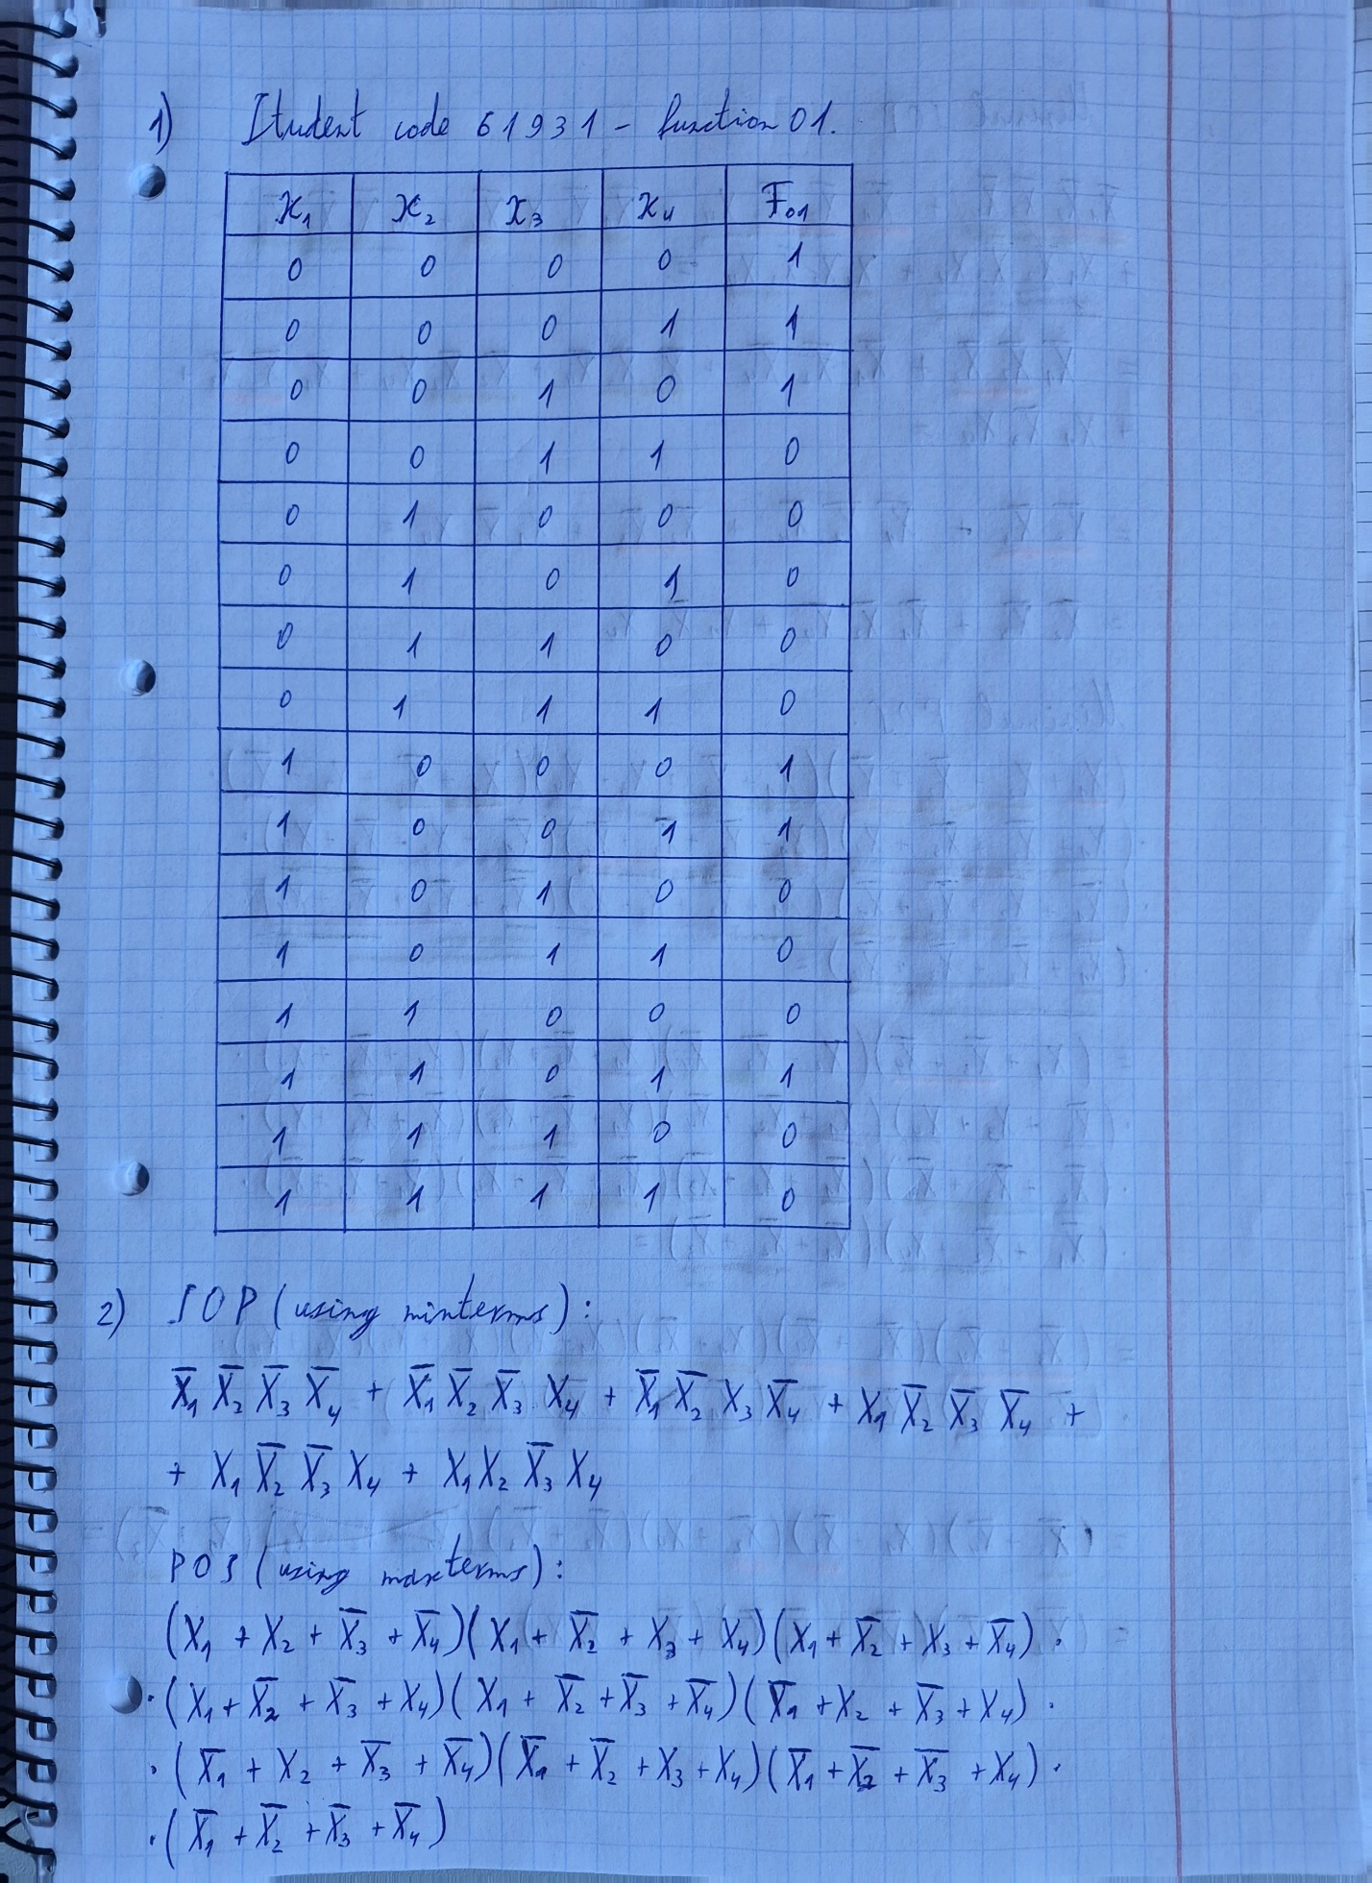
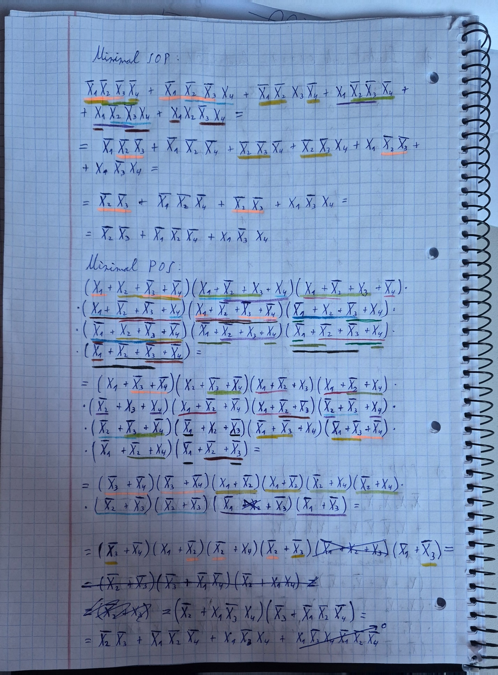
Exercise 3: Designing a Circuit from SOP and POS
Objective: Translate the Sum-of-Products (SOP) expression and Product of Sums (POS) from Exercise 2 into its corresponding digital circuits.
Tasks:
- Using the SOP expression from Exercise 2, design the corresponding circuit in CircuitVerse.
- Using the POS expression from Exercise 2, design the corresponding circuit in CircuitVerse.
- Capture screenshots of the outputs for all input combinations and include them in the report.
- Export your circuit with the filename P2_EX3_YOUR_INITIALS.cv.
- Upload the exported circuit file to Moodle.
- Collate all documentation into a report.

REPORT (you may extend the report as needed beyond this page)
I confirm that the truth tables, derivations, minimisation working, expressions, circuits, code, screenshots and written analysis in this submission are entirely my own work, produced without any AI assistance. | Yes / No
Signature | Timurs Timofejs
Date | 10.11.2026.
The built circuit in CircuitVerse (both SOP and POS):
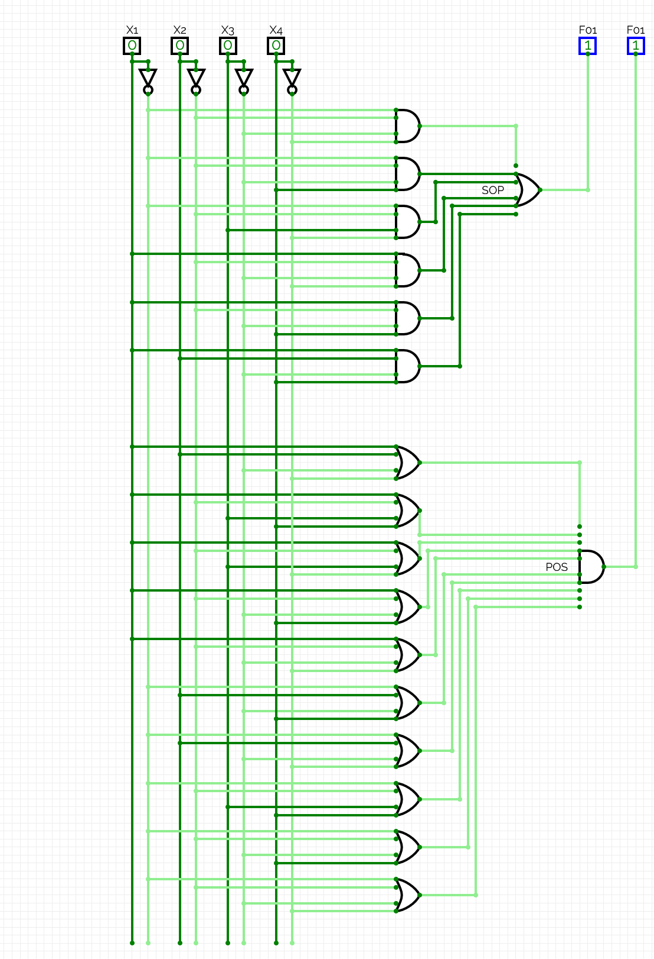
Screenshots of outputs for the inputs of the form (X1,X2,X3,X4):
(0,0,0,0):
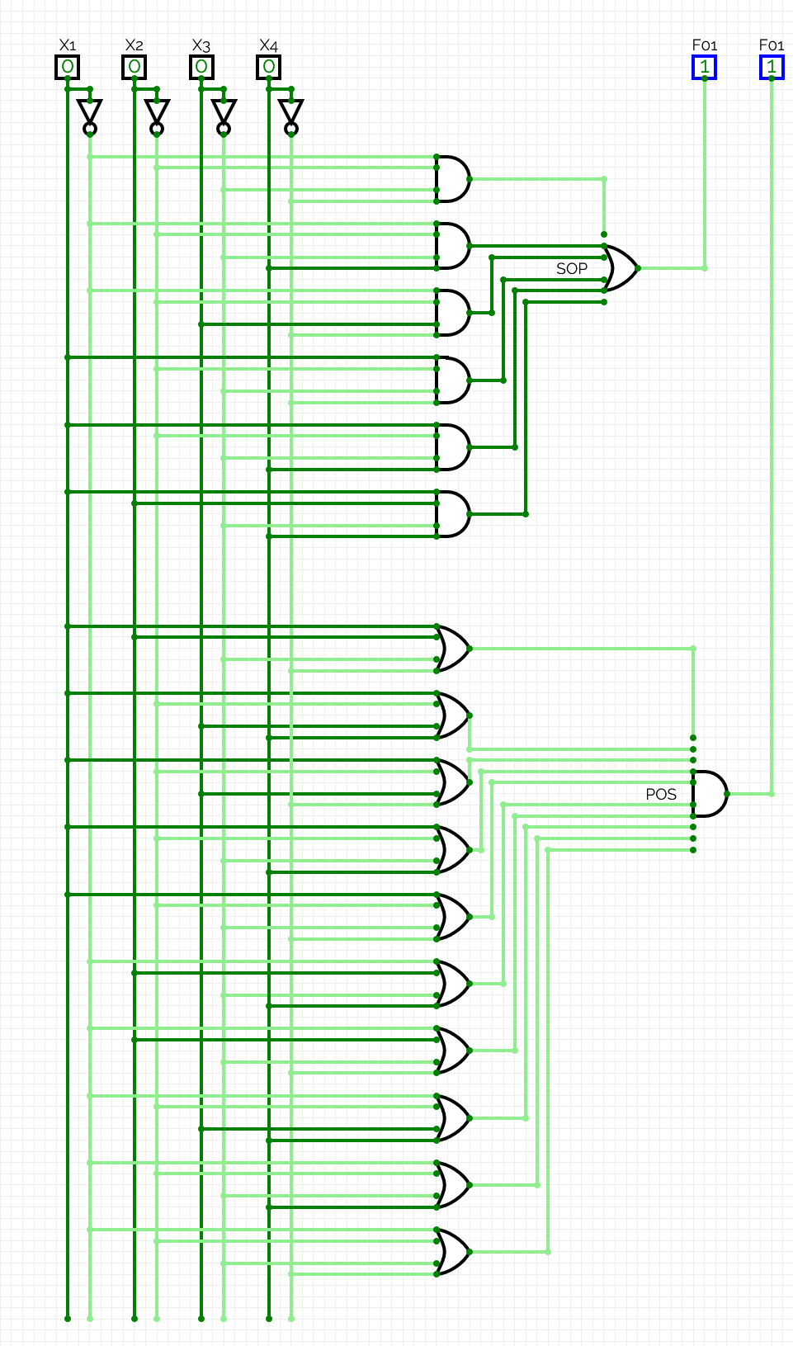
(0,0,0,1):
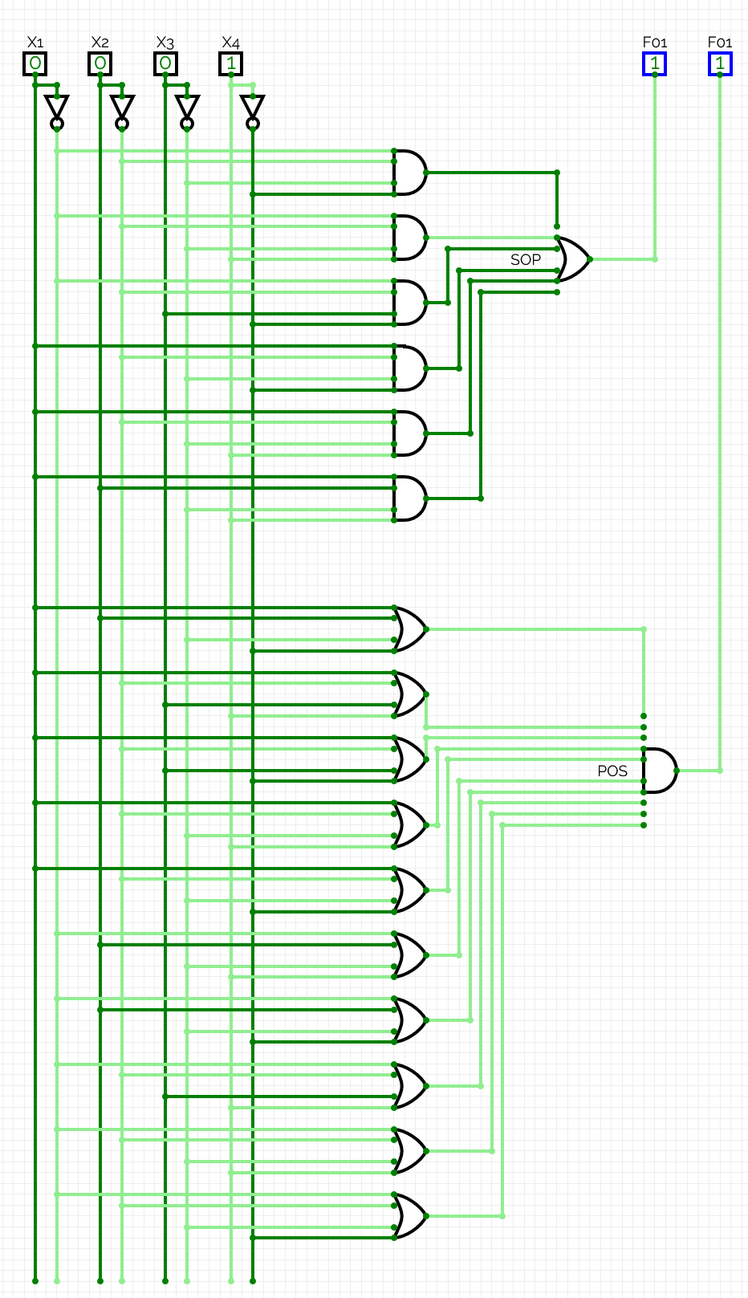
(0,0,1,0):
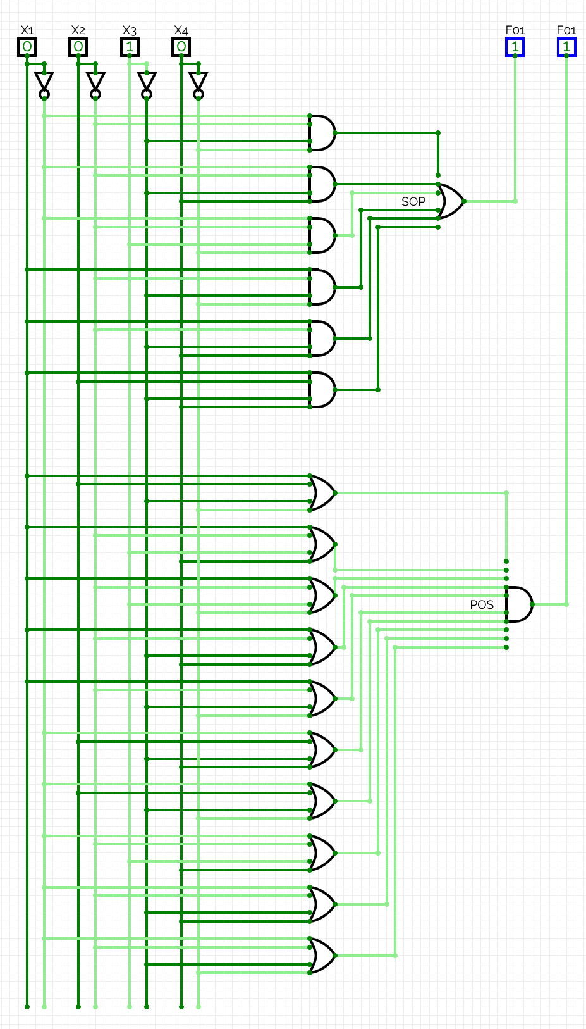
(0,0,1,1):
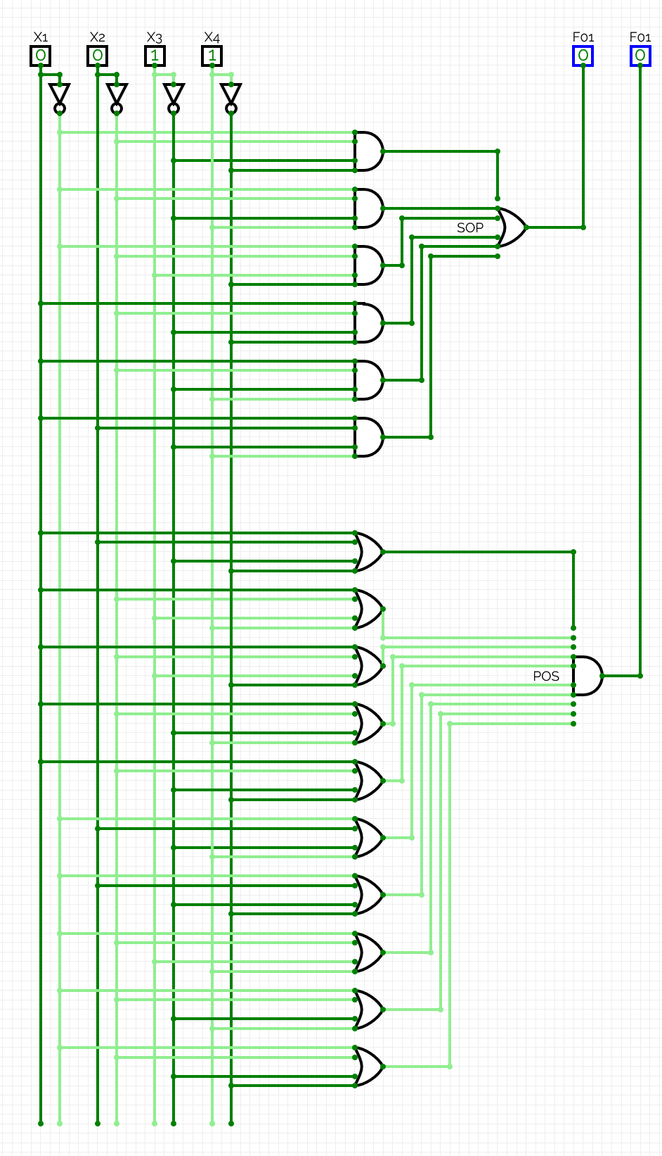

(0,1,0,0):
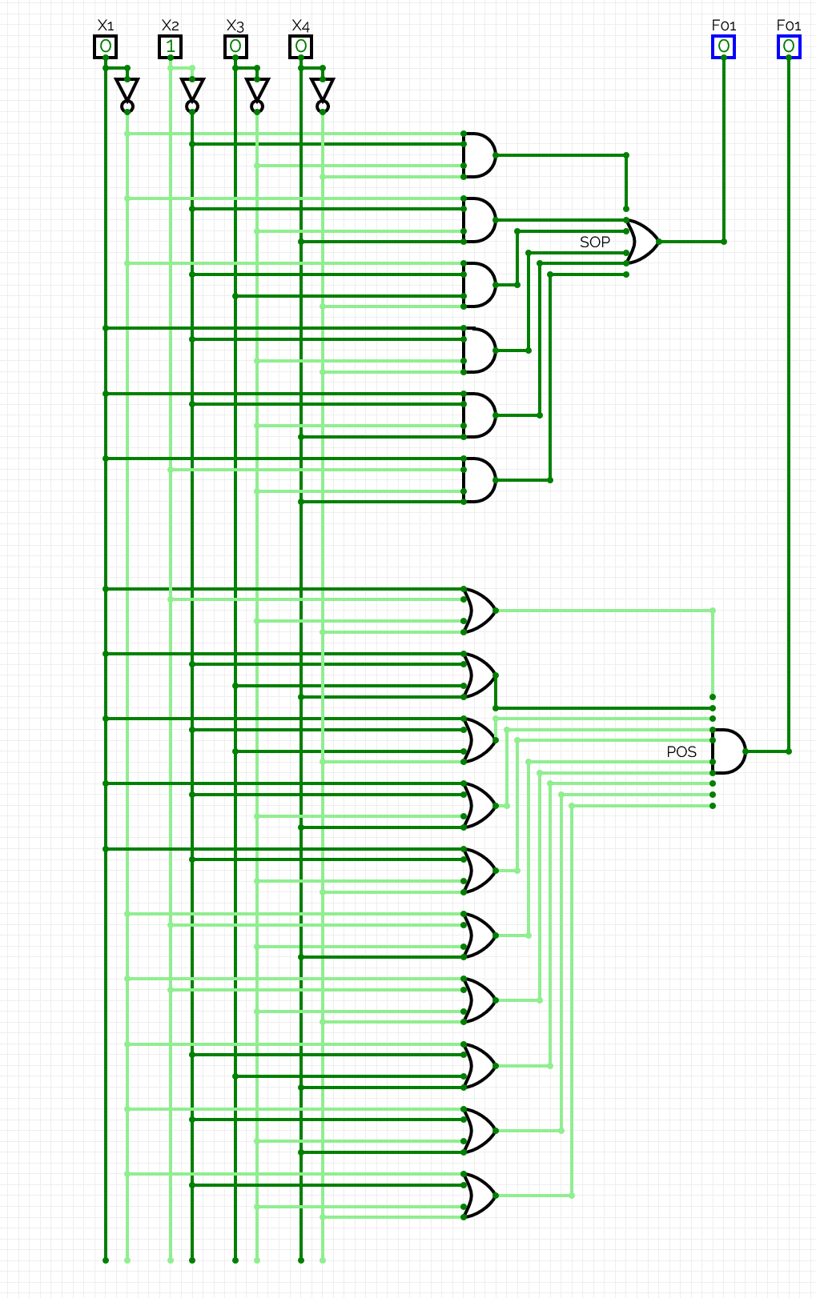
(0,1,0,1):
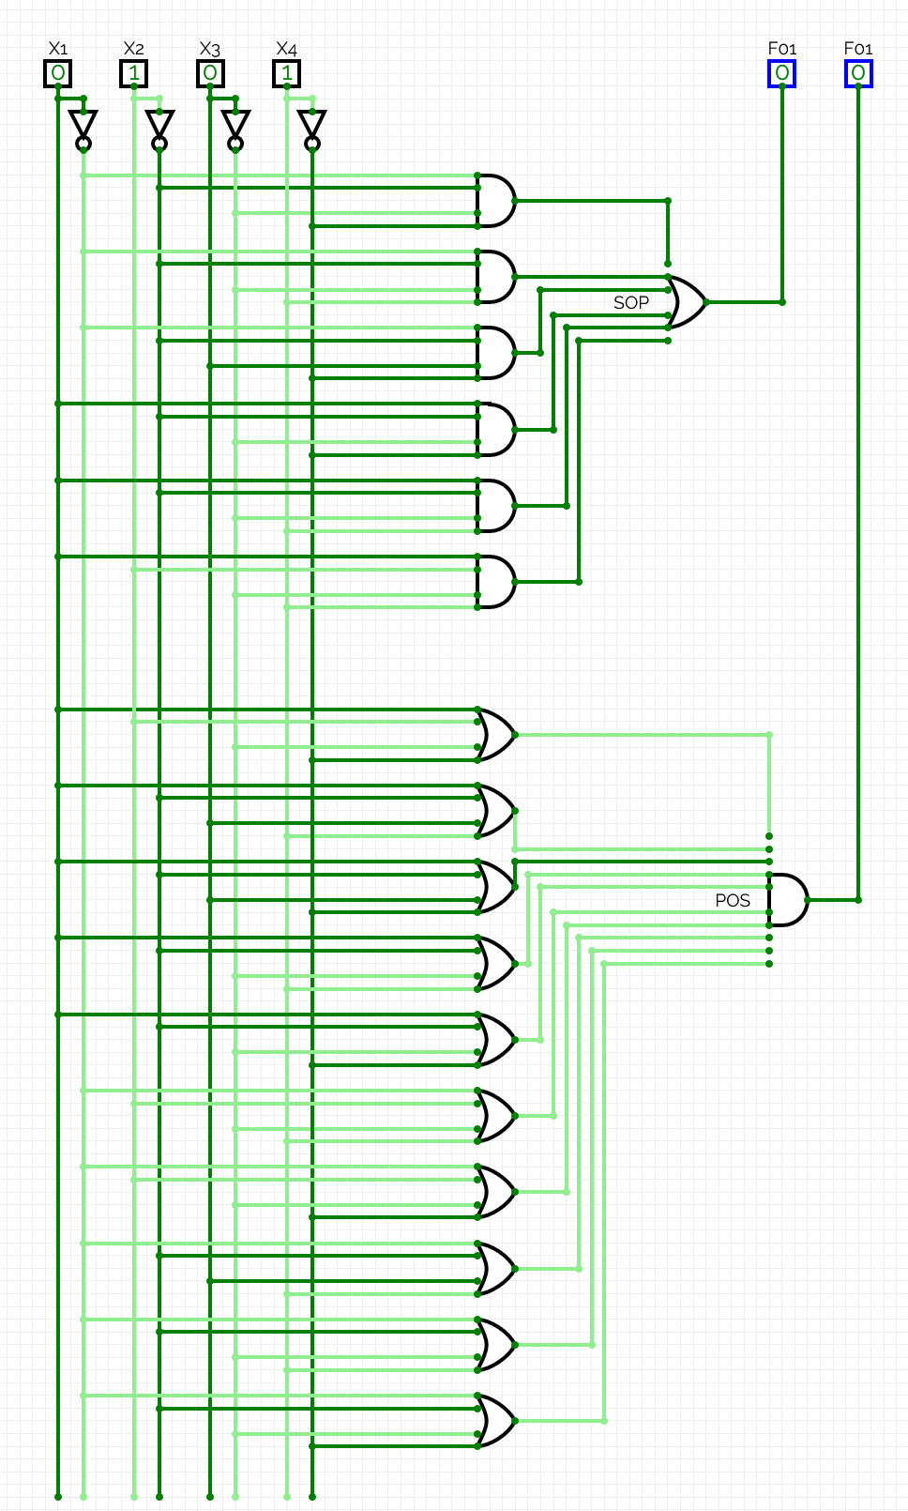

(0,1,1,0):
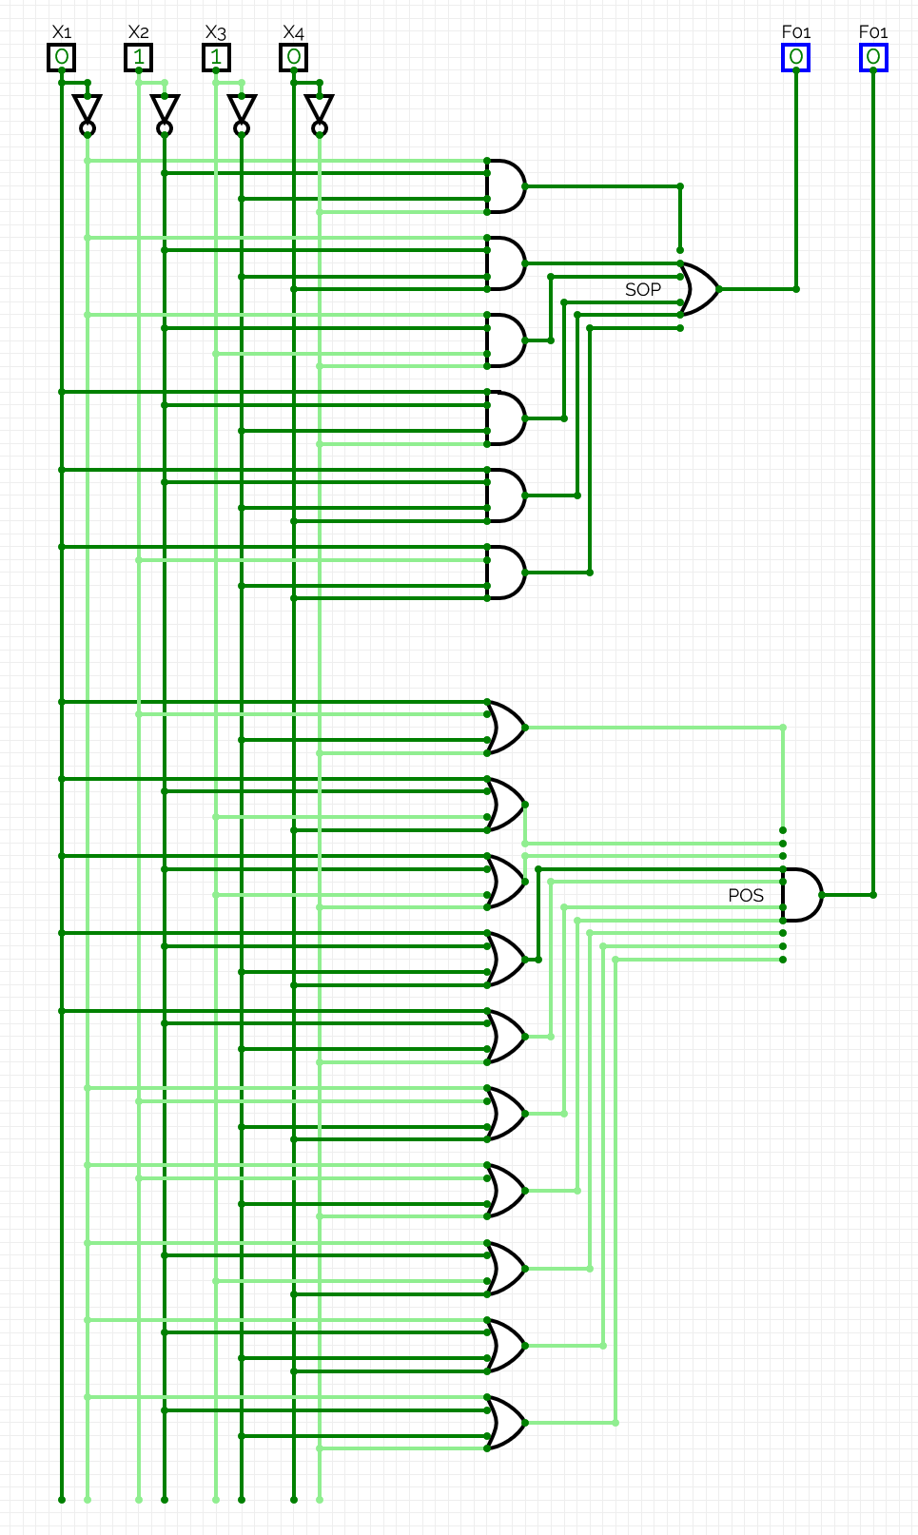
(0,1,1,1):
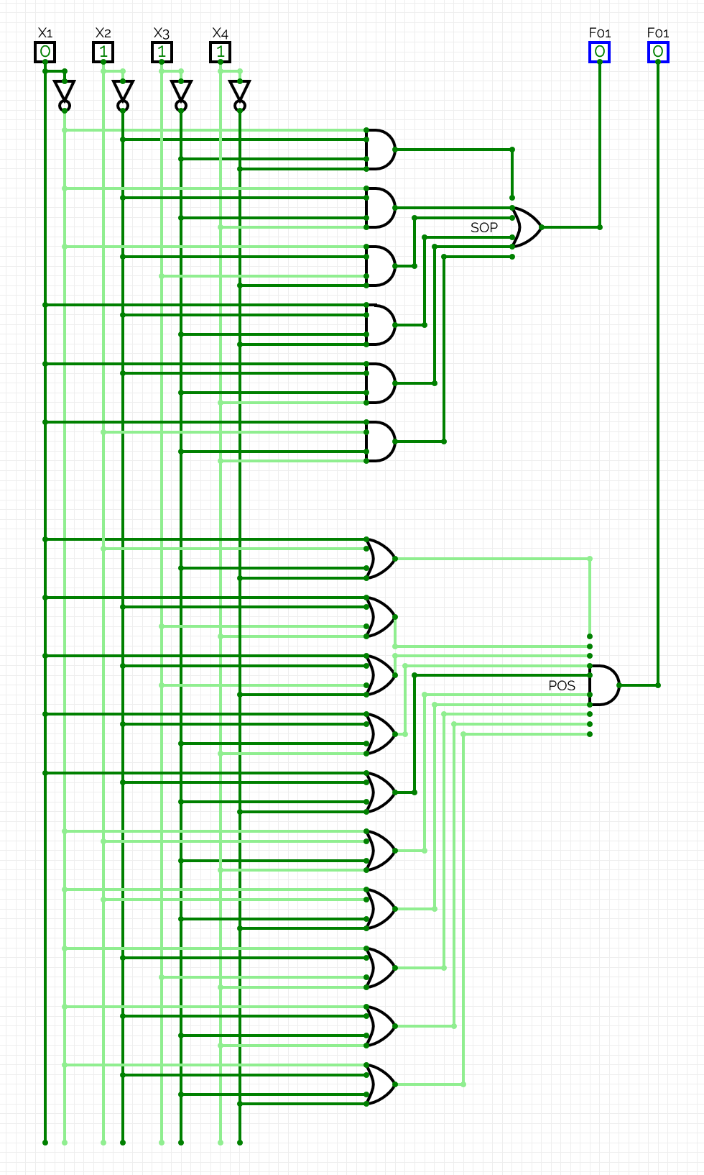
(1,0,0,0):
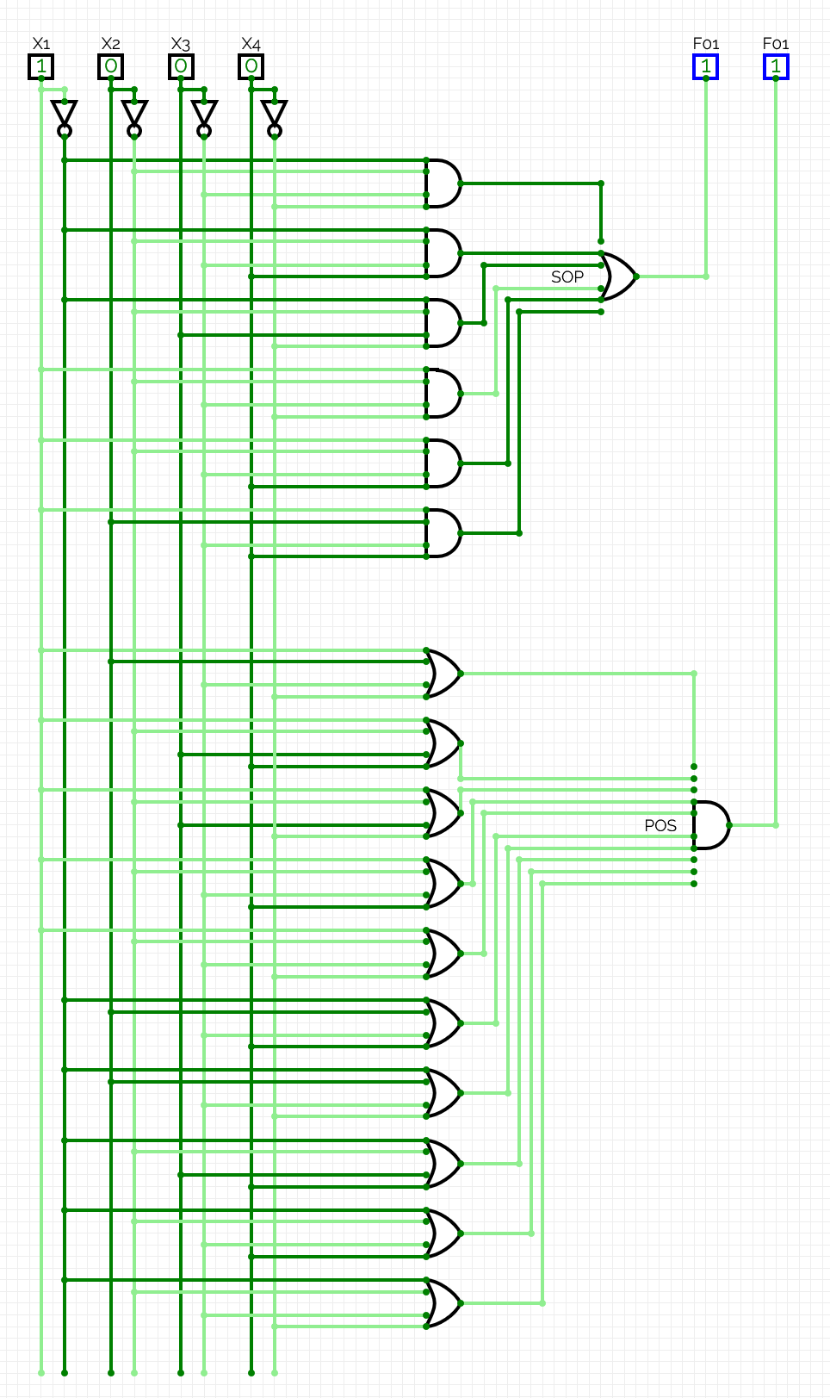
(1,0,0,1):
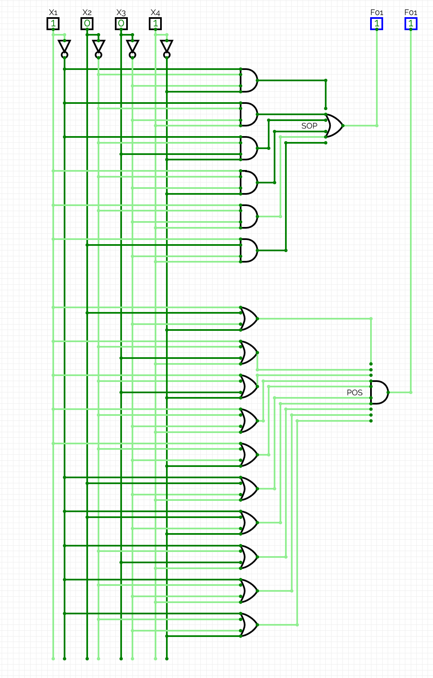
(1,0,1,0):
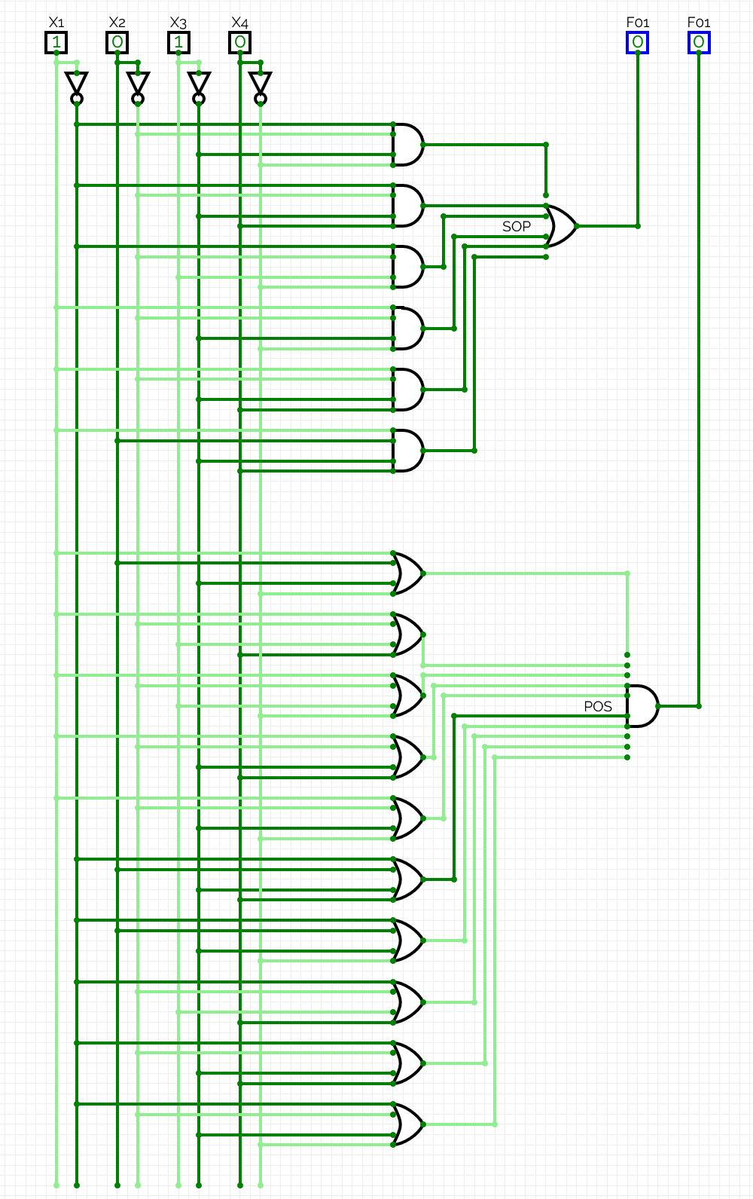
(1,0,1,1):
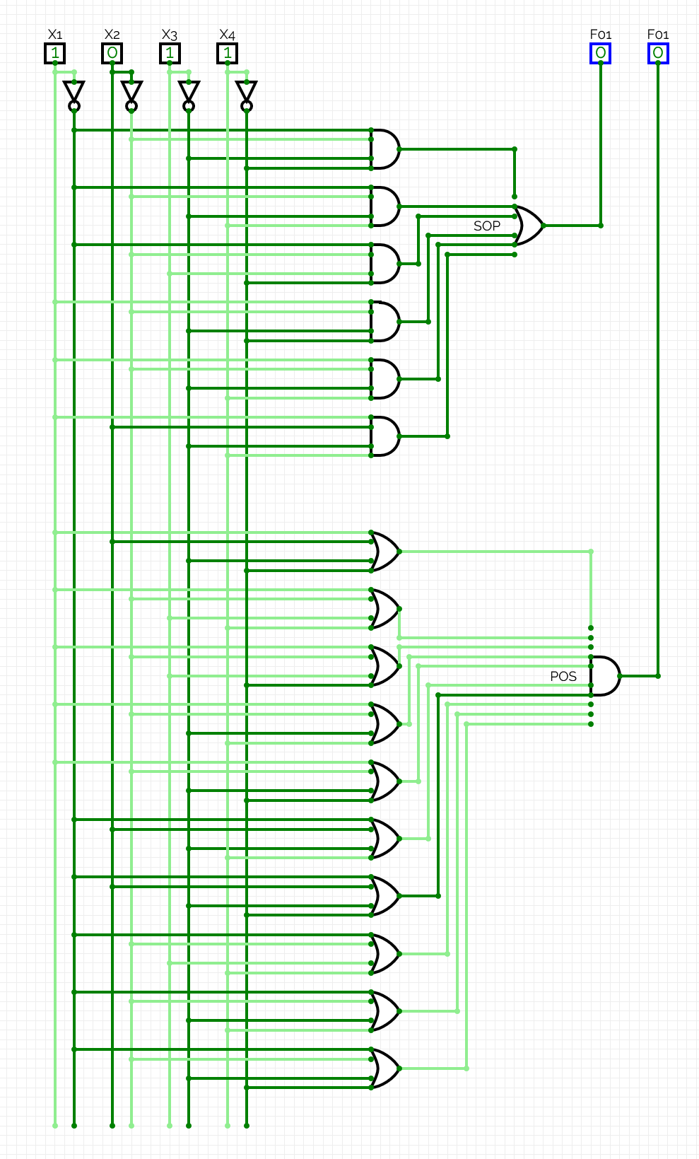
(1,1,0,0):
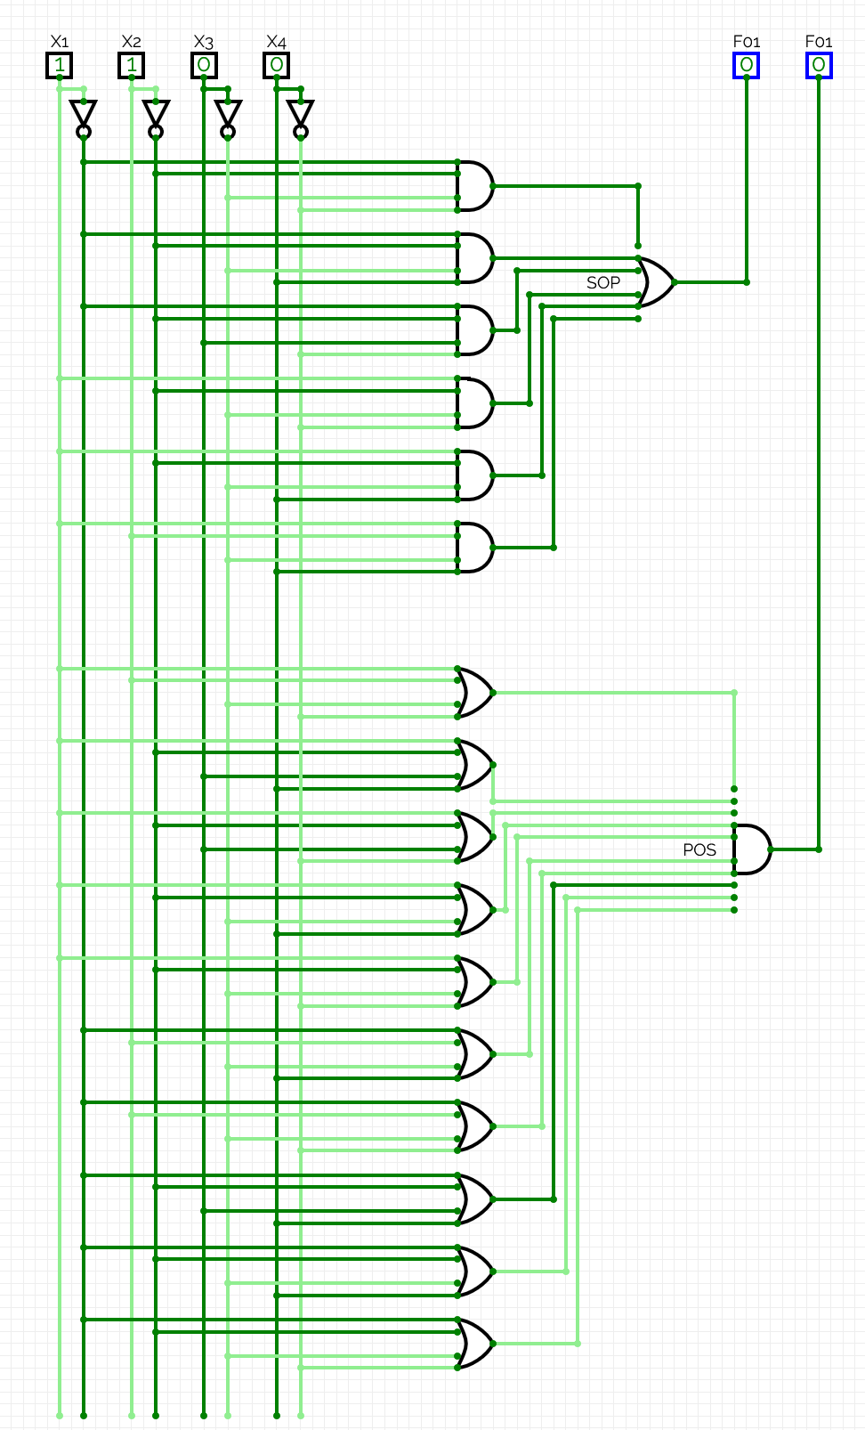
(1,1,0,1):
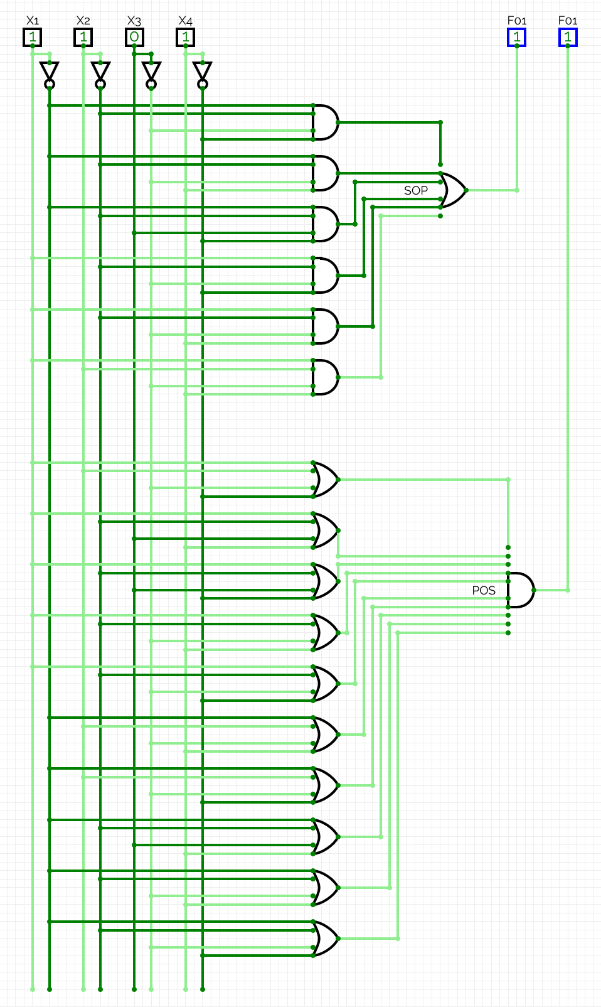
(1,1,1,0):
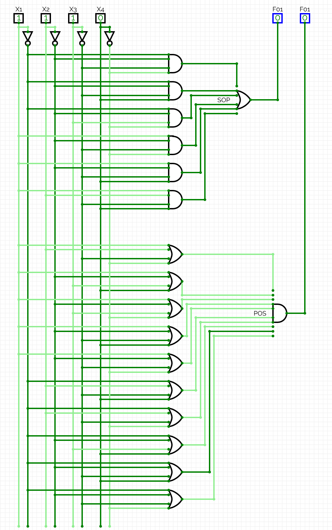

(1,1,1,1):
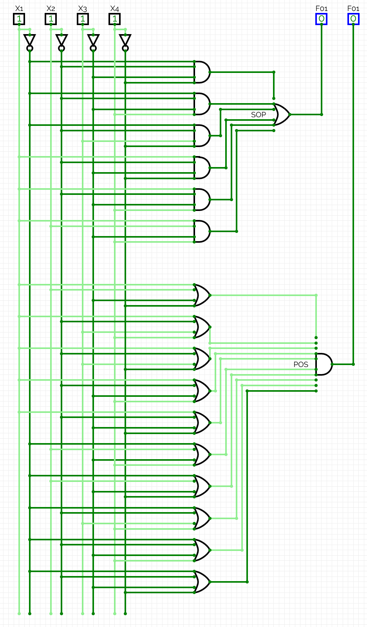
As the results of SOP and POS circuits match the values of a function, the circuits are built correctly.

Exercise 4: Designing a Circuit from simplified expression
Objective: Translate the simplified expression from Exercise 2 into a digital circuit.
Tasks:
- Using the simplified expression from Exercise 2, design the corresponding circuit in CircuitVerse.
- Capture screenshots of the outputs for all input combinations and include them in the report.
- Export your circuit with the filename P2_EX4_YOUR_INITIALS.cv.
- Upload the exported circuit file to Moodle.
- Compile all documentation into a report.
REPORT (you may extend the report as needed beyond this page)
I confirm that the truth tables, derivations, minimisation working, expressions, circuits, code, screenshots and written analysis in this submission are entirely my own work, produced without any AI assistance. | Yes / No
Signature | Timurs Timofejs
Date | 10.11.2026.
The built circuit in CircuitVerse:
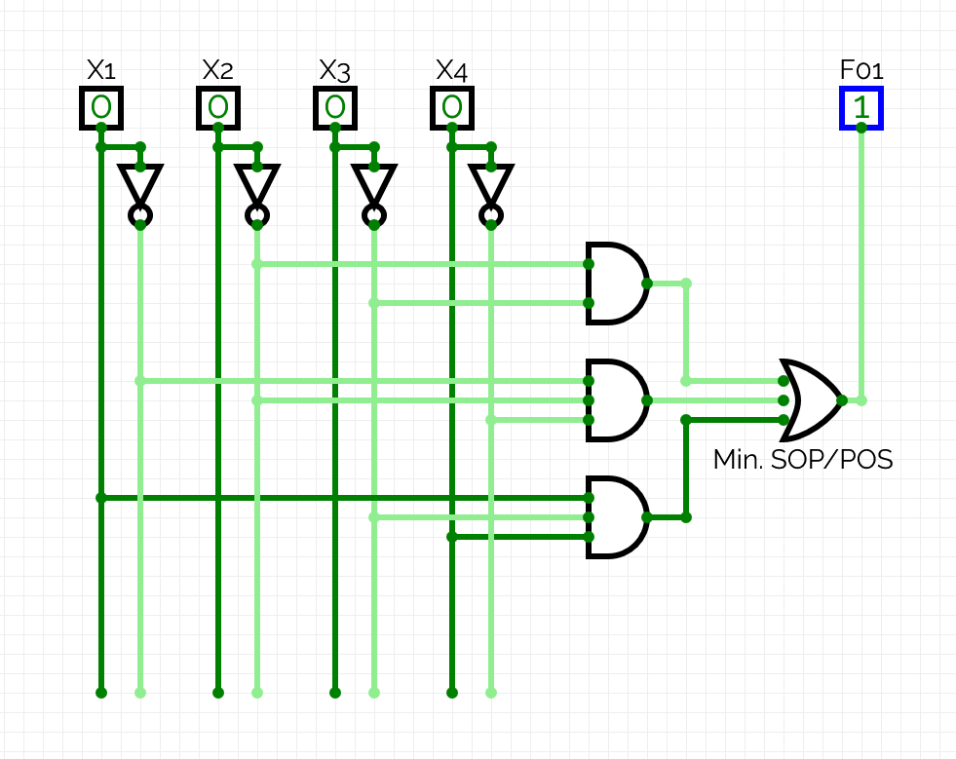

Screenshots of outputs for inputs of the form (X1,X2,X3,X4):
(0,0,0,0):
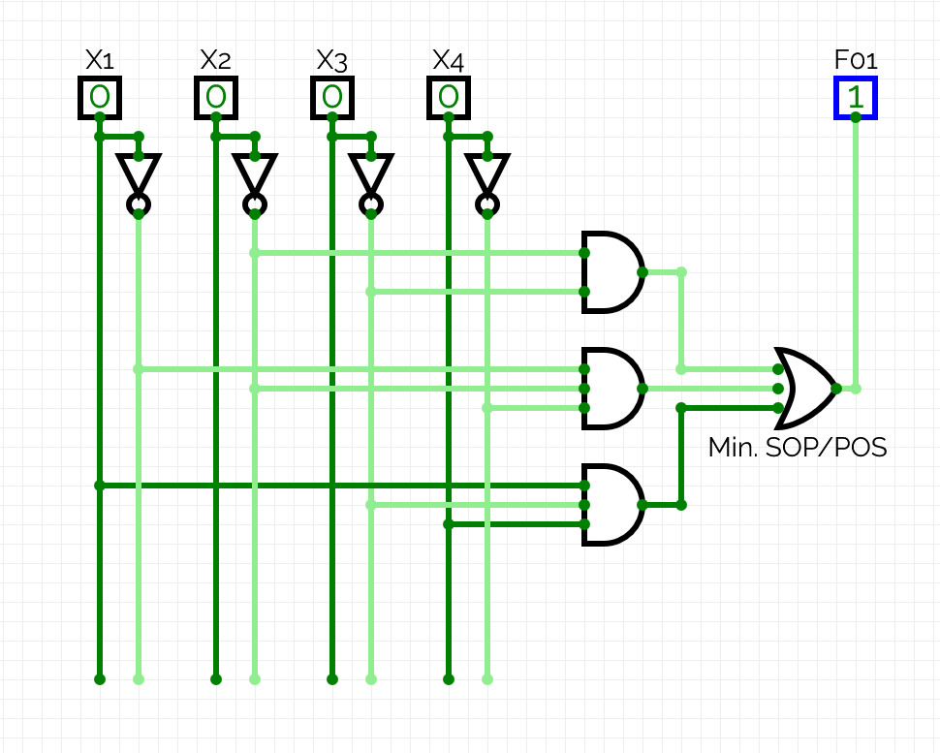
(0,0,0,1):
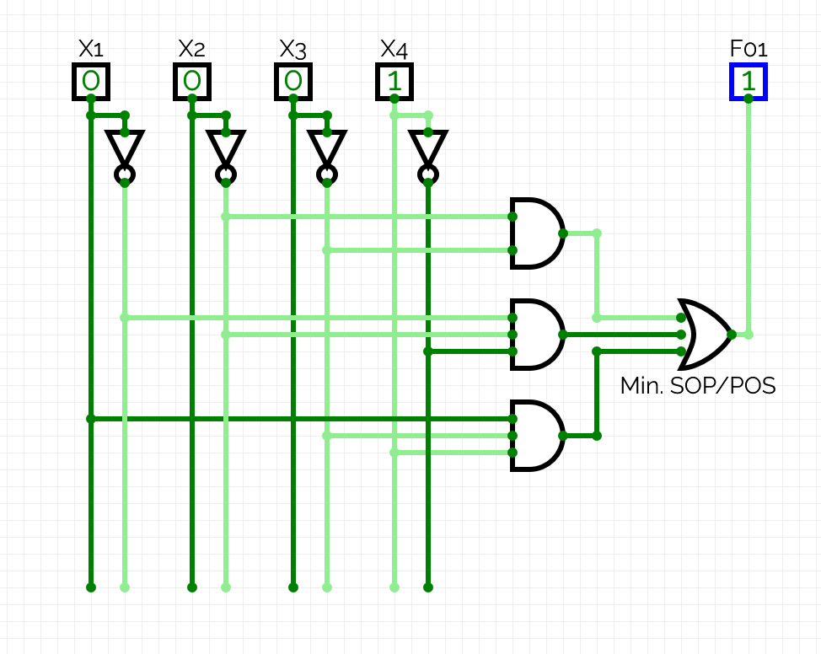
(0,0,1,0):
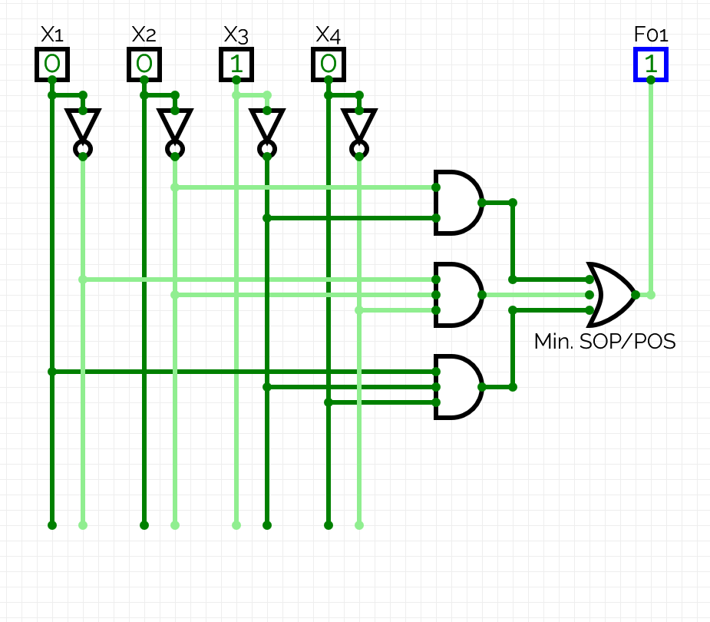
(0,0,1,1):
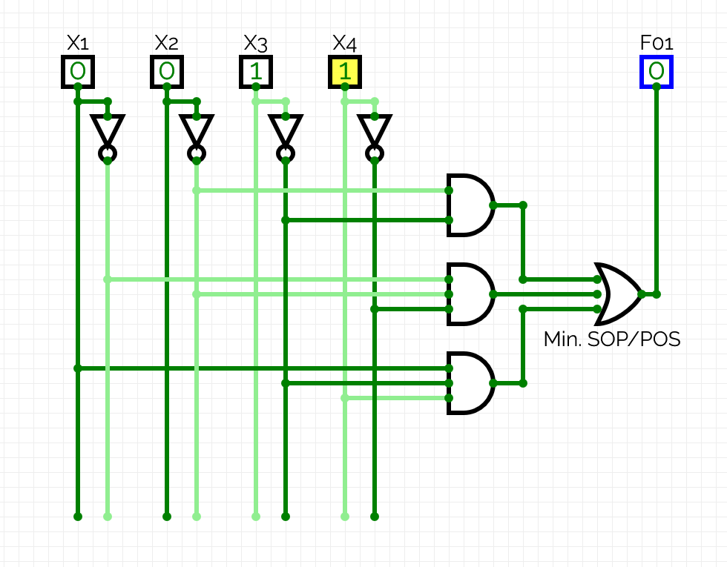
(0,1,0,0):
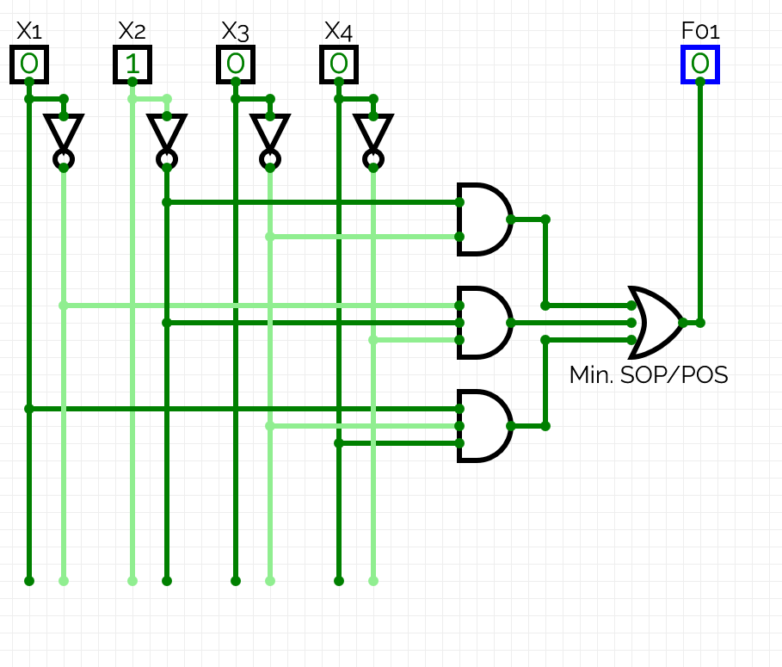
(0,1,0,1):
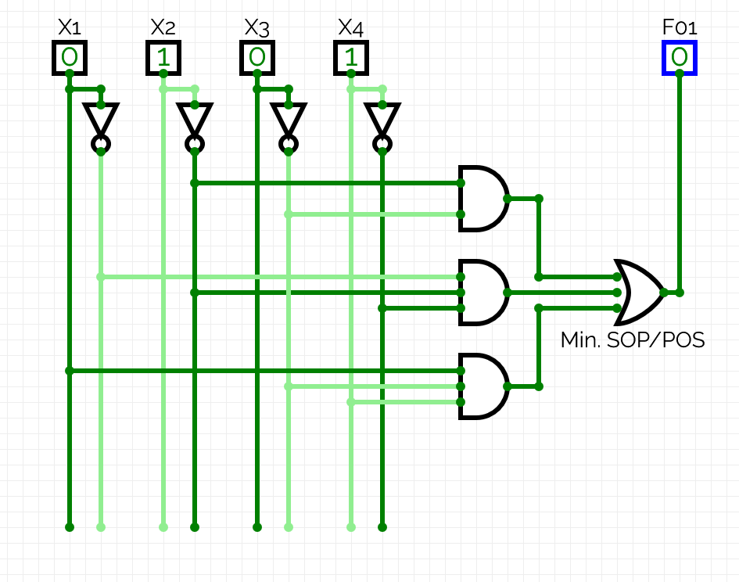

(0,1,1,0):
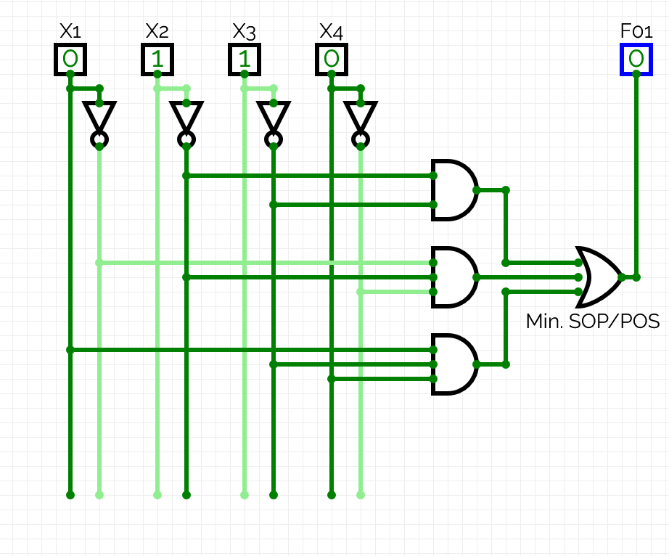
(0,1,1,1):
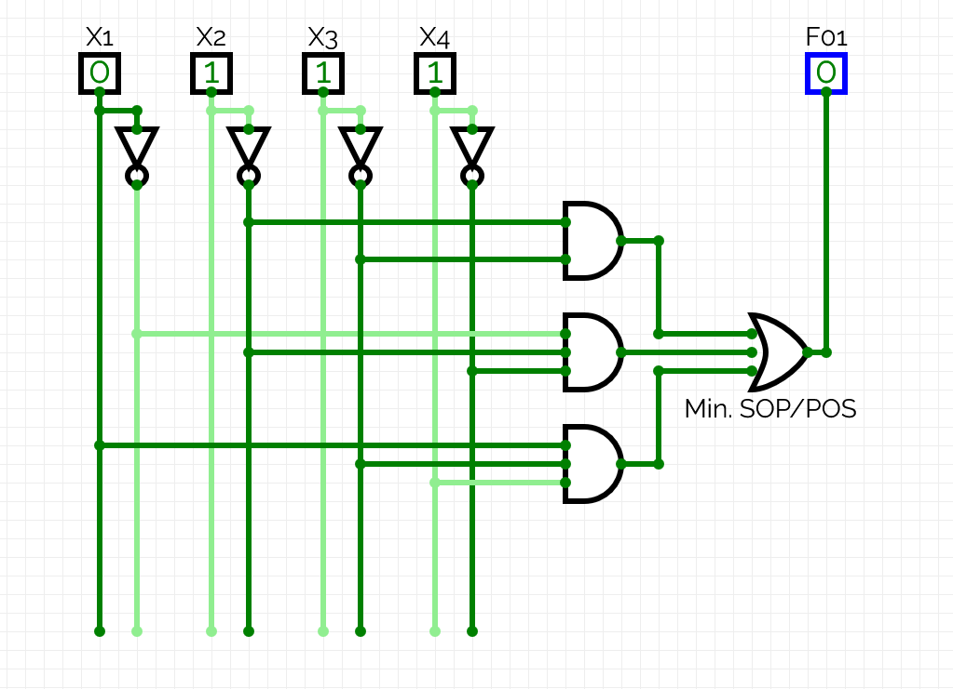
(1,0,0,0):
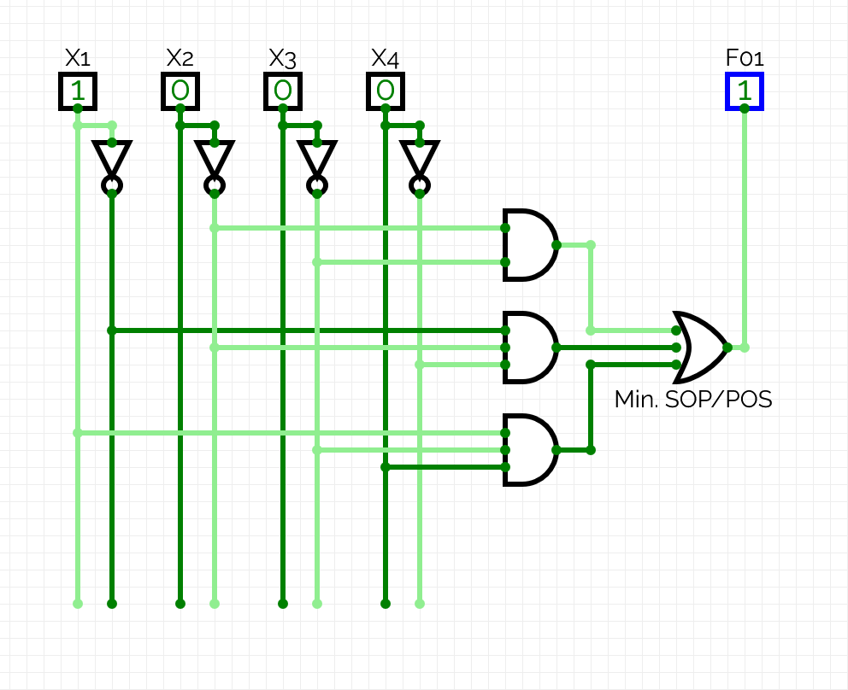
(1,0,0,1):
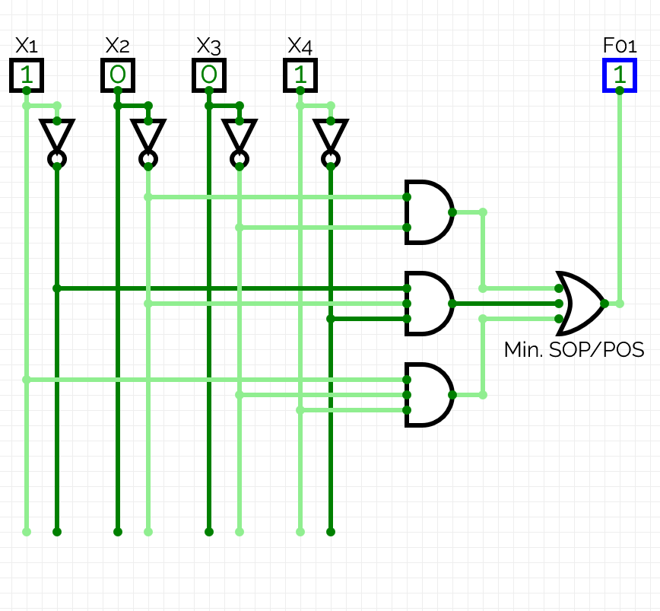

(1,0,1,0):
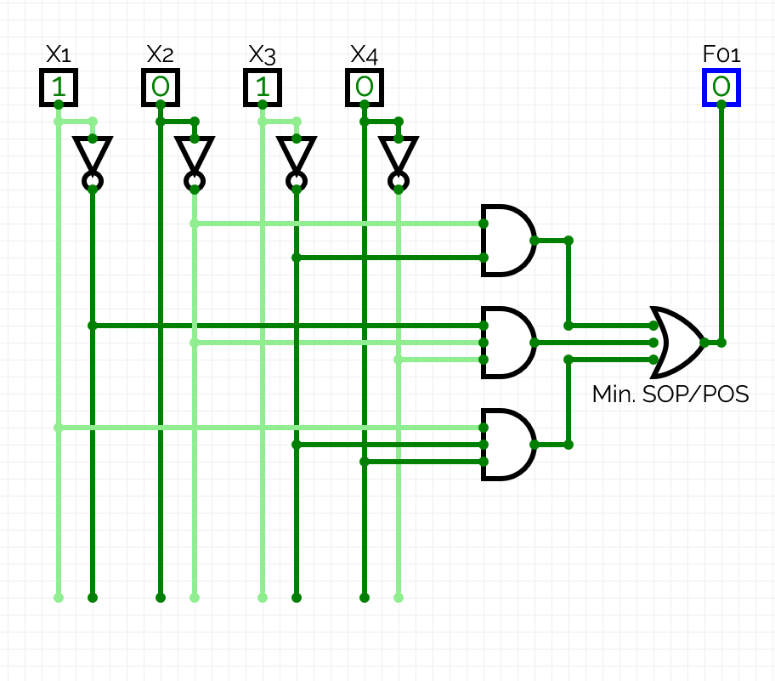
(1,0,1,1):
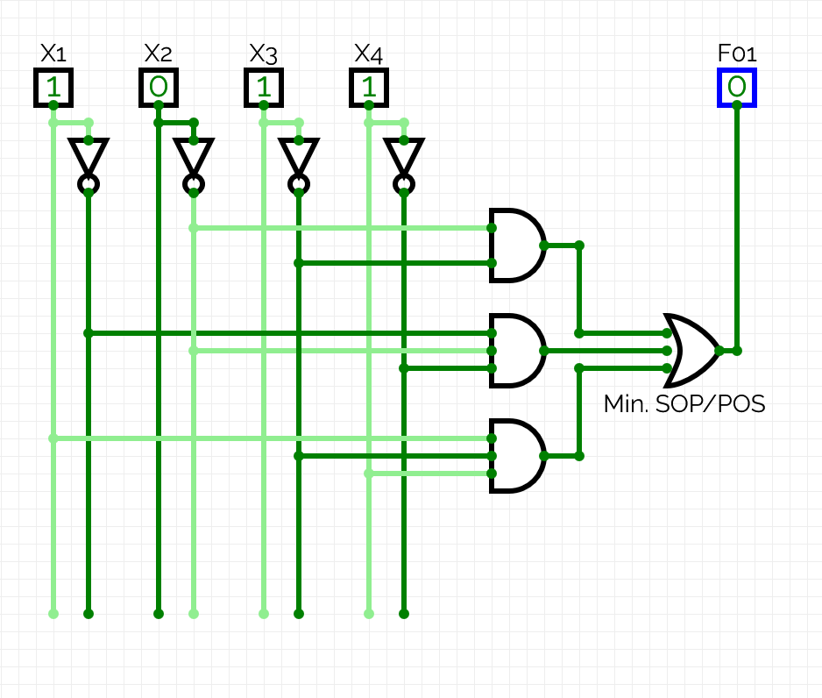

(1,1,0,0):
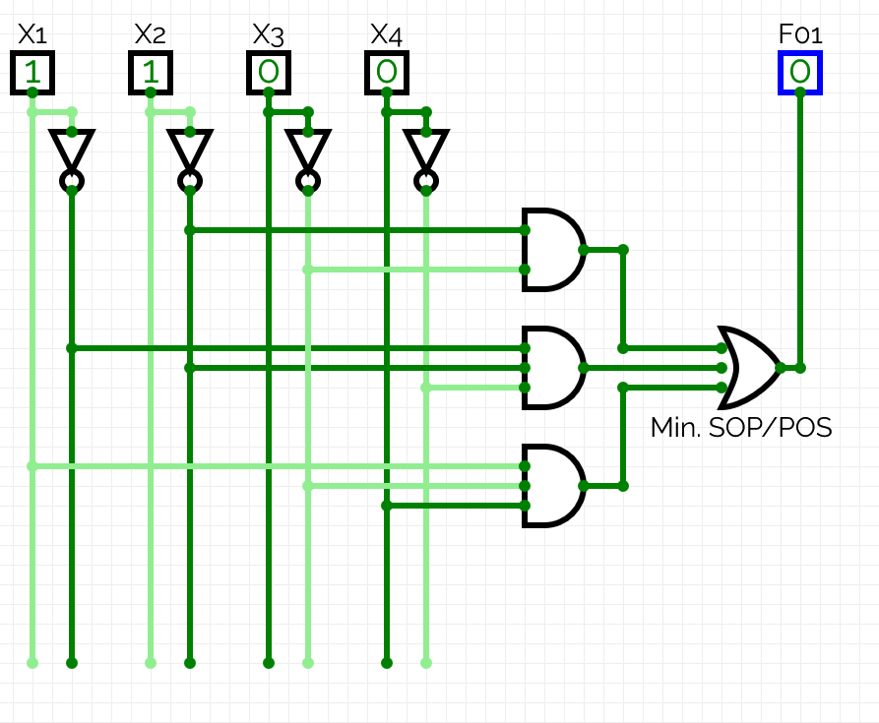
(1,1,0,1):
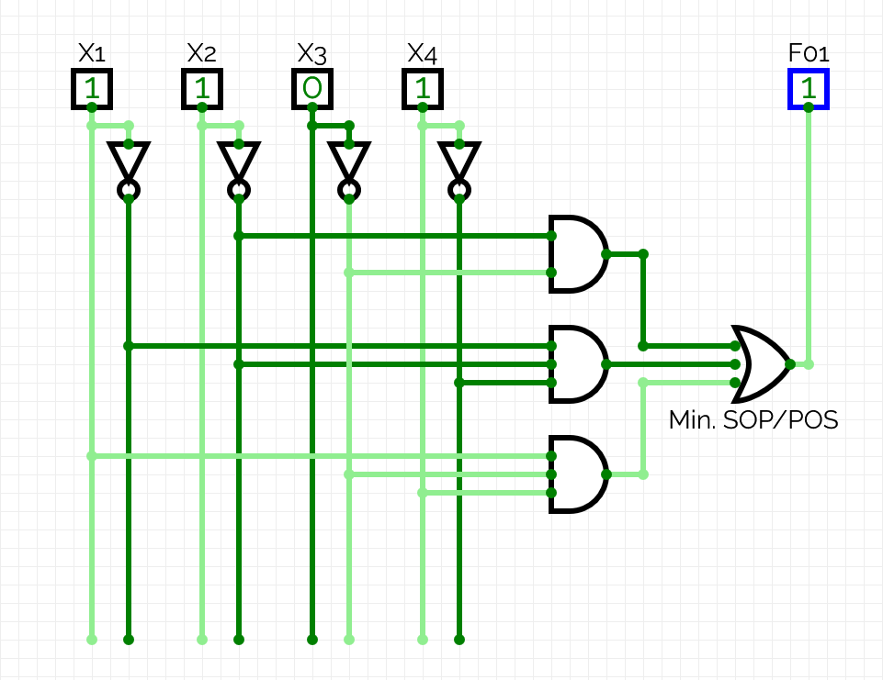

(1,1,1,0):
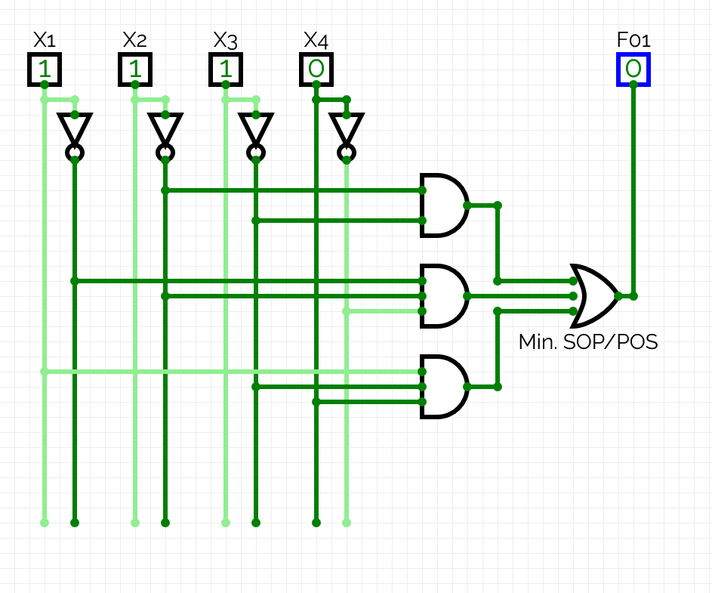
(1,1,1,1):
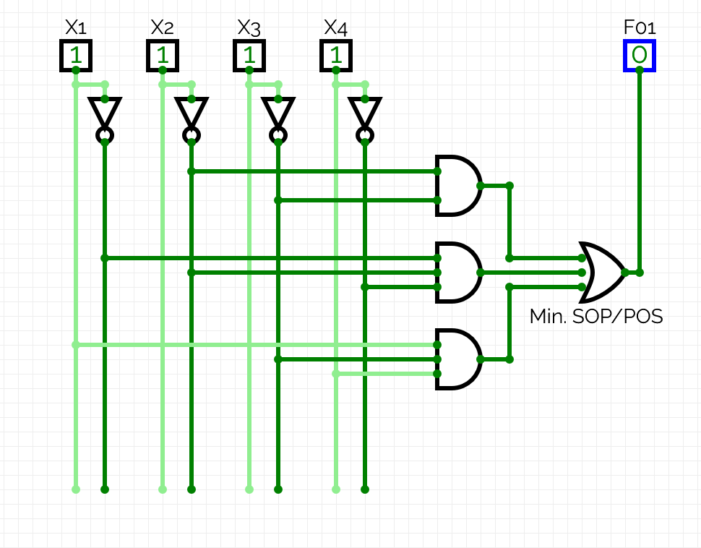

As the circuit with minimal SOP shows the same output as the function, it is implemented correctly.

Exercise 5: Understanding the basic unit of memory (Flip-Flops)
Objective: Understand how a single bit is stored in a Computer System.
Tasks:
- Design circuits in CircuitVerse showcasing the function of different flip-flops like SR, JK, D, and T. Use both logic gates and flip-flop blocks.
- Illustrate the state transitions by capturing screenshots of the outputs for all input combinations.
- Export your circuit with the filename P2_EX5_YOUR_INITIALS.cv.
- Upload the exported circuit file to Moodle.
- Consolidate all documentation into a report.

REPORT (you may extend the report as needed beyond this page)
I confirm that the truth tables, derivations, minimisation working, expressions, circuits, code, screenshots and written analysis in this submission are entirely my own work, produced without any AI assistance. | Yes / No
Signature | Timurs Timofejs
Date | 10.11.2026.
Circuits for SR flip-flops:
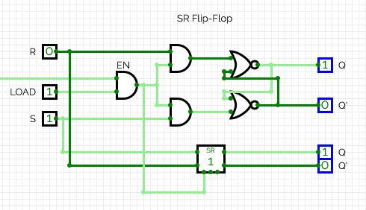
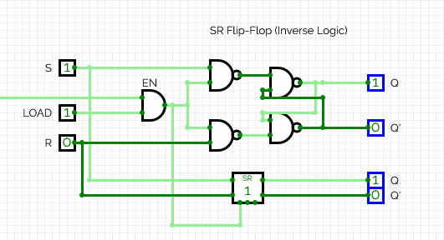

Circuit for JK flip-flop:
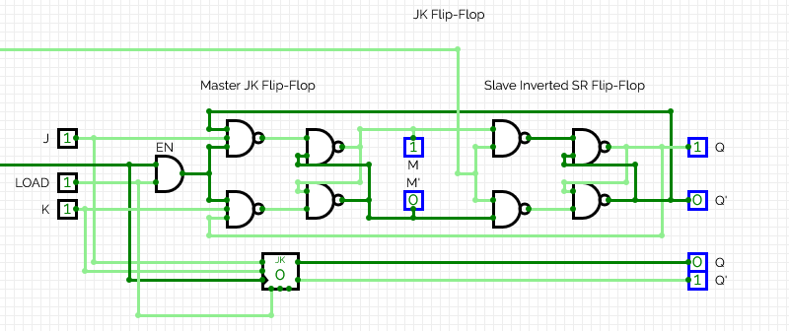
This circuit required a JK master - SR slave setup due to CircuitVerse’s logic updating not just on clock edge, but on any signal edge, resulting in an infinite loop.

Circuit for D flip-flop:
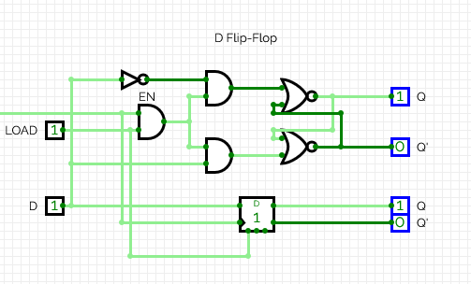

Circuit for T flip-flop:
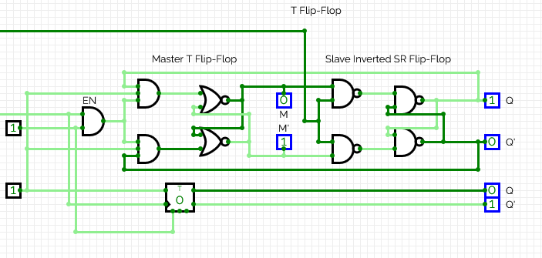
This circuit required a T master - SR slave setup due to CircuitVerse’s logic updating not just on clock edge, but on any signal edge, resulting in an infinite loop.

Q0 – previous value of Q.

SR – flip-flop (normal logic):
Truth table for this circuit:
S | R | Q0 | Q
0 | 0 | 0 | Q0 = 0
0 | 0 | 1 | Q0 = 1
0 | 1 | 0 | 0
0 | 1 | 1 | 0
1 | 0 | 0 | 1
1 | 0 | 1 | 1
1 | 1 | 0 | Invalid
1 | 1 | 1 | Invalid

Screenshots of outputs for the inputs of the form (S,R,Q0):
(0,0,0):
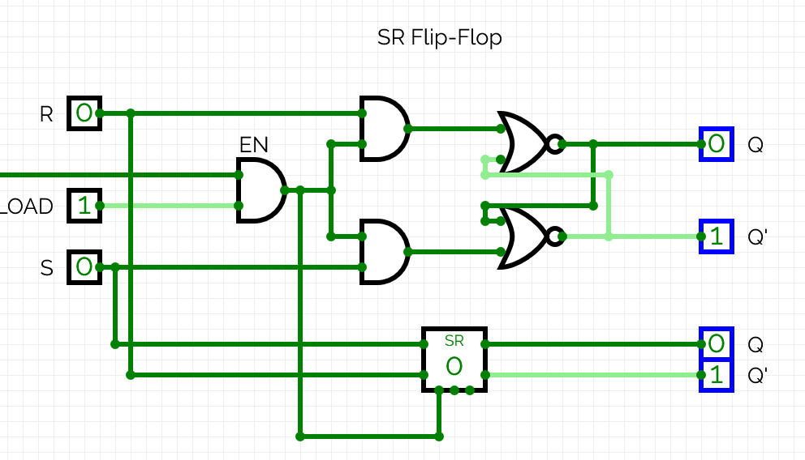

(0,0,1):
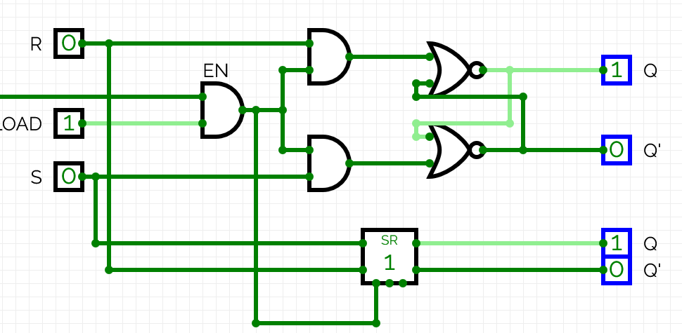

(0,1,X):
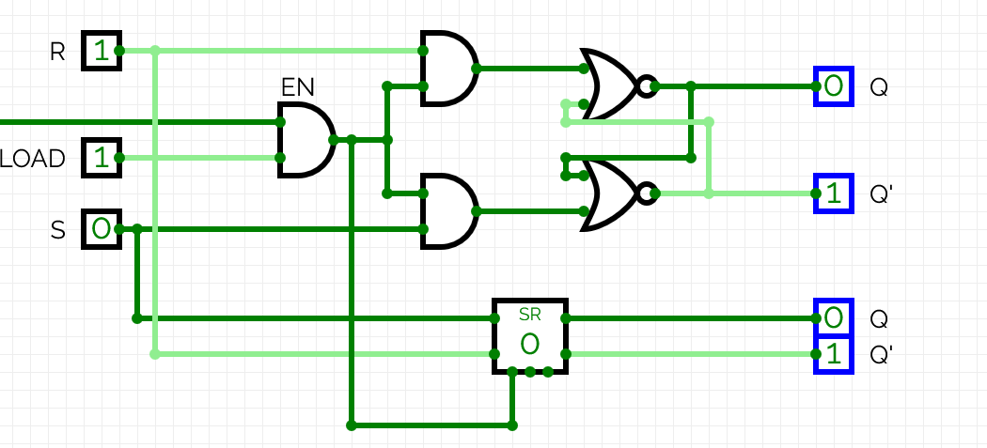

(1,0,X):
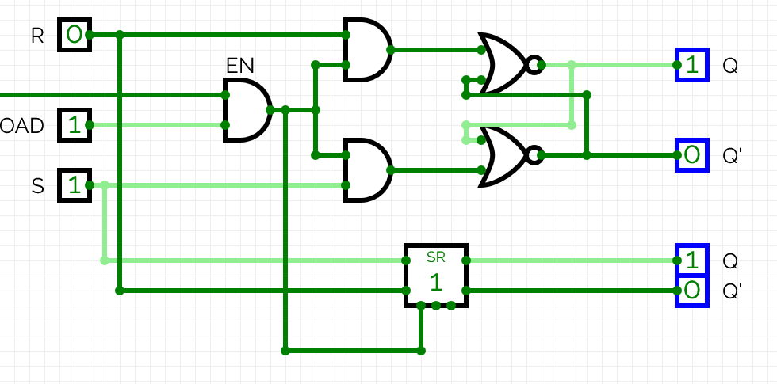
(1,1,X):
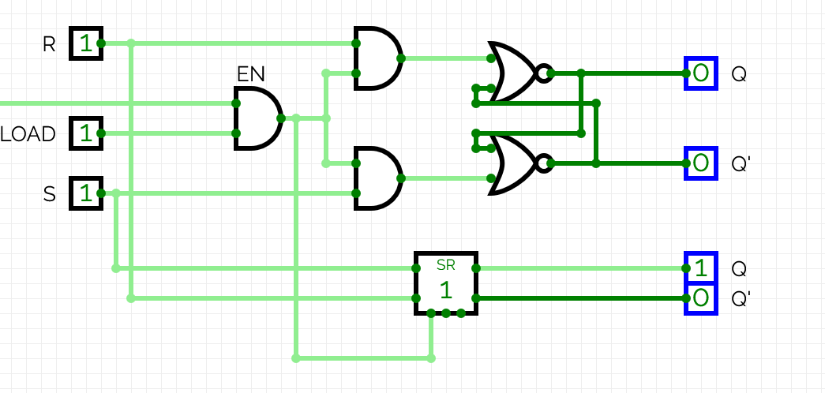

As the circuit follows the truth table for the SR flip-flop, it is built correctly.

SR circuit (Inverse Logic):
Truth table is the same as for SR flip-flop (normal logic).
Screenshots of outputs for inputs of the form (S,R,Q0):
(0,0,0):
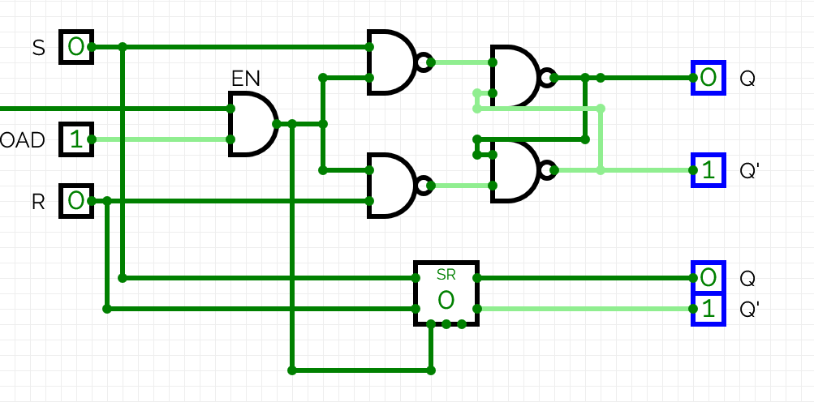

(0,0,1):
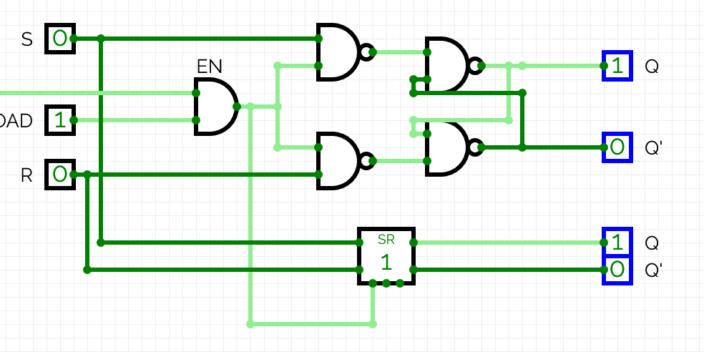
(0,1,X):
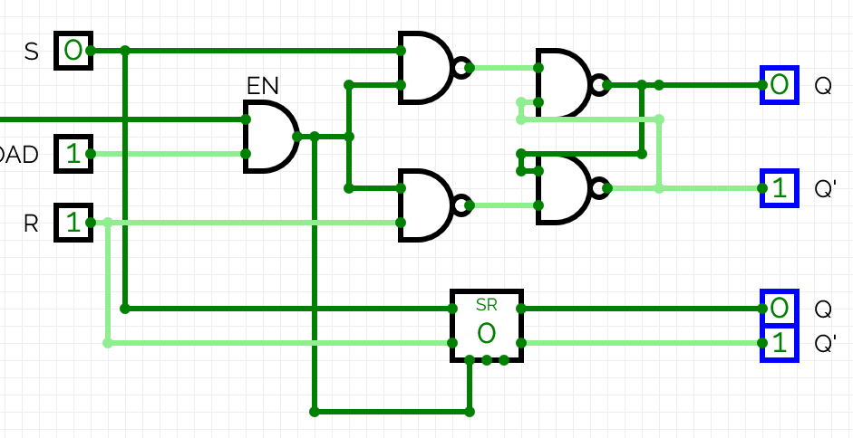

(1,0,X):
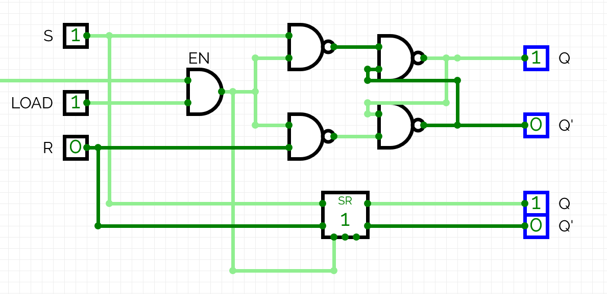

(1,1,X):
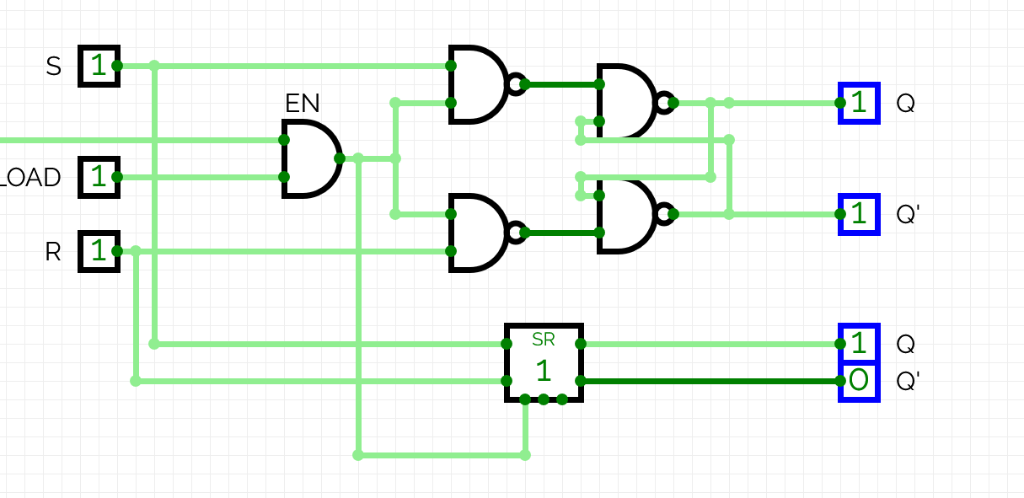

As the circuit follows the truth table for the SR flip-flop, it is built correctly.

JK flip-flop:
Truth table for this circuit:
J | K | Q0 | Q
0 | 0 | 0 | Q0 = 0
0 | 0 | 1 | Q0 = 1
0 | 1 | 0 | 0
0 | 1 | 1 | 0
1 | 0 | 0 | 1
1 | 0 | 1 | 1
1 | 1 | 0 | Q0’ = 1
1 | 1 | 1 | Q0’ = 0

Screenshots of outputs for inputs of the form (J,K,Q0):
(0,0,0):
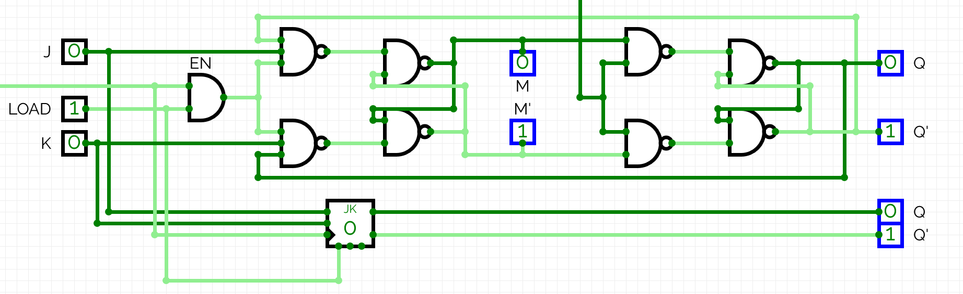
(0,0,1):
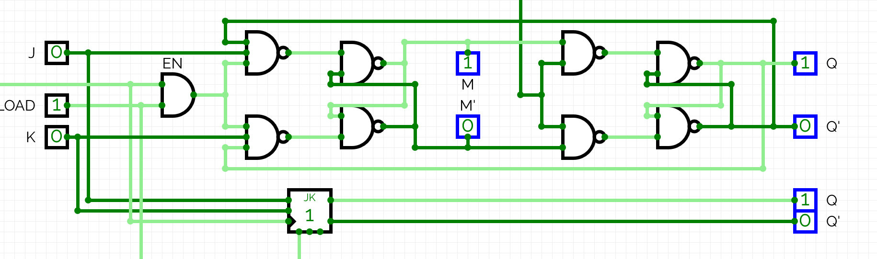
(0,1,X):
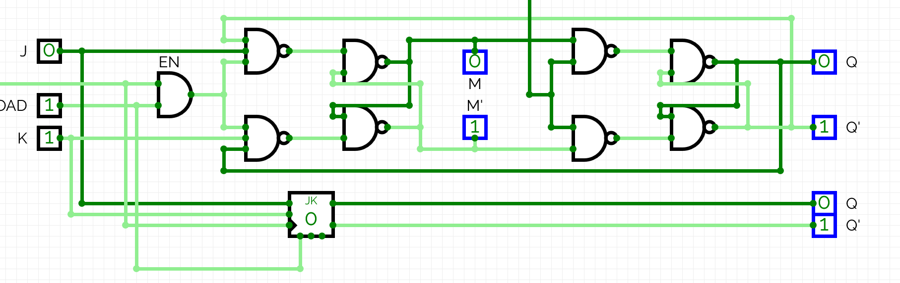
(1,0,X):
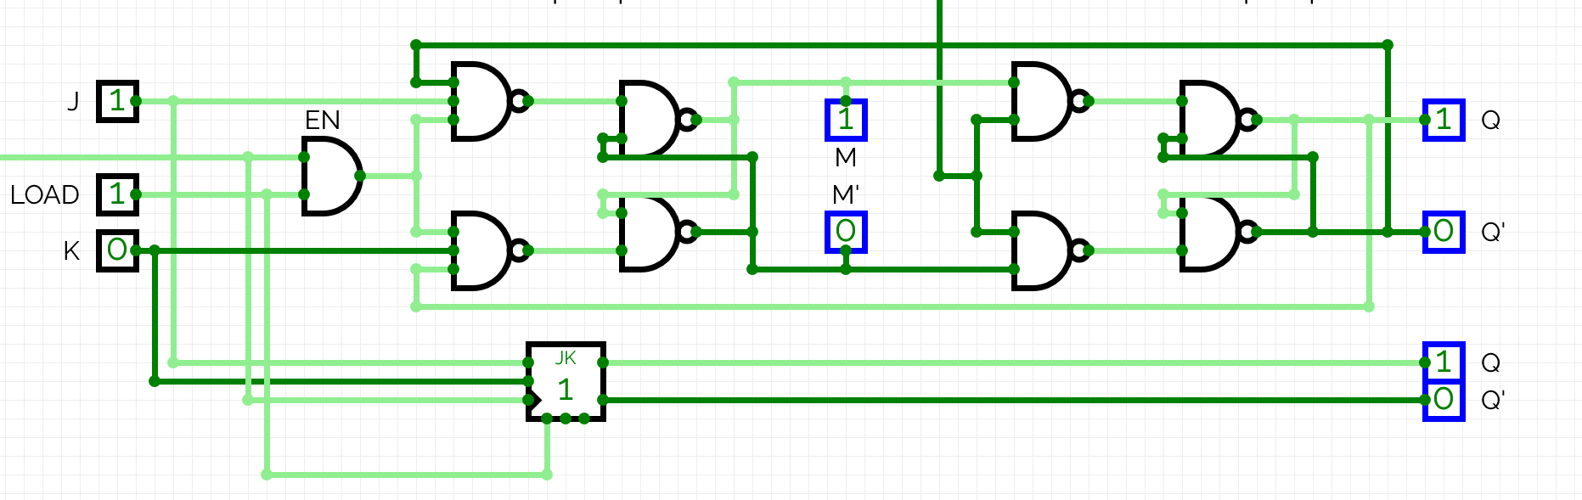
(1,1,0):
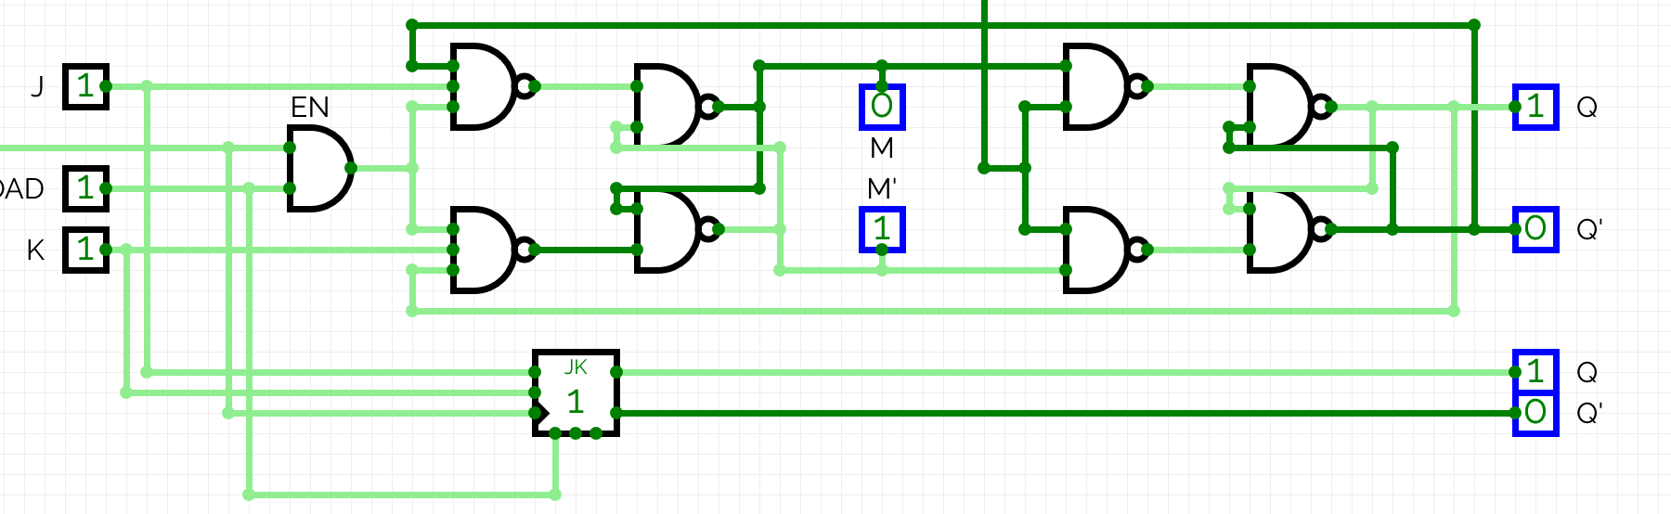
(1,1,1):
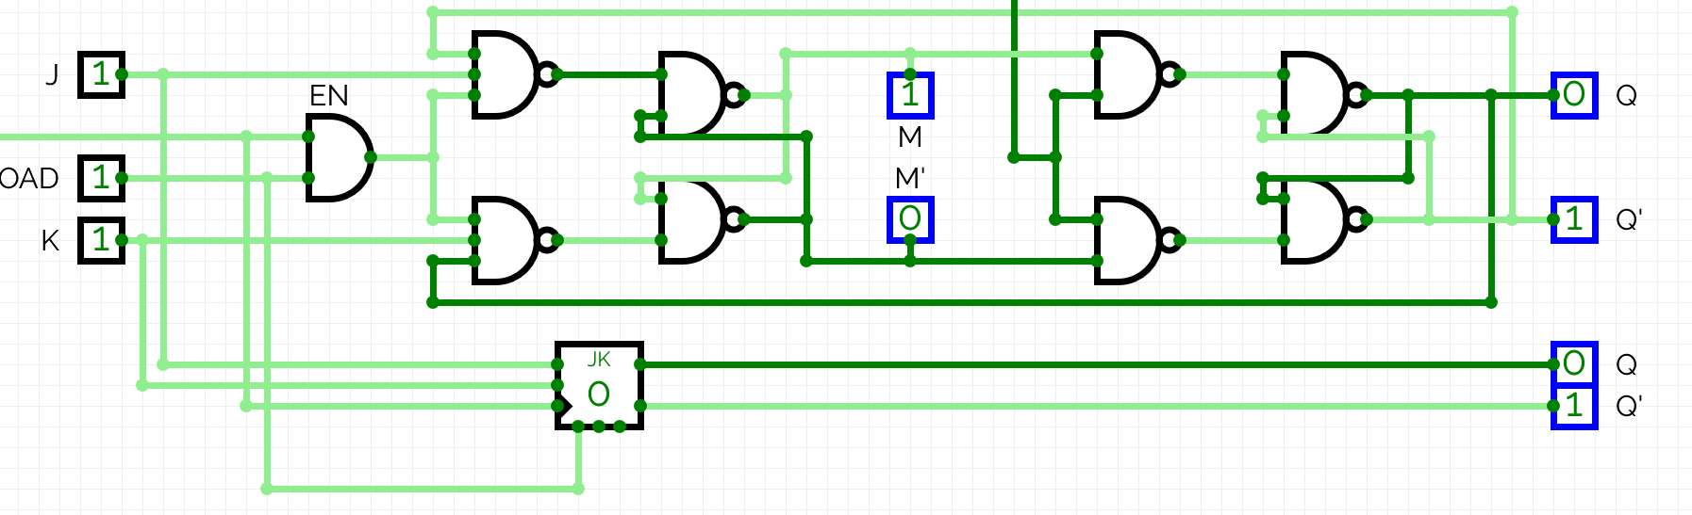

As the circuit follows the truth table for the JK flip-flop, it is built correctly.

D flip-flop:
Truth table for this circuit:
D | Q
0 | 0
1 | 1

Screenshots of output for input of the form (D):
(0):
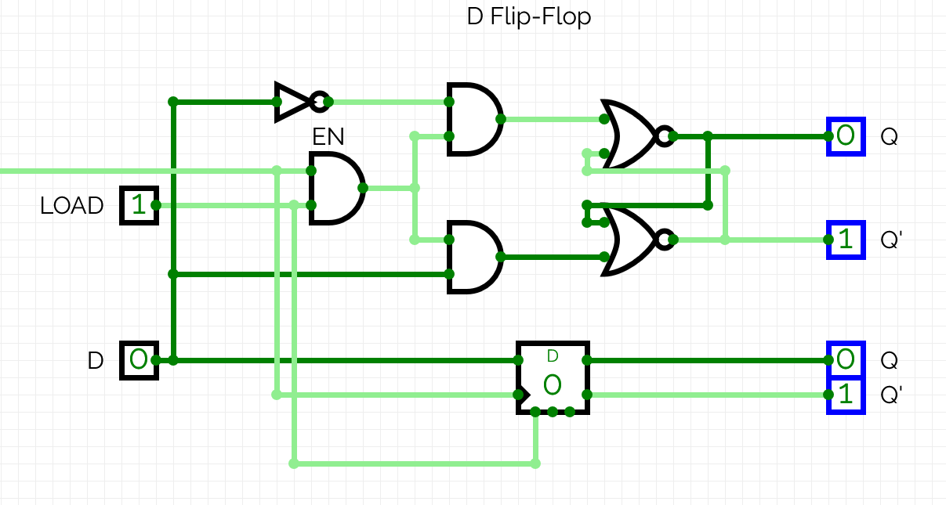
(1):
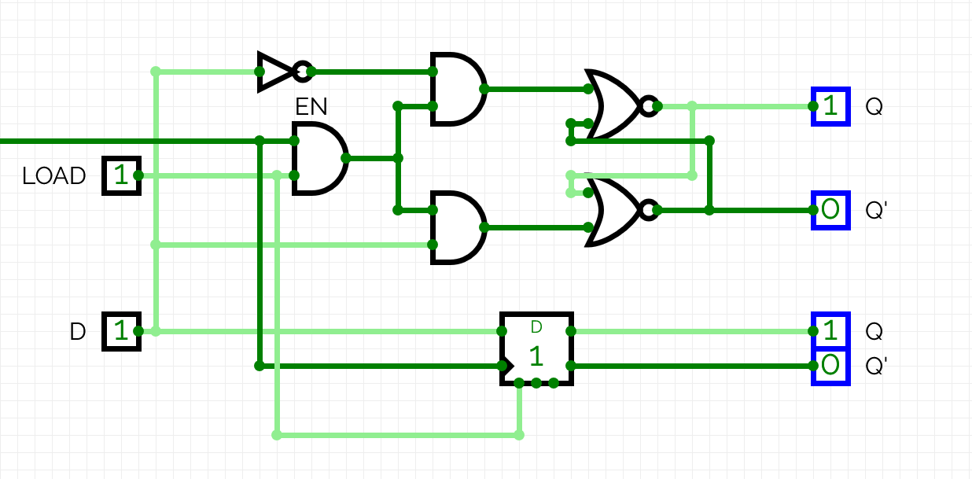

As the circuit follows the truth table for the D flip-flop, it is built correctly.

T flip-flop:
Truth table for this circuit:
T | Q0 | Q
0 | 0 | 0
0 | 1 | 1
1 | 0 | Q0’ = 1
1 | 1 | Q0’ = 0
Screenshots of outputs for inputs of the form (T,Q0):
(0,0):
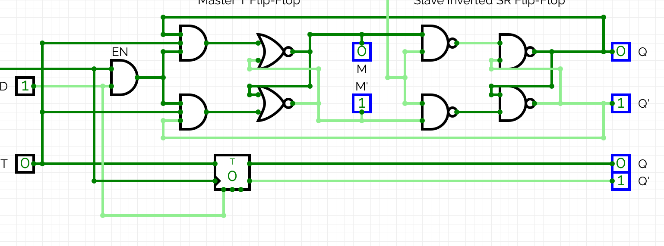
(0,1):
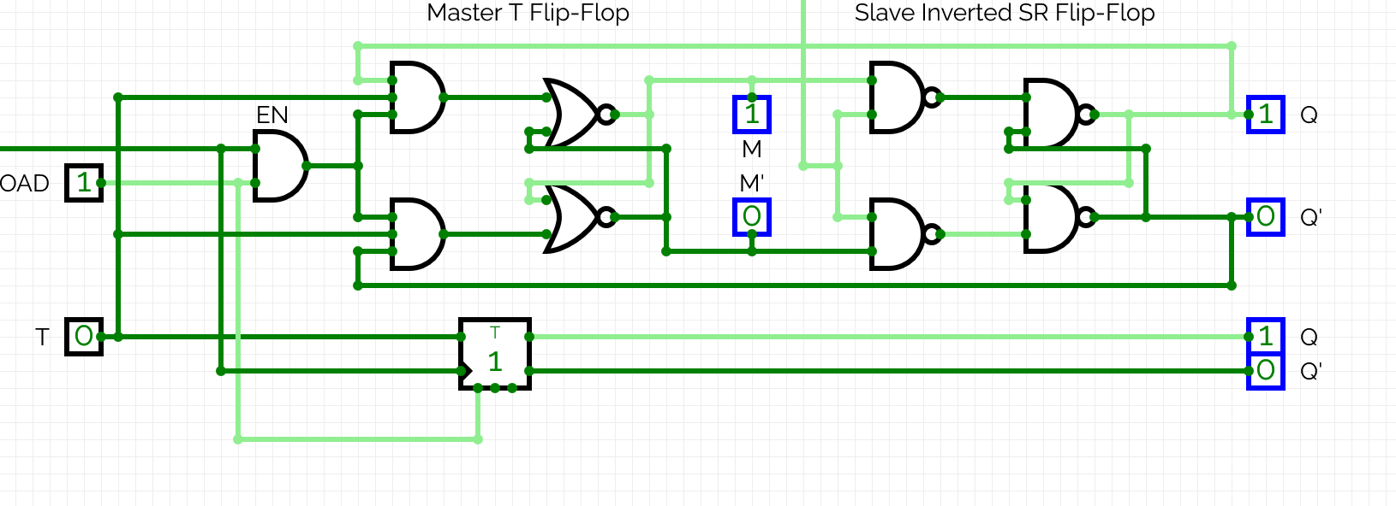
(1,0):
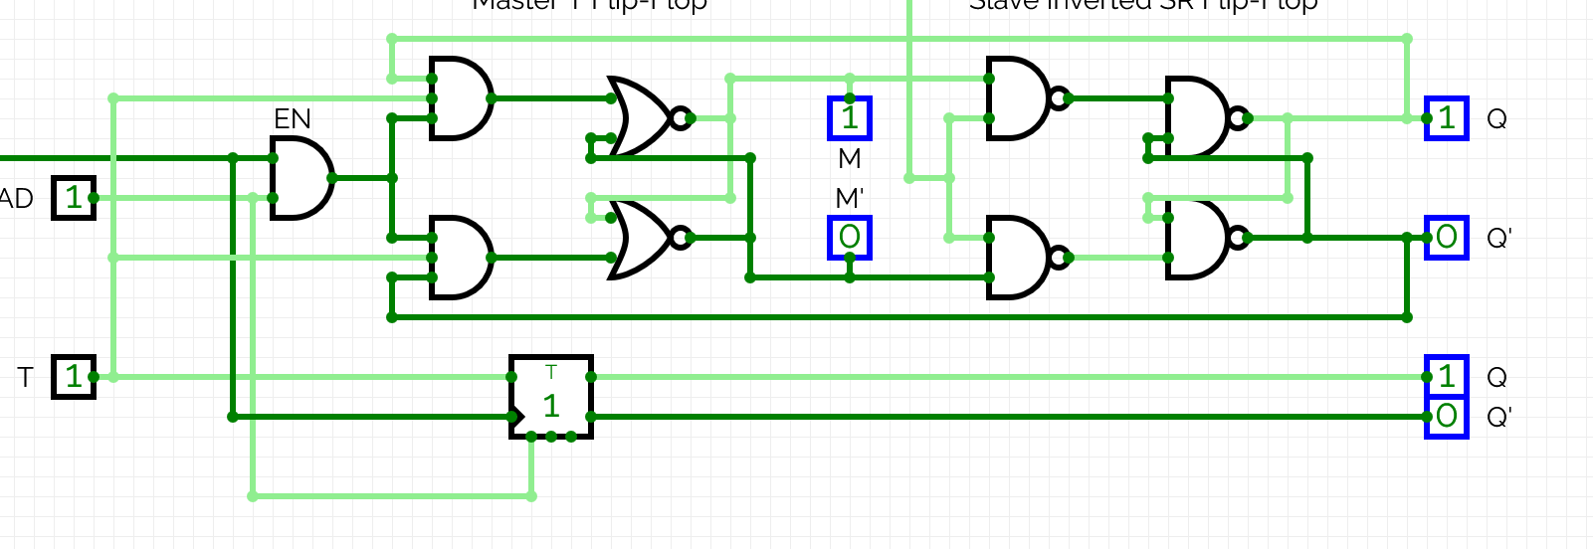
(1,1):
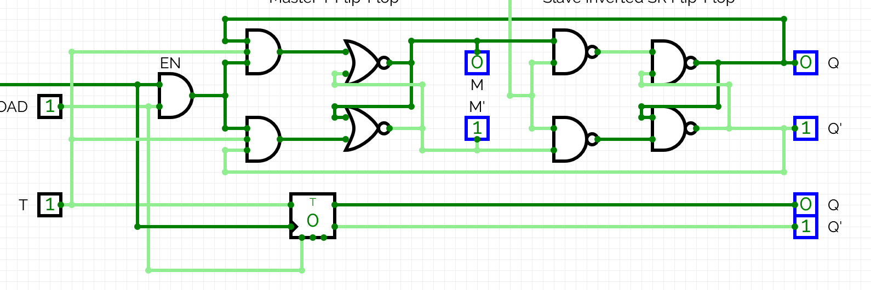

As the circuit follows the truth table for the T flip-flop, it is built correctly.

Exercise 6: Create a basic digital memory circuit
Objective: Taking as a basis the simulated circuits in class, create a solution to store data from a single 8-bit bus in eight 1-byte parallel registers, where the user can select in which register the data is stored.
Tasks:
- Design the solution in CircuitVerse
- Illustrate and explain the logic of your design to route and store the data by capturing screenshots and describing how your circuit works.
- Export your circuit with the filename P2_EX6_YOUR_INITIALS.cv.
- Upload the exported circuit file to Moodle.
- Consolidate all documentation into a report.

REPORT (you may extend the report as needed beyond this page)

I confirm that the truth tables, derivations, minimisation working, expressions, circuits, code, screenshots and written analysis in this submission are entirely my own work, produced without any AI assistance. | Yes / No
Signature | Timurs Timofejs
Date | 10.11.2026.
Here’s the circuit I designed to solve this problem:
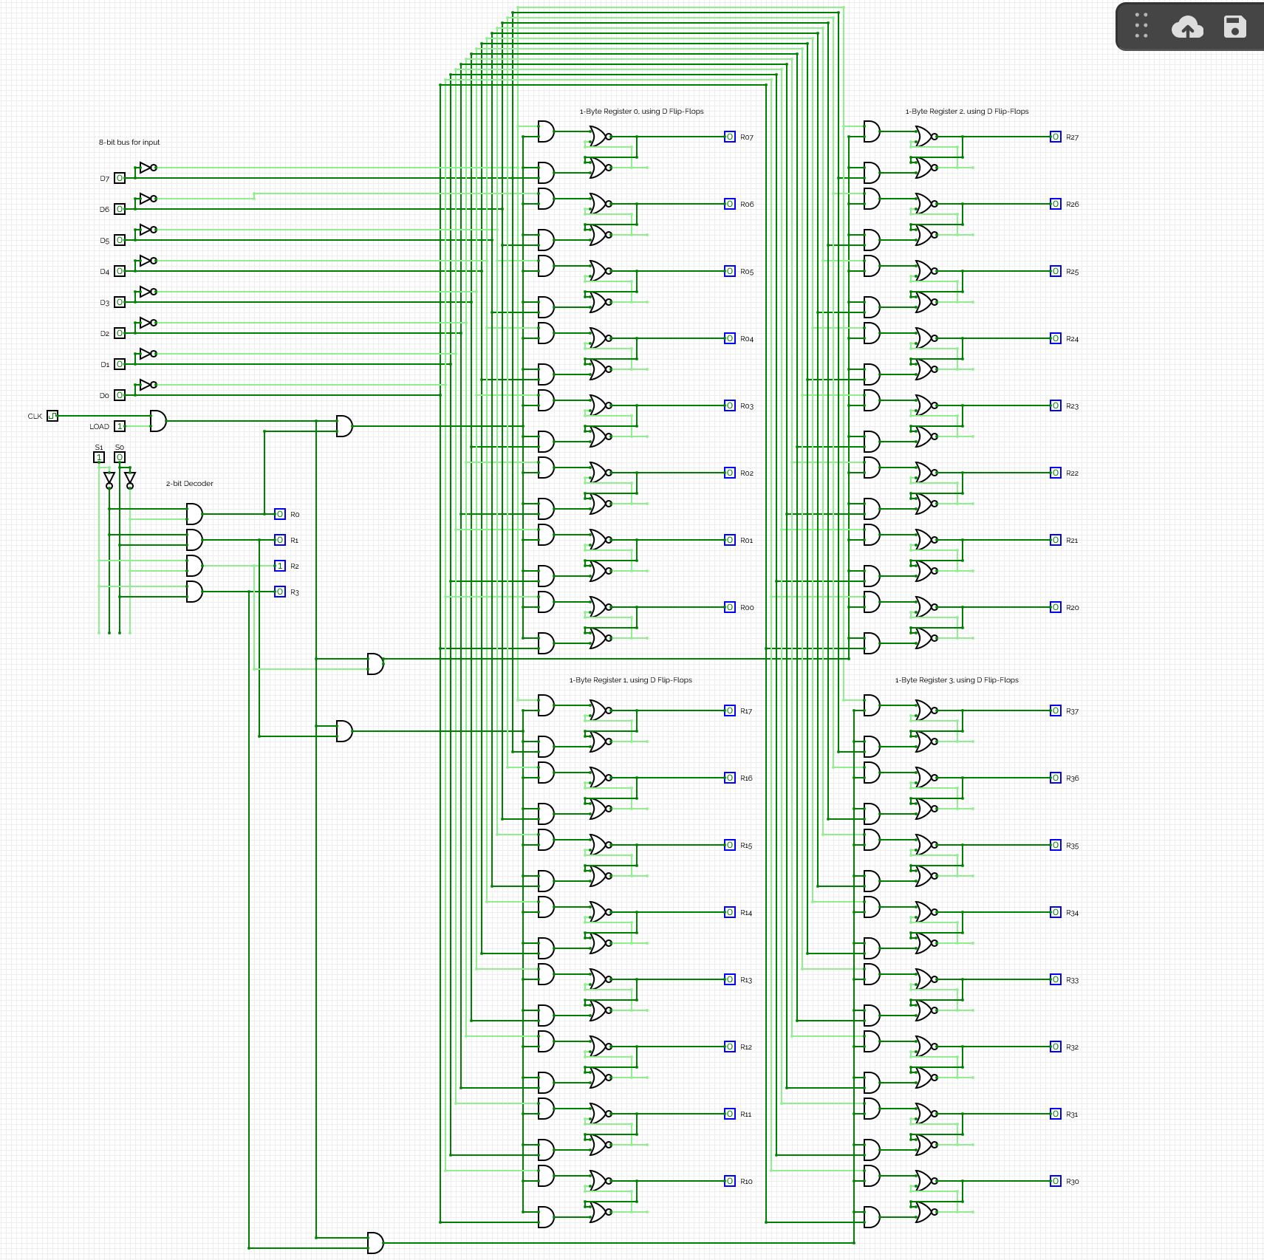

It can be split into 4 main parts:
- The 8-bit bus, made out of 8 separate 1-bit inputs.
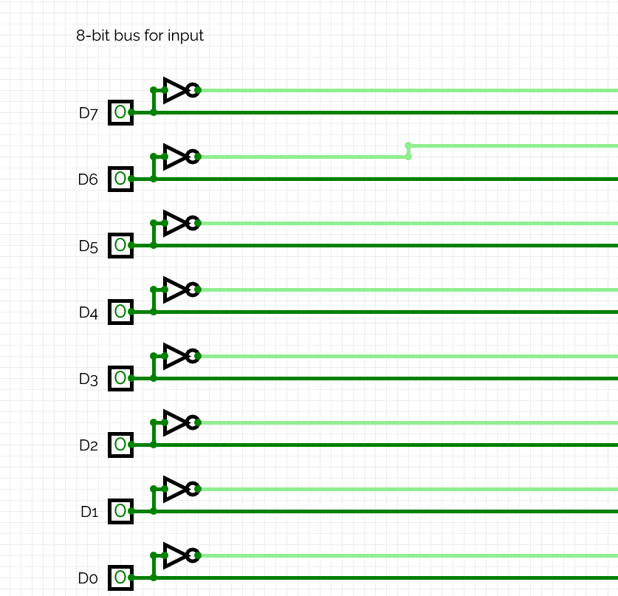
It sends the input byte to store in one of the registers. The inputs’ inverted value is acquired beforehand, as it is used later in the storing process.

- The load-enable, made out of a single 1-bit input field.
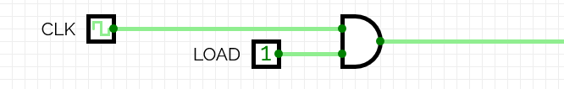
It is accompanied by the master clock, which sends an update signal to store the data.
The logic is as follows:
CLK * LOAD
CLK | LOAD | Result
0 | 0 | 0, do nothing
0 | 1 | 0, do nothing
1 | 0 | 0, do nothing
1 | 1 | 1, store the byte

- The 2-bit decoder, made out of 2 1-bit inputs and 4 output lines.
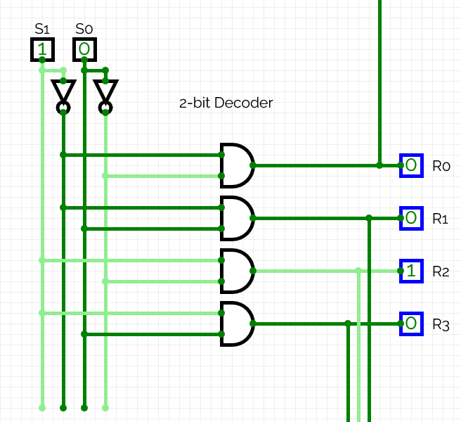
This section decides, to which one of the registers to send the byte. As there are 4 registers, 2 inputs are needed to select a unique line for each.
The logic is as follows:
R0 = S0’S1’
R1 = S0’S1
R2 = S0S1’
R3 = S0S1

S0 | S1 | Result
0 | 0 | Store in register 0
0 | 1 | Store in register 1
1 | 0 | Store in register 2
1 | 1 | Store in register 3

- The 4 8-bit registers, made out of 8 D flip-flops each.
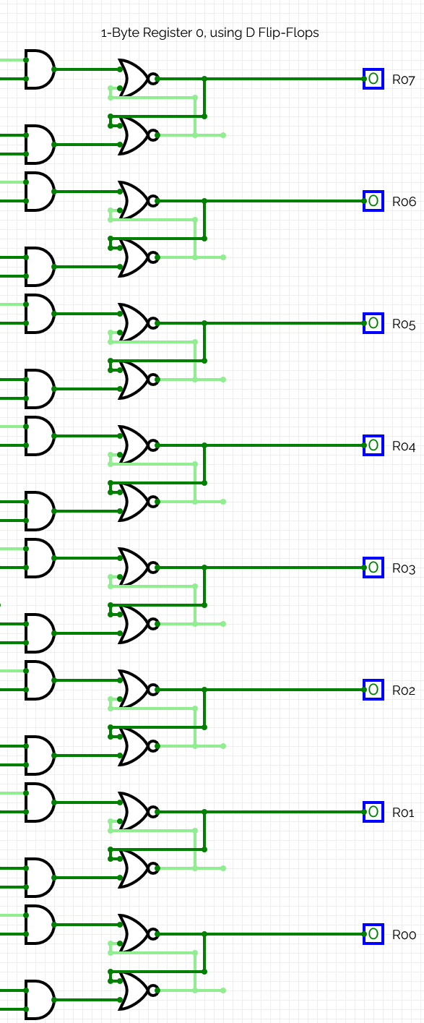

Each one of a D flip-flops is made out of 2 AND gates and 2 NOR gates.
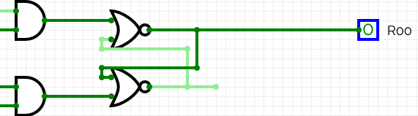

The logic is as follows:
(Example given for register 0, bit 0, similar logic applies to the other ones.)
On the top AND gate:
D0’ * CLK*LOAD*R0, where
D0’ is the inverted bit 0 of data from the input bus.
CLK*LOAD*R0 is the condition, on which to load. Must be on a clock edge, allowed to load and selected register 0 to do so.

On the bottom AND gate:
CLK*LOAD*R0 * D0, where
D0 is the bit 0 of data from the input bus.
CLK*LOAD*R0 is the condition, on which to load.

To summarize, it is a D flip-flop for register 0, bit 0 that stores it if it’s a clock edge, allowed to do so and register 0 is selected.

Screenshots of functionality:
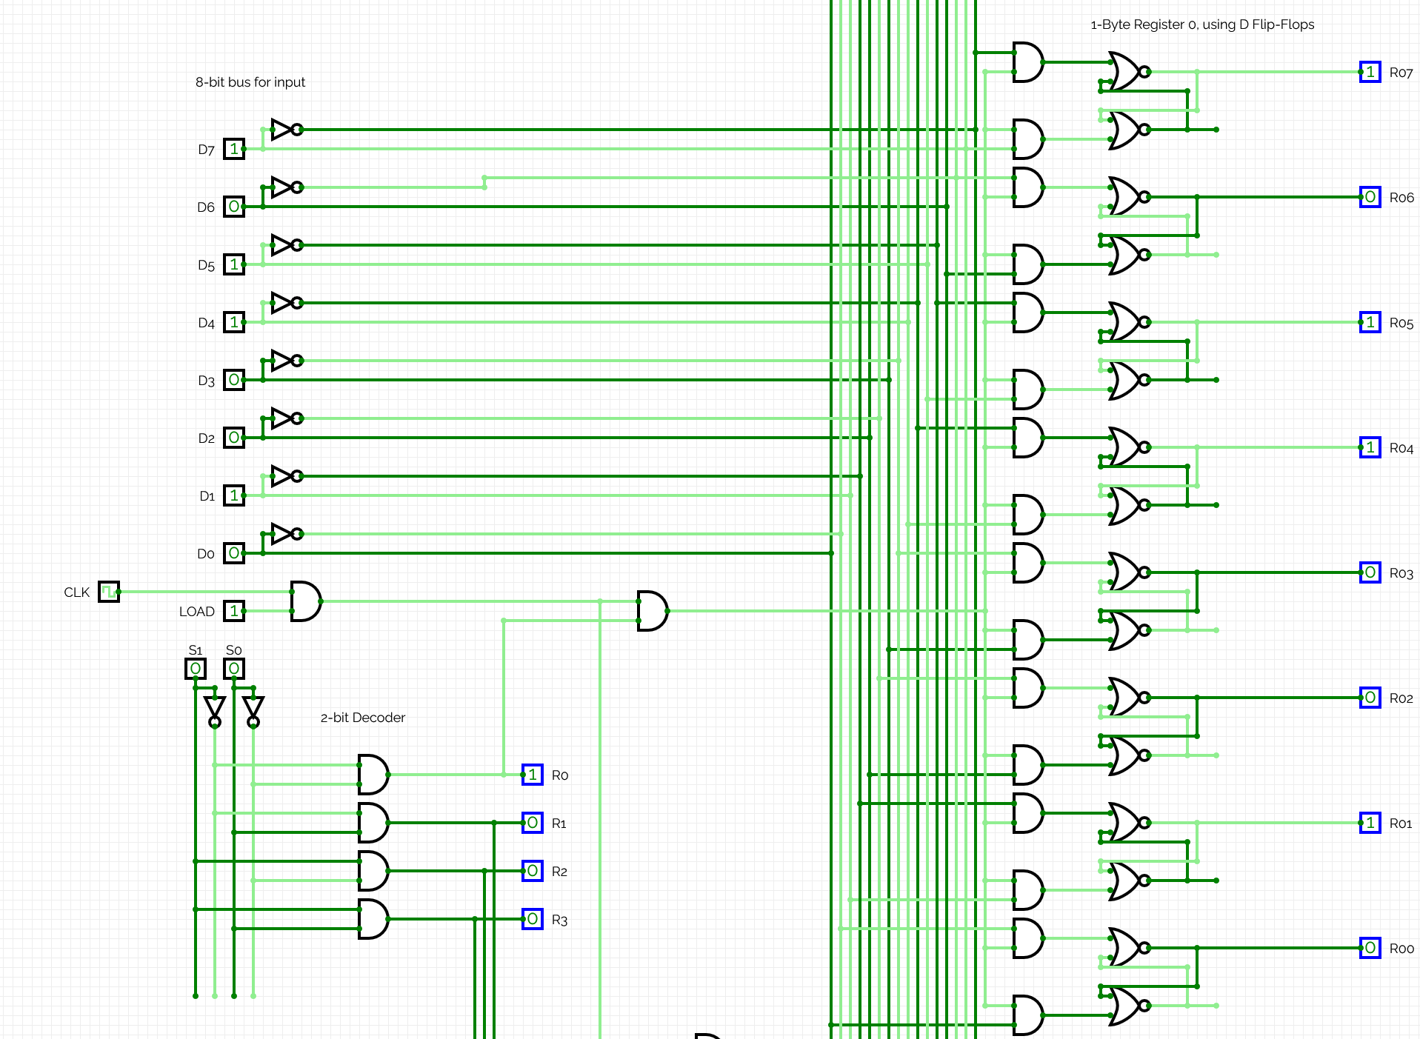

Here, I’m storing the 8 bits from the input bus into register R0. To do so, I input the 8 bits into the input bus (D7 through D0 are 10110010). Then, I select the register to load into (S1 = 0, S0 = 0 ---> R0). Finally, I allow the data to be stored by setting LOAD to 1.
As a result, R07 through R00 read 10110010, the same as in the input bus. Data stored successfully.

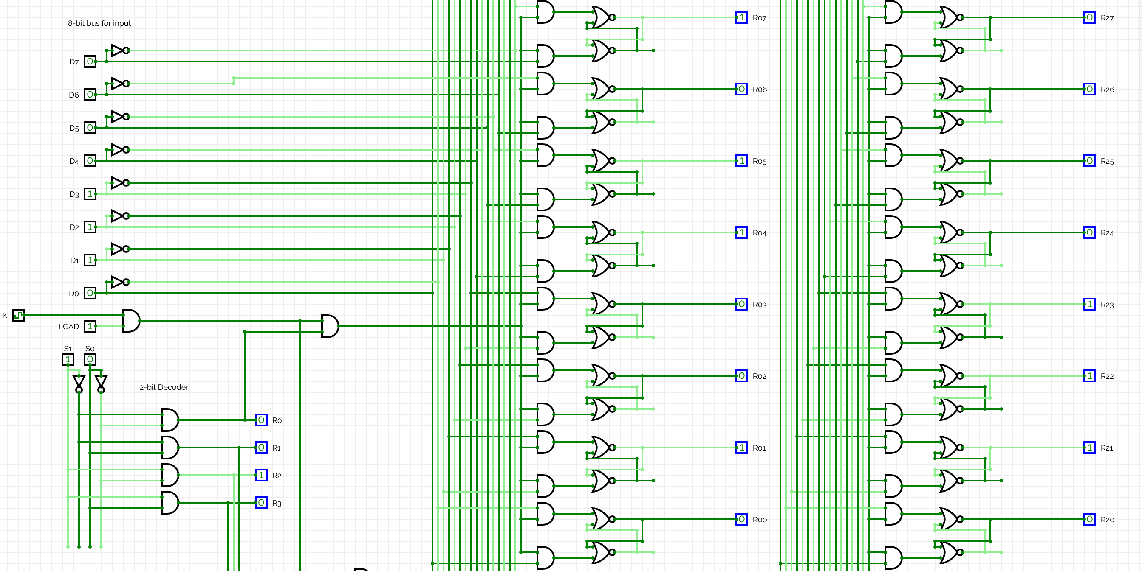

Here, I’m storing the value “00001110” into register 2. Register 2 is selected by S1=1, S0=0, LOAD is enabled. As a result, R27 through R20 show the same value “00001110”, as intended. Furthermore, the register 0 keeps its old value, “10110010”, from the previous run – the D flip-flops keep the data without external signals.

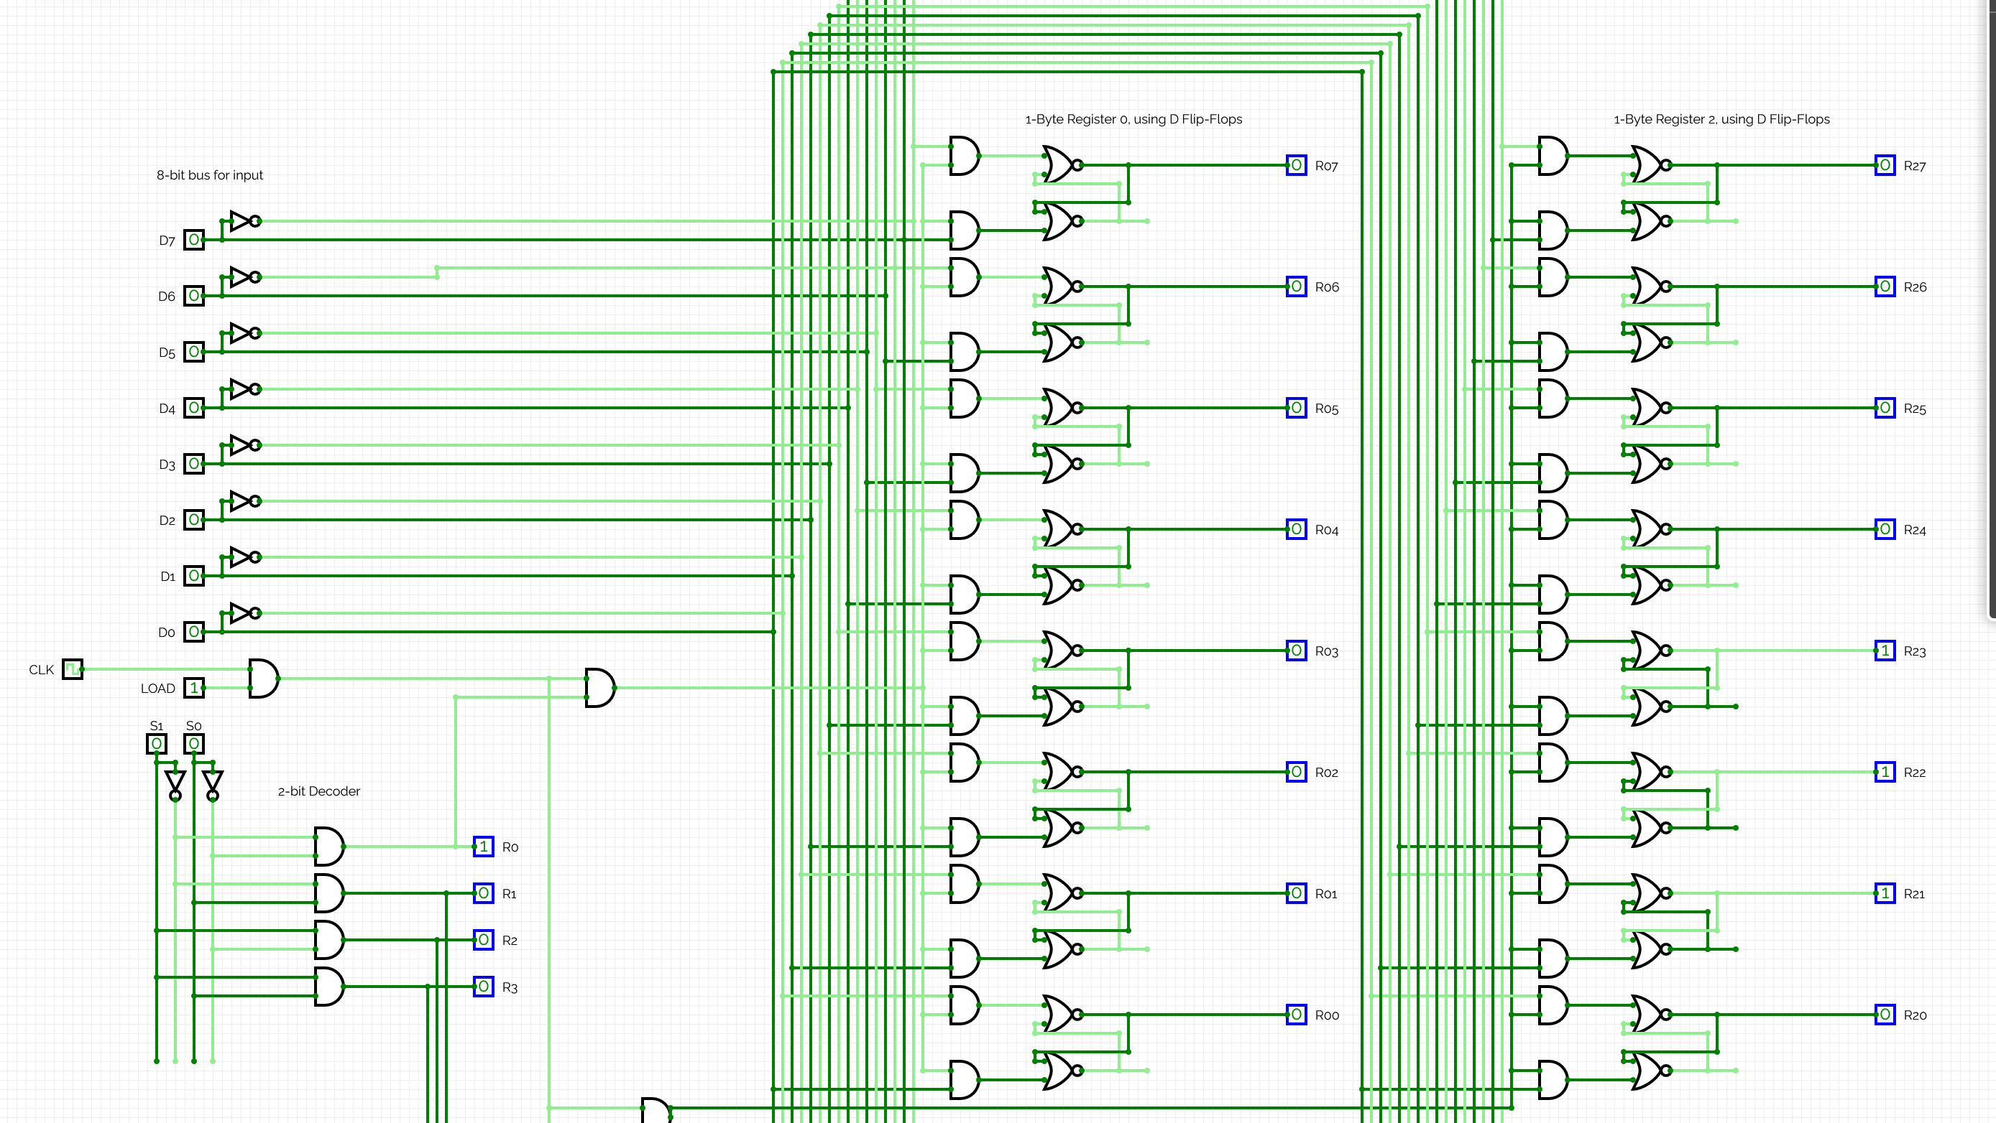

Here, I’m setting the value of register 0 to “00000000”. I changed S1 to 0, S0 to 0 to select register 0, set LOAD to 1. The value of register 0 is indeed now “00000000”. Register 2 keeps its old value, “00001110”.

Registers 1 and 3 work as well in a similar fashion, which can be checked in CircuitVerse using the .cv file.

YOU SHOULD NOT EXPECT TO GET ANY REMINDERS FROM TUTORS ABOUT ANY OF THESE
RESPONSIBILITIES OR DEADLINES

