Auto A11y User Guide
  - Desktop Application User Manual
CNIB Access Labs
July 2026
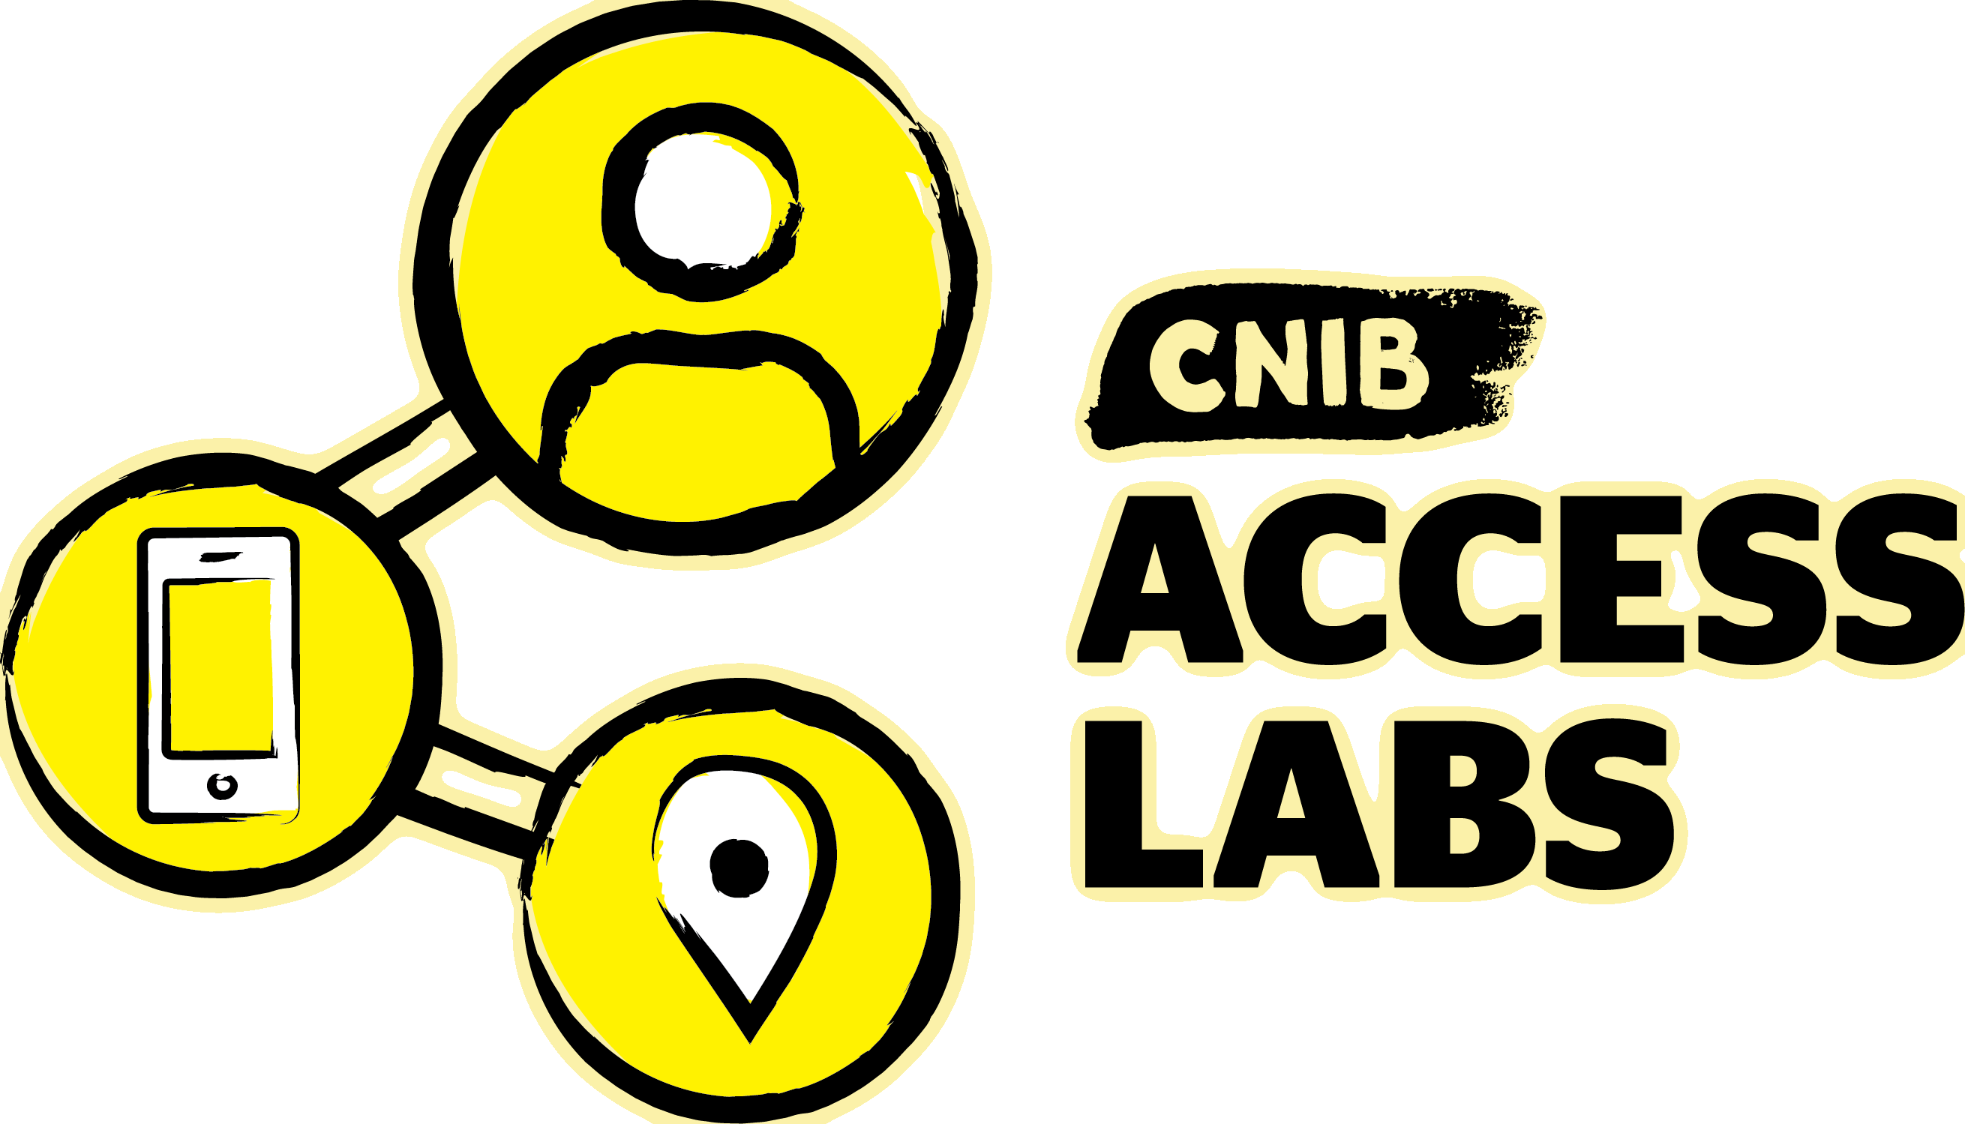
Auto A11y is a web accessibility testing platform. It crawls websites, runs hundreds of automated WCAG checks in a real browser, adds AI-powered visual analysis, tests PDFs, and produces reports ranging from a one-page executive summary to a complete offline audit package.
This guide walks through the desktop application using a real example project — Inaccessibility Matters, a deliberately inaccessible demonstration site — so every screenshot shows genuine test data.

Contents
Update this field (select all, then F9) to build the table of contents.

An introduction to accessibility testing
Web accessibility means building websites that everyone can use, including people who are blind or have low vision, are deaf or hard of hearing, have motor impairments that make a mouse difficult, or have cognitive disabilities. The international standard is the Web Content Accessibility Guidelines (WCAG), organized into success criteria at three conformance levels: A, AA (the common legal target), and AAA.
No single technique catches every accessibility barrier. Auto A11y combines several complementary kinds of testing, and understanding what each can and cannot do is the key to using the tool well.
- Automated DOM testing. Hundreds of programmatic checks run against the page’s structure in a real browser — missing alt text, form fields with no label, invalid ARIA, heading levels that skip. This is fast, exact, and repeatable, but it can only find problems a machine can be certain about. It cannot tell you whether alt text is meaningful, only whether it exists.
- AI visual analysis. Some barriers are only visible in the rendered page: text that looks like a heading but isn’t marked up as one, a reading order that doesn’t match the visual layout, an animation with no pause control. Auto A11y sends page screenshots to Claude AI to catch these — judgment calls that DOM inspection structurally cannot make.
- Manual review (Discovery). Some things a tool can only flag for a human to judge: does this video have accurate captions? Is this form’s error handling clear? Auto A11y surfaces these as Discovery items and collects them in a dedicated report so a human reviewer knows exactly where to look.
- Lived-experience testing. The ultimate test is a person with a disability using the site. Auto A11y can ingest recordings of these sessions and compile their findings alongside the automated results.
- Document testing. Accessibility doesn’t stop at HTML. Auto A11y audits PDF documents against PDF/UA and WCAG.
A complete audit uses all of these. Automated testing tells you where the obvious problems are and gives you a baseline to track over time; AI and manual review find what automation misses; lived experience confirms whether the site actually works for real users. This guide covers each part.
Why the tool won’t give you a “100% accessible” stamp. Automated testing can prove a site fails, but it can never prove a site passes — roughly half of WCAG criteria require human judgment. A clean automated result means “no machine-detectable violations,” which is necessary but not sufficient. Treat the score as a floor, not a certificate.

How Auto A11y works
The workflow is a loop: set up a project, find the pages, test them, review what was found, report — then fix the site and re-test to track progress.
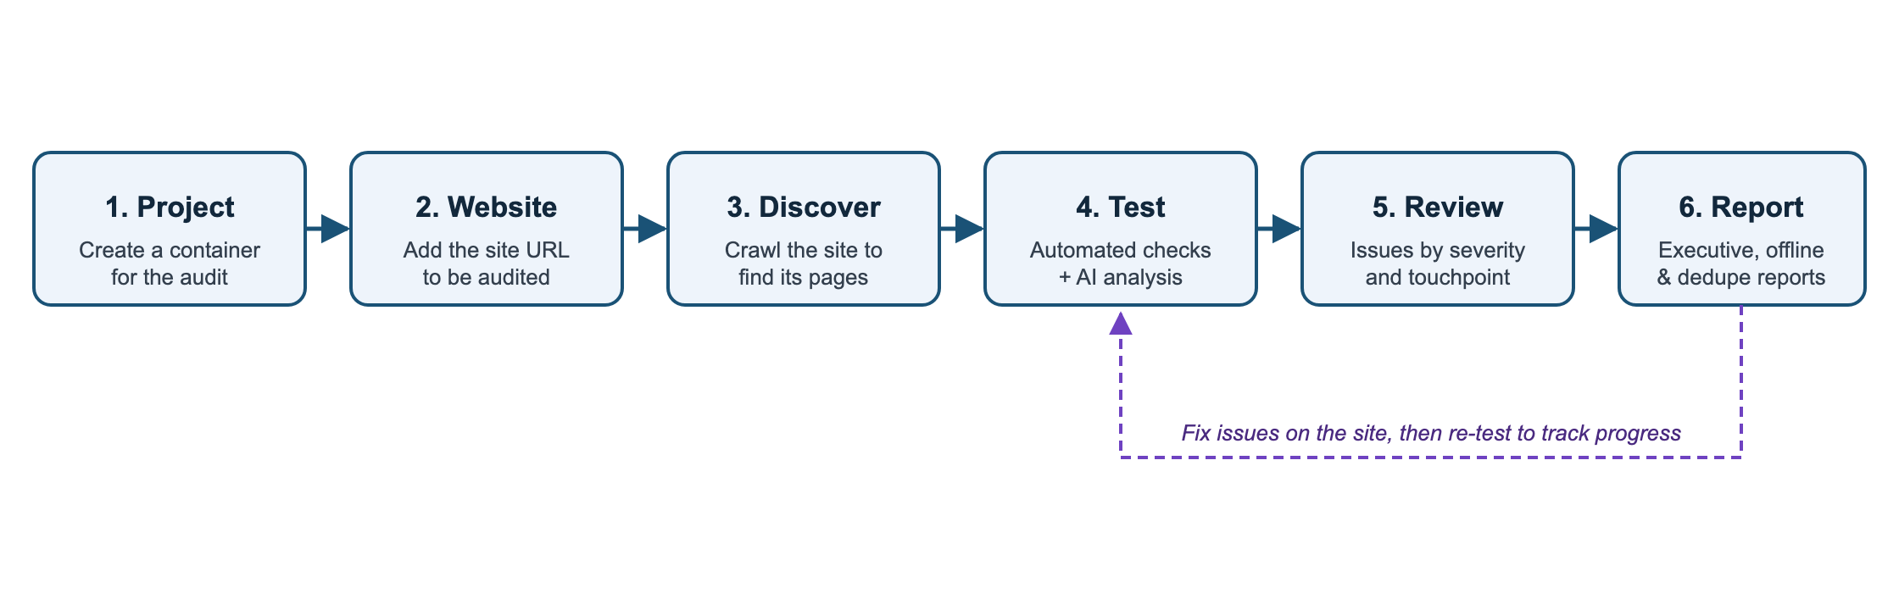
Everything you test lives in a simple hierarchy: a project contains websites, each website contains pages (and PDFs), and every page keeps its own history of test results.
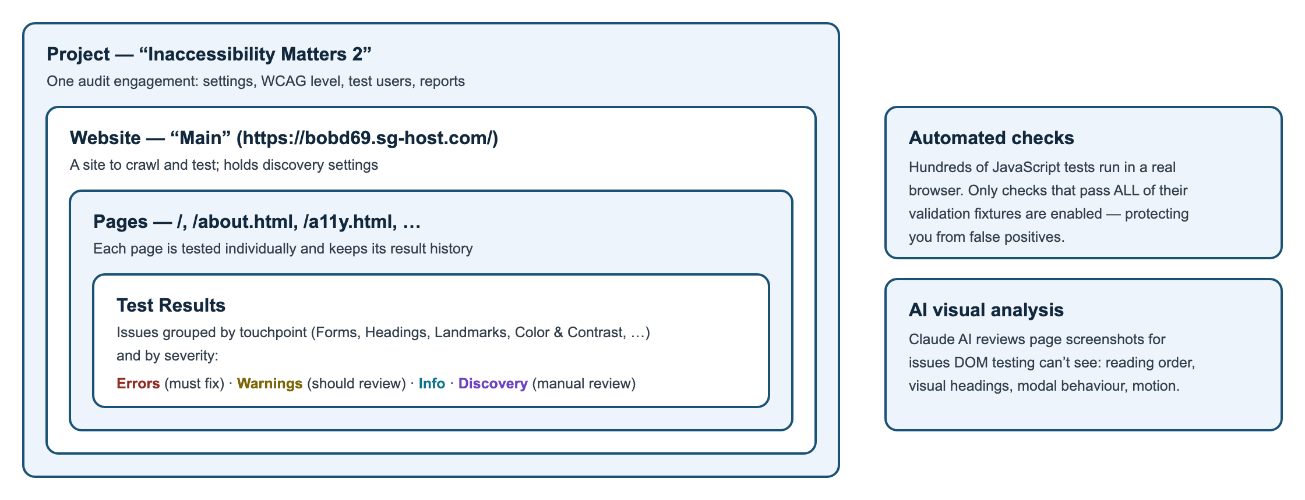
Issues are graded by severity:
Severity | Meaning
Error | A WCAG violation that must be fixed
Warning | A likely barrier that should be reviewed
Info | Worth noting; not necessarily a defect
Discovery | Content the automation found that needs manual review (forms, videos, PDFs, complex widgets)
and organized by touchpoint — the category of accessibility concern (Forms, Headings, Landmarks, Colors and Contrast, Focus Management, and so on). Touchpoints map to the relevant WCAG success criteria in every report, and they are also how you choose what to test (see section 5).
A quality gate protects you from false positives: each automated check is validated against a library of known test cases (“fixtures”), and only checks that pass all of their fixtures are enabled. You can see exactly which checks are active under Testing → Fixture Status, and the full list is in Appendix A.

The Dashboard
The Dashboard is the landing page: portfolio-wide statistics, quick actions, test coverage, and system status.
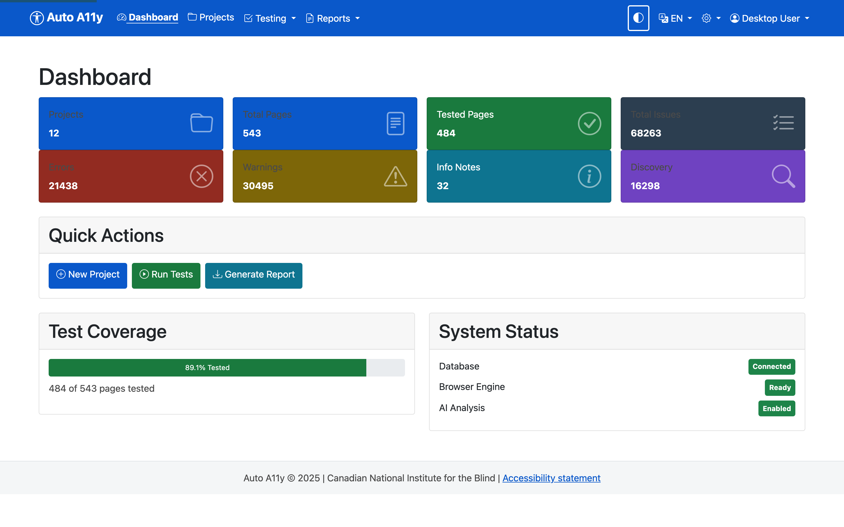
- Stat tiles — totals across all projects: pages, tested pages, and issues broken down by severity.
- Quick Actions — jump straight to creating a project, running tests, or generating a report.
- Test Coverage — how much of your page inventory has been tested.
- System Status — the database, browser engine, and AI analysis must all be green for testing to run.
The top navigation is always available: Dashboard, Projects, Testing (dashboard, configuration, fixture status, trends), and Reports, plus the dark-mode toggle, language switcher (English/French), and settings on the right.

Creating and configuring a project
A project is the container for one audit engagement — its websites, test settings, WCAG level, test users, and reports. From Projects in the navigation, click New Project.
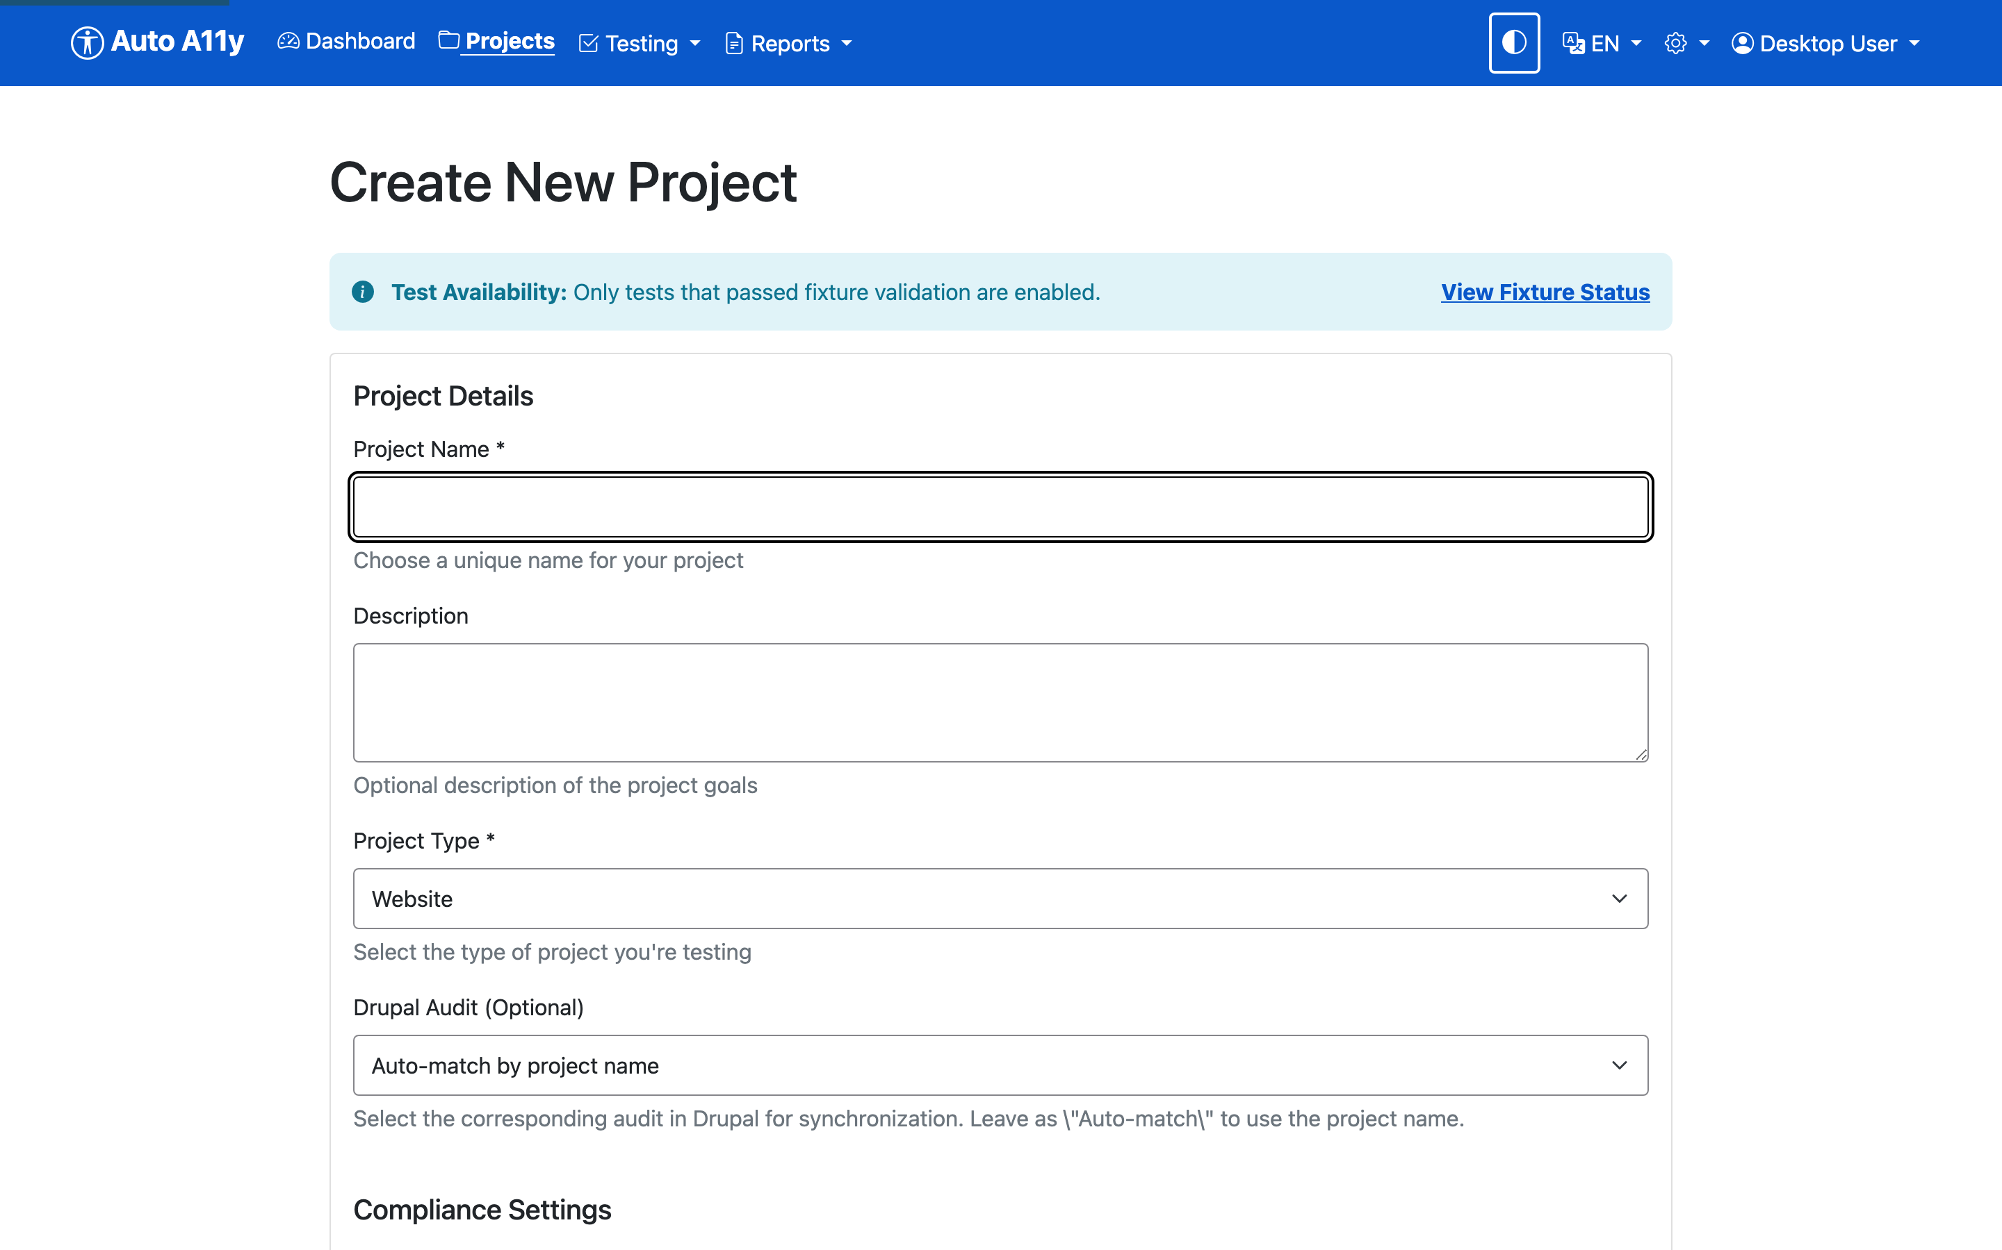
The form is longer than it first appears — scroll down and you configure the entire testing behaviour for the project up front:
- Project Name (required) and Description.
- Project Type — Website is the default.
- Compliance Settings — the WCAG level you’re testing against (A, AA, or AAA). AA is the usual target.
- Inaccessible Fonts — the tool flags hard-to-read fonts. You can use the research-backed default list of 50+ problematic fonts (Comic Sans, Papyrus, narrow and blackletter faces), add your own, or exclude specific fonts your brand requires.
- Browser Display Mode — Headless (invisible, faster) or Visible (shows the Chrome window, useful for debugging).
- Stealth Mode — for bot-protected sites (see section 9).
- Touchpoint Tests — exactly which checks run (see section 5).
- AI-Assisted Testing — the optional Claude analysis (see section 6).
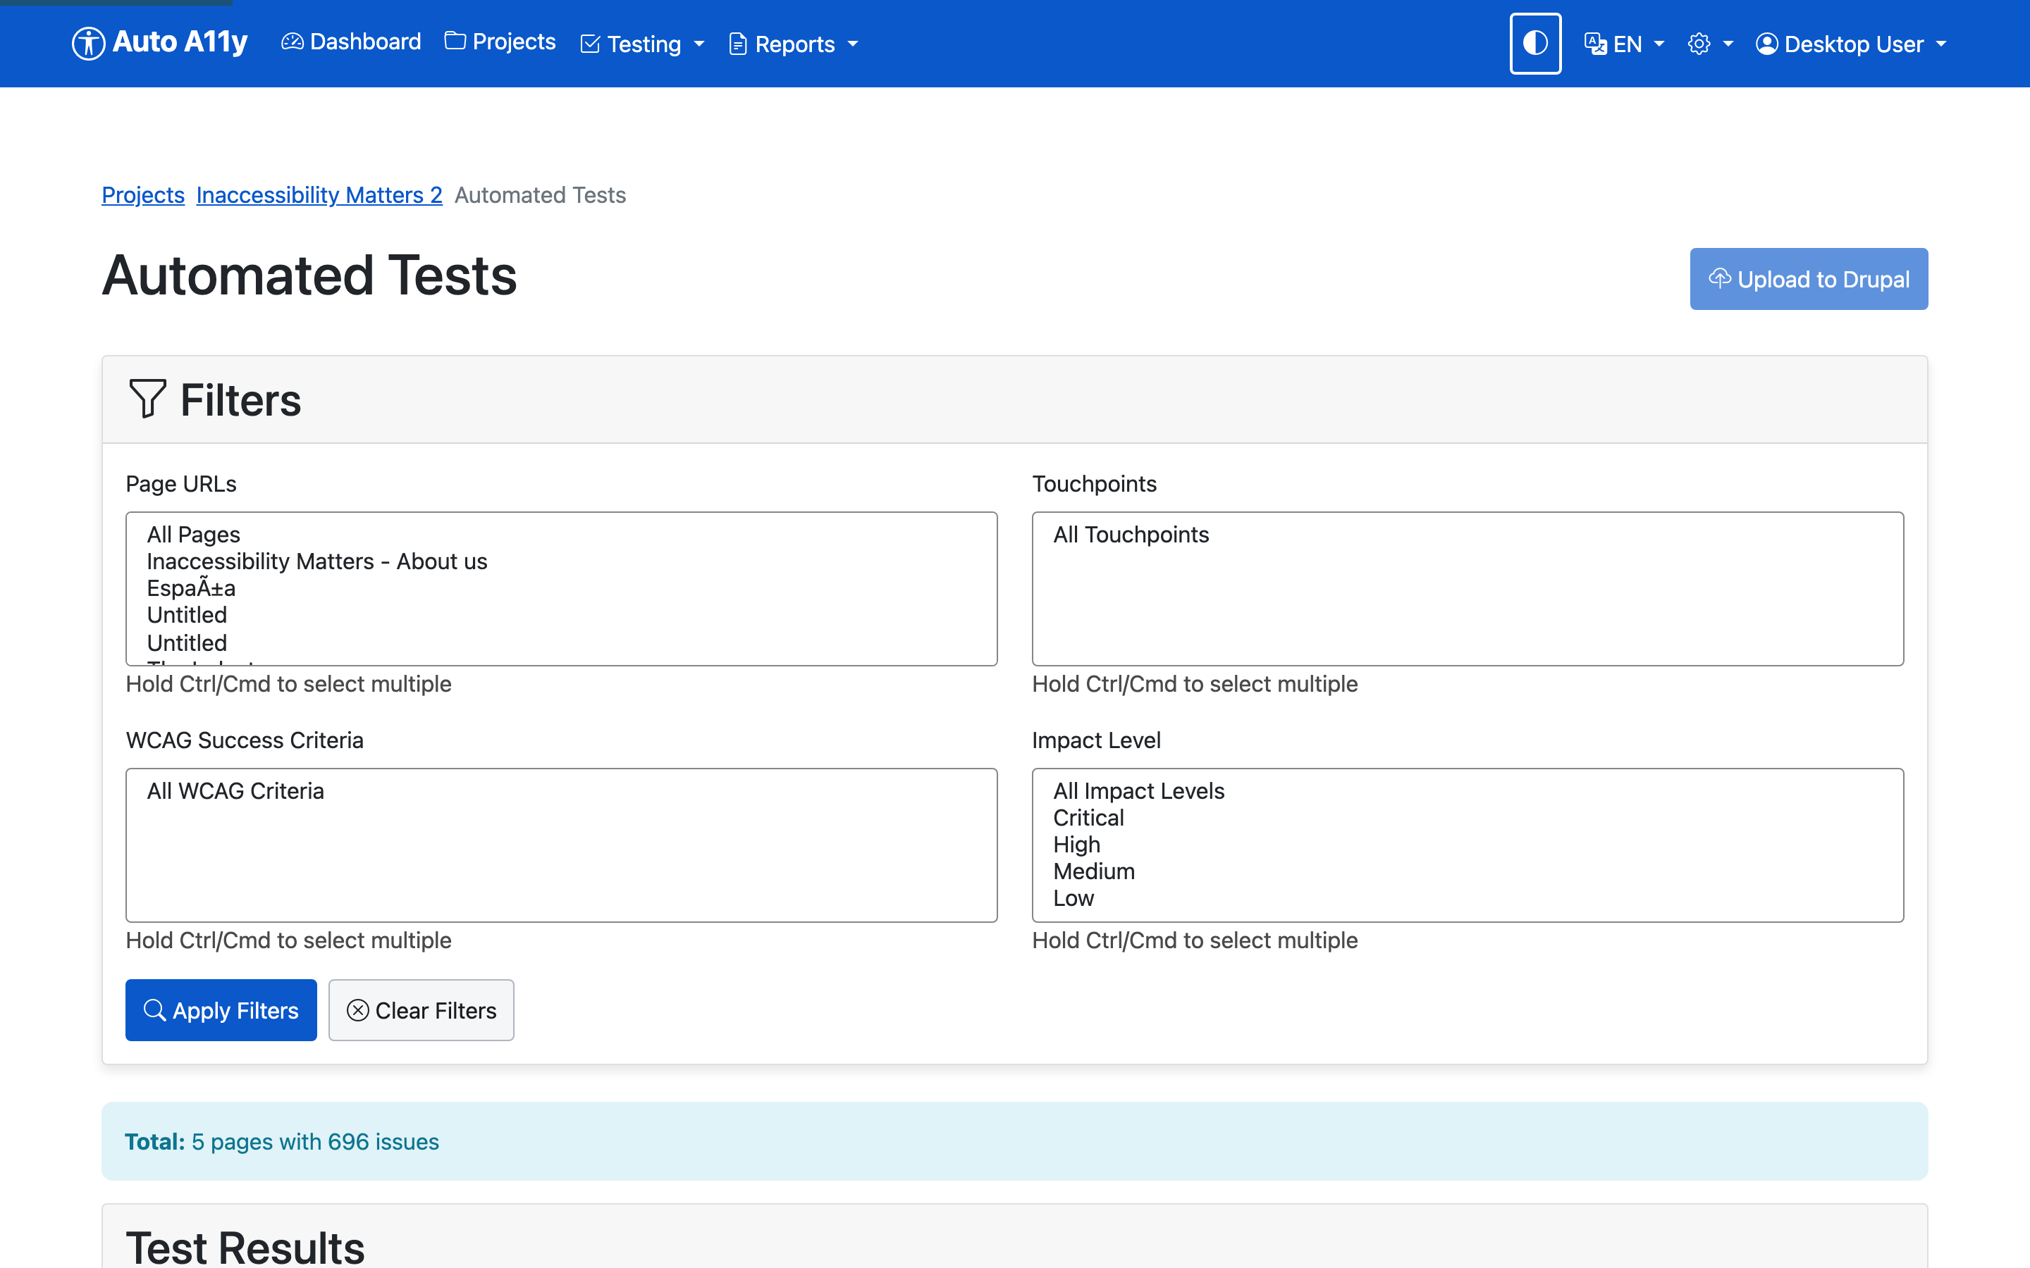
Every setting here can be changed later by opening the project and clicking Edit, or, for the test selection specifically, Automated Tests.

The project page
Once created, opening a project shows everything in one place:
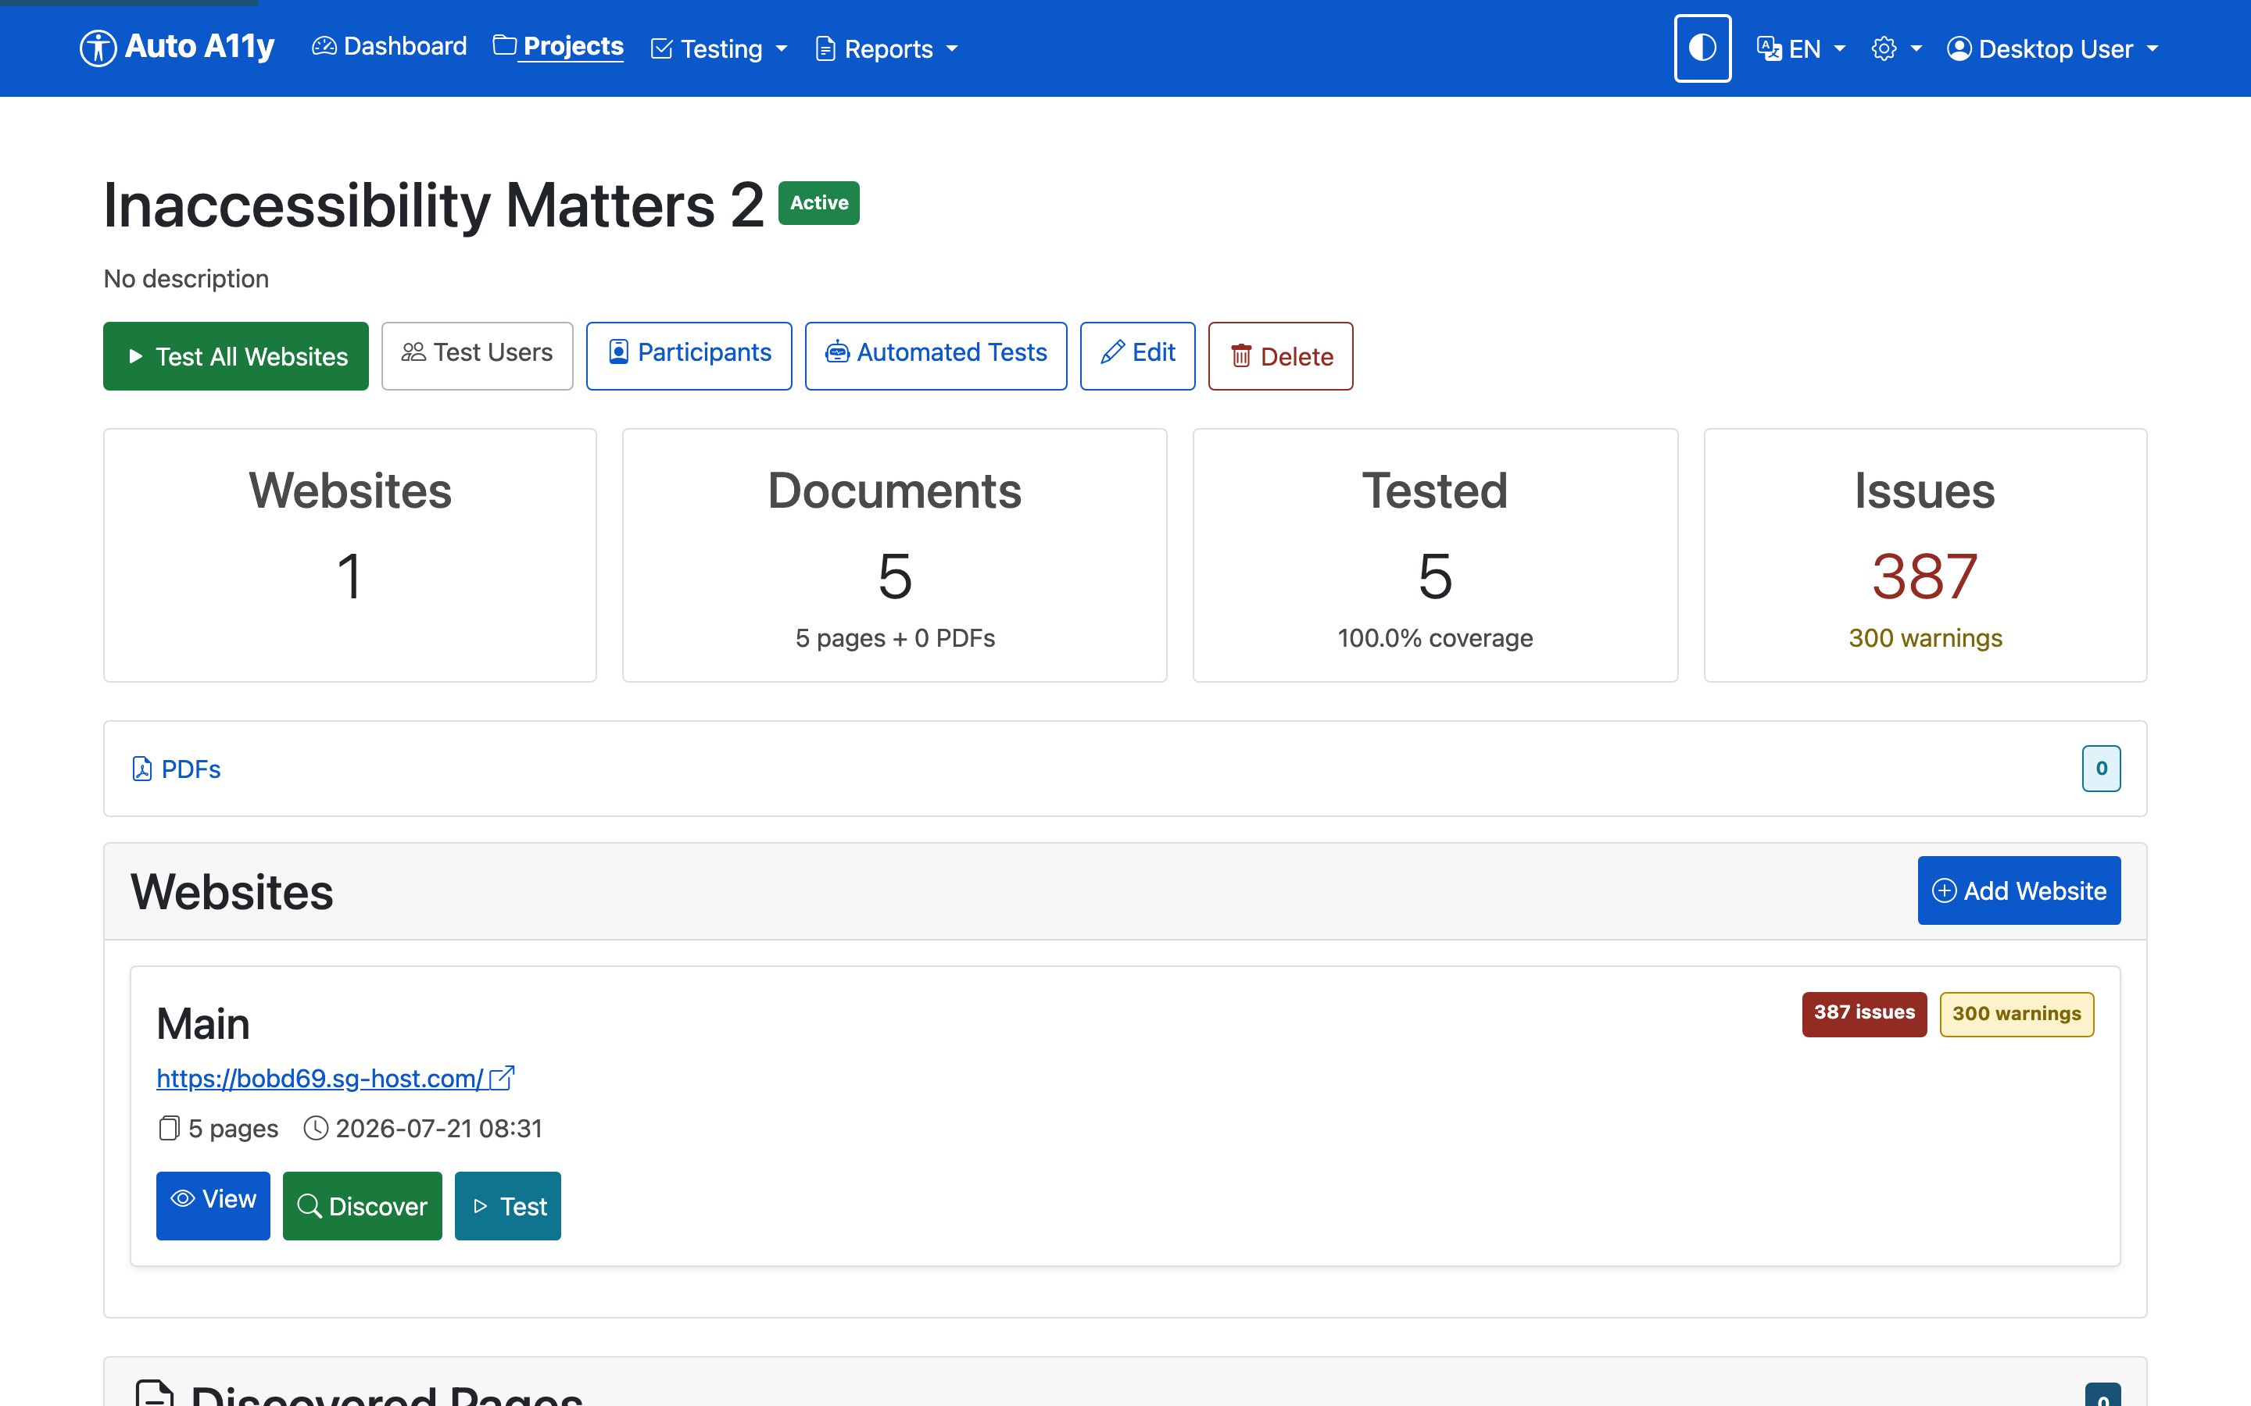
- Test All Websites starts a test run over every website in the project.
- Test Users manages logins for authenticated testing (section 10).
- Automated Tests re-opens the touchpoint/test selection.
- The Websites card lists each site with its issue counts and per-site View / Discover / Test buttons.

Choosing which tests to run
You rarely want every check on every project. A marketing site has no data tables; an internal tool may not care about some discovery notices. Auto A11y lets you choose what runs at two levels of granularity: the touchpoint (a whole category) and the individual test within it.
In the project form (or via Automated Tests / Edit later), the Touchpoint Tests section presents a tree. Each touchpoint is a folder you can expand to reveal its individual checks; each check has its own checkbox.
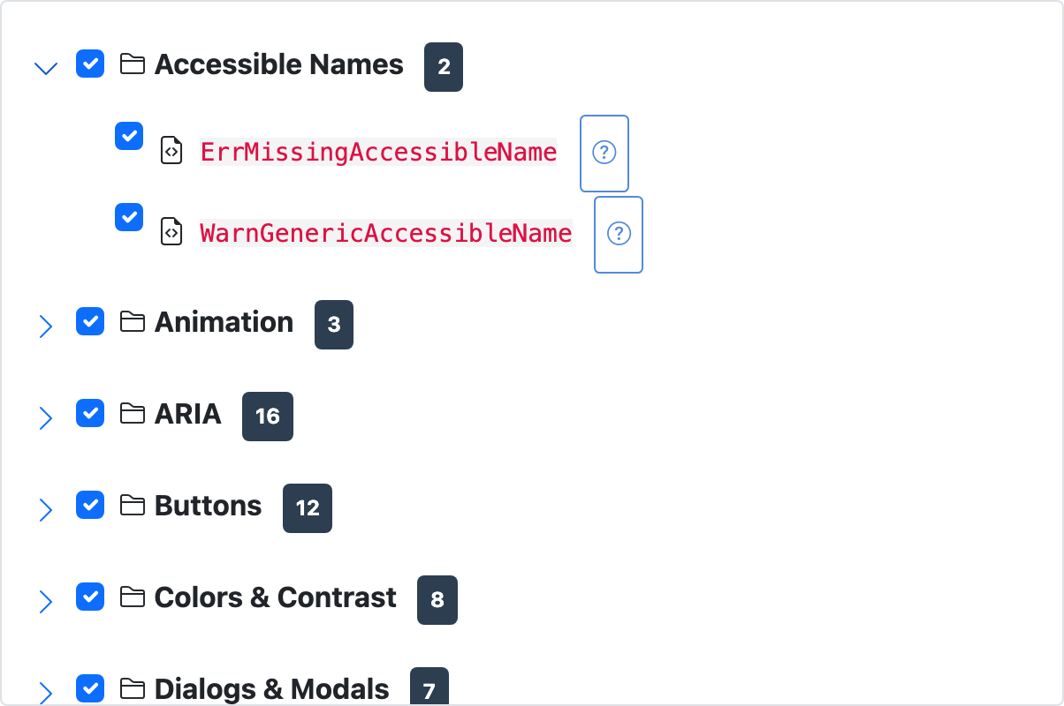
- The number badge on each touchpoint shows how many checks it contains.
- Uncheck a touchpoint to skip the whole category; expand it and uncheck individual tests to fine-tune.
- The help button (question mark) next to each test opens a description of what it checks and why.
- Presets save time: Enable All, Disable All, Minimal (a core subset), and WCAG AA (everything needed for AA conformance).
Checks that haven’t passed fixture validation appear disabled with a status badge — they can’t be enabled because they aren’t trusted for production yet. The complete catalog of checks, grouped by touchpoint, is in Appendix A.

Automated checks versus AI analysis
Auto A11y has two independent testing engines, and the difference between them matters for both cost and interpretation.
Automated (default) checks are deterministic. They run JavaScript against the page in a real browser and apply exact rules: this input has no label, this image has no alt attribute, these two colors fall below the contrast threshold. Given the same page, they return the same result every time. They are free to run, fast, and form the backbone of every test.
AI-assisted checks send page screenshots and HTML to Claude AI for analysis that requires visual judgment. Six analyses are available:
AI check | What it looks for
Heading analysis | Text that looks like a heading but isn’t marked up as one
Reading order | Whether the DOM order matches the visual reading sequence
Modal dialogs | Popup and overlay accessibility (focus, dismissal)
Language | Mixed languages and missing language declarations
Animations | Motion that may need a pause/stop control
Interactive elements | Buttons, links, and controls that look interactive but aren’t properly coded
AI testing is off by default and enabled per project with the AI-Assisted Testing toggle, where you also pick which of the six analyses to run.
Two things to understand before you rely on it:
AI testing costs money. Each AI analysis makes an API call to Claude that is billed by usage. The more pages you test and the more AI checks you enable, the higher the cost. Automated DOM checks have no such cost — enable AI deliberately, not by default.
And, just as importantly:
AI results are stochastic. Unlike the deterministic automated checks, an AI model can return slightly different results on different runs of the same page, and it can occasionally be wrong — a missed issue, or a flagged “issue” that isn’t one. This is inherent to how large language models work, even with the prompting and validation Auto A11y applies. Treat AI findings as expert suggestions to verify, not as ground truth. The automated checks remain your reliable, repeatable baseline.
Used together they’re complementary: the automated engine gives you a solid, repeatable foundation, and AI extends coverage into areas no rule-based tool can reach — as long as you remember which is which.

Responsive breakpoint testing
Modern sites change layout at different screen widths using CSS “media queries” — the point where the layout changes is a breakpoint. An issue can exist at one width and not another: text that has good contrast on desktop may sit on a different background colour once the mobile layout kicks in; a floating element may overlap content only when the viewport is narrow.
For the checks where width matters — colour contrast, floating/obscured content, and some page-level checks — Auto A11y doesn’t just test once. It reads the breakpoints declared in the page’s own CSS, then re-runs the check at each of those widths, so a contrast failure that only appears in the tablet layout is still caught. In the results, these issues are labelled with the specific breakpoint (e.g. “Breakpoint 768px”) so you know exactly which layout to fix.
Checks where width is irrelevant (a missing alt attribute is missing at every width) run once, so this adds testing time only where it actually buys coverage.

Websites and page discovery
Open a website from the project page to manage its pages and testing.
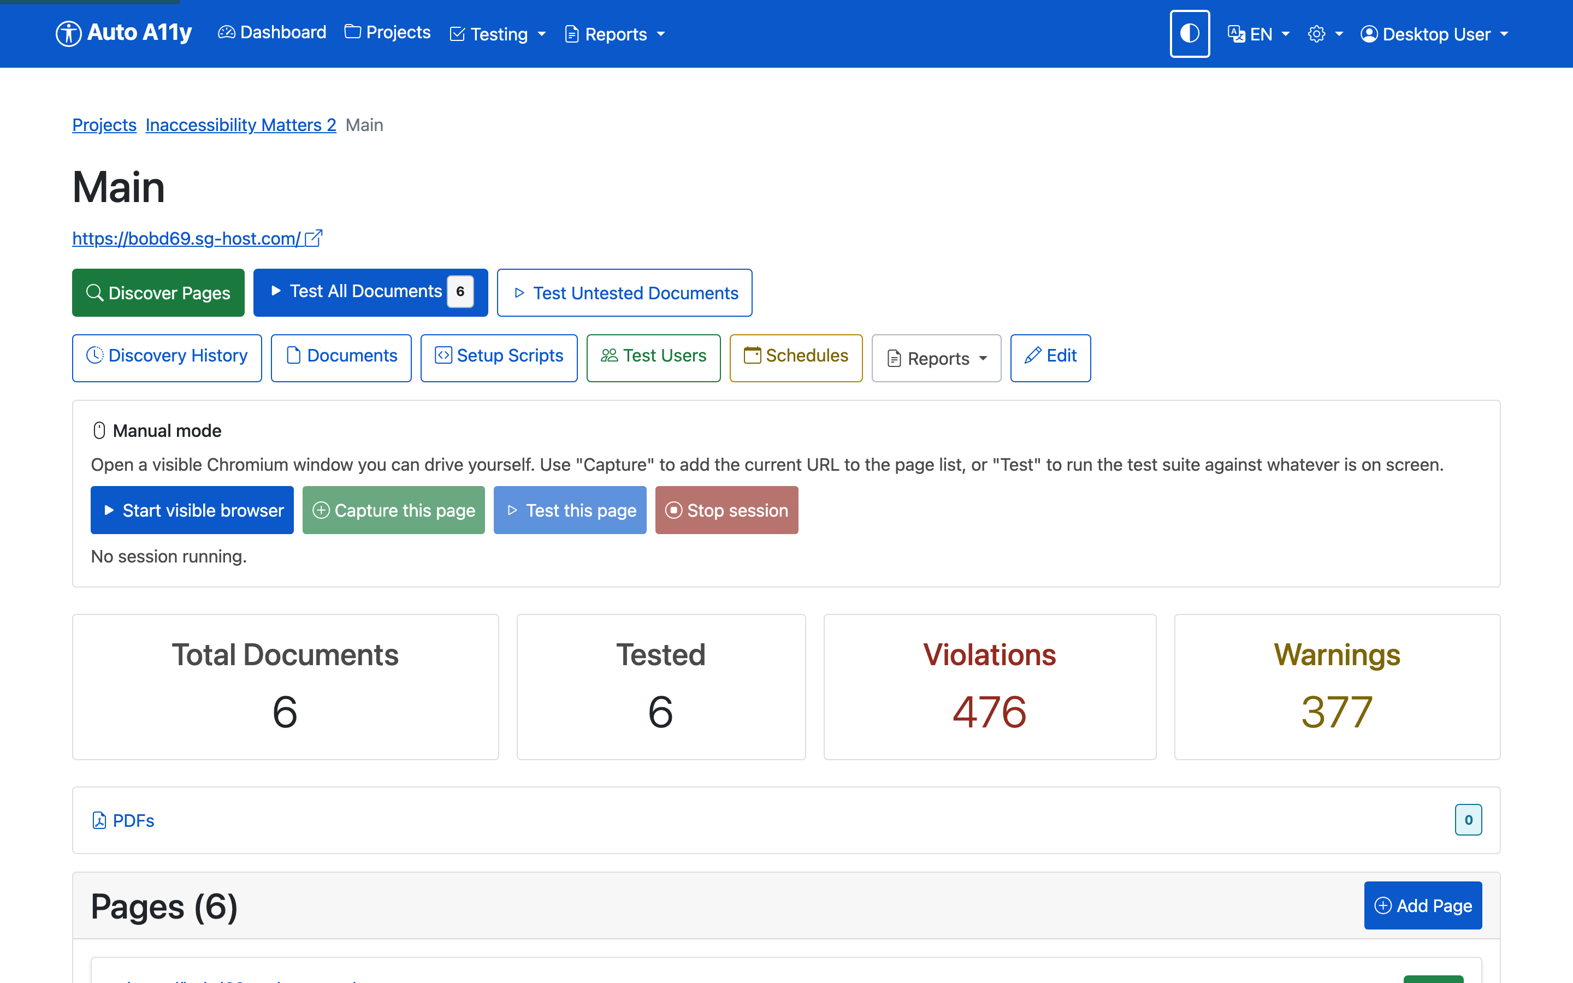

Finding pages
There are three ways to build the page inventory:
- Discover Pages — crawls the site automatically, following links to find pages. Discovery runs in the background; Discovery History shows past crawls.
- Add Page — add a URL by hand (useful for pages the crawler can’t reach).
- Manual mode — opens a visible Chromium window that you drive yourself. Navigate wherever you need — through logins, wizards, or dynamic states — then click Capture this page to add the current URL to the page list, or Test this page to run the test suite against exactly what is on screen.
The Pages list shows every page with its status (tested/untested), latest issue counts, and per-page actions.
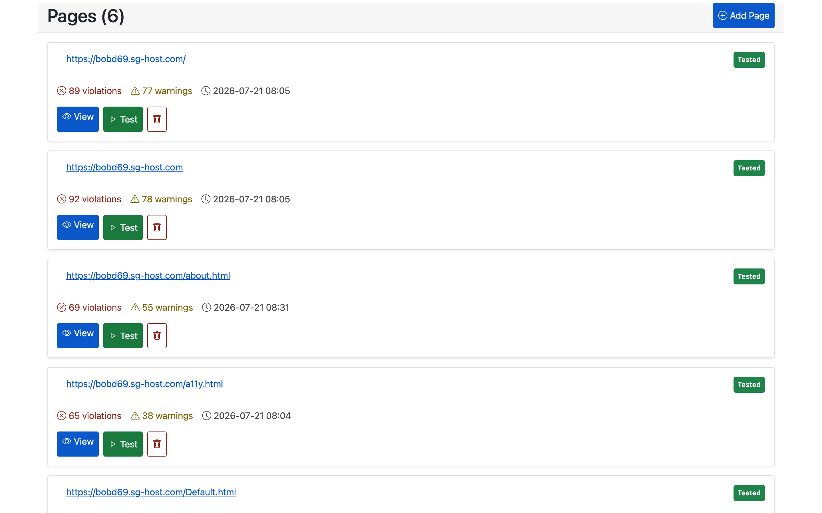

Cloaking: getting past bot protection
Many production sites sit behind bot-protection services such as Cloudflare. These services try to distinguish real browsers from automated ones and will challenge or block traffic they think is a bot — which an accessibility crawler technically is. When a site is protected this way, discovery and testing can fail with challenge pages instead of the real content.
Stealth Mode (the “cloaking” option) is Auto A11y’s answer. When enabled, the browser is disguised to look like an ordinary human-driven session — it hides the automation flags that bot-detectors look for (the webdriver marker, missing browser plugins, and similar tells) so the real page loads.
You enable it per project with the Enable Stealth Mode (for Cloudflare-protected sites) checkbox in the project form.
Only use stealth mode when you need it. The disguise adds significant overhead — roughly 5-15 seconds per page — so discovery and testing run much more slowly. Leave it off for sites that don’t challenge the crawler, and turn it on only when you see bot-protection pages instead of your content. You should also have authorization to test the site; evading bot protection on a site you don’t control may violate its terms of service.

Test users: content behind logins
Much of a real application lives behind a login — a dashboard, an account page, a checkout. An unauthenticated crawler never sees it, so those pages go untested. Worse, what a user can see often depends on their role: a student and an instructor see different pages in a learning platform, an admin sees controls a regular user doesn’t. Each of those views can have its own accessibility problems.
Test users solve both. A test user is a stored login credential that the test runner uses to sign in before testing, so authenticated pages are audited as that user would see them. Because a user carries roles, you can create one test user per role and test each role’s version of the site.
Manage them from Test Users on the project page (they’re shared across all the project’s websites).
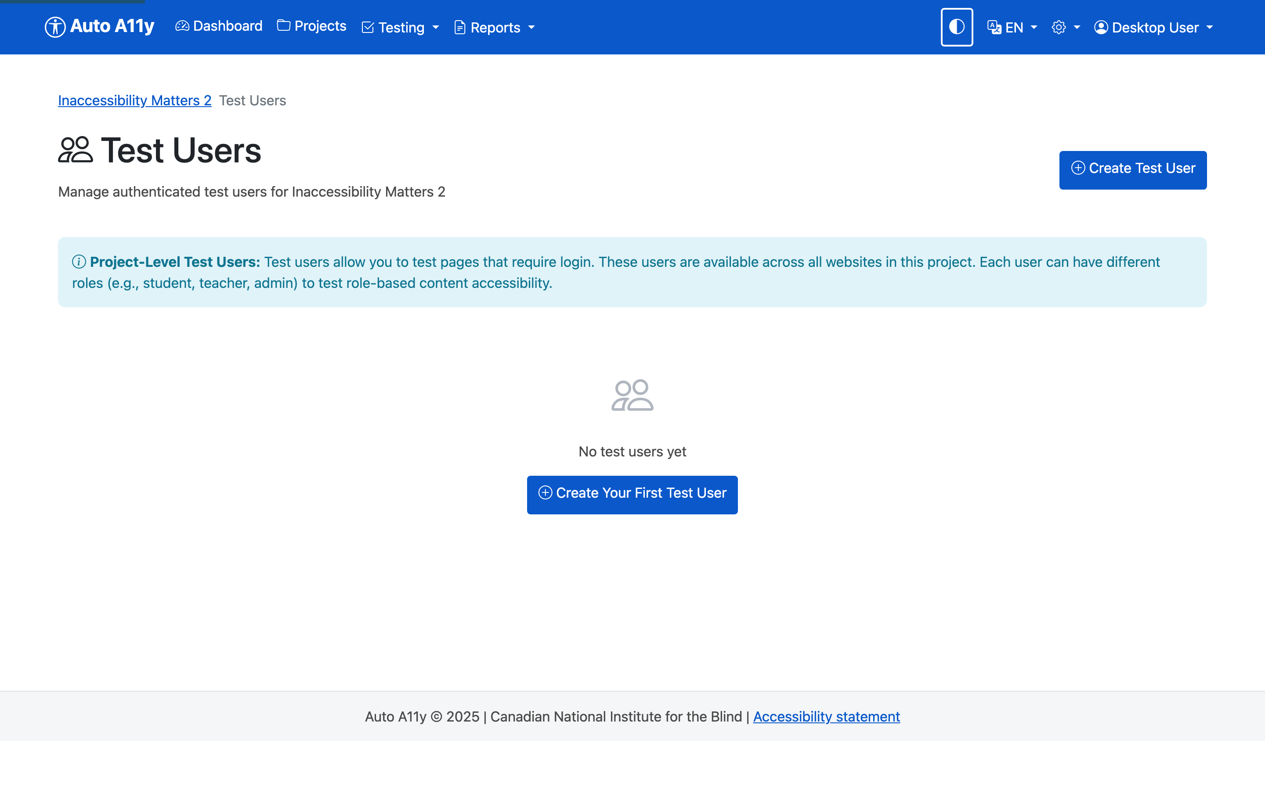
When you create a test user you provide its credentials and choose an authentication method:
- Form login — the standard username/password form; you tell Auto A11y the login URL and which fields to fill.
- HTTP Basic Auth — the browser’s built-in credential prompt.
- Manual login — for logins Auto A11y can’t automate (two-factor codes, multi-step SSO), you sign in yourself once in a visible browser and the session is captured and reused.
Each test user has a Test Login button that runs the login automation on its own, so you can confirm the credentials and selectors work before launching a full test run. In the results, every issue is labelled with the user context it was found under (you’ll see “Guest” for unauthenticated tests), so role-specific problems are attributable to the role.

Setup scripts and multi-state testing
Sometimes the page you want to test isn’t the page that first loads. A cookie banner covers the content until dismissed. A modal has to be opened. A tab has to be selected. A setup script is a short recorded sequence of actions that prepares the page before testing.
Scripts live on individual pages (and can also be defined website-wide). Open a page and choose Scripts, or use Setup Scripts on the website.
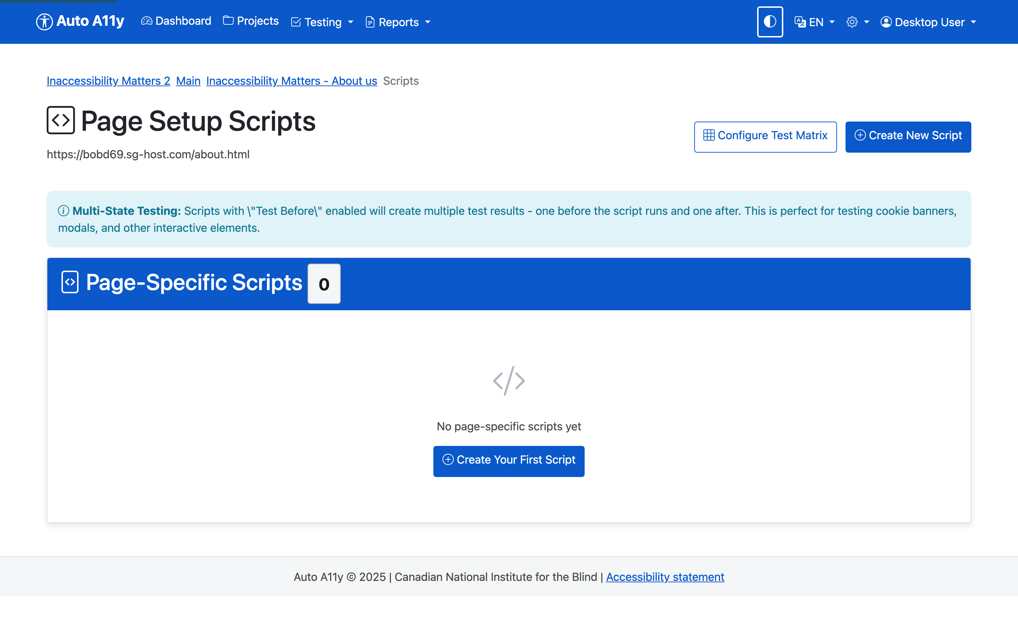
A script is a list of steps, each one an action:
Step type | What it does
Click | Click a button or link (e.g. the cookie “Accept” button)
Type | Enter text into a field
Wait for element | Pause until a selector appears
Wait (fixed) | Pause for a set number of milliseconds
Wait for navigation / network idle | Pause until the page settles
Scroll, Hover, Select, Screenshot | Other page interactions
Elements are targeted with CSS selectors (a class like .cookie-banner, an id like #accept-btn, or an attribute selector). The script editor includes a Quick Help panel with common selector patterns and worked examples.
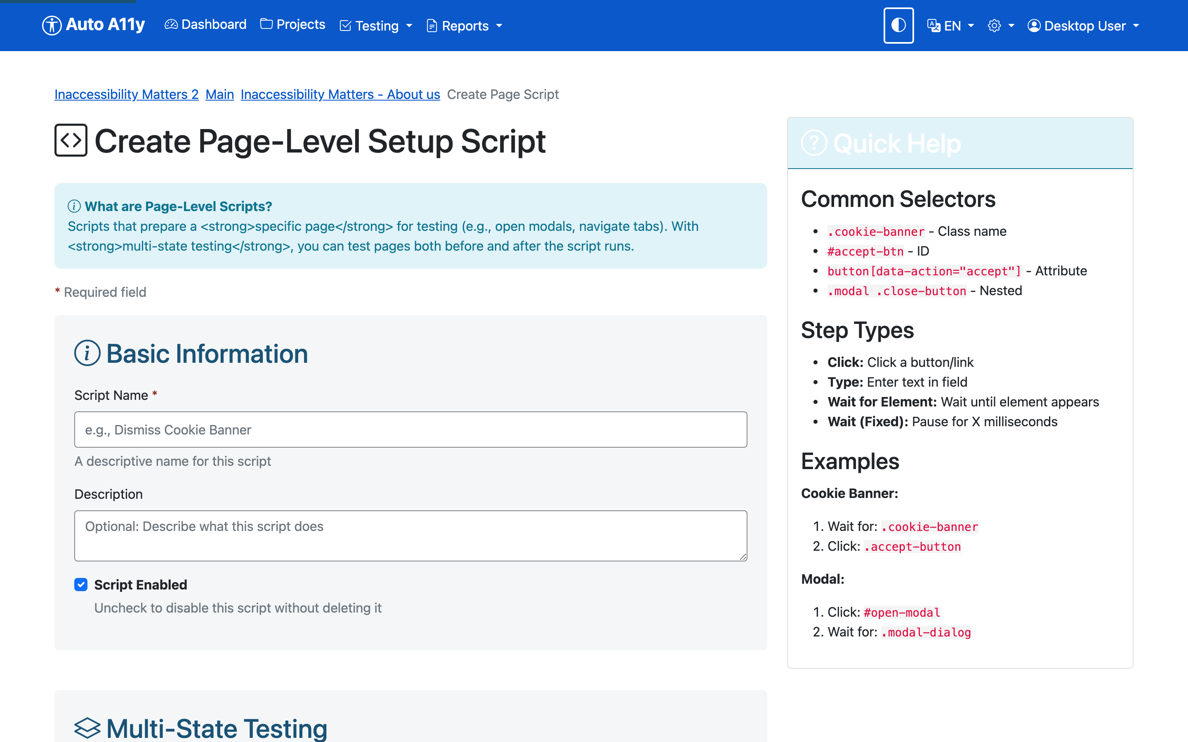

Multi-state testing: test before and after
Here’s the powerful part. A script has a Test Before option. With it enabled, a single test run produces two sets of results:
- The page before the script runs — for a cookie banner, this is the page with the banner covering the content, so you catch any accessibility problems in the banner itself.
- The page after the script runs — the banner dismissed, so you test the real underlying content that was hidden behind it.
Worked example — a cookie notice:
- Create a script named “Dismiss Cookie Notice”.
- Add a step: Wait for element .cookie-banner.
- Add a step: Click .cookie-banner .accept-button.
- Enable Test Before.
- Run the test.
You now get one result for the banner-covered state and one for the banner-dismissed state, each with its own issue list, linked together and labelled with the state they represent (“Initial page state” and “After executing script: Dismiss Cookie Notice”). The same pattern works for testing a modal open versus closed, or any two states of the same page.

Running tests
You can start a test at any scope:
Where | Button | What runs
Project page | Test All Websites | Every page in every website
Website page | Test All Documents | Every page (and PDF) in the site
Website page | Test Untested Documents | Only pages without results
Page list / page view | Test | That single page
During a test, Auto A11y loads the page in a browser (signing in as a test user and running any setup scripts first), injects and runs the JavaScript check suite at each relevant breakpoint, captures a screenshot, and (when enabled) sends the screenshot to Claude AI for visual analysis. Results are saved to the page’s history.
Tests run as background jobs; you can keep working while they run. Progress is visible on the page itself and under Testing → Dashboard.
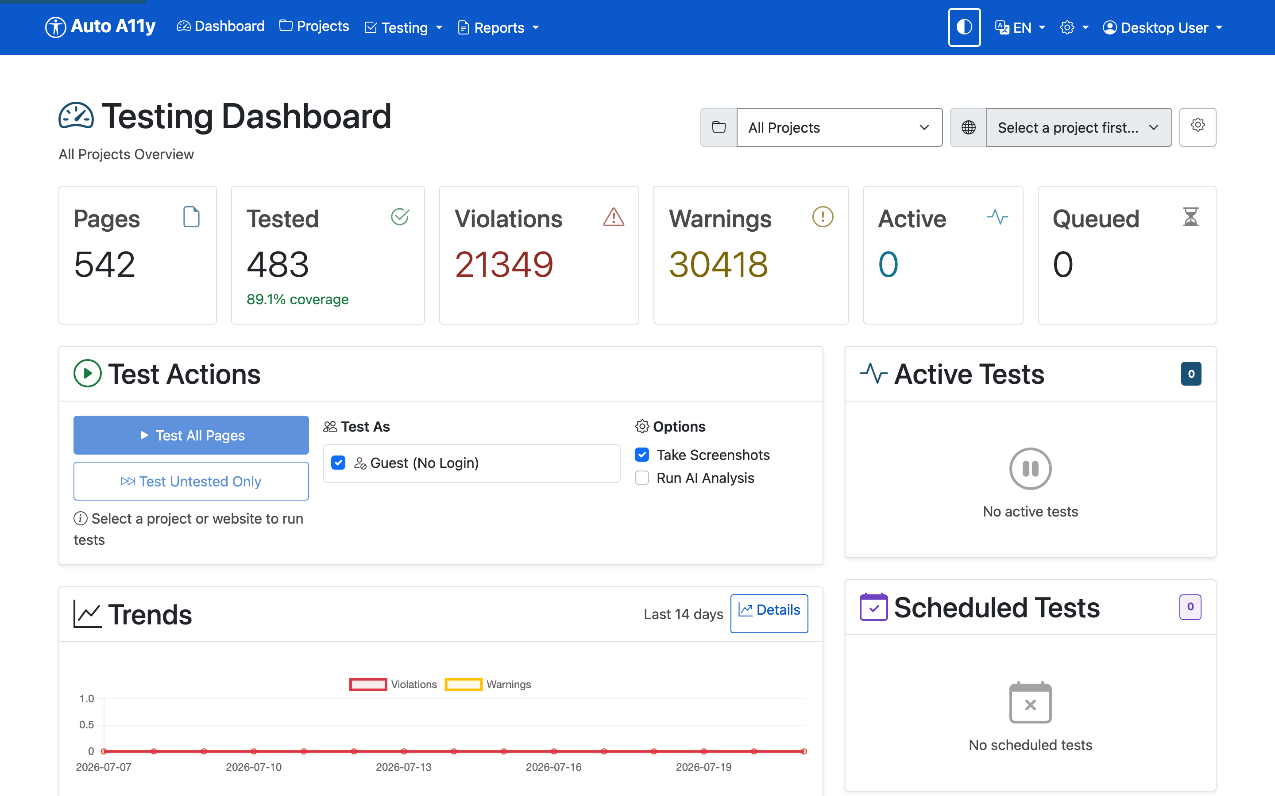

Reading test results
Open any tested page to see its Latest Test Results — the heart of the product. Issues are grouped into severity sections (Errors, Warnings, Info, Discovery), then by touchpoint, then by issue type.
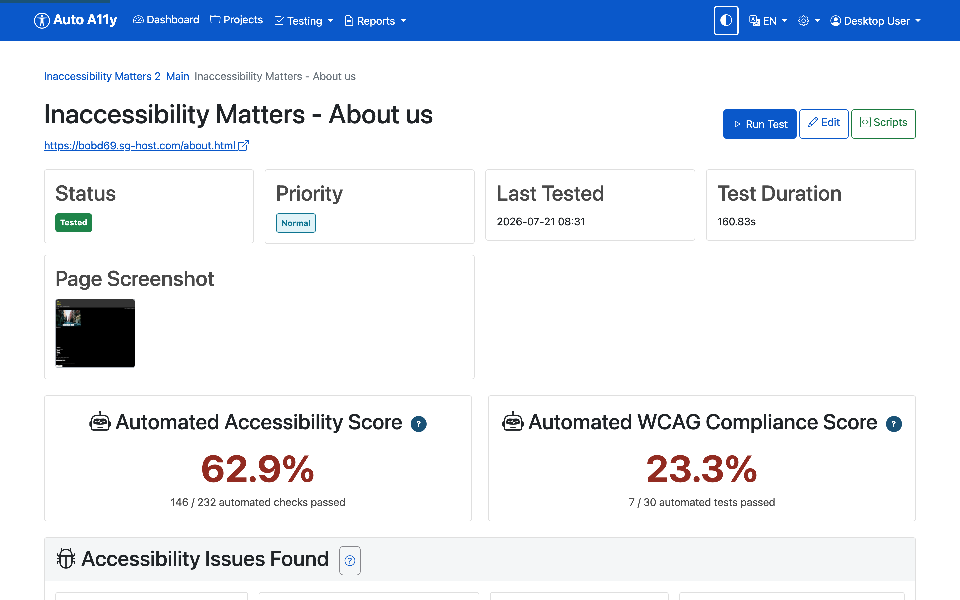
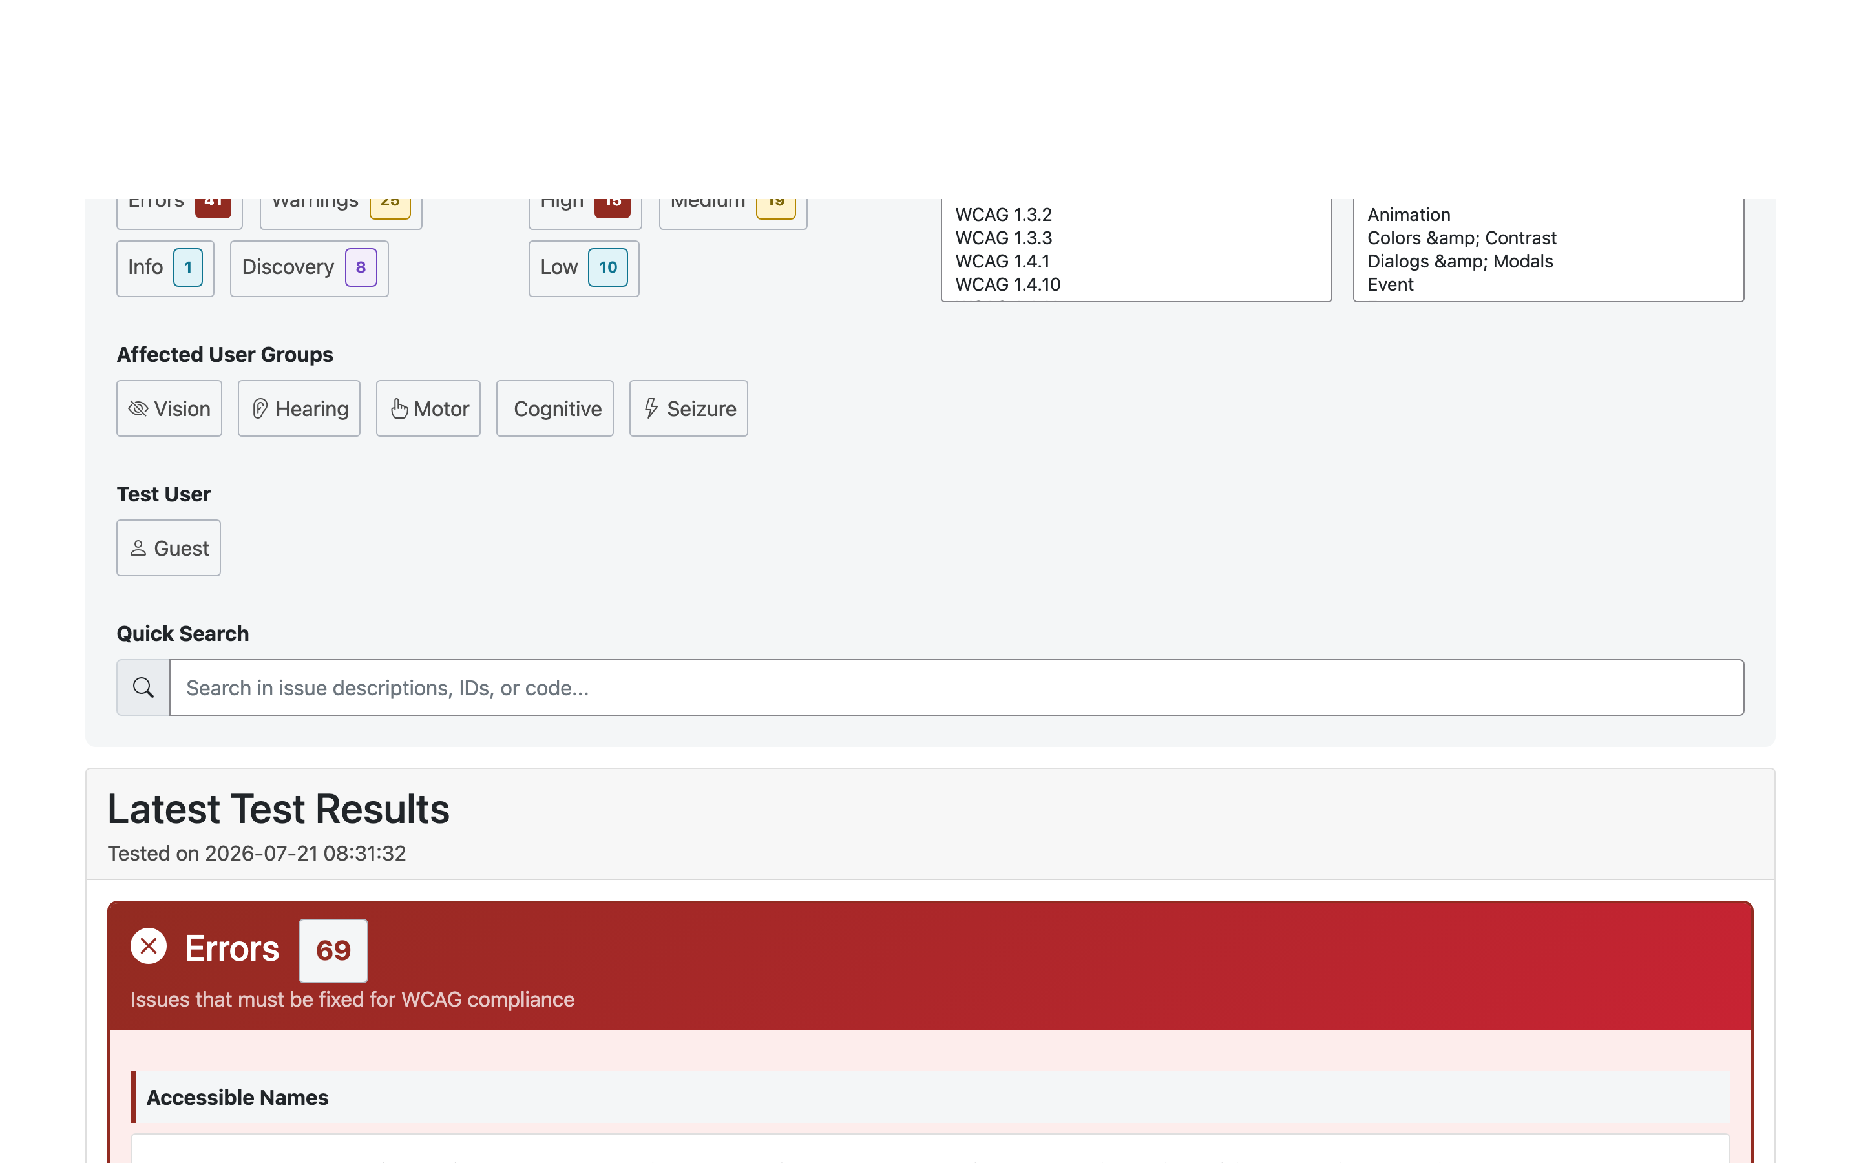
Each issue row shows its impact (High/Medium/Low), the user context it was tested under (e.g. Guest, or a named test-user role), a plain-language description, and the XPath locating the element. Issues with multiple occurrences group their instances. Expand a row for the full detail:
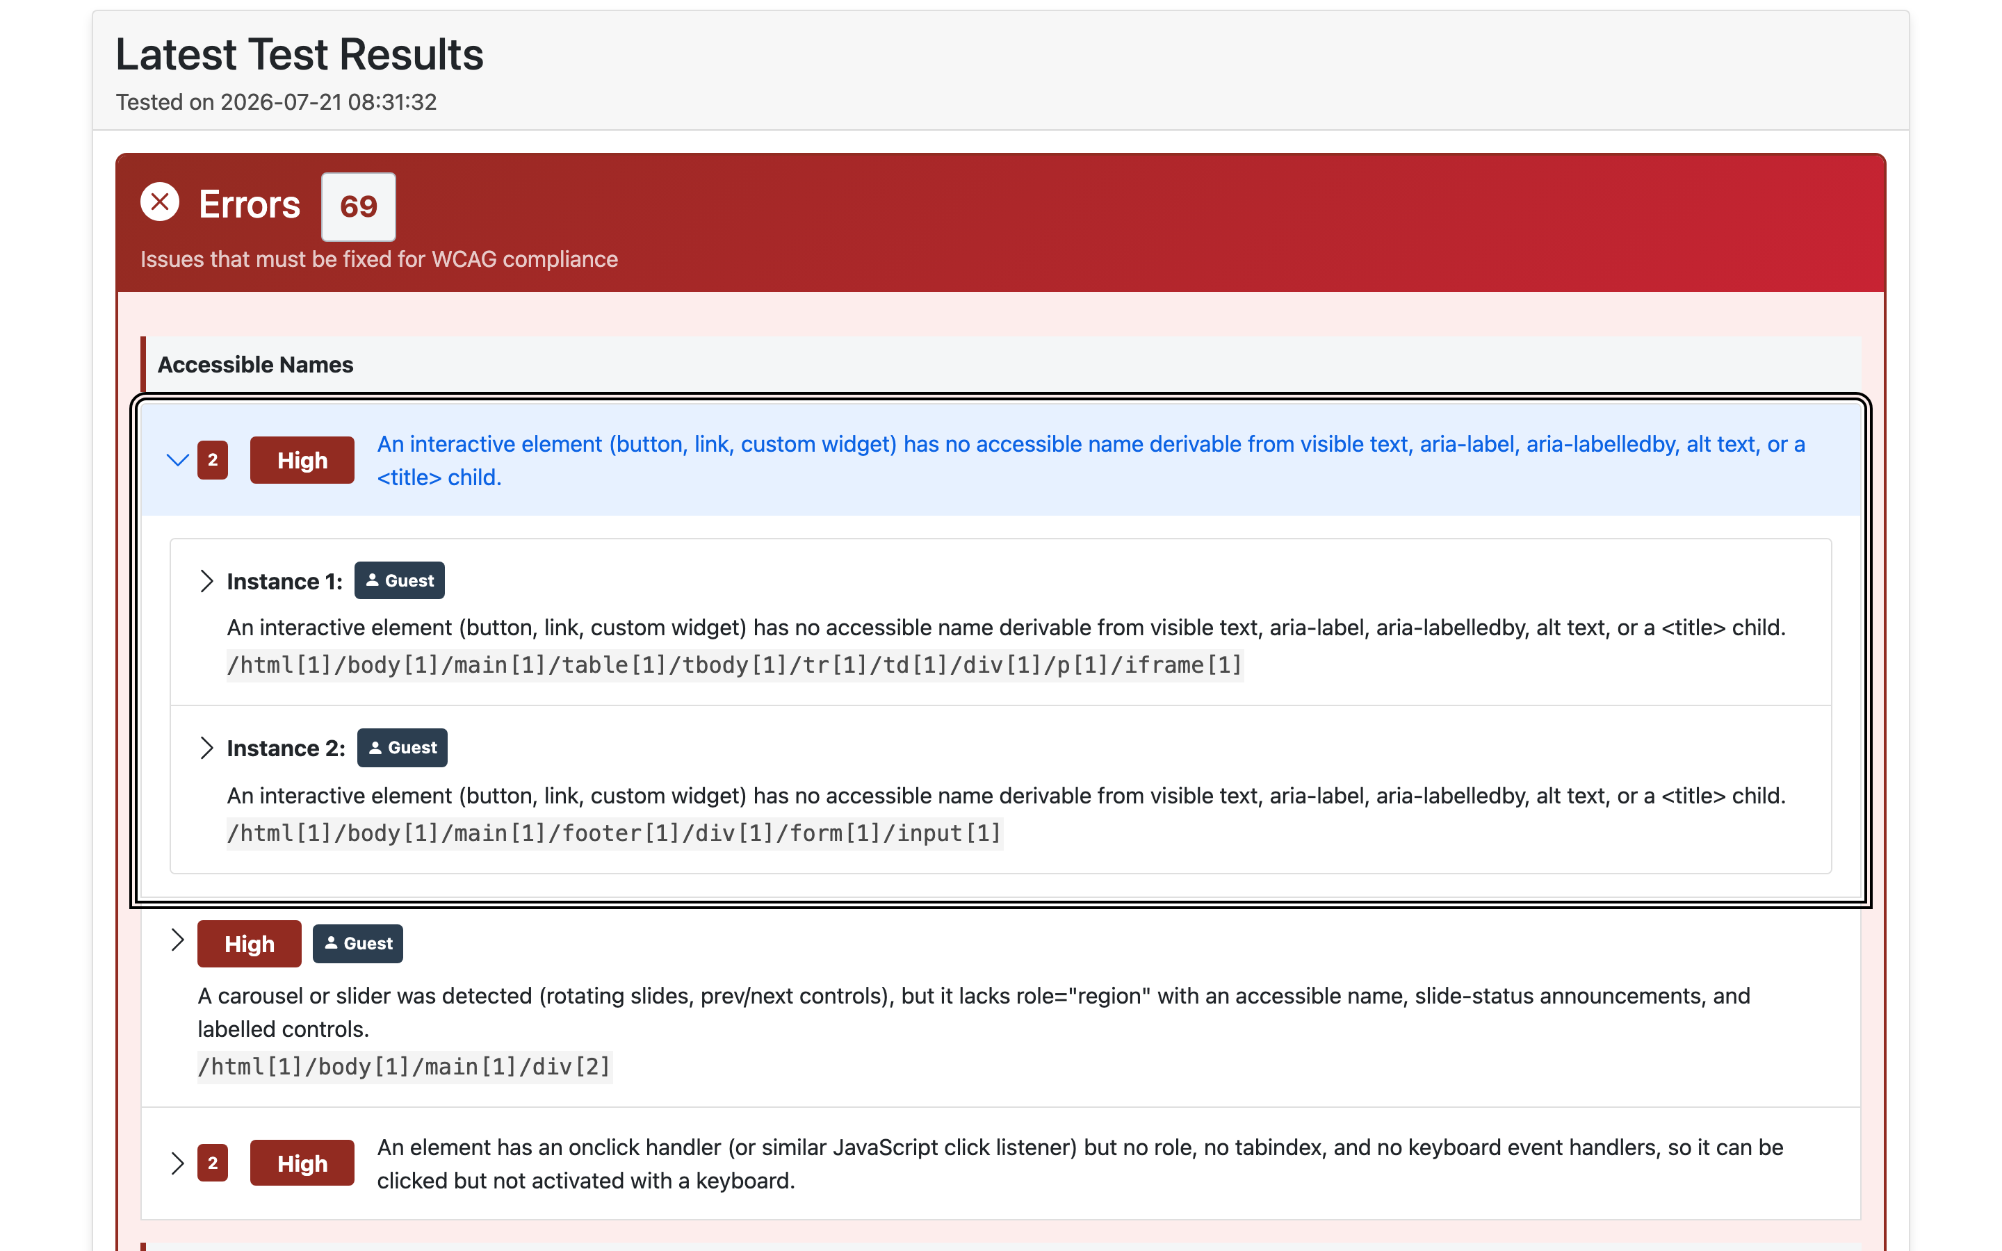
Inside an expanded issue you’ll find:
- What the issue is / Why it matters / Who it affects — plain-language explanations suitable for sharing with content owners.
- How to remediate — concrete fix guidance.
- WCAG success criteria — with links to the W3C Understanding and How to Meet pages.
- Location — the XPath, with a copy button.
- Code snippet — the offending HTML.
- Page thumbnail — the page as it looked at test time.
Every page keeps a Test History table below the latest results, so you can compare runs over time as fixes land. Pages tested in multiple states or at multiple breakpoints show that context on each issue.

Testing PDFs
Accessibility obligations extend to the documents a site links to. Auto A11y audits PDF files against PDF/UA (the PDF accessibility standard) and WCAG — checking the tag structure, reading order, document metadata, and more.
PDFs are managed per project (and per website). Open PDFs from the project or website page.
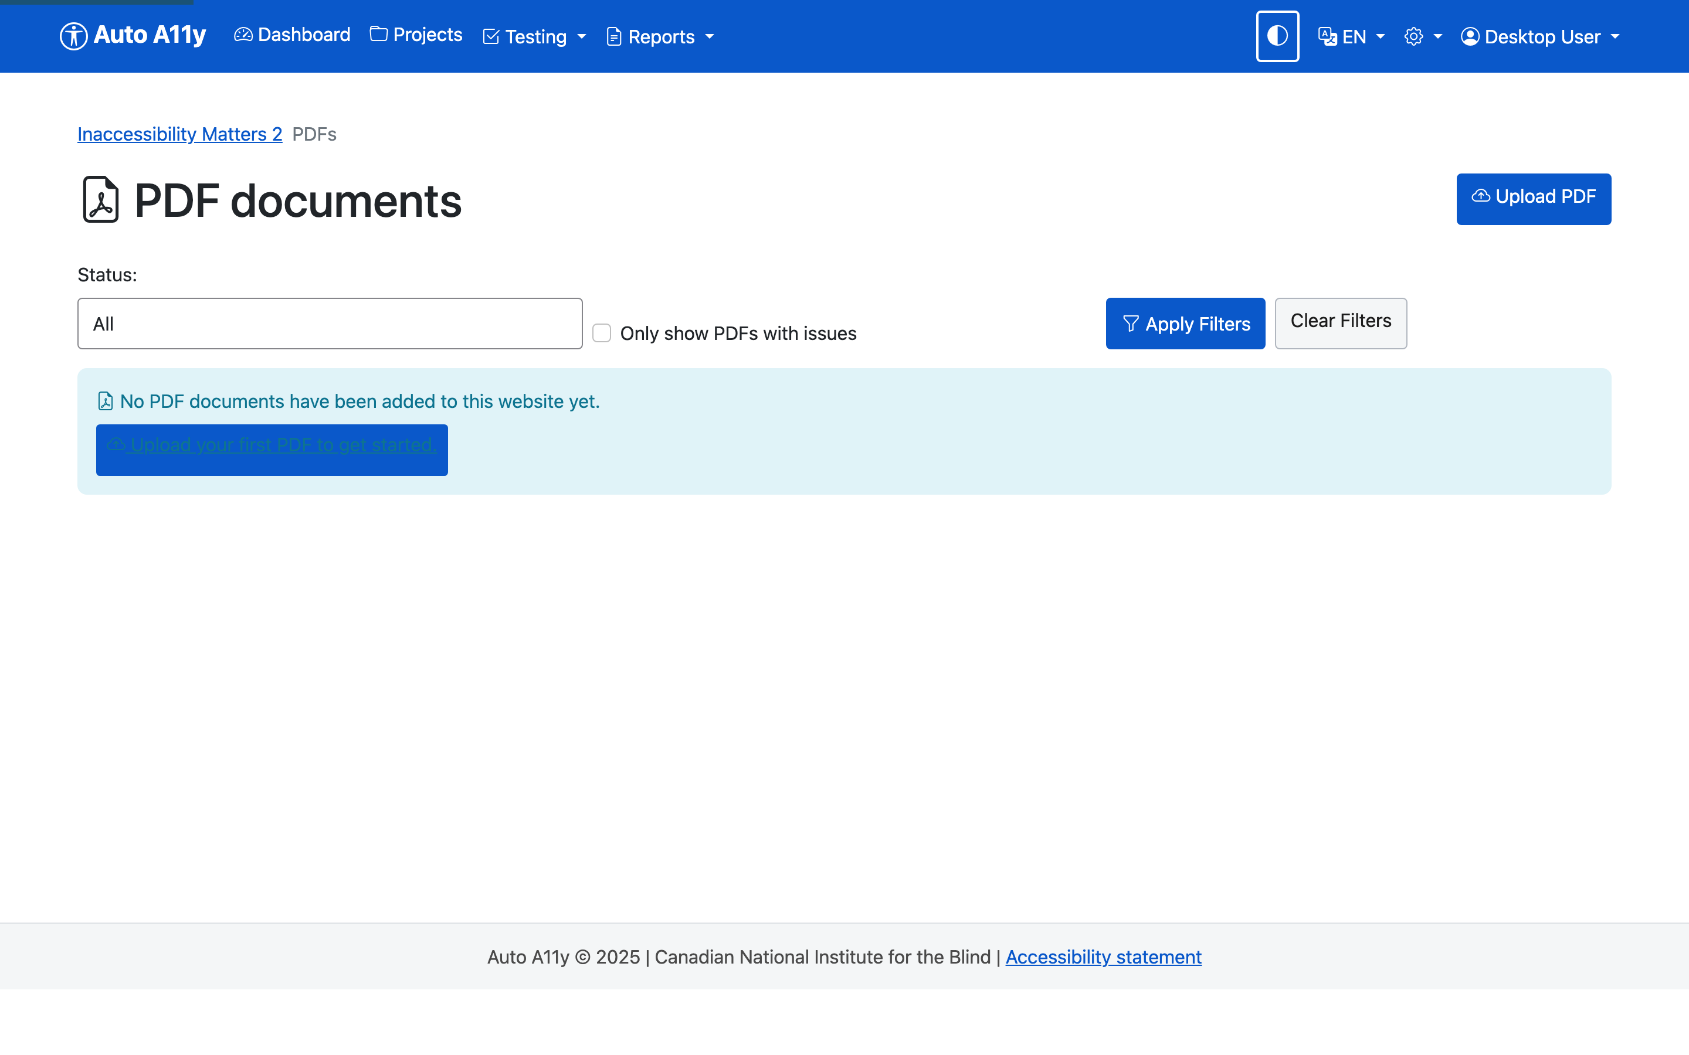
Add a PDF two ways:
- Upload PDF — upload a file from your computer.
- Fetch by URL — point Auto A11y at a PDF’s web address and it retrieves it. (Website discovery can also find linked PDFs automatically.)
Once added, start an audit on the document. Like page tests, audits run in the background; when complete, the PDF shows its issues (FAIL/WARN counts against the accessibility checks), page images, and an issue map. You can export a self-contained PDF audit report in Markdown or HTML, and filter the PDF list to show only documents with issues.

Reports
Open Reports in the navigation. Six report types cover different audiences and purposes; all generate in the background and appear under Recent Reports when complete.
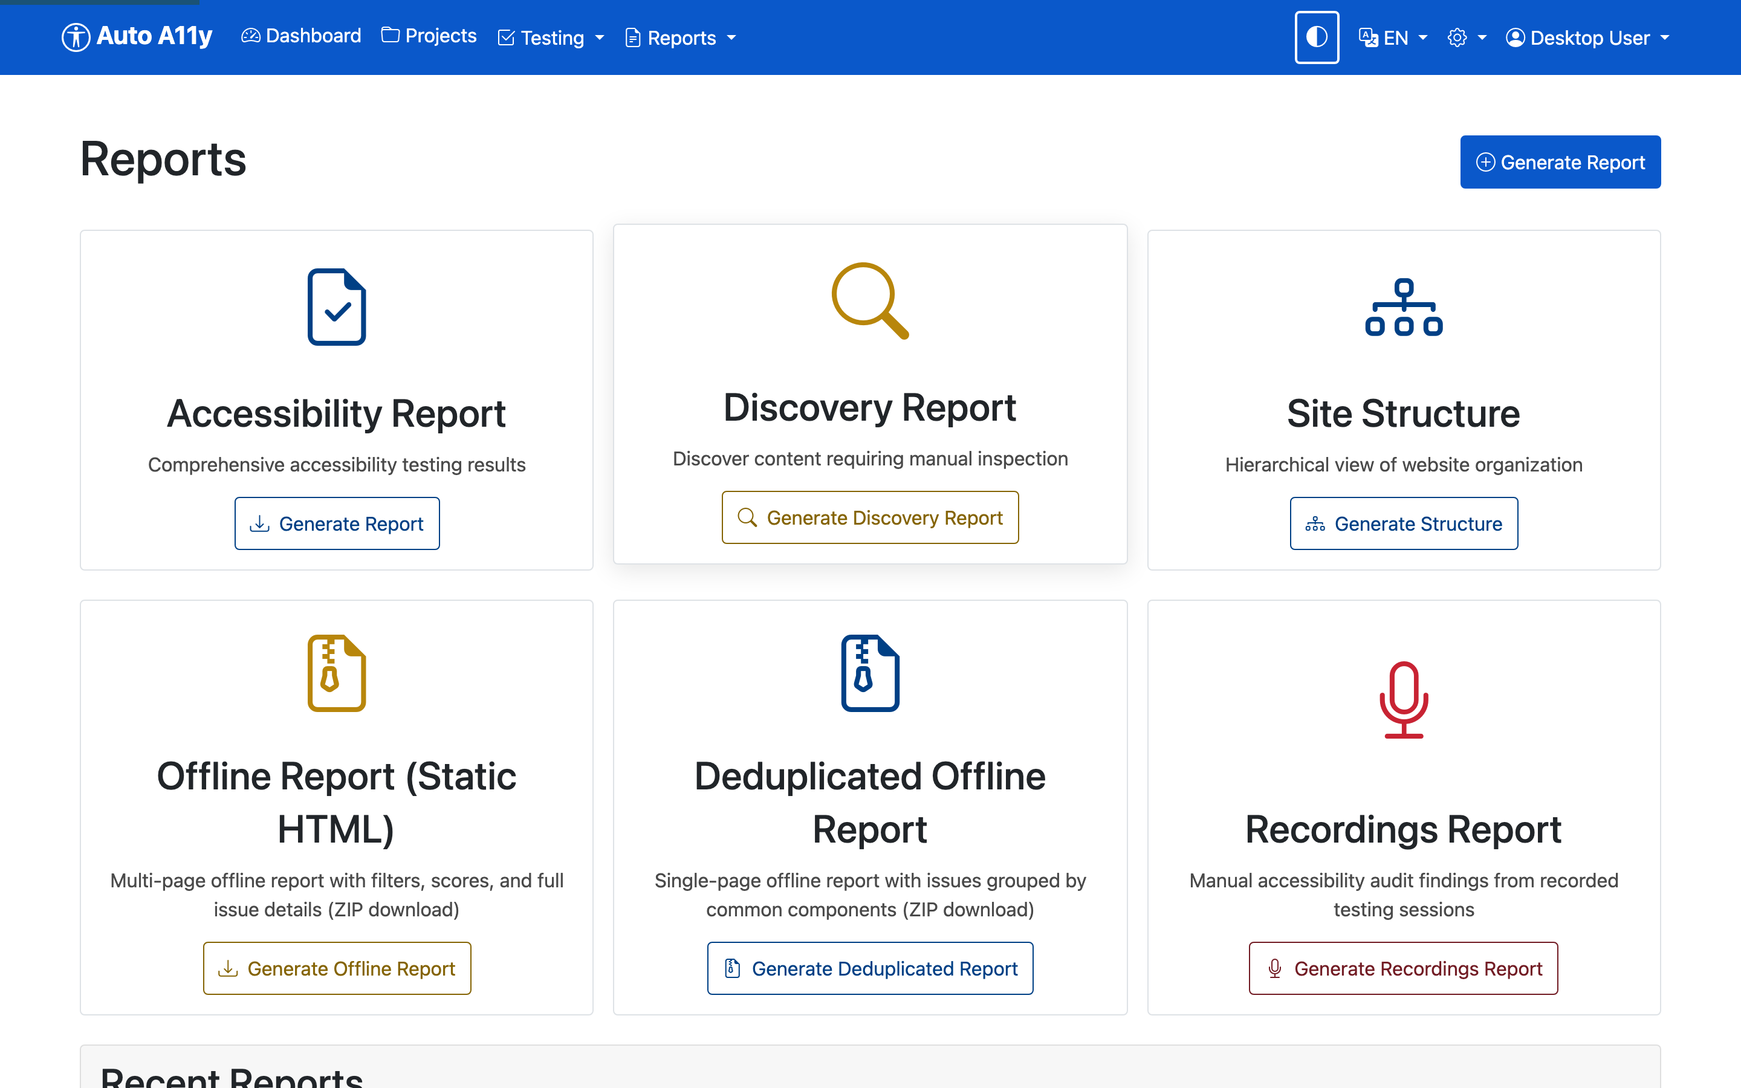

Accessibility Report
Audience: managers and stakeholders. The executive overview.
A structured summary of a project’s (or website’s) accessibility state: compliance score with letter grade, key metrics, issues by touchpoint and by impact, the most frequent issues, prioritized recommendations, and an AI Executive Analysis — an assessment written by Claude AI covering strengths, critical risks, maturity level, user impact by disability group, legal risk, and a phased remediation strategy.
Available formats: HTML (shown below), Excel, CSV, JSON, and PDF.
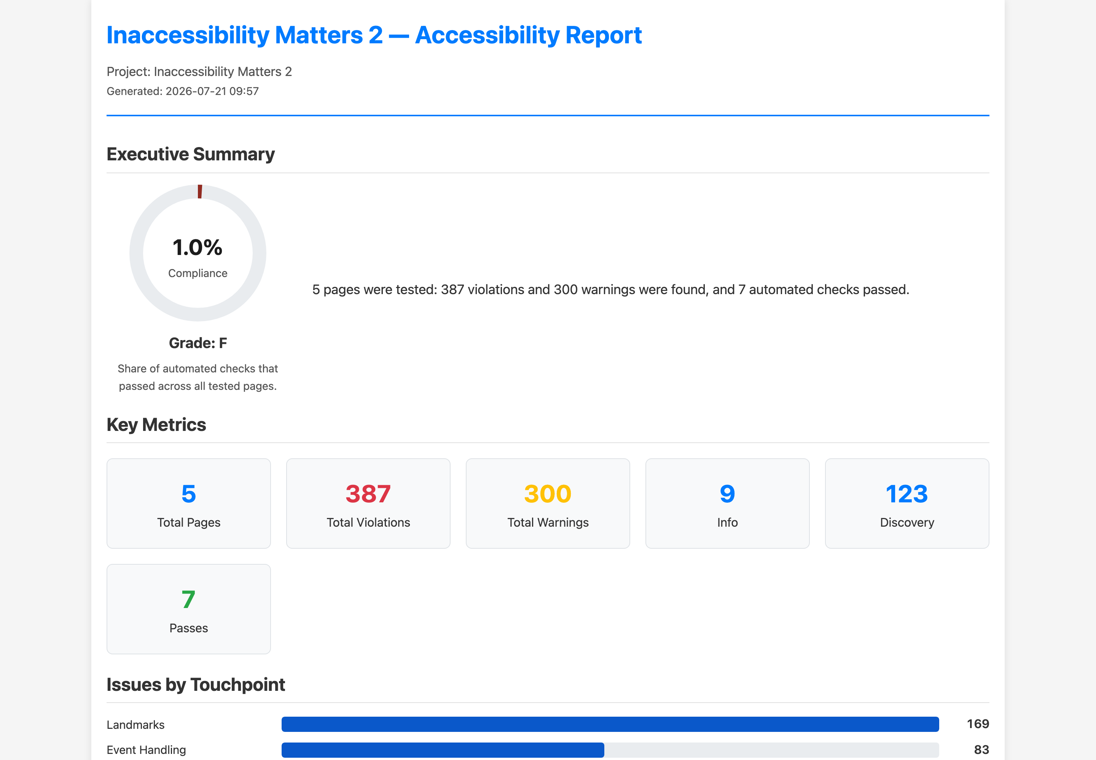
The Excel format is the working spreadsheet: an executive summary sheet plus per-website sheets and a complete issue list with descriptions, WCAG criteria, XPaths, and remediation guidance — ideal for tracking fixes.
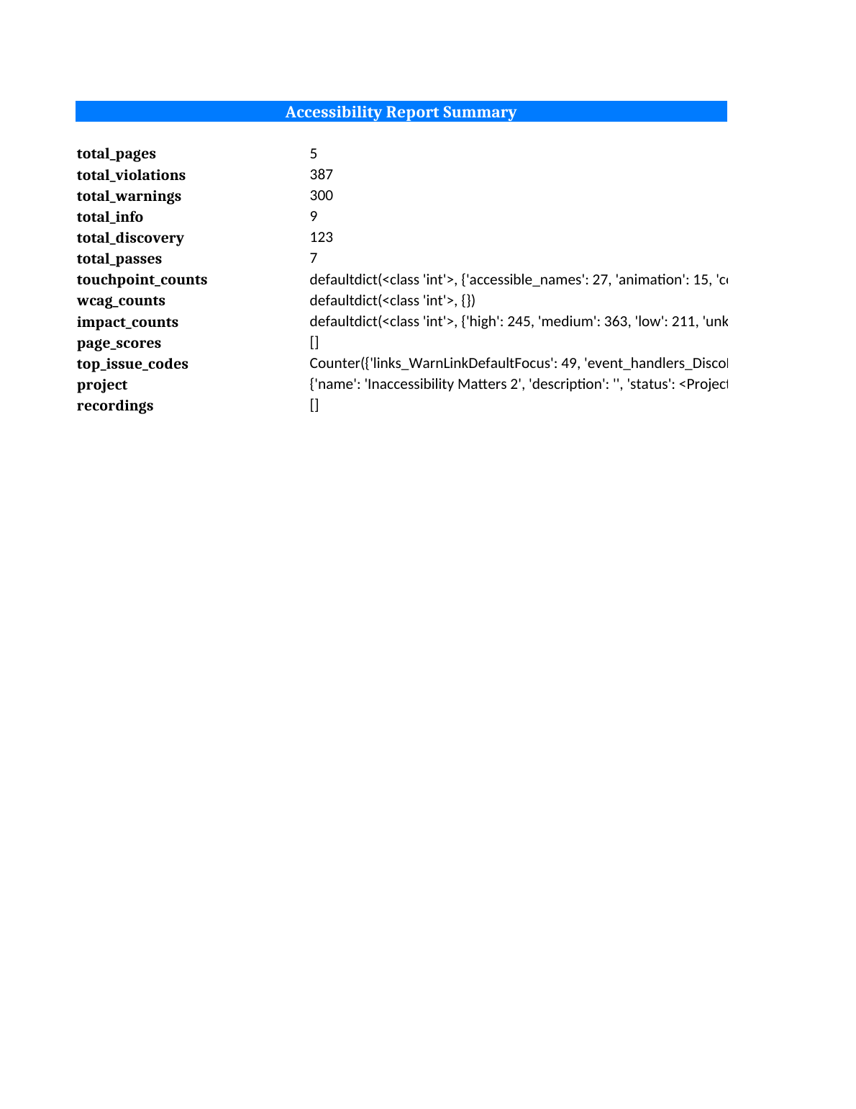

Discovery Report
Audience: auditors planning manual review.
Lists the content that automated testing cannot judge — forms, videos, PDFs, unusual typography, elements with questionable accessible names — so a human reviewer knows exactly where to look. Site-wide issues (appearing on most pages) are separated from page-specific ones so global components get fixed once. Formats: HTML or PDF.
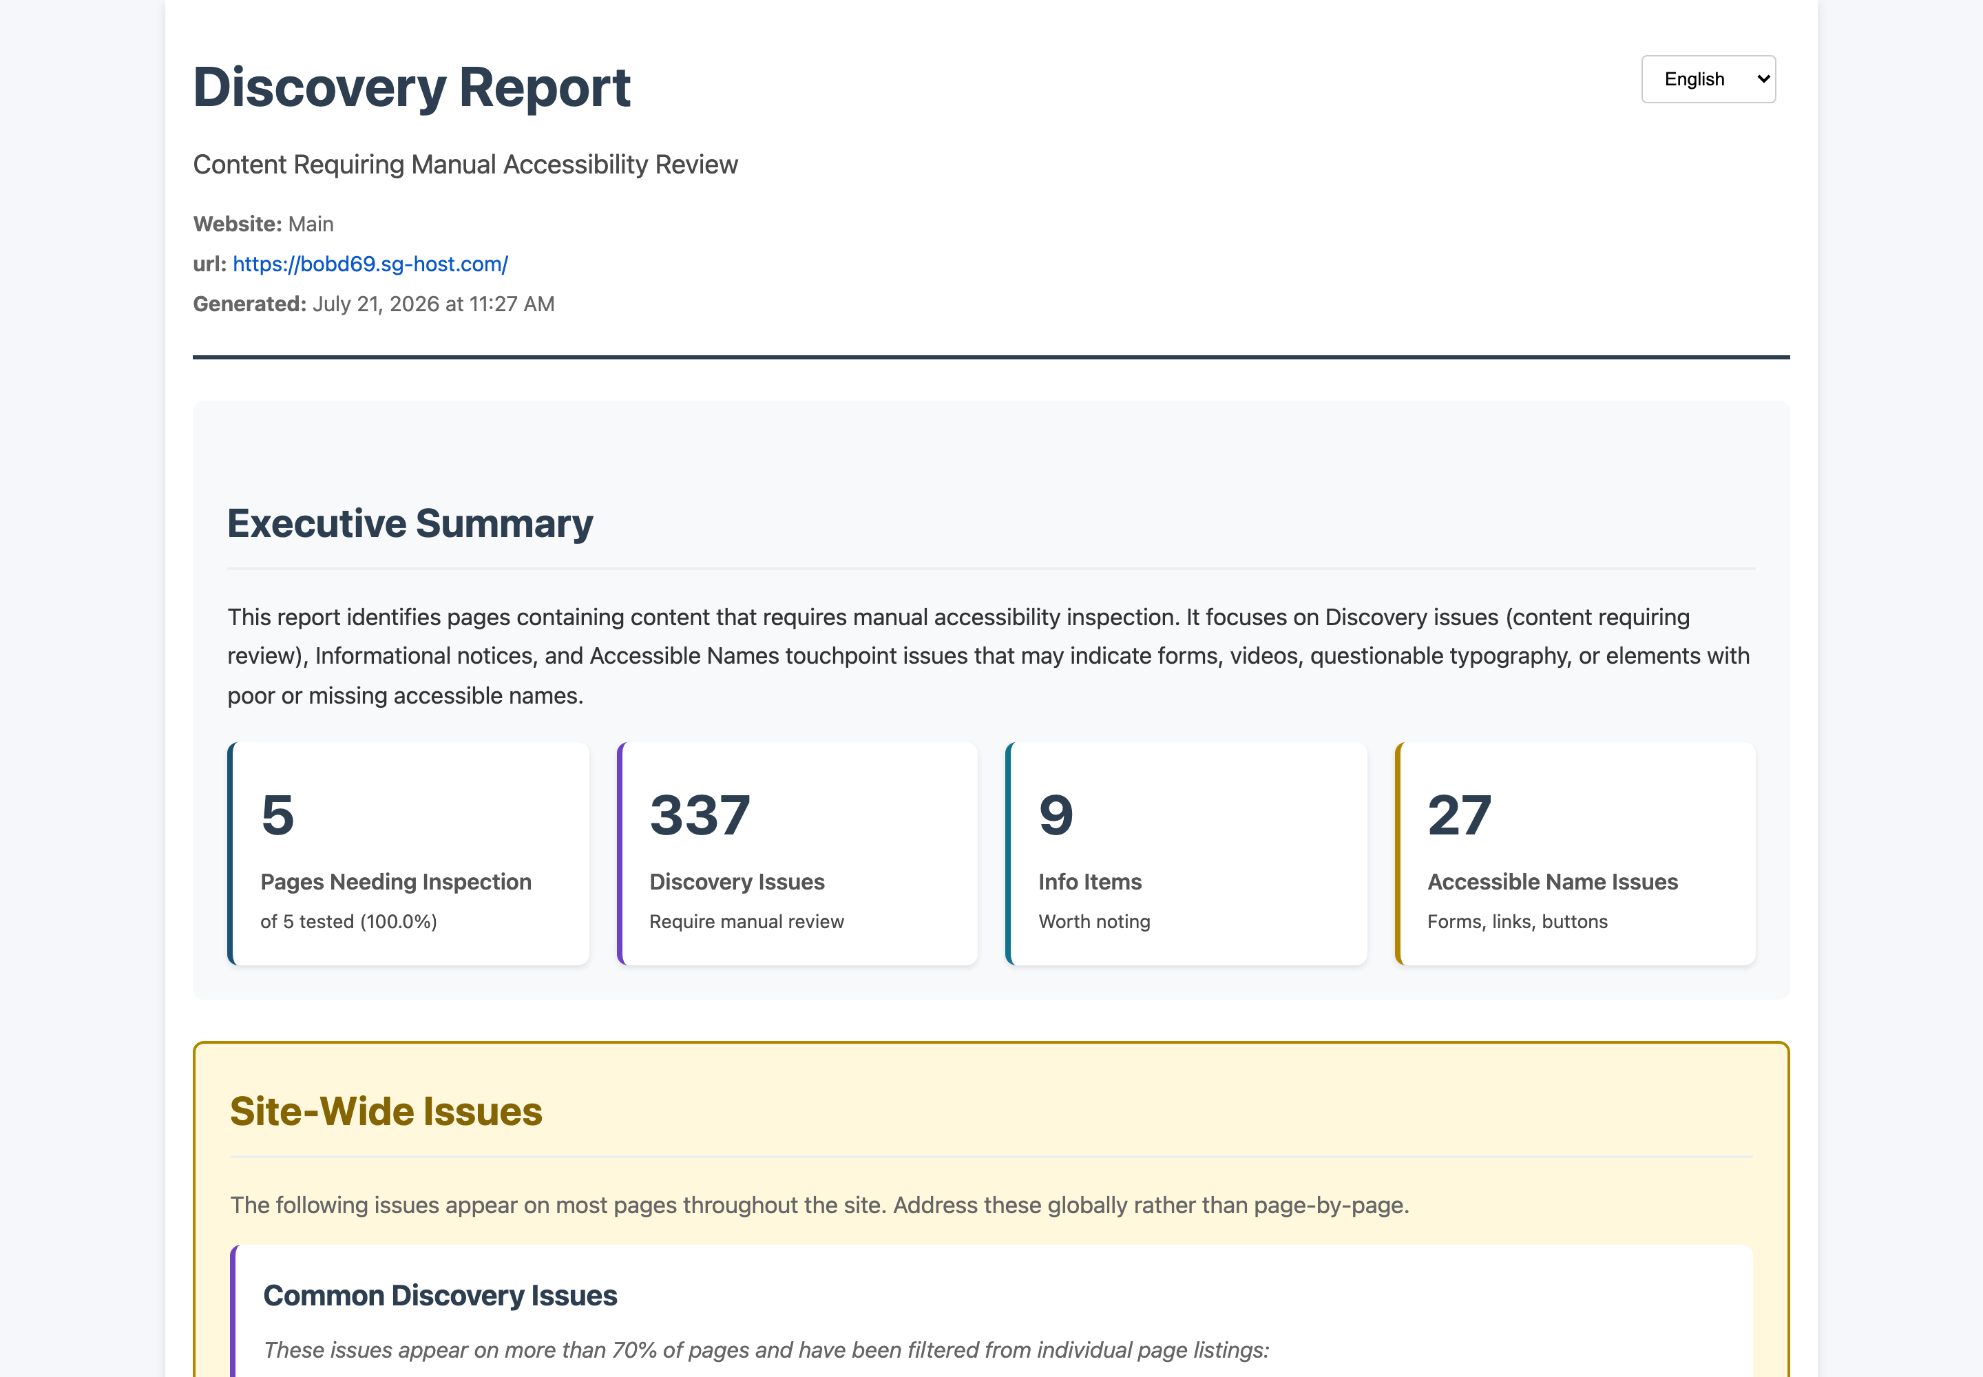

Site Structure
Audience: anyone needing to understand the site’s shape.
A hierarchical tree of the website’s organization as discovered by the crawler, with per-page violation counts — useful for scoping an audit and spotting orphaned sections.
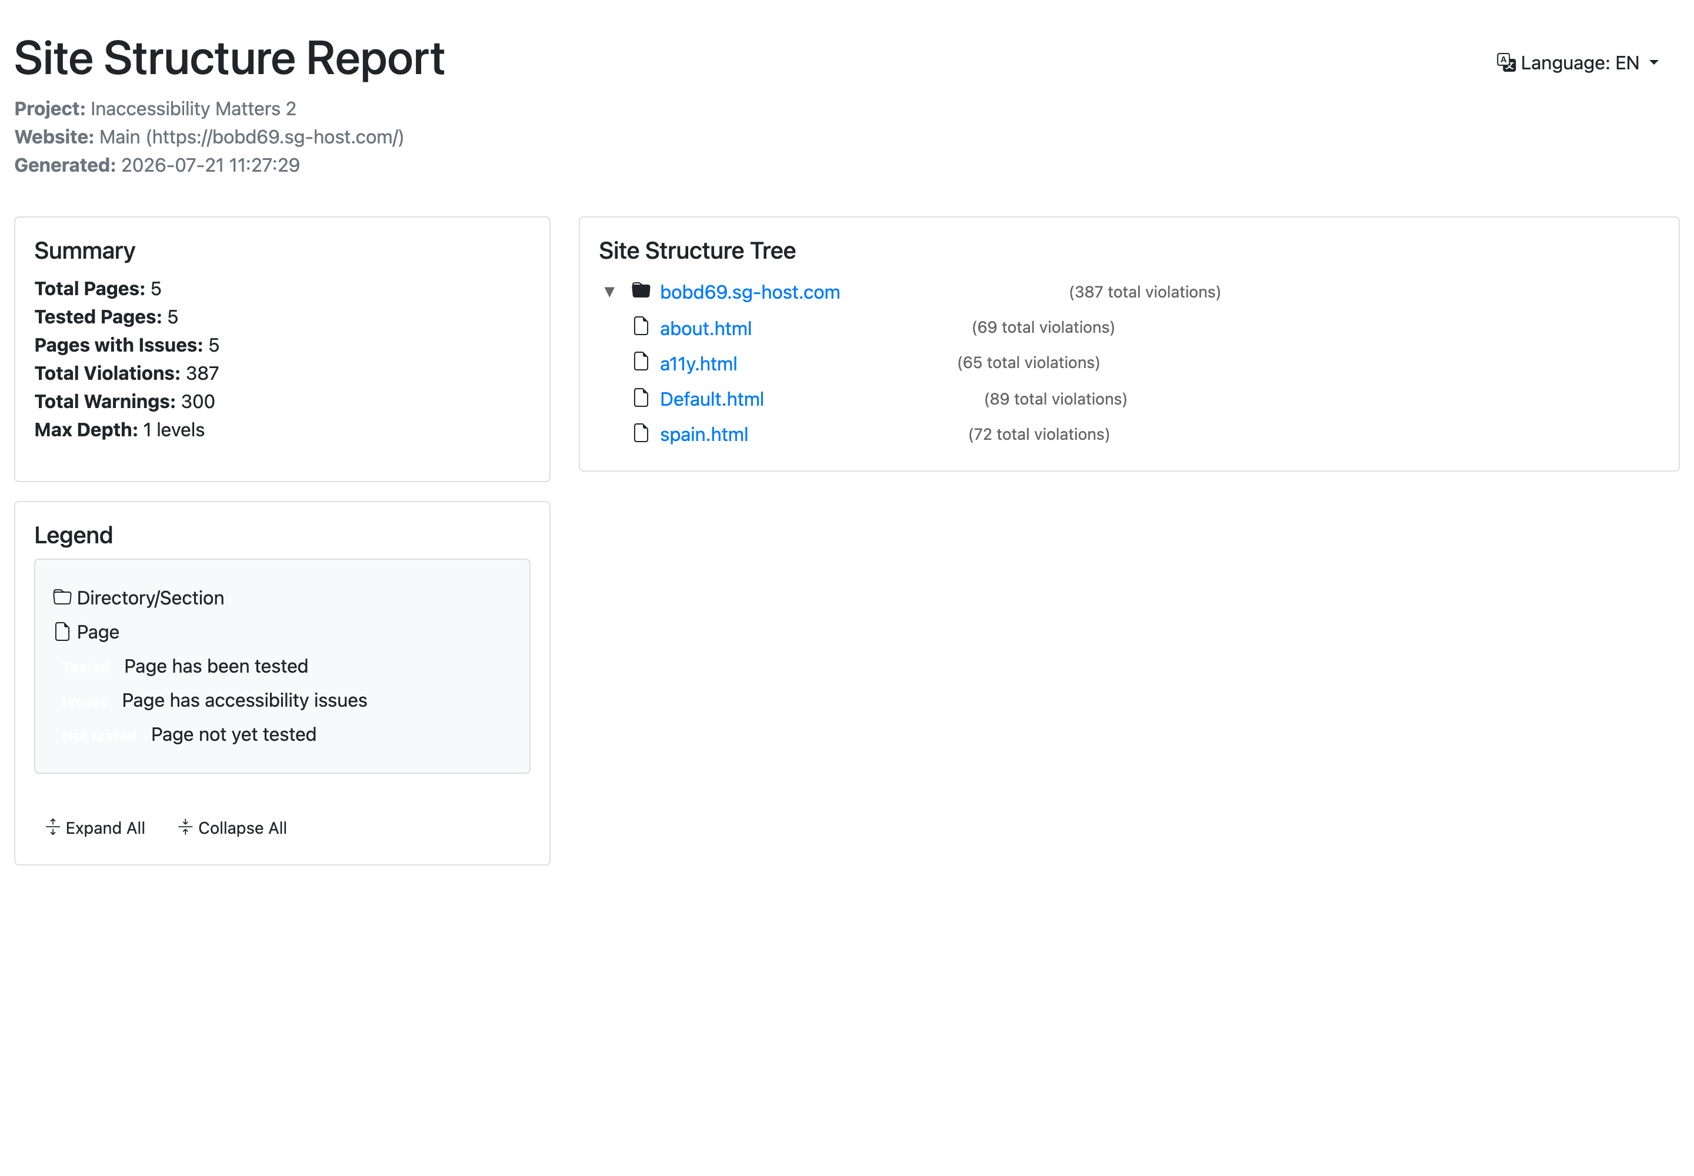

Offline Report (Static HTML)
Audience: clients and teams without access to the app.
A complete, self-contained multi-page website delivered as a ZIP: an index of all tested pages with scores and client-side search/filtering, a summary page with statistics, and a full detail page per tested page with the same issue accordions as the app. Everything — CSS, JavaScript, images, screenshots — is bundled, so it works from a file share or email attachment with no server and no internet. Bilingual: every page has an EN/FR switcher.
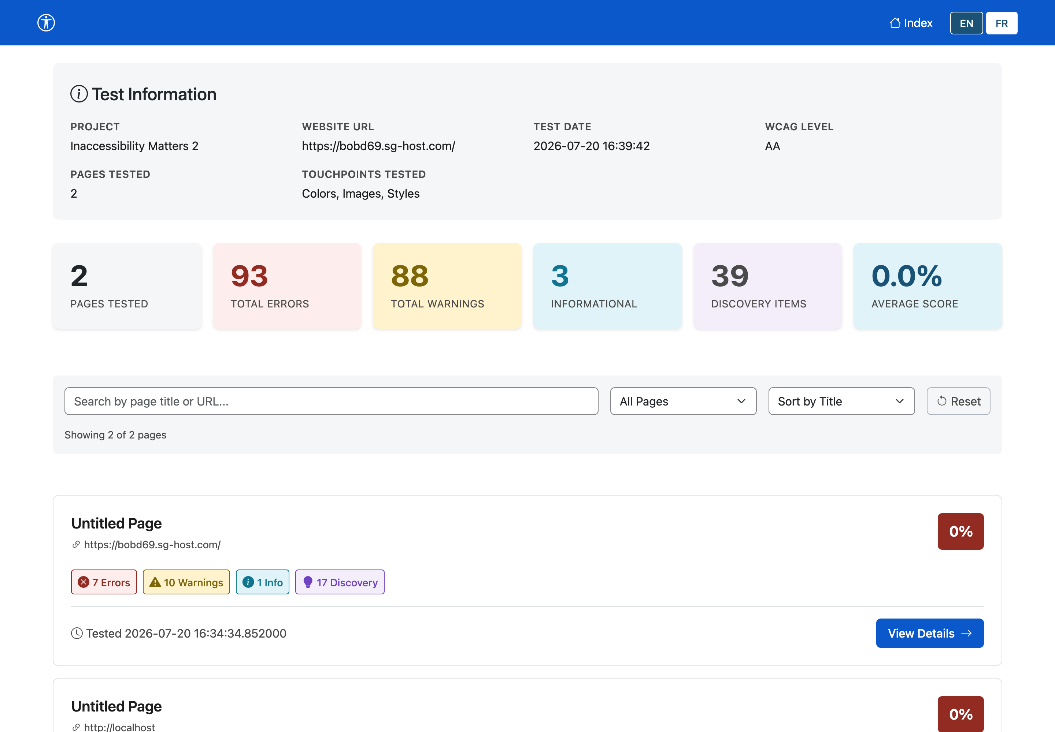
Options when generating: choose project or single website scope, WCAG level, and whether to include screenshots and discovery items.
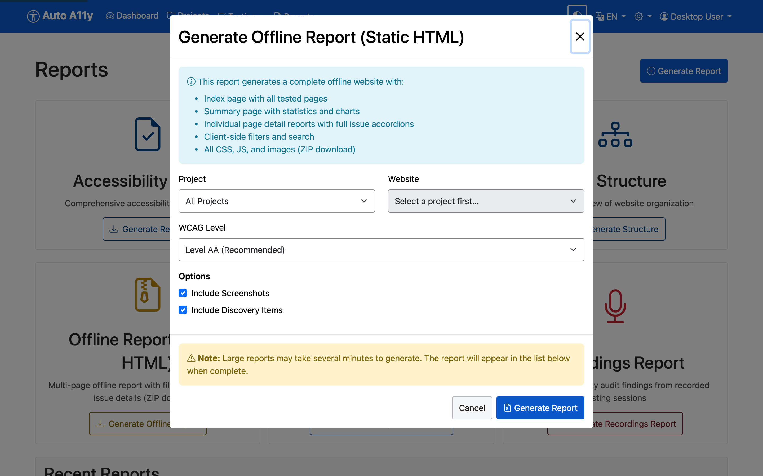

Deduplicated Offline Report
Audience: developers fixing a template-based site.
The same offline ZIP concept, but issues are grouped by common component — the header, navigation, and footer that repeat on every page are reported once, with the pages they affect, instead of once per page. Scores are shown both for the full page and excluding component issues, so you can see how much a single template fix will move the needle. Also bilingual.
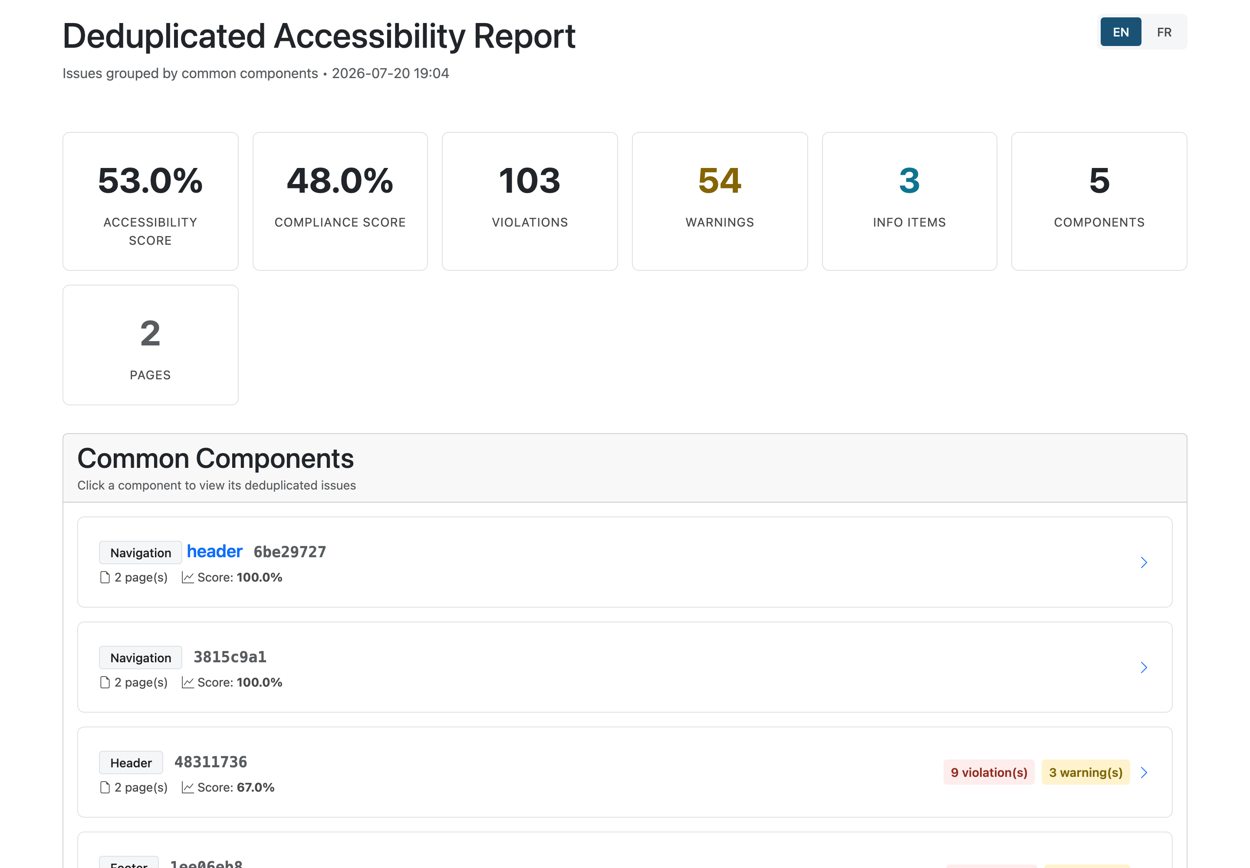

Recordings Report
Audience: teams complementing automation with lived experience.
Compiles findings from recorded manual testing sessions — audio-recorded walkthroughs by testers with disabilities, uploaded to the project — into an audit document: user quotes with timecodes, pain points, and key takeaways, alongside the structured issues raised. (This example uses the YVR Map project, which has recorded sessions.)
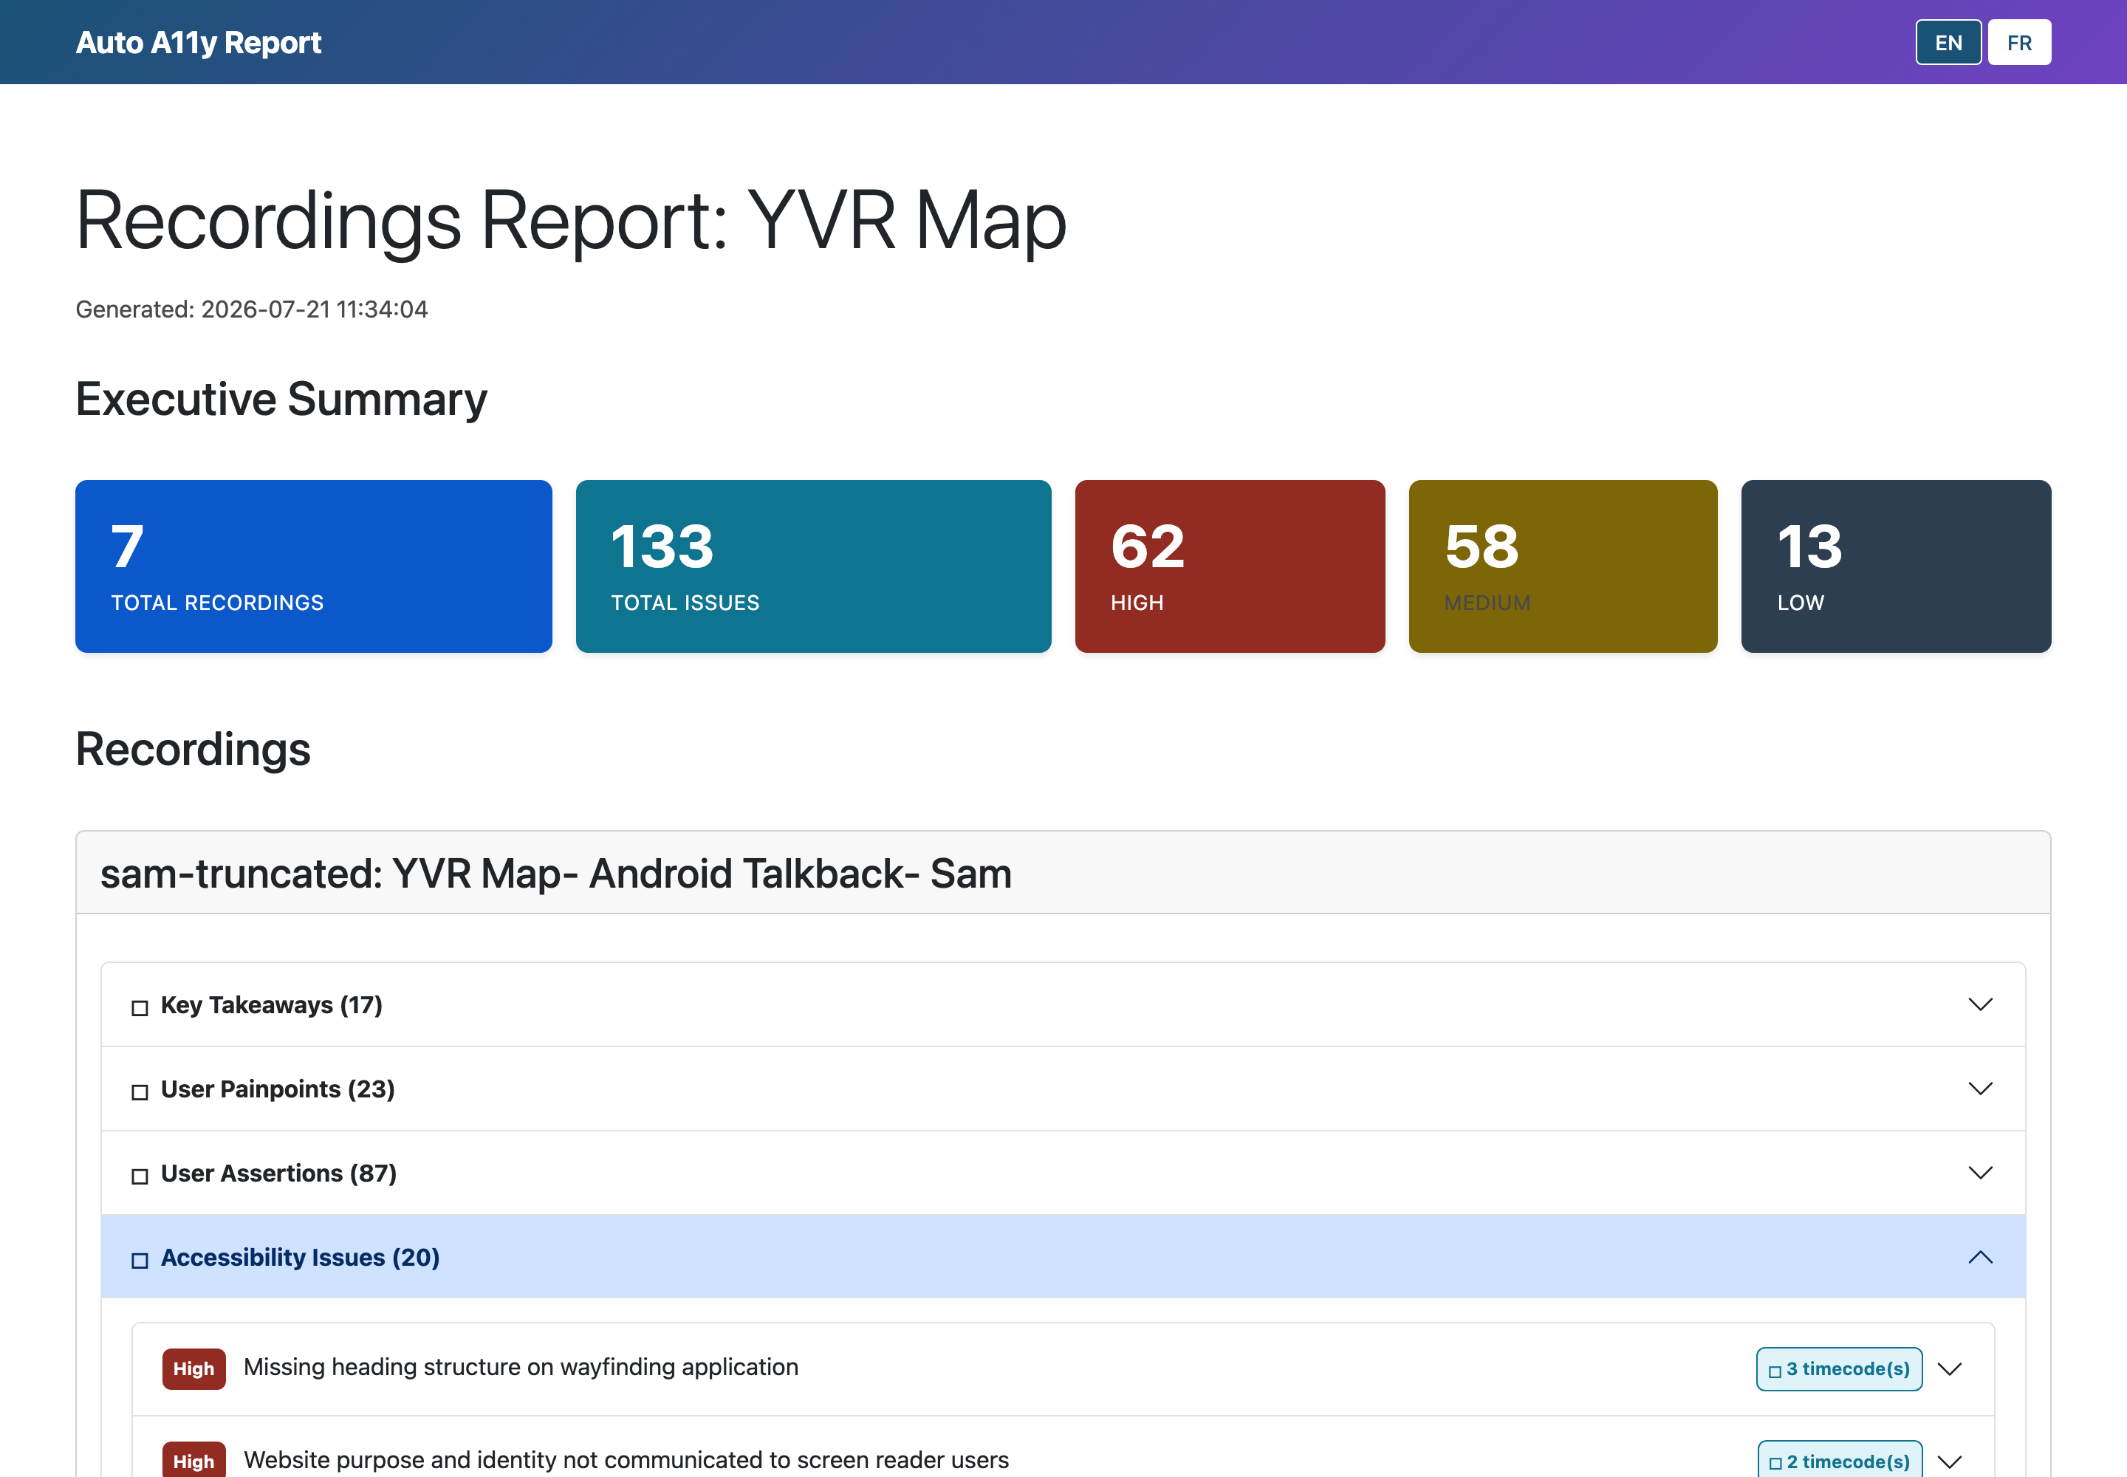

Generating and downloading
Every report generates as a background job — large reports can take several minutes. Finished reports appear in Recent Reports at the bottom of the Reports page with a download button; failed jobs can be restarted, and running jobs can be dropped.

Scheduling recurring tests
Reports → Schedules (or the Schedules button on a website page) lets you run tests automatically — daily, weekly, or monthly — so trend data accumulates without anyone remembering to click Test.
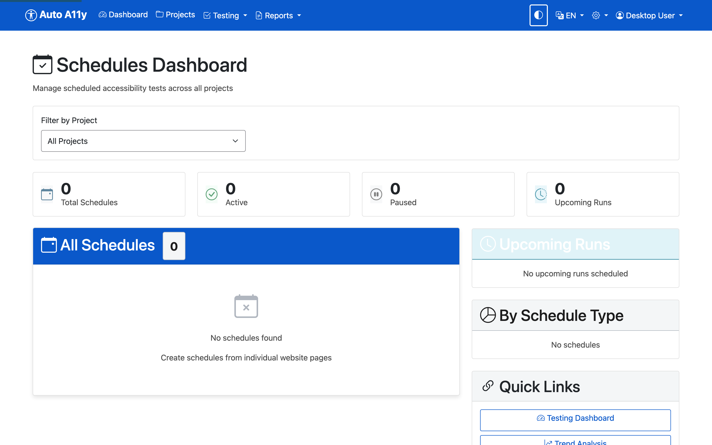

The Testing menu
- Dashboard — live and recent test activity across all projects.
- Configure — runtime testing options.
- Fixture Status — the quality gate: every check in the test suite with its validation state. Only checks passing all fixtures run in production.
- 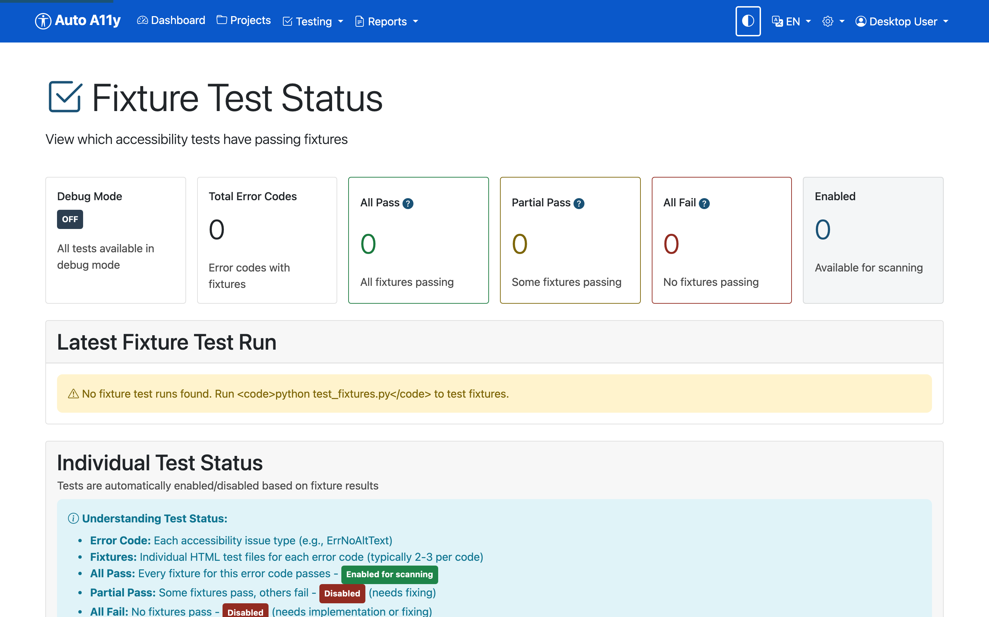
- Trends — violation and warning counts over time, so you can show progress between audits.
- 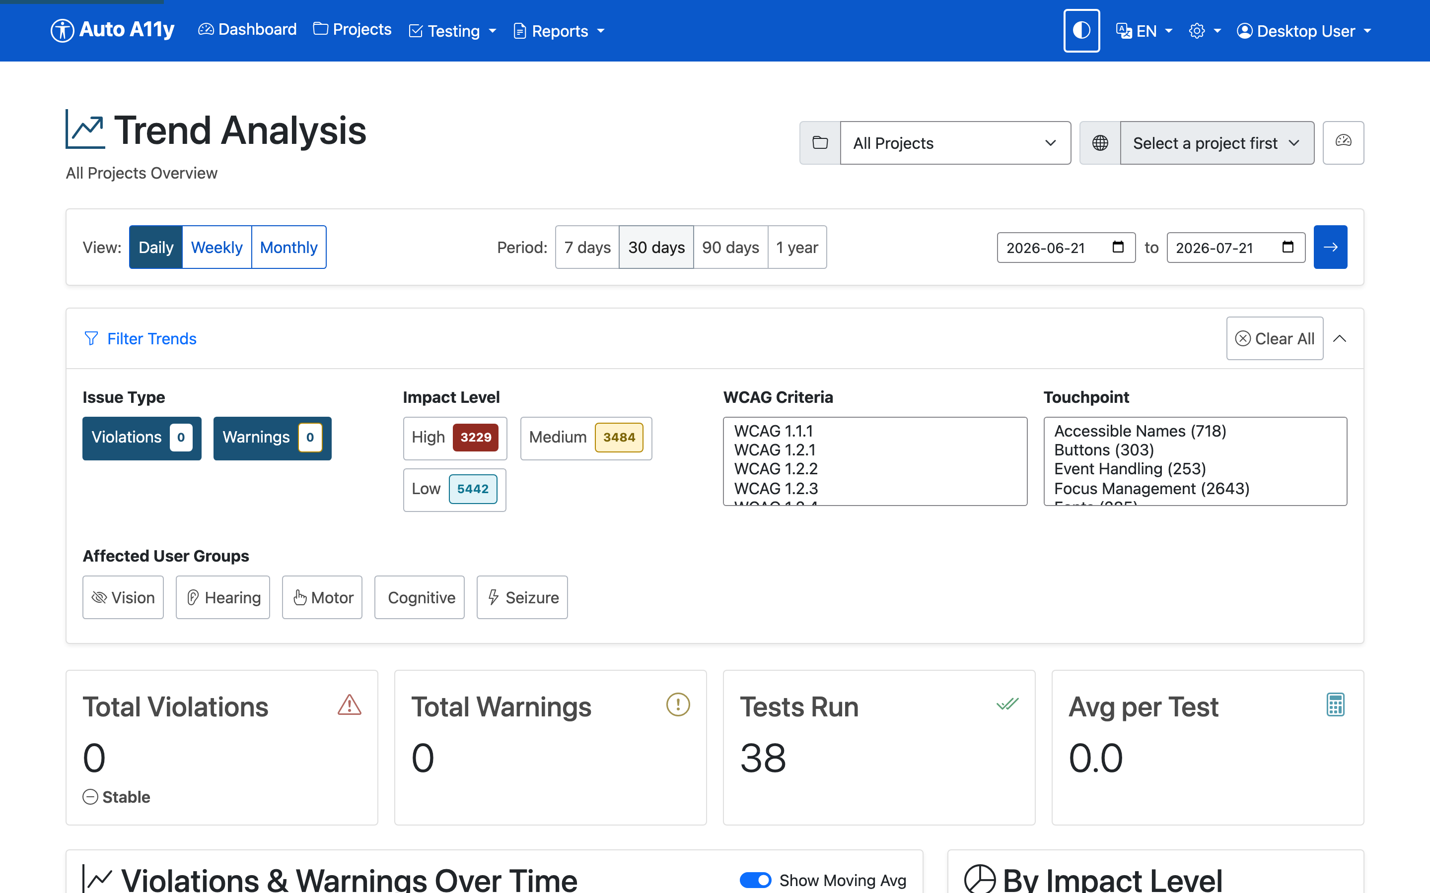

Tips, accessibility features, and troubleshooting
The app practices what it audits. The interface meets WCAG 2.2 AA: full keyboard operation (expanded accordions draw a double-line focus ring around the entire issue), dark mode via the toggle in the navigation bar, a full French translation via the EN/FR switcher, and screen-reader-tested components.
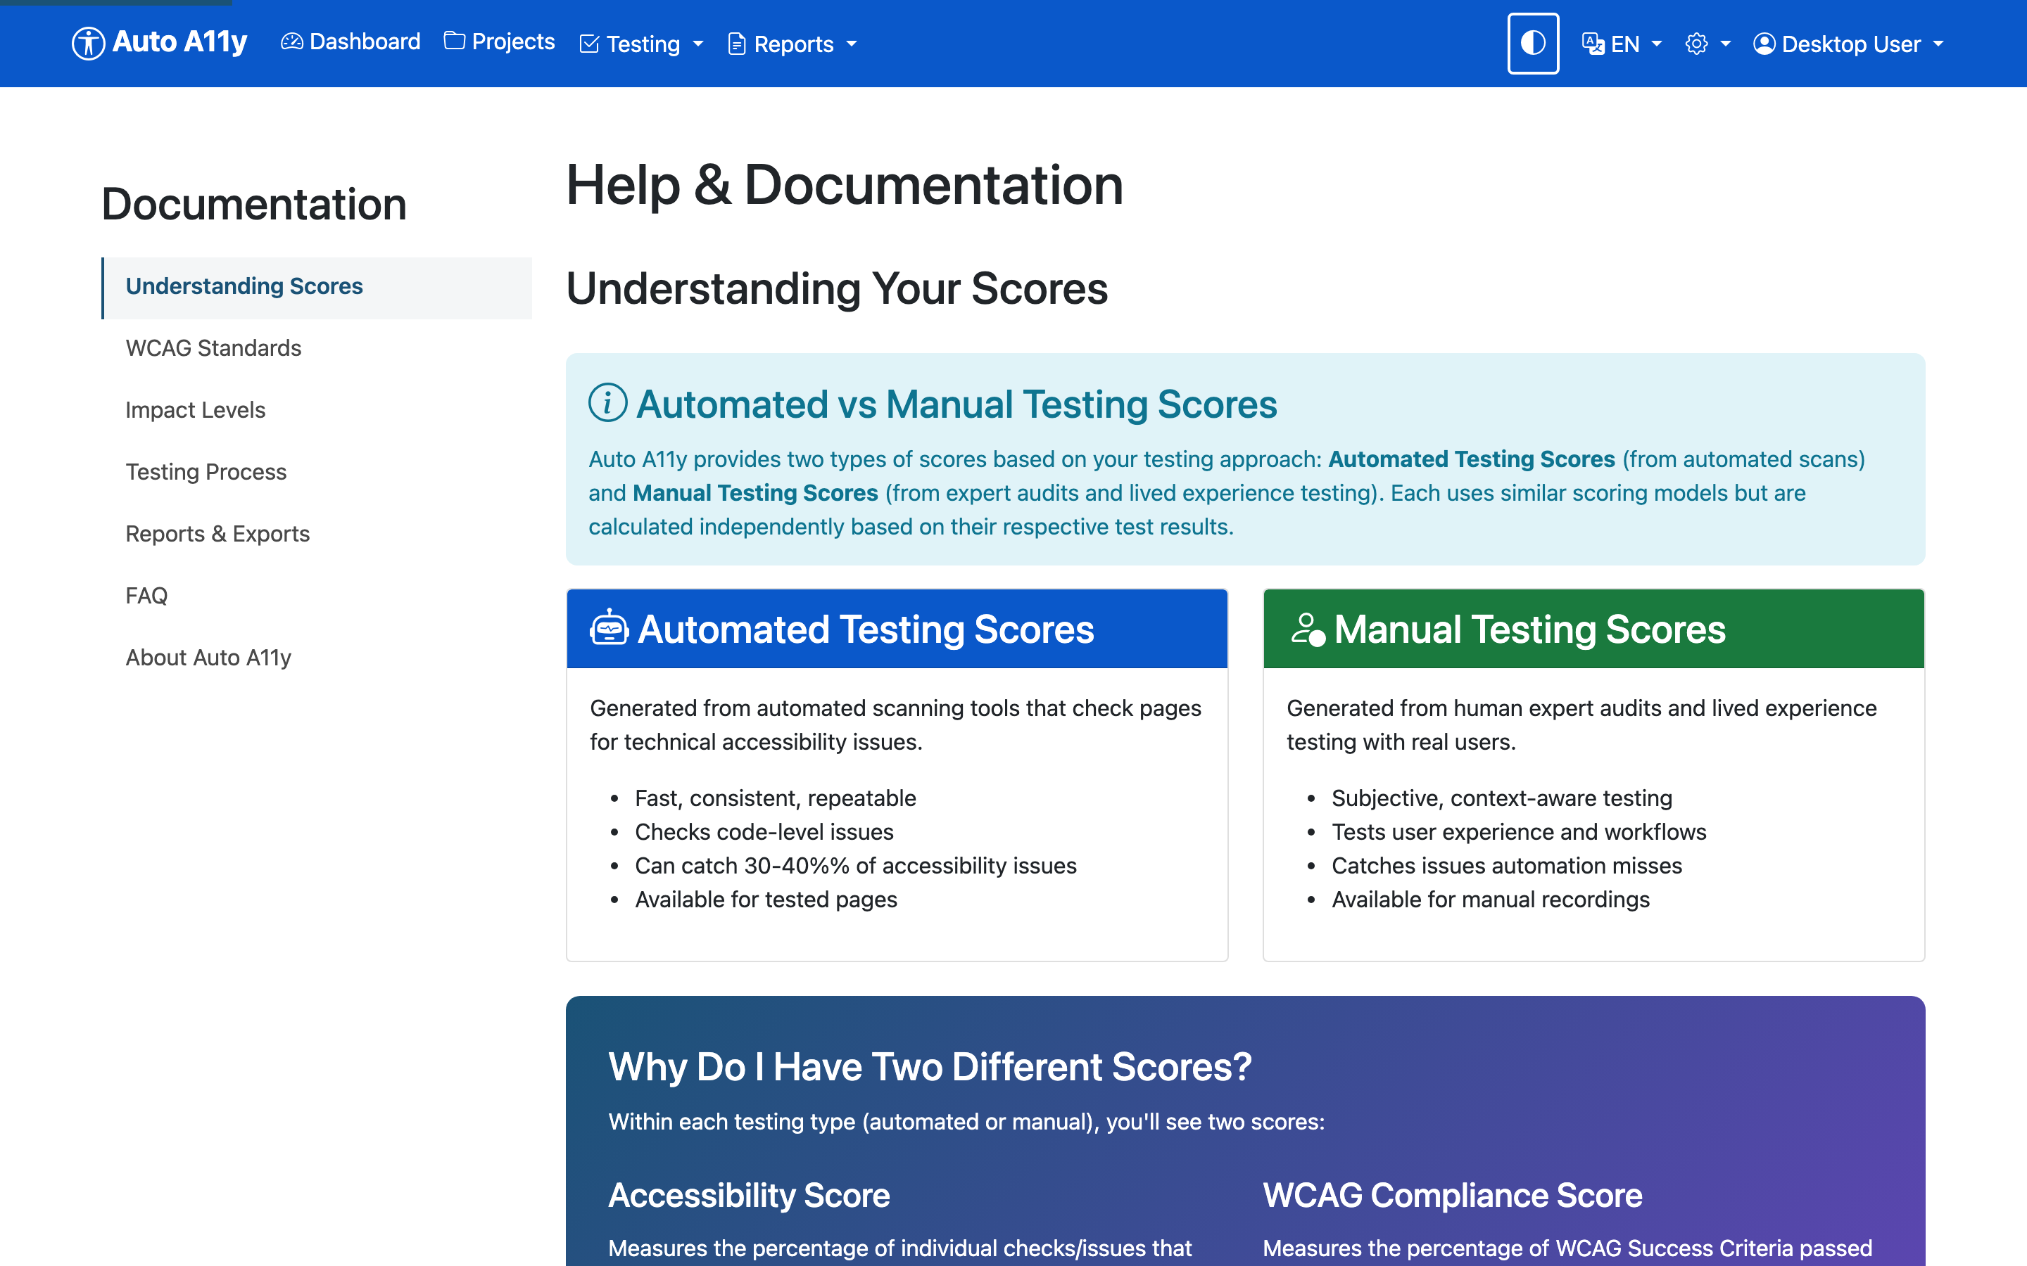
A page loads in the browser but the test reports “Failed to load page”. Usually the page never finishes loading its network activity (hung third-party images, long-polling scripts). Auto A11y tolerates this — it tests the loaded DOM after a grace period — but a page that cannot even reach domcontentloaded within 30 seconds will fail. Check the URL is reachable from this machine.
Discovery or testing returns bot-challenge pages instead of content. The site is bot-protected; enable Stealth Mode on the project (see section 9).
Authenticated pages aren’t being tested. Add a test user with valid credentials and confirm it with the Test Login button (see section 10).
A check you expected didn’t run. Two possibilities: it’s disabled in the project’s touchpoint configuration (see section 5), or it hasn’t passed fixture validation — check Testing → Fixture Status.
AI analysis findings are missing. AI visual analysis is off by default; enable it per project and confirm AI Analysis: Enabled on the Dashboard. Remember it incurs API costs and its results can vary between runs (see section 6).
Report generation seems stuck. Reports over large sites take minutes. The Reports page shows job progress; a stalled job can be dropped and restarted from Recent Reports.
The numbers in this guide look alarming. They should — Inaccessibility Matters is a demonstration site built to fail. A 1.0% compliance score is the point.

Appendix A: Tests by touchpoint
This appendix lists every check in the automated test suite, grouped by touchpoint. Whether a given check runs on a project depends on its fixture-validation status and the project’s touchpoint configuration (see section 5). The AI-assisted analyses (section 6) are separate from this catalog.
The automated test suite contains 213 checks across 19 touchpoints. Whether each check runs depends on its fixture-validation status and the project’s touchpoint configuration. Types: Error (WCAG violation), Warning (likely barrier), Info (informational), Discovery (needs manual review).

ARIA
Check | Type | What it tests
ErrAriaLabelMayNotBeFoundByVoiceControl | Error | aria-label doesn’t match visible text
ErrLabelMismatchOfAccessibleNameAndLabelText | Error | Accessible name doesn’t match visible label

Buttons
Check | Type | What it tests
ErrButtonClipPathWithOutline | Error | Button with non-rectangular clip-path uses outline for focus indicator - outline draws rectangular box not following clipped shape
ErrButtonFocusContrastFail | Error | Button focus outline has insufficient contrast (less than 3:1) against the button’s current background color
ErrButtonFocusObscured | Error | Button focus indicator is partially or fully obscured by other elements due to z-index stacking
ErrButtonOutlineOffsetInsufficient | Error | Button focus outline has outline-offset less than 2px, causing the outline to be lost within the button element
ErrButtonOutlineWidthInsufficient | Error | Button focus outline has outline-width less than 2px, making it too thin to be clearly visible
ErrButtonSingleSideBoxShadow | Error | Button uses outline:none with box-shadow that only appears on one side (directional shadow with offset)
ErrButtonTransparentOutline | Error | Button focus outline uses semi-transparent color (alpha < 0.5) which cannot guarantee sufficient visibility
WarnButtonDefaultFocus | Warning | Button uses browser default focus outline which may not meet contrast requirements on all backgrounds
WarnButtonFocusGradientBackground | Warning | Button with gradient background has focus outline - contrast cannot be automatically verified against gradient
WarnButtonFocusImageBackground | Warning | Button with background image has focus outline - contrast cannot be automatically verified against image
WarnButtonGenericText | Warning | Button uses generic text like “Click here”, “Submit”, or “OK” without context
WarnButtonOutlineNoneWithBoxShadow | Warning | Button uses outline:none with box-shadow for focus, which may not provide clear indication on all sides

Colours & Contrast
Check | Type | What it tests
ErrColorRelatedStyleDefinedExplicitlyInElement | Warning | Color-related styles defined inline
ErrColorRelatedStyleDefinedExplicitlyInStyleTag | Warning | Color-related styles defined in style tag
ErrTextContrast | Error | Text color has insufficient contrast ratio with its background color

Electronic Documents
Check | Type | What it tests
DiscoPDFLinksFound | Discovery | Links to PDF documents detected on page

Event Handling
Check | Type | What it tests
DiscoFoundJS | Discovery | JavaScript detected on page
ErrHandlerColorChangeOnly | Error | Element with event handler indicates focus only through color change without structural change
ErrHandlerFocusContrastFail | Error | Focus indicator on element with event handler has less than 3:1 contrast ratio with adjacent colors
ErrHandlerNoVisibleFocus | Error | Non-interactive element with event handler (onclick, etc.) lacks a visible focus indicator
ErrHandlerOutlineNoneNoBoxShadow | Error | Element with event handler removes default outline with ‘outline:none’ but provides no alternative focus indicator
ErrHandlerOutlineWidthInsufficient | Error | Element with event handler has a focus outline less than 2 CSS pixels thick
ErrHandlerSingleSideBoxShadow | Error | Element with event handler uses box-shadow on only one side for focus indicator
ErrHandlerTransparentOutline | Error | Element with event handler uses semi-transparent (alpha < 0.5) focus outline or box-shadow
ErrTabindexAriaHiddenFocusable | Error | Element has both tabindex (making it focusable) and aria-hidden=‘true’, which is invalid HTML and creates conflicting accessibility semantics
ErrTabindexChildOfInteractive | Error | Child element has tabindex attribute inside an interactive parent element (button, link, etc.), creating improper structure where assistive technologies cannot properly understand the relationships
ErrTabindexColorChangeOnly | Error | Element with tabindex indicates focus only through color change without structural change (outline, border, shape)
ErrTabindexFocusContrastFail | Error | Focus indicator on element with tabindex has less than 3:1 contrast ratio with adjacent colors
ErrTabindexNoVisibleFocus | Error | Non-interactive element made focusable with tabindex attribute lacks a visible focus indicator
ErrTabindexOutlineNoneNoBoxShadow | Error | Element with tabindex removes default outline with ‘outline:none’ but provides no alternative focus indicator
ErrTabindexOutlineWidthInsufficient | Error | Element with tabindex has a focus outline less than 2 CSS pixels thick
ErrTabindexSingleSideBoxShadow | Error | Element with tabindex uses box-shadow on only one side (top, right, bottom, or left) for focus indicator
ErrTabindexTransparentOutline | Error | Element with tabindex uses semi-transparent (alpha < 0.5) focus outline or box-shadow
WarnHandlerDefaultFocus | Warning | Element with event handler has no custom focus styles and relies on browser default focus indicator
WarnHandlerNoBorderOutline | Warning | Element with event handler uses only CSS outline for focus with no border or size change
WarnTabindexDefaultFocus | Warning | Element with tabindex has no custom focus styles and relies on browser default focus indicator
WarnTabindexNoBorderOutline | Warning | Element with tabindex uses only CSS outline for focus with no border or size change

Focus Management
Check | Type | What it tests
ErrNegativeTabIndex | Error | Negative tabindex on interactive element
ErrNoOutlineOffsetDefined | Error | No outline offset defined for focus
ErrOutlineIsNoneOnInteractiveElement | Error | Interactive element has CSS outline:none removing the default focus indicator
ErrPositiveTabIndex | Error | Element uses a positive tabindex value (greater than 0)
ErrTTabindexOnNonInteractiveElement | Error | Tabindex attribute on non-interactive element
ErrTabindexOfZeroOnNonInteractiveElement | Error | tabindex=“0” on non-interactive element
ErrWrongTabindexForInteractiveElement | Error | Inappropriate tabindex on interactive element
ErrZeroOutlineOffset | Error | Outline offset is set to zero

Fonts & Typography
Check | Type | What it tests
DiscoFontFound | Discovery | Font usage detected for review
WarnFontNotInRecommenedListForA11y | Warning | Font not in recommended accessibility list

Forms
Check | Type | What it tests
DiscoFormOnPage | Discovery | Form detected on page - needs manual testing
ErrEmptyAriaLabelOnField | Error | Form field has empty aria-label attribute
ErrEmptyAriaLabelledByOnField | Error | Form field has empty aria-labelledby attribute
ErrFielLabelledBySomethingNotALabel | Error | Field is labeled by an element that is not a proper label
ErrFieldAriaRefDoesNotExist | Error | aria-labelledby references non-existent element
ErrFieldLabelledUsingAriaLabel | Error | Field labeled using aria-label instead of visible label
ErrFieldReferenceDoesNotExist | Error | Label for attribute references non-existent field
ErrFormEmptyHasNoChildNodes | Error | Form element is completely empty with no child nodes
ErrFormEmptyHasNoInteractiveElements | Error | Form has content but no interactive elements
ErrInputBorderChangeInsufficient | Error | Input field border thickens on focus but change is less than 1px (not manifest)
ErrInputFocusColorChangeOnly | Error | Input field focus indicator relies solely on border color change without structural change
ErrInputFocusContrastFail | Error | Input field focus indicator has insufficient color contrast (< 3:1) against background
ErrInputNoVisibleFocus | Error | Text input field has no visible focus indicator (outline:none, no border change, no box-shadow)
ErrInputOutlineWidthInsufficient | Error | Input field focus outline is less than 2px wide
ErrInputSingleSideBoxShadow | Error | Input field uses single-sided box-shadow for focus indicator (does not follow field shape)
ErrLabelContainsMultipleFields | Error | Single label contains multiple form fields
ErrOrphanLabelWithNoId | Error | Label element exists but has no for attribute
WarnFieldLabelledByMulitpleElements | Warning | Field is labeled by multiple elements via aria-labelledby
WarnInputDefaultFocus | Warning | Input field relies on default browser focus styles which vary across browsers and platforms
WarnInputFocusGradientBackground | Warning | Input field has gradient background - focus indicator contrast cannot be automatically verified
WarnInputFocusOutlineExceedsParent | Warning | Input focus outline extends beyond parent container bounds - outline contrast cannot be automatically verified
WarnInputFocusParentGradientBackground | Warning | Input parent container has gradient background - focus outline contrast cannot be automatically verified
WarnInputFocusParentImageBackground | Warning | Input parent container has background image - focus outline contrast cannot be automatically verified
WarnInputFocusParentZIndexFloating | Warning | Input parent container has z-index without solid background - focus outline contrast cannot be automatically verified
WarnInputFocusZIndexFloating | Warning | Input field has z-index positioning and may float over varying backgrounds - focus outline contrast cannot be automatically verified
WarnInputNoBorderOutline | Warning | Input field uses border/box-shadow changes but no separate outline for focus indicator
WarnInputTransparentFocus | Warning | Input field focus indicator is semi-transparent (alpha < 0.5) which may not provide sufficient visibility
forms_DiscoNoSubmitButton | Discovery | Form may lack clear submit button
forms_WarnGenericButtonText | Warning | Button has generic text like “Submit” or “Click here”
forms_WarnNoFieldset | Warning | Radio/checkbox group lacks fieldset and legend
forms_WarnRequiredNotIndicated | Warning | Required field not clearly indicated

Headings
Check | Type | What it tests
ErrEmptyHeading | Error | Heading element (h1-h6) contains no text content or only whitespace
ErrFoundAriaLevelButNoRoleAppliedAtAll | Error | aria-level attribute without role=“heading”
ErrFoundAriaLevelButRoleIsNotHeading | Error | aria-level on element without heading role
ErrHeadingAccessibleNameMismatch | Error | Visible heading text doesn’t match its accessible name
ErrHeadingLevelsSkipped | Error | Heading levels are not in sequential order - one or more levels are skipped (e.g., h1 followed by h3 with no h2)
ErrHeadingOrder | Error | Headings appear in illogical order - high-level headings (H1, H2) appear after lower-level headings (H3, H4, H5, H6)
ErrHeadingsDontStartWithH1 | Error | First heading on page is not h1
ErrInvalidAriaLevel | Error | Invalid aria-level value (not 1-6)
ErrMultipleH1HeadingsOnPage | Error | Multiple h1 elements found on page
ErrNoH1OnPage | Error | Page is missing an h1 element to identify the main topic
ErrNoHeadingsOnPage | Error | No heading elements (h1-h6) found anywhere on the page
ErrRoleOfHeadingButNoLevelGiven | Error | role=“heading” without aria-level
WarnHeadingInsideDisplayNone | Warning | Heading is hidden with display:none
WarnHeadingOver60CharsLong | Warning | Heading text exceeds 60 characters

Images
Check | Type | What it tests
DiscoFoundInlineSvg | Discovery | Inline SVG element detected that requires manual review to determine appropriate accessibility implementation based on its purpose and complexity
DiscoFoundSvgImage | Discovery | SVG element with role=“img” detected that requires manual review to verify appropriate text alternatives are provided
ErrAltOnElementThatDoesntTakeIt | Error | Alt attribute placed on HTML elements that don’t support it (such as div, span, p, or other non-image elements), making the alternative text inaccessible to assistive technologies
ErrImageAltContainsHTML | Error | Image’s alternative text contains HTML markup tags
ErrImageWithEmptyAlt | Error | Image alt attribute contains only whitespace characters (spaces, tabs, line breaks), providing no accessible name
ErrImageWithImgFileExtensionAlt | Error | Alt text contains image filename with file extension (e.g., “photo.jpg”, “IMG_1234.png”, “banner.gif”), providing no meaningful description of the image content
ErrImageWithURLAsAlt | Error | Alt attribute contains a URL (starting with http:// https:// www or file:// instead of descriptive text about the image content

Landmarks
Check | Type | What it tests
ErrBannerLandmarkAccessibleNameIsBlank | Error | Banner landmark has blank accessible name
ErrBannerLandmarkHasAriaLabelAndAriaLabelledByAttrs | Error | Banner landmark has both aria-label and aria-labelledby
ErrBannerLandmarkMayNotBeChildOfAnotherLandmark | Error | Banner landmark nested inside another landmark
ErrComplementaryLandmarkAccessibleNameIsBlank | Error | Complementary landmark has blank accessible name
ErrComplementaryLandmarkHasAriaLabelAndAriaLabelledByAttrs | Error | Complementary landmark has both aria-label and aria-labelledby
ErrComplementaryLandmarkMayNotBeChildOfAnotherLandmark | Error | Complementary landmark is nested inside another landmark
ErrCompletelyEmptyNavLandmark | Error | Navigation landmark contains no content
ErrContentInfoLandmarkAccessibleNameIsBlank | Error | Contentinfo landmark has blank accessible name
ErrContentInfoLandmarkHasAriaLabelAndAriaLabelledByAttrs | Error | Contentinfo landmark has both aria-label and aria-labelledby
ErrContentOutsideLandmarks | Error | Content exists outside of landmark regions, making it invisible to screen reader landmark navigation
ErrContentinfoLandmarkMayNotBeChildOfAnotherLandmark | Error | Contentinfo landmark is nested inside another landmark
ErrDuplicateLabelForBannerLandmark | Error | Multiple banner landmarks have the same label
ErrDuplicateLabelForComplementaryLandmark | Error | Multiple complementary landmarks have the same label
ErrDuplicateLabelForContentinfoLandmark | Error | Multiple contentinfo landmarks have the same label
ErrDuplicateLabelForFormLandmark | Error | Multiple form landmarks have the same label
ErrDuplicateLabelForNavLandmark | Error | Multiple navigation landmarks have the same label
ErrDuplicateLabelForRegionLandmark | Error | Multiple region landmarks have the same label
ErrDuplicateLabelForSearchLandmark | Error | Multiple search landmarks have the same label
ErrElementNotContainedInALandmark | Error | Content exists outside of any landmark
ErrFormAriaLabelledByIsBlank | Error | Form aria-labelledby references blank or empty element
ErrFormAriaLabelledByReferenceDIsHidden | Error | Form aria-labelledby references hidden element
ErrFormAriaLabelledByReferenceDoesNotExist | Error | Form aria-labelledby references non-existent element
ErrFormAriaLabelledByReferenceDoesNotReferenceAHeading | Error | Form aria-labelledby doesn’t reference a heading element
ErrFormLandmarkAccessibleNameIsBlank | Error | Form landmark has blank accessible name
ErrFormLandmarkHasAriaLabelAndAriaLabelledByAttrs | Error | Form landmark has both aria-label and aria-labelledby
ErrFormUsesAriaLabelInsteadOfVisibleElement | Error | Form uses aria-label instead of visible heading or label
ErrFormUsesTitleAttribute | Error | Form uses title attribute for labeling
ErrMainLandmarkHasAriaLabelAndAriaLabelledByAttrs | Error | Main landmark has both aria-label and aria-labelledby attributes
ErrMainLandmarkHasTabindexOfZeroCanOnlyHaveMinusOneAtMost | Error | Main landmark has tabindex=“0” which is inappropriate
ErrMainLandmarkIsHidden | Error | Main landmark is hidden from view
ErrMainLandmarkMayNotbeChildOfAnotherLandmark | Error | Main landmark nested inside another landmark
ErrMultipleBannerLandmarksOnPage | Error | Multiple banner landmarks found
ErrMultipleContentinfoLandmarksOnPage | Error | Multiple contentinfo landmarks found
ErrMultipleMainLandmarksOnPage | Error | Multiple main landmark regions found on the page
ErrNavLandmarkAccessibleNameIsBlank | Error | Navigation landmark has blank accessible name
ErrNavLandmarkContainsOnlyWhiteSpace | Error | Navigation landmark contains only whitespace
ErrNavLandmarkHasAriaLabelAndAriaLabelledByAttrs | Error | Navigation landmark has both aria-label and aria-labelledby
ErrNestedNavLandmarks | Error | Navigation landmarks are nested
ErrNoBannerLandmarkOnPage | Error | Page is missing a banner landmark to identify the site header region
ErrNoMainLandmarkOnPage | Error | Page is missing a main landmark region to identify the primary content area
ErrRegionLandmarkHasAriaLabelAndAriaLabelledByAttrs | Error | Region landmark has both aria-label and aria-labelledby
RegionLandmarkAccessibleNameIsBlank | Error | Region landmark has blank accessible name
WarnBannerLandmarkAccessibleNameUsesBanner | Warning | Banner landmark uses generic term “banner” in label
WarnComplementaryLandmarkAccessibleNameUsesComplementary | Warning | Complementary landmark label uses generic term “complementary”
WarnComplementaryLandmarkHasNoLabel | Warning | Complementary landmark lacks a label
WarnContentInfoLandmarkHasNoLabel | Warning | Contentinfo landmark lacks a label
WarnContentinfoLandmarkAccessibleNameUsesContentinfo | Warning | Contentinfo landmark uses generic term “contentinfo” in label
WarnFormLandmarkAccessibleNameUsesForm | Warning | Form landmark uses generic term “form” in label
WarnHeadingFoundInLandmarkButIsLabelledByAnAriaLabelledBy | Error | Landmark has heading but uses different element for label
WarnHeadingFoundInsideLandmarkButDoesntLabelLandmark | Warning | Heading inside landmark doesn’t label the landmark
WarnMultipleBannerLandmarksButNotAllHaveLabels | Warning | Multiple banner landmarks exist but not all have labels
WarnMultipleComplementaryLandmarksButNotAllHaveLabels | Warning | Multiple complementary landmarks but not all labeled
WarnMultipleContentInfoLandmarksButNotAllHaveLabels | Warning | Multiple contentinfo landmarks exist but not all have labels
WarnMultipleNavLandmarksButNotAllHaveLabels | Warning | Multiple navigation landmarks but not all labeled
WarnMultipleRegionLandmarksButNotAllHaveLabels | Warning | Multiple region landmarks but not all labeled
WarnNavLandmarkAccessibleNameUsesNavigation | Warning | Navigation landmark uses generic term “navigation” in label
WarnNavLandmarkHasNoLabel | Warning | Navigation landmark lacks label
WarnNoContentinfoLandmarkOnPage | Warning | Page is missing a contentinfo landmark to identify the footer region
WarnNoNavLandmarksOnPage | Warning | Page has no navigation landmarks to identify navigation regions
WarnRegionLandmarkAccessibleNameUsesNavigation | Warning | Region landmark incorrectly uses “navigation” in its label
WarnRegionLandmarkHasNoLabelSoIsNotConsideredALandmark | Warning | Region landmark lacks required label to be considered a landmark

Language
Check | Type | What it tests
ErrElementPrimaryLangNotRecognized | Error | Element has unrecognized language code
ErrElementRegionQualifierNotRecognized | Error | Element lang attribute has unrecognized region qualifier
ErrEmptyLanguageAttribute | Error | Element (non-HTML) has a lang attribute present but with no value (lang=““), preventing screen readers from determining language changes
ErrEmptyXmlLangAttr | Error | xml:lang attribute is empty
ErrHreflangAttrEmpty | Error | hreflang attribute is empty on link
ErrHreflangNotOnLink | Error | hreflang attribute on non-link element
ErrIncorrectlyFormattedPrimaryLang | Error | Language code incorrectly formatted
ErrPrimaryHrefLangNotRecognized | Error | hreflang language code not recognized
ErrPrimaryLangAndXmlLangMismatch | Error | lang and xml:lang attributes don’t match
ErrPrimaryLangUnrecognized | Error | Language code not recognized
ErrPrimaryXmlLangUnrecognized | Error | xml:lang language code not recognized
ErrRegionQualifierForHreflangUnrecognized | Error | hreflang region qualifier not recognized
ErrRegionQualifierForPrimaryLangNotRecognized | Error | Region qualifier in primary language code not recognized (e.g., “en-XY”)
ErrRegionQualifierForPrimaryXmlLangNotRecognized | Error | Region qualifier in xml:lang not recognized

Links
Check | Type | What it tests
ErrAnchorTargetTabindex | Error | In-page link target (element with id referenced by href=“#id”) is not keyboard accessible - non-interactive element needs tabindex=“-1”
ErrDocumentLinkMissingFileType | Error | Link to downloadable document (PDF, Word, Excel, PowerPoint, etc.) does not indicate the file type in its accessible name
ErrDocumentLinkWrongLanguage | Error | Link to a downloadable document in a different language than the page language lacks lang attribute or language indication
ErrLinkButtonMissingSpaceHandler | Error | Link is styled to look like a button but lacks Space key handler - keyboard users expect Space key to activate button-like elements
ErrLinkColorChangeOnly | Error | Link focus indicator relies solely on color change without outline, border, box-shadow, or underline
ErrLinkFocusContrastFail | Error | Link focus indicator (outline, border, or underline) has contrast ratio < 3:1 against the background
ErrLinkImageNoFocusIndicator | Error | Image link has no visible focus indicator (no outline, border, or box-shadow)
ErrLinkOpensNewWindowNoWarning | Error | Link opens in new window/tab without warning users
ErrLinkOutlineWidthInsufficient | Error | Link focus outline width is less than 2px
ErrLinkTextNotDescriptive | Error | Link text does not adequately describe the link’s destination or purpose
WarnColorOnlyLink | Warning | Link in flowing text is distinguished from surrounding text only by color, without underline, border, or other non-color visual indicator
WarnColorOnlyLinkWeakIndicator | Warning | Link in flowing text uses only subtle visual indicators (font-weight, bold, or text-shadow) in addition to color - these can be difficult for users to recognize as links
WarnLinkDefaultFocus | Warning | Link uses browser default focus styles which vary across browsers and may fail contrast requirements
WarnLinkFocusGradientBackground | Warning | Link has gradient background - focus indicator contrast cannot be automatically verified and requires manual testing
WarnLinkLooksLikeButton | Warning | Link is styled to look like a button but uses anchor element
WarnLinkOutlineOffsetTooLarge | Warning | Link has both underline and outline with outline-offset > 1px, creating confusing visual gap
WarnLinkTransparentOutline | Warning | Link focus outline or border uses semi-transparent color (alpha < 0.5) which cannot guarantee sufficient contrast
WarnMissingDocumentMetadata | Warning | Link to downloadable document does not provide additional metadata such as file size or page count

Lists
Check | Type | What it tests
ErrListitemEmpty | Error | List item (<li> or role=“listitem”) is empty or contains only whitespace, providing no content for users

Navigation
Check | Type | What it tests
ErrNoCurrentPageIndicatorMagnification | Error | Navigation lacks visual current page indicator, preventing screen magnifier users from knowing their location without panning
ErrNoCurrentPageIndicatorScreenReader | Error | Navigation lacks aria-current=“page” indicator, forcing screen reader users through entire menu to discover current location

Page
Check | Type | What it tests
ErrEmptyPageTitle | Error | Page title element is empty
ErrMissingDocumentType | Error | HTML document is missing the DOCTYPE declaration (<!DOCTYPE html>) at the beginning of the file
ErrMultiplePageTitles | Error | Multiple title elements found in document head causing unpredictable behavior
ErrNoPageTitle | Error | Page has no <title> element in the document head

Page Title
Check | Type | What it tests
ErrEmptyTitleAttr | Error | Empty title attribute
ErrIframeWithNoTitleAttr | Error | Iframe element is missing the required title attribute
ErrImproperTitleAttribute | Error | Title attribute used in particularly problematic patterns (on non-focusable elements or duplicating visible text)
ErrTitleAttrFound | Error | Title attribute used - fundamentally inaccessible to assistive technology
WarnVagueTitleAttribute | Warning | Title attribute contains vague or generic text that provides no useful information

Responsive & Reflow
Check | Type | What it tests
DiscoResponsiveBreakpoints | Discovery | Responsive breakpoints detected on page

Styles
Check | Type | What it tests
DiscoStyleAttrOnElements | Discovery | Inline styles detected
DiscoStyleElementOnPage | Discovery | Style element found in page
ErrStyleAttrColorFont | Error | Inline style attributes define color or font properties directly on HTML elements, overriding user stylesheets and preventing users from customizing visual presentation
ErrStyleTagColorFont | Error | Style tags in HTML document define color or font properties, making it harder for users to override with custom stylesheets due to specificity and source order
WarnStyleAttrOther | Warning | Inline style attributes define layout properties (margin, padding, width, display) directly on HTML elements instead of using CSS classes
WarnStyleTagOther | Warning | Style tags in HTML document define layout properties, which should preferably be in external CSS files for better maintainability and performance
See also: API_GUIDE.md for automating Auto A11y from scripts and CI, and ARCHITECTURE.md for how the platform works internally.

