**Conrad Hild**

Actor/Voice Actor/Communications Specialist

ABOUT RESUME GALLERY VIDEOS/FILMS VOICE WORK CONTACT

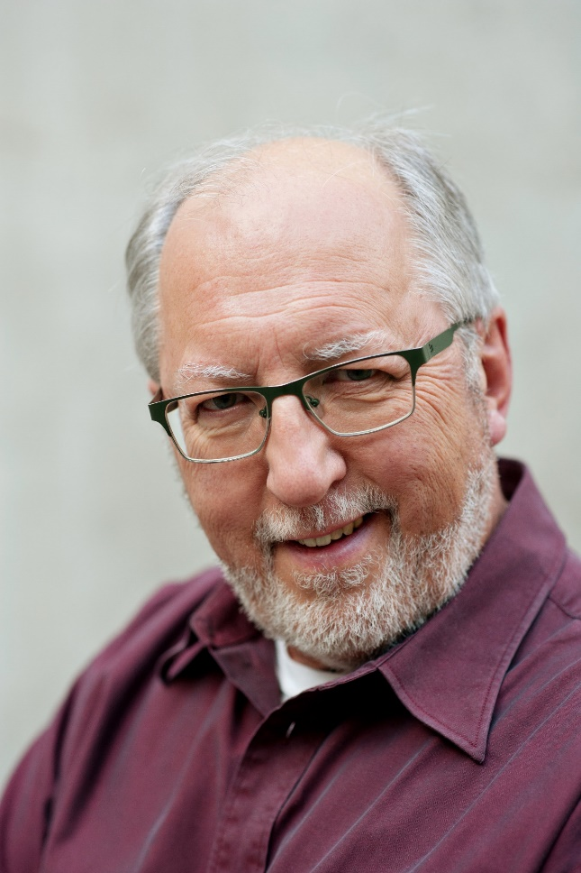

**About**

Conrad lives in Calgary, Alberta, Canada, and is active in the film, theatre and communications world. He has acted in a variety of films and theatre productions, as well as commercial voice work.

He spent many years as a communications specialist, including teaching on the university level in theatre arts, fine arts, communications and public speaking.

Conrad is a father to four adult children and nine grandchildren.