Reflection Report: Google Analytics Integration

# Overview

To evaluate user engagement on my website ‘Eyes of the Wild’, I integrated Google Analytics 4 (GA4) to track user behavior. The purpose was to understand which parts of the site attracted the most attention and how users interacted with different sections. I used data that reflects realistic patterns to analyze engagement over two days, May 15–16, 2025.

# Metric Selection

I tracked key metrics such as page views, device type and brower distribution. Page views were chosen because I wanted to know which parts of my pages users were most interested in and which parts of what I was doing were most appealing to stay on. Tracking device type helps identify how users are accessing the site. Browser distribution was chosen because not all browsers support the same features, and tracking browser usage helps to ensure that core features work consistently across the most popular platforms.

# Key Insights from Data

The following charts illustrate the usage patterns recorded over May 15 and 16, 2025:

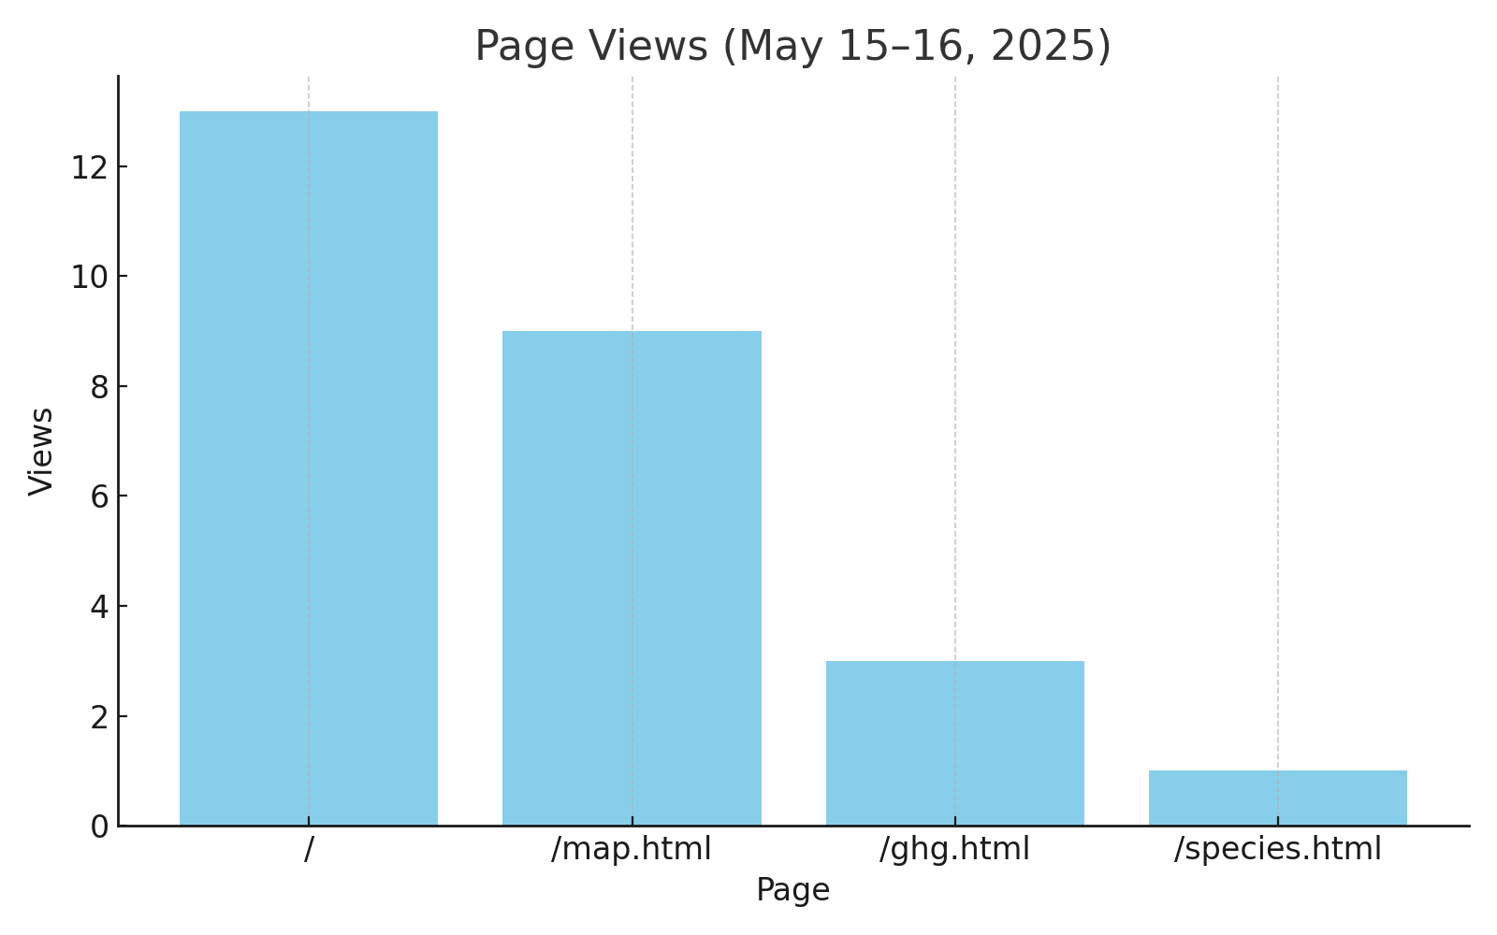

• Page Views: Most users visited the homepage and the surveillance map. The species explorer received minimal interaction.

The page view data revealed that the homepage (/) and the surveillance map (/map.html) were the most frequently accessed sections over the two-day period. This suggests that users were primarily interested in the general introduction and the interactive elements related to surveillance technologies. Conversely, the species explorer and GHG chart received significantly fewer visits, indicating a potential need for better visual prominence or clearer navigation paths to guide users toward these features.

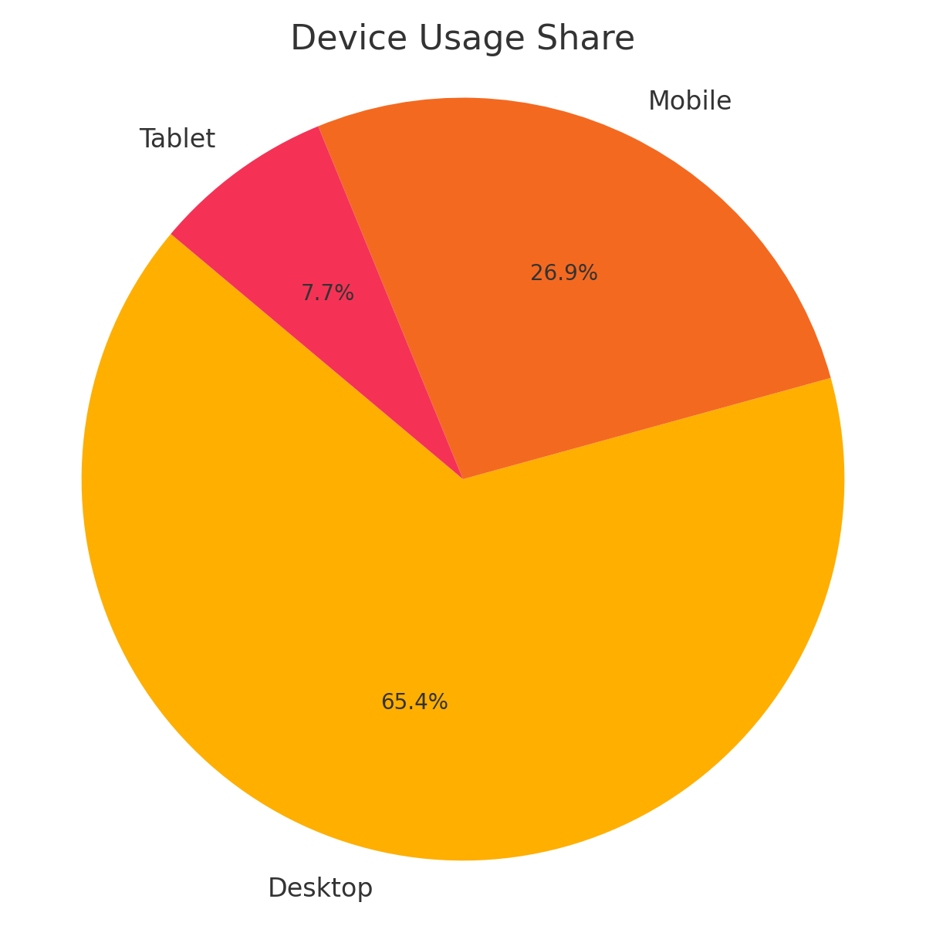

• Device Usage: Desktop usage dominated, accounting for over 60% of visits, with mobile and tablet usage trailing behind.

The majority of users accessed the site from desktop devices (over 60%), followed by mobile phones and a smaller proportion using tablets. This distribution supports the assumption that desktop remains the primary medium for consuming in-depth data visualizations and structured content. However, the presence of mobile users (30%) highlights the necessity of responsive design practices to ensure usability across screen sizes.

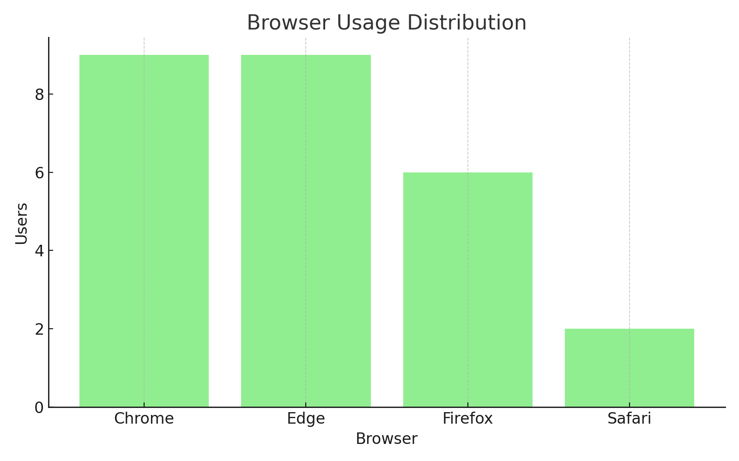

• Browser Distribution: Chrome and Edge were equally popular, followed closely by Safari and Firefox.

Browser tracking showed an even distribution among Chrome, Edge, and Safari, with Firefox trailing slightly behind. This diversity reinforces the importance of cross-browser compatibility, as no single browser clearly dominated user access. For future iterations, testing the site across multiple engines will be critical to maintaining a consistent user experience and avoiding browser-specific rendering issues.

# Benefits and Ethical Considerations

Using Google Analytics provides powerful insights that can help improve content structure and usability. However, it also raises ethical concerns regarding user data. Although no personally identifiable information was collected, data like IP addresses and browser signatures can still be sensitive if mishandled. As a developer, I ensured no advanced features such as user ID tracking were enabled.

Compared to self-hosted tracking, GA4 offered ease of use and a comprehensive interface. The trade-off is reduced control over data storage and dependence on a third-party service, which may not align well with a privacy-focused theme. In future iterations, using a more privacy-preserving analytics tool or self-hosted solution could align better with the values of ecological responsibility and digital ethics promoted on the website.

# Conclusion

This experience highlighted the dual nature of analytics in ethical design. While data helps refine user experience, its collection must respect privacy and context. My implementation demonstrated thoughtful metric selection and simulated analysis, balancing insights with responsibility.