Analysis of Medicare Advantage/Part D Contract Enrollment data

Than Tirouvingadame

ABSTRACT
In this paper, we try to understand the ways Big data analytics can be used in Financial Services, in particular, the Insurance sector. The paper traces the changes that has impacted the Financial Services sector in the US in the recent years and the need to reinvent business models to stay relevant in today’s business scenario. It outlines an architectural framework and methodology, by which Big Data Analytics can be applied to gain useful insights about the target customers and improve business. It also discusses the challenges that the industry is facing in this area.
Big data analytics can be a game-changer for Financial Services companies and can help keep up profits and growth while reducing costs drastically.
Keywords
Big Data Analytics, SQL, HiveQL, Impala, Insurance, Financial Services, Healthcare Insurance, Medicare Advantage Plan, SNPlan, Part D.

INTRODUCTION
Traditionally, financial services sector has been more data-driven, with huge volumes of transaction data as well as market data every second. Companies sit on huge repositories of data both from the customers front and from the market front i.e., in the form of various market performance indicators.

Permission to make digital or hard copies of all or part of this work for personal or classroom use is granted without fee provided that copies are not made or distributed for profit or commercial advantage and that copies bear this notice and the full citation on the first page. To copy otherwise, or republish, to post on servers or to redistribute to lists, requires prior specific permission and/or a fee.

It would be interesting to study how Big data can be of help to improve businesses in this sector. For example, in Banking sector it may generate great value to identify credit card frauds, and potential loan defaults; in Insurance, it may be whether a customer will buy insurance or not; in Financial markets, it may be to predict how a stock/sector perform in future or how to tailor services to lure new investors etc. Also, since most of data is financial in nature, it may be of additional interest to study the security issues that may challenge the system.

PROBLEM FACED
The industry is dogged by many issues, the top one being that it has not been able to attract new customers for several years now. As per the most recent life insurance market research by LIMRA - “Ownership of Individual Life Insurance Falls to 50-Year Low”, which puts the business model at risk the way it currently operates. Improved longevity of the customers, complex nature of the products offered which is confusing new customers, less training of agents are all leading to decreasing revenues.
One way to overcome these obstacles is to take a customer-centric approach and grow organically. Currently, insurance products are marketed to potential customers in a ‘buckshot approach’ where all people are considered potential customers. Using Big Data Analytics, a more targeted approach can be attempted. Insurance companies should think creatively about who their customers are and develop tailor-made products that are simple and suited to their individual needs.
Insurance, again, is a broader term, covering property, auto, accident and other types of insurances. For this research, we would be focusing on Healthcare Insurance.

OBJECTIVE
The idea behind the research was to understand the customer base of healthcare insurance products, by studying the current market realities. To understand who the potential customers are, we started with questions like,
- Who are the customers that go for private insurance?
- Who are the customers who do not go for private insurance and go for public insurance instead?
- What plans are popular among the customers who go for public insurance?
- Are there any Special Needs Plans that customers are interested in?
- What are the healthcare organizations that are popular among customers buying healthcare insurance? Etc.,
The main objective of the research was to analyse healthcare data and various healthcare insurance plans in the United States to learn about the most favoured Medicare Advantage plans by enrollees (customers.

METHODOLOGY
The idea was to understand the customer base which might help in targeting future products to prospective new customers. The analysis was started from a top down approach and we first looked at Census data to gain information about percentage of people who avail healthcare public insurance and private insurance.
With this knowledge, we then went on to analyse the most popular Medicare Advantage Plans and their distribution and other benefits, if any.

Data set used

The datasets used for research comes from two different websites. Both are publicly available sources. The first one is from https://www.census.gov/hhes/www/hlthins/data/utilization/tables.html This is a U.S. govt. site that publishes data periodically about different indicators of society. The data has been collected over years from 2001 – 2011.
This dataset gives a picture of the health status of the population over years. It gives information on select characteristics such as sex, age, income, race, medical provider visits, dentist visits, nights in hospital, prescription medicine use, privately insured %, publicly insured %, uninsured % of population etc. For our research, we would be calling this dataset as Dataset 1.
The other dataset was collected from another U.S. govt website http://cms.gov/Research-Statistics-Data-and-Systems/Statistics-Trends-and-Reports/MCRAdvPartDEnrolData/Monthly-Enrollment-by-Contract-Plan-State-County-Items/Monthly-Enrollment-by-CPSC-2015-04.html?DLPage=1&DLSort=1&DLSortDir=descending which is also a publicly available source. This website gives information onenrollment into Medicare Advantage Plans by customers in U.S. Details such as Plan names, State, county, Plan type are covered in this dataset upto April, 2015. For our research, we would be calling this dataset as Dataset 2.
Using these two datasets, a set of data analytics was attempted to get a thorough understanding about the healthcare insurance industry in the U.S.

Configuration of the Virtual Machine:
The configuration of the Virtual Machine used for running this research is as follows: Physical machine running the VM has 8 GB of memory with an Intel Core i7 processor of 4 cores. The virtual machine is utilizing 4 GB of the memory with 1 virtual core. The host computer is running Microsoft Windows 8 and we are using the Cloudera Linux Virtual Machine for our experiments.

Physical Schema Design

Dataset 1:
In this dataset, the data is stored in XLS format, in rows and columns, in a structured format. This dataset had information spanning over years on the % of people who were covered by private insurance and public insurance.
The schema of the table is as follows:

INSData
Privately insured | String
Publicly insured | String
Medicaid | String
. | .
. | .
Uninsured | String

Figure 1. Schema for Dataset 1.

Dataset 2:

This dataset had information on enrollments upto April 2015, and the data was stored in two different tables, which had two common columns. The schema is as follows:
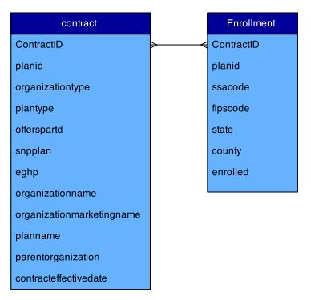
Figure 2. ER Diagram between Contract and Enrollment Tables¹²

CONTRACT TABLE ENROLLMENT TABLE
Contracted | string |  | contractid | String
Planid | string |  | planid | String
Organizationtype | String |  | ssacode | String
Plantype | String |  | fipscode | String
offerspartd | string |  | state | String
Snpplan | string |  | county | String
Eghp | string |  | enrolled | String
organizationname | string
organisationmarketingname | string
Planname | string
parentorganization | string
contraacteffectivedate | string
Figure 3. Schema for Dataset 2
The two matching columns in the two tables gave rise to the possibility of a number of complex queries that could be applied to join the two tables and bring out a wealth of information.

Analytical Tools Used
Since the data is in traditional RDBMS format, it is particularly suitable for querying using SQL based querying tools like HiveQL, Pig, Impala. For this research, querying was done using HiveQL and Impala, to show how easy it is to get insights from data using these tools.
“Apache Hive data warehouse software facilitates querying and managing large datasets residing in distributed storage”⁵. With a SQL-like language called HiveQl, it is built on top of Hadoop and offers user friendly interface to non-technical users.
Impala is a an open-source⁶, “fully integrated, state-of-the-art analytic database architected specifically to leverage the flexibility and scalability strengths of Hadoop - combining the familiar SQL support and multi-user performance of a traditional analytic database with the rock-solid foundation of open source Apache Hadoop and the production-grade security and management extensions of Cloudera Enterprise”¹⁰.

Steps followed in Analysis
The steps followed for analyzing the data is listed below.
- The data was downloaded into the Virtual Machine
- Data was moved to HDFS filesystem.
- Hive table was created for each dataset.
- Data was loaded into the created table.
- Querying was done to get needed information.
The table created in Hive was used for querying in HiveQL as well as Impala.

Data preparation and Analysis

Data preparation for Dataset 1
The website link mentioned above https://www.census.gov/hhes/www/hlthins/data/utilization/tables.html had datasets spanning over years - 2001, 2002, 2003, 2004, 2005, 2009, 2010 and 2011 - 8 years in all. The information regarding health insurance coverage is stored in Table 4 in each year dataset. Since we wanted information on people who avail public insurance and private insurance for each year, Table 4 of each year was copied into a new single excel workbook- 8 sheets for data relating to 8 years of data.

The dataset thus created was used for querying. One important observation about this dataset was that it had information stored in rows and not columns, since that was the case in the original dataset. The SELECT queries in Hive and Impala work on columns. Hence, the TRANSPOSE function in Excel was applied to transpose the rows into columns. This was then loaded into HDFS filesystem.

Size of Dataset 1
The excel workbook containing the healthcare insurance coverage information was converted into a .csv and downloaded into the virtual machine. It was put in HDFS as hc2001.csv, hc2002.csv hc2003.csv hc2004.csv hc2005.csv hc2006.csv hc2007.csv and hc2008.csv. The combined size of these files was 41646 bytes.

Creating table in Hive
To load the data into a Hive table, we first create a similar table called INSData with columns.
hive>CREATE TABLE INSData(Allpeople STRING,
Allpeopleinsured_anytype STRING, Allpeopleprivatelyinsured STRING, AllpeopleMedicare STRING, AllpeopleMedicaid STRING, Allpeoplepublicallyinsured STRING, Allpeopleuninsured STRING, peopleaged0-64 STRING, peopleaged0-64insured_anytype STRING, peopleaged0-64Privatelyinsured STRING, peopleaged0-64Medicare STRING, peopleaged0-64Medicaid STRING, peopleaged0-64Publicallyinsured STRING, peopleaged0-64uninsured STRING, aged18-64 STRING, aged18-64insured_anytype STRING, aged18-64Privatelyinsured STRING, aged18-64Medicare STRING, aged18-64Medicaid STRING, aged18-64Publicallyinsured STRING, aged18-64uninsured STRING, aged65above STRING, aged65aboveinsured_anytype STRING, aged65abovePrivatelyinsured STRING, aged65aboveMedicare STRING, aged65aboveMedicaid STRING, aged65abovePublicallyinsured STRING, aged65aboveuninsured STRING, incomelessthan200%PT STRING, fieldAC STRING,
fieldAD STRING, fieldAE STRING, filedAF STRING, fieldAG STRING, fieldAH STRING, fieldAI STRING, fieldAJ STRING, fieldAK STRING, fieldAL STRING, fieldAM STRING, fieldAN STRING, fieldAO STRING,fieldAP STRING, fieldAQ STRING,fieldAR STRING, fieldAS STRING,fieldAT STRING, fieldAU STRING, fieldAV STRING, fieldAW STRING,fieldAX STRING, fieldAY STRING, fieldAZ STRING,fieldBA STRING,fieldBB STRING,fieldBC STRING) ROW FORMAT DELIMITED FIELDS TERMINATED BY ',' STORED AS TEXTFILE;
The table is creaed in Hive. We then load the data into the created table.

Loading data into table
hive> LOAD DATA INPATH "hc2001.csv" OVERWRITE INTO TABLE INSData;
hive> LOAD DATA INPATH "hc2002.csv" INTO TABLE INSData;
. (repeated for all 8 years of data)
.hive> LOAD DATA INPATH "hc2011.csv" INTO TABLE INSData;
The table with all the data is ready for querying.

Querying for Results
We may apply different queries to gain insights from the table to make sense of the data and come to some conclusions.
Insight 1: What is the average % of people who availed insurance coverage from private companies?
HiveQL: Select avg(aged18-64Privatelyinsured) from INSData where privatelyinsured like '%Percent"%'

IMPALA: The Hive table created already can be used for querying using Impala.
> invalidate metadata;
> select avg(cast(aged18-64Privatelyinsured as double)) from INSData where privatelyinsured like '%Percent"%';
The data is already in Hive. We may access is by the invalidate data query.

Insight 2: What is the average % of people who availed public insurance?
HiveQL: Select avg(aged18-64Publicallyinsured) from INSData where publicallyinsured like '%Percent"%';
IMPALA: select avg(cast(aged18-64Publicallyinsured as double)) from INSData where publicallyinsured like '%Percent"%';
The original raw data had numerical values stored as string. Due to this fact, Impala throws up an error when asked to do aggregate funtions with string variables. HiveQL differs from Impala in this. It is able to carry out aggregate functions even with strings. A workaround for this problem in Impala would be to cast the string variable into integer or double, as the case may be, and proceed with the querying.

Results
The results of the querying showed that 72.27% of the population in the 18-64 years age group are covered by private insurance while 8.34% is covered by public insurance.
It is common knowledge that health insurance includes private insurance and social insurance like Medicare and Medicaid. A further study into the Healthcare domain revealed an interesting fact- that the main categories of private insurance on the market are: Medicare Advantage and Medicare Supplement plans.
“A Medicare Advantage Plan is a type of Medicare health plan offered by a private company that contracts with Medicare to provide you with all your Part A and Part B benefits. Medicare Advantage Plans include Health Maintenance Organizations, Preferred Provider Organizations, Private Fee-for-Service Plans, Special Needs Plans, and Medicare Medical Savings Account Plans. If you're enrolled in a Medicare Advantage Plan, Medicare services are covered through the plan and aren't paid for under Original Medicare¹¹.”
As an extension of the earlier study with Dataset 1, a further study into Medicare Advantage Plans was attempted using Dataset 2.

Data Preparation of Dataset 2
The website link mentioned above had healthcare plans data stored in a zip file http://cms.gov/Research-Statistics-Data-and-Systems/Statistics-Trends-and-Reports/MCRAdvPartDEnrolData/Downloads/2015/Apr/CPSC-Enrollment-2015-04.zip size 22 MB. It has two files – CPSC_Contract_Info_YYYY_MM.csv 1.1MB and CPSC_Enrollment_YYYY_MM.csv 112.6 MB
The CPSC_Contract_Info_YYYY_MM.csv (1.1 MB) contains descriptive attributes for every contract/plan combination that appears in the CPSC_Enrollment_Info_YYYY_MM.csv file upto April 2015.
The CPSC_Enrollment_YYYY_MM.csv file contains the enrollment data till April 2015 for every contract/plan in every state/county.
After downloading into the Virtual Machine, it was found that the files had several missing values where numerical values should have been . The missing values were filled with * which returned a NULL data when queried. Considerable time was spent in cleaning up this data, replacing all the *s with 0s after which it was possible to query for results.
Since the two tables had two matching columns ContractID and PlanId a number of possibilities using joins opened up. Hence, it was important to clean up the data and make it feasible for querying.

Creating table for Dataset 2
The dataset has exhaustive information about healthcare insurance plans stored in 75 columns. To load the data into a Hive table, we first create a similar table, called health2015, with 75 columns.
hive> CREATE TABLE contract(ContractID STRING, PlanID STRING, OrganizationType STRING, PlanType STRING, OffersPartD STRING, SNPPlan STRING, EGHP STRING, OrganizationName STRING, OrganizationMarketingName STRING, PlanName STRING, ParentOrganization STRING, ContractEffectiveDate STRING) ROW FORMAT DELIMITED FIELDS TERMINATED BY',' STORED AS TEXTFILE;
hive>CREATE TABLE enrollment(ContractID STRING, PlanID STRING, SSACode STRING, FIPSCode STRING, State STRING, County STRING, Enrolled STRING ) ROW FORMAT DELIMITED FIELDS TERMINATED BY',' STORED AS TEXTFILE;

Loading data into table created
hive> LOAD DATA INPATH "CPSC_Contract_Info_2015_04.csv" INTO TABLE contract;
hive> LOAD DATA INPATH "CPSC_Enrollment_Info_2015_04-2.csv" INTO TABLE enrollment;

Querying for Results
Insight 3: What are the Medicare Advantage Plan types that are popular?
HiveQL: select sum(e.enrolled) as totalenrolled, c.plantype from enrollment e , contract c where c.planid = e.planid and e.contractid=c.contractid group by c.Plantype order by totalenrolled desc;
IMPALA: invalidate metadata;
select sum(cast(e.enrolled as int)) as totalenrolled, c.plantype from enrollment e , contract c where c.planid = e.planid and e.contractid=c.contractid group by c.Plantype order by totalenrolled desc;

Insight 4: Does the Medicare Advantage Plan offers Part D too?
HiveQL: select sum(e.enrolled) as totalenrolled, c.plantype, c.OffersPartD from enrollment e , contract c where c.planid = e.planid and e.contractid=c.contractid group by c.Plantype, c.OffersPartD order by totalenrolled desc;
IMPALA: select sum(cast(e.enrolled as int)) as totalenrolled, c.plantype, c.OffersPartD from enrollment e , contract c where c.planid = e.planid and e.contractid=c.contractid group by c.Plantype, c.OffersPartD order by totalenrolled desc;

Insight 5: How many of the Medicare Advantage Plans offer Special Needs Plans too?
HIVEQL>select SNPPlan,count(snpplan) as snp from contract group by SNPPlan;
IMPALA> select SNPPlan,count(snpplan) as snp from contract group by SNPPlan;

Insight 6: How many of the Medicare Advantage Plans offer Employers Group Health Plans too?
HIVEQL> select eghp,count(eghp) as employergroup from contract group by eghp;
IMPALA> select eghp,count(eghp) as employergroup from contract group by eghp;

Insight 7: What are the top counties which have more enrollees for Medicare Advantage Plans?
HIVE QL> select sum(e.enrolled) as totalenrolled, e.county from enrollment e , contract c where c.planid = e.planid and e.contractid=c.contractid group by e.county order by totalenrolled desc limit 10;
IMPALA> select sum(e.enrolled) as totalenrolled, e.county from enrollment e , contract c where c.planid = e.planid and e.contractid=c.contractid group by e.county order by totalenrolled desc limit 10;

Insight 8: What are the Organizations that are favoured most for Medicare Advantage Plan?
HiveQL: select sum(e.enrolled) as totalenrolled, c.ParentOrganization from enrollment e , contract c where c.planid = e.planid and e.contractid=c.contractid group by c.ParentOrganization order by totalenrolled desc limit 20;
IMPALA: select sum(cast(e.enrolled as int)) as totalenrolled, c.ParentOrganization from enrollment e , contract c where c.planid = e.planid and e.contractid=c.contractid group by c.ParentOrganization order by totalenrolled desc limit 20;

Insight 9: How are the number of enrollments for the different Medicare Advantage Plan types distributed among the states?
HiveQL: select sum(e.enrolled) as totalenrolled, c.plantype, e.state from enrollment e , contract c where c.planid = e.planid and e.contractid=c.contractid group by c.Plantype, e.state order by totalenrolled desc;
IMPALA: select sum(cast(e.enrolled as int)) as totalenrolled, c.plantype, e.state from enrollment e , contract c where c.planid = e.planid and e.contractid=c.contractid group by c.Plantype, e.state order by totalenrolled desc;

Insight 10: How are the Medicare Advantage Plan enrollees distributed among the states?
HiveQL: select sum(e.enrolled) as totalenrolled, e.state from enrollment e , contract c where c.planid = e.planid and e.contractid=c.contractid group by e.state order by totalenrolled desc;
IMPALA: select sum(cast(e.enrolled as int)) as totalenrolled, e.state from enrollment e , contract c where c.planid = e.planid and e.contractid=c.contractid group by e.state order by totalenrolled desc;

RESULTS
The information that we sought by applying different analytical tools and complex queries are presented visually below.
Popular Medicare Advantage Plan Types :
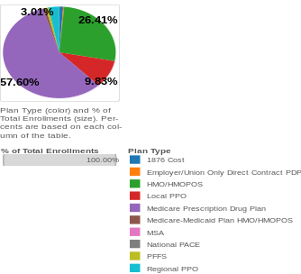
Figure 4. Medicare Advantage Plan Types
From the Figure 4. Above, we can see that Medicare Prescription Drug Plan is the most popular Medicare Advantage Plan Type followed by HMO/HMOPOS. The number of enrollments for each Plan type given by the query was converted to a pie chart for gaining meaningful insight.

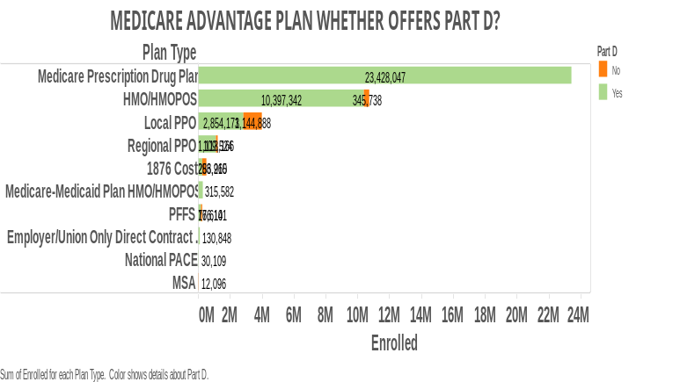
Figure 5. Medicare Advantage Plan offering Part D

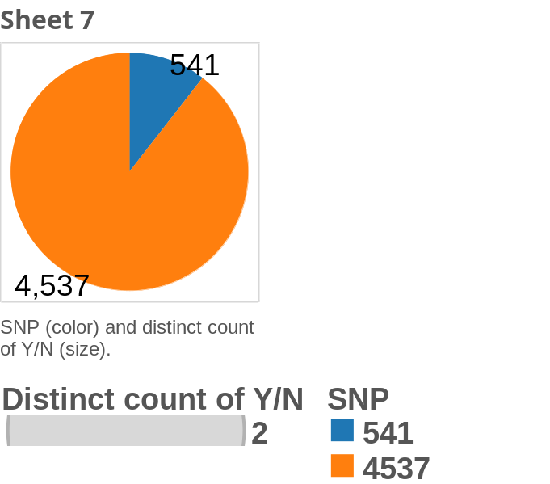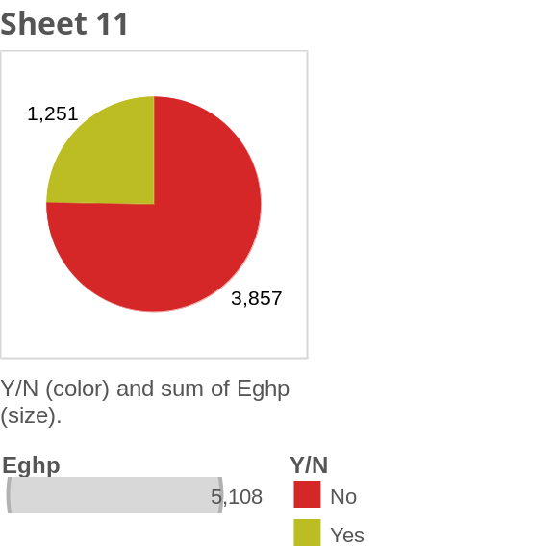

Figure 6&7. No. of Medicare Advantage Plans that offer Special Needs Plans and Employer Group Health Plans, resp.

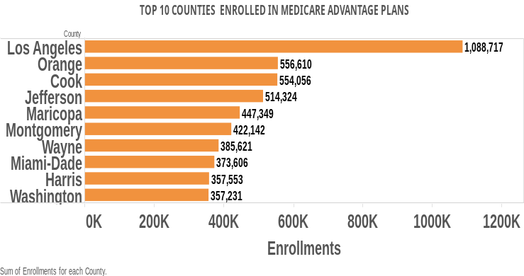

Figure 8. Top 10 counties with most enrollees.
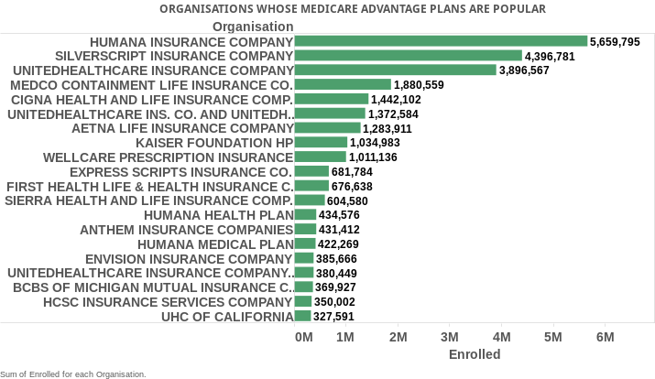
Figure 9. Organizations Favoured Most for Medicare Advantage Plans

STATE WISE DISTRIBUTION OF MEDICARE ADVANTAGE PLANS

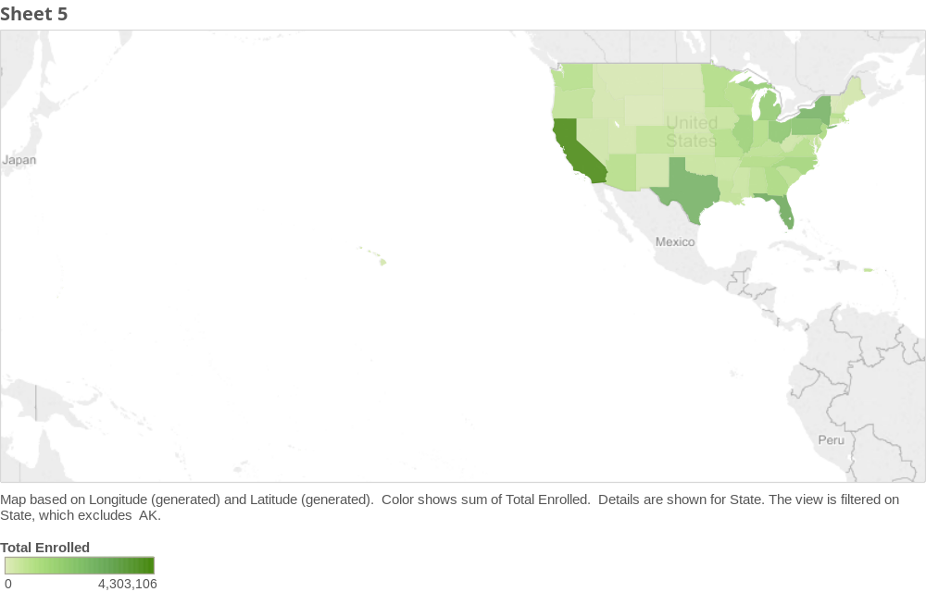
Figure 10. Statewise distribution of enrollments

PRACTICAL IMPLICATIONS OF THIS RESEARCH
The research has many practical uses in real life. The above analysis was done on publicly available data to find out insurance coverage trend exhibited by the population over years and for the current year, the statewise, plan wise breakup had been showed.
Such detailed study comes handy for Business Analysts to take decisions. Cross-selling, Up-selling decisions may be taken based on these results.
For eg., a business manager from Aetna group may want to look at the Part D Plans, Special Needs Plans that are offered by United Healthcare, Humana and other competing groups and study the customer base who are enrolling for them. It may give them some

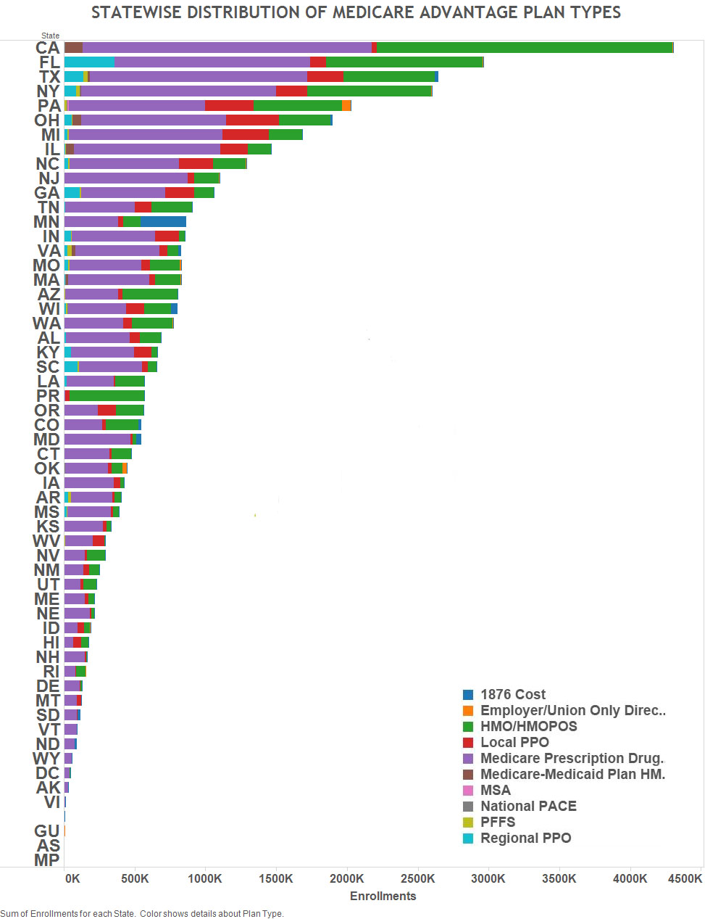
Figure 11. Medicare Advantage Plan Type enrollments distributed statewise.
understanding about their own Plans and how to improve it to attractive potential customers.
A county wise, state wise breakup may give some indicators to a manager as to where he should concentrate more and where he need not. The possibilities are endless and better decisions can be arrived at with better querying and a really good dataset.
Impala is especially handy to Business Analysts who may not be technically trained in analytics but may still come up with solid results easily in real-quick time.

COMPARING IMPALA WITH HIVEQL
Though both HiveQL and Impala are useful in querying such datasets, the advantage that Impala has over HiveQL can be clearly understood from the Table given below.
Table 1. Comparison Of Impala With HiveQL
 | IMPALA | HIVE QL
 | Interactive SQL | Batch Processing
Developed by | Cloudera | Facebook
Metadata, ODBC driver, SQL syntax and user interface | Same for both. No need to reinvent implementation wheel⁶. | Same.
Type Casting | Does not implicitly cast between string and numeric or Boolean types⁹. Always use CAST() for these conversions. | Automatic type casting.
Virtual columns | Does not provide virtual columns⁹. | Provides virtual columns⁹.
Analytics | Supports set of aggregate functions listed in Impala Aggregate Functions and analytic functions listed in Analytic Functions⁹. | Supports certain aggregate functions: covar_pop, covar_samp, corr, percentile, percentile_approx, histogram_numeric, collect_set.⁹
Querying | Impala allows some workarounds for multiple DISTINCT clauses per query⁹. | Allows multiple DISTINCT clauses per query⁹.
Latency | Does’nt have to translate SQL query into another processing framework, hence quick results, i.e., Low latency⁸. | SQL query is translated into map/shuffle/reduce operations, hence slow results, High latency.
Best suited for | BI style queries⁶, Real time, ad-hoc queries over a subset of data. For eg. Business Analysts may want to look at and analyze some data without building robust jobs. | Batch processing⁷ jobs over BigData. For eg. ETL type of jobs
Fault Tolerance | No. Highly memory intensive (MPP), not fit for tasks that require heavy data operations like joins, as you just can’t fit everything into memory⁷. | Yes

Both HiveQL and Impala produced same results but Impala produced results faster than HiveQL. Impala is well suited for Business Analysts who may want to look at data and come up with pointers or directions for future course of action. It is extremely easy to deploy and implement even for a non-technical person and it can come in handy for business situations.

EXPERIENCES
The experience of doing this research was quite an eye-opener about Big Data Analytics. Since the focus was on Financial services sector, it was not easy to come up with a suitable data set for research. Financial data of customers or companies are not publicly available. Whatever data that was publicly available was either not suitable for complex querying or had lot of inconsistencies or limitations.
For example, our Dataset 1 did not have data for continuous years. An exhaustive search for a dataset for continuous years did not yield satisfactory results. Either the data for the older years did not have the corresponding columns or had more missing values and dirty data, making it useless for analysis.
The other Dataset 2 that we used in this research had lots of missing values which were filled with * symbols. This did not allow for querying. So, we had to spend a lot of time and effort in cleaning up this data. The * were replaced with 0s and then the data became available for aggregate functions.
Also, healthcare insurance data is quite complex and needs lot of time to understand the domain to come up with meaningful insights. The healthcare industry is intrinsically complex, with lots of stakeholders, like Federal Govt., State Govt, Medical Practitioners, Organiations, Medical practices, Plans that service the various practices, all of which come into play while dealing with Healthcare plans. More than analyzing the data, gaining the domain knowledge to understand the intricacies became a major impediment.
Another important point to be added is that though utmost care has been taken to verify the accuracy of the data and the data source, since the datasets have come from government sources who are the authority in that domain, there is not much we could do to ensure accuracy. Care had been taken in selecting a proper dataset for study that depicts a representative picture of the real world.
Overall, it was a great learning experience to realize that every project is different and every dataset is unique. It was an exhilarating experience working with real data.

SCOPE FOR FUTURE WORK
The above analysis was done on publicly available data to find out insurance coverage trend exhibited by the population over years.
Other than these publicly available datasets, financial services companies also own huge repositories of their customer data which is not publicly available. The sector has always been data-driven and has voluminous historical data on customer transactions spanning over several decades. Mobile apps and other enhancements to improve customer experience is driving up the transaction volumes further day by day.
All these data are typically structured and can be put to good use to create value for the companies. For example, for Medical Insurance Claims, one can mine for
- Claims whose medical invoices are outside the coverage period,
- Unusual number of Claims where medical invoice values are just under the radar of detection,
- Excessive number of Claims from an insured person within a short period (abnormal behavior)
- Claims where the requested amount and the billed amount in the invoice do not match etc.,
Querying and getting results is very easy and can lead to enormous savings to insurance companies in terms of time, cost and improved bottomline.
In Banking sector, predictive analytics can be done in areas such as anti-money laundering, credit scoring, fraud detection & prevention and price optimization. In the insurance sector, areas where predictive modeling and analysis can be done include Claims Fraud Detection, Underwriting Rate Optimization, Agent Performance Prediction, Agent Life Time Value, Policy Lapse Prediction etc.
In addition to the industry specific areas cited above, other areas which are applicable to all customer data include predicting customer churn/attrition, customer life time value, customer retention, campaign management, cross sell and up-sell.
Also, there are huge amounts of unstructured data coming in by the day, in the form of user generated contents such as images, videos, blogs, voice uploads and social networking sites. Text mining and social network analysis are two areas which are gaining popular currency today to understand the customer pulse.
One can understand the pulse of the ‘target customers’ by analyzing social network sites and studying the brand recall, doing sentiment analysis etc.

RELATED WORK
The Intelligent Customer Analytics for Recognition and Exploration (iCARE) is a framework that was presented to analyze banking customer behaviors from banking data, through analytical modeling methodologies and techniques designed for a key business scenario. iCARE helped generate insights for active customers based on their transaction behavior, using close to 20 terabytes of data in a real case study of a bank in southeast China.
The benefits of Big Data and specific analysis methods for Insurance Fraud Detection were discussed in a paper with regard to Public Health Insurance System in Romania.

CHALLENGES
The most frequently encountered challenge is that we simply do not have good data. As explained earlier, that which is publicly available is either not clean or relevant or appropriate for analysis. It takes considerable time and cost to clean up the dirty data and make it available for analysis.
The other major problem is the dearth of published, established techniques that are especially suited for financial services industry for such analysis.
Some challenges that are specific to this industry are security issues and regulatory compliance. Since most of the data is financial in nature, cybercrimes will increase in scope and sophistication. Also, state restrictions on certin activities will increase.
It would augur well for the sector as well as Big Data Analytics if companies come out with well-developed techniques that help in managing these challenges.

CONCLUSIONS
The Financial Services sector is unique in that there are no physical products to sell. Information is the only asset, in that sense. Information on products, customers, their preferences, markets, regulations, competitors etc., can bring immense value to business, when managed efficiently.
The tools explored and the methodology stated above are only a sample of the kind of work that can be done to extract meaningful information from data. In future, more sophisticated information can be drawn using complex queries and elaborate analysis with better datasets. The possibilities are endless and will eventually result in a marketplace that is highly evolved and customized to meet the needs of niche customers, thereby ringing in better profits.
It makes sense for the financial services companies to apply Big Data techniques and draw insights about their business that will help them stay relevant in a dynamic marketplace.

ACKNOWLEDGMENTS
Our thanks to ACM SIGCHI for allowing us to modify templates they had developed.

REFERENCES
- Barrachina, Arantxa Duque, and Aisling O’Driscoll. "A big data methodology for categorising technical support requests using Hadoop and Mahout." Journal Of Big Data 1.1 (2014): 1.
- BOLOGA, Ramona, Razvan BOLOGA, and Alexandra FLOREA. "Big Data and Specific Analysis Methods for Insurance Fraud Detection." Database Systems Journal 4.4 (2013): 30-39.
- Chaiken, Ronnie, et al. "SCOPE: easy and efficient parallel processing of massive data sets." Proceedings of the VLDB Endowment 1.2 (2008): 1265-1276.
- Davenport, Thomas H., and Jill Dyché. "Big data in big companies." May 2013(2013).
- http://hive.apache.org/
- http://impala.io/
- http://stackoverflow.com/questions/16755599/how-does-impala-provide-faster-query-response-compared-to-hive
- http://vision.cloudera.com/impala-v-hive/
- http://www.cloudera.com/content/cloudera/en/documentation/core/latest/topics/impala_langref_unsupported.html
- http://www.cloudera.com/content/cloudera/en/products-and-services/cdh/impala.html
- http://www.medicare.gov/sign-up-change-plans/medicare-health-plans/medicare-advantage-plans/medicare-advantage-plans.html
- https://www.draw.io/
- Kirlidog, Melih, and Cuneyt Asuk. "A fraud detection approach with data mining in health insurance." Procedia-Social and Behavioral Sciences 62 (2012): 989-994.
- Kornacker, M., et al. "Impala: A modern, open-source SQL engine for Hadoop." Proceedings of 2015 CIDR Conference on Innovative Database Research. 2015.
- Kumar, Rakesh, et al. "Comparison of SQL with HiveQL." International Journal for Research in Technological Studies 1.9 (2014): 2348-1439.
- LaValle, Steve, et al. "Big data, analytics and the path from insights to value."MIT Sloan Management Review 21 (2013).
- LeFevre, Jeff, et al. "Opportunistic physical design for big data analytics."Proceedings of the 2014 ACM SIGMOD international conference on Management of data. ACM, 2014.
- Raghupathi and Raghupathi: Big data analytics in healthcare: promise and potential. Health Information Science and Systems 2014 2:3
- Steinbrook, Robert. "Personally controlled online health data-the next big thing in medical care?." New England Journal of Medicine 358.16 (2008): 1653.
- Sun, N., et al. "iCARE: A framework for big data-based banking customer analytics." IBM Journal of Research and Development 58.5/6 (2014): 4-1.

