# 

IS203.3 Enterprise Systems

Group Assignment 1

# **HR ERP SYSTEM**

# **Payroll module**

Submission Date: 17-10-2019

Group members

K.A.D.G.T.Wijepala - 10026006

T.T Kaluthanthiri - 10025567

T.K.Ambepitiya - 10023776

D.D.G.Chathuranga - 10025348

H.M.H.M Kumara - 10024739

P.M.H.T Puswella - 10024727

# **Human Resource Module**

## Description

Human resource is widely implemented ERP module.

ERP HR module streamlines the management of human resources and human capitals.

HR modules routinely maintain a complete employee database including contact information, salary details, attendance, performance evaluation and promotion of all employees. Advanced HR module is integrated with knowledge management systems to optimally utilize the expertise of all employees.

ERP HR modules refer to the systems and processes at the intersection between [human resource management (HRM)](https://en.wikipedia.org/wiki/Human_resource_management) and information technology. On the whole, these ERP systems have their origin on software that integrates information from different applications into one universal database.

The linkage of its financial and human resource modules through one database is the most important distinction to the individually and proprietary developed predecessors, which makes this software application both rigid and flexible.

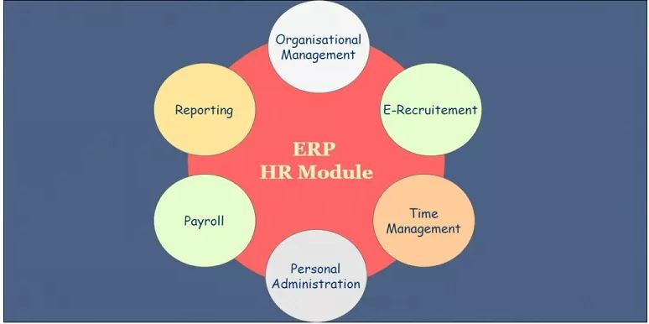

These fragments are In Human Resource ERP module. We selected Payroll fragment for our assignment.

## Functionalities of Payroll fragment

* Login
* Insert employee salary details
* Delete details
* Update details

**Login**

We are creating login form for administrator to log into the system by entering admin username and password.

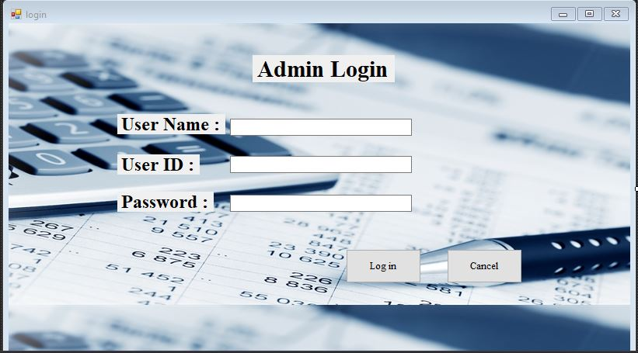

**Insert employees’ salary details**

Insert form includes columns i.e employee id , employee first name and last name , account number , designation , days worked , overtime hours worked , leaves taken and loan installments. Above inserted data will record in employee data table. Employee id will auto generated one. Payment per day will be fixed amount and overtime payments will calculate per hour basis. Salary will be deducted per day basis if leaves were taken more than 2 within a month. And also loan installments will be deducted if loans were taken by employees.

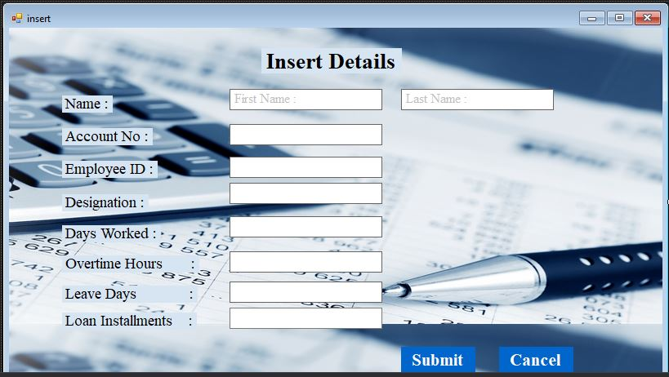

**Delete details**

If admin wants to delete an inserted data he/she can delete through delete form by clicking delete button

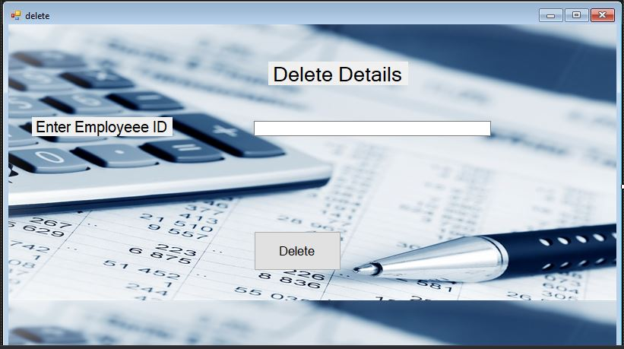

**Update details**

Admin can update a record by clicking update button. From that page admin can update whatever entered data belongs to particular employee id.

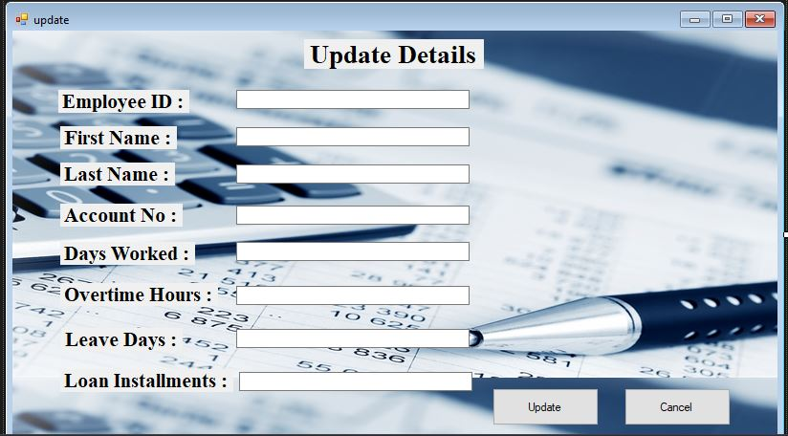

**Employee Details**

In employee details page all the inserted details will be displayed in a table. Each record consist of update and delete button.

