**python实验报告7**

**学号：** 117060400120 **姓名**： 程丽亚 **班级：** 17应统1班  **指导老师：** 林卫中老师

**实验目的：①七段数码管颜色变换**

**②函数的递归**

**③汉诺塔**

**算法实现：**

# -*- coding: utf-8 -*-

"""

Created on Thu Apr 12 11:00:27 2018

@author: 慕程程

"""

import turtle,datetime

strcol = ['red','yellow','grey','khaki','tan','pink','purple','green','orange','brown']

import turtle, datetime

def drawGap(): #绘制数码管间隔

turtle.penup()

turtle.fd(5)

def drawLine(draw): #绘制单段数码管

drawGap()

turtle.pendown() if draw else turtle.penup()

turtle.fd(40)

drawGap()

turtle.right(90)

def drawDigit(digit): #根据数字绘制七段数码管

turtle.pencolor(strcol[digit])

drawLine(True) if digit in [2,3,4,5,6,8,9] else drawLine(False)

drawLine(True) if digit in [0,1,3,4,5,6,7,8,9] else drawLine(False)

drawLine(True) if digit in [0,2,3,5,6,8,9] else drawLine(False)

drawLine(True) if digit in [0,2,6,8] else drawLine(False)

turtle.left(90)

drawLine(True) if digit in [0,4,5,6,8,9] else drawLine(False)

drawLine(True) if digit in [0,2,3,5,6,7,8,9] else drawLine(False)

drawLine(True) if digit in [0,1,2,3,4,7,8,9] else drawLine(False)

turtle.left(180)

turtle.penup()

turtle.fd(20)

def drawDate(date): #获得要输出的数字

for i in date:

if i == '-':

turtle.pencolor("black")

turtle.write('年',font=("Arial", 18, "normal"))

turtle.fd(40)

elif i == '=':

turtle.pencolor("black")

turtle.write('月',font=("Arial", 18, "normal"))

turtle.fd(40)

elif i == '+':

turtle.pencolor("black")

turtle.write('日',font=("Arial", 18, "normal"))

else:

drawDigit(eval(i))

def main():

turtle.setup(800, 350, 200, 200)

turtle.penup()

turtle.fd(-300)

turtle.pensize(5)

drawDate(datetime.datetime.now().strftime('%Y-%m=%d+'))

turtle.hideturtle()

turtle.done()

main()

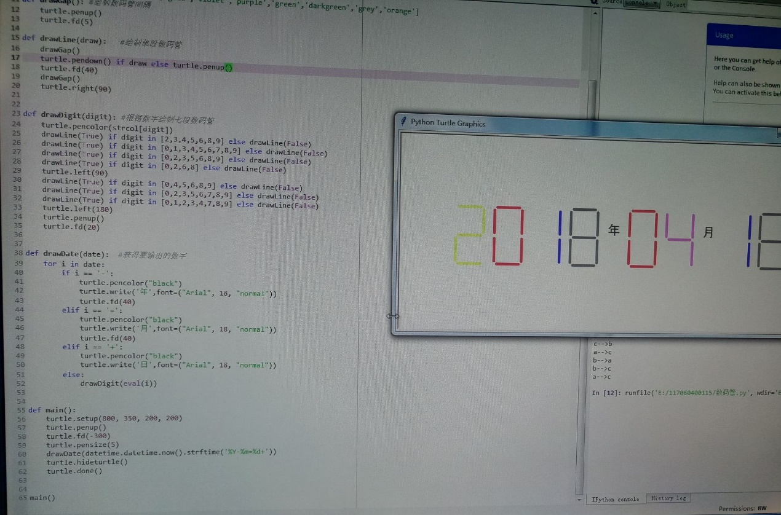

def reverse(s):

if s == "":

return s

else:

return s[-1]+reverse(s[0:-1])

str = input("请输入一个字符串：")

print(reverse(str))

**n个圆盘由a柱移动到c柱，借助b柱**

**def hanoi(a,b,c,p):**

**if p == 1:**

**print(a + "-->" + c)**

**else:**

**hanoi(a,c,b,p-1)**

**hanoi(a,b,c,1)**

**hanoi(b,a,c,p-1)**

**hanoi('a','b','c',3)**

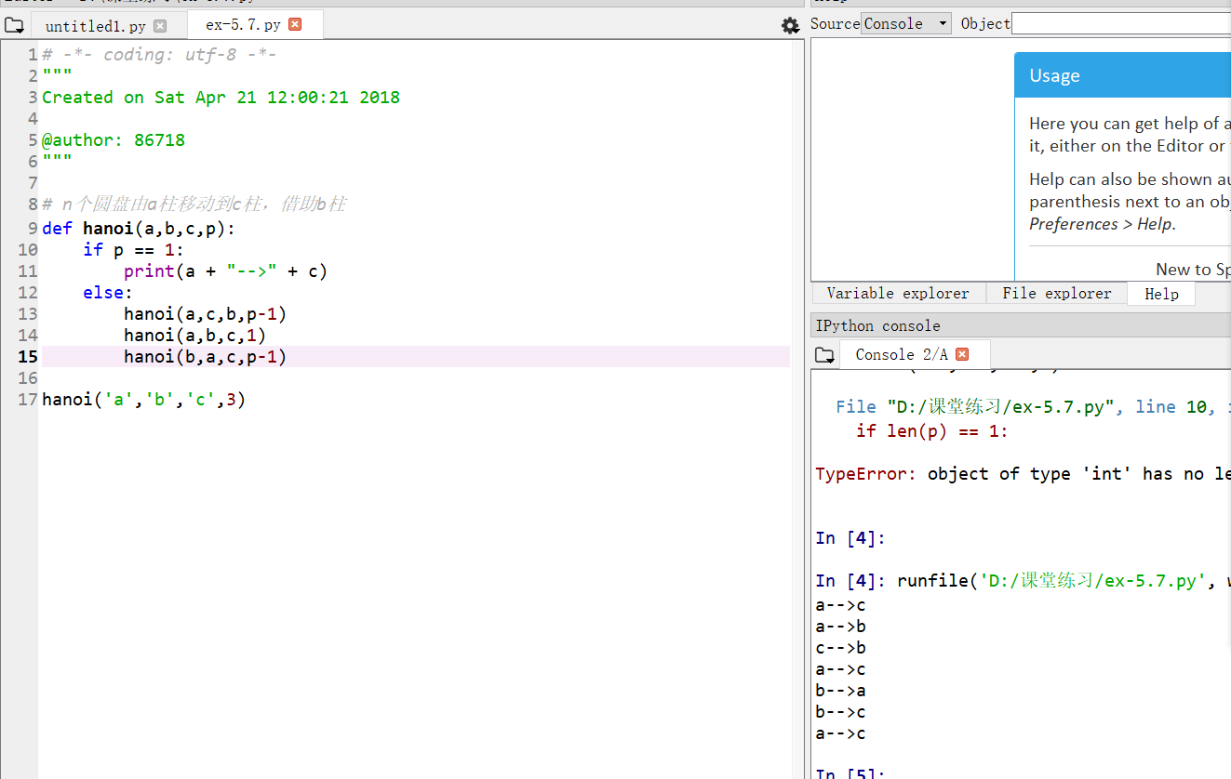

**实验结果：（要有截图，白底黑字）**