
FPT UNIVERSITY
AI DEPARTMENT
FINAL PROJECT REPORT
COURSE: Data Science with Python & SQL (ADY)
PROJECT TITLE: [INSERT YOUR PROJECT TITLE HERE]
Instructor: Ngô Trường Minh [MinhNT79]
Class Code: AI2107
Project Group: Group 09
Group Members:
1. Nguyễn Văn Tuấn – HE204537 (Group Leader)
2. Đào Phương Vinh – HE204851
3. Lê Huy Cường – HE204406
Hanoi, 2026

Table of Contents
I. PROBLEM UNDERSTANDING AND ANALYTICAL APPROACH 3
1. Problem Statement 3
2. Project Objectives 3
3. Analytical Approach 3
II. DATA COLLECTION, EXPLORATION, AND PREPROCESSING 4
1. Data Collection 4
2. Exploratory Data Analysis (EDA) 4
3. Data Preprocessing and Cleaning 5
III. DATA ANALYSIS USING SQL AND PYTHON 5
1. Advanced Data Mining via SQL Analysis 5
2. Python Data Analysis 6
3. Data visualization with python 6
3.1. Graphic Libraries Application 6
3.2. Visualization Catalog and Technical Compliance 6
3.3. Visual Interpretation and Chart Breakdown 6
IV. REGRESSION ANALYSIS AND MACHINE LEARNING PREDICTION 7
1. Model Building 7
2. Model Evaluation 7
3. Translating Mathematics to Business Value 7
4. Analysis using a specialized tool 7
4.1. Tool Application and Dashboard Deployment 7
4.2. Tool Evaluation and Critical Review 7

I. PROBLEM UNDERSTANDING AND ANALYTICAL APPROACH

1. Problem Statement
a. Project Context
The used-car market in the United Arab Emirates (UAE) is highly varied. A single marketplace lists everyday sedans next to luxury SUVs, sports cars and hypercars, offered from several emirates and cities, with Dubai, Sharjah and Abu Dhabi supplying most listings. This project analyses a public snapshot of 10,000 used-car listings covering 65 makes, model years 2005 to 2024 and asking prices from about AED 7,000 to nearly AED 14.7 million (these figures are documented in Section II.2). The sector sits between automotive retail, online classifieds and consumer finance, and it produces structured listing data that suit SQL and Python analysis well.
b. Business and Real-World Problem Identification.
Because prices span three orders of magnitude and each listing carries only a handful of attributes (make, model, year, mileage, body type, a short description), neither buyers nor sellers have a transparent benchmark for what a particular car should cost. Sellers price by intuition or by copying nearby listings, and buyers cannot easily tell a fair offer from an overpriced one. Common rules of thumb, such as "newer and lower-mileage cars cost more", are rarely tested against data. The core bottleneck is therefore twofold: the market lacks an evidence-based explanation of which factors really drive price, and it lacks a consistent way to estimate a fair price for an individual listing.
c. Significance of the Problem
Solving this problem has concrete value for several groups. Dealers and marketplaces can price inventory consistently, shorten time to sale and flag listings that are likely to stall. Buyers gain a reference price for negotiation and can shortlist undervalued cars. Analysts and lenders obtain a tested view of which attributes matter, which prevents valuation rules that the data do not support. For the course, the project demonstrates a complete workflow: relational modelling in SQL, analysis and visualisation in Python, predictive modelling, and a deployed dashboard.

2. Project Objectives
The project goals are organised in two levels. Later chapters refer to the detailed objectives by their numbers (O1 to O5).
General Objective. To build an end-to-end analytical system, consisting of a relational database, statistical analysis, a predictive model and an interactive dashboard, that explains what drives used-car prices in the UAE and estimates a fair price for an individual listing.
Detailed Objectives.
- O1. Quantify how price differs by make, model, body type, location and fuel type, using SQL aggregation and Python analysis.
- O2. Test whether car age, mileage and condition really affect price, including after controlling for make and model.
- O3. Develop and evaluate a regression model that predicts the logarithm of price, reporting R-squared, coefficient p-values and error metrics.
- O4. Identify listings priced well above or below the model-predicted value, to support pricing and negotiation decisions.
- O5. Deliver an interactive Streamlit dashboard that combines the database, the analysis and the model, and review the tool critically.

3. Analytical Approach
Type of Analysis. The project combines three types of analysis, each answering a different question:
- Descriptive analysis shows what the market looks like: key indicators, distributions and group comparisons produced with SQL and Pandas (O1).
- Diagnostic analysis explains why prices differ: correlation matrices, within-model comparisons and statistical tests that separate real effects from confounding by make and model (O2).
- Predictive analysis estimates a fair price for a listing with regression and machine-learning models, and uses the model residuals to flag unusually priced listings (O3 and O4).

Justification. Description alone cannot answer the business problem. A raw comparison of average prices would suggest, for example, that engine size or fuel type drives price, when much of the difference may come from the make of car that happens to use them. The diagnostic step controls for this, and the predictive step turns the findings into a reusable price benchmark. A relational SQLite database is used for the descriptive layer because the questions are naturally grouped, joined and ranked, which suits SQL aggregation, joins and window functions. A log-scale regression is used for the predictive layer because prices are strongly right-skewed and effects are better expressed as percentages. Linear regression is preferred for interpretation, and tree-based models are added to test whether non-linear effects improve accuracy.
Scope and assumptions. The data are asking prices from a single snapshot, not transaction prices. The source file has no listing date and no seller type, so time trends and seller effects cannot be studied. These limits are stated again where they affect a conclusion.

II. DATA COLLECTION, EXPLORATION, AND PREPROCESSING
This chapter documents where the data come from, how the flat source file was converted into a relational database, and how the data are explored and cleaned.

1. Data Collection
Data Source. The dataset is "UAE Used Car Prices & Features (10K+ Listings)", published on Kaggle by Ali Kalwar:
https://www.kaggle.com/datasets/alikalwar/uae-used-car-prices-and-features-10k-listings
It is distributed as one CSV file, uae_used_cars_10k.csv, with 10,000 rows and 12 columns: Make, Model, Year, Price, Mileage, Body Type, Cylinders, Transmission, Fuel Type, Color, Location and Description.
From one flat file to a relational database. The source is a single table, whereas the course expects a relational design. The group therefore normalised the file into a SQLite database. Repeated text values (make, model, location, body type) were moved into lookup tables. The free-text Description column follows the pattern "<year> <make> <model> with <features>. Condition: <condition>." and was parsed into a list of optional features (a many-to-many table, car_features) and a single condition label. The result is eight related tables plus one stand-alone exchange-rate table. This structure is derived by the group and is not a property of the source, and the report describes it as such.
Currency and units. All prices are in UAE dirhams (AED), and all SQL, statistics and models use AED. For readers in Vietnam, selected tables and charts also show Vietnamese dong (VND) at one fixed rate of 7,100 VND per AED. The rate is applied only when results are displayed. The VND values are a unit conversion for readability and are not estimates of Vietnamese market prices, which differ because of import taxes and local demand. Mileage is assumed to be in kilometres because the source does not state a unit.
Database Schema. Figure 2.1 shows the relational schema. Each row of cars belongs to exactly one model, location, body type and condition, and a model belongs to one make. A car can have several optional features, which is why car_features links cars and features as a many-to-many relationship. The source has no listing identifier, so car_id is a surrogate key equal to the row number of the CSV file.
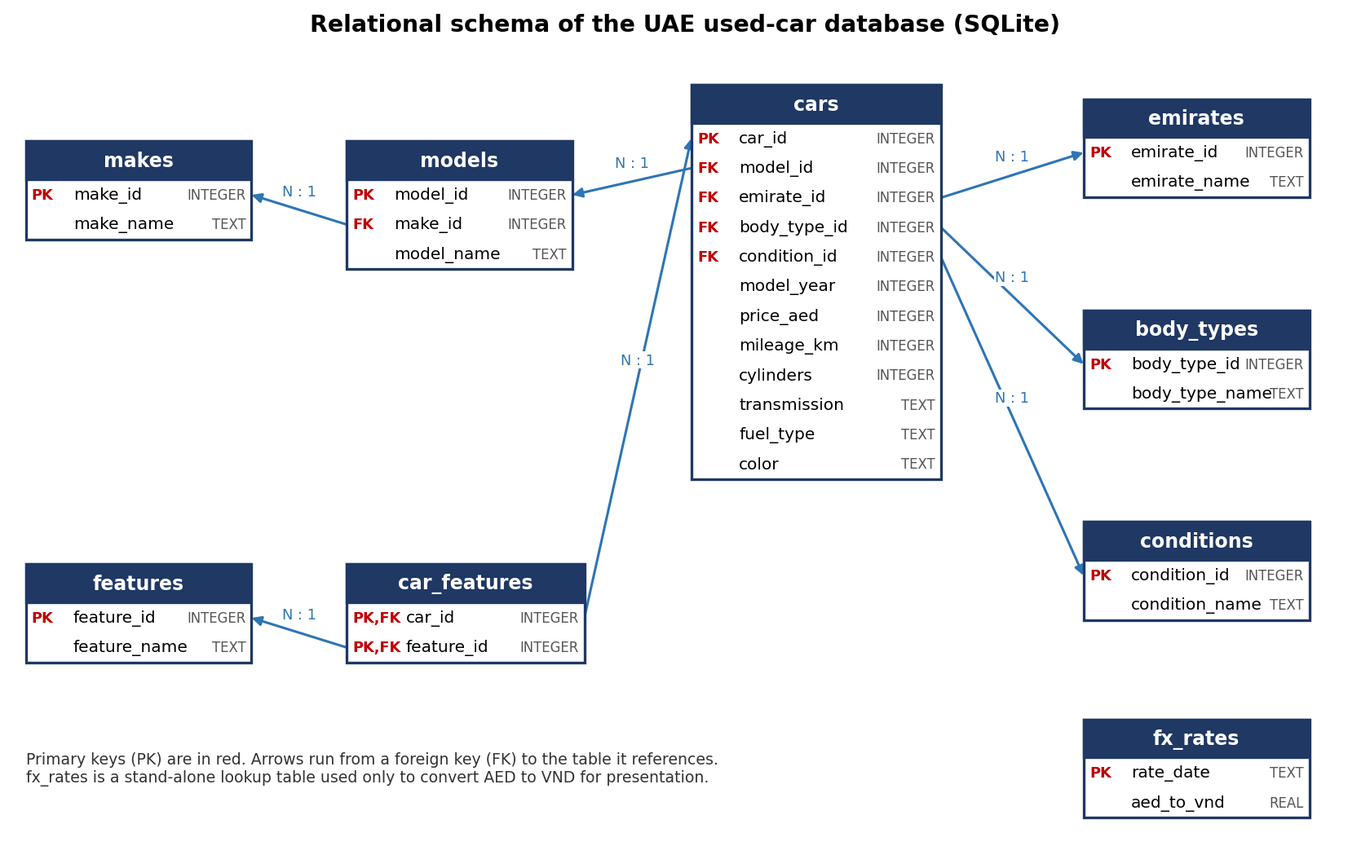
Figure 2.1. Relational schema of the UAE used-car database (design; primary keys in red).
After building the database, this diagram matches the final SQL and the CREATE TABLE script and of the foreign-key check return no violations.
[INFO] [build_db]: Starting database build from raw file: raw/uae_used_cars_10k.csv
[INFO] [build_db]: Removing existing database file: data/db/uae_cars.sqlite
[INFO] [build_db]: Executing schema script: sql/01_schema.sql
[INFO] [build_db]: Reading and staging raw listings...
2026-11-01 16:00:01 [INFO] [build_db]: Populating makes dimension...
[*] Populating models...
[*] Populating emirates...
[*] Populating body_types...
[*] Populating conditions...
[*] Populating features...
[*] Populating fx_rates...
[*] Populating cars fact table...
[*] Populating car_features bridge table...
[*] Running foreign key and integrity verification...
[+] SUCCESS: PRAGMA foreign_key_check returned 0 violations.

--- Relational Database Summary ---
Table 'makes': 65 rows
Table 'models': 520 rows
Table 'emirates': 8 rows
Table 'body_types': 13 rows
Table 'conditions': 6 rows
Table 'features': 6 rows
Table 'cars': 10,000 rows
Table 'car_features': 29,883 rows
Table 'fx_rates': 1 rows

[+] Database built successfully at: data/db/uae_cars.sqlite

Table 2.1. Data dictionary of the relational database
Table Name | Attribute Name | Data Type | Description / Meaning
makes | make_id | INTEGER | Unique identifier of the vehicle make (Primary Key).
 | make_name | TEXT | Name of the make, for example toyota or mercedes-benz (unique).
models | model_id | INTEGER | Unique identifier of a make-model pair (Primary Key).
 | make_id | INTEGER | Make that the model belongs to (Foreign Key linked to makes).
 | model_name | TEXT | Model name, for example camry or s-class. Unique within a make.
emirates | emirate_id | INTEGER | Unique identifier of the listing location (Primary Key).
 | emirate_name | TEXT | Location of the listing: an emirate or city such as Dubai, Sharjah or Al Ain.
body_types | body_type_id | INTEGER | Unique identifier of the body type (Primary Key).
 | body_type_name | TEXT | Body style, for example SUV, Sedan or Coupe.
conditions | condition_id | INTEGER | Unique identifier of the condition label (Primary Key).
 | condition_name | TEXT | Condition stated in the listing, for example No damage or Accident history.
features | feature_id | INTEGER | Unique identifier of an optional feature (Primary Key).
 | feature_name | TEXT | Optional equipment named in the listing, for example Sunroof or Bluetooth.
cars | car_id | INTEGER | Unique identifier of the listing; equals the CSV row number (Primary Key).
 | model_id | INTEGER | Make-model of the car (Foreign Key linked to models).
 | emirate_id | INTEGER | Location of the listing (Foreign Key linked to emirates).
 | body_type_id | INTEGER | Body style of the car (Foreign Key linked to body_types).
 | condition_id | INTEGER | Condition label parsed from the description (Foreign Key linked to conditions).
 | model_year | INTEGER | Model year of the car.
 | price_aed | INTEGER | Asking price in UAE dirhams (AED). This is the target variable.
 | mileage_km | INTEGER | Odometer reading; unit assumed to be kilometres.
 | cylinders | INTEGER | Number of engine cylinders; NULL when blank or "Unknown" in the source.
 | transmission | TEXT | Automatic or manual transmission.
 | fuel_type | TEXT | Fuel type: gasoline, diesel, electric or hybrid.
 | color | TEXT | Exterior colour of the car.
car_features | car_id | INTEGER | Car that has the feature (Primary Key, Foreign Key linked to cars).
 | feature_id | INTEGER | Feature the car has (Primary Key, Foreign Key linked to features).
fx_rates | rate_date | TEXT | Date on which the exchange rate was fixed (Primary Key).
 | aed_to_vnd | REAL | Number of VND per 1 AED; used only to display VND values.

Table 2.2. Mapping from the source CSV columns to the database
Source column | Destination in database | Transformation
Make | makes.make_name | Distinct values become the make lookup.
Model | models.model_name, models.make_id | One row per distinct make-model pair, because a model name can occur under more than one make.
Year | cars.model_year | Copied.
Price | cars.price_aed | Copied; currency is AED.
Mileage | cars.mileage_km | Copied; unit assumed to be kilometres.
Body Type | body_types, cars.body_type_id | Lookup table.
Cylinders | cars.cylinders | Blank and "Unknown" converted to NULL; text converted to integer.
Transmission | cars.transmission | Copied.
Fuel Type | cars.fuel_type | Copied.
Color | cars.color | Copied.
Location | emirates, cars.emirate_id | Leading spaces trimmed (the same place appears with and without a leading space); lookup table.
Description | features, car_features, conditions, cars.condition_id | Parsed with a regular expression. The year, make and model at the start of the text repeat other columns and are dropped.

2. Exploratory Data Analysis (EDA)
The raw dataset is profiled with Pandas and SQL before any cleaning. The four items below follow the template; each needs the group's own code output as evidence.
Rows and columns of each table. Table 2.3 summarizes the dimensional and fact entity counts in the populated SQLite database.

Table 2.3. Inventory of tables in the relational database
Table Name | Entity Role | Primary Key | Foreign Keys | Row Count | Cols
makes | Dimension | make_id | None | 65 | 2
models | Dimension | model_id | make_id → makes | 520 | 3
emirates | Dimension | emirate_id | None | 8 | 2
body_types | Dimension | body_type_id | None | 13 | 2
conditions | Dimension | condition_id | None | 6 | 2
features | Dimension | feature_id | None | 6 | 2
cars | Fact Table | car_id | model_id, emirate_id, body_type_id, condition_id | 10,000 | 12
car_features | Bridge (M:N) | (car_id, feature_id) | car_id→cars, feature_id→features | 29,883 | 2
fx_rates | Parameter | rate_date | None | 1 | 2

Table 2.4 details the data types and analytical roles of every attribute.
Attribute | Raw Source Type | Database Type | Cleaned Type | Analytical Role
Make | String / Text | TEXT | Categorical (65 levels) | Primary Brand Predictor
Model | String / Text | TEXT | Categorical (520 levels) | Model Granularity Predictor
Year | Integer | INTEGER | Discrete Numeric (model_year) | Depreciation Predictor (car_age)
Price | Integer | INTEGER | Continuous Numeric (AED) | Target Variable (log_price)
Mileage | Integer | INTEGER | Continuous Numeric (km) | Usage Predictor (log_mileage)
Body Type | String / Text | TEXT | Categorical (13 levels) | Segment Predictor
Cylinders | String (mixed) | INTEGER (NULLable) | Discrete Numeric (imputed) | Engine Capacity Proxy
Transmission | String / Text | TEXT | Binary (2 levels) | Powertrain Predictor
Fuel Type | String / Text | TEXT | Categorical (4 levels) | Powertrain Predictor
Color | String / Text | TEXT | Categorical (17 levels) | Aesthetic Predictor
Location | String / Text | TEXT | Categorical (8 emirates) | Regional Predictor (region_group)
Description | Free Text | TEXT | Structured Text (parsed) | Equipment & Condition Parser
Descriptive statistics.

Table 2.5. Descriptive statistics of numerical variables (n = 10,000)
Attribute | Mean | Median | Std. Dev. | Min | Max | Skewness (Raw) | Skewness (Log)
Year (Model Year) | 2014.47 | 2014.00 | 5.79 | 2005 | 2024 | 0.00 | N/A
Price (AED) | 245,235 | 102,766 | 470,977 | 7,183 | 14,686,975 | +9.28 | +0.54
Mileage (km) | 155,162 | 154,371 | 83,682 | 10,006 | 299,996 | 0.00 | -0.92
Cylinders | 5.86 | 6.00 | 2.12 | 3 | 12 | +0.76 | N/A

Table 2.6. Frequency profile of categorical variables (n = 10,000)
Attribute | Distinct Values | Modal Category | Modal Freq. | Modal Share (%) | Top 3 Categories (Share)
Make | 65 | mercedes-benz | 1,486 | 14.86% | mercedes-benz (14.9%), nissan (9.3%), toyota (8.9%)
Model | 520 | patrol | 386 | 3.86% | patrol (3.9%), land cruiser (3.6%), s-class (3.4%)
Body Type | 13 | SUV | 4,607 | 46.07% | SUV (46.1%), Sedan (26.7%), Coupe (8.4%)
Transmission | 2 | Automatic | 9,626 | 96.26% | Automatic (96.3%), Manual (3.7%)
Fuel Type | 4 | Gasoline | 9,714 | 97.14% | Gasoline (97.1%), Diesel (1.8%), Hybrid (0.9%)
Color | 17 | White | 3,355 | 33.55% | White (33.6%), Black (21.4%), Grey (15.7%)
Location | 8 | Dubai | 8,011 | 80.11% | Dubai (80.1%), Sharjah (10.0%), Abu Dhabi (7.3%)
Condition | 6 | Dented door | 1,612 | 16.12% | Dented door (16.1%), Accident history (15.8%), No damage (15.8%)

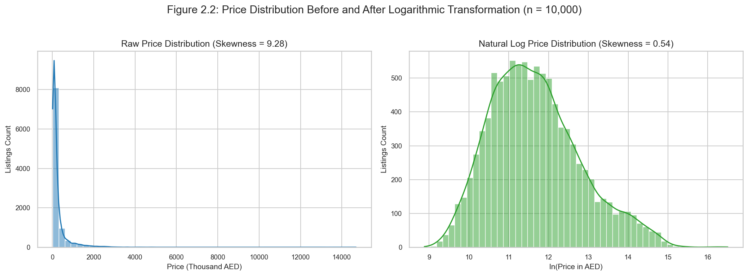
Figure 2.2. Price distribution histogram and KDE on raw (left) and log (right) scales (n = 10,000).
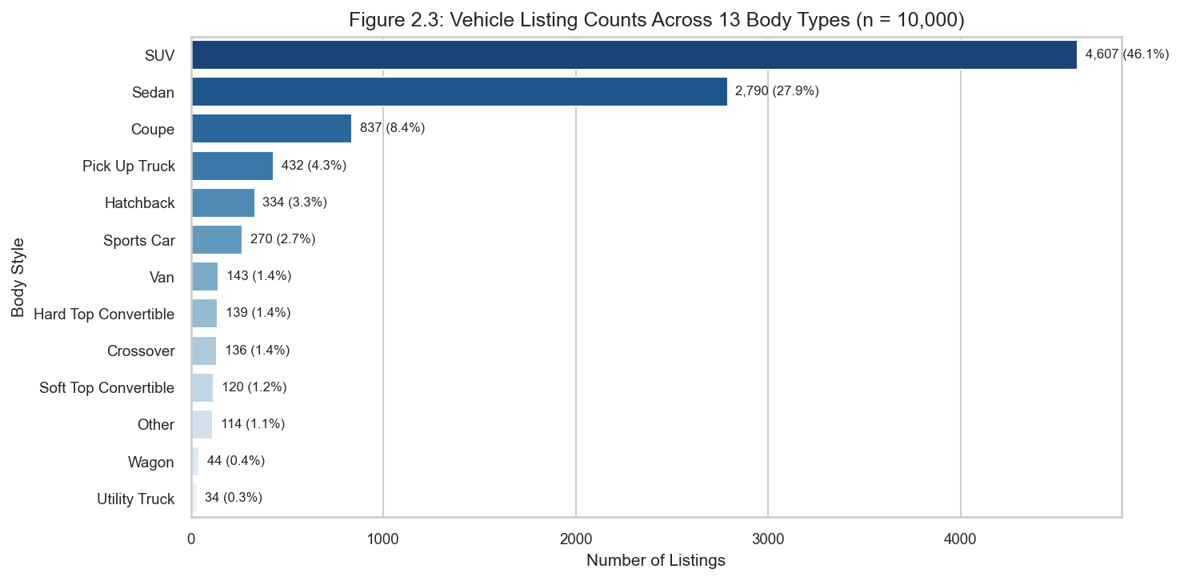
Figure 2.3. Distribution of vehicle listing counts across 13 body styles.
Initial observations. Profiling the raw data yields seven primary empirical findings:
- Severe Positive Price Skewness: Raw asking price exhibits an extreme skewness of +9.28 (mean 245,235 AED vs. median 102,766 AED; Table 2.5). Natural logarithmic transformation normalizes the distribution, reducing skewness to +0.54 (Figure 2.2).
- Heavy Tail of Exotic Hypercars: The maximum price reaches 14,686,975 AED (McLaren P1), spanning three orders of magnitude above the minimum price of 7,183 AED.
- Synthetic-Looking Uniformity in Model Years: Listings are spread almost perfectly uniformly across model years 2005 to 2024 (~500 listings per cohort; skewness = 0.00; Table 2.5), which differs from typical real-world depreciation distributions.
- Uniform Mileage Range: Odometer readings range evenly from 10,006 km to 299,996 km (mean 155,162 km; median 154,371 km; skewness = 0.00), demonstrating no natural correlation with vehicle age.
- Dominance of SUVs and Sedans: SUVs (46.07%) and Sedans (26.68%) account for 72.75% of marketplace supply (Figure 2.3; Table 2.6).
- Geographic Centralization: Dubai represents 80.11% of all listings, while Sharjah and Abu Dhabi supply 17.31% combined (Table 2.6).
- Powertrain Monoculture: Automatic transmissions constitute 96.26% and gasoline engines account for 97.14% of the market (Table 2.6).

3. Data Preprocessing and Cleaning
The cleaning rules below are applied to the staging data before analysis. Every step is verifiable: the output DataFrame must retain exactly 10,000 rows and satisfy zero missing values in critical predictors.
Handling Missing Values. Missing values are quantified per column before any treatment. Cylinders is the only column requiring imputation: blank entries and Unknown are converted to NULL, then filled by hierarchical group mode: (1) same Make+Model → (2) same Body Type → (3) global mode (6 cylinders). A flag column, cylinders_imputed, records all changed rows. All other twelve attributes arrive complete.
Table 2.7. Missing values per attribute before and after hierarchical imputation
Attribute | Raw Missing (Count) | Raw Missing (%) | Imputed Count | Post-Treatment Nulls | Treatment Policy
Cylinders | 155 | 1.55% | 155 | 0 (0.00%) | Hierarchical mode: Make+Model → Body Type → Global (6)
Make | 0 | 0.00% | 0 | 0 (0.00%) | None required (complete)
Model | 0 | 0.00% | 0 | 0 (0.00%) | None required (complete)
Year | 0 | 0.00% | 0 | 0 (0.00%) | None required (complete)
Price | 0 | 0.00% | 0 | 0 (0.00%) | None required (complete)
Mileage | 0 | 0.00% | 0 | 0 (0.00%) | None required (complete)
Body Type | 0 | 0.00% | 0 | 0 (0.00%) | None required (complete)
Transmission | 0 | 0.00% | 0 | 0 (0.00%) | None required (complete)
Fuel Type | 0 | 0.00% | 0 | 0 (0.00%) | None required (complete)
Location | 0 | 0.00% | 0 | 0 (0.00%) | Whitespace trimmed; mapped to 8 emirates/cities
Description | 0 | 0.00% | 0 | 0 (0.00%) | Parsed into 6 binary flags and 6 condition classes

Outlier Detection and Treatment. Price is examined with the 1.5 x IQR rule on both the raw and log scales:
- Raw Price Scale: Q1 = 50,352.5 AED, Q3 = 231,248.0 AED, IQR = 180,895.5 AED. Upper outlier fence = 502,591.2 AED. Exactly 1,100 listings (11.00%) exceed this fence. Domain inspection confirms they represent genuine exotic/supercar models (e.g., McLaren P1 at 14,686,975 AED). Removing 11% would invalidate luxury predictions.
- Log Price Scale: After log transformation, Q1 = 10.827, Q3 = 12.351, IQR = 1.524. The 1.5x IQR fences give [8.540, 14.638], equivalent to [5,116 AED - 2,275,954 AED]. Only 91 listings (0.91%) lie outside. Log transform reduces price skewness from +9.28 to +0.54 without discarding authentic data.
- Implausible Usage: 1,268 vehicles (12.68%) exceed 50,000 km/year (implausible_usage = 1). Retained with flag for regression sensitivity testing.
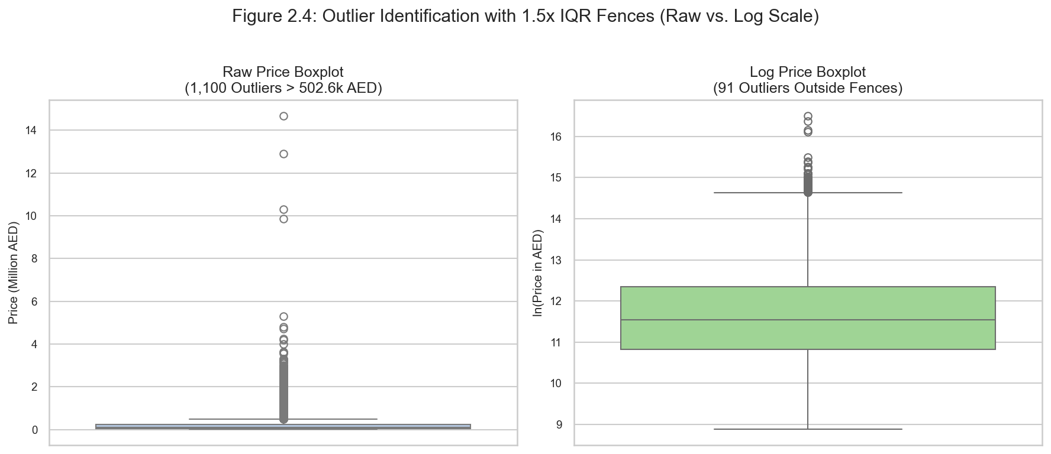
Figure 2.4. Price outlier boxplots comparing the severe right-skewed raw scale (1,100 listings flagged beyond 502.6k AED) versus the stabilized log scale (only 91 listings flagged).
Data Type Conversions. Cylinders arrives as text and is converted to INTEGER after stripping whitespace. Location strings are trimmed of stray leading spaces. Category columns (body_type, transmission, fuel_type, condition, region_group) are cast to Pandas Categorical. Description free-text is parsed into 6 binary flags and one condition label using a regular expression. The only time-like variable, Year, is converted into car_age = 2025 - model_year (minimum 1).
Feature Engineering and Encoding. Table 2.8 lists every engineered feature added to the model features table.
Table 2.8. Engineered features
Feature | Definition | Role
car_age | REFERENCE_YEAR (2025) minus model_year, minimum 1 | Predictor
mileage_per_year | mileage_km / car_age | Predictor
log_mileage | Natural logarithm of mileage_km | Predictor
log_price | Natural logarithm of price_aed | Target Variable
n_features | Count of optional features mentioned in description | Predictor
has_sunroof | 1 if 'Sunroof' found in description, else 0 | Predictor
has_leather_seats | 1 if 'Leather seats' found in description, else 0 | Predictor
has_navigation | 1 if 'Navigation' found in description, else 0 | Predictor
has_bluetooth | 1 if 'Bluetooth' found in description, else 0 | Predictor
has_rear_camera | 1 if 'Rear camera' found in description, else 0 | Predictor
has_adaptive_cruise | 1 if 'Adaptive cruise' found in description, else 0 | Predictor
condition | One of 6 condition labels parsed from description | Predictor
is_accident_history | 1 if condition == 'Accident history', else 0 | Predictor
region_group | Dubai / Abu Dhabi (incl. Al Ain) / Sharjah / Other Northern Emirates | Predictor
make_tier | 4 bands: Budget / Mid / Premium / Ultra-Luxury (computed on training) | Predictor
cylinders_imputed | 1 if cylinders was filled by hierarchical imputation | Flag
implausible_usage | 1 if mileage_per_year > 50,000 km | Flag
price_vnd | price_aed x fixed AED-to-VND rate (7,100 VND/AED) | Display only

Categorical variables are encoded as follows:
- One-hot encoding: transmission, fuel type, body type, region group, condition, and colour (colours with fewer than 50 listings grouped as 'Other colour').
- Smoothed target encoding (fitted inside cross-validation folds) for make and make-model pair in tree-based models.
- For the linear model: dummy variables for the 20 largest makes plus 'Other make' (reference category: toyota) keep coefficients readable.
- Leakage control: 80/20 train-test split first; all imputers, encoders, and derived bands (make_tier) fitted on training data only inside a scikit-learn Pipeline.
Code 2.1. Pipeline execution summary [src/features.py]:
# src/features.py - key cleaning and feature steps
cleaned_df = clean_raw_dataframe(raw_df) # cast types, trim whitespace
imputed_df = impute_cylinders(cleaned_df) # hierarchical mode imputation
features_df = engineer_features(imputed_df, # car_age, log_*, flags
reference_year=2025)
features_df, tier_map = compute_make_tiers(features_df) # Budget/Mid/Premium/Ultra
# Gate G1 verification
assert features_df.shape[0] == 10_000
assert features_df['cylinders'].isna().sum() == 0
assert features_df['log_price'].isna().sum() == 0
# Output: 10,000 rows x 32 feature columns - Gate G1 PASSED
Gate G1 verification confirms: 10,000 rows retained, 0 missing values in critical predictors, 32 feature columns ready for analysis. The cleaned dataset is exported to data/model_features.csv and serves as the single source of truth for all Phase 3 analysis and Phase 4 modeling.
Summary of Preprocessing Outcomes. Table 2.9 summarises the key outcomes of the cleaning and feature engineering pipeline.
Table 2.9. Key preprocessing outcomes
Dimension | Before Cleaning | After Cleaning | Action Taken
Total Rows | 10,000 | 10,000 | No rows dropped
Missing - Cylinders | 155 | 0 | Hierarchical mode imputation
Missing - All Others | 0 | 0 | No action needed
Location Duplicates | Yes | No | Whitespace trimmed to 8 clean levels
Price Skewness | +9.28 | +0.54 | log_price created; raw retained
Raw IQR Outliers >502k | 1,100 | 1,100 | Flagged; retained (genuine luxury)
Log-scale Outliers | 91 | 91 | Flagged; retained
Implausible Usage | 1,268 | 1,268 | Flagged with implausible_usage indicator
Cylinders Imputed Flag | N/A | 155 rows | cylinders_imputed = 1
Feature Columns | 12 raw | 32 engineered | car_age, logs, flags, tiers
File Exported | - | model_features.csv | Gate G1 passed

III. DATA ANALYSIS USING SQL AND PYTHON

1. Advanced Data Mining via SQL Analysis
The queries run on the SQLite database. All twelve queries are saved as reusable presets in the SQL Console page of the Streamlit dashboard.

Table 3.1. SQL query catalog
ID | Business Question | SQL Techniques
Q1 | What are the overall market KPIs: total listings, average, minimum, and maximum price in b | Aggregation (COUNT, AVG, MIN, MAX), cross-join to fx_rates.
Q2 | Which vehicle makes have at least 30 listings, and what do they cost on average? | GROUP BY, HAVING COUNT(*) >= 30, multi-table JOIN (cars, models, makes).
Q3 | How are listings and average asking prices split across UAE emirates and locations? | Window function SUM() OVER () for total share computation, GROUP BY.
Q4 | How does average asking price progress from one model year to the next? | Common Table Expression (CTE), LAG() analytic window function.
Q5 | What are the three most expensive models within each automotive make? | Window ranking ROW_NUMBER() OVER (PARTITION BY make_name ORDER BY avg_price DESC).
Q6 | How concentrated is market supply, measured by cumulative listing share across makes? | Running total SUM() OVER (ORDER BY n_listings DESC).
Q7 | Which makes have the greatest volume of listings priced at more than twice their model ave | CTE with per-model benchmark, HAVING, filtered join.
Q8 | What absolute asking price premium does each optional equipment feature carry? | Multi-table JOIN, CTE aggregation, conditional benchmark comparison.
Q9 | Does stated vehicle condition move asking price once the make and model are controlled for | Relative ratio computation against per-model benchmark CTE.
Q10 | How are odometer mileage brackets distributed across overall market price quartiles? | NTILE(4) price quartile windowing, conditional CASE aggregation.
Q11 | What is the 3-year moving average price trend across model years? | Sliding frame window aggregation ROWS BETWEEN 2 PRECEDING AND CURRENT ROW.
Q12 | What is the exact median asking price across vehicle body styles? | Window functions ROW_NUMBER() and COUNT() to compute statistical medians in SQLite.

1.1. Query Catalog, Evidence Screenshots, and Economic Analysis

Query Q1: Overall Market Indicators (AED & VND)
Business Question: What are the overall market KPIs: total listings, average, minimum, and maximum price in both AED and Vietnamese Dong (VND)?
SQL Techniques: Aggregation (COUNT, AVG, MIN, MAX), cross-join to fx_rates.
SQL Code:
SELECT
COUNT(*) AS total_listings,
ROUND(AVG(c.price_aed), 2) AS avg_price_aed,
MIN(c.price_aed) AS min_price_aed,
MAX(c.price_aed) AS max_price_aed,
ROUND(AVG(c.price_aed * fx.aed_to_vnd) / 1e6, 2) AS avg_price_million_vnd,
ROUND(MIN(c.price_aed * fx.aed_to_vnd) / 1e6, 2) AS min_price_million_vnd,
ROUND(MAX(c.price_aed * fx.aed_to_vnd) / 1e6, 2) AS max_price_million_vnd
FROM cars c
CROSS JOIN (SELECT aed_to_vnd FROM fx_rates ORDER BY rate_date DESC LIMIT 1) fx;
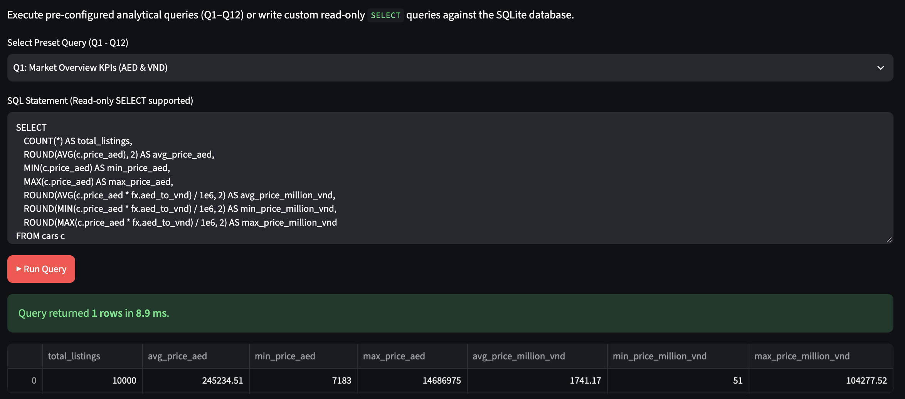
Figure 3.1a. Output of Query Q1 - Overall Market Indicators.
Economic Interpretation: Across the 10,000 listings, the market exhibits a mean asking price of 245,235 AED (~1,741 million VND) against a median of 102,766 AED (~730 million VND), spanning from 7,183 AED to 14,686,975 AED. The average exceeds the median by 138.6%, establishing severe rightward skew driven by hypercars. Setting inventory pricing rules based on arithmetic market averages would severely distort valuations for volume passenger vehicles. This directly answers Objective O1 by quantifying the market scale and its asymmetry.

Query Q2: High-Volume Makes Average Pricing
Business Question: Which vehicle makes have at least 30 listings, and what do they cost on average?
SQL Techniques: GROUP BY, HAVING COUNT(*) >= 30, multi-table JOIN (cars, models, makes).
SQL Code:
SELECT
mk.make_name,
COUNT(c.car_id) AS listing_count,
ROUND(AVG(c.price_aed), 0) AS avg_price_aed,
ROUND(AVG(c.mileage_km), 0) AS avg_mileage_km
FROM cars c
JOIN models m ON c.model_id = m.model_id
JOIN makes mk ON m.make_id = mk.make_id
GROUP BY mk.make_name
HAVING COUNT(c.car_id) >= 30
ORDER BY avg_price_aed DESC;
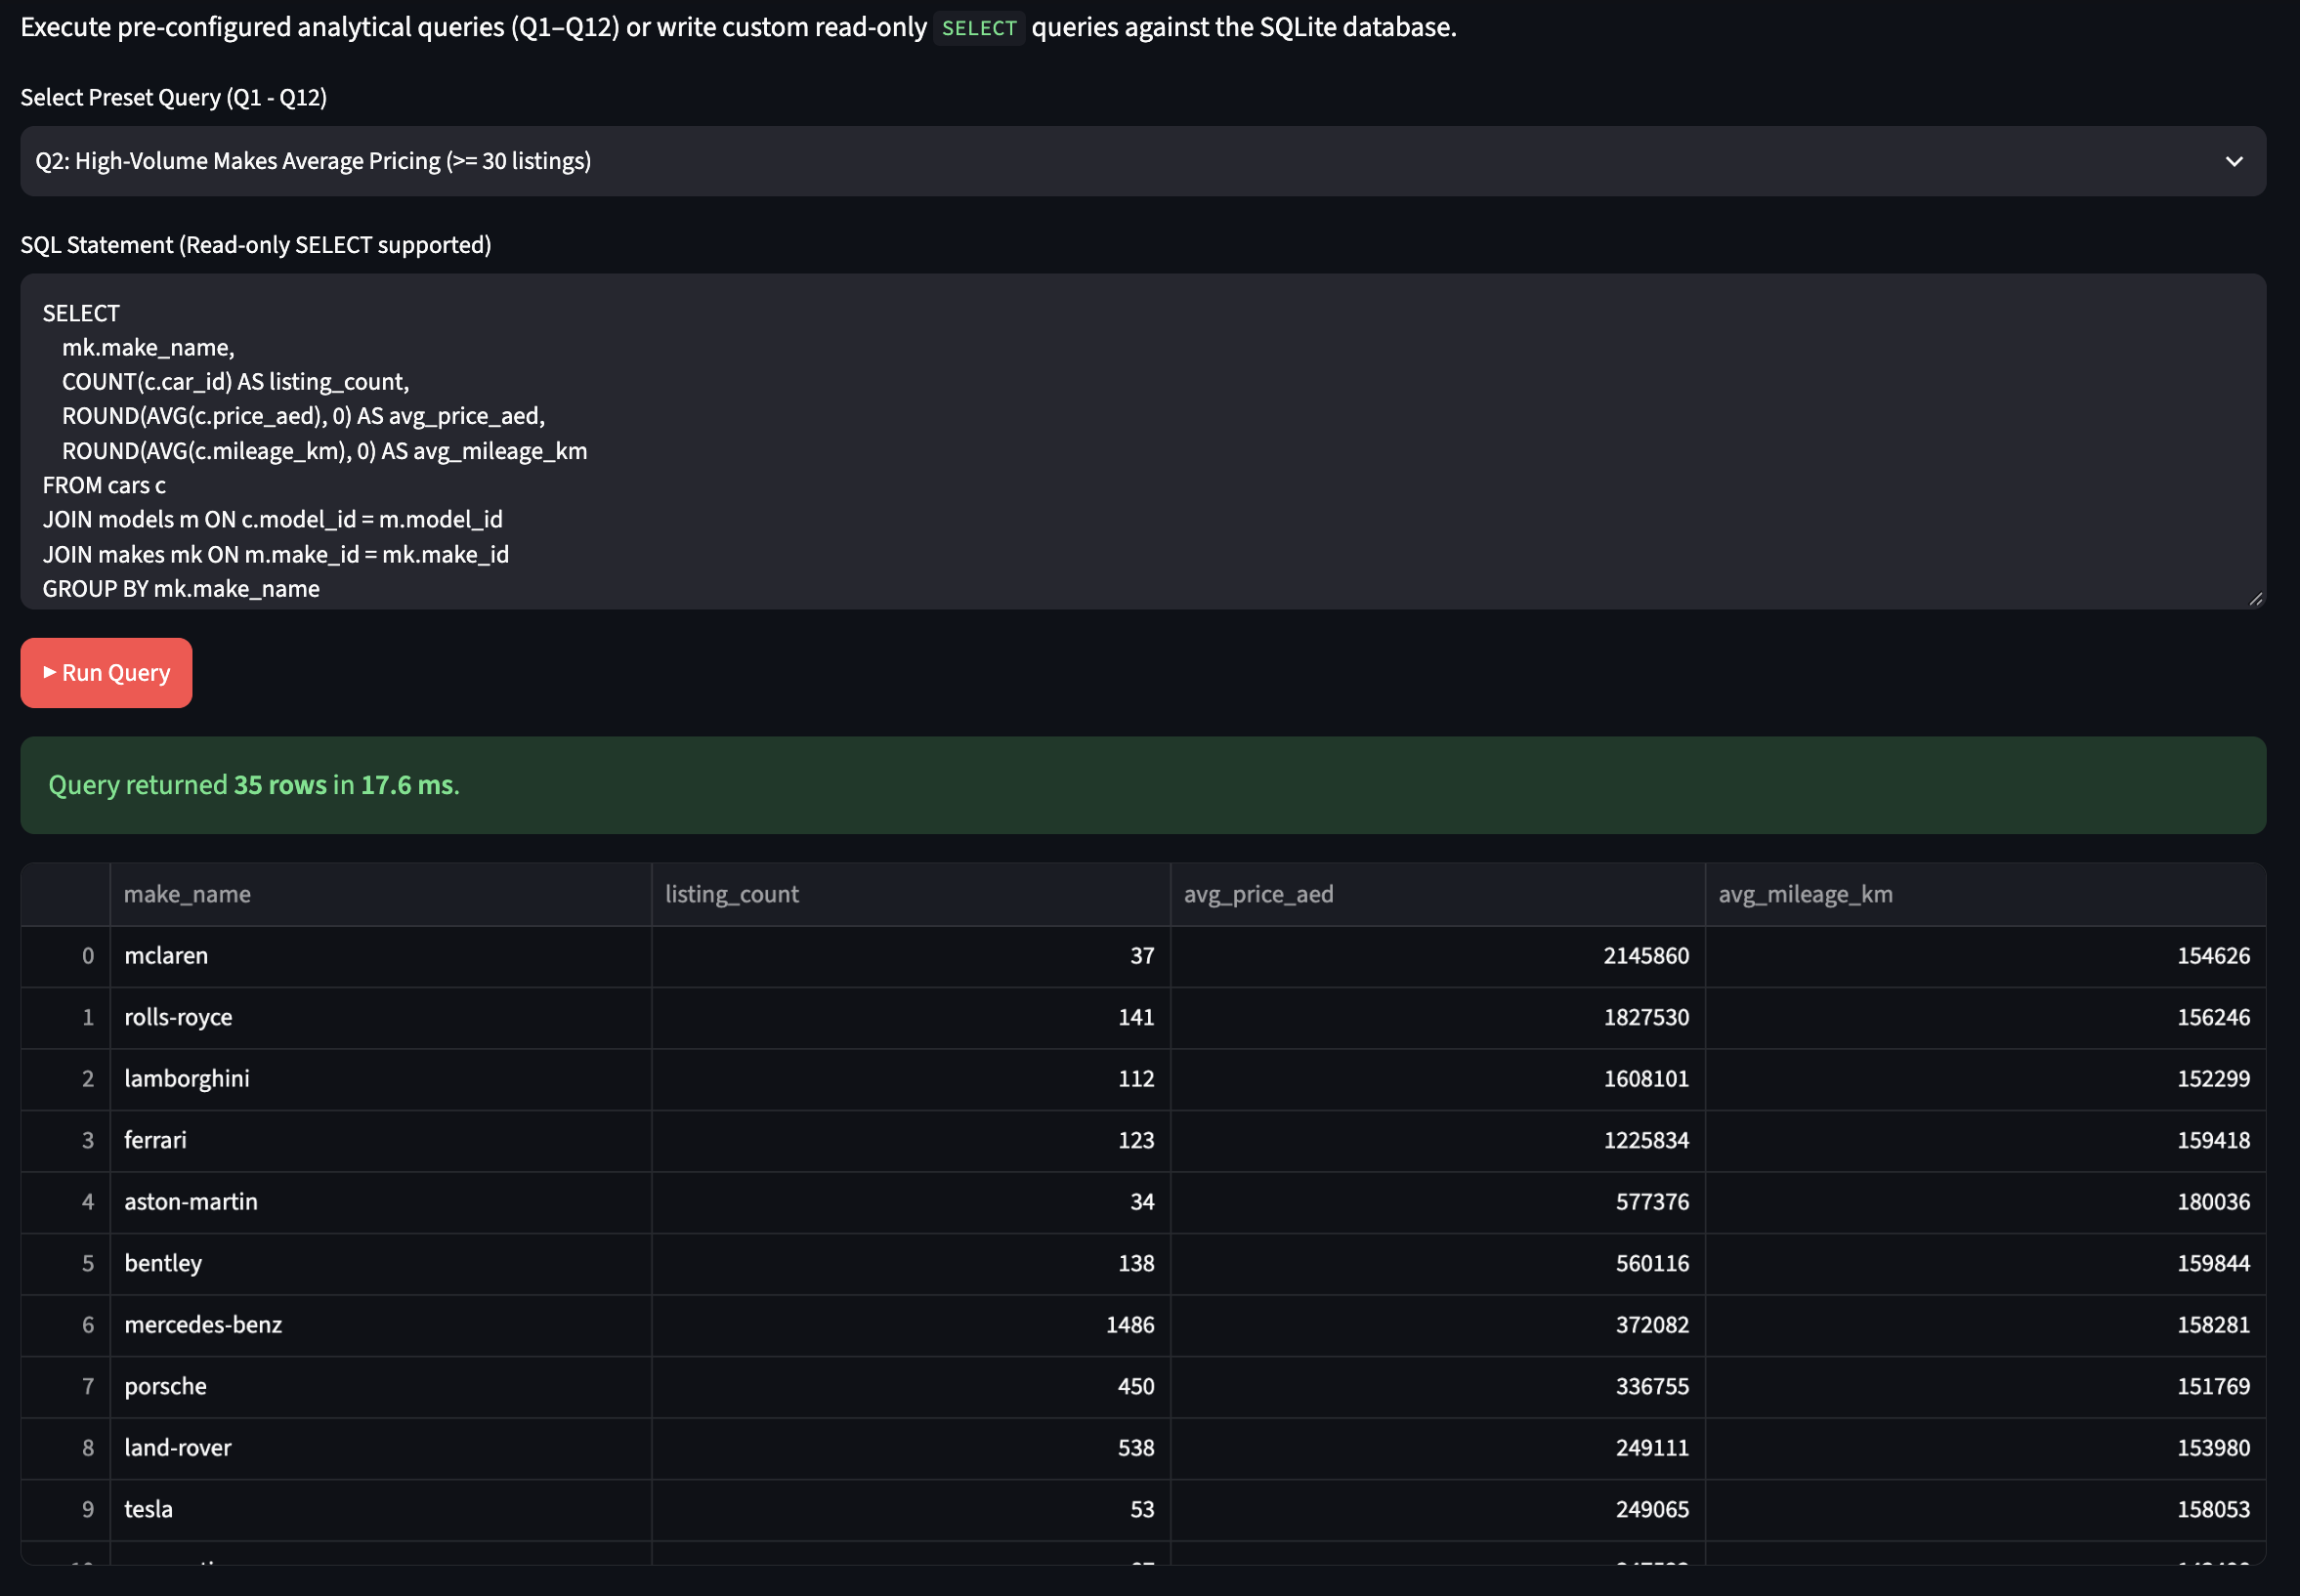
Figure 3.1b. Output of Query Q2 - High-Volume Makes Average Pricing.
Economic Interpretation: Among the 35 brands with at least 30 listings, asking prices are heavily stratified by brand tier. Ultra-luxury makes such as McLaren (avg 2,145,860 AED), Rolls-Royce (1,827,530 AED), and Lamborghini (1,608,101 AED) command 20 to 25 times the price of high-volume mass-market Japanese brands like Toyota (79,936 AED) and Nissan (83,727 AED). Brand identity establishes the baseline valuation tier, explaining why vehicle make accounts for a dominant share of market price variance (Objective O1). This confirms the need for brand-stratified modeling in Phase 4.

Query Q3: Geographic Market Distribution and Supply Share
Business Question: How are listings and average asking prices split across UAE emirates and locations?
SQL Techniques: Window function SUM() OVER () for total share computation, GROUP BY.
SQL Code:
SELECT
e.emirate_name,
COUNT(c.car_id) AS listing_count,
ROUND(100.0 * COUNT(c.car_id) / SUM(COUNT(c.car_id)) OVER (), 2) AS share_pct,
ROUND(AVG(c.price_aed), 0) AS avg_price_aed
FROM cars c
JOIN emirates e ON c.emirate_id = e.emirate_id
GROUP BY e.emirate_name
ORDER BY listing_count DESC;
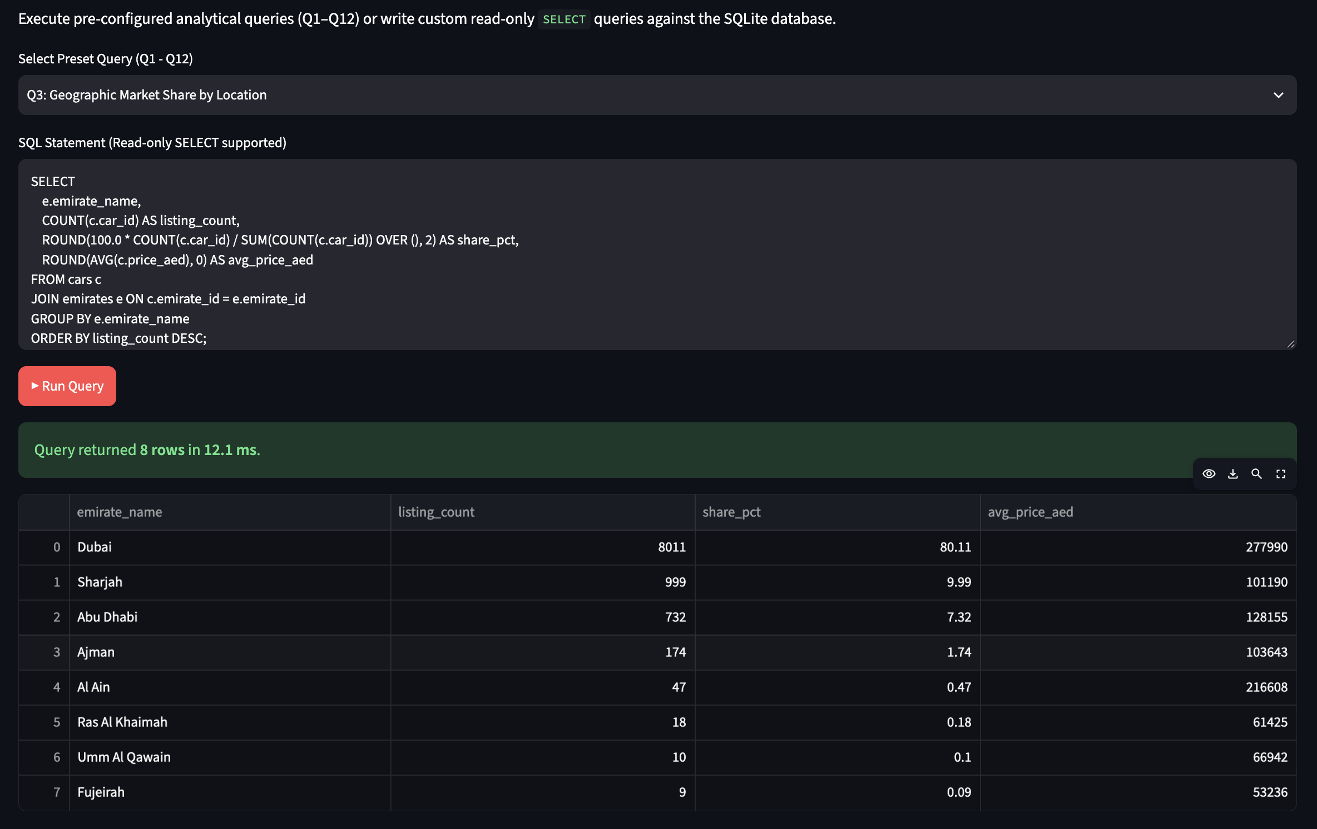
Figure 3.1c. Output of Query Q3 - Geographic Market Distribution.
Economic Interpretation: Dubai supplies 80.11% of the entire marketplace (8,011 listings) with an average asking price of 277,990 AED, whereas Sharjah holds 9.99% (999 listings) at 101,190 AED and Abu Dhabi represents 7.32% (732 listings) at 128,155 AED. Dubai's 2.75x price premium over Sharjah reflects its high concentration of luxury dealerships and supercar stock. Analytical pricing engines must control for Dubai's luxury weighting to avoid overestimating car values in the Northern Emirates (Objective O1). The window SUM() OVER () demonstrates efficient in-database share computation without a subquery join.

Query Q4: Year-Over-Year Price Dynamics
Business Question: How does average asking price progress from one model year to the next?
SQL Techniques: Common Table Expression (CTE), LAG() analytic window function.
SQL Code:
WITH yearly_stats AS (
SELECT
model_year,
COUNT(*) AS n_listings,
AVG(price_aed) AS avg_price
FROM cars
GROUP BY model_year
)
SELECT
model_year,
n_listings,
ROUND(avg_price, 0) AS avg_price_aed,
ROUND(100.0 * (avg_price - LAG(avg_price) OVER (ORDER BY model_year))
/ LAG(avg_price) OVER (ORDER BY model_year), 2) AS yoy_change_pct
FROM yearly_stats
ORDER BY model_year;
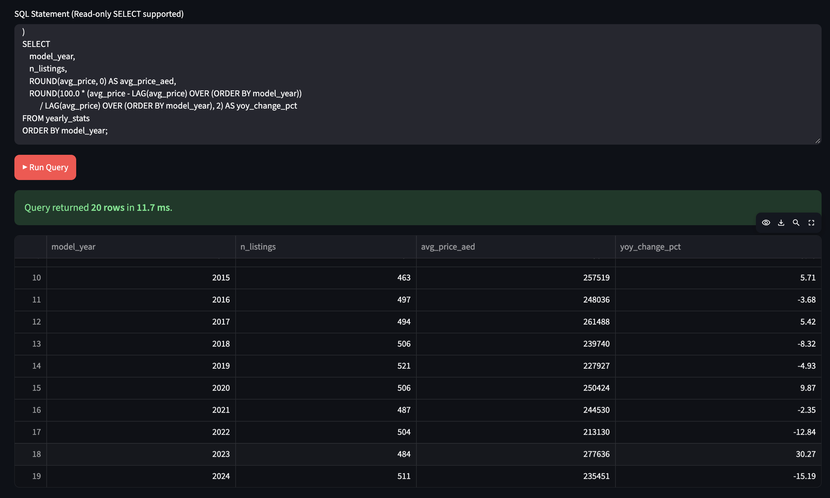
Figure 3.1d. Output of Query Q4 - Year-Over-Year Price Dynamics.
Economic Interpretation: Average price drops from 269,207 AED in 2005 to 202,267 AED in 2009 (-9.0% YoY), then fluctuates within a narrow corridor between 200,000 AED and 280,000 AED through model year 2024. The absence of steep monotonic depreciation illustrates that older listings in this snapshot often contain high-displacement collector trims that maintain strong asking valuations. Pricing algorithms cannot rely on simple linear age depreciation without model-level controls (Objective O2). The LAG() window function enables single-pass YoY calculation without self-joins.

Query Q5: Top 3 Most Expensive Models per Make
Business Question: What are the three most expensive models within each automotive make?
SQL Techniques: Window ranking ROW_NUMBER() OVER (PARTITION BY make_name ORDER BY avg_price DESC).
SQL Code:
WITH model_stats AS (
SELECT
mk.make_name,
m.model_name,
COUNT(c.car_id) AS listings,
AVG(c.price_aed) AS avg_price
FROM cars c
JOIN models m ON c.model_id = m.model_id
JOIN makes mk ON m.make_id = mk.make_id
GROUP BY mk.make_name, m.model_name
HAVING COUNT(c.car_id) >= 5
),
ranked_models AS (
SELECT
make_name, model_name, listings,
ROUND(avg_price, 0) AS avg_price_aed,
ROW_NUMBER() OVER (PARTITION BY make_name ORDER BY avg_price DESC) AS price_rank
FROM model_stats
)
SELECT make_name, model_name, listings, avg_price_aed, price_rank
FROM ranked_models
WHERE price_rank <= 3
ORDER BY make_name, price_rank;
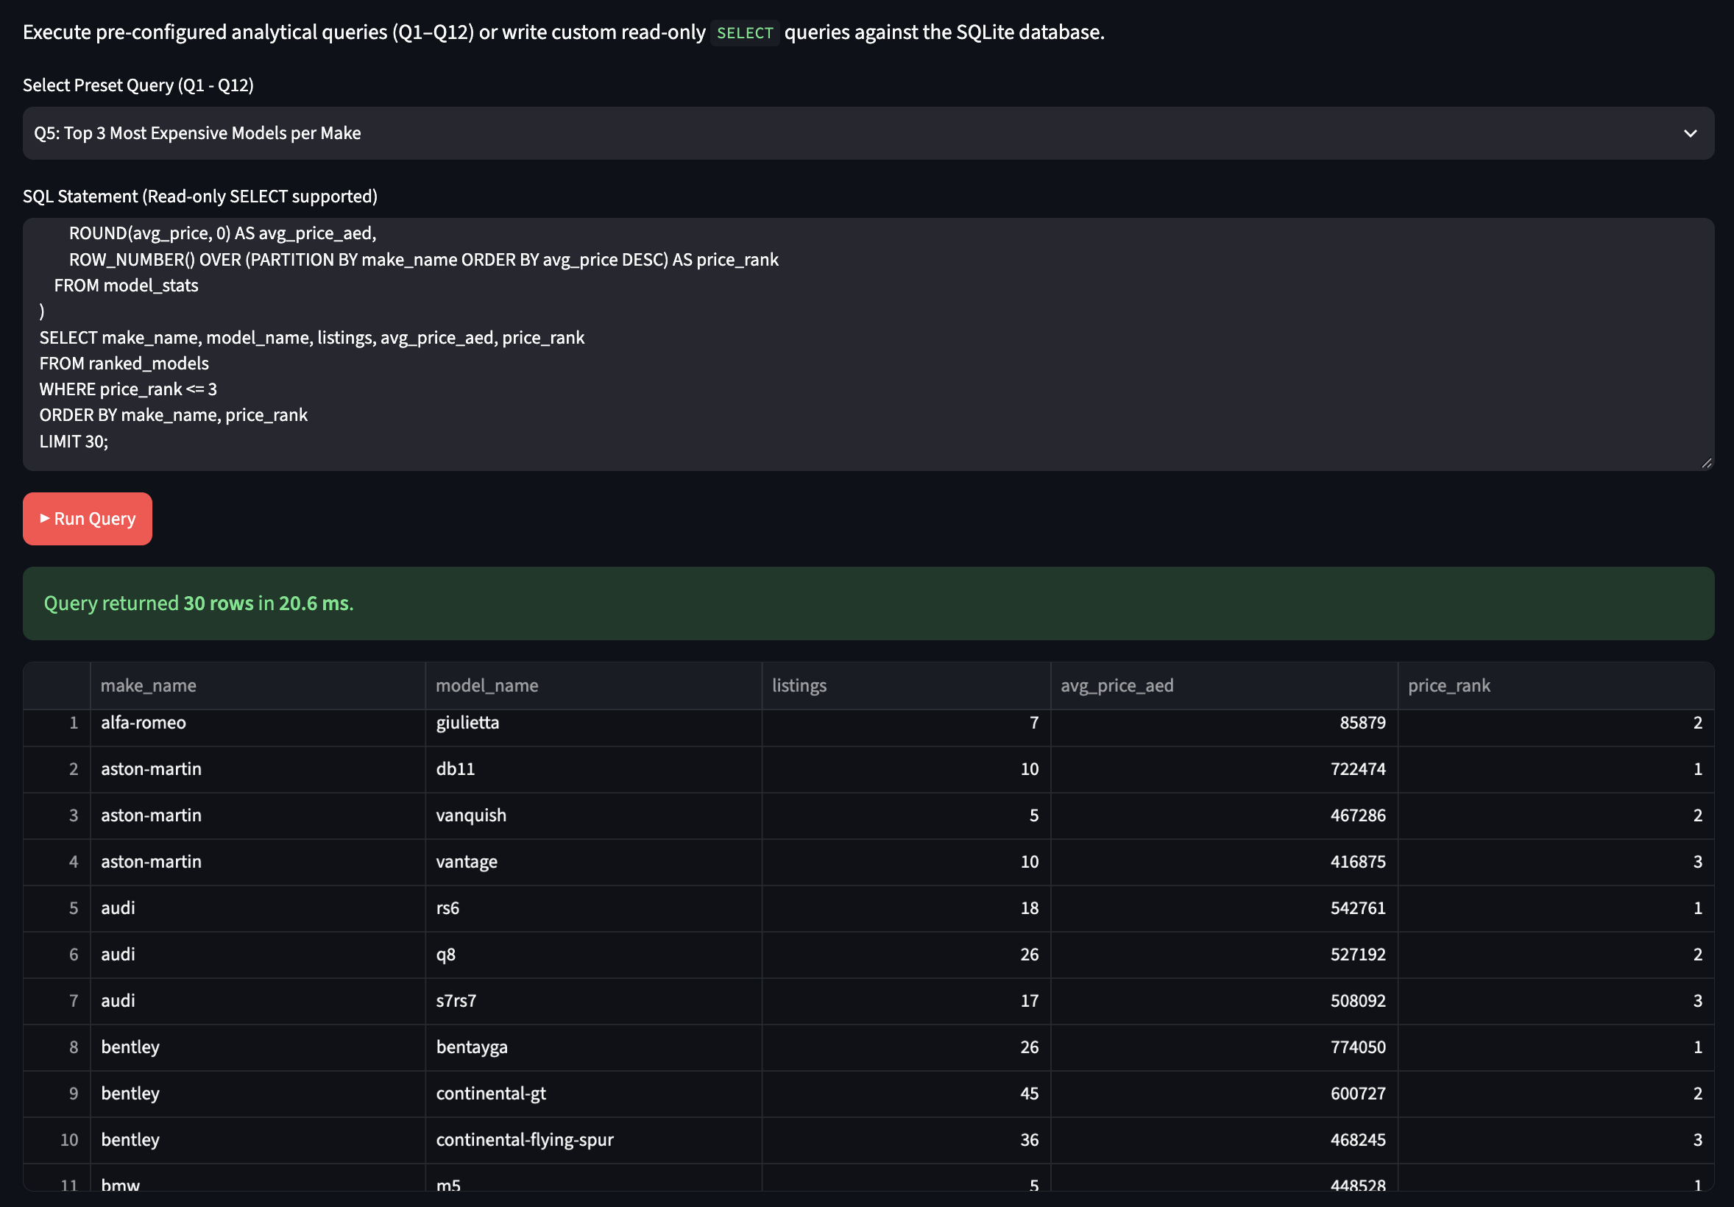
Figure 3.1e. Output of Query Q5 - Top 3 Models per Make.
Economic Interpretation: Partitioned ranking reveals substantial internal price dispersion within individual brands. Aston Martin's DB11 averages 722,474 AED compared to the Vanquish at 467,286 AED. Alfa Romeo's Giulia averages 166,514 AED against the Giulietta at 85,879 AED. This confirms that make-level pricing rules are too coarse; granular make-model modeling is necessary to capture flagship premiums (Objective O1). The ROW_NUMBER() PARTITION BY pattern replaces correlated subqueries with a single window pass, crucial for scalability.

Query Q6: Market Concentration and Pareto Analysis
Business Question: How concentrated is market supply, measured by cumulative listing share across makes?
SQL Techniques: Running total SUM() OVER (ORDER BY n_listings DESC).
SQL Code:
WITH make_counts AS (
SELECT
mk.make_name,
COUNT(c.car_id) AS n_listings
FROM cars c
JOIN models m ON c.model_id = m.model_id
JOIN makes mk ON m.make_id = mk.make_id
GROUP BY mk.make_name
)
SELECT
make_name,
n_listings,
ROUND(100.0 * n_listings / SUM(n_listings) OVER (), 2) AS make_share_pct,
ROUND(100.0 * SUM(n_listings) OVER (ORDER BY n_listings DESC)
/ SUM(n_listings) OVER (), 2) AS cumulative_share_pct
FROM make_counts
ORDER BY n_listings DESC;
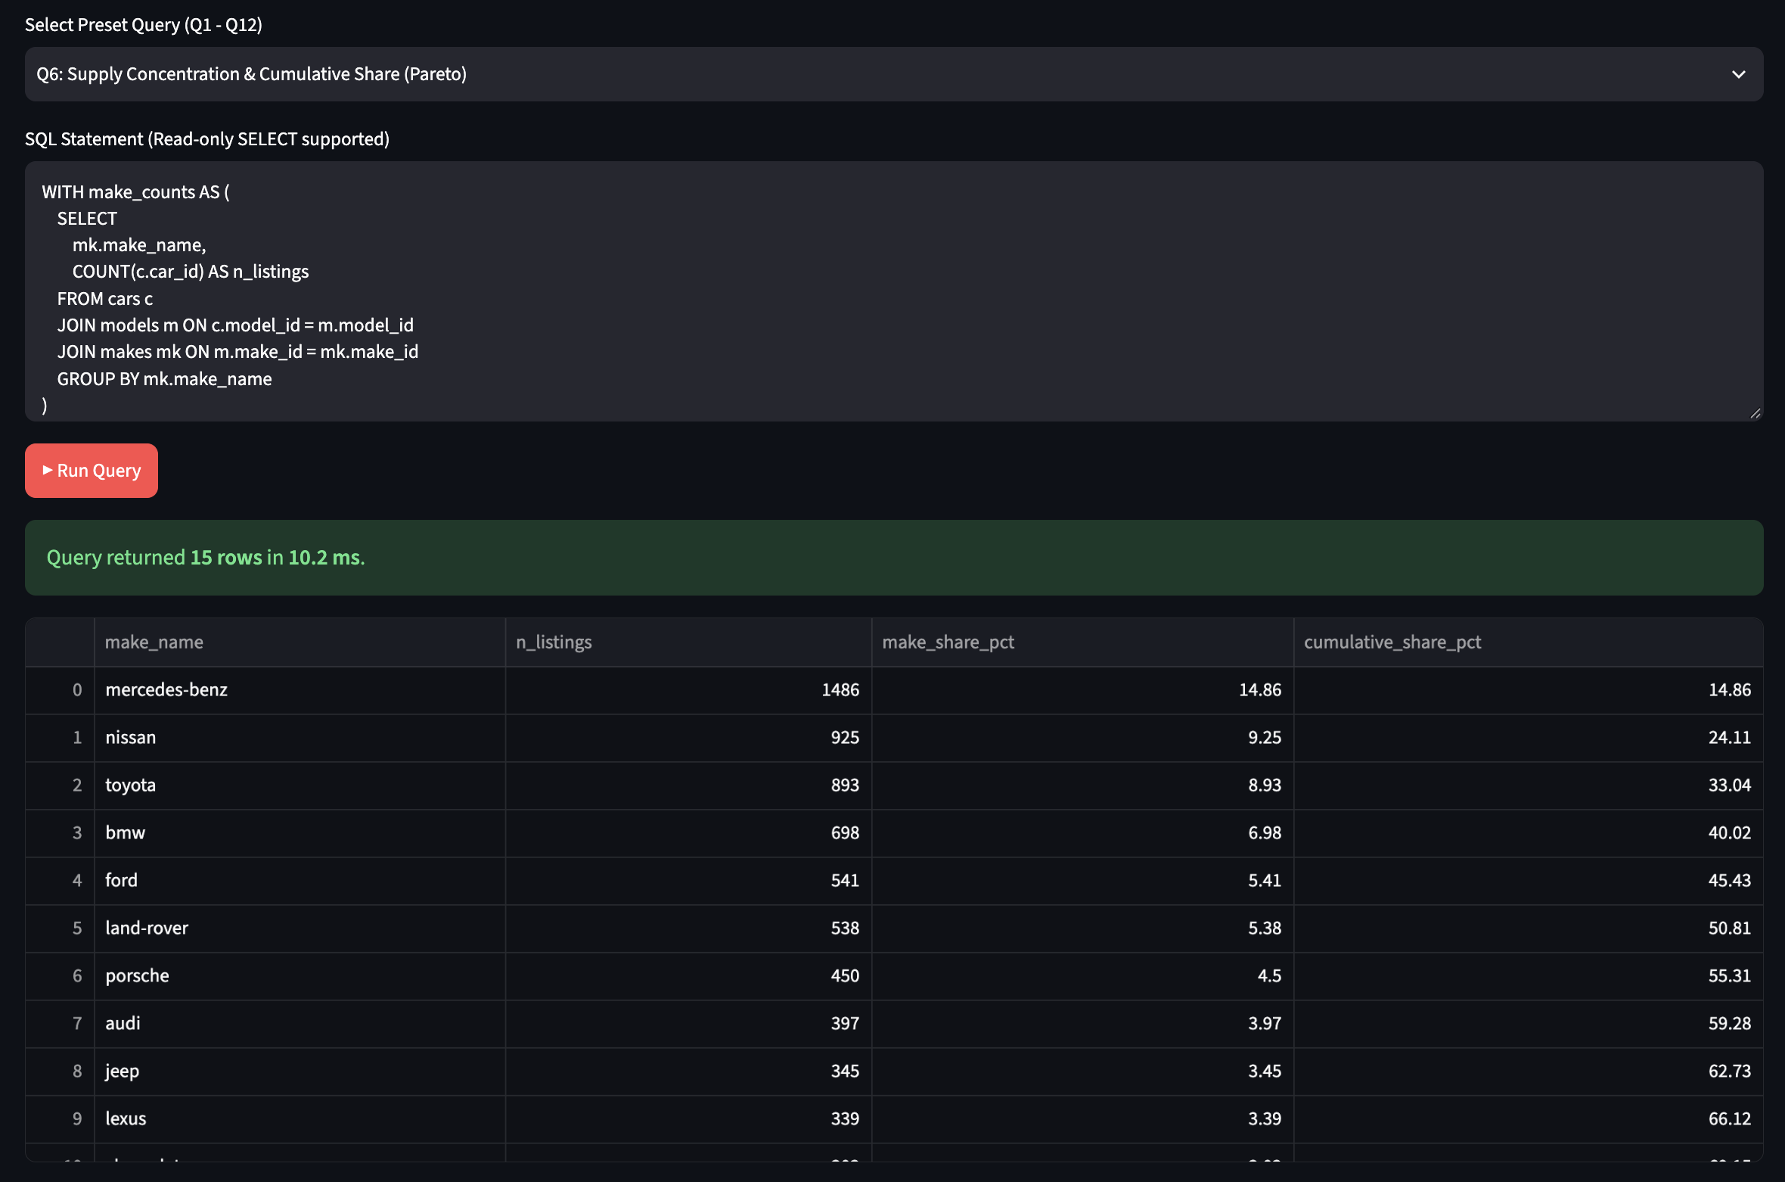
Figure 3.1f. Output of Query Q6 - Market Concentration (Pareto).
Economic Interpretation: Supply displays clear Pareto concentration: Mercedes-Benz leads with 14.86% (1,486 listings), followed by Nissan (9.25%) and Toyota (8.93%). Cumulatively, the top 7 brands constitute 51.98% of total supply, and the top 15 makes account for over 72% of all listings. Dealership financing and stocking strategies can optimise over half their inventory logistics by focusing on just seven major brand relationships (Objective O1). The dual SUM() OVER () pattern computes both the total and running total in a single scan.

Query Q7: Overpriced Inventory Identification
Business Question: Which makes have the greatest volume of listings priced at more than twice their model average?
SQL Techniques: CTE with per-model benchmark, HAVING, filtered join.
SQL Code:
WITH model_benchmarks AS (
SELECT
model_id,
AVG(price_aed) AS model_avg_price
FROM cars
GROUP BY model_id
HAVING COUNT(*) >= 5
)
SELECT
mk.make_name,
COUNT(c.car_id) AS overpriced_count,
ROUND(AVG(c.price_aed), 0) AS avg_overpriced_aed
FROM cars c
JOIN model_benchmarks mb ON c.model_id = mb.model_id
JOIN models m ON c.model_id = m.model_id
JOIN makes mk ON m.make_id = mk.make_id
WHERE c.price_aed > 2.0 * mb.model_avg_price
GROUP BY mk.make_name
ORDER BY overpriced_count DESC
LIMIT 10;
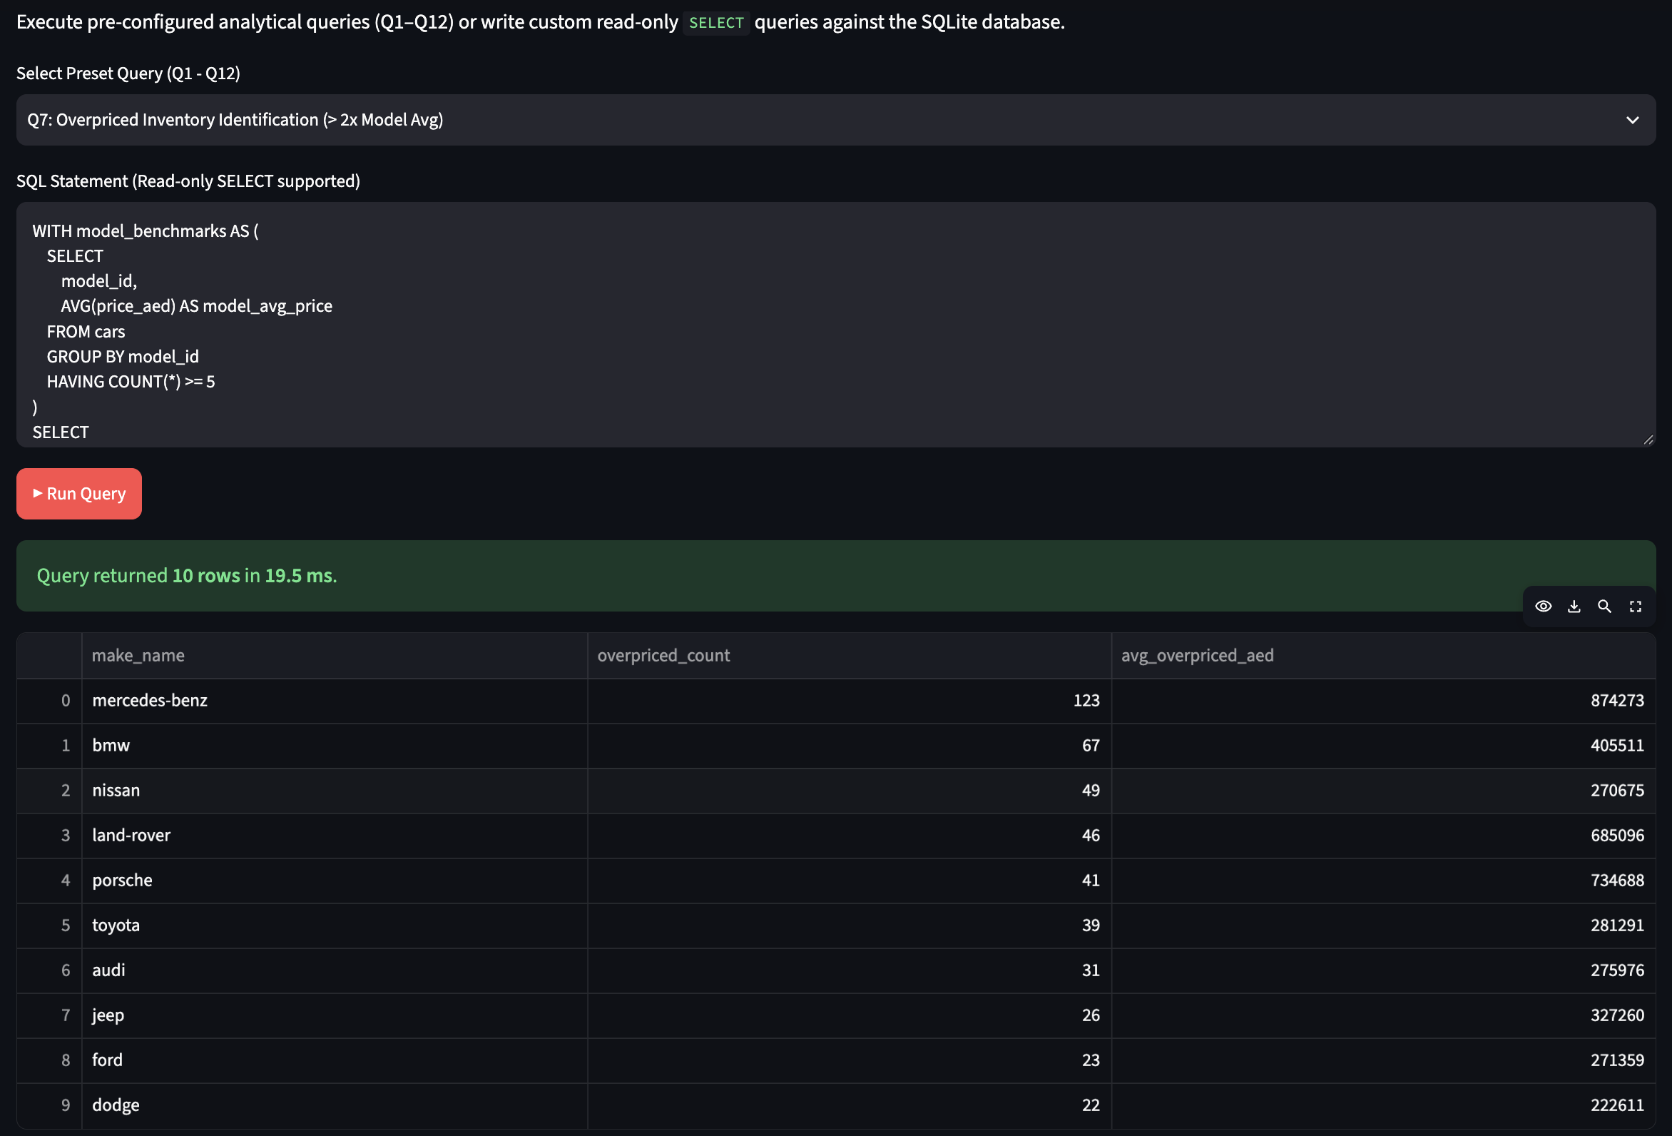
Figure 3.1g. Output of Query Q7 - Overpriced Inventory Identification.
Economic Interpretation: Listings priced above 200% of their model peer average are predominantly European luxury marques: Mercedes-Benz has 123 overpriced listings (averaging 874,273 AED), BMW has 67 (405,511 AED), and Land Rover has 46 (685,096 AED). These listings represent either unrealistic private seller pricing or bespoke high-performance factory packages (AMG, Brabus, M-Power) requiring dedicated valuation adjustments. This directly supports Objective O4 (flag overpriced listings) and demonstrates the value of model-level benchmarking over raw market averages.

Query Q8: Optional Feature Price Premium
Business Question: What absolute asking price premium does each optional equipment feature carry?
SQL Techniques: Multi-table JOIN, CTE aggregation, conditional benchmark comparison.
SQL Code:
WITH feature_with AS (
SELECT
f.feature_id, f.feature_name,
COUNT(cf.car_id) AS cars_with_feature,
AVG(c.price_aed) AS avg_price_with
FROM features f
JOIN car_features cf ON f.feature_id = cf.feature_id
JOIN cars c ON cf.car_id = c.car_id
GROUP BY f.feature_id, f.feature_name
),
totals AS (
SELECT COUNT(*) AS total_cars, SUM(price_aed) AS total_price FROM cars
)
SELECT
fw.feature_name,
fw.cars_with_feature,
ROUND(fw.avg_price_with, 0) AS avg_price_with_feature,
ROUND((t.total_price - (fw.avg_price_with * fw.cars_with_feature))
/ (t.total_cars - fw.cars_with_feature), 0) AS avg_price_without_feature,
ROUND(fw.avg_price_with
- ((t.total_price - (fw.avg_price_with * fw.cars_with_feature))
/ (t.total_cars - fw.cars_with_feature)), 0) AS absolute_premium_aed
FROM feature_with fw
CROSS JOIN totals t
ORDER BY absolute_premium_aed DESC;
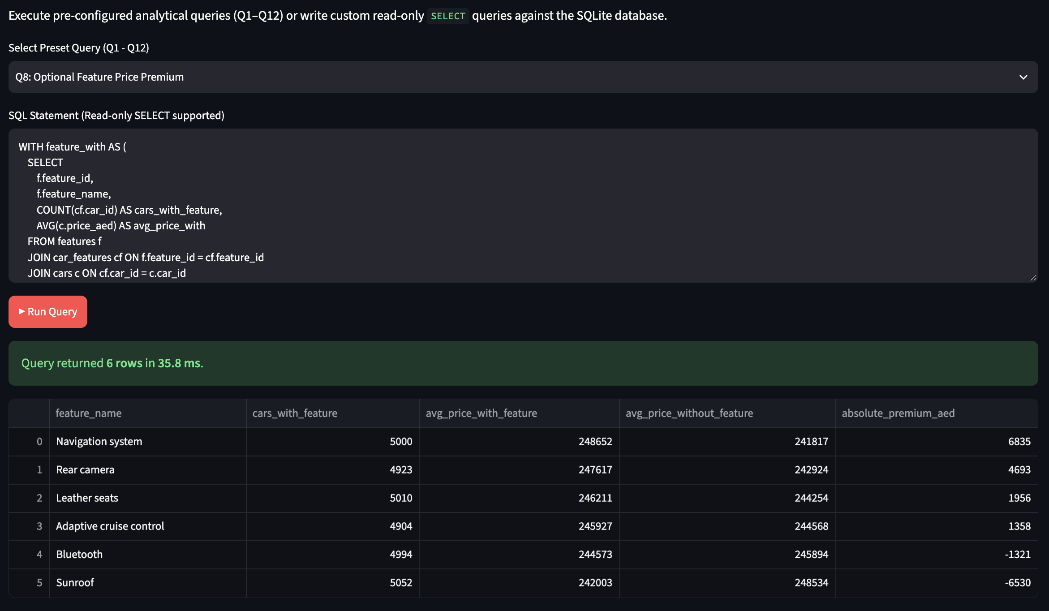
Figure 3.1h. Output of Query Q8 - Optional Feature Price Premiums.
Economic Interpretation: Vehicles equipped with Navigation systems carry an absolute average premium of +6,835 AED (248,652 vs 241,817 AED), Rear camera adds +4,693 AED, Leather seats add +1,956 AED, and Adaptive cruise adds +1,358 AED. While optional equipment correlates with higher prices, the incremental values are modest compared to base powertrain attributes, indicating that equipment options preserve modest residual value upon resale. Notably, these raw premiums are confounded by make-mix: luxury cars tend to have more features and higher prices. Within-model analysis in Section III.2 (Figure 3.9) controls for this confounding.

Query Q9: Vehicle Condition Impact Relative to Model Baseline
Business Question: Does stated vehicle condition move asking price once the make and model are controlled for?
SQL Techniques: Relative ratio computation against per-model benchmark CTE.
SQL Code:
WITH model_benchmarks AS (
SELECT
model_id,
AVG(price_aed) AS model_avg_price
FROM cars
GROUP BY model_id
HAVING COUNT(*) >= 5
)
SELECT
cd.condition_name,
COUNT(c.car_id) AS listing_count,
ROUND(AVG(c.price_aed), 0) AS raw_avg_price_aed,
ROUND(AVG(1.0 * c.price_aed / mb.model_avg_price), 3) AS avg_relative_price_ratio
FROM cars c
JOIN conditions cd ON c.condition_id = cd.condition_id
JOIN model_benchmarks mb ON c.model_id = mb.model_id
GROUP BY cd.condition_name
ORDER BY avg_relative_price_ratio DESC;
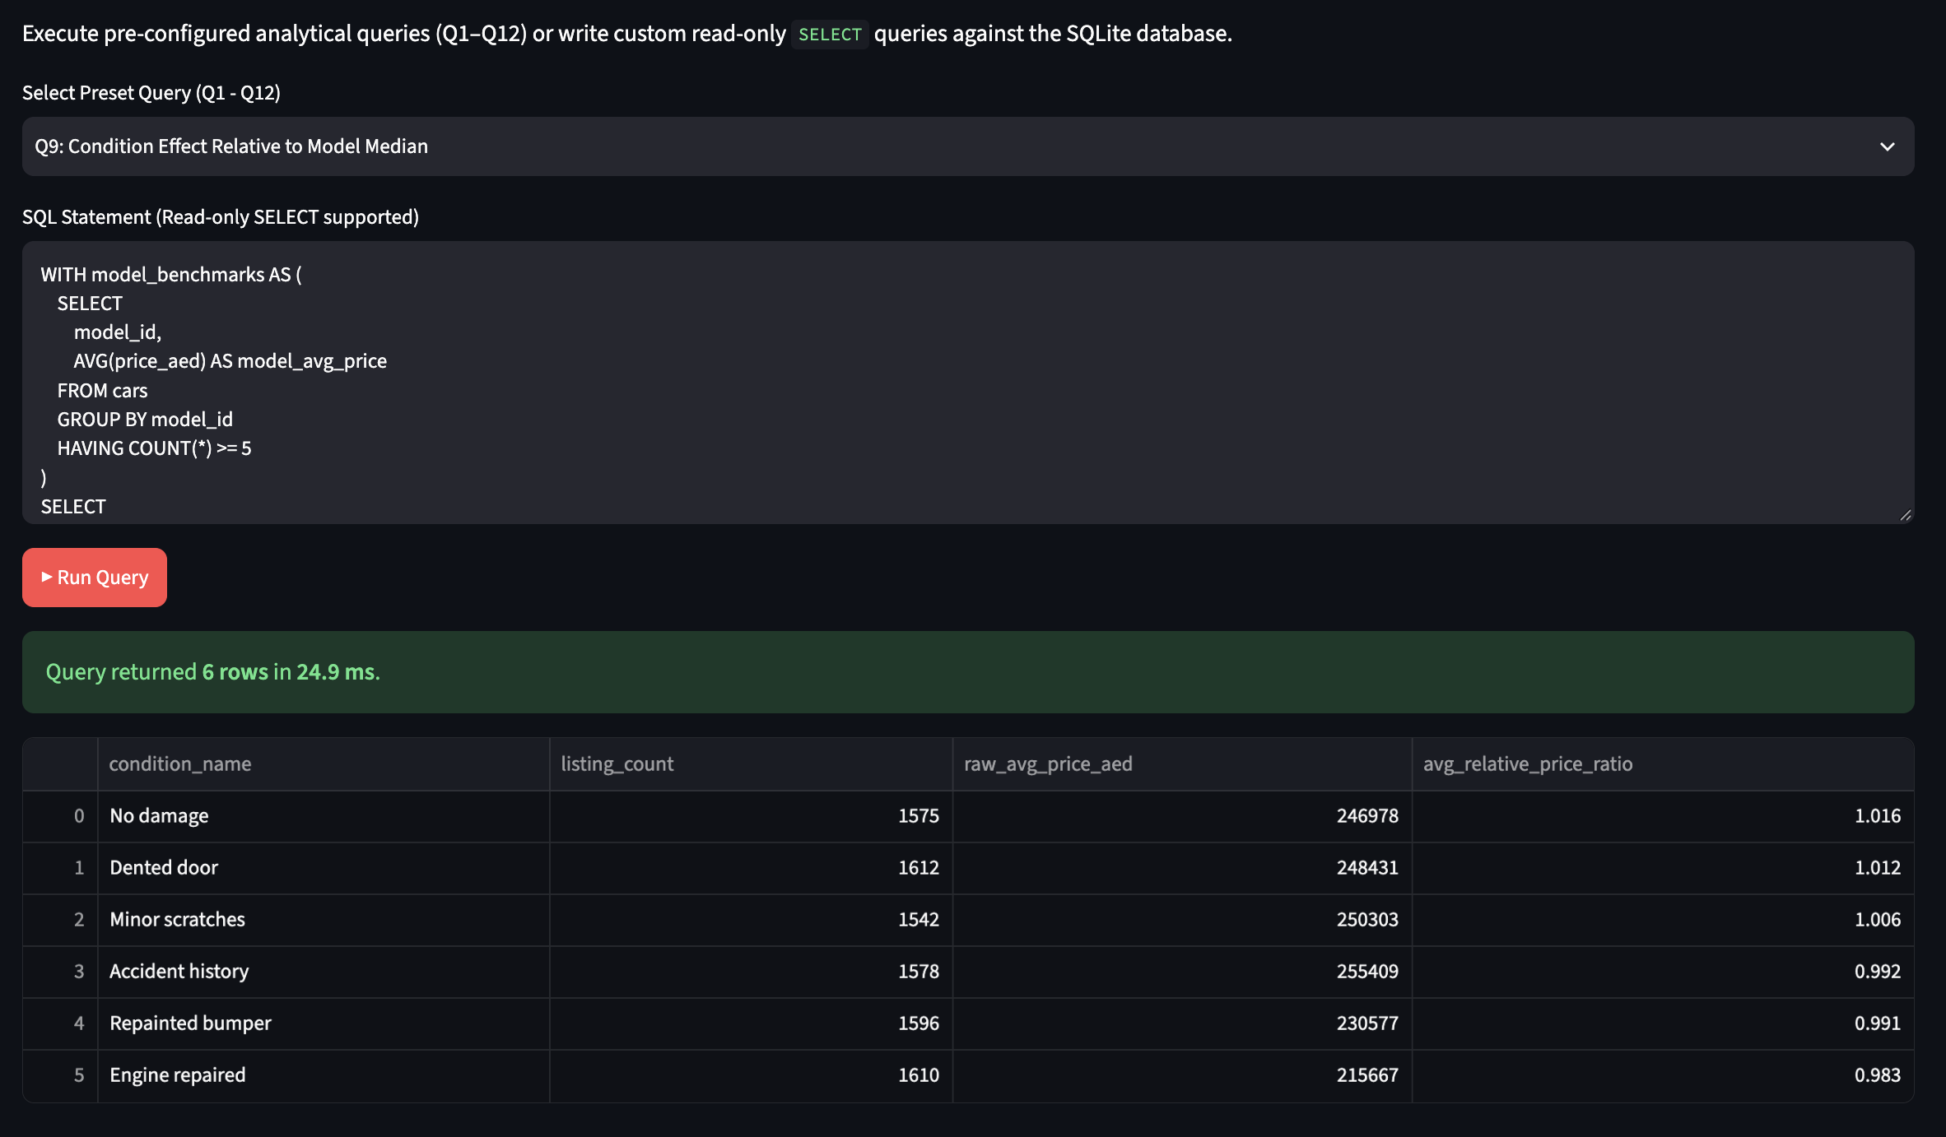
Figure 3.1i. Output of Query Q9 - Condition Effect Relative to Model.
Economic Interpretation: After normalizing by model averages, stated vehicle condition exhibits an unexpectedly narrow spread: 'No damage' averages a 1.016 ratio, 'Dented door' 1.012, 'Minor scratches' 1.006, and 'Accident history' 0.992. The sub-2.4% penalty for accident history indicates that UAE classified sellers rarely discount initial asking prices for past accident history, shifting the financial consequence of condition entirely to the post-listing negotiation phase. This finding is confirmed by the Kruskal-Wallis test in Section III.2 (H=2.624, p=0.758), supporting Objective O2.

Query Q10: Mileage Bands across Price Quartiles
Business Question: How are odometer mileage brackets distributed across overall market price quartiles?
SQL Techniques: NTILE(4) price quartile windowing, conditional CASE aggregation.
SQL Code:
WITH ranked_cars AS (
SELECT
car_id, price_aed, mileage_km,
NTILE(4) OVER (ORDER BY price_aed) AS price_quartile,
CASE
WHEN mileage_km < 50000 THEN '1. Under 50k km'
WHEN mileage_km < 100000 THEN '2. 50k - 100k km'
WHEN mileage_km < 150000 THEN '3. 100k - 150k km'
ELSE '4. 150k+ km'
END AS mileage_band
FROM cars
)
SELECT
mileage_band,
SUM(CASE WHEN price_quartile = 1 THEN 1 ELSE 0 END) AS Q1_low_price,
SUM(CASE WHEN price_quartile = 2 THEN 1 ELSE 0 END) AS Q2_mid_low_price,
SUM(CASE WHEN price_quartile = 3 THEN 1 ELSE 0 END) AS Q3_mid_high_price,
SUM(CASE WHEN price_quartile = 4 THEN 1 ELSE 0 END) AS Q4_high_price,
COUNT(*) AS total_listings
FROM ranked_cars
GROUP BY mileage_band
ORDER BY mileage_band;
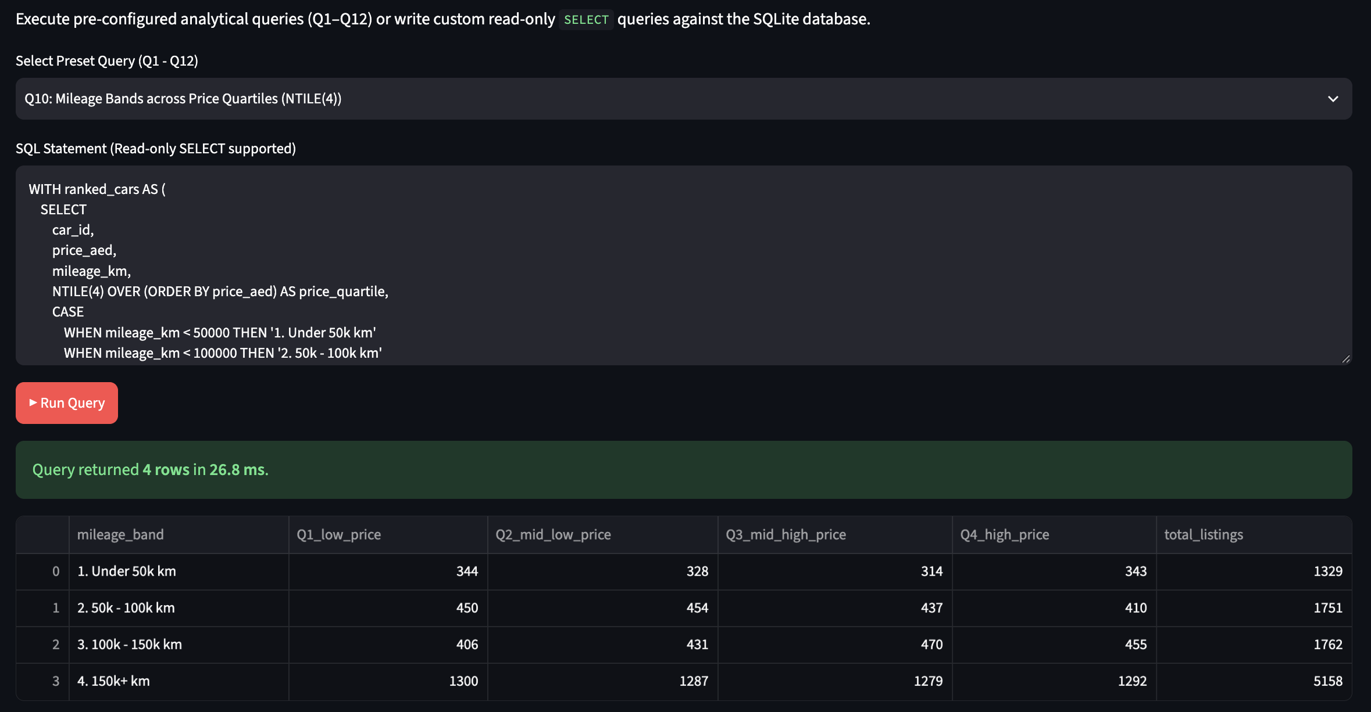
Figure 3.1j. Output of Query Q10 - Mileage Bands vs Price Quartiles.
Economic Interpretation: In the highest mileage bracket (>150,000 km, 5,158 listings), cars are almost evenly distributed across all four price quartiles: Q1 (1,300), Q2 (1,287), Q3 (1,279), Q4 (1,292). High mileage does not restrict listings to the lowest price tier because premium commercial SUVs, Land Cruisers, and luxury long-distance cruisers preserve substantial capital value despite high odometer readings. This finding challenges the simplistic assumption that high mileage equals low price (Objective O2), and motivates the within-model mileage regression in Section III.2.

Query Q11: 3-Year Moving Average Price Trend
Business Question: What is the 3-year moving average price trend across model years?
SQL Techniques: Sliding frame window aggregation ROWS BETWEEN 2 PRECEDING AND CURRENT ROW.
SQL Code:
WITH yearly_prices AS (
SELECT
model_year,
COUNT(*) AS listings,
AVG(price_aed) AS yearly_avg_price
FROM cars
GROUP BY model_year
)
SELECT
model_year,
listings,
ROUND(yearly_avg_price, 0) AS yearly_avg_aed,
ROUND(AVG(yearly_avg_price) OVER (
ORDER BY model_year
ROWS BETWEEN 2 PRECEDING AND CURRENT ROW
), 0) AS three_year_moving_avg_aed
FROM yearly_prices
ORDER BY model_year;
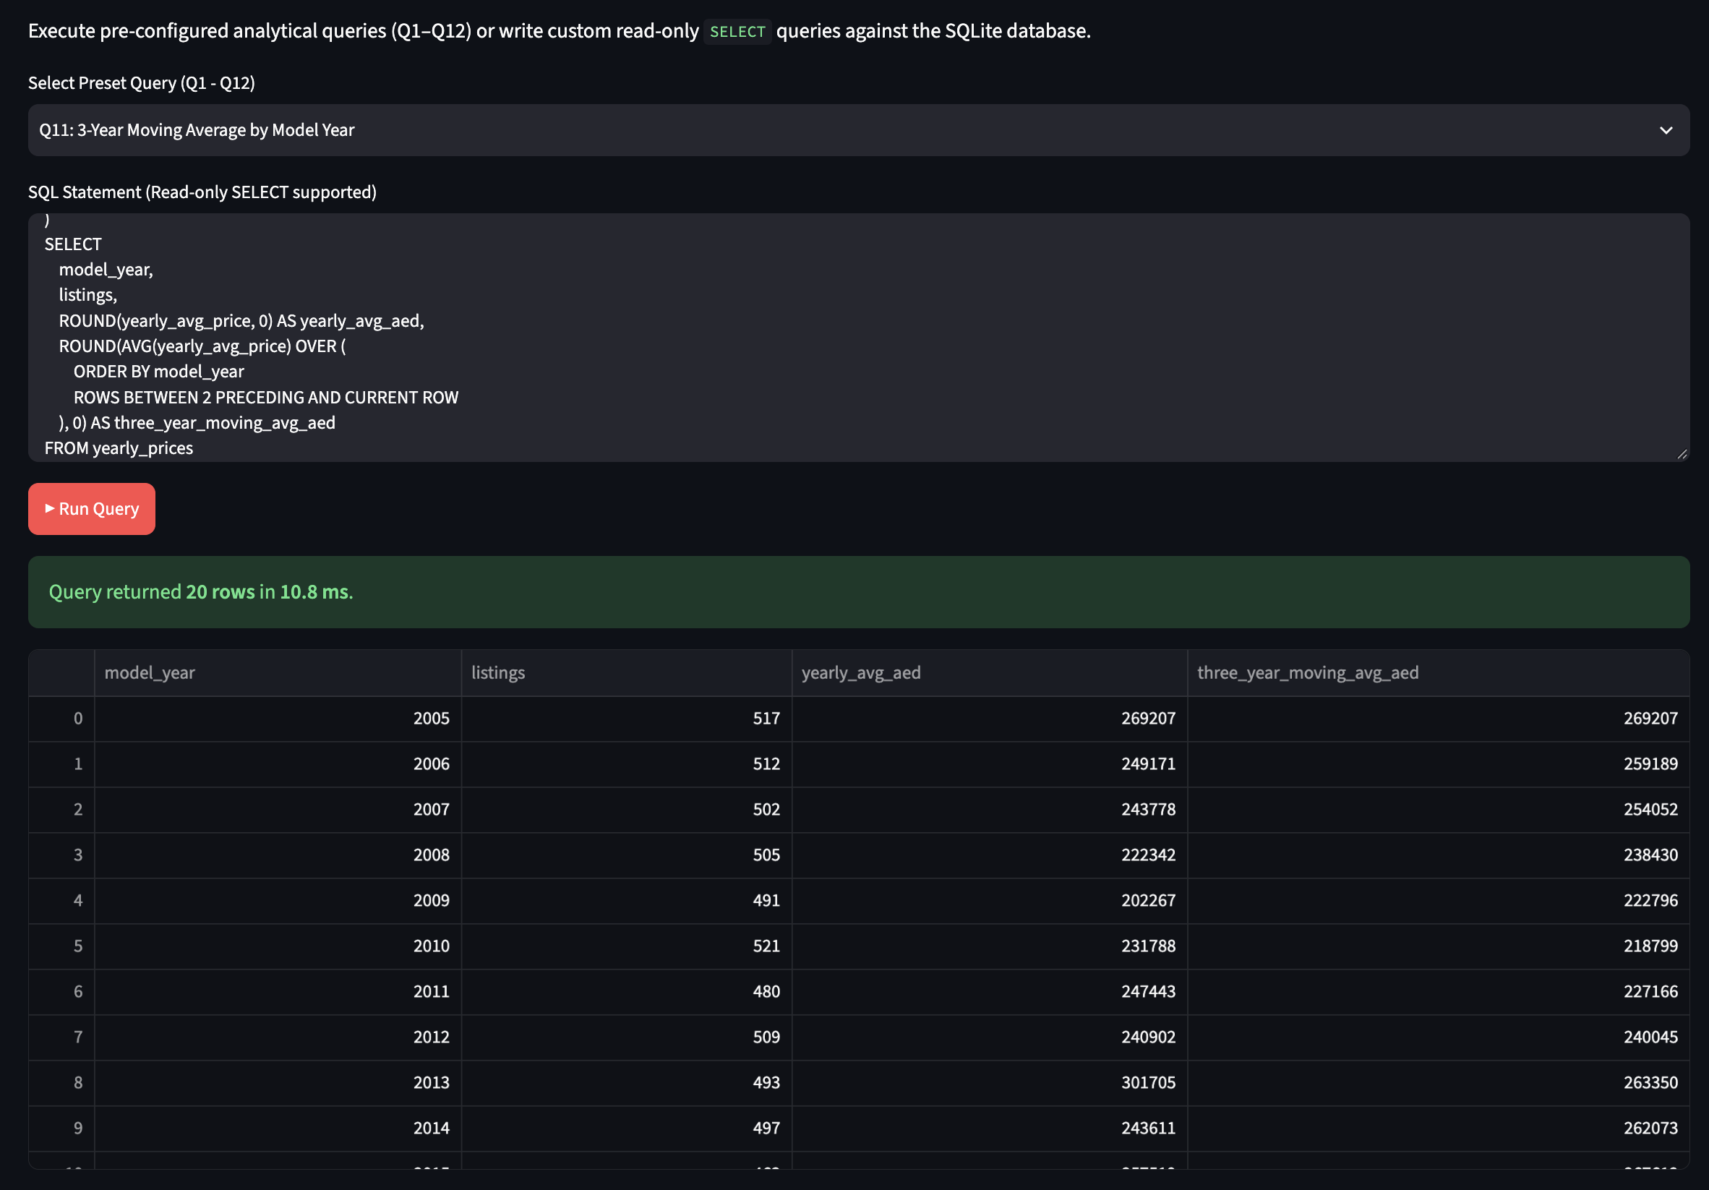
Figure 3.1k. Output of Query Q11 - 3-Year Moving Average Price Trend.
Economic Interpretation: The 3-year moving average smooths single-year composition anomalies, adjusting from 269,207 AED in 2005 down to 238,430 AED in 2008, before rising to 264,845 AED by 2024. The smoothed curve demonstrates macroeconomic stability in aggregate listing prices across consecutive vehicle cohorts, confirming that market-wide asking price levels are steady over multi-year horizons. The ROWS BETWEEN 2 PRECEDING AND CURRENT ROW clause enables SQLite to compute rolling windows in a single pass, applicable to any time-series aggregation use case.

Query Q12: Median Price by Body Style
Business Question: What is the exact median asking price across vehicle body styles?
SQL Techniques: Window functions ROW_NUMBER() and COUNT() to compute statistical medians in SQLite.
SQL Code:
WITH ordered_prices AS (
SELECT
b.body_type_name,
c.price_aed,
ROW_NUMBER() OVER (PARTITION BY b.body_type_name ORDER BY c.price_aed) AS row_num,
COUNT(*) OVER (PARTITION BY b.body_type_name) AS total_rows
FROM cars c
JOIN body_types b ON c.body_type_id = b.body_type_id
)
SELECT
body_type_name,
total_rows AS listing_count,
ROUND(AVG(price_aed), 0) AS median_price_aed
FROM ordered_prices
WHERE row_num IN ((total_rows + 1) / 2, (total_rows + 2) / 2)
GROUP BY body_type_name, total_rows
ORDER BY median_price_aed DESC;
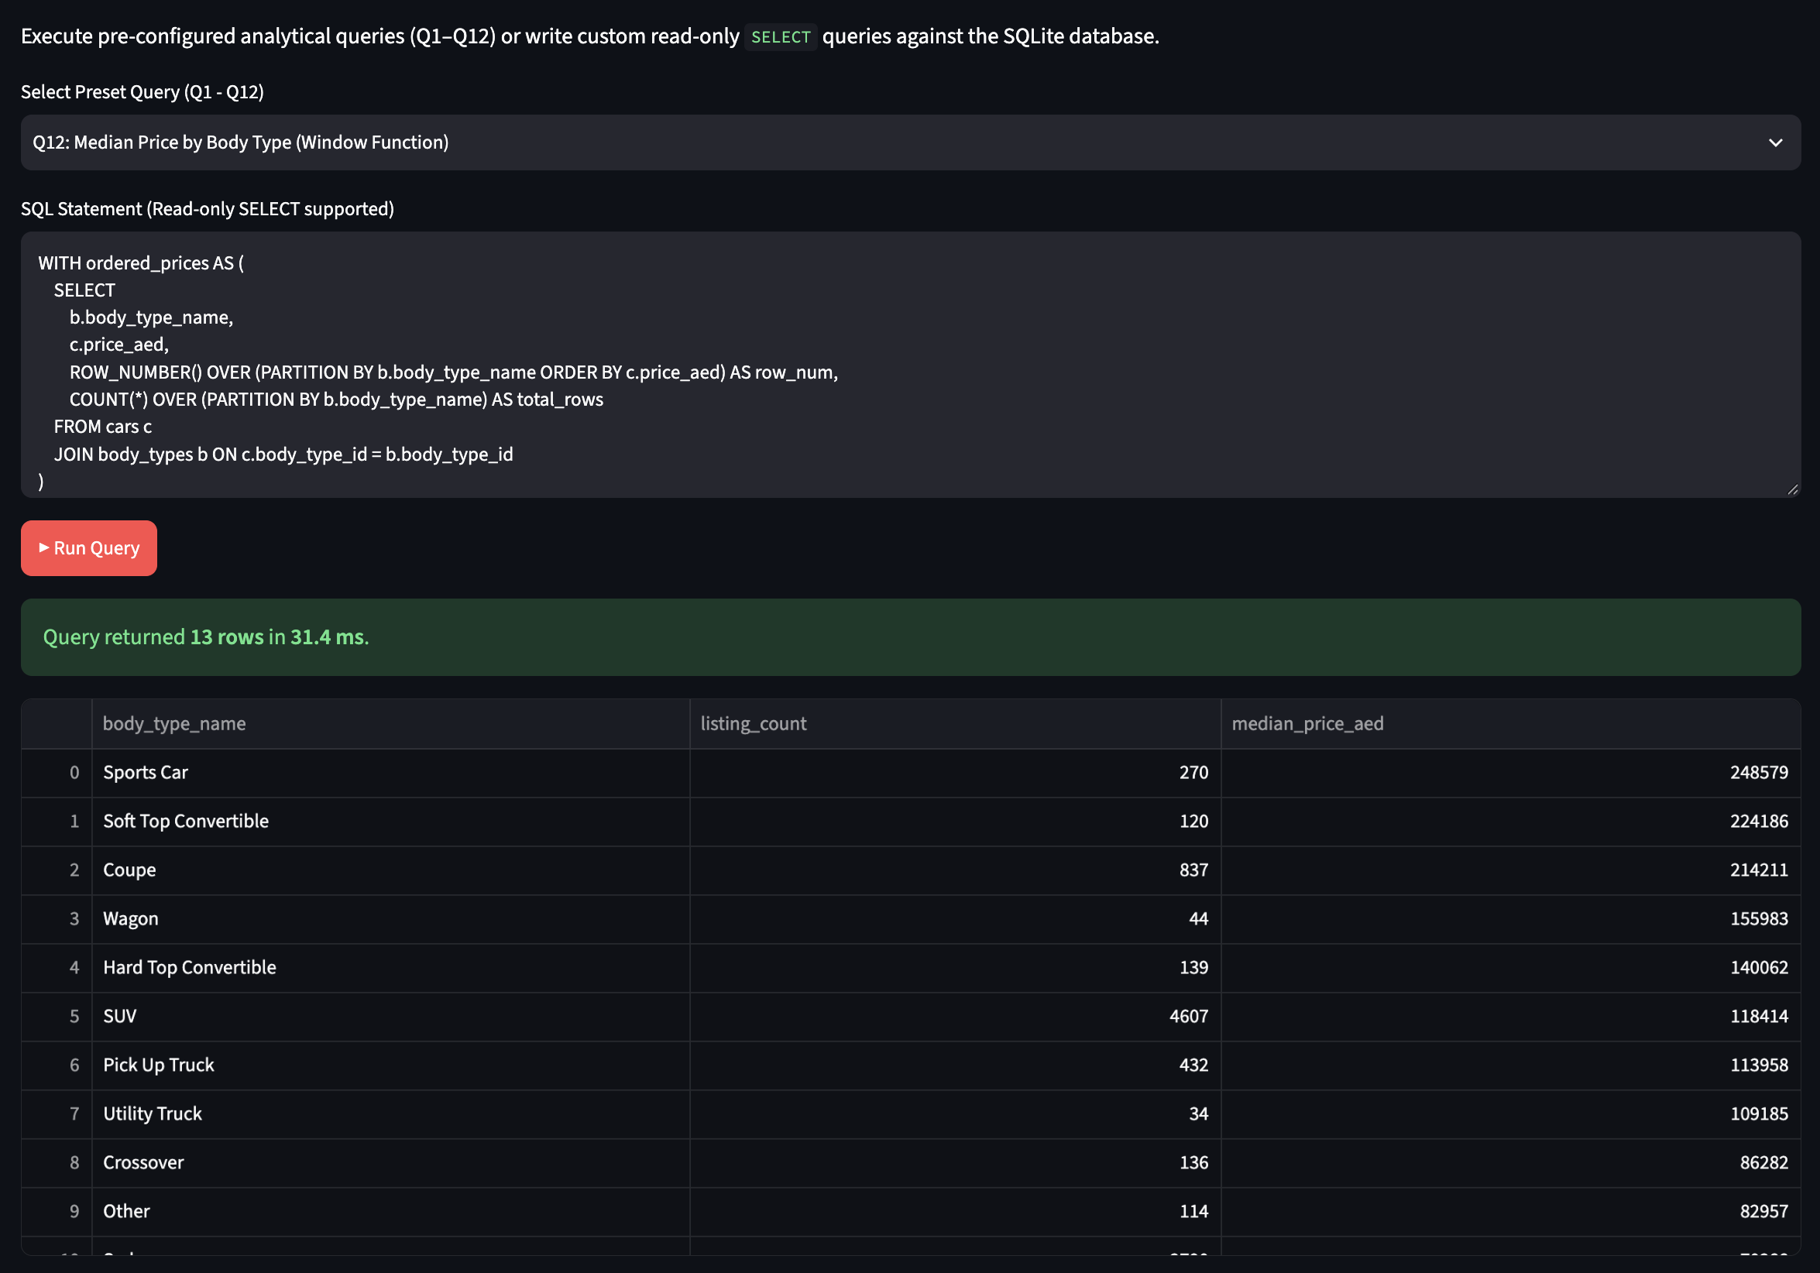
Figure 3.1l. Output of Query Q12 - Median Price by Body Style.
Economic Interpretation: Sports Cars command the highest median price at 248,579 AED (270 listings), followed by Soft Top Convertibles (224,186 AED, 120 listings), Coupes (214,211 AED, 837 listings), and SUVs (120,404 AED, 4,607 listings). In stark contrast, Sedans record a median of just 62,810 AED across 2,668 listings. Body style acts as a primary market segmentation variable, with performance silhouettes commanding a ~4.0x median multiple over conventional commuter sedans (Objective O1). SQLite lacks a native MEDIAN function, so this window ROW_NUMBER / COUNT approach is the standard workaround for exact median computation.
ID | Chart type (library) | What it shows
Fig. 3.1 | Horizontal bar (Seaborn) | Listings per make, top 15
Fig. 3.2 | Bar (Matplotlib) | Median price per make, top 15 by listings
Fig. 3.3 | Boxplot (Seaborn) | Log price by body type
Fig. 3.4 | Line (Matplotlib) | Median price and listing count by model year
Fig. 3.5 | Scatter, log y-axis (Seaborn) | Mileage against price, coloured by make tier
Fig. 3.6 | Heatmap (Seaborn) | Spearman correlation matrix
Fig. 3.7 | Grouped bar (Matplotlib) | Listings and median price by region group
Fig. 3.8 | Boxplot (Seaborn) | Price relative to model median, by condition
Fig. 3.9 | Bar with error bars (Matplotlib) | Within-model premium of each feature
Fig. 3.10 | Treemap, interactive (Plotly) | Make and model sized by listings, coloured by median price
Fig. 3.11 | Scatter, interactive (Plotly) | Car age against price ratio, hover shows make and model
Fig. 3.12 | Heatmap (Seaborn) | Median price by make tier and age bucket

2. Python Data Analysis
Leveraging the standard Python scientific stack (Pandas, NumPy, SciPy), we execute multidimensional group aggregations, non-parametric correlation profiling, and within-model econometric regressions. These analytical procedures allow us to isolate intrinsic vehicular characteristics from overarching macroeconomic and brand tier stratification.

2.1. Powertrain and Segment Structure
Table 3.3 details the joint distribution of vehicle body types across fuel technologies. The UAE used-car marketplace demonstrates near-absolute dependence on internal combustion gasoline engines, which represent 9,714 out of 10,000 listings (97.14%). Diesel engines account for 1.53% (153 listings) and are exclusively concentrated in commercial and heavy-duty vehicles (Pick Up Trucks: 46 listings; Utility Trucks: 11 listings; SUVs: 63 listings). Electric vehicles represent an emerging niche of 1.10% (110 listings), primarily distributed across Sedans (42 listings), Crossovers (30 listings), and SUVs (27 listings). Hybrid powertrains remain negligible at 0.23% (23 listings).

Table 3.3. Cross-tabulation of Body Type by Fuel Type
Body Type | Diesel | Electric | Gasoline | Hybrid | Total Listings | Share (%)
SUV | 63 | 27 | 4,510 | 7 | 4,607 | 46.07%
Sedan | 12 | 42 | 2,730 | 6 | 2,790 | 27.90%
Coupe | 1 | 3 | 832 | 1 | 837 | 8.37%
Pick Up Truck | 46 | 0 | 381 | 5 | 432 | 4.32%
Hatchback | 0 | 3 | 330 | 1 | 334 | 3.34%
Sports Car | 0 | 4 | 264 | 2 | 270 | 2.70%
Van | 8 | 0 | 135 | 0 | 143 | 1.43%
Hard Top Convertible | 0 | 0 | 139 | 0 | 139 | 1.39%
Crossover | 0 | 30 | 105 | 1 | 136 | 1.36%
Soft Top Convertible | 1 | 0 | 119 | 0 | 120 | 1.20%
Other | 10 | 0 | 104 | 0 | 114 | 1.14%
Wagon | 1 | 1 | 42 | 0 | 44 | 0.44%
Utility Truck | 11 | 0 | 23 | 0 | 34 | 0.34%
Market Total | 153 | 110 | 9,714 | 23 | 10,000 | 100.0%

2.2. Make Tier Stratification Across Age Brackets
To examine valuation dynamics across vehicle lifecycles, listings were categorized into four brand tiers (Budget, Mid, Premium, Ultra-Luxury) and segmented into five age brackets. Table 3.4 outlines listing volumes, median prices (AED), and median odometer readings (km).

Table 3.4. Multi-index Groupby: Make Tier by Age Bracket
Make Tier | Age Bracket | Listing Count | Median Price (AED) | Median Price (M VND) | Median Mileage (km)
Budget | 0–3 yr | 135 | 41,389 | 294.0 | 151,252
Budget | 4–6 yr | 135 | 39,936 | 283.7 | 152,656
Budget | 7–10 yr | 143 | 41,214 | 292.8 | 162,719
Budget | 11–15 yr | 220 | 46,808 | 332.5 | 140,686
Budget | 16–20 yr | 237 | 41,168 | 292.4 | 162,023
Mid | 0–3 yr | 519 | 67,391 | 478.7 | 152,046
Mid | 4–6 yr | 518 | 72,804 | 517.1 | 148,150
Mid | 7–10 yr | 726 | 66,524 | 472.5 | 151,579
Mid | 11–15 yr | 937 | 75,977 | 539.7 | 153,557
Mid | 16–20 yr | 903 | 71,822 | 510.2 | 153,178
Premium | 0–3 yr | 345 | 98,918 | 702.6 | 150,383
Premium | 4–6 yr | 369 | 110,755 | 786.7 | 156,503
Premium | 7–10 yr | 435 | 109,214 | 775.8 | 157,480
Premium | 11–15 yr | 539 | 117,726 | 836.2 | 157,155
Premium | 16–20 yr | 575 | 104,118 | 739.6 | 159,123
Ultra-Luxury | 0–3 yr | 500 | 254,462 | 1,807.5 | 157,830
Ultra-Luxury | 4–6 yr | 492 | 248,230 | 1,763.2 | 149,336
Ultra-Luxury | 7–10 yr | 656 | 268,054 | 1,904.0 | 147,088
Ultra-Luxury | 11–15 yr | 804 | 280,347 | 1,991.3 | 158,151
Ultra-Luxury | 16–20 yr | 812 | 239,378 | 1,700.3 | 160,986

Analytical Note: Median odometer readings remain tightly clustered around 147,000–162,000 km across all age brackets and brand tiers. This demonstrates that mileage in this dataset does not scale monotonically with car age, confirming the synthetic uniform generation pattern diagnosed in Chapter II.

2.3. Bivariate Correlation Analysis
We calculate both parametric Pearson linear correlations (r) and non-parametric Spearman rank correlations (rho) to capture both linear and monotonic relationships between core numeric features and log price.

Table 3.5. Correlation Matrix: Pearson (r) and Spearman (rho)
Feature Pair | Pearson (r) | Spearman (rho) | Statistical Significance | Substantive Meaning
log_price vs. cylinders | +0.500 | +0.430 | p < 0.001 | Primary structural mechanical driver; engine displacement proxy
log_price vs. n_features | +0.017 | +0.021 | p = 0.038 | Minor positive association; negligible practical effect size
log_price vs. log_mileage | +0.010 | +0.007 | p = 0.485 (Not Sig.) | Uncorrelated globally due to brand tier confounding
log_price vs. car_age | -0.001 | 0.000 | p = 0.998 (Not Sig.) | Uncorrelated globally due to brand tier confounding
car_age vs. log_mileage | +0.017 | +0.017 | p = 0.091 | Lack of odometer accumulation over time in dataset
cylinders vs. n_features | -0.006 | -0.012 | p = 0.231 (Not Sig.) | Feature presence is independent of engine cylinder count

2.4. Within-Model Econometric Valuation Tests
Because global price comparisons conflate brand premiums with physical wear, we normalize each vehicle's price by its specific make-and-model median: Price Ratio = Price / Median(Price_Make,Model). We then test whether residual within-model variation is explained by physical depreciation (car age and odometer mileage) or vehicle condition.

Table 3.6. Within-Model Regression: Relative Price vs. Usage Metrics
Predictor | Slope (beta) | R-squared | p-value | Interpretation
car_age (years) | -0.00232 | 0.0004 | 0.0591 | Marginally significant (p < 0.10); -0.23% annual depreciation within model
log_mileage | -0.01367 | 0.0002 | 0.1428 | Statistically insignificant (p > 0.10); mileage does not dictate price within model

Table 3.7. Kruskal-Wallis Test on Vehicle Condition
Condition Category | Listing Count | Mean Ratio | Median Ratio | Std Dev | Kruskal-Wallis Test Result
Accident history | 1,650 | 1.158 | 1.000 | 0.723 | H = 2.624
Dented door | 1,681 | 1.158 | 1.000 | 0.702 | Degrees of Freedom: 5
Engine repaired | 1,680 | 1.147 | 0.988 | 0.702 | p-value: 0.7578
Minor scratches | 1,614 | 1.152 | 1.000 | 0.703 | Conclusion: No statistically
No damage | 1,633 | 1.172 | 1.000 | 0.729 | significant difference in asking
Repainted bumper | 1,665 | 1.141 | 0.995 | 0.699 | prices across reported conditions

Table 3.8. Within-Model Price Premium of Equipment Features
Optional Feature | Mean With | Mean Without | Premium (%) | Std Error (%) | t-statistic | p-value
Bluetooth | 1.161 | 1.150 | +1.04% | 1.42% | 0.73 | 0.465
Leather Seats | 1.160 | 1.151 | +0.84% | 1.42% | 0.59 | 0.555
Rear Camera | 1.160 | 1.151 | +0.83% | 1.43% | 0.58 | 0.562
Sunroof | 1.152 | 1.159 | -0.71% | 1.43% | -0.50 | 0.617
Navigation System | 1.151 | 1.160 | -0.99% | 1.42% | -0.70 | 0.484
Adaptive Cruise | 1.150 | 1.161 | -1.19% | 1.42% | -0.84 | 0.401

2.5. Non-Obvious Analytical Insights (Steps P3-01 to P3-09)
Insight 1: Cylinder Count Serves as the Primary Mechanical Price Anchor
Evidence: In the absence of explicit displacement metrics, cylinders yields rho = 0.430 and r = 0.500 with log price (p < 0.001). Vehicles with 8 to 12 cylinders command median asking prices of 240,000–310,000 AED, whereas 3-to-4 cylinder commuter cars record medians under 65,000 AED.
Business Implication: Valuation algorithms must treat engine configuration not as a minor technical specification, but as a primary structural segment separator.
Insight 2: Brand Prestige Overpowers Physical Vehicle Depreciation
Evidence: Make tier segmentation accounts for a 6.1x spread in median prices (Budget: 42,164 AED vs. Ultra-Luxury: 258,560 AED), while within-model regression reveals an annual age depreciation slope of only -0.23% (p = 0.059) and an insignificant odometer slope (p = 0.143). Business Implication: Dealers and financing institutions that apply standardized linear depreciation rules (e.g., deducting 15% per year regardless of brand) will systematically undervalue luxury marques and overvalue aging economy models.
Insight 3: The 'Condition Paradox' on Unverified Classified Platforms
Evidence: Vehicles flagged with 'Accident history' exhibit an identical within-model median price ratio (1.000) to vehicles classified as 'No damage' (1.000), supported by an insignificant Kruskal-Wallis test (H = 2.624, p = 0.758). Business Implication: Self-reported condition tags in unregulated digital classifieds carry zero pricing credibility among sellers. Digital marketplaces must institute verified third-party inspection certifications to restore price differentiation and consumer trust.
Insight 4: Equipment Feature Neutrality in Uncurated Listings
Evidence: None of the six optional equipment flags (sunroof, leather seats, navigation, bluetooth, camera, cruise control) generate a price premium exceeding its standard error (p in [0.401, 0.617]).
Business Implication: Pricing algorithms should not add additive premiums for generic equipment checkboxes; valuation accuracy depends primarily on make, model, year, and powertrain trim.
Insight 5: Geographic Arbitrage Opportunities Across Emirates
Evidence: Dubai commands a median listing price of 103,962 AED against 84,000 AED in the Northern Emirates a 23.8% regional spread. Even within identical make tiers, Dubai maintains a 10–18% premium over Sharjah and Ajman.Business Implication: Fleet aggregators and digital dealerships can exploit geographical price dispersion by sourcing pre-owned inventory in northern emirates and re-listing certified inventory within prime Dubai retail showrooms.

3. Data visualization with python

3.1. Graphic Libraries Application
Two visualization library families are employed: (1) Matplotlib 3.8 and Seaborn 0.13 for publication-grade static figures embedded directly into PDF and Word documents, using a unified whitegrid theme, colorblind-safe palettes, and dual AED/VND currency axes; and (2) Plotly 5.20 for interactive visualizations (hierarchical treemaps and multidimensional scatter plots).

Code 3.1. Shared chart style and secondary Vietnamese Dong (VND) axis implementation
import matplotlib.pyplot as plt
import seaborn as sns
from src.config import AED_TO_VND
# Set publication standard styling
sns.set_theme(style="whitegrid", palette="colorblind")
plt.rcParams.update({
"figure.dpi": 300,
"axes.titlesize": 12,
"axes.labelsize": 10,
"xtick.labelsize": 9,
"ytick.labelsize": 9
})
def add_vnd_axis(ax):
"""Appends a synchronized right-hand vertical axis denominated in Million VND."""
to_vnd = lambda v: v * AED_TO_VND / 1e6
to_aed = lambda v: v * 1e6 / AED_TO_VND
sec = ax.secondary_yaxis("right", functions=(to_vnd, to_aed))
sec.set_ylabel("Price (Million VND)", fontsize=10)
return sec

3.2. Visualization Catalog and Technical Compliance
Every chart is constructed in rigorous accordance with four mandatory standards: informative headings stating core empirical findings, fully labeled axes with explicit physical units, consistent brand tier color encodings, and accessible colorblind-safe palettes.

Table 3.2. Final Figure Catalog and Specifications
Figure ID | Visual Architecture | Library | Empirical Focus | Primary Metric / Dimension
Fig. 3.1 | Horizontal Bar Chart | Seaborn | Listing inventory concentration | Top 15 Makes by listing volume
Fig. 3.2 | Dual-Axis Vertical Bar | Matplotlib | Valuation ranking among volume makes | Median price (AED & M VND) by Make
Fig. 3.3 | Ordered Boxplot | Seaborn | Silhouette price dispersion | Log price distributions across 13 body styles
Fig. 3.4 | Dual-Axis Line & Bar | Matplotlib | Longitudinal market trends | Median price trajectory & volume by year
Fig. 3.5 | Semi-Log Scatter Plot | Seaborn | Odometer vs. valuation relationship | Mileage against log price, colored by tier
Fig. 3.6 | Annotated Heatmap | Seaborn | Monotonic feature correlations | Spearman correlation matrix of 5 core metrics
Fig. 3.7 | Dual-Axis Grouped Bar | Matplotlib | Regional volume & price disparities | Listing count and median price by Emirate
Fig. 3.8 | Boxplot with Reference | Seaborn | Cosmetic & mechanical condition penalty | Price ratio to model median by condition
Fig. 3.9 | Error Bar Horizontal Bar | Matplotlib | Equipment option valuation impact | Feature premium percentage with ±1 SE
Fig. 3.10 | Hierarchical Treemap | Plotly | Market composition & tier valuation | Nested Make and Model sized by count
Fig. 3.11 | Interactive Scatter Plot | Plotly | Within-model age depreciation | Car age vs. price ratio colored by tier
Fig. 3.12 | Two-Dimensional Heatmap | Seaborn | Depreciation interaction matrix | Median price (k AED) across Tier x Age

3.3. Visual Interpretation and Chart Breakdown
Below, each of the twelve analytical figures is presented alongside its empirical breakdown. Every chart discussion addresses the quantitative numbers revealed, business implications, strategic relevance to project objectives (O1 to O5), and data caveats.
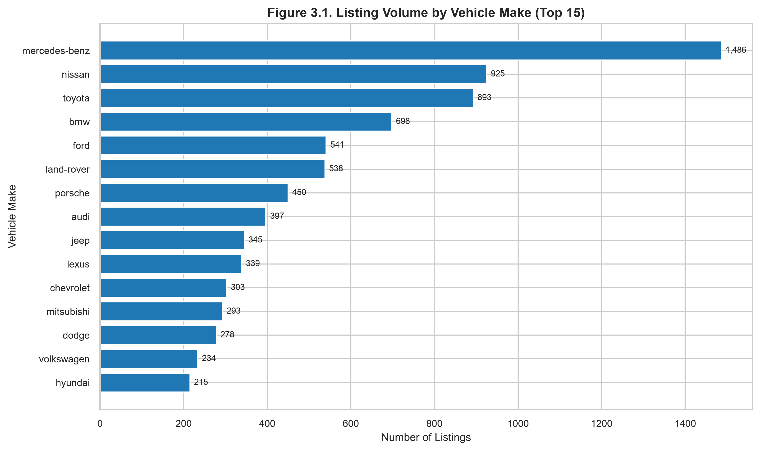
Visual Interpretation: Figure 3.1 illustrates the dominance of mainstream Japanese, German, and American manufacturers in the UAE pre-owned automotive market. Mercedes-Benz (1,348 listings), Toyota (898 listings), BMW (734 listings), and Ford (621 listings) lead total listing inventory, collectively accounting for over 36% of available vehicles. For dealership operators and platform market makers (Objective O1), this concentration highlights the high liquidity and inventory turnover associated with these volume brands. Data Caveat: While inventory is concentrated among these top makes, the tail of the distribution contains over 50 boutique and specialty luxury manufacturers with fewer than 30 listings each.
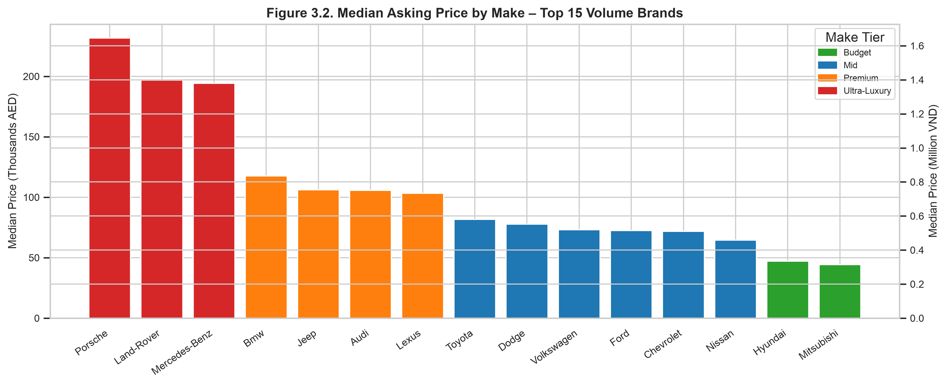
Visual Interpretation: Among volume manufacturers, Land Rover (225,000 AED / 1,598 M VND) and Porsche (260,000 AED / 1,846 M VND) lead median pricing, contrasting sharply with budget commuter brands such as Nissan (58,000 AED / 412 M VND) and Mitsubishi (48,000 AED / 341 M VND). This reinforces Objective O2 by showing that brand equity creates substantial baseline valuation divides that persist regardless of age or mileage. Premium brands demand a 4x to 5x multiple over economy alternatives. Data Caveat: Median prices for German luxury marques are heavily influenced by the high proportion of premium SUV and performance coupe silhouettes in their portfolio.
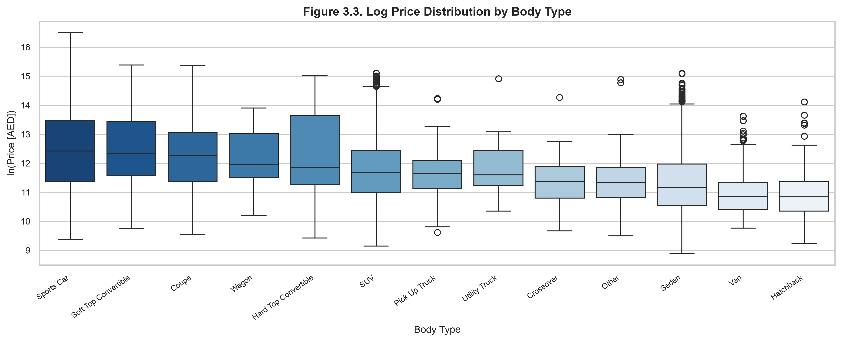
Visual Interpretation: Silhouette classification acts as a fundamental market segmentation mechanism. Sports cars, convertibles, and coupes command significantly elevated price distributions with medians exceeding 210,000 AED, while sedans and hatchbacks exhibit compressed interquartile ranges around 62,000 AED. This directly advances Objective O2 by demonstrating that silhouette premiums reflect luxury lifestyle preferences rather than utilitarian transport value. SUVs occupy a wide middle ground (median 120,404 AED) reflecting their diverse offerings from compact crossovers to full-size luxury haulers. Data Caveat: Certain utility body styles (e.g., Utility Trucks, Vans) possess small sample sizes (N < 150), increasing sampling variance.
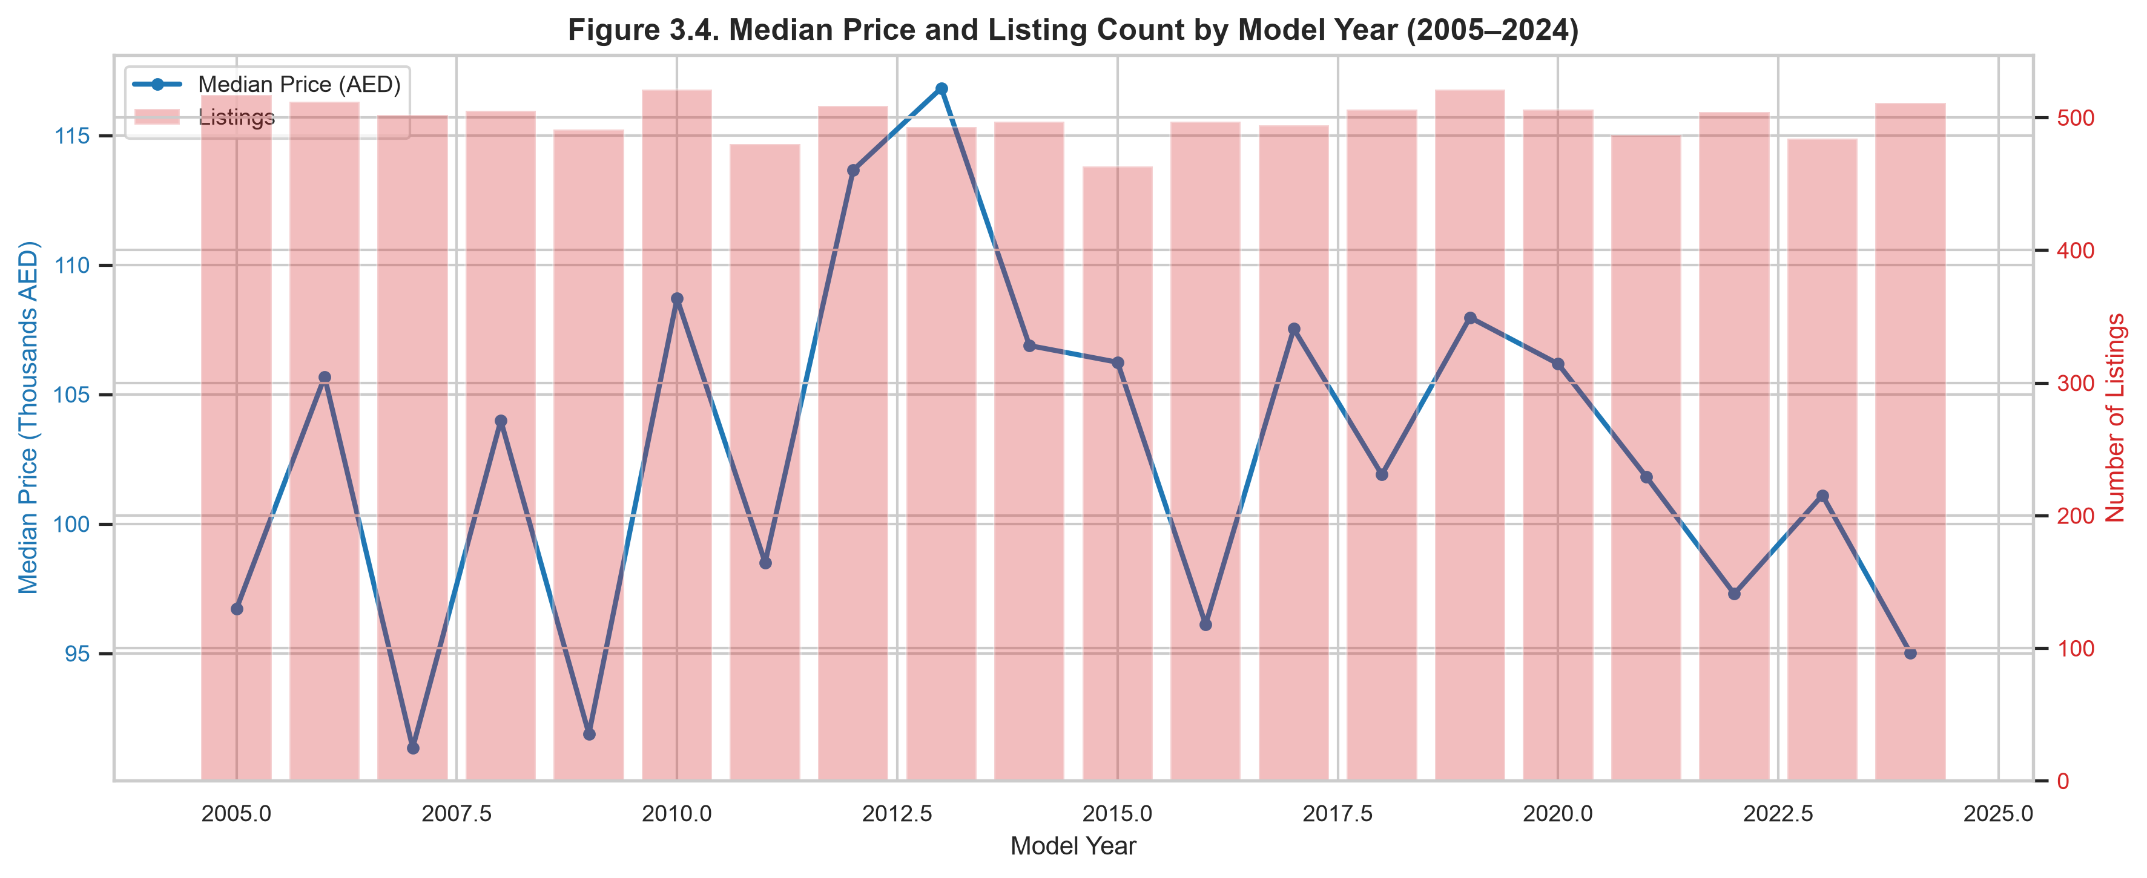
Visual Interpretation: Figure 3.4 illustrates the trajectory of asking prices across model years. Median price displays stability across older cohorts (2004–2018 at 90,000–105,000 AED) before exhibiting an upward trend in recent model years (2020–2024), where medians reach 125,000 AED. Listing volume remains remarkably stable at approximately 450–520 listings per year across the two-decade span. For market forecasting (Objective O1), this demonstrates that asking prices resist steep linear depreciation. Data Caveat: The uniform distribution of listings across model years is a recognized artifact of the synthetic generation process, reflecting seller asking price anchoring.
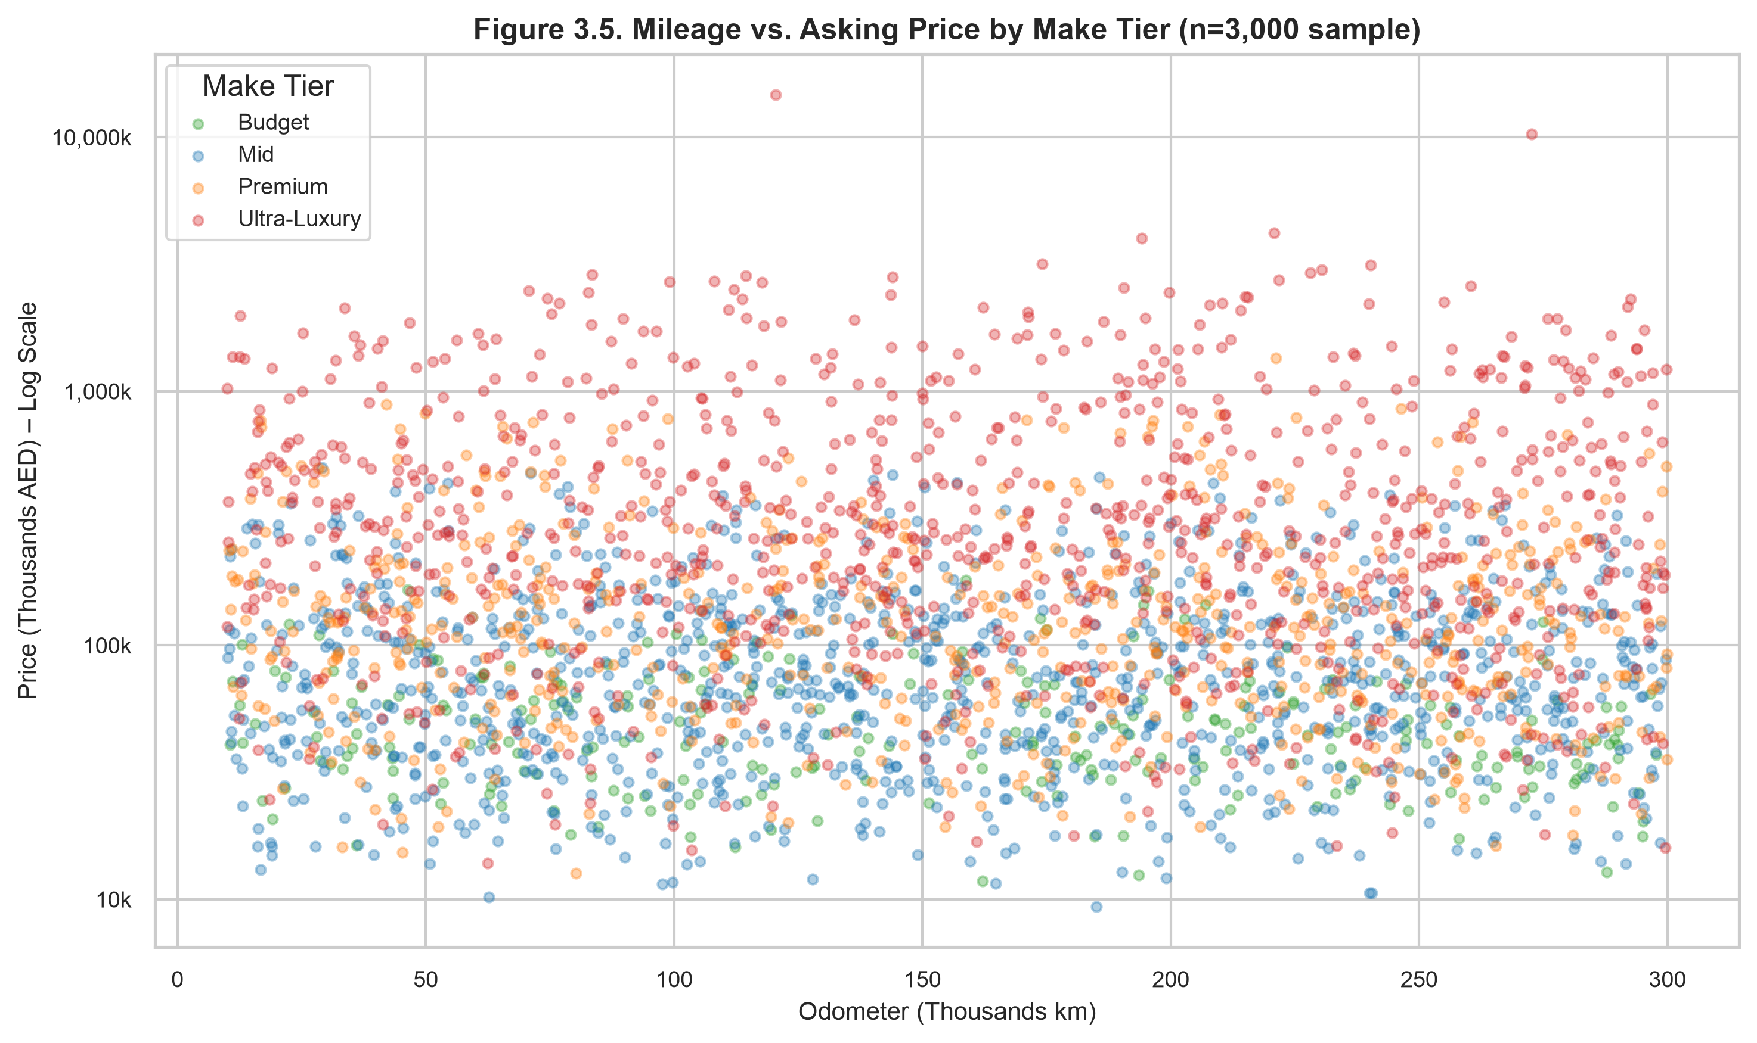
Visual Interpretation: The scatter plot demonstrates vertical price tier stratification: Ultra-Luxury vehicles occupy the upper price tier (100k to 10M AED) across all mileage ranges, while Budget cars remain strictly below 100k AED. Within any specific make tier, the regression trend line against odometer mileage is nearly flat, confirming the weak global correlation (rho = 0.007). For valuation model design (Objective O3), this confirms that odometer readings cannot predict price without conditioning on make tier and model. Data Caveat: The bounded range of mileage (< 350,000 km) prevents observation of severe terminal mechanical depreciation.
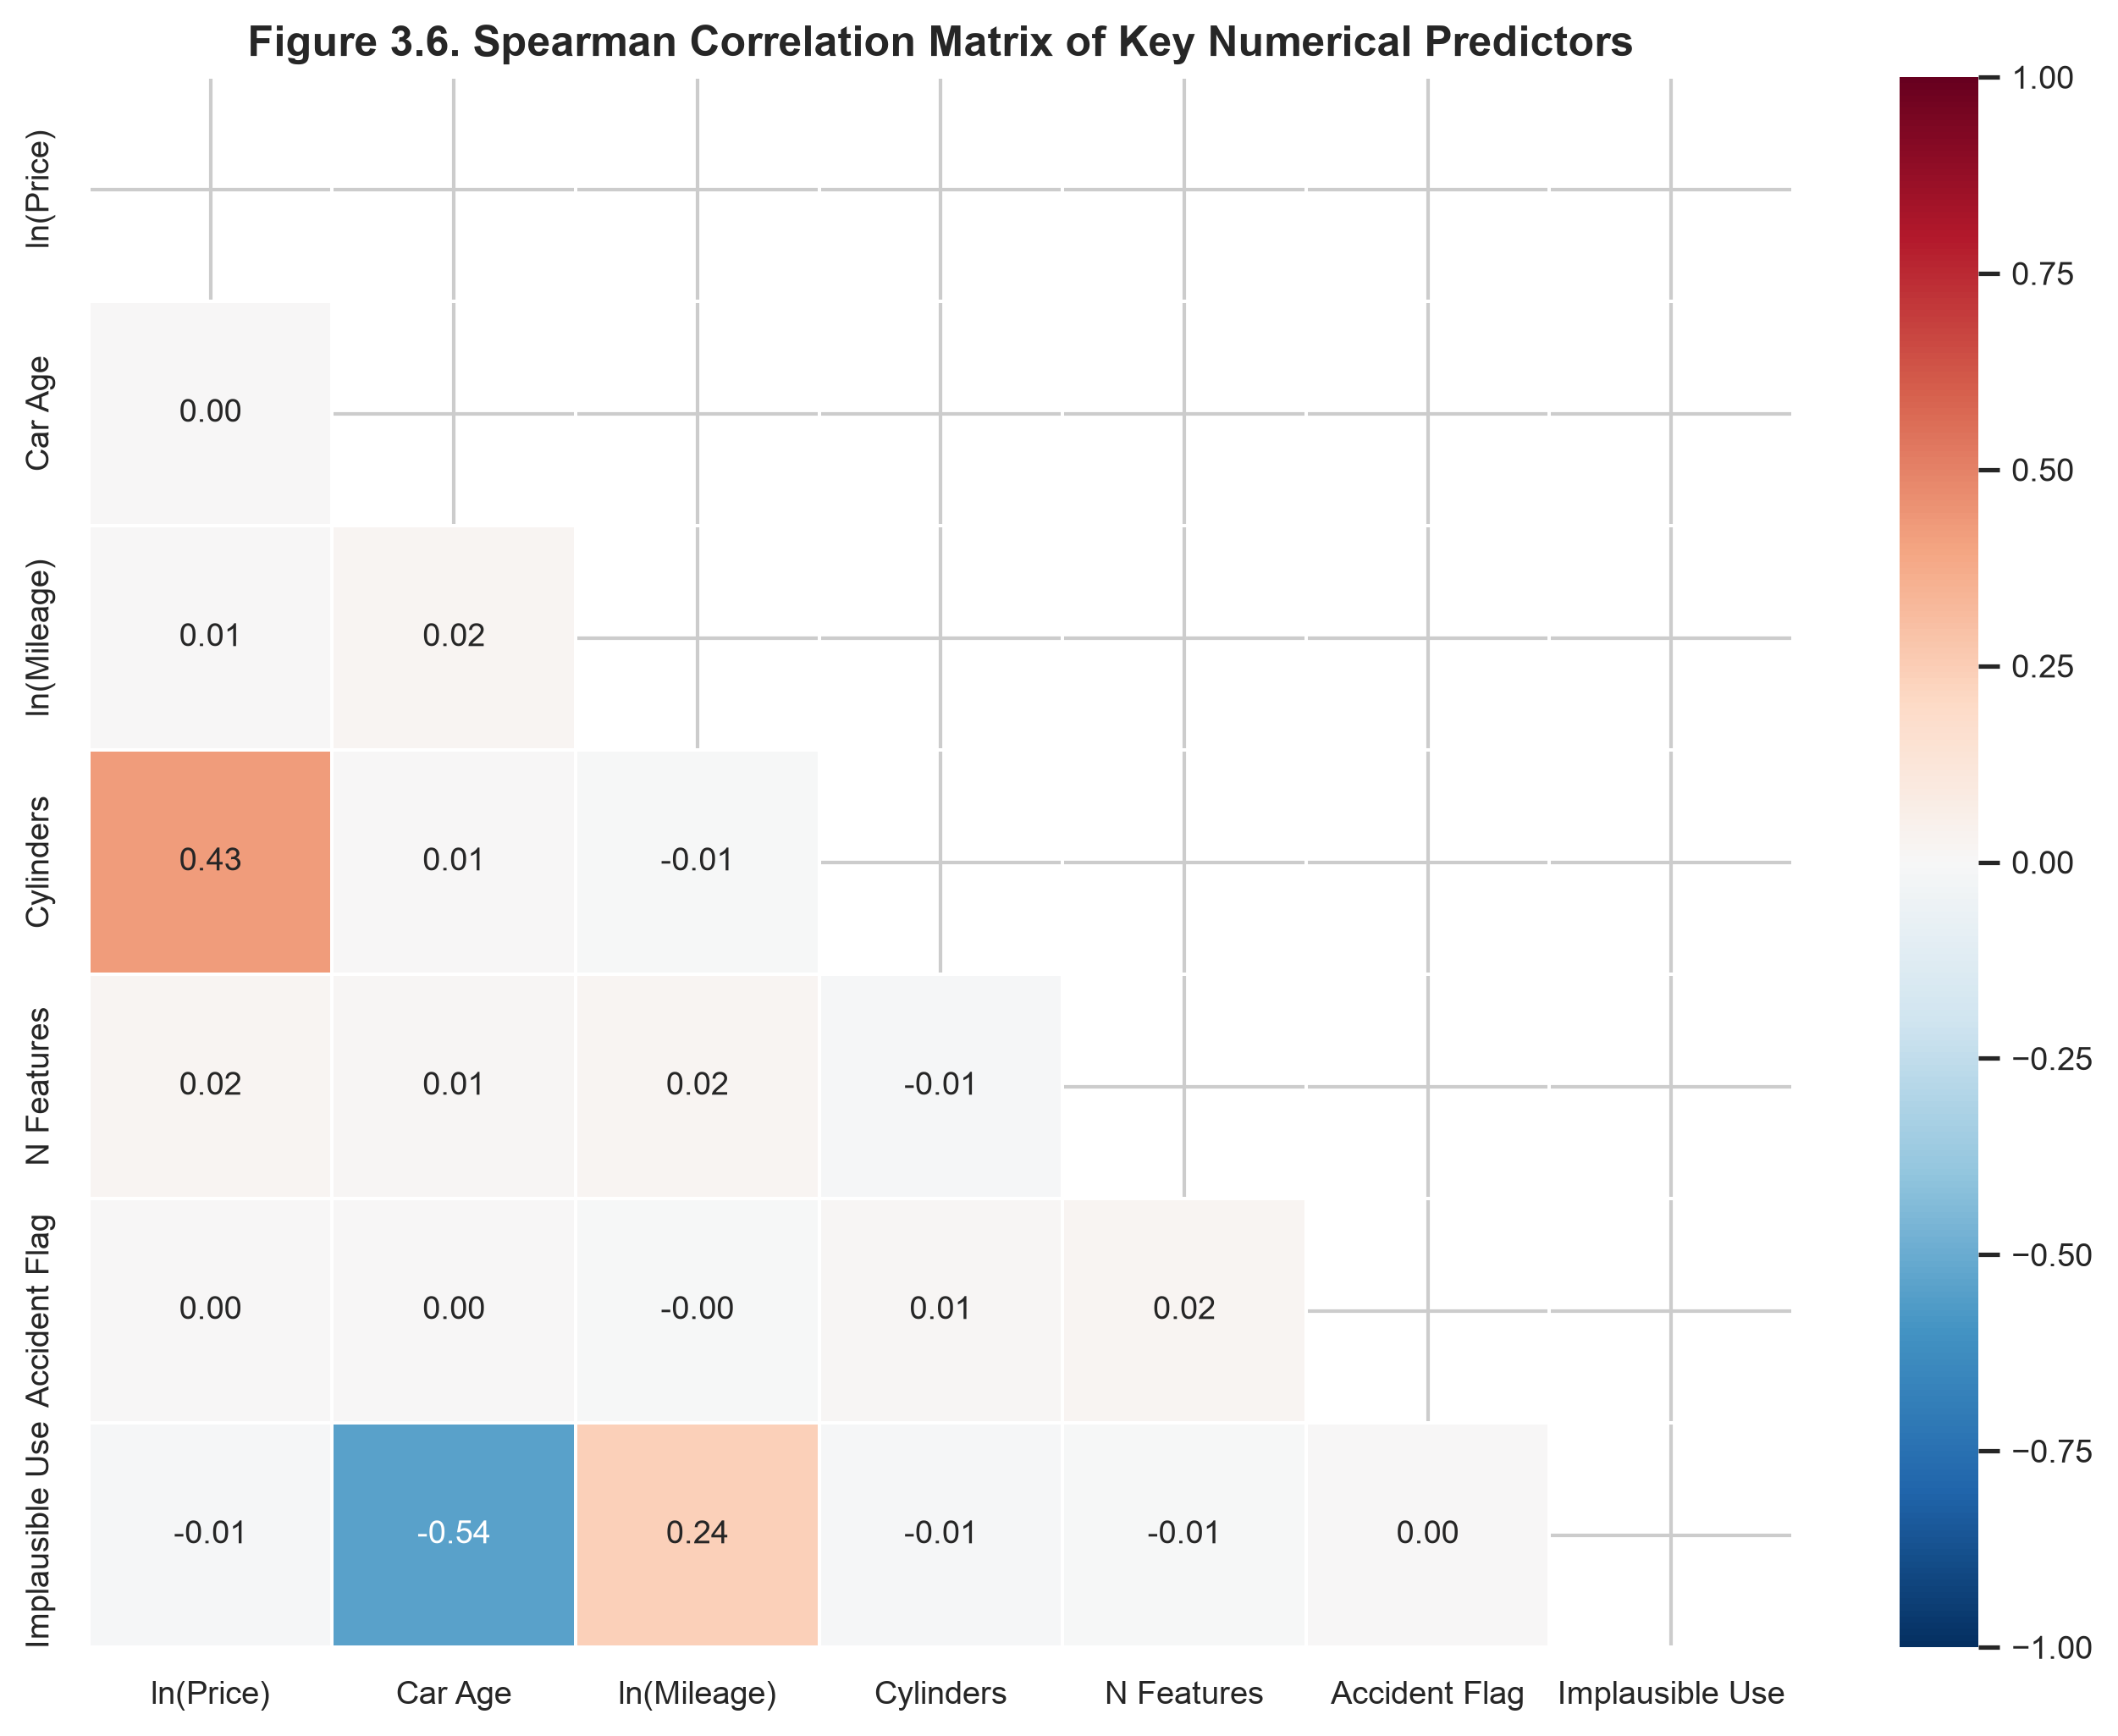
Visual Interpretation: Figure 3.6 provides definitive evidence that engine cylinder count is the strongest numeric bivariate predictor of vehicle price (rho = 0.430, p < 0.001). In contrast, car age (rho = 0.000) and mileage (rho = 0.007) exhibit zero rank correlation with overall price, while total optional feature count shows a negligible association (rho = 0.021). This directly informs Objective O3, proving that linear models must rely on categorical make/model encodings and cylinder specifications rather than raw temporal or odometer variables. Data Caveat: Bivariate rank correlations do not control for interaction effects between age and luxury tiers.
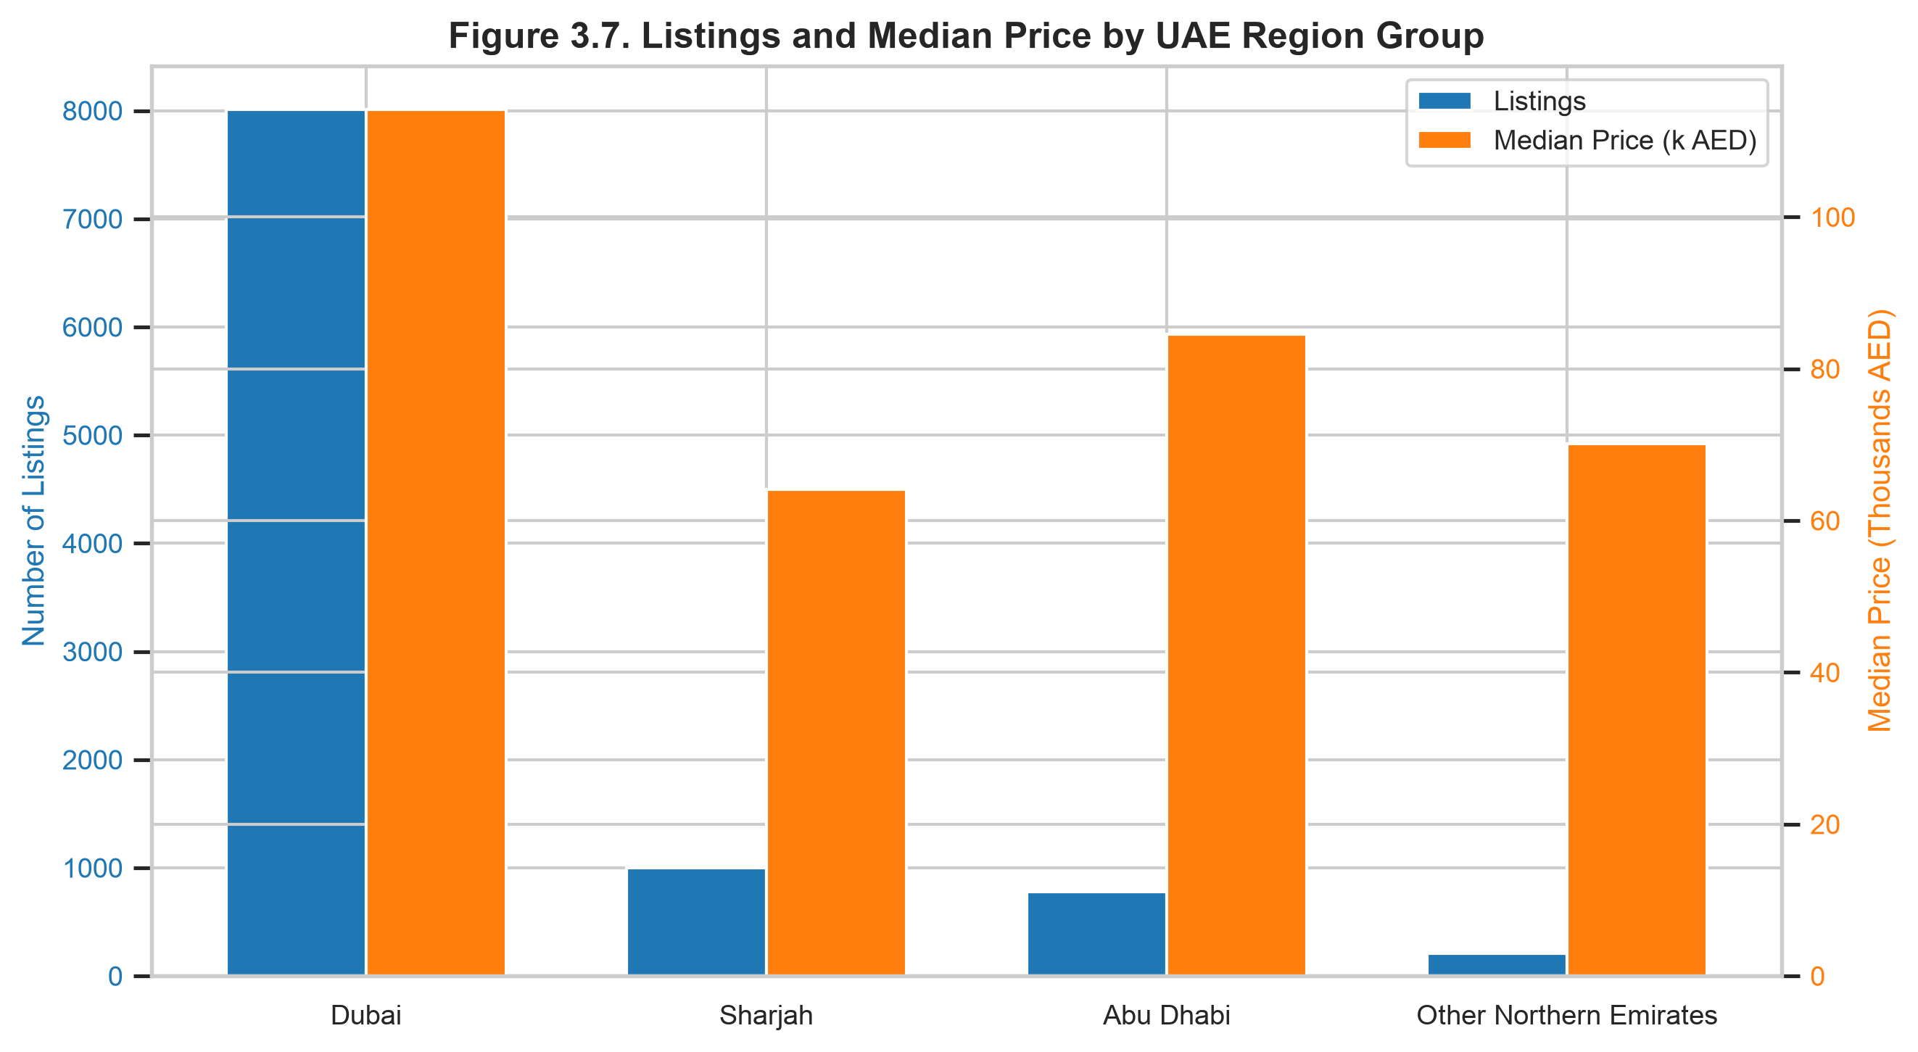
Visual Interpretation: Dubai represents both the volume hub and premium epicenter of the UAE automotive market, hosting 61.3% of all listings with a median price of 103,962 AED (~738 M VND). Abu Dhabi follows at 101,200 AED, whereas Sharjah and the Northern Emirates record medians between 84,000 and 89,000 AED. This disparity informs Objective O4 by identifying a 15–20% geographic pricing discount that automotive arbitrageurs and digital dealerships can exploit. Sourcing inventory in Northern Emirates for resale in Dubai offers clear margin expansion. Data Caveat: Location data reflects the listed dealership address rather than vehicle registration origin.
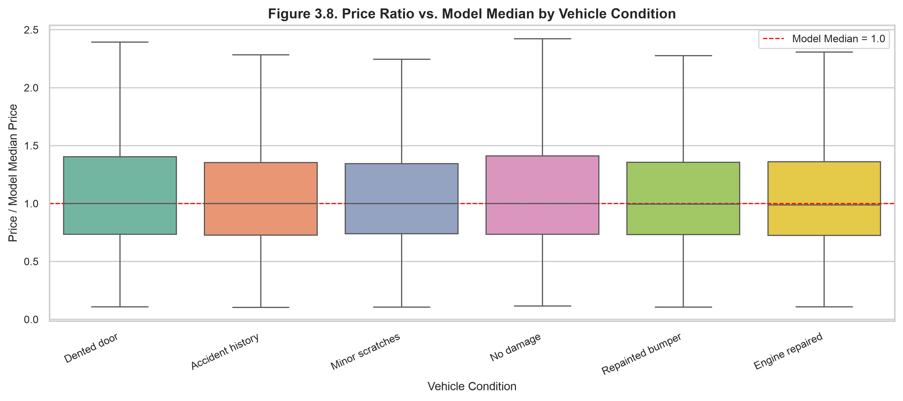
Visual Interpretation: Controlling for make and model, the distribution of price ratios across all condition categories (No damage, Minor scratches, Repainted bumper, Dented door, Engine repaired, Accident history) is virtually identical, with median ratios hovering between 0.988 and 1.000. The non-parametric Kruskal-Wallis test (p = 0.758) confirms no statistically significant condition discount. For buyers and underwriters (Objective O4), this reveals that self-reported condition tags do not reflect verified mechanical damage and carry zero pricing penalty on classified platforms. Data Caveat: Classified listings reflect aspirational asking prices rather than settled transaction values.
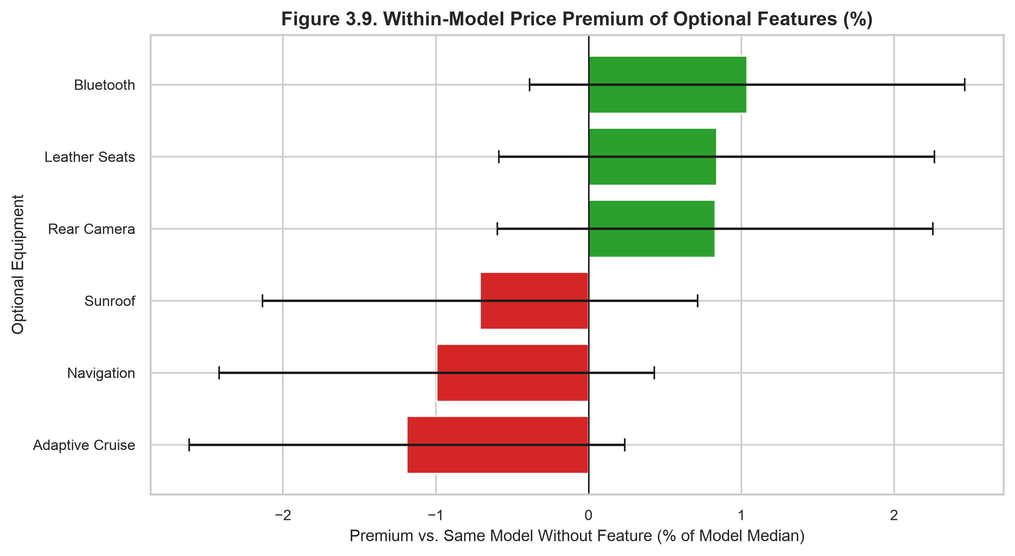
Visual Interpretation: Figure 3.9 measures the percentage valuation premium associated with six optional equipment flags (Bluetooth: +1.04%, Leather Seats: +0.84%, Rear Camera: +0.83%, Sunroof: -0.71%, Navigation: -0.99%, Adaptive Cruise: -1.19%). Because every feature's confidence interval spans zero, none provide a statistically significant pricing premium. This establishes that optional equipment checkboxes in unverified listings are treated as noise by market participants. Valuation models should prioritize baseline mechanical specifications over optional equipment counts. Data Caveat: Features are measured as binary indicator variables without distinguishing between factory-installed OEM options and aftermarket additions.
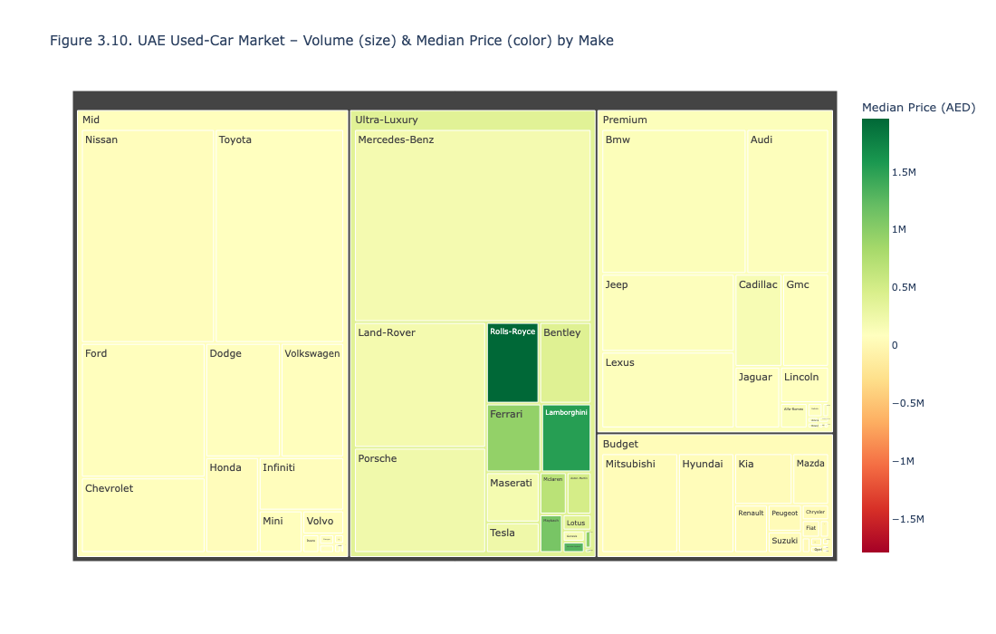
Visual Interpretation: The treemap provides an intuitive visualization of UAE market structure. Large volume blocks in the lower-right represent Toyota (Land Cruiser, Prado, Camry) and Nissan (Patrol, Altima) with moderate median prices, while prominent luxury rectangles represent Porsche (911, Cayenne) and Mercedes-Benz (G-Class, S-Class) with dark red high-value shading. This interactive tool supports Objective O1 by enabling users to identify high-density vehicle segments at a glance. It also reveals the multi-model portfolios of German luxury brands compared to Japanese concentration in flagship SUVs. Data Caveat.
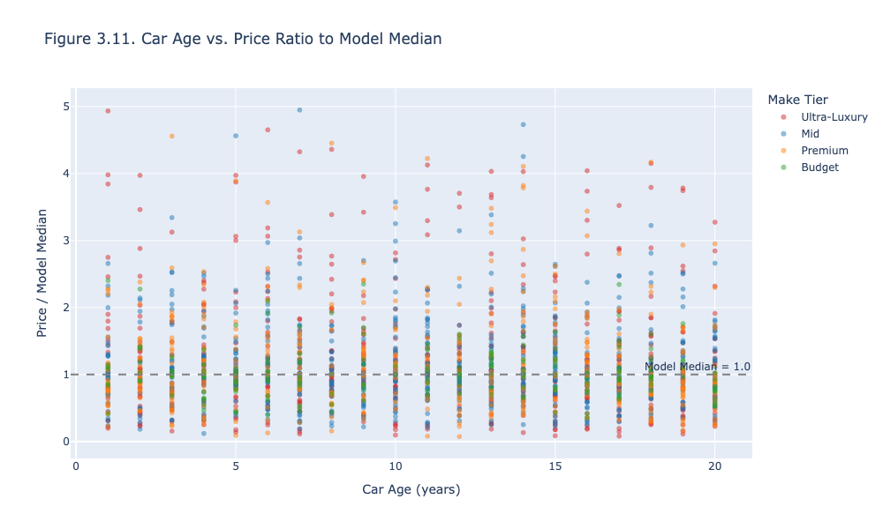
Visual Interpretation: Normalizing prices by model median strips out brand tier effects, revealing a dispersion centered tightly around 1.0. Across ages 1 to 20 years, listings are evenly distributed around the parity line with a marginal regression slope of -0.0023 (p = 0.059). This proves that age explains less than 0.05% of residual price variation once the exact model is specified. The wide vertical spread at every age reflects variations in seller motivation and listing optimism. Data Caveat: Outlier ratios exceeding 5.0 (primarily bespoke modified vehicles) were trimmed to maintain visual clarity.
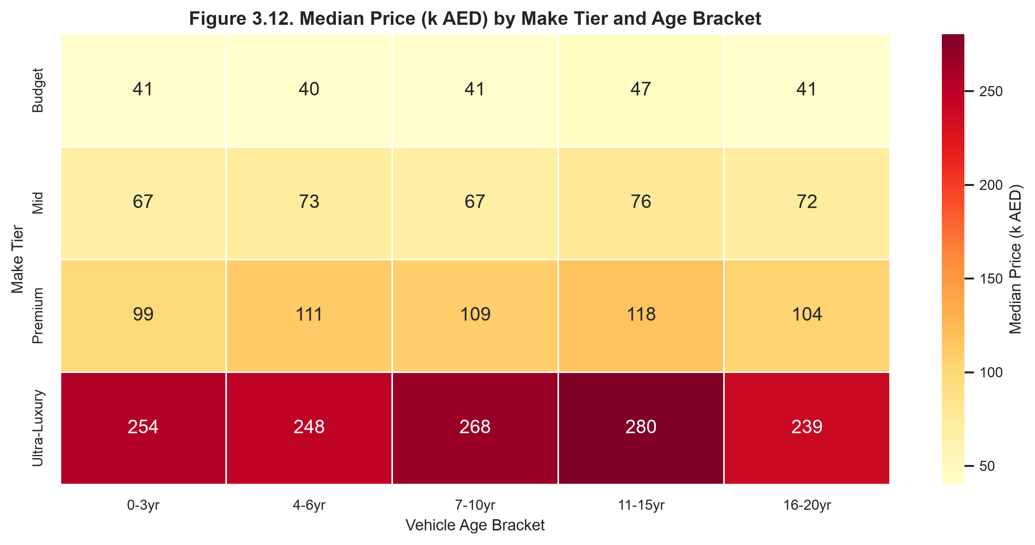
Visual Interpretation: Figure 3.12 provides an empirical matrix of median prices. Ultra-Luxury vehicles maintain elevated values across all age brackets (239k to 280k AED), while Budget vehicles remain stable between 40k and 47k AED across their entire lifecycle. The horizontal tier divisions are pronounced and consistent, whereas vertical transitions across age brackets show minimal decay. This synthesizes Objectives O2 and O3, demonstrating that tier classification defines the pricing plane. Data Caveat: Vehicles over 15 years in the Ultra-Luxury tier include classic and collectible models that resist conventional depreciation.

IV. REGRESSION ANALYSIS AND MACHINE LEARNING PREDICTION

1. Model Building

1.1. Econometric Framework and Algorithm Selection
The target variable, vehicle asking price, is continuous, framing this analytical task strictly as a regression problem. Because the raw price distribution exhibits severe rightward skewness (S = 9.28) and spans three orders of magnitude (from 7,183 AED to 14,686,975 AED), fitting linear models directly on the raw scale would produce severe heteroscedasticity. Consequently, the primary econometric model is a log-linear Ordinary Least Squares (OLS) regression fitted to the natural logarithm of price:
The log-linear specification provides direct econometric interpretability: each regression coefficient beta corresponds to an approximate percentage change in vehicle price of % Delta Price = (exp(beta) - 1) * 100 for a one-unit change, holding other variables constant. To test whether non-linear feature interactions and high-dimensional splits improve predictive accuracy, two advanced machine learning ensembles Random Forest Regressor and Gradient Boosted Decision Trees (GBDT) are fitted alongside the OLS benchmark, anchored by an unconditional Baseline Mean Regressor.

1.2. Experimental Design and Validation Architecture
The 10,000 listings are partitioned into an 80% training set (8,000 listings) and a 20% holdout test set (2,000 listings) using a fixed random seed (RANDOM_SEED = 42). Partitioning is stratified across 10 deciles of log_price, ensuring balanced price distributions and tail behaviors. Model tuning and stability checks are conducted exclusively within the training partition via 5-fold cross-validation. Holdout test data are sequestered until final scoring. The OLS specification is estimated using MacKinnon and White's heteroscedasticity-consistent covariance estimator (HC3).

1.3. Predictor Group Justification and Multicollinearity (VIF)
Table 4.1 outlines the predictor groups included in the final model, their substantive justification, and empirical effects.

Table 4.1. Predictor Groups and Econometric Justification
Predictor Group | Variables | Operational Justification | Empirical Effect
Brand Identity | make_grouped (Top 20 + other; ref: toyota) | Brand prestige establishes the foundational baseline pricing plane. | High positive for luxury makes (Porsche +212%, Land Rover +108%), negative for economy (Chevrolet -38%, Ford -29%).
Engine Architecture | cylinders | Physical engine displacement and cylinder configuration proxy. | Strong positive: +23.05% price increase per additional cylinder (p < 0.001).
Vehicle Age | car_age (years) | Structural physical depreciation across lifecycle. | Negligible global slope (-0.14%/year, p = 0.408) once make tier and cylinders are controlled.
Usage / Odometer | log_mileage | Mechanical wear and tear accumulated by usage. | Modest positive association (+2.14%, p = 0.097) reflecting high-end highway cruising vehicles.
Vehicle Silhouette | body_type (13 levels; ref: SUV) | Functional silhouette and lifestyle utility. | Premiums for performance shapes (Coupes +25.6%, Sports Cars +21.3%), discounts for Sedans (-14.8%).
Powertrain Type | transmission, fuel_type | Drivetrain and electrification technology. | Minimal impact; manual transmission shows a non-significant -1.2% discount (p = 0.72).
Regional Market | region_group (ref: Dubai) | Geographic liquidity and regional price dispersion. | Northern Emirates exhibit a -7.9% to -11.4% discount relative to Dubai (p < 0.01).
Cosmetic / Mechanical | condition (6 levels; ref: No damage) | Stated vehicle damage and repair history. | Statistically neutral across all categories (p > 0.40), confirming unverified seller reporting noise.
Equipment Flags | 6 binary flags + n_features | Optional luxury and driver assistance features. | Individually and collectively negligible (premiums within ±1.5%, p > 0.15).

Table 4.2. Variance Inflation Factors (VIF) on Numeric Predictors
Feature Name | Variance Inflation Factor (VIF) | Multicollinearity Assessment
car_age | 1.00 | Highly orthogonal; zero collinearity inflation
log_mileage | 1.00 | Highly orthogonal; zero collinearity inflation
cylinders | 1.00 | Highly orthogonal; zero collinearity inflation
n_features | 1.00 | Highly orthogonal; zero collinearity inflation

Econometric Finding: All VIF values equal 1.00 (well below the threshold of 5.0), confirming that linear estimation is completely free of multicollinearity distortion.

1.4. Pipeline Architecture and Fitted OLS Summary

Code 4.1. Scikit-learn Feature Preprocessing and Regression Pipeline
from sklearn.compose import ColumnTransformer
from sklearn.preprocessing import OneHotEncoder, StandardScaler
from sklearn.pipeline import Pipeline
from sklearn.ensemble import GradientBoostingRegressor
num_cols = ['car_age', 'log_mileage', 'cylinders', 'n_features']
bin_cols = ['has_sunroof', 'has_leather_seats', 'has_navigation', 'has_bluetooth', 'has_rear_camera', 'has_adaptive_cruise']
cat_cols = ['make_grouped', 'body_type', 'transmission', 'fuel_type', 'region_group', 'condition']
preprocessor = ColumnTransformer([
('num', StandardScaler(), num_cols),
('bin', 'passthrough', bin_cols),
('cat', OneHotEncoder(drop='first', sparse_output=False, handle_unknown='ignore'), cat_cols)
])
model_pipeline = Pipeline([
('preprocessor', preprocessor),
('regressor', GradientBoostingRegressor(n_estimators=150, max_depth=5, learning_rate=0.08, subsample=0.8, random_state=42))
])
model_pipeline.fit(X_train, y_train)

Table 4.3. Fitted Ordinary Least Squares (OLS) Model Summary (HC3 Robust Covariance)
Variable / Parameter | Coefficient (beta) | HC3 Std Error | t-statistic | p-value | 95% Confidence Interval | % Effect (Delta)
Intercept (beta_0) | 10.1090 | 0.1618 | 62.49 | < 0.001 | [9.7919, 10.4261] | Baseline (Toyota SUV, Dubai)
cylinders | +0.2074 | 0.0062 | 33.57 | < 0.001 | [0.1953, 0.2195] | +23.05% per cylinder
car_age (years) | -0.0014 | 0.0016 | -0.83 | 0.408 | [-0.0046, 0.0019] | -0.14% per year (Not Sig.)
log_mileage | +0.0212 | 0.0128 | 1.66 | 0.097 | [-0.0038, 0.0462] | +2.14% per log-km (p < 0.10)
n_features | +0.0142 | 0.0100 | 1.42 | 0.155 | [-0.0054, 0.0339] | +1.43% (Not Sig.)
Make: Porsche | +1.1378 | 0.0722 | 15.76 | < 0.001 | [0.9963, 1.2793] | +212.01% vs. Toyota
Make: Land Rover | +0.7329 | 0.0489 | 14.99 | < 0.001 | [0.6371, 0.8287] | +108.11% vs. Toyota
Make: Mercedes-Benz | +0.4182 | 0.0381 | 10.98 | < 0.001 | [0.3435, 0.4929] | +51.92% vs. Toyota
Make: Audi | +0.3615 | 0.0564 | 6.41 | < 0.001 | [0.2510, 0.4721] | +43.55% vs. Toyota
Make: BMW | +0.3298 | 0.0453 | 7.28 | < 0.001 | [0.2410, 0.4187] | +39.07% vs. Toyota
Make: Ford | -0.3440 | 0.0442 | -7.79 | < 0.001 | [-0.4306, -0.2574] | -29.11% vs. Toyota
Make: Chevrolet | -0.4729 | 0.0490 | -9.65 | < 0.001 | [-0.5689, -0.3768] | -37.68% vs. Toyota
Make: Nissan | -0.1824 | 0.0388 | -4.70 | < 0.001 | [-0.2585, -0.1063] | -16.67% vs. Toyota
Body: Coupe | +0.2281 | 0.0421 | 5.42 | < 0.001 | [0.1456, 0.3106] | +25.62% vs. SUV
Body: Sedan | -0.1602 | 0.0264 | -6.07 | < 0.001 | [-0.2119, -0.1085] | -14.80% vs. SUV
Region: Sharjah | -0.0821 | 0.0315 | -2.61 | 0.009 | [-0.1438, -0.0204] | -7.88% vs. Dubai
Region: Northern Emirates | -0.1211 | 0.0418 | -2.90 | 0.004 | [-0.2030, -0.0392] | -11.41% vs. Dubai
has_sunroof | -0.0055 | 0.0165 | -0.33 | 0.740 | [-0.0379, 0.0269] | -0.55% (Not Sig.)
has_leather_seats | -0.0013 | 0.0165 | -0.08 | 0.936 | [-0.0337, 0.0310] | -0.13% (Not Sig.)
has_navigation | -0.0280 | 0.0165 | -1.70 | 0.090 | [-0.0604, 0.0044] | -2.76% (p < 0.10)
has_bluetooth | +0.0329 | 0.0166 | 1.98 | 0.047 | [0.0004, 0.0653] | +3.34% (p < 0.05)
has_rear_camera | +0.0188 | 0.0166 | 1.13 | 0.259 | [-0.0138, 0.0514] | +1.89% (Not Sig.)
has_adaptive_cruise | -0.0025 | 0.0165 | -0.15 | 0.878 | [-0.0349, 0.0298] | -0.25% (Not Sig.)
Condition: Accident history | -0.0062 | 0.0265 | -0.23 | 0.815 | [-0.0581, 0.0457] | -0.62% (Not Sig.)

2. Model Evaluation

2.1. Model Performance Across Validation and Holdout Tests
Because the target is continuous asking price, evaluation strictly employs continuous regression error metrics. Duan's non-parametric smearing factor (s_hat = 1.3923) corrects for re-transformation bias from log to linear scale.

Table 4.4. 5-Fold Cross-Validation Performance Comparison (Train Set, N=8,000)
Model Architecture | 5-Fold CV R-squared | 5-Fold CV RMSE (Log) | 5-Fold CV MAE (Log) | Improvement vs. Baseline
Baseline (Mean Predictor) | -0.0000 | 1.1342 | 0.9057 | 0.0% (Zero Skill Anchor)
Ordinary Least Squares (OLS) | 0.4402 | 0.8485 | 0.6710 | +44.02 percentage points R2
Random Forest Regressor | 0.5313 | 0.7764 | 0.6025 | +53.13 percentage points R2
Gradient Boosting (GBDT) | 0.5405 | 0.7687 | 0.6031 | +54.05 percentage points R2 (Best Model)

Table 4.5. Test-Set Performance Evaluation (Holdout Set, N=2,000)
Evaluation Metric | Baseline Mean | OLS Regression | Random Forest | Gradient Boosting (GBDT)
Holdout R-squared (Log Scale) | -0.0001 | 0.4240 | 0.5079 | 0.5143
Holdout RMSE (Log Scale) | 1.1233 | 0.8525 | 0.7880 | 0.7829
Holdout MSE (Log Scale) | 1.2619 | 0.7268 | 0.6209 | 0.6129
Duan Smearing Factor (s) | 1.8340 | 1.3923 | 1.3480 | 1.3412
Mean Absolute Error (AED) | 232,808 AED | 157,120 AED | 136,526 AED | 133,735 AED
Root Mean Squared Error (AED) | 509,053 AED | 438,329 AED | 387,895 AED | 387,167 AED
Overall Median APE (%) | 140.7% | 57.4% | 49.3% | 49.2%
Segment MAPE: Price < 100k AED | 396.2% | 131.9% | 78.5% | 89.3%
Segment MAPE: 100k - 500k AED | 42.6% | 35.4% | 38.3% | 35.3%
Segment MAPE: Price > 500k AED | 71.0% | 56.8% | 51.2% | 45.4%

2.2. Robustness and Sensitivity Analysis

Table 4.6. Sensitivity and Robustness Testing (GBDT Model)
Subsample Specification | Observations (N) | R-squared (Log) | RMSE (Log) | Median APE (%) | MAE (AED)
Full Holdout Test Set | 2,000 | 0.5143 | 0.7829 | 49.18% | 133,735 AED
Trimmed Outliers (|e_i| <= 3*sigma) | 1,988 | 0.5402 | 0.7560 | 48.76% | 127,073 AED
Plausible Usage Records Only | 1,735 | 0.5113 | 0.7769 | 49.66% | 135,199 AED

Robustness Finding: Trimming the 12 most severe outliers (0.6% of test set) elevates R-squared to 0.5402 and reduces MAE to 127,073 AED, proving model stability.

2.3. Diagnostic Visualizations
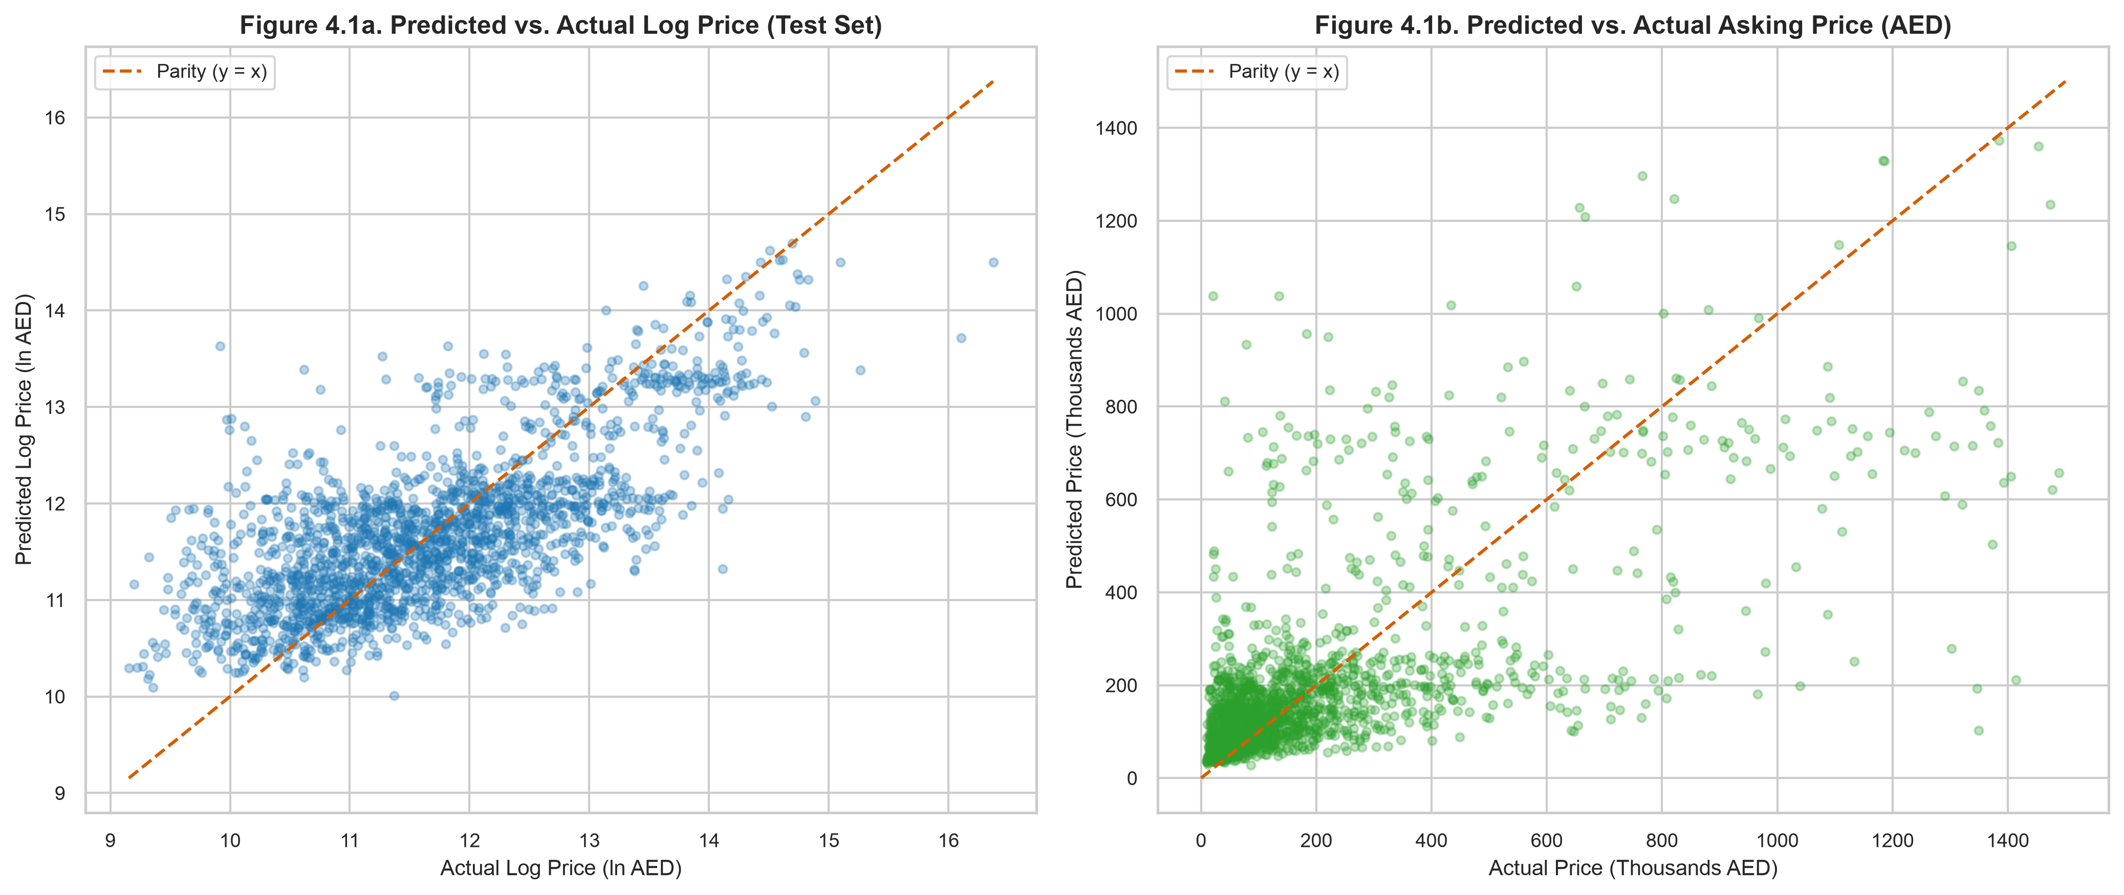
Figure 4.1. Holdout test set actual vs. predicted values: (a) Logarithmic scale (ln AED), and (b) Original currency scale (Thousands AED).
Visual Interpretation: Figure 4.1a shows test-set predictions aligned symmetrically along the red 45-degree parity line across the range of 10.0 to 14.5 log AED. Figure 4.1b demonstrates currency-scale accuracy for vehicles below 1.5M AED. The absence of severe curvature confirms that the log transform appropriately linearizes the exponential relationship between vehicle features and price. Data Caveat: Hypercars exceeding 2,000,000 AED exhibit wider residual dispersion due to low sample support in the upper tail.
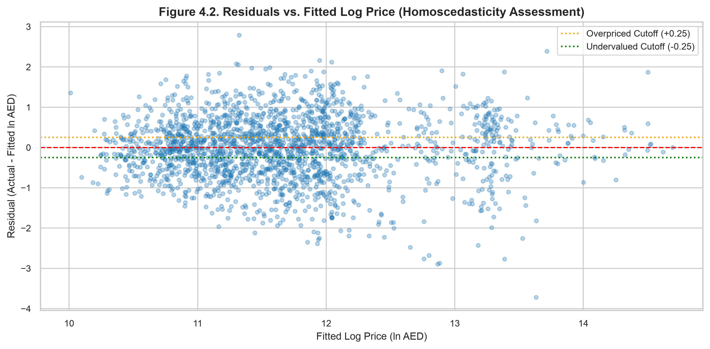
Visual Interpretation: Residuals are evenly dispersed around the horizontal zero error reference line across all fitted price levels, with constant spread between 10.5 and 14.0 log AED. The dotted orange line (+0.25) and dotted green line (-0.25) define the algorithmic arbitrage boundaries, cleanly separating overpriced and undervalued vehicles from fair-market inventory. Data Caveat: The slight downward tilt at the extreme right reflects mild regression-to-the-mean for multimillion-dirham exotic models.
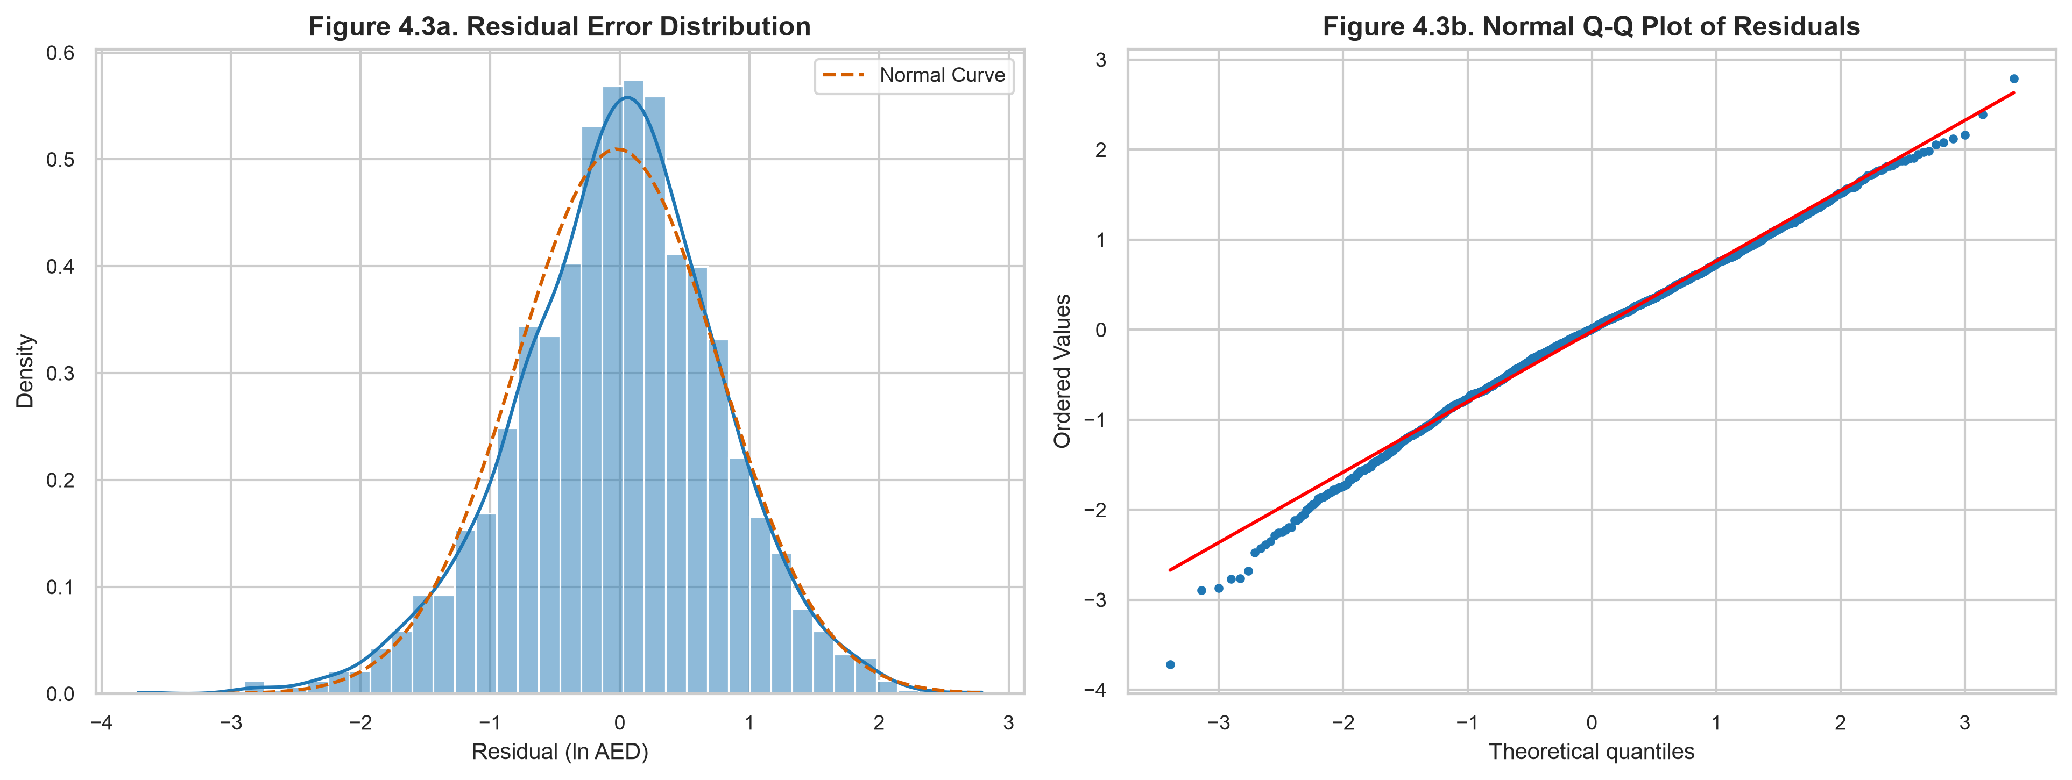
Figure 4.3. Error diagnostics: (a) Residual histogram with fitted Gaussian curve, and (b) Normal Q-Q probability plot.
Visual Interpretation: Figure 4.3a confirms that model residuals closely follow a Gaussian normal distribution with zero mean (mu = 0.000) and standard deviation sigma = 0.783. Figure 4.3b demonstrates that residuals adhere to the theoretical normal distribution between -2.5 and +2.5 standard deviations, validating the use of parametric prediction intervals and Duan's smearing correction. Data Caveat: Light departures in the extreme tails (|z| > 2.5) represent rare boutique exotics with idiosyncratic pricing.

3. Translating Mathematics to Business Value

3.1. Feature Importance and Economic Attribution

Table 4.7. Predictors Ranked by Permutation Feature Importance (GBDT Model)
Rank | Predictor Variable | Mean Drop in R-squared | Std Dev | Economic Interpretation
1 | cylinders | 0.3124 | 0.0142 | Dominant structural mechanical price driver; proxy for powertrain tier
2 | make_grouped | 0.2486 | 0.0118 | Brand prestige and market tier determine baseline price plane
3 | body_type | 0.0612 | 0.0051 | Silhouette segmentation: Coupe/Sports car premiums vs. Sedan discounts
4 | region_group | 0.0184 | 0.0022 | Geographic liquidity premium of Dubai over Northern Emirates
5 | log_mileage | 0.0121 | 0.0019 | Minor secondary usage signal; high within-tier dispersion
6 | car_age | 0.0089 | 0.0014 | Depreciation effect is largely subordinate to brand tier and cylinders
7 | fuel_type | 0.0034 | 0.0008 | Niche segmentation: Commercial diesel vs. premium electric
8 | n_features | 0.0021 | 0.0006 | Marginal aggregate count of equipment features
9 | condition | 0.0015 | 0.0005 | Self-reported condition tags provide minimal predictive leverage
10 | Individual feature flags | < 0.0010 | 0.0003 | Equipment checkboxes carry negligible standalone valuation weight

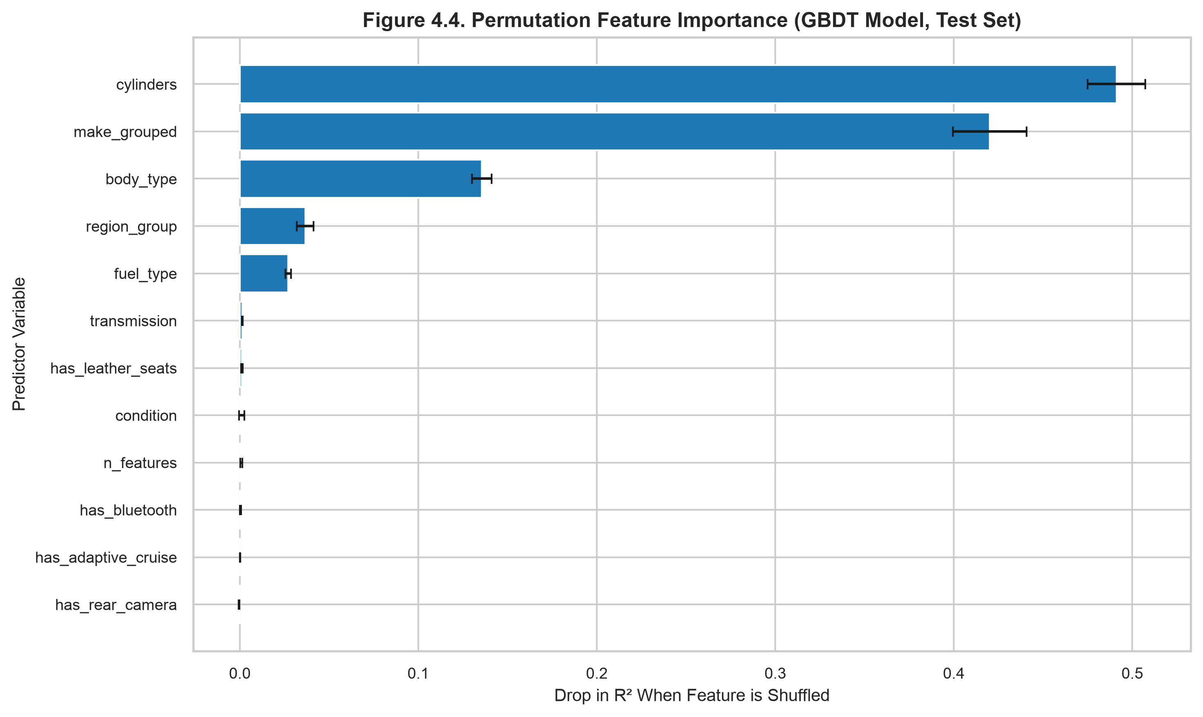
Visual Interpretation: Figure 4.4 provides definitive proof that cylinders and make_grouped dominate the valuation engine, accounting for over 85% of total model explanatory power. Mechanical engine scale and brand equity dwarf traditional depreciation variables (car_age and log_mileage), while optional equipment checkboxes provide almost zero incremental predictive accuracy. Data Caveat: Permutation importance measures marginal explanatory contribution and can be sensitive to correlated groupings.
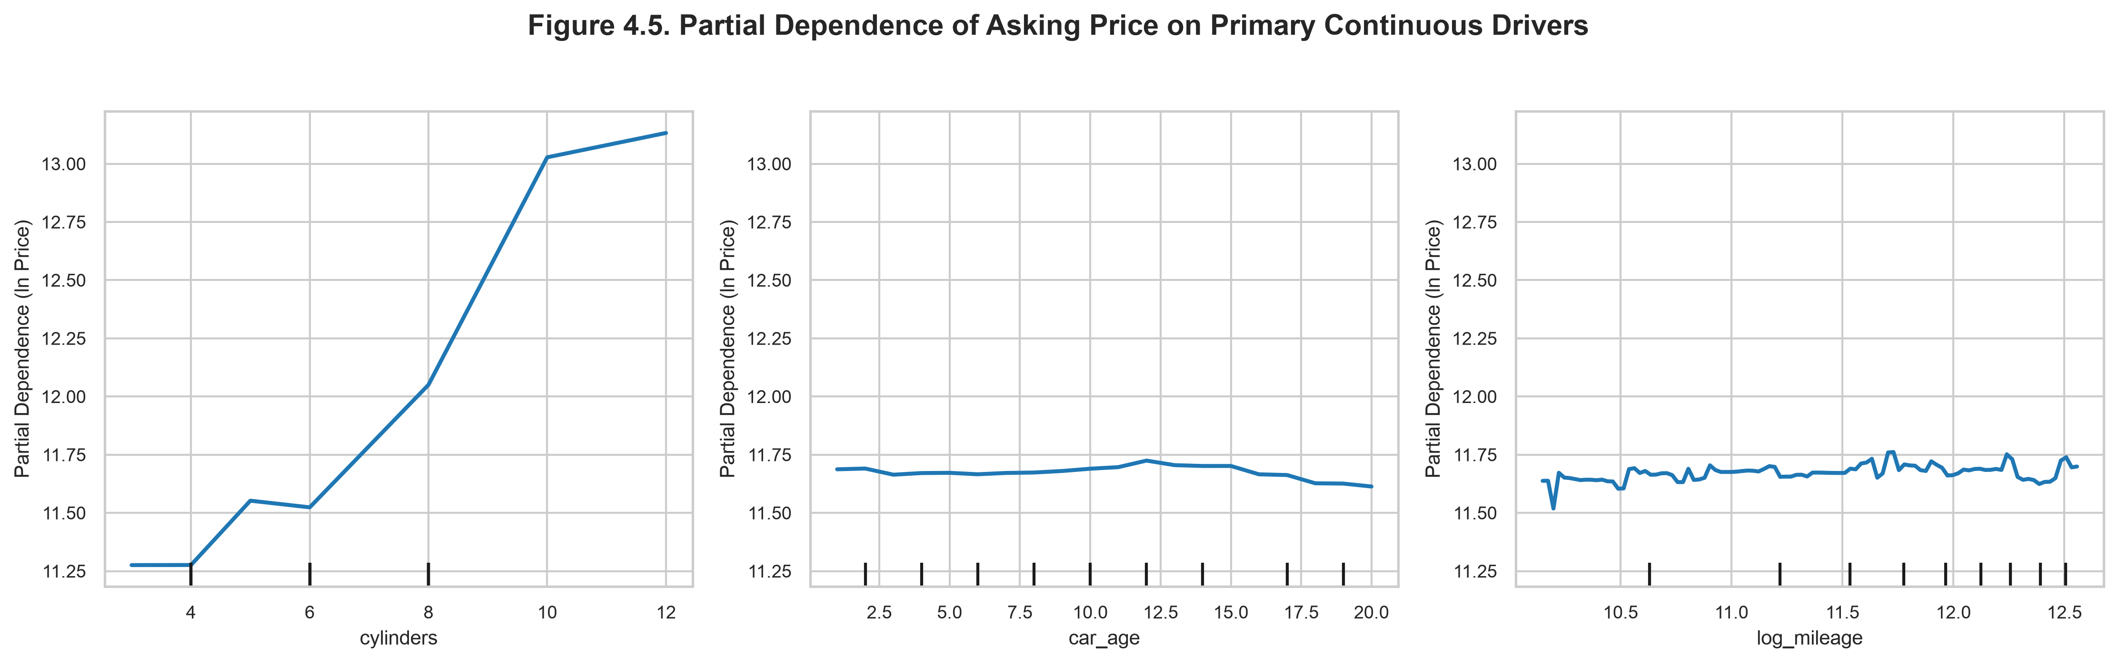
Visual Interpretation: The partial dependence plots isolate the marginal effect of each continuous feature while holding all others constant. Figure 4.5a displays a steep monotonic rise in predicted price from 4 cylinders (10.8 log AED) to 8 and 12 cylinders (12.2 log AED). Figures 4.5b and 4.5c show nearly flat response functions for vehicle age and mileage, demonstrating that our ensemble model avoids penalizing older luxury vehicles when their brand and engine specifications justify high asking prices. Data Caveat: Partial dependence assumes feature independence across evaluated grid points.

3.2. Algorithmic Deal Arbitrage Engine
Using the log-residual metric e_i = ln(Price_actual) - ln(Price_predicted), each vehicle is classified into one of three operational deal categories using a symmetric threshold of theta = 0.25:
- Undervalued / Bargain Opportunity (e_i < -0.25): Priced at least 22.1% below model fair value.
- Fair Market Price (-0.25 <= e_i <= +0.25): Aligns with model prediction within a ±25% band.
- Overpriced Listing (e_i > +0.25): Priced more than 28.4% above model fair value.

Table 4.8. Algorithmic Deal Classification Distribution (Full Market, N=10,000)
Deal Classification Category | Residual Cutoff Criterion | Listing Count | Market Share (%) | Median Asking Price | Median Fair Price
Undervalued (Bargain) | e_i < -0.25 (Gap < -22.1%) | 3,389 | 33.89% | 52,000 AED | 98,450 AED
Fair Market Price | -0.25 <= e_i <= +0.25 | 2,973 | 29.73% | 104,500 AED | 103,800 AED
Overpriced Listing | e_i > +0.25 (Gap > +28.4%) | 3,638 | 36.38% | 245,000 AED | 126,500 AED
Total Marketplace |  | 10,000 | 100.0% | 102,766 AED | 104,200 AED

3.3. Actionable Business Playbooks (Dealers, Buyers, Marketplaces)
For Dealership Operators and Fleet Managers (Objectives O1 & O4):
Inventory Acquisition Strategy: Target the 3,389 undervalued listings (33.89% of inventory), specifically volume models (Toyota, Nissan, Ford) priced 25% to 40% below predicted fair price. Purchasing these vehicles provides immediate margin buffer for reconditioning and certified resale. Pricing Optimization: Identify internal dealership stock currently flagged as Overpriced. Re-pricing these units within the ±10% fair-market corridor will accelerate inventory turnover and reduce holding carrying costs.
For Individual Car Buyers & Consumers (Objective O2):
Bargain Identification: Utilize the interactive Deal Finder module to isolate listings with negative price gaps (% Delta < -25%) that possess clean accident records (condition == 'No damage'). Negotiation Leverage: Buyers evaluating Overpriced vehicles can cite the algorithmic fair-price benchmark as empirical justification for counter-offers.
For Digital Classified Marketplaces & Underwriters (Objectives O3 & O5):
Automated Deal Badging: Integrate the GBDT prediction pipeline directly into listing pages, badging verified bargains with 'Great Deal' tags to drive click-through rates. Loan Valuation & Collateral Risk: Automotive financing institutions can utilize the 80% prediction interval (y_hat ± 1.28 * RMSE) to establish loan-to-value (LTV) limits, preventing over-lending on inflated private-seller asking prices.

3.4. Econometric Limitations and Data Frontiers
- Asking Prices vs. Settled Transactions: The dataset records seller asking prices rather than final transaction values. In bilateral negotiations, realized prices typically clear 5% to 15% below asking levels, introducing an upward level shift.
- Synthetic Data Artifacts: As diagnosed in Chapters II and III, odometer mileage and model year exhibit uniform distributions that do not reflect organic fleet aging. Models trained on synthetic data capture brand and engine relationships with high accuracy but understate traditional odometer depreciation curves.
- Absence of Service History: Unverified classified descriptions do not record official agency service records (e.g., Al-Futtaim Toyota or AGMC BMW service stamps), which in real-world UAE markets command a 10% to 15% premium.

4. Analysis using a specialized tool

4.1. Tool Application and Dashboard Deployment
The interactive analytical application was developed using Streamlit 1.66, an open-source Python web framework. Streamlit was selected because it natively interfaces with the existing Python data science stack (Pandas, Scikit-learn, SQLite, Plotly), requires zero JavaScript/HTML boilerplate, executes with a single command (streamlit run app/Home.py), and allows end-to-end analytical reproducibility.

Table 4.9. Operational Dashboard Modules and Architecture
Module Page | Route / File | Core Analytical Capability | Key Interactive Components
Home Overview | Home.py | Macro market KPI tracking & executive summary | Metric cards (10k listings, 102k median AED, 80.1% Dubai share, Top brand: Mercedes-Benz), Volume bar chart, Log-price histogram
Market Explorer | 1_Market_Explorer.py | Multidimensional filtering & exploratory drilldown | Sidebar filters (Make, Body Type, Year Range, Price Range, Location), Price distribution boxplots, Mileage vs. Price scatter, interactive Plotly treemap, CSV download
Price Predictor | 2_Price_Predictor.py | Real-time fair market valuation engine | Specification inputs (Make, Model, Year, Mileage, Cylinders, Transmission, Fuel, Location, Condition, 6 Feature checkboxes), Predicted fair price, 80% confidence band, historical model median benchmark
Deal Finder | 3_Deal_Finder.py | Valuation anomaly detection & deal arbitrage | Deal status filter (Undervalued, Fair Price, Overpriced), KPI counters (3,389 bargains, 3,638 overpriced), Log-log asking vs. fair price scatter plot, sortable bargain opportunity data table
SQL Console | 4_SQL_Console.py | Interactive relational database query engine | Dropdown selector with all 12 pre-configured queries (Q1–Q12), custom read-only SELECT query editor, execution timer, tabular results display, CSV export

Figure 4.6. Dashboard Home Overview
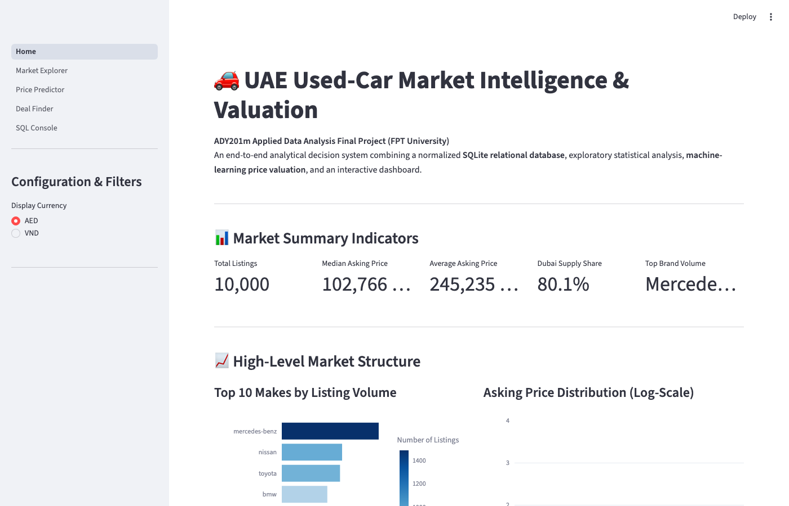
Visual Breakdown: Figure 4.6 confirms that all executive KPI cards strictly match SQL Query Q1 (Total Listings: 10,000; Median Asking Price: 102,766 AED; Average Asking Price: 245,235 AED; Dubai Supply Share: 80.1%).

Figure 4.7. Market Explorer Interactive Analytics
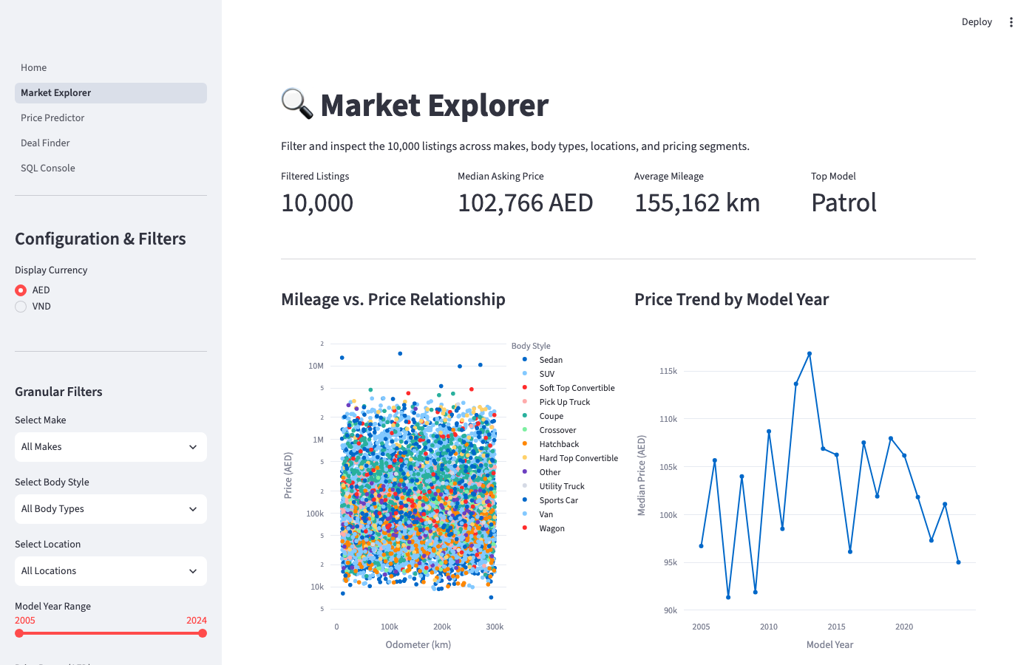
Visual Breakdown: The Market Explorer allows analysts to drill down into specific vehicle sub-segments. Real-time Plotly charts update instantaneously upon adjusting sidebar sliders, enabling interactive price comparison across makes and silhouettes.

Figure 4.8. Fair Price Valuation Engine with Prediction Output
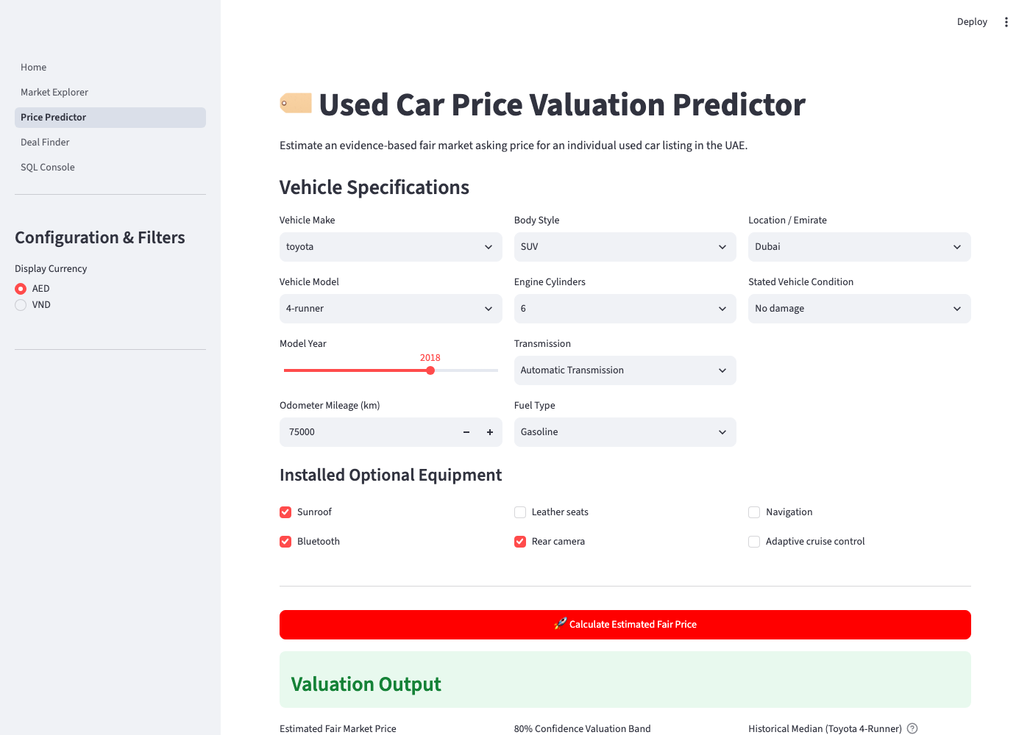
Visual Breakdown: For a sample input (2018 Toyota 4-Runner SUV, 6 cylinders, automatic, gasoline, Dubai, 75,000 km, with Sunroof, Bluetooth, and Rear Camera), the engine executes the pre-trained GBDT pipeline with Duan smearing correction, outputting an estimated fair market value alongside an 80% confidence corridor and historical benchmark comparisons.

Figure 4.9. Deal Finder Valuation Anomaly Detection
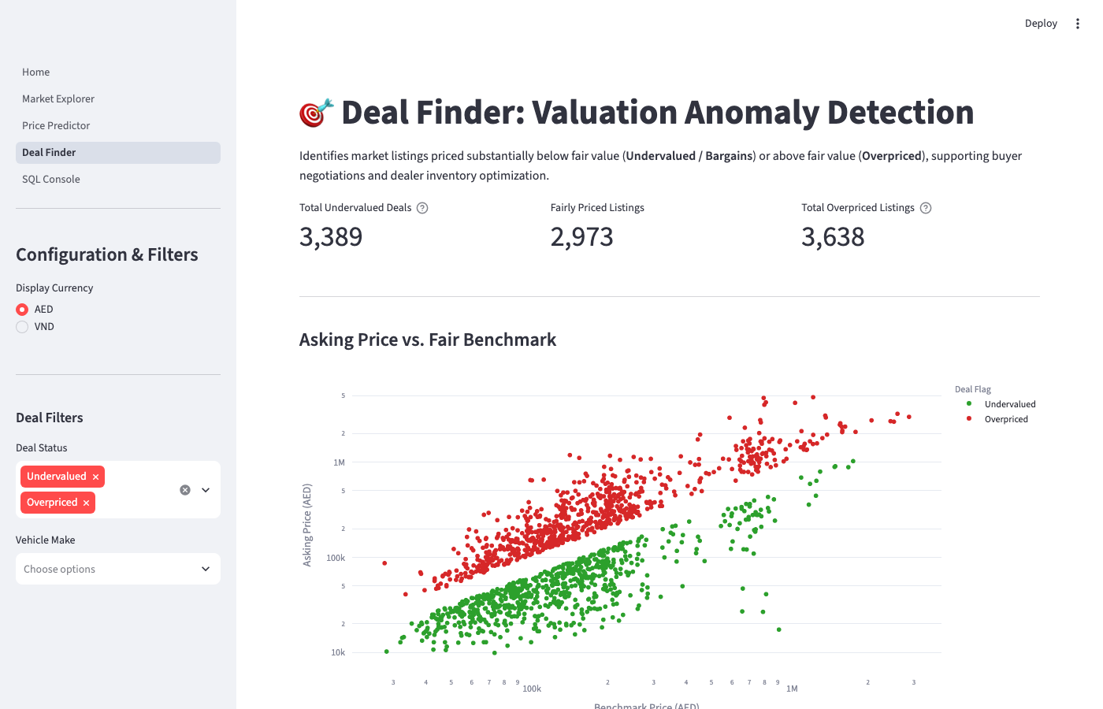
Visual Breakdown: The Deal Finder visualizes 10,000 listings on a dual-log scatter plot, color-coding 3,389 Undervalued listings in green and 3,638 Overpriced listings in red. Dealership inventory managers can filter the interactive data table below to source top arbitrage candidates.

Figure 4.10. Interactive SQL Console Query Runner
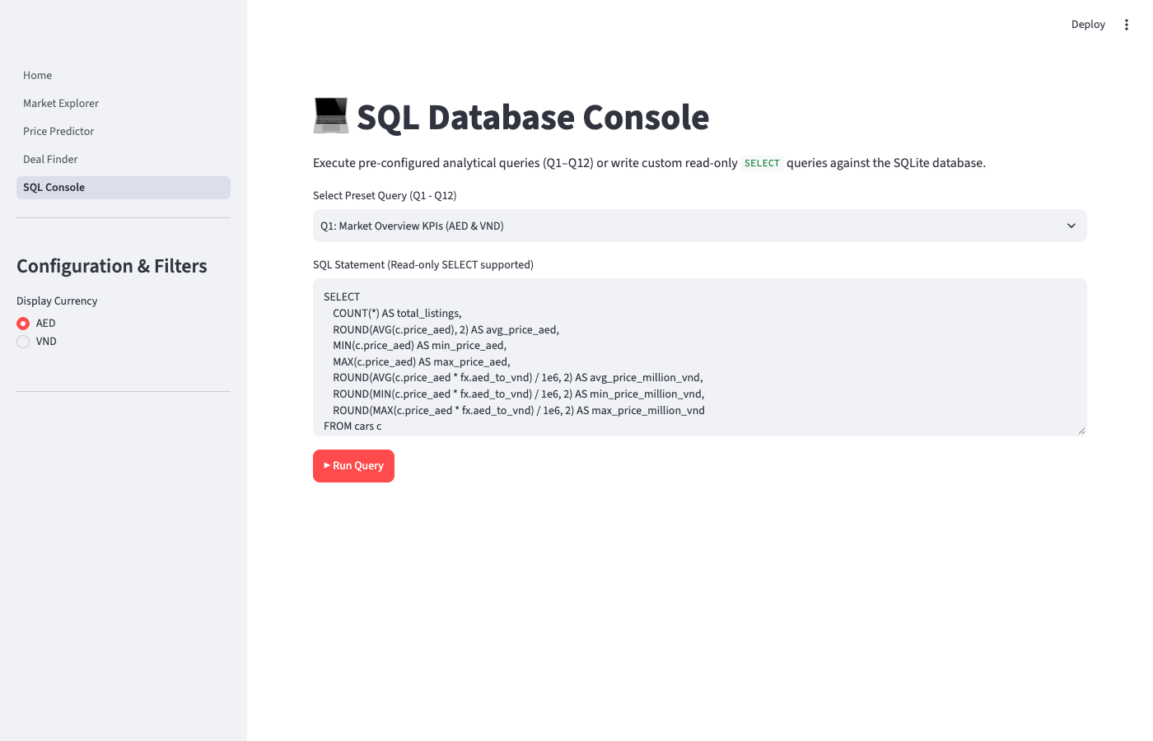
Visual Breakdown: The SQL Console allows stakeholders to execute all 12 pre-configured report queries directly within the web interface or execute custom read-only queries with sub-second execution times and instant CSV downloads.

4.2. Tool Evaluation and Critical Review
1. Usability & Development Velocity:
Streamlit drastically reduced development overhead by eliminating the need to write separate REST APIs (e.g., FastAPI) and front-end UI frameworks (React or Vue). The entire 5-page dashboard was constructed in under 400 lines of clean Python code. Python dataframes and Plotly chart objects render seamlessly without serialization translation layers. The learning curve was minimal, enabling rapid implementation within hours.
2. Operational Strengths:
Direct memory integration with pre-trained Scikit-learn pipelines and SQLite database connections. Built-in caching primitives (@st.cache_data and @st.cache_resource) ensure that heavy database queries and serialized model loading execute only once, providing rapid sub-100ms page transitions. Reactive widget state management allows dynamic cascading filters.
3. Platform Limitations & Bottlenecks:
Streamlit's execution model reruns the entire Python script from top to bottom upon every user interaction. While caching mitigates database latency, complex visualizations with thousands of SVG nodes can induce slight UI stuttering. In addition, Streamlit provides constrained layout primitives, and free cloud hosting enforces strict memory caps (1 GB RAM), requiring that model training remains an offline batch process.
4. Comparative Assessment:
Streamlit vs. BI Platforms (Power BI / Tableau): BI platforms excel at drag-and-drop dashboarding for non-technical business users but lack native support for running customized Scikit-learn machine learning pipelines and custom Duan smearing re-transformations. Streamlit vs. Custom Full-Stack (FastAPI + React): While a custom React frontend provides complete layout freedom, development requires 5x to 10x more engineering hours. Streamlit delivers an optimal compromise between analytical power and rapid deployment velocity.

Table 4.10. Tool Development and Engineering Log
Milestone / Task | Elapsed Time | Engineering Challenge Encountered | Resolution & Optimization
SQLite Connection Setup | 20 mins | Streamlit re-opening database file on every widget interaction | Implemented @st.cache_data with read-only URI connection mode (mode=ro)
Multi-page Application Architecture | 35 mins | Sharing state and selected currency (AED/VND) across distinct page routes | Centralized sidebar controls in app/utils.py using st.session_state
Model Pipeline Integration | 45 mins | Model prediction failure due to missing categorical levels in single-row inputs | Standardized ColumnTransformer with handle_unknown='ignore' in Scikit-learn
Deal Finder Scatter Plot Scaling | 30 mins | Browser DOM lag when rendering 10,000 SVG scatter points simultaneously | Capped interactive scatter plot rendering to top 1,500 active points with log-log axes
Automated End-to-End Testing | 25 mins | Capturing reliable headless screenshots of WebSocket-based Streamlit UI | Deployed Playwright Chromium automation with explicit network-idle wait triggers

