1. **Edges can also be extracted from the image by computing the contrast gradients within the image. The gradient equation is:**

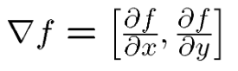

**Calculate edge strength by taking the magnitude of the image derivatives[2]:**

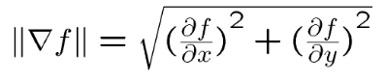

**Plot the input image, summed x and y derivative image and magnitude image [1]. Comment on the image quality.**

*Hint: Use numpy.gradient function which will give you derivatives across x and y axis.*

*[3]Evidence of code calculating edge strength. Plot the correct output.*

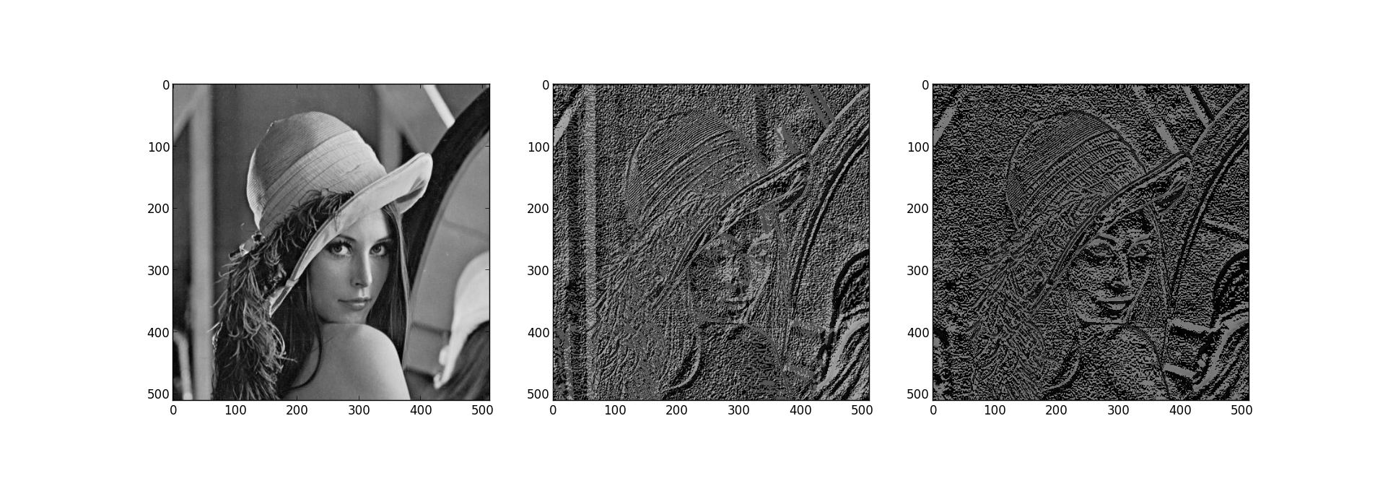

*[1] High noise levels*

1. **We learnt in edge detection 1 that Gaussian filters can be used to smooth images (i.e. reduce noise). Differentiate a simplified Gaussian filter, finding the magnitude of it's x & y components and convolve it with the image [1]. Comment on the difference between this image and the output of question 1 [1]. What trade off is made [1]?**

[1] Magnitude of Gaussian derivative blurred image plotted

[1] Lower noise levels, fewer edges detected.

[1] Edge detection (localisation) vs noise level (smoothing)

1. **Taking the second derivative of an image produces a Laplacian.**
2. **Fourier analysis allows us to extract spatial information within the image. Using Fourier filters we can precisely specify which spatial scales are to be remove from an image. Therefore we can isolate edges within an image using a band pass Fourier filter. Why is this not a plausible method of edge detection in the brain?**

[1]

[1] Physiologically implausible for the complex mathematics involved in Fourier transforms.

1. **“Canny” Edge detection program**
2. **Define image edges?**[1] Discontinuities in intensity
3. **Apply to a square wave/sin wave grating**
4. **Compare to On/Off Ganglion cells - think about receptive fields.**