1. **Edges can also be extracted from the image by computing the contrast gradients within the image. The gradient equation is:**

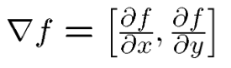

**Calculate edge strength by taking the magnitude of the image derivatives[2]:**

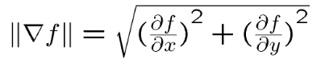

**Plot the input image, summed x and y derivative image and magnitude image [1]. Comment on the image quality.**

*Hint: Use numpy.gradient function which will give you derivatives across x and y axis.*

1. **Taking the second derivative of an image produces a Laplacian.**
2. **Fourier analysis allows us to extract spatial information within the image. Using Fourier filters we can precisely specify which spatial scales are to be remove from an image. Therefore we can isolate edges within an image using a band pass Fourier filter. Why is this not a plausible method of edge detection in the brain?**
3. **“Canny” Edge detection program**
4. **Define image edges?**[1] Discontinuities in intensity
5. **Apply to a square wave/sin wave grating**
6. **Compare to On/Off Ganglion cells - think about receptive fields.**