Models of Higher Brain Functions: Signal detection theory - Sensitivity, bias and ROC-curve

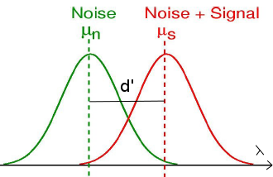

**1. Noise and Signal+Noise Distribution**

Plot the noise and signal+noise distributions for different sensitivity, *d’*, values: *[0.25, 0.5, 1.0, 3.0, 7.0]. Generate these distributions across a range of +/- 4.*

Also, plot the criterion for five different values of λ, with λ being equally spaced between $μ_{noise}$ and $μ_{signal+noise}$.

It is often assumed that the decision axis values, *x*, are distributed normally and with equal variance in noise (S = 0) and signal+noise trials (S = 1). With *S = 0, X ∼ N(0, 1)* and with *S = 1, X ∼ N(d’,1)*

*Hint: Use the stats.norm.pdf function to generate your distribution. And matplotlib.pyplot.plt for plotting*

**2. Hits, False Alarms and ROC-curves**

Plot the theoretically derived ROC-curves (hits vs. false alarms) for the sensitivity, d’, and criterion, λ, combinations described above. Use the same color for points that lie on one ROC-(isosensitivity-)curve.

*Hint: Use the stats.norm.cdf function to generate your cumulative distribution.*

**3. Nonstandard normal distributions (Add-on)**

Solve the problems b-g of Exercise 1.4 in the Analytical Tutorial with the programming routines you just developed.