- 20/20 Vision Test: Using the Snellen chart provided, sitting 6 meters (or 20 feet) away, for each eye note the smallest line which you can accurately see. Measure the size of the letters on this line with a ruler. Using the visual angle equation in the figure and the equation for visual acuity, calculate the visual acuity for each of your eyes. Make sure this value is in feet [5].

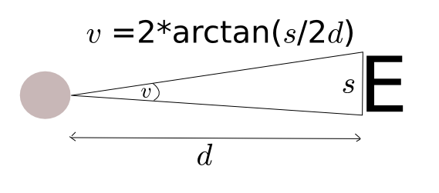
Visual acuity = Distance at which test is made / distance at which the smallest letters identified subtends an angle of 5 arcminutes

Hints: 1 arcminute = 1/60 of a degree , 1 meter = 3.28 feet.

Answer for smallest letter size visible e.g. s = 8mm

[1] Do the experiment and measure the size of letters you can see at a distance of 6m away.
[1] Rearrange visual angle equation: d = s / (2 * tan(v/2))

[1] With s = 8mm, v = 5/60 degrees → d= 5.5 metres

[1] Therefore Visual acuity = 6/5.5 in meters or 20/18 in feet

[1] Correct units

- Visual angle illusion: Holding the page about an arms length away, stare at the fixation point in the middle of the black circle on the next page for 30 seconds, then look to the right in the blank space next to it . You will see it's negative after image. Blinking will help the image come back after it fades.
Continuing to look at the white space, now bring the page slowly towards your eyes. What happens to the size of the negative after image [1]? Why do you think this happens [2]? use the rearranged visual angle equation in your argument [1]. What does this illusion say about our perceptual abilities [1]?

Hint: the perceived visual angle remains constant throughout, as the after image created by bleaching of the retina, which only fades.

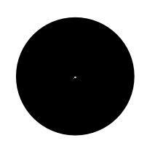

[1] It gets smaller, when you move the page closer to your eyes

[1/2] The brain calculates the distance to the paper
[2/2] and from this extrapolates the size of the circle.

[1] In the rearranged visual angle equation, the distance to the image is directly proportional to the size of the image. Therefore when you move the page towards you, i.e. distance gets smaller, the size also gets smaller.

[1] They aren't perfect/ Based on simple assumptions/ Easily fooled.

Maximum marks 10/10

