Testing the validity of adjustment method in lightness matching experiment

Kwangjun Lee

ABSTRACT : Lightness is the perceived reflectance of a surface. Our visual system is consistent at
judging the lightness of a surface even when the source of illumination changes. The neural mechanism behind the lightness constancy is yet to be understood. One of the explanations is that the contrast between an image and its surround influences lightness perception. However, we found that observers matched increment and decrement during the lightness matching experiment. Such pairs of opposite contrast polarities suggest that the method of adjustment in matching experiment may not ensure perceptual equivalence in resulting pairs. In this experiment, we tested the validity of perceptual equivalence in resulting pairs of the adjustment matching method by adding an ellipse under identical context as the target to compare the target with the perceptually equal match and the new comparison whose luminance values were manipulated in the physical domain.

Introduction

The human visual system is proficient at judging the surface lightness of an object. Regardless of the varying illumination on a surface, the perceived lightness of the surface stays fairly constant. For instance, humans can easily distinguish between a white surface inside the shadow from a black surface under the sunlight. How the visual system determines surface lightness from luminance information in the retinal image is yet to be understood.
When human observers encounter a visual scene, the retinal image is generated with luminance profiles of the scene. This luminance is a combination of reflectance and illumination on the surface. In determining reflectance of an object, the visual system can either discount the illumination by estimating illumination with cues, such as gloss, shading, object’s geometry, depth structure, and etc.; or it could go around the problem of dissecting illumination and surface lightness by measuring physical contrasts between an object and the surround at the surface level. Sometimes, failures in lightness perception, or illusions, where physical attributes do not match with perceptual counterparts, suggest useful insights to the nature of lightness perception. For example, early findings of simultaneous contrast effect can provide one possible explanation to why the two checks of same physical attribute (equi-luminance) on Adelson checkerboard (check 1 and 2; Figure 1) are perceived differently in terms of lightness: check 1 appears lighter due to its dark surround; and check 2 appears darker due to its bright surround. Another explanation would be that the visual system takes the viewing conditions, such as illumination created by the shadow, into account while computing the lightness of the two checks.
In our attempt to study how the visual system gives rise to lightness perception, we conducted lightness matching experiments with adjustment method using the Adelson checkerboard. It was found that observers sometimes matched ellipses with contrasts of opposite polarities, when target and match ellipses were placed on equi-luminant checks under different illumination conditions. If lightness perception can be explained by contrast computation, positive contrast (increment) and negative contrast (decrement) should never match in lightness with each other. In order to account for this observation, we tested on how sound the adjustment matching method is in determining the perceptual equivalence in its resulting target-match pairs.
In this experiment, an addition ellipse (comparison ellipse) was added to the scene in which target and match ellipse luminances were predetermined from the adjustment experiment as perceptually equal. Unlike the target-match pair, whose local (check reflectance) and global (illumination) contexts were different, the target-comparison parir had same local and global contexts. While varying the comparison ellipse luminance in seven different proportions to the target ellipse luminance, the task was to determine which of the two pairs, the target-match or the target-comparison pair, look more similar in lightness. If the perceptual equivalence determined by the adjustment method is valid, then the percentage of choosing the target-match pair should be at the binary chance level (50%) when target and comparison have the same luminance; and, it would increase towards 100% as the difference between target and comparison increases.

Methods

Observers A single observer (the author), with normal visual ability and prior experience in psychophysical experiments, had participated in the experiment.

Stimuli and Apparatus Stimuli were presented on a linearized 21-inch Siemens SMM2106LS monitor (400x300mm, 1024x766 px, 130Hz) using a DataPixx toolbox (Vpixx Technologies INC. Saint-Bruno, QC, Canada) and a custom presentation software (hrl; https://github.com/TUBvision/hrl) in a dark room at 110 cm distance from the observer. Responses were made and collected with a ResponsePixx button-box (Vpixx Technologies INC. Saint-Bruno, QC, Canada).
A template stimulus image of 6x6 checkerboard with a cylinder on top to cast a shadow on parts of its surface was rendered using Povray (Persistence of Vision Raytracer Pty. Ltd., 2004) script. Using Python, the four carrier checks on which ellipses were later placed (1-4; Figure 1) depending on each condition's requirement were masked and given a uniform gray-scale value (58; equivalent to 126.25 cd/m²). The masked template image was then normalized to 0.0 - 1.0 scale and translated into luminance values using the match table previously measured using a photometer. The check luminance on all four positions were measured using a photometer to ensure that they have an equal luminance value. Ellipses were created on top of this rendered template image, using the custom presentation software (hrl).
Figure 1: a template 6x6 checkerboard with a cylinder that casts a shadow on parts of the surface
Adjustment experiment The purpose of this experiment was to determine perceptually equal luminance pairs of two ellipses placed in two different contexts: one sitting on the dark check outside the shadow and the other sitting on the light check inside the shadow.
The experiment was divided into two conditions. First, in the shadow target condition, the luminance of match ellipse sitting on the dark check outside the shadow was adjusted to match the luminance of target ellipse sitting on the light check inside the shadow (Figure 2; left), whose value was always decrement to its surrounding. Second, in the plain target condition, the contexts of target and match ellipses were switched (Figure 2; right), and the target ellipse was always increment to its surrounding.
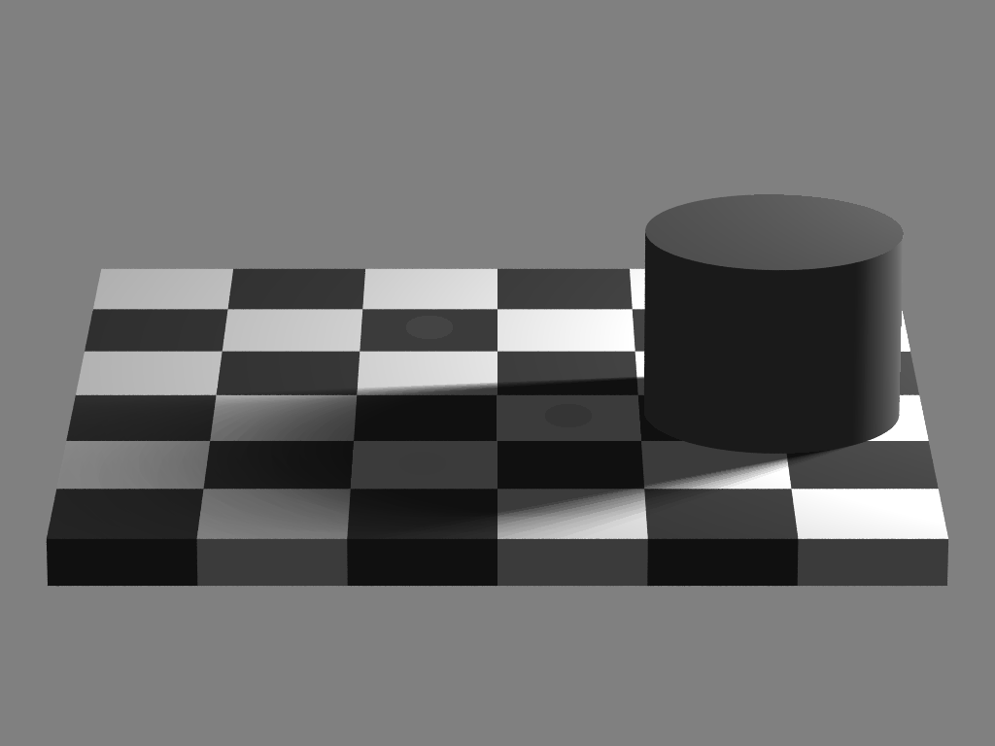
Shadow Target Condition
Plain Target Condition
Figure 2. Left: the shadow target condition. Right: the plain target condition. The luminance of the match ellipse inside the blue dotted circle was adjusted to match the luminance of the target ellipse inside the red dotted circle.

For each condition, there were 50 trials: 5 target ellipse luminance values, linearly spaced from the surrounding check luminance (62, 79, 98, 107, 116 for the shadow target condition; and 137, 146, 155, 172, 190 for the plain target condition), were tested 10 times each. The order of stimulus presentation was randomized. The initial luminance value of match ellipses was selected randomly from 0 to 530 cd/m². With the Datapixx controller, subjects could make one of the four adjustment choices : big increase (+10 cd/m²), big decrease (-10cd/m²), small increase (+2cd/m²), and small decrease (-2cd/m²). There was no time limit on a matching trial, as each stimulus screen with a target ellipse luminance value stayed on until the end button was pressed.

Triad 2-AFC experiment The purpose of this experiment was to test the validity of the perceptual equality determined in the previous experiment. On top of the target and match ellipses, whose luminance values were predetermined as perceptually equal from the adjustment experiment, a third ellipse (comparison ellipse) was added to the checkerboard.
The experiment was divided into two conditions: (1) the dark comparison condition, where the comparison ellipse was lying on the dark check outside the shadow (Figure 3; left); and (2) the light comparison condition, where the comparison ellipse was lying on the light check inside the shadow (Figure 3; right). On each trial, a checkerboard containing three ellipses was presented for 500 milliseconds (ms). It was followed by a blank screen, during which subject had to make a choice which of two ellipses, match and comparison, looked more different in perceived luminance from target ellipse. There was no time limit for the response. The luminance of the blank screen was set to the same value as the background of checkerboard stimulus.
A total of 1120 trials were run: each of the 2 conditions had 4 perceptually equal pairs (target-match pairs), which were tested against 7 luminance variations of comparison ellipses for 20 times each. While the luminance values of target and match ellipses were predetermined from the adjustment experiment, the luminance value of comparison ellipse was chosen randomly from the 7 luminance proportions of the target ellipse (80%, 90%, 95%, 100%, 105%, 110%, and 120%) on each trial. For example, 80% means that the comparison ellipse would have 80% luminance of the target ellipse.

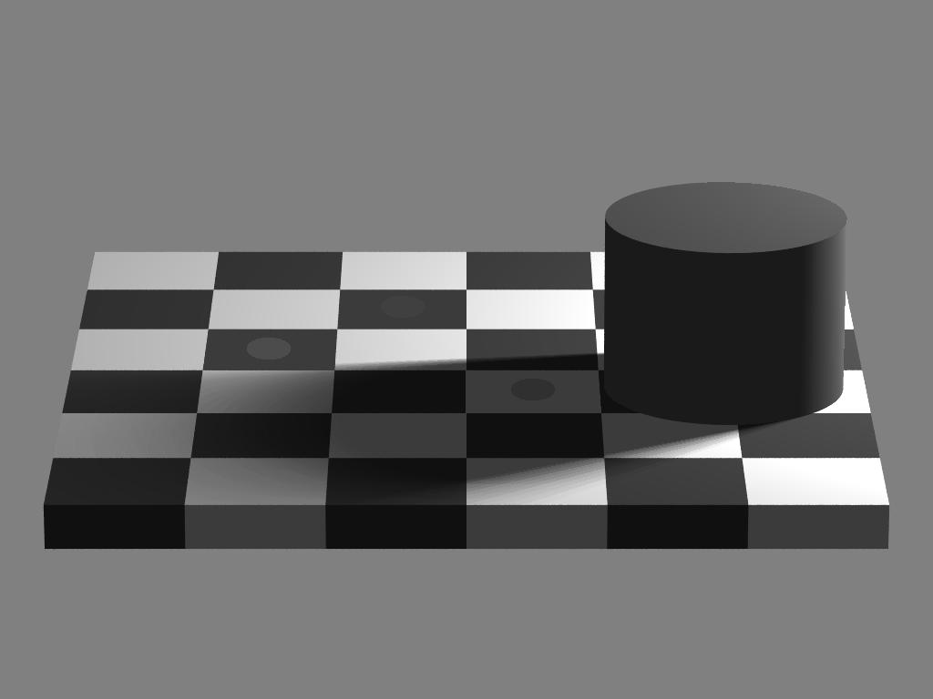
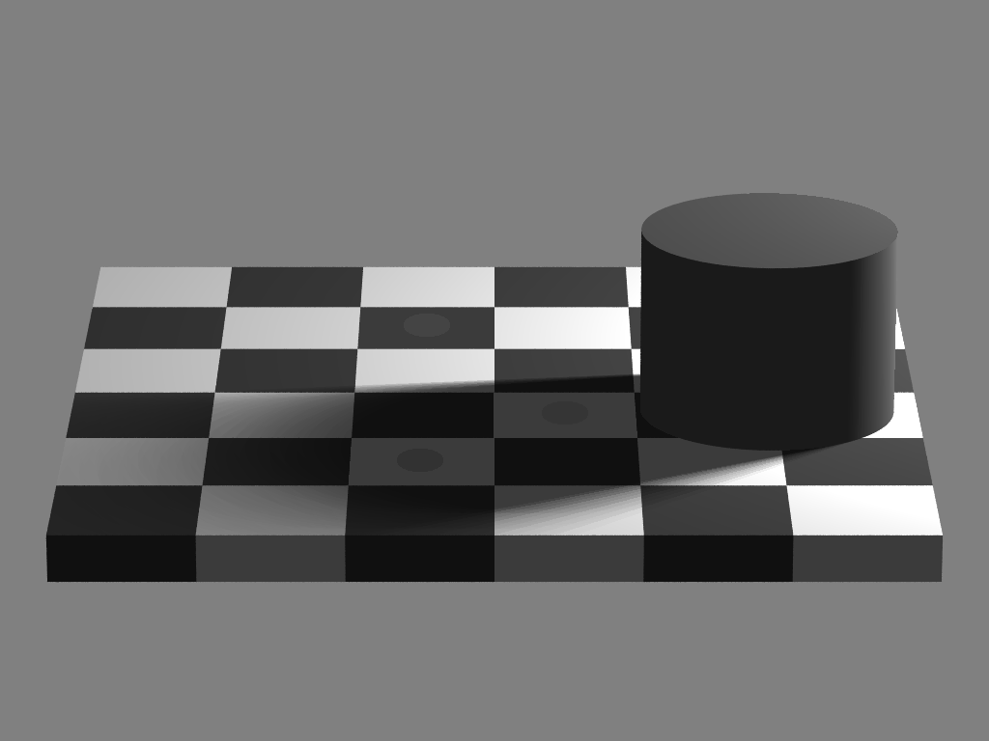
Dark Comparison Condition
Light Comparison Condition
Figure 3. Left: the dark comparison condition. Right: the light comparison condition. Subject had to decide whether the match ellipse (blue) or the comparison ellipse (yellow) was more different in perceived luminance when compared to the target ellipse (red).

Results

Adjustment experiment The average match ellipse luminance was computed over 20 trials on each target ellipse luminance. In each condition, there were three increment-decrement luminance pairs of target and match ellipses. The luminance values were (98,130), (107,139), and (116, 153) in shadow and (137,113), (146, 121), and (155,124) in plain target conditions (Figure 4; left). In these pairs, the luminance of target and match ellipses had opposite contrast polarities in relation to the luminance of surrounding check: in the shadow target condition, the target luminance were decrements to their surrounding check, while the match luminance were increments to their surrounding check; in the plain target condition, the target luminance were increments to their surrounding check while the match luminance were decrements to their surrounding check.
The Michelson contrast values of target ellipse to its surrounding check were computed by the ratio between their difference over sum [i.e. (Lt – Ls) / (Lt + Ls)]. Although target ellipse luminance were equally spaced in both conditions, the luminance contrast measures between the target ellipse and its surround were not the same for the two conditions (Figure 4; right). The contrast range of the target ellipse luminance in the plain target condition (0.16) was almost half of the range of the shadow target condition (0.3). The contrast range of the match ellipse luminance in the plain target condition (0.0682) was almost one third of the range of the shadow target condition (0.237).
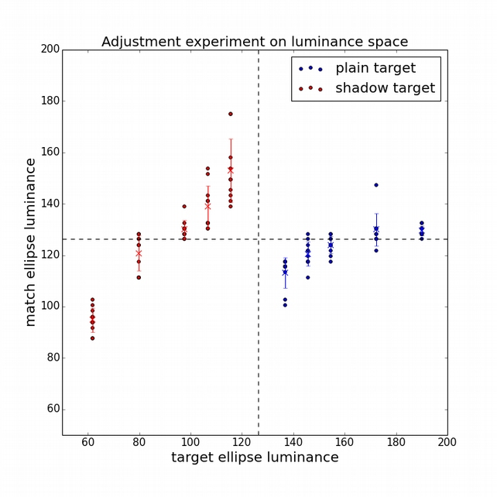
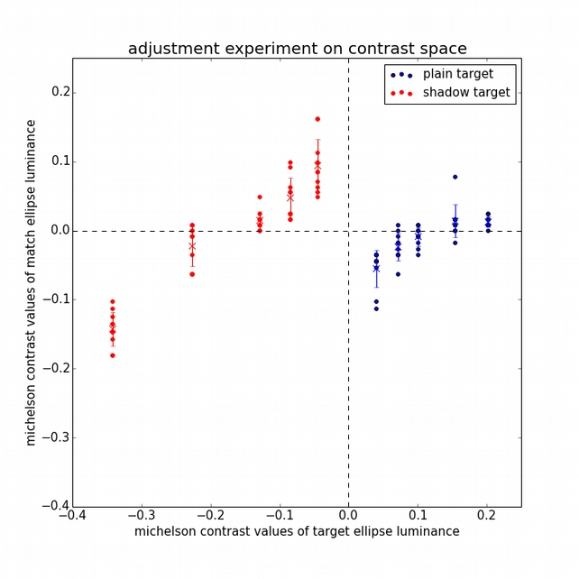
Figure 4. Left: luminance matching scatter plot on luminance space. Each point indicates the match luminance manually adjusted on a single trial. The average match luminance was marked with 'x'. The error bar was constructed with one standard deviation above and below the average match luminance. The plain target condition was marked with blue , and the shadow target condition was marked with red. Right: converted the luminance into Michelson contrast values to plot on contrast space.
Pair 1
Pair 2
Pair 3
Pair 4

Triad 2-AFC experiment The four pairs that were determined as perceptually equal in lightness from the adjustment experiment were used in this experiment (Figure 4; pair 1-4). The percentage of choosing the perceptually equal pair (target-match) over the physically similar pair (target-comparison) was computed and fitted by a psychometric function (Figure 5), whose parameters were estimated using maximum likelihood estimation. When the ellipse luminance values from each pair were organized in terms of the check containing them (Figure 1; check 1 or 2), the target and match locations switch between plain and shadow target conditions. It was found that the luminance values of check 1 (S) and check 2 (CD) were very similar between pairs 1&3 (107&113, 139&137) and pairs 2&4 (116&121, 153&147). Hence, the percentage choice data from pairs 1&3 were put together as group 1, while the percetange choice data from pairs 2&4 were put together as group 2 for the model fitting analysis. The parameter estimation in each of the two groups were done in two separate steps: once from 100% to 80% (Figure 5; left to the dotted line) luminance proportion to target ellipses and another from 100% to 120% (Figure 5; right to the dotted line). It was done separately, because the response of making a choice depends on how different or similar the comparison ellipse luminance is from the target ellipse luminance. In other words, the stimulus intensity in this experiment was not a continuous function from low to high luminance values, but two separate processes with equal spacing from the middle, which represents the difference between target and comparison ellipses.
In order to assess how well the model describe the data, the goodness of fit was measured with the bootstrap deviance analysis. For each group, the data were re-sampled 2000 times using the fitted parameters on each side (80-100% and 100-120%) separately: hence, there were eight choice data sets for the model fitting analysis. If an empirical deviance value lied within the 95% confidence interval of sampled deviance distribution, then the fit was considered to be good. In light comparison condition, all the fits were good except the 100-120% side of group 2. On the other hand, only the 100-120% side of group 1 passed the goodness of fit test in dark comparison condition.

Discussion

Adjustment Experiment The two conditions had the same surrounding check luminance (126 cd/m²), but the target ellipses were always increments in the plain target condition and decrements in the shadow target condition. If the unit of comparison for the visual system to perform luminance matching is contrast, the difference in slopes of the two conditions (0.99 and 0.3; Figure 4; left) can be explained in contrast space. According to Michelson's contrast formula, values of the nominator in two conditions (difference) were roughly equal and only differed in signs. On the other hand, values of the denominator (sum) were always bigger with increments. Hence, despite the target ellipses being equally spaced from the surrounding check luminance, there were larger contrasts in decrement targets as compared to increment targets (Figure 4; right). As a result, the match luminance range in the plain target condition (increment targets) was indeed much smaller. It suggests that the visual system is less sensitive to incremental than decremental changes.
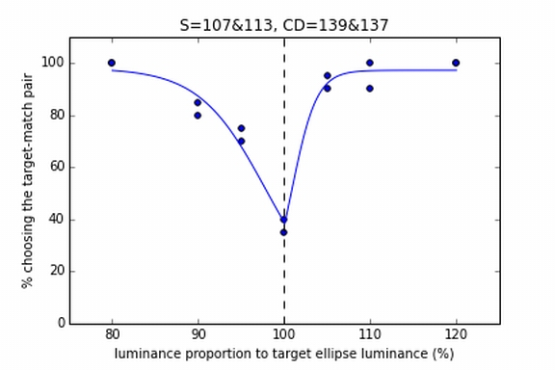
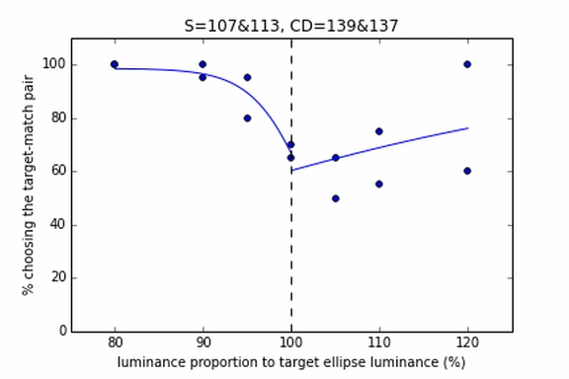
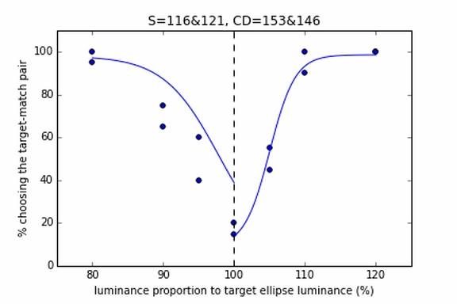
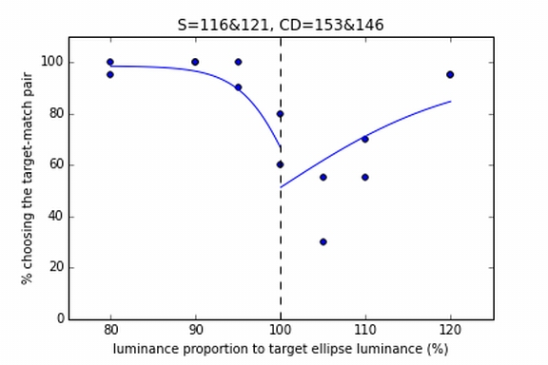
Good fit
Good fit
Good fit
Good fit
Good fit
Good fit
Bad fit
Bad fit
Figure 5: The psychometric function fits for the triad 2-AFC experiment. In this 2x2 matrix representation, each row corresponds to each of the group of two perceptually equal pair groups determined from the adjustment experiment. The S and CD indicate the ellipse luminance value placed on the light check inside the shadow (Figure 1; check 1) and the dark check outside shadow (Figure 1; check 2) respectively. The column represents the condition of experiment, dark and light comparison condition. On each plot, the average percentage of choosing the perceptual equality (target-match pair) was plotted against the luminance ratio between the comparison and target ellipses in percentage scale as blue dots. The blue line represents the best fitting model computed by maximum likelihood estimation. The dotted line in the middle indicates the point at which all three ellipses are expected to appear equal in perceived luminance.

The matchings of opposite contrast polarities, or the increment-decrement pairs, occurred when luminance values of target ellipse and the surrounding check were in close range (126 ± 30 cd/m²; Figure 4). When the two values were sufficiently far apart (> ± 30 cd/m²), matchings were of same contrast polarities. Perhaps, there exists a threshold luminance difference between an ellipse and its surround; and if the luminance difference falls within this range, judgment of contrast polarity becomes arbitrary. In fact, it was difficult to judge whether an ellipse is brighter or darker than its surrounding check on some trials. Consequently, adjusting the match ellipse luminance to be either increment or decrement to its surrounding check did not give a satisfactory match. As a compromise, a perceptually arbitrary luminance had to be chosen. However, it was not physically arbitrary on average, since the average match ellipse luminance were consistently opposite in contrast polarities to the target ellipse luminance (Figure 4; left).
One pair in each condition was dropped [(98,130) in shadow and (155, 124) in plain target condition] for the triad 2-AFC experiment, because the match ellipse was very difficult to see on the screen. Two pairs from each condition that had increment-decrement relationship were chosen to be used in the triad 2-AFC experiment (Figure 4; pairs 1-4).

Triad 2-AFC experiment On each trial, there were two pairs to compare: the target-match ellipse pair that had different local and global contexts with each other but determined during the adjustment experiment to be equal in perceived lightness; and the target-comparison ellipse pair that had same local and global contexts but varying comparison ellipse luminance whose values were given in proportions of target ellipse luminance. Each point on Figure 5 represents the percentage of choosing the target-match pairs as more similar than the target-comparison similar pairs on 40 trials. For instance, 100% on y-axis means that the subject perceived the target-match pairs more similar than the target-comparison pairs at all trials. The x-axis represents the luminance ratio between the comparison and target ellipses in percentage scale. The target and match ellipses were fixed as a single target-match pair across the x-axis. For instance, at luminance ratio of 100, the target and comparison ellipses had the same physical luminance value, while the target and match ellipses were perceived equal in lightness.
Since all three ellipses are expected to be perceived equal in lightness when the luminance ratio between comparison and target is 100, the percentage of choosing the target-match pair is expected to be around 50. When the luminance ratio moves away from 100 (physical equality) in either direction, the difference between luminance values between the target and comparison ellipses increases. The percentage of choosing the target-match pair is expected to increase in in two directions separately. At the luminance ratio percentage where the comparison ellipse can be perceived clearly different from the target ellipse in lightness, the percentage of choosing the target-match pair would be 100%. In all intervals, the increase towards 100% in the percentage of choosing the target-match pair was observed with the luminance ratio moving away from 100% (Figure 5).
The fits that did not pass the goodness of fit tests are mostly due to the fact that their percentage of choice at the point of physical equality between target and comparison ellipses are far from the chance level (50%) of a binary response task. Since the model took binomial distribution into account, it failed to fit the data when the expected chance level was violated (80-100% side of group 1 and both sides of group 2 in dark comparison condition and 100-120% side of group 2 in light comparison condition; Figure 5).

Conclusion

Although further data is required to assess the validity in finer details, the data from this experiment supports our hypothesis that resulting pairs of matching in the adjustment experiment may not reflect perceptual equality.

Appendix

Triad 2-AFC Experiment The collected data on percentage of choosing perceptual equality over physical similarity was fitted by a psychometric function with the following formula:

In the formula above, θ represents the parametric vector that consists of γ (the guessing rate), λ (the lapsing rate), and α and β (related to the threshold and slope of the sigmoid function). A low lapse rate was assumed and approximated by beta-distribution, Beta (2,20), because the subject was the experimenter himself who is well acquainted with the experiment.
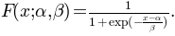

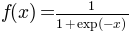

The 'sigmoid' function (f) is a nonlinear psychometric function without a parameter. The 'core' function (g) adds two unconstrained parameters, α and β, and performs a linear transformation of stimulus intensities. The values of unconstrained parameters were estimated by maximum likelihood estimation.

