Using edge based contrast to infer interior luminance values
-
ISO-Orientation Surround Suppression
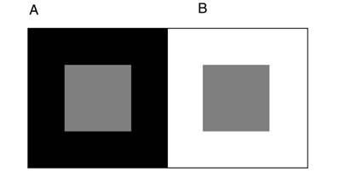Illustration 1: Simultaneous brightness contrast
Simultaneous brightness contrast, SBC, is the observation that perceived luminance values of test patches depend on the perceived luminance of the surround. Particularly that dark surrounds (incremental edges,A above) produce a brightening of test patches and light surrounds (decremental edges, B above) produce a darkening. The resultant effect is that the gray test patches in A and B appear to have a lightness difference. A being lighter. B being darker. Even though they are they same pixel value.

Illustration 2: White's Illusion

In White's illusion we observe seemingly contradictory results. Even though the left hand side test patches are in contact with a greater quantity of light surround (darkening edges), it is observed to brighten, as we would expect a dark surround dominated test patch to. One mechanism to account for this difference is Iso-Orientation Surround Suppression (Torsten 2015). In many image processing applications orientation sensitive filters can be applied to an image to extract orientation specific information about the image. IOSS is described as the result of surround inhibition of filter responses between the grating bars of Whites illusion. Explicitly, filters parallel to (in line with) the edges of the test patch and in the direction of the grating are inhibited by surrounding edge responses within the same orientation (Figure 3). This inhibition has the effect of reducing the effect of the light surround on the test patch , and as so eliminates its tendency to darken when in proximity with a light surround. The vertical edges dominate, resulting in the observed lightening of the test patch luminance due to the dark surround.

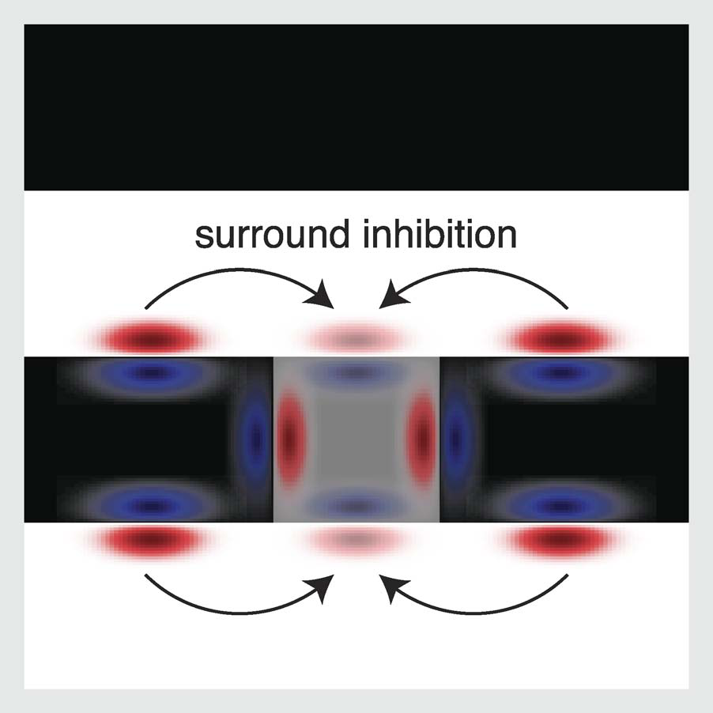Illustration 3: Iso-orientation surround suppression diagram
Below is a square (rather than rectangular) version of White's illusion with horizontal and vertical edge images (left). The horizontal edges have been inhibited within the proximity of the test patches, as described by IOSS (middle). Now the question arises, how one integrates this inhibited edge information back into luminance values within the test patches. Also, to what extent does the degree of luminance change at the test patches' edges effect the internal representation of its luminance.

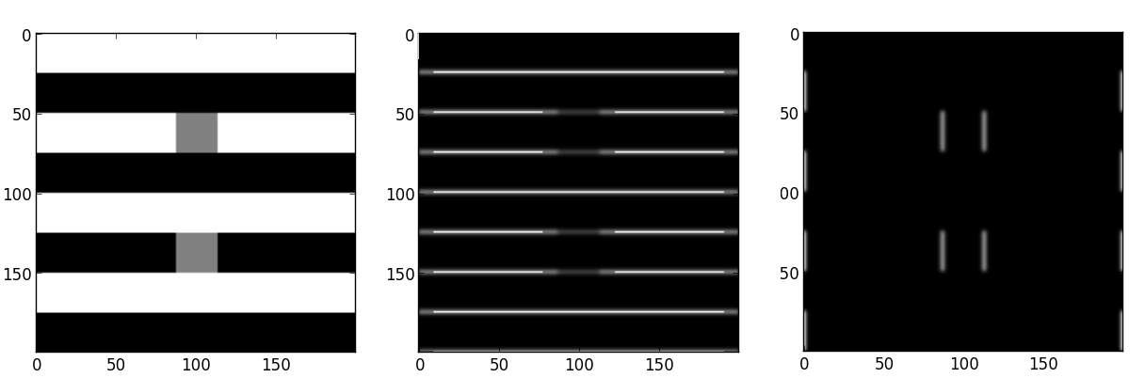Illustration 4: White's Illusion (left), Inhibited horizontal edges (middle), vertical edges (right)
Filling-in, the theoretical diffusion/spreading of color from edge contrast values, has been modeled in various forms but none have proven completely satisfactory. We have one working neural network model (Francis 2012) , an extension of Grossberg's FACADE model, which locates regions of uniform color and averages between them. Francis conception of filling-in is a diffusion process of color information flowing across an internal neural map, however diffusion is computationally expensive. He therefore introduces Filling-In Domains (FIDOs) which represents edge connect regions capable of constraining color flow. If edges of these regions are disrupted, for example with contour adapters, the regions' boundaries can no longer “dam” the color inside them and the color is averaged within the regions they are connected to. This is as if you were to rub out the edge on a color by number drawing, the connected regions' color becoming the average of the sum. This is a binary outcome in the sense that, the model either averages the connected regions colors (Figure 5 right) or they keep their original color (Figure 5 left). Either the edges defines a distinct region, and its color is maintained, or the edge is disrupted to the extent that filling in occurs.
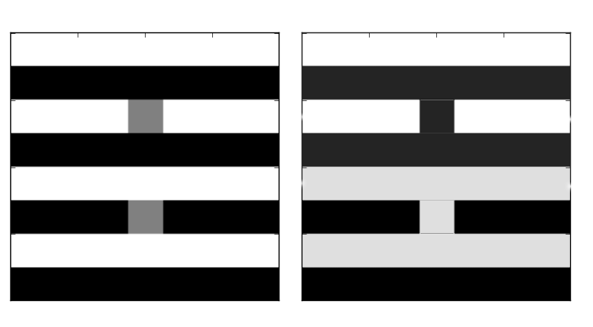Illustration 5: Boundary structures mediate filling-in, (left) filling-in without adaptation, (right) filling-in after adaptation

Assuming the surface lightness of a test patch is determined by a filling-in method based on edge information, as IOSS does, it cannot be the filling-in method described by Francis. The model output doesn't produce the observed intermediate pyschophysical fractional color differences between test patches on different bars, i.e. test patches appear to be the same color (Figure 5 left) to the computer even-though we still observe a difference.

This model has been built to account for contour adaptation induced filling-in and within this context it accurately models many common literature based stimuli, however the above mentioned failure indicates that it is not modeling a context-based edge-contrast filling-in process as is required by IOSS. And so, we need a new filling-in model to reconcile observations with IOSS, or perhaps an additional post-processing step which incorporates edge information.

Qualities of new filling-in method
-Uses edge information to constrain filling-in (i.e. integrates boundary magnitudes especially when weakened by contour adaptation)
-Has “soft-threshold” in the sense that partial filling-in can occur even across well defined boundaries under certain conditions.
-3D depth selective filling-in (Grossberg 2000)

Qualities of new module
-Lightness anchoring (Grossberg 2006 )
-Figure/Ground processing
-Other context/orientation-specific color adjustments

Open questions
- What would this model look like? i.e. how to integrate edge information, specifically contrast, and interior luminance values of a test patch into a perceived luminance value.
- How does this relationship change between the simple example of SBC and whites illusion, and why does there appear to be an orientation/context specificity?
- Are filling-in and brightness contrast part of the same process? Or two different contrast/color mechanisms?
- How could we generate a computationally cheap diffusion simulation? (Replacing FIDOs)

References
Francis, G., & Kim. J. (2012). Simulations of induced visual scene fading with boundary offset and filling-in. Vision Research, 62, 181–191.
Torsten Betz; Robert Shapley; Felix A. Wichmann; Marianne Maertens (2015). Testing the role of luminance edges in White's illusion with contour adaptation. Journal of Vision August, Vol.15, 14
Kelly, F.J. and Grossberg, S. (2000). Neural dynamics of 3-D surface perception: Figure-ground separation and lightness perception. Perception & Psychophysics, 62, 1596-1619.

Stephen Grossberg and Simon Hong (2006) A neural model of surface perception: Lightness, anchoring, and filling-in Spatial Vision, Volume 19, Issue 2, pages 263 – 321

