Using edge based contrast to infer interior luminance values
-
ISO-Orientation Surround Suppression
Exchangeable words
Luminance/Colour/Lightness
Boundary/edge-contrast

Abstract
Iso-Orientation Surround Suppression, IOSS, a mechanism explaining White's Illusion, relies upon the suppression of image boundary signals. Boundary signals, representing the magnitude of contrast at an edge, are extracted from an image using Gaussian filters. Post-filtering, IOSS requires a filling-in mechanism to convert these suppressed boundary signals back into a luminance image. In Gregory Francis' filling-in method the boundary signals mediate filling-in. Specifically, boundary signals are used define distinct Filling-In-Domains (FIDOs). The suppression of boundary signals in IOSS disrupts these distinct FIDOs, and in the case of White's Illusion, the test patch is averaged with the regions connected to the suppressed edges. This averaging produces a luminance difference that is far greater than the psycho-physically observed luminance difference. The desired effect of suppressing test patch boundary signals differs between Francis' model and the IOSS description. The IOSS model and Francis' filling-in model are therefore incompatible. And so a new model is needed (IOSS/filling-in/or additional intermediate stage).

Simultaneous Brightness Contrast
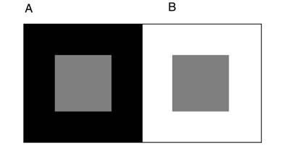Illustration 1: Simultaneous brightness contrast
Simultaneous brightness contrast, SBC, is the observation that perceived luminance values of test patches depend on the perceived luminance of the surround. Particularly, dark surrounds (Illustration 1, A) produce a brightening of test patches whereas light surrounds (Illustration 1, B) produce a darkening. The resultant effect is that the gray test patches in A and B appear to have a lightness difference with A being lighter and B being darker. Despite both having the same pixel gray value.

Illustration 2: White's Illusion

White's Illusion
In White's illusion we observe seemingly contradictory results. The gray test patches on the left hand side (Illustration 2) have more edges with white than black, which we would expect to cause darkening. However, it is observed to brighten, as we would expect a dark-edge-dominated test patch to. The converse is true of the right hand test patches.

IOSS
One mechanism to account for this observation is IOSS (Betz 2015). IOSS is the inhibition of certain filter responses within the same orientation as the grating. More explicitly, the filters present across test patch contrast edges are inhibited by surrounding the edge responses within the same orientation (Illustration 3). This suppression reduces the effect of the light surround on the test patch, and as so eliminates its tendency to darken when in proximity with a light surround. The dark surround edges dominate, resulting in the observed lightening of the test patch.
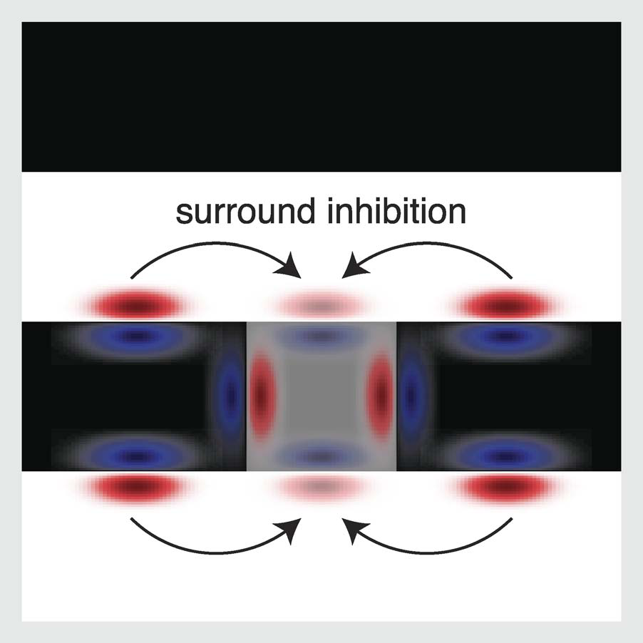Illustration 3: Iso-orientation surround suppression diagram
Filling-in
Filling-in, the theoretical diffusion of colour from edges, has been modeled in various forms but none have proven completely satisfactory. We have one working neural network model (Francis 2012), an extension of Grossberg's FACADE model, complete with filling-in mechanism. Francis notes that diffusion is computationally expensive to simulate and instead uses Filling-In Domains (FIDOs) which represent regions connect by contrast edges capable of constraining a filling-in type mechanism. Once the images contrast-edges have been extracted by Gaussian filters, an algorithm searches for connected boundaries within the image. Each connected boundary is a crude form of form recognition, for example the outline of a cross. This FIDO map is then used as a mask over the original unfiltered image, and within each unique FIDO a luminance value is calculated from the average of the interior pixel grey values.

Boundary signals can be suppressed, for example with contour adapters, which disrupts these unique regions. The boundaries of these regions can no longer “dam” the colour inside them and the colour is averaged with the regions to which they are connected to. This is as if you were to rub out the edge on a colour by number drawing, the connected regions' colour becoming the average of the sum.

Cross-region colour-averaging is commonly observed in contour adaptation stimuli. There exists a psychophysical threshold beyond which the brain cannot distinguish between a test patch and its surround and in the presence of contour adapters, the test patch can merge with its surround. In the simulation, this threshold is defined by the magnitude of the boundary signals required to define unique FIDOs. Contour adapters reduce the magnitude of boundary signals, which disrupt the original FIDOs, creating a new FIDO encompassing the test patch and its surround. This new FIDO is averaged, causing the luminance changes observed. In this sense, the model either averages the colour of the connected regions when adapters are present or they keep their original colour.

Simulations
Below is a square version of White's illusion with horizontal and vertical edge images (Illustration 4). A Gaussian filter set has been applied to extract contrast edges in the horizontal and vertical directions of the image(Illustration 4, middle & right). The horizontal edges, filter responses, then receive inhibition within the proximity of the test patches, as described by IOSS (Illustration 4, middle). Whereas the vertical edges have been left constant (Illustration 4, right)

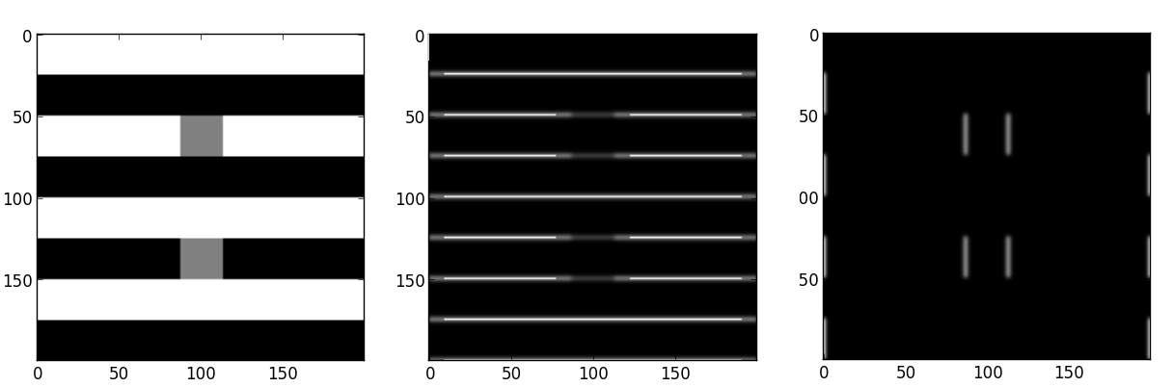Illustration 4: White's Illusion (left), Inhibited horizontal edges (middle), vertical edges (right)
The inhibited horizontal edges and vertical edges are combined into a single contrast-edge image (Illustration 5, left). The filling-in mechanism then searches for distinct FIDOs in the image. However, due to the suppression of boundary structures across the test patches edges, the FIDO of the test patch is not distinct from that of the FIDO representing the grating bars above and below it. The code therefore averages the regions (Illustration 5, right).

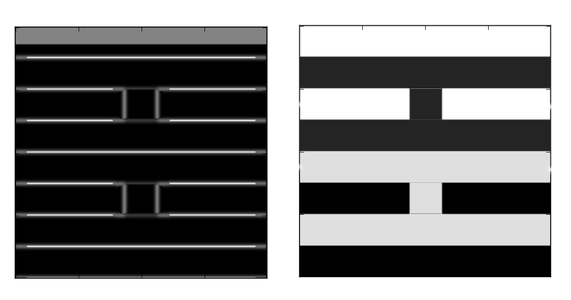Illustration 5: Boundary structures that mediate filling-in (left) filling-in after IOSS (right)

In this model, the inhibition caused by a IOSS type mechanism serves only to average the test patch with the grating bars above and below it. This is because surround inhibition of contrast edge magnitude has prevented the algorithm from defining the test patch as a unique colour region.

Discussion
Contrast edges hold no information about luminance and are only filtered out to generate FIDOs. Altering the magnitude of the filters will only alter, indirectly, whether or not colour regions have distinct FIDOs and have no direct impact on the luminance of the test patch.

Assuming the surface lightness of a test patch is determined by a filling-in method based on edge information, as IOSS does, it cannot be the filling-in method described by Francis. The model output doesn't produce the observed intermediate psychophysical fractional colour differences between test patches on different bars, i.e. test patches appear to be the same colour (Illustration 5, left) to the computer even-though we still observe a difference.

This model has been built to account for contour adaptation induced filling-in and within this context it accurately models many common literature based contour adaptation stimuli, however the above mentioned failure indicates that it is not modeling a context-based edge-contrast luminance calculation. And so, we need a new filling-in model to reconcile observations with IOSS, or an additional intermediate or post-processing step which incorporates edge information into luminance calculations.

Perhaps a step-back needs to be taken to explore how to integrate this inhibited contrast edge information back into luminance values within the image. And also to what extent the contrast at the test patches edges effect the internal representation of its luminance

Qualities of new filling-in method
-Uses contrast-edge magnitudes to constrain filling-in
-Has “soft-threshold” in the sense that partial filling-in can occur even across well defined boundaries under certain conditions.
-3D depth selective filling-in (Grossberg 2000)

Qualities of new module
-Lightness anchoring (Grossberg 2006 )
-Figure/Ground processing
-Other context/orientation-specific colour adjustments

Open questions
- What would this model look like? i.e. how to integrate edge information, specifically contrast, and interior luminance values of a test patch into a perceived luminance value.
- How does this relationship change between the simple example of SBC and whites illusion, and why does there appear to be an orientation/context specificity?
- Are filling-in and brightness contrast part of the same process? Or two different contrast/colour mechanisms?
- How could we generate a computationally cheap diffusion simulation? (Replacing FIDOs)

References
Francis, G., & Kim. J. (2012). Simulations of induced visual scene fading with boundary offset and filling-in. Vision Research, 62, 181–191.
Torsten Betz; Robert Shapley; Felix A. Wichmann; Marianne Maertens (2015). Testing the role of luminance edges in White's illusion with contour adaptation. Journal of Vision August, Vol.15, 14
Kelly, F.J. and Grossberg, S. (2000). Neural dynamics of 3-D surface perception: Figure-ground separation and lightness perception. Perception & Psychophysics, 62, 1596-1619.

Stephen Grossberg and Simon Hong (2006) A neural model of surface perception: Lightness, anchoring, and filling-in Spatial Vision, Volume 19, Issue 2, pages 263 – 321

