# Question1.

## 1.

GJ/GHI

## 2.

1NF, there are non-prime attribute A and B is functionally determined by G.

## 3.

$F_{m}=$ {B -> D, B -> E, CD->E, AHI->C, AHI->J, AJ->E, AJ->H, AJ->I, G->A, G->B}

## 4.

$∵R_{1}=\{ABE\},R_{2}=\{CDH\},R_{3}=\{EGHIJ\}$

$$∴ π_{R_{1}}(F_{1})=\{\},π_{R_{2}}(F_{2})=\{\},π_{R_{3}}(F_{3})=\{\}$$

$F^{'}=F_{1}∪F_{2}∪F_{3}$

$$Since F^{'+}≠F^{+},hence R_{1},R_{2} and R_{3} are not dependency preserving regarding F.$$

## 5.

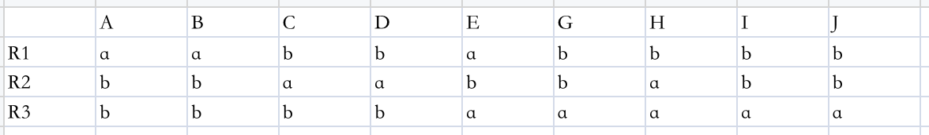

Now no row is entirely a’s, so the decomposition is not lossless join property.

## 6.

For $F=$ {B -> DE, CD->E, AHI->CJ, AJ->EHI, G->AB}

Consider AHI->CJ, AHI is not a superkey, split R into R1: {A, C, H, I, J}, R2: {A, B, D, E, G, H, I}

Consider AJ->HI in R1: {A, C, H, I, J} AJ is not a superkey, split R1 into R11: {A, H, I, J}, R12: {A, C, J}

Consider B -> DE, Bis not a superkey, split R2 into R21: {B, D, E}, R22: {A, B, G, H, I}

Consider G->AB, G is not a superkey, split R22 into R3: {A, B, G}, R4: {G, H, I}

A lossless decomposition of R into BCNF normal form is: R11, R12, R21, R3, R4

# Question2.

## 1.

at checkpoints T1, T2, T3, T4 transactions start, but no transaction commits. At crash point, T3, T4 commit. So we only need to redo T3 and T4, and T1, T2, T5 undo.

## 2.

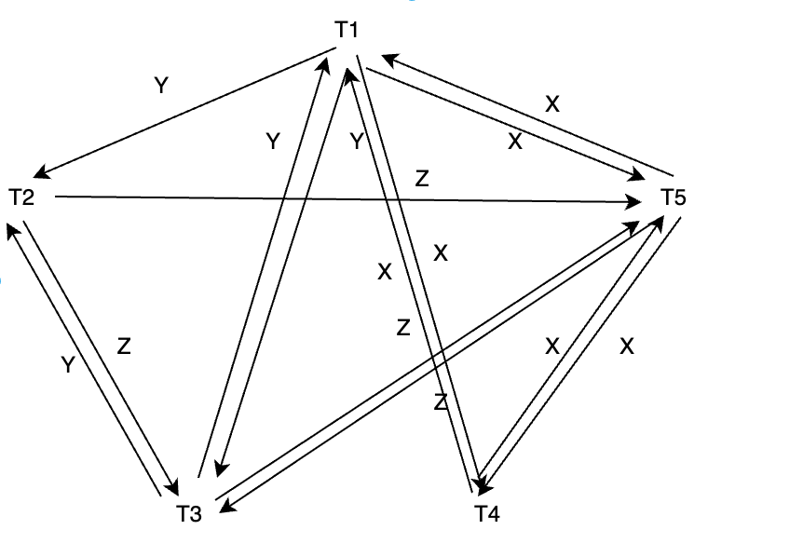

The precedence graph is acyclic, so it is not conflict serializable.

## 3.

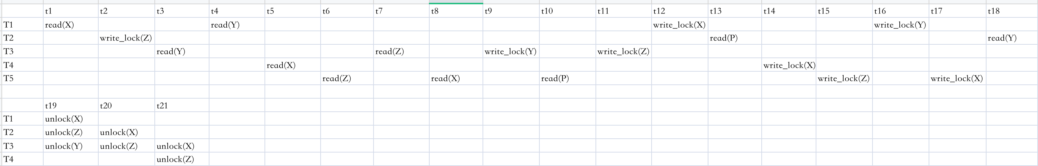

# Question3.

## 1.

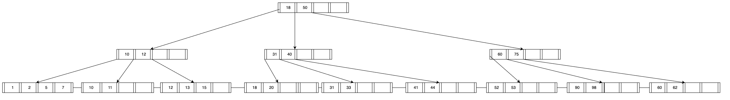

## 2.

