# Exercise 3

Q1:

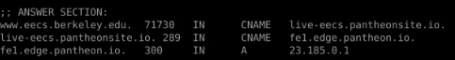

The IP address of [www.eecs.berkeley.edu](https://eecs.berkeley.edu/) is 23.185.0.1. The type of DNS query is “A”, which means sent to get the IPV4 address.

Q2:

As the figure showed in Q1, the canonical name is “live.eecs.pantheonsite.io” and the “live.eecs.pantheonsite.io”has the canonical name that “fel.edge.pantheon.io”

Aliases (when present) are easier to remember than host canonical names. Applications can call DNS to obtain the canonical hostname corresponding to the host alias and the IP address of the host.

Q3:

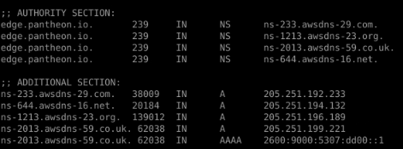

In the Authority section, each line is what is the name server corresponding to the URL, and in the Additional section: each line corresponds the IPV4 and IPV6 addresses of its name server.

Q4:

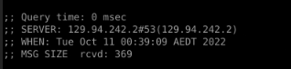

the IP address of the local nameserver for my machine is 129.94.242.2

Q5:

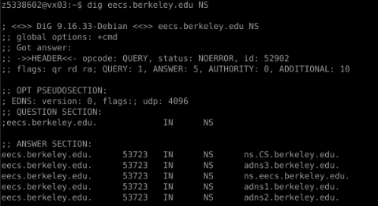

the DNS nameservers for the “eecs.berkeley.edu.”is the responding of the Answer section in the figure like the ns.CS.berkeley.edu and so on.

Q6：

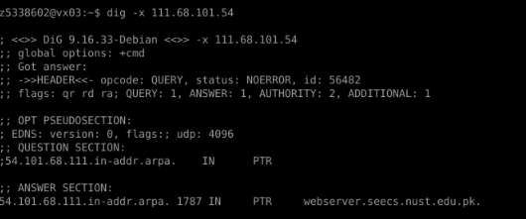

The DNS name is webserver.seecs.nust.edu.pk. Send the query “PTR” to obtain this information.

Q7:

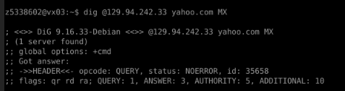

In the last line, it has not include the “aa”(which means the authoritative answer), so I do not get an authoritative answer. The reason that we do not get an authoritative answer is that we are using the CSE server request the answer.

Q8：

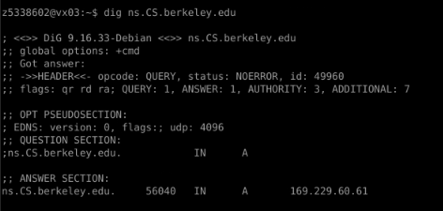

The result is the name server’s IPV4 address, is 169.229.60.61

Q9：

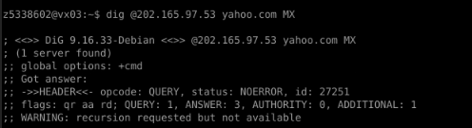

“202.165.97.53” is the IP address of the Yahoo domain name. Using the MX query to obtain this information.

Q10:

The querry include:

Dig . NS

Dig @198.41.0.4 au.

Dig @162.159.25.38 edu.au.

Dig @65.22.196.1 unsw.edu.au.

Dig @129.94.0.192 lyre00.cse.unsw.edu.au A

Dig @129.94.242.2 lyre00.cse.unsw.edu.au A

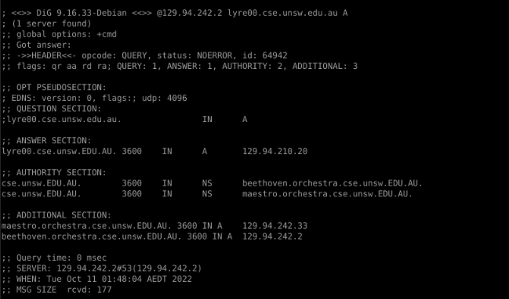

There is a aa(authoritative answer) in the answer, so it is in the end.

So I have to query 6 servers to get the authoritative answer?

Q11:

Yes, A computer can have more than one ip address at a time. We can have multiple IP addresses in a single computer with following ways:

1. Add additional Network Adaptor in the system

2. Add Another IP Address in the same network adaptor.

# Exercise 4

The python version is python 3.

Firstly, find a exist png file.

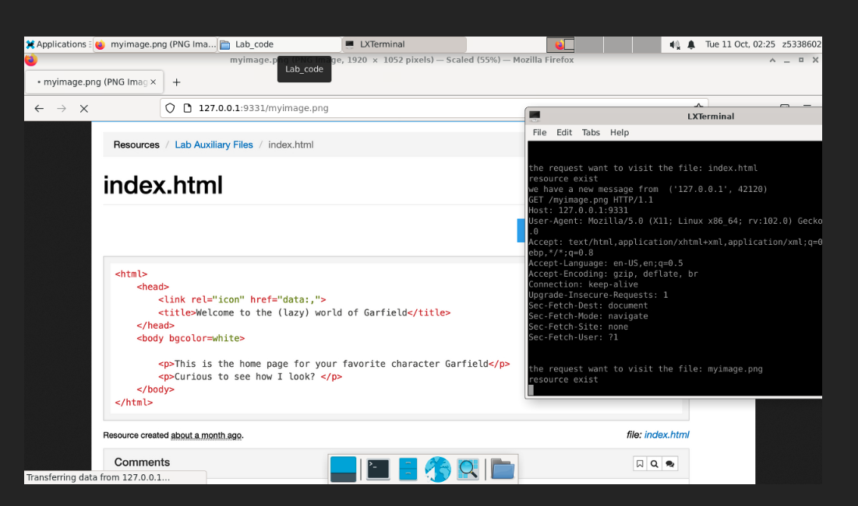

Then, find a exist html file

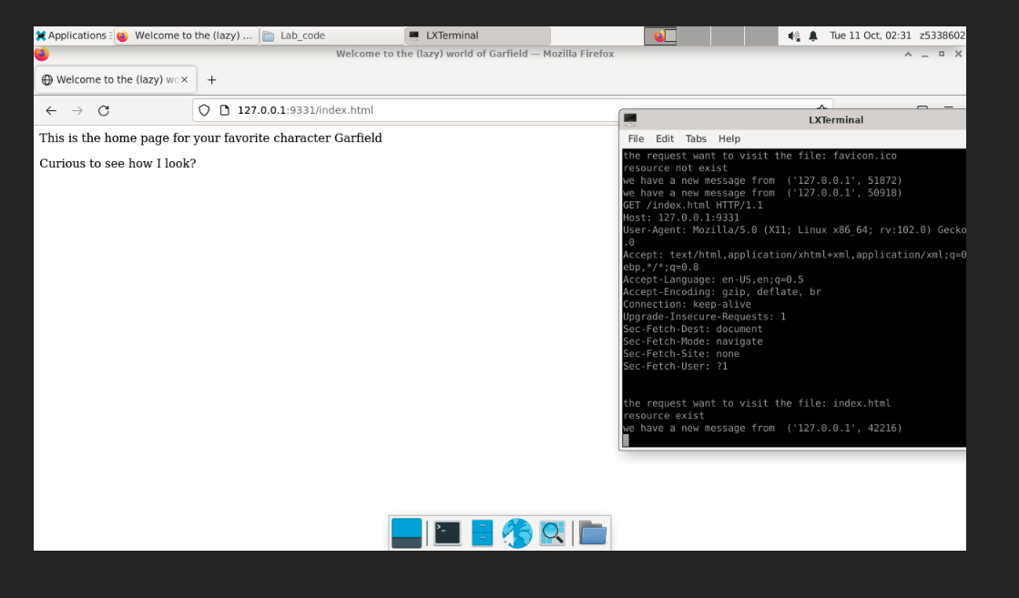

Lastly, find a not exist html file.

