**Exercise 3:**

## Question1:



It response 200 and OK, it means the server response successfully.

## Question2:

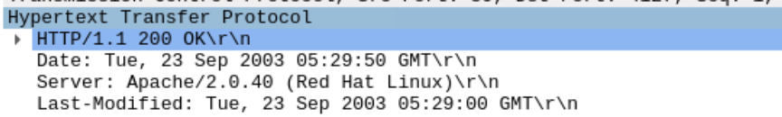

Last modified time is on Sep 23, 2003 5:29:00. And the response also contain a DATE header.

Date refers to the date and time when the server generates and sends the response message.

Last-Modified means the time when the object was created or last modified.

## Question3:



According to the figure above, it can find that the connection is persistent.

## Question4:

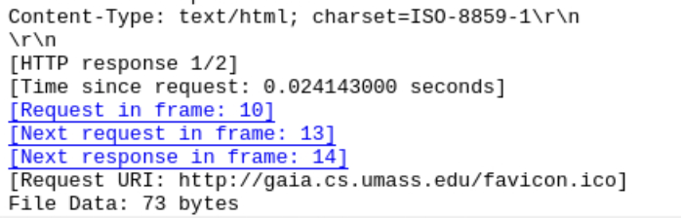

According to the figure above, there are 73 bytes contents are being returned to the browser.

## Question5:



The data contained inside the HTTP response packet is a html projects named ‘lab2-1.html’.

**Exercise 4:**

## Question1:

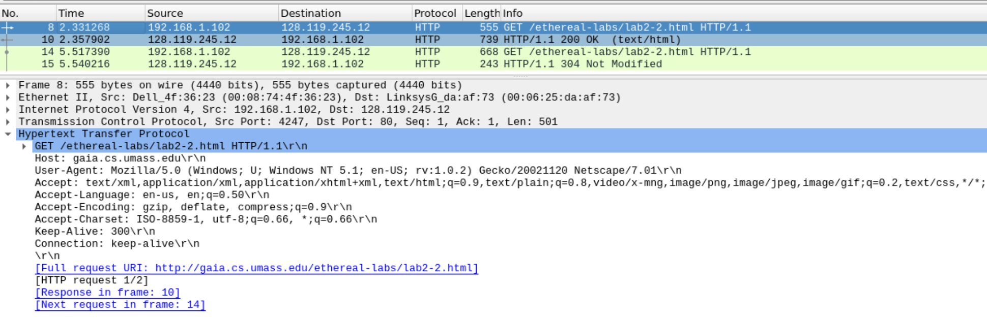

There is not “IF-MODIFIED-SINCE” line in the HTTP GET.

## Question2:

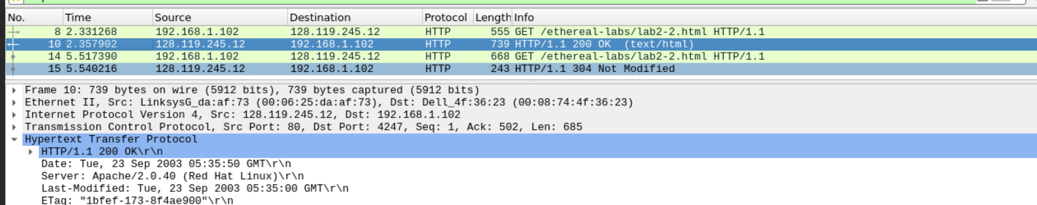

No, requested file was not modified.

## Question3:

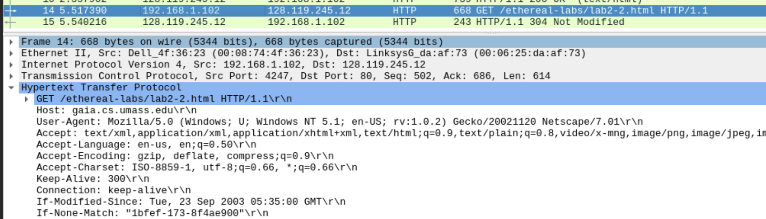

There are ‘If-Modified-Since’ and ‘If-None-Match’ lines in the HTTP GET. If-Modified-Since’is a header line sent by the client to the server to record the last modification time of the page. If-None-Match’ appear only when: the server return the requested resource if and only if no resource's ETag attribute value on the server matches the one listed in the header

## Question4:

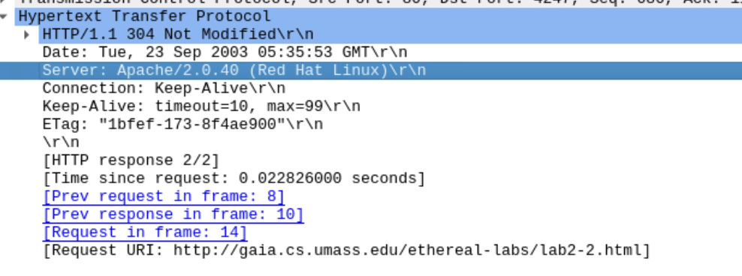

the HTTP status code and phrase returned from the server in response to this second HTTP GET is 304 and Not Modified. The server explicitly returns the contents of the file and the file was not modified.

## Question5:



The value of the Etag was shown in figure. The Etag can be compared with the If None Match header line sent by the client. The content of this header is that the Etag server returned by the server at the first request determines whether the sent Etag matches the calculated Etag.And the status code is 304 means there is not change since the first response.

**Exercise 5:**

# 

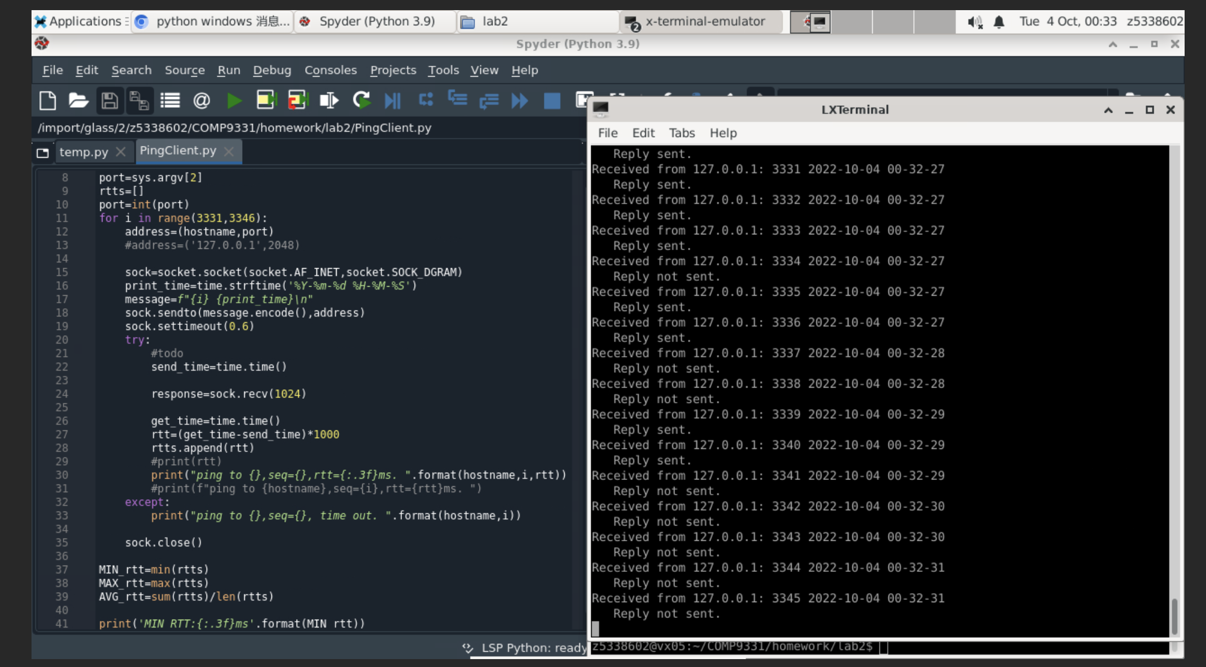

Python version is 3.9.

As shown in the figure: The client request 15 times, of which the server successfully responded 7 times, the minimum RTT is 7.323ms and the maximum RTT is 199.495ms, the average RTT is 99.856ms.