Contents

Introduction 2

Global trends 3

Quay Wall 4

Flexibility 5

# Introduction

“The strategic planning phase within a terminal’s development is rather segregated, in which economists make traffic projections, afterwich a port engineering team translates that projection into a terminal plan, before having the economist re-evaluate the terminal plan and analyse its feasibility. This results in a very coarse feedback mechanism in which the final economic analysis may require the port engineers to redo their initial design, leading to an increase in design costs. Integrating economic analysis into the design process sets out to facilitate this process by supporting port engineers through visualizing the economic impact of their design assumnptions. **Check introduction to Cornelis’ introduction.”**

All in all, Predictions for future situations usually have an increasing uncertainty over time. Port master

plans are designed for large periods of time and some variables that -among others- determine the

terminal dimensions may therefore be subject to uncertainty. In the present situation calculations

are made by assuming certain values for parameters that are uncertain, this can lead to under or

over dimensioning of terminals. In order to account for uncertainty we can incorporate a

probability distribution for specific variables. This way many input combinations are included in

one single calculation resulting in a more complete and realistic analysis.

Among the main concerns for parties that order the design of a terminal are the economic and

financial feasibility. In order to make a project feasible costs are an important aspect. It would

therefore be useful to be able to give a rough construction cost estimate for a terminal design in

the feasibility phase of a project. Similarly to the design rule parameter values uncertainties about

the prices or costs of terminal elements are common. This of course lends itself for a similar

probabilistic calculation approach.

# Global trends

Global demand for agricultural commodities such as maize, wheat and soybeans has soared in the past decades (USDA, 2018). This trend is set to continue, driven by global population growth accompanied by a substantial increase in welfare. In the 19th century, the German statistician Engel observed a positive correlation between per capita food demand and income, ultimately levelling out at high incomes (Bodirsky, Rolinski, Biewald, & Weindl, 2015). The impact of higher living standards on food consumption can be dissected into three components; increased daily consumption, increased food waste and a dietary shift towards animal products.

The impact of a global dietary shift to animal products should not be underestimated; currently 32% of the world’s yielded grains and up to 68% of the grains used by developed countries are being fed to livestock (Elferink, Nonhebel, & Moll, 2008). This portion is set to increase, as the past 50 years have seen the global demand for animal products and the amount of crop production used for feed approximately triple (330% and 300% respectively) (Food and Agriculture Organization of the United Nations, 2014). Examples of clear dietary shifts as a result of increasing GDP can be seen in Brazil, where annual per capita meat consumption rose from 28 to 82 kg between 2000 and 2010(Lee et al., 2012), while GDP rose from 655 to 2209 billion US$(The World Bank, n.d.). Another such example can be found in China, where average meat consumption increased from 3.8 to 52.4 kg per capita and GDP rose from 427 to 1471 billion US$(The World Bank, n.d.) between 1990 and 2002(Lee et al., 2012).

The increase in food demand will be met with limitations on local production due to regional climates, boosting the global trade in agricultural commodities. The global trends seen in Figure 1.1 underscore the industry’s growth potential and are based on the UN’s yearly population assessment(UN Population Division, 2017) and the OECD’s global GDP forecasts(OECD, 2018) noted in real terms (i.e. adjusted for inflation and rising cost of services).

The three commodities that fall within the scope of this research are maize, soybeans and wheat, as they all share two characteristics: they are currently traded in substantial volumes and they all show signs of large growth potential. As shipping will be the main form of transport capable of transporting such trade volumes between global regions, attention should be paid to the efficient design of its corresponding terminals. An efficient design is one that minimizes and postpone costs whenever possible, increases revenues by living up to market demand and expedites revenues to reduce overall project risk.

# Quay Wall

Arrival rate λ = calls per year/ operation hours per year

Service rate $μ$ = 1/ $t_{s}+t_{m}$

Berth occupancy $ρ$ = λ / $μ$

Utilization factor u = $ρ$/number berths

|  |  |  |  |
| --- | --- | --- | --- |
|  |  | ***Source*** | ***Applied?*** |
| • | Opex quay wall ≈ 1% - 1.5% of initial investment annually | Gijt (2010) | 🗶 |
| • | Retention height accounts for 75% of the cost of quay walls | Gijt (2010) | 🗶 |
| • |  |  | 🗶 |
| • |  |  | 🗶 |

# Flexibility

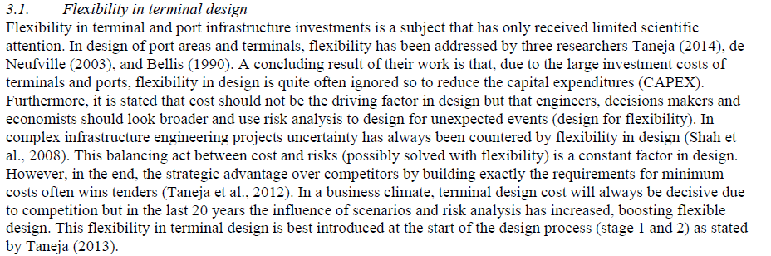

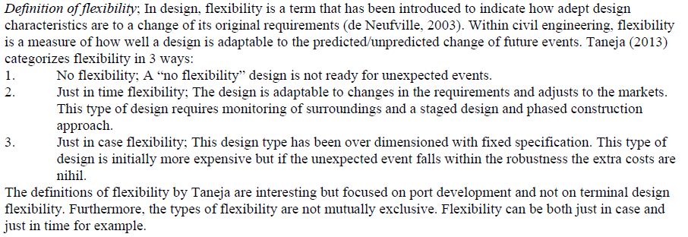

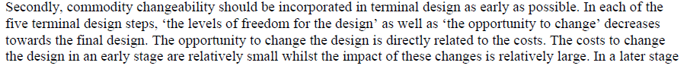

In some cases, for instance, providing flexibility (e.g. over-dimensioning of the quay wall) may justify a higher investment cost, as it reduces the cost of potential future expansions (i.e. deepening of the port basin).