Use Cases and Logical Architecture

* XID: X00160711
* Name: Cianan Nicolai
* Project Title: Short Range Messaging Application

**Provide at least 6 Use-cases describing the functionality of the proposed system**

## Section 1: For Each Use Case:

|  |  |
| --- | --- |
| Title (goal) | Post |
| Primary Actor | User 1, User 2 |
| Story | 1. User 1 creates post. 2. User 2 can see post as they are within 15 miles. 3. User 2 movies outside 15 miles and can no longer see post. |

|  |  |
| --- | --- |
| Title (goal) | Event Post |
| Primary Actor | User 1, Business 1 |
| Story | 1. Business 1 creates event. 2. User is within the set range, therefore can see the event the days leading up to it. |

|  |  |
| --- | --- |
| Title (goal) | Like Post |
| Primary Actor | User 1, User 2 |
| Story | 1. User 1 creates post. 2. User 2 can see post as they are within 15 miles, then likes the post. 3. User 2 movies outside 15 miles and they can still see the post as they liked it. |

|  |  |
| --- | --- |
| Title (goal) | Comment on Post |
| Primary Actor | User 1, User 2 |
| Story | 1. User 1 creates post. 2. User 2 can see post as they are within 15 miles, then comments on the post. 3. User 2 movies outside 15 miles and they can still see the post as they comment on it. |

|  |  |
| --- | --- |
| Title (goal) | Delete Post |
| Primary Actor | User 1 |
| Story | 1. User 1 creates post. 2. User 1 wishes to remove post and deletes it. |

|  |  |
| --- | --- |
| Title (goal) | Sign in / Out |
| Primary Actor | User 1 |
| Story | 1. User 1 signs in, only options available are to sign in or create account. 2. User 1 is signed in. Can only see the options to sign out. 3. User 1 signs out. Can now see options to sign in or create account. |

## Section 2: Logical Architecture

In this section use [www.draw.io](http://www.draw.io) to show how your architecture is distributed. Your architecture should to show:

Software Components

Databases

App engines

Mobile platforms

APIs and languages (per component)

Deployment EG REStful, JDBC, sessionless etc

Security e.g. Https, certificates, authentication, etc.

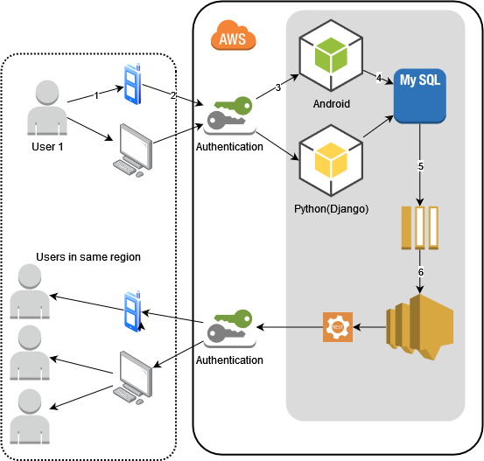

## Logical Architecture Discussion

* Discuss each component of your architecture
* Add numbers to the arrows and discuss the flow of data

Users can either use their phone or computer to login then begin posting.

Currently, I only have plans to produce the application as a website however it would be nice to eventually get it working as mobile app and on the app store. That would look really great for the final presentation.

The database I use is mySQL as I believe it would be the easiest to set up which then takes the message produced and put in the database and sends it as a message or ‘post’ and assuming that process is authenticated it is send to the device(s) of the users in the same region.

I think it would also be nice have no search function, messages are purely regional so it’s only the users that can be confirmed ( at least if they don’t use a vpn) to be in that region.

All this imagery is also presented with AWS in the corner but ideally, it would not be run using AWS. If I could help it and it every actually gets to that point in development where the only thing left to do is host the site live for an extended period of time.