A04 — TUFF+ BASE Foundation Installation
  - Revision 0.6 | Two-section helical pile, adjustable hold-down and floor-edge support | Engineering review draft
STATUS: DESIGN CONCEPT — NOT FOR CONSTRUCTION. Site-specific geotechnical and structural engineering approval, supplier drawings, test evidence and installation criteria are required before procurement or field use.

1. Purpose and basic principle
TUFF+ BASE is a ground-bearing FRP foundation section. Its bottom surface bears on a level, engineered, compacted substrate; the helical piles restrain the structure against uplift and other design actions as applicable. The piles are not assumed to carry normal gravity loads unless the project engineer explicitly designs them to do so.
The proposed pile consists of a lower helical lead section approximately 3 ft (0.91 m) long, a matching upper extension approximately 3 ft long, and a replaceable adjustable head. Two sections are a logistics and assembly preference, not a fixed foundation depth: the required installed length and helix embedment are established by soil testing and capacity verification. Additional extensions or a different system may be necessary.

2. Reference image supplied for design discussion
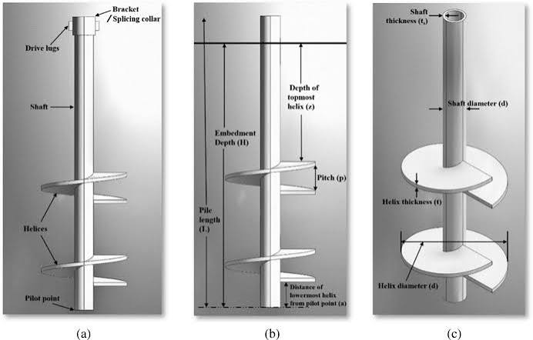
Figure 1. User-supplied reference illustrating a helical pile shaft, multiple helix plates, drive interface, pitch and embedment terminology. This is a reference image, not a TUFF+ approved fabrication drawing.

3. Recommended concept and reason for selection
Element | Proposed direction / reason
Lower section | Approx. 3 ft steel helical lead with manufacturer-designed helix arrangement. Factory welded plates reduce field assembly and help quality control.
Upper section | Approx. 3 ft plain extension with a manufacturer-rated positive-locking coupling. Easier transport and replacement; joint must carry full tension, torsion and relevant lateral actions.
Head | Replaceable, lockable self-aligning stud/head interface, designed for the observed pile inclination rather than bending the stud to fit.
Levelling | About 5 mm of fine adjustment at the head, locked after survey verification. Major level corrections belong in site preparation and set-out.
FRP hold-down | Rectangular engineered bearing plate/washer on the upper surface of the extended FRP bottom lip, with nut above it.
Why not a rigid welded stud? | A pile can finish inclined; a rigid stud would inherit that angle, risking eccentric loading and incomplete plate contact.
Why modular? | Potentially lower shipping and handling cost than long piles, while retaining replaceable extensions and a standard pile supplier.

4. Explain the uplift design simply
When wind tries to lift the house, the load travels from the wall/roof system through the TUFF+ BASE, the rectangular plate and nut, the threaded head, the pile shaft and its coupling, and finally the helix plates into the surrounding soil. Every link in that chain must resist the required force.
The current planning target is about 2 metric tonnes-force (19.6 kN) of uplift per pile. This is a target to investigate, not proof that a particular pile, coupling, washer, FRP lip or soil will safely carry it. Design actions, load combinations and resistance factors must be established by the engineer.

5. What the helical geometry means
Helix size and number: Larger or additional plates can increase resistance in suitable soil, but also change installation torque, soil disturbance, manufacturing cost and required depth. There is no universally best tapered arrangement.
Plate spacing: Spacing around three times a helix diameter is a commonly examined design concept, not an exact rule for every soil and plate combination. The supplier and geotechnical engineer must select and validate spacing.
Depth: A deeper, competent soil layer may provide more reliable uplift resistance than shallow fill. The suggested “5–7 diameters” is not a universal acceptance rule.
Installation torque: Measured torque can help indicate installed capacity when a validated, product- and soil-specific correlation exists. Torque alone is not a universal proof of uplift capacity.
Two-piece coupling: The connection between the 3 ft sections must resist uplift and installation torque without slippage or excessive movement. The coupling may govern the whole pile capacity.
Soil: Site-specific investigation determines whether a two-section pile is sufficient and where piles should be located.

6. Installation and inspection sequence — project-controlled
1. Obtain soil report, approved foundation plan, design uplift demands and supplier pile schedule.
2. Prepare and verify the compacted bearing formation; establish survey benchmarks and the base footprint.
3. Set out proposed pile locations with regard to the extended lip and approved connection edge distances.
4. Install the specified lower and extension sections using the manufacturer’s approved method; record torque, depth, inclination and final position.
5. Inspect each installed pile against approved position and inclination limits. A 20–30 mm offset or up to 5° inclination is a possible field deviation, not an automatic acceptance criterion.
6. Confirm the head can align the stud independently without introducing unacceptable eccentricity; confirm base bearing and fine level adjustment.
7. After approval of the as-built pile positions, locate the lip penetrations and connection plates according to the engineered detail. Do not enlarge holes or force a tilted stud into alignment.
8. Check that the rectangular plate bears evenly on the lip; install and secure the specified fastener assembly using the approved procedure.
9. Survey final base levels, straightness, parallel wall lines, diagonals and dimensions. Record hold-point sign-off before walls are installed.

7. Design decisions requiring approval
- Site soil profile, groundwater, allowable settlement and verified compacted bearing capacity.
- Pile shaft material and diameter; helix number, geometry, spacing, thickness, pitch, corrosion protection and minimum embedment.
- Coupling geometry, bolt or pin arrangement, torsion/tension resistance and proof testing.
- Head articulation range, fine adjustment and locking method, including how vertical load is transferred with eccentric pile alignment.
- Threaded stud grade/diameter, nut, rectangular plate dimensions and thickness, hole shape and minimum FRP edge distance.
- FRP lip thickness, local bending, bearing and tear-out strength, plus creep and durability.
- Project-specific pile layout, wind/seismic load paths, tolerances, inspection records and acceptance testing.

8. Information to request from pile suppliers
Ask suppliers to quote two concepts: (A) conventional rigid-head pile for near-vertical installations; (B) two-section pile with a lockable self-aligning head. Request indicative manufacturing and delivered cost, section weights, coupling test data, torque-capacity evidence, corrosion specification, sample availability and a drawing showing the pile-head connection to the actual TUFF+ FRP profile. Do not specify a fixed 2 × 3 ft solution where the soil report calls for greater depth.

9. Source notes and limitations
Source basis: user-supplied pile illustration and TUFF+ project specifications from this discussion. The user-supplied AI research notes are treated as hypotheses for engineering review, not verified universal rules; in particular the claimed 50% benefit of tapered helices, exact 3D spacing, depth thresholds and sand tension/compression ratio are not adopted as specifications. The existing supplier TUFF+ BASE cross-section drawing should remain the dimensional authority for the FRP profile.

10. Upper lip — perimeter floor-edge support
The TUFF+ BASE profile includes a projecting upper lip whose intended function is to support the perimeter edge of the floor panel and limit unsupported edge bending. This is separate from the extended lower lip used for the helical-pile uplift hold-down connection. Both features must be retained in manufacturing and installation drawings.
At the perimeter, gravity floor loads pass from the floor panel edge into the upper supporting lip and the BASE section, then into the prepared bearing substrate as designed. The lip must provide continuous, effective contact with the floor edge; it is not intended to replace the floor panel’s engineered support system across its span.

10.1 Site installation and quality checks
- Identify the upper floor-support lip and lower hold-down lip before positioning the BASE; do not confuse their functions.
- Survey the BASE for line, level, twist and local irregularities before flooring is placed.
- Inspect the upper lip for damage, distortion and obstructions; confirm the floor-panel edge will bear on the intended surface.
- Verify the floor panel’s specified edge overlap/bearing width, joints and any required bedding, sealant or fastening against the approved project detail.
- Check for gaps or point contacts along the floor edge; refer nonconformities for correction before loading or enclosure.
- Record perimeter floor-support inspection and approval before the floor is concealed by finishes or walls.

10.2 Design confirmation required
An engineer must confirm upper-lip projection, thickness, FRP strength and stiffness, local bearing and bending, connection to the remainder of the BASE, floor-panel properties, concentrated edge loads, long-term creep, thermal/moisture movement, and permitted installation tolerances. The supplier CAD image establishes the intended shape but does not establish an approved floor-support capacity.

11. Interface clarification — revised A05 floor system
The TUFF+ BASE is ground-bearing. Exterior grade is at its bottom. Its raised interior upper lip is approximately two-thirds of BASE height from the bottom. The compacted interior engineered fill must terminate level with the TOP of that lip. Recessed XPS rests on both the fill and the upper lip, with the MgO floor deck above. The lower extended lip remains a separate uplift connection to the helical pile. Final geometry and performance require engineer approval.


