A05 — Ground-Bearing XPS Floor System
Revision 0.7 | New chapter inserted after A04 | Design concept — NOT FOR CONSTRUCTION
Status: Project-specific structural, geotechnical, moisture, product and building-code approvals are required before construction. The drawings explain the intended geometry, not verified dimensions or capacities.

1. Purpose
Explain the interface between the prepared ground, compacted interior fill, FRP TUFF+ BASE, water-recessed XPS panels and MgO floor deck. The base upper lip supports the XPS/floor perimeter; the base lower lip provides the helical pile hold-down interface.

2. Levels and essential geometry
Exterior finished ground level aligns with the bottom of the TUFF+ BASE, leaving the outside face of the BASE visible above ground. Inside, the compacted engineered gravel/substrate rises to exactly the TOP of the small projecting upper lip. The upper lip is located approximately two-thirds of the way up the BASE height, measured from its bottom. The XPS rests ON this level compacted fill and ON the raised lip, not below it. The floor deck rests above the XPS.

3. Materials and layers
Wall SIP: XPS core between MgO skins, with the exterior MgO skin extending slightly over the upper BASE edge as shown in the concept. Floor: approximately 50 mm water-recessed interlocking XPS panel and 15 mm MgO floor deck per the latest user-supplied floor illustration; final thicknesses and specifications must be verified against the approved BoM and structural design. Blue is a drawing convention only; actual XPS panels are white.

4. Moisture and movement
Provide the intended perimeter expansion allowance of up to 5 mm, subject to final floor product specifications. The XPS recesses illustrate drainage provision but do not by themselves establish an approved drainage or waterproofing system. Confirm capillary break, vapour control, drainage outfall, moisture testing and applicable code requirements.

5. Installation sequence
1. Obtain site soil report, approved substrate specification and floor/BASE interface drawings. 2. Prepare and compact exterior bearing soil to the BASE bottom level. 3. Install, level and anchor the TUFF+ BASE under the approved A04 procedure. 4. Place and compact interior engineered fill to the TOP surface of the raised BASE upper lip; check this level continuously. 5. Inspect the upper lip and lay recessed XPS panels so their underside bears on both the lip and interior fill. 6. Install MgO floor deck to approved fastening/joint specifications, preserving perimeter movement allowance. 7. Inspect, document and release before wall/floor concealment.

6. Hold points and QA
Record surveyed elevations: exterior grade, BASE bottom, upper lip top, interior compacted fill top and XPS bearing plane. Check continuous XPS contact without bridging, panel interlocks, drainage recess orientation, floor-edge bearing, MgO deck joints and perimeter gap. Record soil compaction results and engineer approval. Reject any condition in which the interior fill terminates below the upper lip.

7. Interfaces and dependencies
A04 — foundation, pile hold-down and BASE geometry; A06 — wall module identification and raising; A07 — wall interlock; B-series — inspection and hold points; C-series — approved design, BoM, purchasing and traceability.

8. Outstanding engineering confirmations
Confirm actual FRP lip height and width, laminate and allowable bearing; XPS compressive strength and creep; floor deck structural grade and fastening; drainage and moisture detailing; compaction density and material; permitted movement gap; seismic and uplift interfaces. These are open design decisions, not field discretion.

Figure A05-1 — Geometry clarification
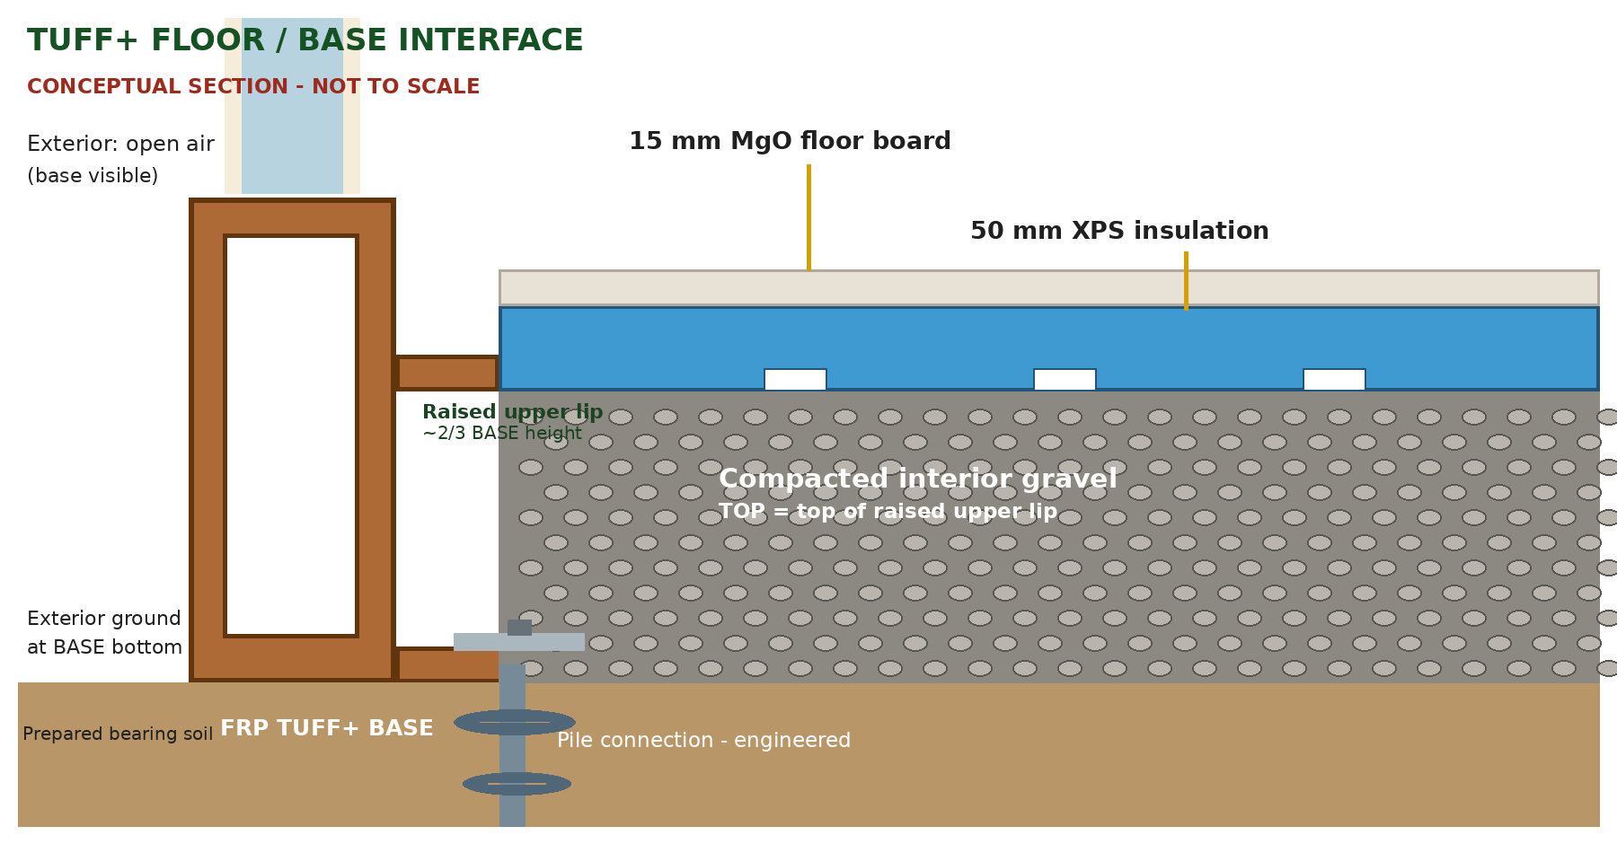
Diagram intentionally prioritises the two specified level relationships. Brown is FRP, blue is XPS, white recesses are drainage grooves. Not to scale.

Figure A05-2 — Earlier infographic (visual reference only)
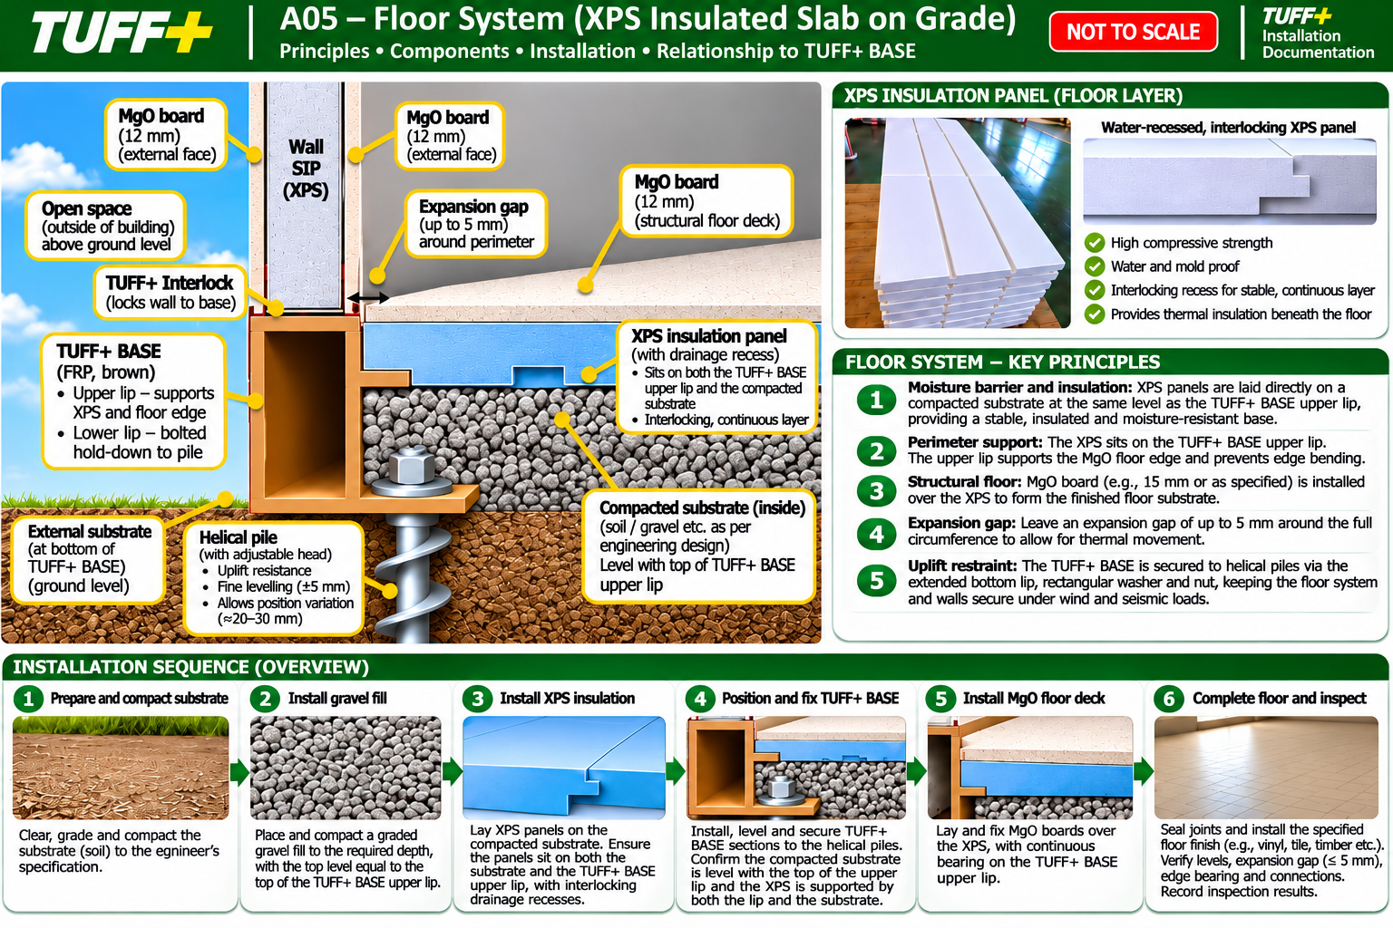
Previous annotated illustration included for design traceability only. Any inconsistent substrate or lip elevations are superseded by Figure A05-1 and the written instructions.

