00 — BIM and Design-to-Delivery Integration
TUFF-DOC-000-00 | Version 0.1 | Draft for TUFF+ review

1. Scope
Defines how configurable WallPlanner designs, permit drawings, the generated BoM, pricing, customer authorization and INTEGRATOR workflows are related. Jorge’s Caribbean house is a reference example only, not a standard kit design.

2. Information model
Information object | Origin / relationship
Customer requirements | Sales / project brief; may trigger revisions
WallPlanner design | Individual configurable layout and component positions
Approval package | Project drawings and permit submission; record actual authority approval separately
BoM | Derived from a specified design revision; preserve native component IDs
Quote | Priced scope tied to BoM revision and commercial assumptions
Customer order | Accepted scope and commercial terms; controlled release for procurement
INTEGRATOR record | Proposed link between sales, supply chain, delivery, quality and handover
Installation package | Approved drawings, component schedule, standard methods and inspections

3. Reference workflow
1. Capture requirements and create or modify WallPlanner design.
2. Review drawings and seek required engineering and building approvals.
3. Generate BoM from the identified design revision.
4. Prepare and confirm quotation; process customer acceptance and order.
5. Release authorized components to suppliers and manufacturing.
6. Record packing, shipping, delivery and kit inventory reconciliation.
7. Issue project-specific installation instructions and complete inspections.
8. Record handover and as-built changes.
Revision loop: a change to an approved design may affect drawings, permits, BoM, quotation, supplier orders and installation instructions. A documented impact assessment and approvals must precede release of changed work.

4. BIM maturity and implementation status
The TUFF+ BIM diagram presents four maturity levels, from CAD through 2D/3D and 4D/5D to full integration. It is a conceptual roadmap. Current software capabilities and operational status require verification before representing the highest level as implemented.

5. Jorge reference project
Reference inputs: 34-page WallPlanner V25-41 permit set printed September 1, 2026; house quote workbook dated September 2, 2026. The permit drawings identify a 74 m² floor plan, 15 helical piles on the foundation plan, and 42 roof SIP strips. Quantities and dimensions must be reconciled against the exact approved design and matching BoM revision.

6. Source diagrams
TUFF+ BIM maturity diagram
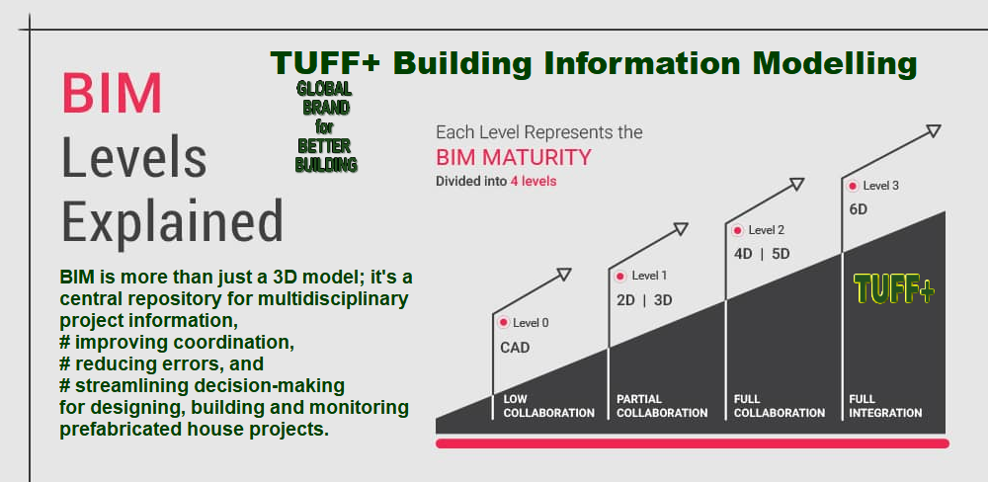
TUFF+ sales and supply chain workflow


7. Required identifiers and controls — proposal
- Project ID and customer order ID
- Design revision, approval status and approving authority
- BoM revision and component IDs (including position and orientation)
- Quote revision, accepted scope and change order history
- Manufacturing lot / supplier and delivery status
- Installation checkpoint, inspector, date and nonconformance records

8. Open decisions
- Confirm whether WallPlanner component identifiers persist across design revisions.
- Confirm INTEGRATOR fields and which handoffs are currently automated.
- Confirm approval and signed engineering references for the example project.
- Reconcile permit set with BoM and any differences in floor material specifications.
- Define where videos are hosted and how timestamps and revisions are maintained.

